User Manual
for the
MYSTRAN General Purpose Finite Element Structural Analysis Computer Program
(Open Source Version)

Dr. Bill Case – Original Author

Subsequent Authors:
Brian Esp
Victor Kemp
Bruno Paschoalinoto
Zach Lerner
Steve Doyle


www.mystran.com
github.com/MYSTRANsolver

(October 2026)
Most consistent with MYSTRAN program version 19.0

TABLE OF CONTENTS
1 TABLE OF CONTENTS 2
2 INTRODUCTION 7
2.1 MYSTRAN Brief History 12
3 SETUP AND RUN CMD WINDOW 14
4 INPUT DATA – BASIC DESCRIPTION 15
5 INPUT DATA – DETAILED DESCRIPTION 17
5.1 File Management 17
5.2 Executive Control 17
5.2.1 IN4 Exec Control command 19
5.2.2 OUTPUT4 and PARTN Exec Control commands 19
6 FINITE ELEMENT MODEL 26
6.1 Grid points 26
6.1.1 Grid point and coordinate system definition 26
6.1.2 Grid point sequencing 27
6.2 Elements 29
6.2.1 Element connection, property, and material definition 29
6.2.2 Elastic elements 30
6.2.3 Rigid elements 42
6.2.4 RBE3 element 44
6.2.5 RSPLINE element 44
6.3 Applied loads 45
6.3.1 Forces and moments directly applied to grids 45
6.3.2 Pressure loads on plate elements 45
6.3.3 Gravity loads 46
6.3.4 Equivalent loads due to thermal expansion 46
6.3.5 Equivalent loads due to enforced displacements 47
6.3.6 Loads due to rigid body rotation about a specified grid (RFORCE) 47
6.3.7 LOAD Bulk Data entry – combining loads 47
6.4 Constraints 48
6.4.1 Single point constraints 48
6.4.2 Multi point constraints 53
6.4.3 Boundary degrees of freedom in Craig-Bampton analyses (SUPORT) 53
6.5 Mass 53
6.5.1 Mass density on material entries 54
6.5.2 Mass per unit length or area of finite elements 54
6.5.3 Concentrated masses at grids 54
6.5.4 Model total mass 55
6.5.5 Mass units 55
6.6 Displacement set notation 56
7 EXECUTIVE CONTROL – MYSTRAN SOLUTION TYPES 59
7.1 Static Analysis 59
7.2 Natural Frequency (Normal Modes) 59
7.3 Differential Stiffness 60
7.4 Buckling 60
7.5 Craig-Bampton model generation 60
8 CASE CONTROL – OVERVIEW 62
8.1 Detailed Description of Case Control Entries 64
8.2 Output File Types 65
9 BULK DATA – OVERVIEW 67
10 QUICK REFERENCE – CASE CONTROL 81
10.1 BEGIN BULK 82
10.2 ACCELERATION 83
10.3 DISPLACEMENT 84
10.4 ECHO 88
10.5 ELDATA 89
10.6 ENFORCED 92
10.7 FORCE 94
10.8 GPFORCE 96
10.9 LABEL 97
10.10 LOAD 98
10.11 MEFFMASS 99
10.12 METHOD 100
10.13 MPC 101
10.14 MPCFORCES 102
10.15 MPFACTOR 103
10.16 OLOAD 104
10.17 SET 105
10.18 SPC 107
10.19 SPCFORCES 108
10.20 STRAIN 109
10.21 STRESS 112
10.22 SUBCASE 113
10.23 SUBTITLE 114
10.24 TEMPERATURE 115
10.25 TITLE 116
10.26 VECTOR 117
11 QUICK REFERENCE – BULK DATA 118
11.1 ASET 119
11.2 ASET1 121
11.3 BAROR 123
11.4 CBAR 125
11.5 CBUSH 130
11.6 CELAS1 134
11.7 CELAS2 135
11.8 CELAS3 136
11.9 CELAS4 137
11.10 CHEXA 138
11.11 CMASS1 139
11.12 CMASS2 140
11.13 CMASS3 141
11.14 CMASS4 142
11.15 CONM2 143
11.16 CONROD 145
11.17 CORD1C 147
11.18 CORD1R 149
11.19 CORD1S 151
11.20 CORD2C 153
11.21 CORD2R 155
11.22 CORD2S 157
11.23 CPENTA 159
11.24 CQUAD4 160
11.25 CQUAD8 162
11.26 CROD 165
11.27 CSHEAR 167
11.28 CTETRA 168
11.29 CTRIA3 169
11.30 CUSERIN 171
11.31 EIGR 173
11.32 EIGRL 175
11.33 FORCE 177
11.34 GRAV 178
11.35 GRDSET 180
11.36 GRID 181
11.37 LOAD 182
11.38 MAT1 184
11.39 MAT2 186
11.40 MAT8 188
11.41 MAT9 190
11.42 MOMENT 192
11.43 MPC 193
11.44 MPCADD 195
11.45 OMIT 196
11.46 OMIT1 197
11.47 PARAM 199
11.48 PARVEC 213
11.49 PARVEC1 214
11.50 PBAR 216
11.51 PBARL 218
11.52 PBUSH 223
11.53 PCOMP 225
11.54 PCOMP1 227
11.55 PELAS 229
11.56 PLOAD2 230
11.57 PLOAD4 232
11.58 PLOTEL 234
11.59 PROD 235
11.60 PSHEAR 236
11.61 PSHELL 237
11.62 PSOLID 239
11.63 PUSERIN 241
11.64 RBE2 243
11.65 RBE3 245
11.66 RFORCE 248
11.67 RSPLINE 250
11.68 SEQGP 252
11.69 SLOAD 253
11.70 SPC 254
11.71 SPC1 256
11.72 SPCADD 258
11.73 SPOINT 259
11.74 SUPORT 260
11.75 TEMP 261
11.76 TEMPD 263
11.77 TEMPP1 265
11.78 TEMPRB 267
11.79 USET 270
11.80 USET1 271
12 REFERENCES 273
13 DEBUG – FOR DEVELOPERS 275
13.1 DEBUG 275

INTRODUCTION
MYSTRAN is a general-purpose finite element analysis computer program for structures that can be modeled as linear (i.e. displacements, forces and stresses proportional to applied load). MYSTRAN is an acronym for “My Structural Analysis”, to indicate its usefulness in solving a wide variety of finite element analysis problems on a personal computer (although there is no reason that it could not be used on mainframe computers as well). For anyone familiar with the popular NASTRAN computer program developed by NASA (National Aeronautics and Space Administration) in the 1970’s and popularized in several commercial versions since, the input to MYSTRAN will look quite familiar. Indeed, many structural analyses modeled for execution in NASTRAN will execute in MYSTRAN with little, or no, modification. MYSTRAN, however, is not NASTRAN. All of the finite element processing to obtain the global stiffness matrix (including the finite element matrix generation routines themselves), the reduction of the stiffness matrix to the solution set, as well as all of the input/output routines are written in independent, modern, Fortran 90/95 code. The major solution algorithms (e.g., triangular decomposition of matrices and forward/backward substitution to obtain solutions of linear equations) as well as the Givens method of eigenvalue extraction, however, were obtained from the popular LAPACK code, Reference 1, available to the general public on the World Wide Web. The code for the Lanczos method of eigenvalue extraction, Reference 2, was obtained from the ARPACK library, also available to the general public on the World Wide Web. The code for the grid point sequencing algorithm (used to ensure a minimum bandwidth for the stiffness matrix) was obtained from the author of Reference 3.
As of Version 11.3, MYSTRAN has available the sparse solver SuperLU (see Reference 13). This solver is currently only used for SOL101, 103, 105, and is the default method used for matrix decomposition and equation solution (Forward-Backward Solution, or FBS).
There is no inherent limitation to problem size, or number of degrees of freedom, for MYSTRAN. Rather, the users’ personal computer memory (RAM and disk) limitations will dictate what size problems can be effectively solved using MYSTRAN on their computer.
Major features of the program are:
- NASTRAN style input. NASTRAN model files will run in MYSTRAN with little or no modification for static and eigenvalue analyses.
- 3D structures with arbitrary geometry.
- Linear static analysis.
- Eigenvalue analysis via Lanczos, Givens and modified Givens methods. In addition, for the fundamental mode there is also an Inverse Power method.
- Optional calculation of modal mass and/or modal participation factors (Reference 8)
- Craig-Bampton model generation.
- Interface to the Femap pre/post processor program (legacy neutral file).
- Grid points (3 translations and 3 rotations per grid) that define the finite element model mesh:
- Locations can be defined in rectangular, cylindrical or spherical coordinate systems that can be different for each grid.
- Global stiffness matrix can be formulated in rectangular, cylindrical or spherical coordinate systems that can be different for each grid.
- Scalar points (SPOINT’) that have no defined geometry (one degree of freedom)
- A finite element library consisting of the following elastic and rigid elements.
- 1D and scalar elements.
- BAR element with two grids and stiffness for up to six degrees of freedom per grid (axial, two planes of bending, torsion) for beams that have their shear center and elastic axis coincident.
- BUSH element (spring connecting two grids).
- ELAS1,2,3,4 elements (scalar spring connecting two degrees of freedom).
- ROD element (axial load and torsion element connected to two grid points)

- Triangular and quadrilateral plate elements for thick (Mindlin plate theory) and thin (Kirchhoff plate theory) plates. The plates can include membrane and/or bending stiffness and can be either single or multi-ply composite laminates. The following is a brief overview and Section 6.2 discusses the options in more detail:
- TRIA3: Flat triangular plate element with separate membrane and bending stiffness, as well as transverse shear flexibility, based on Mindlin thick plate theory (Reference 4). It can be either a single or multi-ply composite.
- QUAD4 with MITC4+: Quadrilateral plate element with separate membrane and bending stiffness, as well as transverse shear flexibility. (Reference 15). This is the default for the QUAD4TYP parameter, equivalent to “PARAM, QUAD4TYP, MITC4+”.
- QUAD4 with MIN4: Mindlin quadrilateral plate element with separate membrane and bending stiffness, as well as transverse shear flexibility, based on Mindlin thick plate theory (Reference 5). This is essentially a flat element, however small distortion out of plane is accommodated. It can be either a single or multi-ply composite. This is alternative option for the QUAD4TYP parameter, equivalent to “PARAM, QUAD4TYP, MIN4”.
- QUAD8 MITC8: Quadrilateral plate element with combined membrane and bending stiffness, as well as separate transverse shear flexibility. (Reference 16). It can be curved out of plane but is limited to statics with isotropic material and no body loads.
- SHEAR element that carries in-plane shear stresses.
- TRIA3K: Legacy element – no longer supported. Flat triangular plate element with separate membrane and bending stiffness based on Kirchhoff thin plate theory (Reference 6).
- QUAD4K: Legacy element – no longer supported. Quadrilateral plate element with separate membrane and bending stiffness based on Kirchhoff thin plate theory (Reference 7). This is essentially a flat element, however small distortion out of plane is accommodated.
- 3D solid elements
- TETRA 4 and 10 node solid elements. See Reference 10.
- PENTA 6 and 15 node elements with selective substitution reduction for shear (if desired). See Reference 10.
- HEXA 8 and 20 node elements with selective substitution reduction for shear (if desired). See Reference 10.
- R-elements:
- RBE2 rigid element specifying a relationship for one or more degrees of freedom (DOF's) of one or more grids being rigidly dependent on the DOF's of another grid.
- RBE3 element for distributing loads or mass from one grid to other grids.
- RSPLINE element for interpolating displacements between elements.
- User defined elements:
- CUSERIN element where the user inputs the stiffness and mass matrices and specifies the connection of the element to defined grids and scalar points.
- Single point constraints (SPC’s) wherein some degrees of freedom are grounded (e.g. for specifying boundary conditions).
- Other SPC’s wherein specified degrees of freedom have a specified motion (enforced displacements).
- Multi point constraints (MPC’s), wherein specified degrees of freedom are linearly dependent on other degrees of freedom.
- Loads on the finite element model via:
- Forces and/or moments applied directly to grid points.
- Pressure loading on plate element surfaces.
- Gravity loads on the whole model (in conjunction with mass defined by the user).
- Equivalent loads due to thermal expansion.
- Equivalent loads due to enforced displacements.
- Inertia Loads due to rigid body angular velocity and acceleration about some specified grid (RFORCE).
- Loads on scalar SPOINT’s (via SLOAD)
- Linear isotropic, orthotropic and anisotropic material properties.
- Mass defined via:
- Density on material entries.
- Mass per unit length, or per unit area, for finite elements.
- Concentrated masses at grids (CONM2) with possible offsets and moments of inertia.
- Scalar masses (CMASS1,2,3,4).
- Multiple subcases to allow for solution for more than one loading condition in one execution.
- Output of:
- Displacements (six degrees of freedom per grid) for any defined set of grids desired.
- Applied loads for any defined set of grids.
- Single point forces of constraint for any defined set of grids.
- Multi point forces of constraint for any defined set of grids (includes forces of constraint due to MPC’s as well as rigid elements).
- Grid point force balance for any defined set of grids.
- Element engineering and/or nodal forces for any defined set of elements.
- Element stresses for any defined set of elements.
- Element strains for 2D and 3D elements (including ply strains in composite elements).
- Effective modal mass and/or modal participation factors in eigenvalue analyses.
- Output transformation matrices (OTM's) in Craig-Bampton analyses for displacement, acceleration, force, and stress quantities.
- Interface to Femap post processing program for display of model and results (see Bulk Data entry PARAM, PRTNEU). The Neutral file (.neu) is a legacy file option. The version used in MYSTRAN may be version 7.1. It can be called via “PARAM, PRTNEU, YES”.
- Guyan reduction to statically reduce the stiffness and mass matrices. This is needed if the Givens method of eigenvalue analyses is used to remove degrees of freedom that have no mass (however, LANCZOS is the preferred method of eigenvalue extraction).
- Limited CHKPNT/RESTART feature that allows a previous job to be restarted to obtain new or different outputs (displacements, etc.). The finite element model and solution (SOL in Exec Control) must remain the same.
- General:
- AUTOSPC (automatic SPC generation based on used control).
- Stiffness matrix equilibrium checks on request (Bulk Data PARAM entry EQCHECK)
- Automatic grid point resequencing to reduce matrix bandwidth (Bulk Data PARAM entry GRIDSEQ with value BANDIT – default).

MYSTRAN Brief History
Dr. Bill Case spent his career at NASA, frequently using the Nastran program in the 1970’s and 1980’s. Later, he and a colleague created their own version of Nastran, called MYSTRAN, based on modern Fortran. This effort is suspected to have started in the 1990’s. The MYSTRAN program was originally a commercial program.
In the mid 2010’s, Bill met Dr. Brian Esp and began discussing the MYSTRAN project. In 2019, Bill offered the source code to Brian and requested that he carry on the MYSTRAN project.
The source code was eventually open-sourced and placed on GitHub with a permissive MIT license. By making the program open-source, other members joined the MYSTRAN project. Along with Bill, these members made significant contributions. Bill passed away in 2021, but all of the pieces were in place to allow the team to make progress towards creating a complete Nastran-like solver for linear static and Eigen problems (buckling and natural frequency). The following is a partial list of accomplishments since the program became open source.
- Compiling processes (Bruno Paschoalinoto)
- Sparse solver SuperLU added (Bill Case)
- OP2 support added (Steven Doyle)
- Fixed RBE3 (Bruno Paschoalinoto)
- Fixed BUSH elements (Various)
- Fixed many memory bugs (Bruno Paschoalinoto)
- Upgraded documentation (Various)
- Created f06csv tool – supports validation effort (Bruno Paschoalinoto)
- Shell buckling added (Victor Kemp)
- Shell elements: Fixes to existing and added MITC4+ 4-node quad (Victor Kemp)
- Bug fixes (Various)
- Support and general oversight of all previously listed items (Zach Lerner)
- Added an accurate K6ROT (Victor Kemp)
- Validation – Tools and method to support automatic validation (Victor Kemp and Bruno Paschoalinoto)
- Project Oversight (Brian Esp)

In addition, Brian Esp and Zach Lerner provided financial support to ensure the above goals were accomplished.
As of June 2026, with the efforts of the MYSTRAN team, all of the major features have been completed. The major remaining efforts are related to fixing bugs, continued validation of the solver, improving the documentation, and increasing performance. However, there are various other features on the horizon (such as the continued development of the MITC8 8-node quad) and potentially some MYSTRAN specific features.

SETUP AND RUN CMD WINDOW
The MYSTRAN program is a stand-alone executable, with no external dependencies. Because of this, it is straightforward to set up and run. However, for convenience, some additional options are presented in the “Quick Setup Guide”. Three options are presented in that document.
The “Run CMD Window Guide” for MYSTRAN provides additional discussion about the run information that is provided in the CMD window.

INPUT DATA – BASIC DESCRIPTION
A general description of MYSTRAN input data (referred to as a data section) is given in this section. A more detailed description of each of the three parts of the data section is given in Section 5.
The MYSTRAN Sample Problem:
https://github.com/MystranSolver/MYSTRAN_Documentation, contains a sample MYSTRAN input and may be of help when reviewing this section.
The MYSTRAN data section consists of three distinct parts:
- The Executive Control section
- The Case Control section
- The Bulk Data section

The Executive Control section is an overall identification of the job and the solution type to be performed (e.g. statics, eigenvalues). It usually consists of a very few entries. It begins with an ID entry and ends with a mandatory CEND entry. All Executive Control section entries are described in Section 7.
The Case Control section defines the job title that is printed out with the output, the loading for each of the different subcases, the constraint boundary conditions and the sets that define the grids and elements for displacement, load and stress output. The Case Control section begins with the entry following the Executive Control CEND entry and ends with the mandatory BEGIN BULK entry. The only requirement on the order of entries in the Case Control section is that the order makes sense when there are multiple subcases. The details of each of the Case Control section entries are given in Sections 8 and 10.
The Bulk Data section defines the finite element model in detail. It begins with the entry immediately following the BEGIN BULK entry and ends with the mandatory ENDDATA entry. Grid points form the “mesh” of the finite element model and are defined with their locations (in any of several coordinate systems). The elements that make up the finite element model are defined by the grid points to which they are connected, by their physical properties and by their material properties. Loads and boundary conditions are also defined in the Bulk Data section. In the case of eigenvalue analysis, the eigenvalue extraction method is also defined here.
All physical Bulk Data entries are broken down into 10 fields of 8 columns each with field 1 being a mnemonic that defines the type of entry (e.g. GRID for a grid point definition, PBAR for a bar element property definition, etc.). Since 10 fields may not be enough for some of the entries, provision is made to include “continuation” entries. For example, the PBAR Bulk Data entry that defines geometric properties for a bar element has three physical entries necessary to define all of the properties. These three physical entries comprise the one logical PBAR entry. This is explained in detail in the description of Bulk Data entries in Section 9. Suffice it to say here that a logical Bulk data entry in MYSTRAN may consist of several physical entries with the initial entry being called the “parent” entry and subsequent continuation entries (if necessary) called “child” entries. Since all logical Bulk Data entries have a mnemonic that defines which type of input it describes, there is no requirement on the order of logical entries in the Bulk Data section. Physical entries that make up a given logical entry must, however, be in order and grouped together.

INPUT DATA – DETAILED DESCRIPTION
The input entries for the Executive Control, Case Control and Bulk Data Sections are described in detail in the next three sections. In all of the sections, an entry with a $ sign in column 1 is considered as a comment and is ignored. In addition, any blank entry is ignored. Input is not case-sensitive (it is internally converted to upper case). Anything after $ on a line is a comment. File names given on IN4, RESTART and ENFORCED are also converted to upper case, which matters on Linux/macOS."
The MYSTRAN Sample Problem:
https://github.com/MystranSolver/MYSTRAN_Documentation, contains a sample MYSTRAN input and may be of help when reviewing this section

File Management
As mentioned earlier, the input data file consists of 3 sections: Executive Control, Case Control and Bulk Data. In order to make the most efficient use of resources, each of these can contain requests to include some defined file to be part (or all) of that portion of the input data file. This is accomplished through the use of an INCLUDE entry whose format is:
INCLUDE ‘filename’
Where filename is the name of a file to include at the location where the INCLUDE entry exists. The INCLUDE entries can be used in any or all of the 3 sections of the input data file. In addition, multiple INCLUDE entries in any section are permitted. The quotes around filename are recommended but not required.

Executive Control
The Executive Control Section consists of only a few entries. Most are free field; that is they can begin in any column and the parts of an entry may be separated by any amount of columns within the confines of the 80 column physical entry. In addition, the fields of an entry may be delimited by tabs, as well as a white space. Some of the entries are required and some are not required but are recognized. Other entries are ignored with a warning message printed in the output. Any requirements on the order of the entries in the Executive Control Section are noted.

With the CHKPNT/RESTART feature, users may restart a previously run job to get additional outputs. In a restart the Bulk Data must remain the same except for a few PARAM and DEBUG entries. Case Control requests for additional displacements, element forces, stresses, etc. will be processed.
Table 5.1 Executive Control Entries required and/or recognized by MYSTRAN
Entry | Required  (Y/N) | Format | Description
ID | N | Free Field | If input, it is generally the first entry in the Exec Control Section.
IN4 | N |  | Defines a file containing element stiffness, mass and other data for a CUSERIN element.
APP | N | Free Field | An entry of APP DISP is common if this entry is included.
CHKPNT | Y/N | Free Field | Required if the user expects to restart the current job, at a later date, to obtain additional outputs.
DEBUG | N | Fields of 8 chars like Bulk Data | These are the same as the Bulk Data DEBUG entries and are allowed here since some DEBUG values need to be used prior to reading the Bulk Data.
OUTPUT4 | N | Free Field | Requests for CB matrices to be written to unformatted files in the same format as NASTRAN uses. An example is shown below along with the allowable matrices that can be output.
PARTN | N | Free Field | Requests to partition a previously defined OUTPUT4 matrix.
RESTART | Y/N | Free Field | Required only if the current job is a restart of an earlier job in which the CHKPNT entry was present. Give the base name of the CHKPNT'd run without its extension, e.g. RESTART JOB1. If omitted, the current input file name is used.
SOL | Y | Free Field | SOL entry must have a value that designates what kind of problem this is:  - SOL 101 or SOL STATICS designates the job as a statics problem.  - SOL 103 or SOL = MODAL or SOL MODES or SOL NORMAL MODES for eigenvalues.  - SOL 31 or SOL GEN CB MODEL for Craig-Bampton (CB) model generation.  - SOL 105 or SOL BUCKLING for linear static buckling  - SOL 104 or SOL DIFFEREN for static analysis with the same differential stiffness that is used in static buckling analyses.
TIME | N | Free Field | TIME n, where n is the job estimated time in minutes.
CEND | Y | Free Field | The CEND entry has no other input required. It must be the last entry in the Exec Control Section.

IN4 Exec Control command
The Exec Control command IN4 specifies binary files (NASTRAN INPUTT4 format) which contain the element matrices needed for CUSERIN Bulk Data element definition. The IN4 command has the following format:
IN4 i filename
Where i is the ID of the file and is what must appear in field 3 of the Bulk Data PUSERIN property entry for the CUSERIN element. filename is the name of the file that contains the matrices specified on the PUSERIN entry for the element. filename must contain the full path unless the file is in the current path where the program is being executed. An example is: IN4 100 cb1_example1.OP1

OUTPUT4 and PARTN Exec Control commands
MYSTRAN allows output of selected matrices to binary files in the OUTPUT4 format that is the same as that currently used by NASTRAN. The form of the OUTPUT4 command is:
OUTPUT4 MAT1,MAT2,MAT3,MAT4,MAT5//ITAPE/IUNIT $
From 1 to 5 matrices can be output per OUTPUT4 command. All 4 commas must be present even if fewer than 5 matrices are requested. The // followed by ITAPE value (must be 0 to -3 but is currently not used) must also be present. The final / followed by a file unit number (can be 21-27) is also required. A trailing $ can exist but is not required. If present, it signifies the end of data read for the OUTPUT4 command.
These OUTPUT4 matrices can be partitioned, in some cases, using an Exec Control PARTN command. The resulting partitioned matrix will be the one output to the OUTPUT4 binary file. The partitioning vectors that define which columns and rows to partition from the original OUTPUT4 matrix are defined on Bulk Data PARVEC and PARVEC1 entries. These Bulk Data partitioning vector entries give the grid and component pairs of the columns and rows to partition. As such, the partitioning can only be done on OUTPUT4 matrices that have columns and/or rows that are part of a normal displacement set (the G-set, M-set, etc.). See section 6.6, “Displacement set notation”, for a definition of all of the displacement sets. The general form for the PARTN command for MYSTRAN is:
PARTN MAT, CP, RP / $
where MAT is an OUTPUT4 matrix previously requested for OUTPUT4 output and CP and RP are column and row partitioning vectors defined in the Bulk data using PARVEC and/or PARVEC1 Bulk Data entries.
If the input file for a MYSTRAN run is filename.DAT, the binary OUTPUT4 file names are filename.OPi where i=1,7 (corresponding to units 21-27 used as values for UNIT in the OUTPUT4 command). The format in which these files are written is the same as that for the NASTRAN OUTPUT4 matrices.

The table on the following page shows the matrices that are currently eligible for OUTPUT4 output. Note that there is a correspondence between MYSTRAN and NASTRAN matrix names. The OUTPUT4 commands can use either name as desired by the user. All matrix names must be no more than16 characters long. An example of the use of the Exec Control commands OUTPUT4 and PARTN is given following the table.
Table 5.2: Matrices that can be written to OUTPUT4 files (and the correspondence between MYSTRAN matrix names, NASTRAN names and CB Equation Variables)
 | MYSTRAN  Matrix Name  (OUTPUT4 matrices) | NASTRAN  DMAP  Name | CB equation variable – See Theory Manual  (where applicable) | Matrix size¹ | Partition  rows  and/or  cols
1 | CG_LTM |  | $$\left[\begin{matrix}LTM11_{6r} & LTM12_{6N} & 0\end{matrix}\right]$$ | 6x(2R+N)
2 | DLR | DM | $$D_{LR}$$ | LxR | rows and  cols
3 | EIGEN_VAL | LAMA | $$Ω_{NN}^{2}$$ | NxN
4 | EIGEN_VEC | PHIG | $$Φ_{GN} , (Φ_{LN}\text{ with rows expanded to G-set})$$ | GxN | rows
5 | GEN_MASS | MI | $$m_{NN}$$ | Nx1 vector of diag. terms
6 | IF_LTM |  | $$\left[\begin{matrix}LTM21_{RR} & LTM22_{RN} & LTM23_{RR}\end{matrix}\right]$$ | Rx(2R+N) | rows
7 | KAA | KAA | $$K_{AA}$$ | AxA | rows and  cols
8 | KGG | KGG | $$K_{GG}$$ | GxG | rows and  cols
9 | KLL | KLL | $$K_{LL}$$ | LxL | rows and  cols
10 | KRL | KLR(t) | $$K_{LR}$$ | LxR | rows and  cols
11 | KRR | KRR | $$K_{RR}$$ | RxR | rows and  cols
12 | KRRcb | KBB | $$k_{RR}=K_{RR}+K_{LR}^{T}D_{LR}$$ | RxR | rows and  cols
13 | KXX | KRRGN | $$K_{XX}$$ | (R+N)x(R+N)
14 | LTM | LTM | CG_LTM and IF_LTM merged | (6+R)x(2R+N)
15 | MCG | RBMCG | $$m_{cg}$$ | 6x6
16 | MEFFMASS |  | Modal effective mass | Nx6
17 | MPFACTOR |  | Modal participation factors | Nx6 or NxR
18 | MAA |  | $$M_{AA}$$ | AxA | rows and  cols
19 | MGG |  | $$M_{GG}$$ | GxG | rows and  cols
20 | MLL | MLL | $$M_{LL}$$ | LxL | rows and  cols
21 | MRL | MRL | $$M_{RL}$$ | RxL | rows and  cols
22 | MRN |  | $$m_{RN}=m_{NR}^{T}$$ | RxN | rows
23 | MRR | MRR | $$M_{RR}$$ | RxR | rows and  cols
24 | MRRcb | MBB | $$m_{RR}=M_{RR}+M_{LR}^{T}D_{LR}+(M_{LR}^{T}D_{LR})^{T}+D_{LR}^{T}M_{LL}D_{LR}$$ | RxR | rows and  cols
25 | MXX | MRRGN | $$M_{XX}=\left[\begin{matrix}m_{RR} & m_{NR}^{T} \\ m_{NR} & m_{NN}\end{matrix}\right]$$ | (R+N)x(R+N)
26 | PA |  | (A-set static reduced loads - only used in statics) |  | Rows
27 | PG |  | (G-set static loads - only used in statics) |  | Rows
28 | PL |  | (L-set static reduced loads - only used in statics) |  | rows
29 | PHIXG | PHIXG | $$Ψ_{AX} , (Ψ_{AX}\text{ with rows expanded to G-set})$$ | Gx(R+N) | rows
30 | PHIZG |  | The G-set displacement transformation matrix is written out in the f06 file under  “C B D I S P L A C E M E N T O T M” | Gx(2R+N) | rows
31 | RBM0 |  | Rigid body mass matrix relative to the basic origin | 6x6
32 | TR6_0 | RBR | $T_{\text{R6}}$: rigid body displacement matrix for R-set relative to the model basic coordinate system | Rx6 | rows
33 | TR6_CG | RBRCG | $T_{\text{R6}}$: rigid body displacement matrix for R-set relative to the model CG | Rx6 | rows
Note: (t) indicates matrix transposition
Example of OUTPUT4 request in Exec Control
Format:
OUTPUT4 MAT1, MAT2, MAT3, MAT4, MAT5 // ITAPE / IUNIT $
Example:
OUTPUT4 PHIZG, KRRcb,,, // -1 / 22 $
- The OUTPUT4 entry is free-field (except that there can be no blank characters in any of the names, including OUTPUT4).
- MATi can be any of the matrix names in the OUTPUT4 table above. There can be 1 to 5 matrices in any OUTPUT4 request but all 4 commas must be present. If there is a name for the matrix in the column “NASTRAN DMAP Name”, that name can be used in place of the MYSTRAN Matrix Name for OUTPUT4 purposes
- ITAPE (using NASTRAN notation) should be: -$3≤ITAPE≤0$ (but is currently not used in MYSTRAN),
- IUNIT must be: $21≤IUNIT≤28$. (says 27 above). Any number of the OUTPUT4 matrices can be sent to one IUNIT and more than one IUNIT can be used in one Exec Control section,
- The / characters must be present,
- Anything after the $ character (if present) is ignored.

Example of PARTN request in Exec Control
Format:
PARTN MAT, CP, RP/ $
CP is the column partitioning vector and RP is the row partitioning vector
Example:
OUTPUT4 PHIZG,, RVEC1 / $
- The PARTN entry is free-field (except that there can be no blank characters in any of the names, including PARTN).
- MAT is the name of the matrix to partition (with restrictions noted in Table 6-1 regarding whether rows and or column of this matrix are available for partitioning).
- RP (RVEC1 in the example) is the row partition vector which must be specified using either the PARVEC or PARVEC1 Bulk Data entry.
- The PARTN entry must have 2 and only 2 commas. Note that in the example above that CP is not specified (since PHIZG is only available for row partitioning) but the 2nd comma is present.
- The PARTN entry for MAT must follow (but not necessarily immediately) the mandatory OUTPUT4 request for it.

FINITE ELEMENT MODEL
The finite element model is specified by defining:
- Grid points that locate the frame to which elements are connected
- Finite elements (connection, property and material definitions)
- Applied loads
- Constraints
- Mass at grid points and or of elements

The following sub-sections discuss each of these.

Grid points

Grid point and coordinate system definition
Grid points are defined on GRID Bulk Data section entries. The GRID entry gives the grid point number and the coordinates of the grid point in any of several types of coordinate systems. The grid point numbers can be any arbitrary integers containing from 1 to 8 digits as long as the numbers are unique among all grids. The GRID entry can also be used to specify constraint information. A “basic” coordinate system is implicitly defined and is rectangular. Grid coordinates are either defined in the basic system or in other rectangular, cylindrical or spherical coordinate systems whose location can be traced back to the basic system. If coordinate systems other than the implicitly defined basic system are used, their locations are defined using the CORD2R, CORD2C and CORD2S Bulk Data entries (for rectangular, cylindrical and spherical coordinate systems). These entries give the location of three points in some other coordinate system that is previously defined. This is cascaded until the last coordinate system is defined relative to the basic system.
In addition to locating grid points, the GRID entry references another coordinate system, known as the global coordinate system for that grid point. This global coordinate system is the system in which the overall (global) stiffness matrix is generated for each grid and in which constraints are applied and solution for displacements is obtained. Again, the basic system is the default for the global system at any grid but can be overridden on the GRID entry for the grid in question. It is important to realize that when reference is made to the “global” coordinate system, what is really meant is a collection of coordinate systems that may be different for each grid point. Alternatively, the global coordinate system for a grid point is also referred to as its displacement coordinate system.
Each grid point has six degrees of freedom: translations along three orthogonal axes and the orthogonal rotations about these three axes. The six degrees of freedom will be collectively referred to as the displacements of the grid point in question and are denoted as:
$u_{1_{g}},u_{2_{g}},u_{3_{g}},θ_{1_{g}},θ_{2_{g}},θ_{3_{g}}$ (6.1)
where g designates a grid point. In the case of a rectangular displacement coordinate system for a grid point, the three orthogonal translations are positive along axes that are at the grid and parallel to the three coordinate axes directions defined by a CORD2R entry. The three rotations are positive for right hand rule rotation (in radians) about these three axes. For a cylindrical displacement coordinate system for a grid point, the translations are along the radial, tangential and axial directions at the grid and the rotations are again positive for right hand rule rotation about these three axes. For a spherical displacement coordinate system, the three translations are in the radial, meridional and azimuthal directions with the rotations about these axes. The three coordinate systems are shown in the CORD1C, CORD1R, CORD1S and (CORD2C, CORD2R, CORD2S) entries (See Section 11).
The GRID entry also has a field that can be used to denote constraints that are for zero displacement for any of the six degrees of freedom for that grid point. These constraints are known as permanent single point constraints (or PSPC’s).

Grid point sequencing
It is important to include provision for internally rearranging the order of the grids in order to obtain a global stiffness matrix that has a minimal bandwidth. The CPU time to perform linear equation solutions is directly dependent on the stiffness matrix bandwidth. In addition, several matrices have to be put into “banded” form for the LAPACK algorithms used in MYSTRAN. Thus, bandwidth is extremely important in determining the disk storage requirements for those matrices.
The sequencing method used in any execution of MYSTRAN is controlled via the Bulk Data PARAM GRIDSEQ entry. The user has several options for specifying sequencing that are basically manual or automatic, as explained below.

Automatic grid point sequencing
Automatic grid point sequencing to achieve a minimal stiffness matrix bandwidth is accomplished using an algorithm called BANDIT which is described in Reference 3. The code for accomplishing this was obtained from that author and is imbedded in MYSTRAN. BANDIT, when originally written, was a stand-alone program that generated SEQGP Bulk Data entries (see section on the Bulk Data section) which defined the sequence order for each grid. Within MYSTRAN, BANDIT is a subroutine which generates these SEQGP entries and MYSTRAN uses these to define the grid sequencing. BANDIT is the default sequencing method in MYSTRAN and is equivalent to including a Bulk Data PARAM GRIDSEQ entry with BANDIT specified in field 3 of the PARAM entry. When BANDIT sequencing is used, any user supplied SEQGP Bulk Data entries are ignored and a warning message is given.

Manual grid point sequencing
In manual grid sequencing, the user supplies the Bulk Data section SEQGP entries which are used to sequence the grids. However, only those grids which are to be re-sequenced from their initial order need to have their sequence number specified on SEQGP entries. In order to facilitate this MYSTRAN starts out with a predefined sequence order that can then be modified with the user supplied SEQGP entries. The predefined sequence order can be one of two possibilities (and is defined on the PARAM GRIDSEQ Bulk Data entry):
- Grid numerical order (PARAM GRIDSEQ GRID)
- Order of the grids as they appear in the Bulk Data section (PARAM GRIDSEQ INPUT)

The following beam model with seven grid points illustrates this:
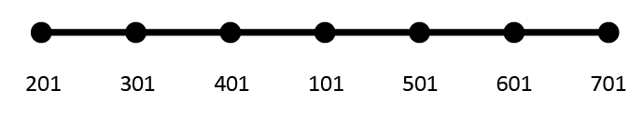

Assuming that the user has the initial order set with PARAM GRIDSEQ GRID then grid 101 would be sequenced 1st initially. However, for a minimum stiffness matrix bandwidth, it should be sequenced so that it is 4th. Using the SEQGP entry, grid 101 can be re-sequenced to be 4th by giving it a sequence number between where grids 401 and 501 are sequenced. Since the sequence number can be a decimal value then grid 101’s sequence number should be a number that is greater than 4 but less than 5 (say 4.1)

Elements

Element connection, property, and material definition
Elastic elements are defined by their connectivity (the grids to which they attach), by their geometric properties and, in all but the ELAS1 element, by their material properties. The mnemonic in field 1 of all elastic element connection entries begins with a “C” followed by the element name. The mnemonic in field 1 of a bar element connection entry, for example, is CBAR (in columns 1-4). Field 2 of a connection entry gives the element ID, which is an arbitrary integer (although elements must have unique IDs among the set of all elements). Field 3 of the connection entry for all one- and two-dimensional elements gives the ID of an element property Bulk Data entry that is used to specify geometric properties of the element. Following this on the element connection entry, the grid points to which the element connect are specified. With the exception of the scalar spring element, all elements have a local element coordinate system. This local element coordinate system is defined by the order of the grids on the element connection entry and by, for some elements, an orientation vector that is also defined on the element connection entry. This will be discussed in detail in each of the separate element sections below.
Element property entries define the geometric properties of the elements (e.g. cross-sectional areas, moments of inertia of bars, thickness of plates, etc.). The mnemonic in field 1 for all property entries begins with a “P” followed by the element name. The property entry for a bar element, for example, has PBAR in field 1 and has, in field 2, the property ID that was referenced on the connection entry. Field 3 specifies an ID of a material Bulk Data entry. The remaining fields define the geometric properties of the bar element and can take up to three physical entries for the complete description. For example, the PBAR entry has the following properties:
- Cross-sectional area
- Moments of inertia and product of inertia
- Torsional constant
- Mass per unit length
- Up to four locations, on the cross-section, where stresses are to be calculated
- Area factors for shear flexibility

Material properties are specified on the MAT1 Bulk Data entry for linear isotropic materials and on the MAT8 entry for linear orthotropic materials (plate elements only). Field 2 contains the material ID and the remaining fields contain material constants (such as Young’s modulus, Poisson’s ratio, mass density, thermal expansion coefficients, etc.).
The reason for the connection entries pointing to property entries which, in turn, point to material entries is the following: every element must have a connection entry but many of them may be for elements that have the same physical properties and there may be even fewer material entries needed. Also, in this manner, it is not required that the entries in the Bulk Data section be in any specific order with the exception that, for continuation entries, the child entries must follow the parent entry in order.

Elastic elements

Scalar spring (ELAS and BUSH elements)
The ELAS1 scalar spring element connects between two degrees of freedom. The CELAS1 Bulk Data entry defines the connection information, which consists of a pair of grid points and the displacement components at those grid points that the spring is to be connected between. In addition, the CELAS1 entry references a PELAS property entry that will define the spring rate, K, and a stress recovery coefficient, S, such that S times the elongation of the spring gives the stress that is output for the element. No material entry is needed for the CELAS1 element.
Care must be taken when using scalar spring elements that rigid body motion of the model is not constrained. For example, if the spring is connected between two non-coincident grids then rigid body motion of the model may be constrained if the degrees of freedom that the spring is connected to are not along a line between the grids.
Output for a spring element can include any, or all, of the following:
- Element nodal forces:
- Output in either global or basic coordinates at all grids for selected elements
- Element stress (positive for positive engineering forces):
- Stress calculated as the spring stress recovery coefficient (specified on the PELAS Bulk Data entry) times the spring elongation.

The BUSH element is a spring connecting two grid points. It can have up to 6 stiffness values (one for each displacement degree of freedom). The element connection can take into consideration that the two grid points are not coincident. It is a better choice for a scalar spring than the ELAS elements if the grids are not coincident. The BUSH can have the following element outputs:
- Element nodal forces:
- Output in either global or basic coordinates at all grids for selected elements
- Element engineering forces:
- Element stress (positive for positive engineering forces):
- Stress calculated as the spring stress recovery coefficient (specified on the PBUSH Bulk Data entry) times the spring elongation.

BUSH element
The BUSH element connects between 2 grid points and can have up to 6 stiffness values defined. It is the same as the BUSH element in some of the NASTRAN software programs. It can have offsets in 3 directions from the line between the 2 grids.

Rod element
The rod is a one-dimensional element that is connected between two grid points (G1 and G2) and which has stiffness for axial and torsional motion. The CROD entry specifies the element connection for the rod and the PROD entry defines the area, torsional constant, torsional stress recovery coefficient and mass per unit length for the rod. The local element coordinate system only requires the definition of one axis; namely along the axis from grid point G1 through grid point G2 as shown in the CROD entry.
Output for a rod element can include any, or all, of the following:
- Element engineering forces:
- Axial force (positive is tension)
- Torsion (positive as shown on the CROD entry)
- Element nodal forces:
- Output in either local, global, or basic coordinates at all grids for selected elements
- Element stresses (positive for positive engineering forces):
- Axial stress and margin of safety
- Torsional stress and margin of safety

Bar element
The bar element is a simple beam that has its shear center coincident with its neutral axis. It is defined using the CBAR connection entry and the PBAR property entry. It can carry bending and shear in two planes, axial force and torque. Shear flexibility can also be included. The associated figures are shown in the CBAR entry.
The ends of the bar element can be offset from the grids GA and GB, as indicated in the CBAR entry. This is a rigid offset and can have components in up to three orthogonal directions. The components of the offset vectors are specified on the CBAR entry in the global coordinate systems of grids GA and GB, respectively.
The v vector is used to determine Plane 1 and Plane 2 of the bar, as indicated in the figure in the CBAR entry. This is necessary so that the moments of inertia (I1, I2, I12) on the PBAR entry can be interpreted correctly. The v vector is specified on the CBAR entry as either three components of a vector measured from end “A” in the global coordinate system of grid GA, or by a grid point, G0, along the v vector (which, together with end “A”, defines v). The moment of inertia, I1, on the PBAR entry is the moment of inertia about the element z_{element} axis. Moment of inertia, I2, on the PBAR entry is about the element y_{element} axis. Planes 1 and 2 need not be principal planes. If they are not, then the product of inertia, I12, must be specified on the PBAR entry.
The bar can be disconnected from a grid point in any of the six degrees of freedom, resulting in the corresponding force(s) in the bar being zero. This is referred to as a “pin flag” feature for the bar. Either end of the bar can be pin flagged. However, the pin flags specified cannot result in the bar being completely disconnected from the grid mesh in any rigid body degree of freedom. For example, degree of freedom 1 (axial) cannot be pin flagged at both ends. This would result in the bar being disconnected from the grid mesh along its x_{element} axis.
The following output is available for the bar element:
- Element engineering forces:
- Axial force
- Torque
- Bending moments at both ends in each of the two planes
- Shear in the two planes
- Element nodal forces
- Output in either local, global, or basic coordinates at all grids for selected elements
- Element stresses (positive for positive engineering forces):
- Stresses due to bending in the two planes at up to four points defined by the user on the PBAR entry
- Stress due to axial force
- Maximum, and minimum, combined bending and axial stress at each end of the bar
- Margins of safety for tension and compression stresses, flagged when they are less than zero
- Torsional stress (if SCOEFF is input on the Bulk data PBAR entry)

Maximums and minimums are determined from the stress due to axial force and the bending stresses at the four points, at each end, if the user specified those points on the PBAR entry. Otherwise, the maximums and minimums are based on the stress due to axial force.

Plate and Shell Elements: Overview
MYSTRAN provides for both triangular and quadrilateral plate elements that include membrane and/or bending stiffness, several of which may be used to model thick plates consistent with Mindlin plate theory. All of the plate element formulations have uniform thickness. The separate connection entries available for this modeling are given below (in all cases the mid-plane of the plate can be offset from the grids with the exception of the CQUAD8).
Currently, MYSTRAN has two versions of the QUAD4 quadrilateral plate element, referred to as MITC4+ and MIN4. The MITC4+ version is described in Reference 15. The MIN4 version is described in Reference 5. The default QUAD4 is the MITC4+ version. Both versions (MITC4+ and MIN4) are differentiated by the Bulk Data File PARAM named QUAD4TYP. A value of QUAD4TYP = MITC4+ uses the quad in Reference 15, whereas a value of MIN4 uses the quad element in Reference 5. Note that as of approximately 2026-10-25, the newer MITC4+ element formulation became the default since various improvements were made.
Note that in Version 2.06 of MYSTRAN, the MIN4T version of the QUAD4 element (described in Reference 9) was added to correct the deficiency in the MIN4 QUAD4 that could develop stresses in rigid body motion for elements that were not rectangular. The MIN4T QUAD4 element is made up of 4 non-overlapping TRIA3 elements. However, the MIN4T demonstrated poor results for the problem of a plate with a hole (incorrect stress concentration). Therefore, the MIN4T has been deprecated as of 2025-09-01.
- Combination Membrane-Bending Elements:
- CTRIA3: 3-node triangular element for modeling thick plates and shells
- CQUAD4: 4-node quadrilateral element for modeling thick plates and shells
- CQUAD8: 8-node quadrilateral element for modeling thick plates and shells
- In-plane shear element Elements:
- CSHEAR: quadrilateral element for modeling thin shear plates

The property entry used for the combination membrane-bending elements is either the PSHELL or PCOMP/PCOMP1 entry. The CSHEAR element properties are specified via the PSHEAR entry. The PSHELL entry has provision for specifying membrane, bending and transverse shear properties (CTRIA3K, CQUAD4K do not have transverse shear flexibility – these elements exist in solver but are legacy elements and not documented or validated). As with other property entries, the PSHELL entry has the property ID in field 2 and up to three material IDs (fields 3, 5 and 7); one each for membrane, bending and transverse shear. In addition, the membrane, bending and transverse shear properties themselves are input (fields 4, 6 and 8). A mass per unit area can also be input (field 9). The membrane, bending and transverse shear properties and material IDs are discussed in detail below.
- PSHELL Property Values and Material IDs:
- Membrane
- Field 3 specifies MID1, the ID of a material entry for the membrane portion of the plate. If this field is left blank, no membrane stiffness will be computed.
- Field 4 specifies TM, the membrane thickness. This is required, even if the MID1 field is left blank, since it is used in the computation of bending and transverse shear properties.
- Bending
- Field 5 specifies MID2, the ID of a material entry for the bending portion of the plate. If this field is left blank, no bending stiffness or transverse shear flexibility will be computed.
- Field 6 specifies 12(I/TM**3), a normalized bending property where I is the moment of inertia per unit width of the plate and TM is the membrane thickness discussed above. This normalized bending property has a default value of 1.0. If field 6 is left blank, it signifies a homogeneous plate.
- Transverse Shear
- Field 7 specifies MID3, the ID of a material entry for the transverse shear portion of the plate. If this field is left blank, no transverse shear flexibility will be calculated. Only the CTRIA3 and CQUAD4 thick plate elements have the capability for transverse shear flexibility.
- Field 8 specifies TS/TM, the ratio of shear to membrane thickness. This has a default value of 5/6 = 0.833333, if field 8 is left blank. This is an historic value that is based on the shear stress distribution in a solid cross-section beam. A more realistic value for plates is based on Mindlin plate theory and is $\frac{π^{2}}{12}$ (or 0.822467), which is only a few percent different than the historic value. The default value for all PSHELL property entries can be reset on the Bulk Data entry PARAM (with name TSTM_DEF in field 2 and the new value in field 3).

The PCOMP or PCOMP1 property entry is for defining the plies (lamina) of composite laminates. Each ply can have a distinct material property that can be isotropic, orthotropic, or anisotropic. The assumption is made that each ply is in a state of plane stress, the bonding material between the plies is perfect, and two-dimensional plate theory can be used for the laminate. This is consistent with Classical Laminate Theory.
The triangular and quadrilateral element coordinate systems are shown in the CTRI3, CQUAD4, and CQUAD8 entries (cards) shown in Section 11. Figures 6.1 and 6.2 show the convention for plate force resultants, which are the basis for calculating element stresses.
The quadrilateral elements can accommodate some out of plane warping, but they are generally intended for use as flat elements. When the quadrilateral element has out of plane distortion, the (x-y)_{element} plane for the element (as shown in CQUAD4 entry) (anything about CQUAD8?) is the mean plane between the grids.
Output for the plate elements includes:
- Element engineering forces:
- Membrane force resultants (force/length) as shown on Figure 6.1
- Bending moment resultants (moment/length) as shown on Figure 6.2
- Transverse shear force resultants (force/length) for the QUAD4 and TRIA3 as shown on Figure 6.2
- Element nodal forces
- Output in either global or basic coordinates at all grids for selected elements
- In plane element stresses at fiber distances Z1 and Z2 (on the PSHELL entry, with +/-TM/2 as default) that are derived from the above force and moment resultants
- Normal stress in the x_{element} direction
- Normal stress in the y_{element} direction
- In-plane shear stress
- Major and minor principal stress and the associated angle
- Max in-plane shear stress
- von Mises or max shear stress
- Transverse shear stresses (for the QUAD4 and TRIA3)

For the QUAD4, the stresses, strains, and element engineering forces can be output at the element center as well as at the corner nodes of the element. The TRIA3 element has constant stress/strain so only one output per element is provided.

Plate and Shell Elements: QUAD4 Detailed Discussion
MYSTRAN supports two formulations for the CQUAD4: MITC4+(default) and MIN4. The formulation that is used is controlled by the QUAD4TYP parameter. Comparisons are shown in the following tables:

Linear Static (SOL 101)
 | MITC4+ | MIN4
Isotropic | Y | Y
Orthotropic | Y | Y
Anisotropic | Y | Y
PCOMP | Y | Y
PSHELL MID1 | Y | Y
PSHELL MID2 | Y | Y
PSHELL MID3 | Y | Y
PSHELL MID4 | Y | N*
Gravity | Y | Y
Thermal load | Y | Y
Pressure load | Y | Y
Offset | Y | Unknown
Stress Output | Y | Y
Strain Output | Y | Y
Element Force Output | Y | Y
*Does not appear to be working correctly
Buckling (SOL 105)
 | MITC4+ | MIN4
Isotropic Buckling | Y | Y
Orthotropic Buckling | Y | Y
Anisotropic Buckling | Y | Y
PCOMP, symmetric | Y | Y
PCOMP, unsymmetric | Y | N
PSHELL, symmetric, MID1≠MID2 | Y | Y
PSHELL, unsymmetric, [B]≠[0] | Y | N

NOTE: For the PSHELL, MID2 represents the bending stiffness matrix, which can be correlated to a laminate’s [D] matrix. For an unsymmetric laminate, [D] may be substituted with [D]*, to obtain an approximate solution (Reference 14). D*=D-BA⁻¹B. The “ABD_To_PShell” document, stored in the MYSTRAN_Documentation Github repository, explains this process.
Natural Frequency/Normal Modes (SOL 103)
The MITC4+ and MIN4 and are supported for SOL 103.

Plate and Shell Elements: QUAD8 Detailed Discussion
MYSTRAN has limited support for the CQUAD8, which is based on the MITC8 formulation (Reference 16). It supports an isotropic material with simple mechanical loading.

Linear Static (SOL 101)
 | MITC8
Isotropic | Y
Orthotropic | N
Anisotropic | N
PCOMP | N
PSHELL MID1 | Y
PSHELL MID2 | Requires MID2=MID1
PSHELL MID3 | Y
PSHELL MID4 | N
Gravity | N
Thermal load | N
Pressure load | N
Offset | N
Stress Output | Y
Strain Output | Y
Element Force Output | Y

Plate and Shell Elements: Running Loads/Moments
The following two figures show the show running loads and running moments (the forces/moments per unit width).
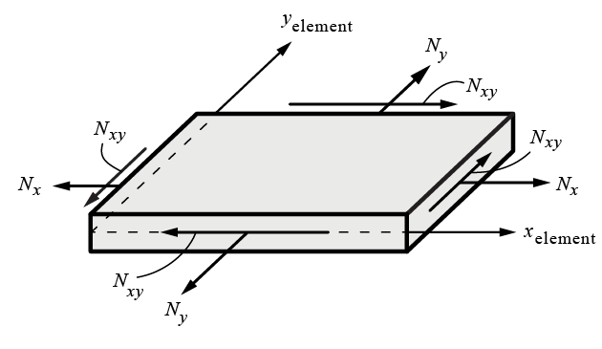
Figure 6.1: Shell membrane force resultants (running loads = load per width)

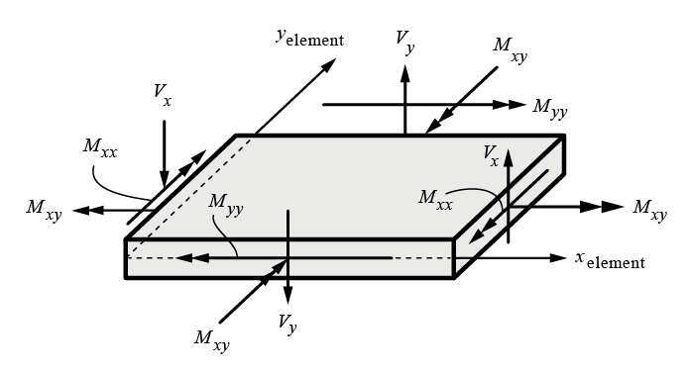
Figure 6.2: Shell bending moment and transverse shear force resultants (running moments = moment per width)

Plate and Shell Elements: K6ROT (Drilling DOF)
The drilling DOF (torsional stiffness) for a shell can be implemented via the use of the K6ROT parameter.
- Applies to the CQUAD4 and CTRIA3 elements.
- At each node of the element, a torsional spring (about the element normal) is added, which grounds the DOF.
- For QUAD4 elements, it uses the normal to the mean plane even if the element is warped.
- On grid points where SNORM is defined, it uses the SNORM normal. Here, it works well as an AUTOSPC alternative even with large values of K6ROT because that's a singularity DOF which is harmless to constrain. (SNORM is undocumented so this statement should be too)
- It does not improve accuracy for curved shells. For other implementations of Nastran, accuracy is improved for curved shells.
- At grid points shared by more multiple shell elements that are not coplanar, there is no singularity so K6ROT introduces an artificial elastic constraint on the other rotation DOFs. Because of that, one should set it to the smallest possible value. 1.0E-4 (0.0001) seems to be acceptable in many cases (not 1.0E+2 (100.0) which is the default for MSC Nastran).
- One intended purpose is to constrain drilling DOFs if AUTOSPC is turned off.
- Default value is 0.0.

The following is for the new K6ROT implementation (Reference 18) on June 2026 (just roughed out):
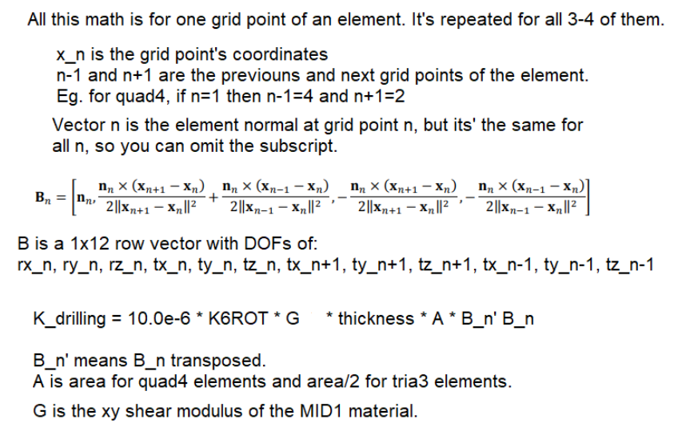

3D Solid elements
MYSTRAN has hexahedra, pentahedra and tetrahedra elements for modeling of 3D structures. The CHEXA hex element comes in 8 node and 20 node versions. The CPENTA element comes in 6 node and 15 node versions. The CTETRA is available in 4 node and 10 node versions. Properties for these solid elements are specified on the PSOLID Bulk Data entry, with several choices for integration order and integration scheme. Material properties are specified on the MAT1 entry. Outputs for the solid elements are in the form of stresses at the element center and can include von Mises and max shear results.

Rigid elements
In addition to the elastic elements discussed above, MYSTRAN also has a capability for specifying a rigid relationship among specified degrees of freedom. These elements are suited for situations where a portion of a model is so much stiffer than the remainder that it could cause ill conditioning of the stiffness matrix if it were modeled with elastic elements. When rigid elements are used, selected degrees of freedom are eliminated from the solution set using equations (automatically generated in MYSTRAN) that represent rigid body notion of the “dependent” degrees of freedom based on rigid motion of a selected set of “independent” degrees of freedom. Specification of rigid elements in MYSTRAN is accomplished with Bulk Data entries similar to elastic element connection entries (however, no property ID is needed). Field 1 of the rigid element connection entry, like elastic elements, has a mnemonic describing the rigid element type.
Care must be taken when using rigid elements in thermal distortion analyses. The rigid elements do not expand with temperature and can otherwise constrain a model that the user expects to expand in a stress-free manner.

RBE2 rigid element
The RBE2 element specifies that the motion of a set of grid points (all having the same set of dependent degree of freedom numbers) are dependent on the six degrees of freedom at another grid point.

The following needs review and maybe a better example.
An example of the equations developed by MYSTRAN to eliminate the dependent degrees of freedom is shown in Figure 6.3 and 6.4 (for a simple one-dimensional problem). For this example, degrees of freedom 1, 2, and 6 at grid 103 will be eliminated from the solution set of degrees of freedom using the equations shown. The user does not have to input these equations; only the Bulk Data RBE2 field entries.
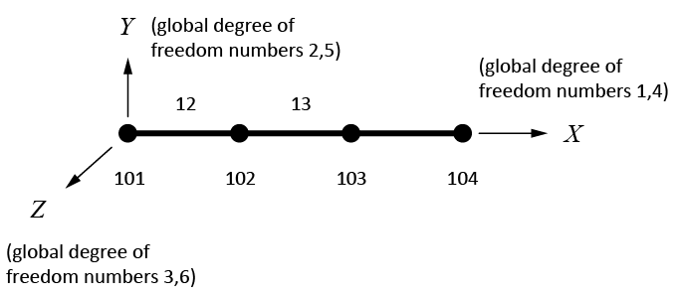
Figure 6.3: X

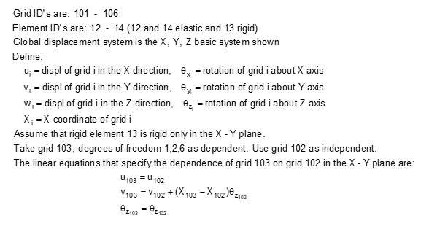
Figure 6.4: X For above, is 101-106 correct?

RBE3 element
The RBE3 element is not a rigid element but is used to distribute loads and mass from some central grid point to other grids in the model. It is defined by a dependent, central, point at which the load or mass is defined along with grids to which the load or mass are to be distributed along with weighting factors at these distributed grids. The dependent point on the RBE3 should never be connected to other elastic elements in the model to avoid stiffening of the structure by the RBE3 element. The MYSTRAN Theory Manual gives a mathematical derivation of the RBE3 equations which reduce the dependent grid point out of the model equations of motion.

RSPLINE element
The RSPLINE element is generally used to model transitions from a coarse to a fine mesh. In MYSTRAN, the RSPLINE element connects to 2 independent end points. Displacements along and perpendicular to the line between the end points is interpolated using the 6 displacements of the end points as follows:
- Displacements along the line and rotations about the line are linear
- Displacements perpendicular to the line are cubic
- Rotations normal to the line are quadratic

Applied loads
MYSTRAN provides several methods of specifying applied loads:
- Forces and/or moments applied directly to grids
- Pressure loading on plate elements
- Gravity loads
- Equivalent loads due to thermal expansion
- Equivalent loads due to enforced displacements
- Loads on scalar points (SLOAD)

All of the Bulk Data entries defining these loads have a set ID which is used to control whether they are used in a particular subcase. Thus, the user is free to include load entries in the Bulk Data that may not be used in a particular execution of the program (that might be used in a subsequent run, for example).

Forces and moments directly applied to grids
Bulk Data entries FORCE and MOMENT are used to define forces and/or moments applied directly to a grid point. Both of these entries have, in field 2, a set ID.
Field 3 of both the FORCE and MOMENT entry specifies the grid point where the load is to be applied. Field 5 specifies an overall scale factor and fields 6 – 8 specify the vector components of the load. The load applied in a component direction is the product of the overall scale factor times the vector component in that direction. The vector components are in a coordinate system whose ID is specified in field 4.
FORCE and MOMENT entries to be used in a particular subcase must be requested in Case Control with a LOAD = SID Case Control entry. The SID is either the set ID from the FORCE and/or MOMENT entries or is the set ID of a Bulk Data LOAD entry (see below) that has the FORCE and/or MOMENT set IDs specified.

Pressure loads on plate elements
Pressure loads normal to the surface of plate elements can be specified on PLOAD2 and PLOAD4 Bulk Data entries. As with the grid point load entries discussed above, the PLOAD entries have a set ID in field 2 that must be referenced (directly or indirectly) in Case Control in order to be used for a particular subcase. The pressure value is specified in field 3. The remainder of the entry presents two options for specifying what plate elements are to have this pressure value. One option is to list the element IDs using in fields 4 through 9 of the parent entry and, if necessary, fields 2 through 9 of continuation entries. The other option allows the elements to be specified using a THRU option, in which case any element whose ID is in the range of EID1 (field 4) through EID2 (field 6) will receive the pressure value in field 3.
Pressure loads are requested in Case Control the same as was described for the FORCE and MOMENT entries (either directly or by use of the LOAD Bulk Data entry).

Gravity loads
Gravity loads for the model are specified using the GRAV Bulk Data entry. The GRAV entry specifies an acceleration vector that, in conjunction with the mass at the grid points (discussed later), allows MYSTRAN to calculate static forces at all of the grid points due to the specified acceleration using the inertia properties of the model (grid point masses, etc., discussed later). As with other loads, the GRAV entry has a set ID in field 2. Fields 4 through 7 specify the magnitude and vector components of the acceleration in a coordinate system whose ID is given in field 3. The magnitude and/or vector components must be given in units consistent with model mass, discussed in a later section.
Gravity loads are requested in Case Control the same as was described for the FORCE and MOMENT entries (either directly or by use of the LOAD Bulk Data entry).

Equivalent loads due to thermal expansion
The equivalent loads due to thermal expansion are calculated automatically in MYSTRAN based on grid and/or element temperature data supplied by the user on a variety of Bulk Data entries, listed below, all of which have a set ID in field 2 of the entry:
- Grid temperature definition Bulk Data entries:
- TEMPD specifies a default temperature for all grids
- TEMP specifies a temperature for grids listed on this entry. These temperatures override any default values on TEMPD entries.
- Element temperature Bulk Data entries:
- TEMPRB specifies average element temperatures for ROD and BAR elements as well as temperature gradients through the depth for BAR elements
- TEMPP1 specifies average element temperatures and gradients through the thickness for plate elements

When a temperature load is to be used, all of the elements in the model must have a temperature defined. This may be done either indirectly using a TEMPD or TEMP entry that defines the temperatures of the grids to which the element connects, or directly by specification on a TEMPRB or TEMPP1 element temperature entry. Thermal expansion coefficients and reference temperatures, needed in the calculation of equivalent loads due to thermal expansion, must be specified on material Bulk Data entries.
The user must request temperatures in Case Control with the Case Control entry TEMP = SID where SID is the set ID on the above Bulk Data temperature entries which define the temperatures for the model.

Equivalent loads due to enforced displacements
If the user knows, a priori, the displacement (translation or rotation) of some degrees of freedom, MYSTRAN handles this by what is referred to as “enforced displacements”. The user specifies the known displacement on a Bulk Data SPC entry (in the global directions for the grid) and MYSTRAN uses this as a constraint. The Bulk Data SPC entries’ set ID must be selected in Case Control with the Case Control entry SPC = SID, where SID is the set ID of the Bulk Data SPC entries defining the enforced displacements.
The program calculates loads necessary to enforce this constraint and applies them to the structure in combination with all other loads specified. When forces of constraint are calculated in the program, the forces listed (in the output, if Case Control entry SPCFORCES is included) are those necessary to make the degrees of freedom displace the amounts that were specified as enforced displacements.

Loads due to rigid body rotation about a specified grid (RFORCE)
The finite element model can have loads calculated due to a rigid body angular velocity and/or angular acceleration. The loads are calculated as if the body were rotating when, in actuality, it is fixed. The equivalent loads due to this angular velocity and acceleration are applied to the fixed body. In this fashion, situations such as rotating turbines with centripetal forces can be simulated. This force is calculated via the Bulk data entry RFORCE.

LOAD Bulk Data entry – combining loads
Loads defined via the FORCE, MOMENT, GRAV and PLOAD2 entries that have different set IDs can be combined into one set for use in a subcase using the LOAD Bulk Data entry (not to be confused with the LOAD Case Control entry). The LOAD Bulk Data entry has a set ID in field 2. The following fields (including possible continuation entries) specify which of the individual load sets to use. This is specified as pairs of set IDs (FORCE, MOMENT, GRAV, PLOAD2, PLOAD4, RFORCE, and SLOAD can be combined) and scale factors for each of the separate loads. In addition, an overall scale factor for the combination of the loads on the LOAD Bulk Data entry is defined in field 3.
PLOAD4? RFORCE? Also for Section 8 (Case Control overview) and 10.10 (Load Case Control Entry)

Constraints

Single point constraints
Single point constraints (SPC’s) are needed for the following reasons:
- To specify boundary conditions where the model is to be grounded. These constraints will result in those degrees of freedom being zero and will also result in, generally, non-zero forces of constraint at the specified degrees of freedom.
- To specify enforced displacements at degrees of freedom where the user knows, a priori, the nonzero value of those displacements.

For the user defined SPC’s the constraints are specified on SPC or SPC1 Bulk Data entries (or as “permanent” single point constraints in field 8 of the GRID Bulk Data entry). Both the SPC and SPC1 entries have a set ID in field 2. In addition, there is a SPCADD Bulk Data entry that can be used to combine requests made by the SPC and/or the SPC1 entries. The constraints specified on the SPC, SPC1 or SPCADD entries must be selected in Case Control with the SPC = SID Case Control entry, where SID is the set ID of either a SPCADD or of one or more SPC and/or SPC1 Bulk Data entries.
The SPC Bulk Data entry must be used for nonzero enforced displacements. Either the SPC or SPC1 entry (two different methods of specifying zero constraints of selected degrees of freedom) can be used for the other types of SPC’s.
There can be only one SPC request in Case Control for any one MYSTRAN execution.

AUTOSPC - Introduction
The following entire section requires further review/rework.
To remove singularities in the model. The global stiffness matrix is built on the basis of six degrees of freedom (3 translations and 3 rotations) per grid point which. For some models, this means that some degrees of freedom may not have any stiffness. For example, a 2D model of a plate with bending and membrane action would have, at most, five degrees of freedom per grid since the plate elements have no stiffness for rotation about the normal to the plate. Thus, this plate model will have a singular global stiffness matrix for the degrees of freedom representing rotation about the normal to the plate. The user has a choice of identifying these explicitly or by having MYSTRAN constrain degrees of freedom that are singular through the use of an AUTOSPC feature (see Bulk Data PARAM entry for parameter AUTOSPC). In either event, these degrees of freedom are constrained to zero prior to solving for the displacements. If there is no stiffness for these degrees of freedom, the forces of constraint for them will be zero.
For above, K6ROT needs to be discussed (above is no longer valid for all shells).
The following figure provides some examples of AUTOSPC constraints.

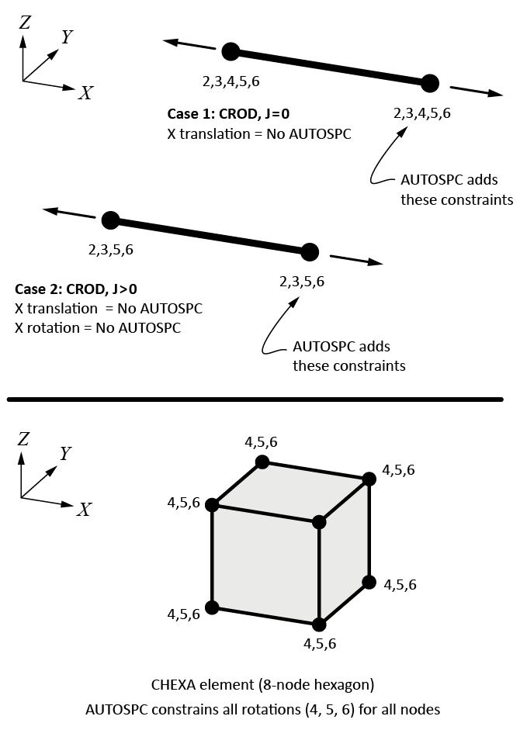

AUTOSPC – Detailed Discussion
The following entire section requires further review/rework.
The AUTOSPC feature mentioned above is done automatically in MYSTRAN unless the user includes a Bulk data PARAM, AUTOSPC entry with an N in field 3 to request that MYSTRAN do not perform an AUTOSPC calculation. The explanation of the AUTOSPC feature that follows assumes the user is familiar with the displacement set notation defined in Section 6.6.
In order to identify singular degrees of freedom when the G-set singularity processor is run, MYSTRAN uses a comparison of stiffness terms to a small number and constrains the degree of freedom if this criterion is met. The specific procedure is explained below:
- For each grid of the G-set stiffness matrix, the two 3x3 stiffness matrices (one for translation and one for rotation) are obtained for one grid.
- The three eigenvalues and eigenvectors of the two 3x3 matrix are determined.
- The ratio of each of the three eigenvalues to the eigenvalue that is the max among the three is determined. A comparison of the ratio to AUTOSPC_RAT (see PARAM, AUTOSPC Bulk Data entry field 4) is made.
- If the ratio is less than the criteria, one degree of freedom will be constrained. The degree of freedom that is constrained is the one whose eigenvector absolute value is largest (using the eigenvector corresponding to the eigenvalue for that ratio).

If the eigenvalues of the 3x3 matrices are exactly zero, then no forces of constraint will result from the AUTOSPC’s. There are instances in problems with near singularities in which the eigenvalue ratios are not exactly zero and, in those cases, some small force of constraint will result. These should be generally negligible, but the user should always request output of the forces of constraint, especially when using the AUTOSPC feature. An example of a case where these small ratios can be nonzero is in the case of modeling a curved surface with only plate elements. If the user makes several models and continually refines the mesh, then at some point two contiguous elements will become nearly parallel. At this point there will be negligible stiffness at a common node for rotation about the normal to the plate. When this stiffness gets small enough, MYSTRAN will constrain it if the AUTOSPC feature is turned on.
Through this procedure, the AUTOSPC feature can identify many, but perhaps not all, singular degrees of freedom. In the case where the model has either rigid elements or multi-point constraints (MPC’s) a situation can arise where the G-set stiffness matrix is singular. When the G-set singularity processor is called for each grid, any grid that is specified as independent on an MPC or rigid element is skipped. This is done since these grids may not have any stiffness (they may have no elastic element connected to all six grid components) in the G-set stiffness matrix but may get stiffness when the MPC and rigid element degrees of freedom are eliminated. Thus, they must be ignored until after the reduction from the G-set to the N-set. After this reduction, the N-set stiffness matrix will be scanned (if AUTOSPC_NSET on the PARAM AUTOSPC entry is equal to 1) to see if any rows are null. There may be null rows if some of the independent degrees of freedom on MPC’s and rigid elements do not have stiffness at this point. If any rows are null, the degrees of freedom corresponding to these rows are AUTOSPC’d also. AUTOSPC_NSET can also be set to 2 or 3 also. If equal to 2, then MYSTRAN will remove any N-set degrees of freedom whose diagonal stiffness ratio (to max diagonal stiffness) is less than AUTOSPC_RAT. If it is equal to 3, then both actions for AUTOSPC_NSET = 1 and 2 are applied. In general, AUTOSPC_NSET = 1 (default) is recommended.

Multi point constraints
Multi point constraints (MPC’s) may be needed for the following reason:
- To specify linear dependence of some degrees of freedom on other degrees of freedom. The equation relating the linear dependence is specified on MPC Bulk Data entries. Rigid elements are really automated multi point constraints that represent rigid motion of an “element” and are a subset of the more general MPC relationship. MPC’s are a more general way of specifying linear dependence of some degrees of freedom on other degrees of freedom.

There can be only one MPC request in Case Control for any one MYSTRAN execution.

Boundary degrees of freedom in Craig-Bampton analyses (SUPORT)
This feature is primarily included for Craig-Bampton (CB) model generation. It provides a set of degrees of freedom (DOF’s) that are to be boundary DOF’s used in calculating modal properties of a substructure. Reference 11 and the MSYTRAN Theory Manual describe the Craig-Bampton method as it is currently implemented in MYSTRAN. The boundary DOF’s are identified on Bulk Data SUPORT entries and define the R-set of degrees of freedom (see later discussion on displacement set notation). For CB analyses the modal properties of the substructure are determined with fixed boundaries so that the R-set is constrained to zero for the purposes of calculating modal properties of the substructure. The SUPORT feature is not intended for use in any of the other MYSTRAN solutions (e.g. statics, eigenvalues). If the SUPORT feature is used in any solution method other than Craig-Bampton, the result is the same as if the SUPORT DOF’s were identified as constrained to zero motion on SPC or SPC1 Bulk Data entries.

Mass
Mass for the finite element model can be specified in several ways:
- Mass density for finite elements (specified on property Bulk Data material entries)
- Mass per unit length, or per unit area, for finite elements (specified on element property Bulk Data entries)
- Concentrated masses at grids (using CONM2 Bulk Data entry) with possible offsets and moments of inertia.

Any of the above can be used in combination, or separately, in defining the mass for any finite element (or grid point in the case of CONM2’s) in the model.

Mass density on material entries
The MAT1 Bulk data entry used to define material properties, discussed earlier, has a field to specify the mass density of the material. This mass density, together with the volume of each finite element, can be used by MYSTRAN to calculate a mass for each element. For example, plate elements have a surface area defined by the grid locations of the three or four grids that the plate element is connected to. The plate element thickness (membrane thickness on the property entry PSHELL) along with the surface area defines a volume for the element. The mass density on the MAT1 entry times this volume defines the mass for this element. Similarly, a beam element (BAR) has a length defined by the two grids that the element connects to and has a cross-sectional area specified on the PBAR entry. The element volume is calculated from this area and length.

Mass per unit length or area of finite elements
Mass can also be defined using data entered on the element property Bulk Data entries. The PBAR entry, for example, has a provision for specifying mass per unit length of the bar. The plate element property entries have a field in which a mass per unit area can be defined. These can be used in conjunction with the other two methods of defining mass, or can be used independently to completely define the mass for an element.

Concentrated masses at grids
Concentrated masses can be placed directly at grid points using the CONM2 Bulk Data entry. This entry provides the user with the option of specifying a mass value with possible offsets from the grid point and mass moments of inertia, including products of inertia. The offsets and inertia’s can be specified in a coordinate system referenced on the CONM2 entry. Use of the CONM2 presents a convenient method for including “rigid masses” at grid points. The CONM2 entry has an “element” ID in field 2, the ID for the grid to which the mass is attached in field 3, the coordinate system in which the mass properties are specified in field 4 and the mass value in field 5. The remainder of the logical entry (which can span two physical entries) is used to specify possible offsets and moments and products of inertia. The offsets are the relative coordinates of the c.g of the mass with respect to the grid and are specified in the coordinate system whose ID is in field 4. The inertia values are the moments and products of inertia of the mass about its own c.g., also with respect to the coordinate system specified in field 3. Moments of inertia about any of the three axes of this coordinate system can be specified. There are, possibly, six products of inertia but only the three independent ones need be specified. The offsets and inertia values are optional.
A 6 x 6 symmetric mass matrix, M, (at the c.g. of the mass) is created by MYSTRAN as given by:
$M=\left[\begin{matrix}m & 0 & 0 & 0 & md_{3} & -md_{2} \\ & m & 0 & -md_{3} & 0 & md_{1} \\ 0 & & m & md_{2} & -md_{1} & 0 \\ & & & I_{11} & -I_{12} & -I_{13} \\ & SYM & & & I_{22} & I_{23} \\ & & & & & I_{33}\end{matrix}\right]$ (6.1)
In the above, m denotes the mass value on the CONM2 entry and d₁, d₂ and d₃ denote the offsets of m from the grid and Iij are the six independent moments and products of inertia. The 1,2 and 3 subscripts refer to the 3 axes of the coordinate system whose ID is in field 4 of the CONM2 entry.

Model total mass
MYSTRAN can calculate the rigid body mass properties (total mass, overall c.g. and moments of inertia) of the finite element model if the user desires. The calculation is done in the basic coordinate system and can be done relative to any user specified grid point. The Bulk Data entry PARAM with a parameter name of GRDPNT in field 2 is used to request output of the rigid body mass properties of the model. If field 3 of this PARAM entry contains a grid point ID, the calculation will give the mass properties relative to that grid point. If field 3 is blank (or zero), the calculation will be done relative to the origin of the basic coordinate system.

Mass units
All units of mass input in the Bulk data must be consistent. However, the user can input these in terms of mass or weight. If weight units are used, the finite element mass matrix must be converted back to mass units prior to performing eigenvalue analyses. This is accomplished using the Bulk Data PARAM entry with a parameter name of WTMASS in field 2. The value of the WTMASS parameter is used to multiply the mass matrix prior to eigenvalue analyses. Thus, if the user has input weight units instead of mass units a WTMASS value of 1.0/gravity (e.g. 1.0/386 if gravity is 386 in/sec²) must be used. The units of the output for the rigid body mass properties of the whole model (discussed above) are the same as the input units (mass or weight).
If the user has specified a gravity loading (see section on Applied Loads) the units of the acceleration on the GRAV entry must also be consistent with the units of mass. For example, if mass units are used then the GRAV entry should specify the gravity loading in acceleration units. However, if weight units are used the gravity loading should be specified in terms of g’s.

Displacement set notation
As was mentioned in an earlier section, MYSTRAN originally constructs stiffness and mass matrices for the model based on all grid points having six degrees of freedom. These matrices are referred to as the G-set matrices such that if there are n grid points, the original stiffness and mass matrices will have 6n rows and columns (i.e., the G-set consists of 6n degrees of freedom). The stiffness matrix for these G-set degrees of freedom must, therefore, be singular since no constraints of any kind will have been imposed on it; either through specification of boundary constraints or through rigid elements (which cause constraints as well). In order to reduce this matrix to the independent degrees of freedom, MYSTRAN partitions and reduces the G-set to the independent degrees of freedom, denoted as the L-set. This section describes the various sets as MYSTRAN reduces from the G-set to the L-set.
The G set is initially constructed in a degree of freedom (DOF) order that is discussed in the section on Grid point sequencing. The G-set is then partitioned into two sets; one of which consists of all degrees of freedom denoted as dependent on rigid elements or multi-point constraints (M-set) plus all others (denoted as the N-set). In displacement set notation, then:
$U_{G}=\left\{\begin{matrix}U_{N} \\ U_{M}\end{matrix}\right\}$ (6.2)
The M-set degrees of freedom are eliminated using the multi point constraint equations as well as equations developed in MYSTRAN based on the rigid element geometry and the dependent degrees of freedom in the N-set. Following this reduction, the stiffness and mass matrices are in terms of the N-set degrees of freedom. This N-set is further partitioned into two sets; those that are constrained via single point constraints (denoted as the S-set) plus all other degrees of freedom from the N-set (denoted as the F-set). The displacement set notation for this is:
$U_{N}=\left\{\begin{matrix}U_{F} \\ U_{S}\end{matrix}\right\}$ (6.3)
The S-set degrees of freedom are eliminated using the single point constraints (both zero constraints and enforced displacements). Following this reduction, the stiffness and mass matrices are in terms of the F-set degrees of freedom. At this point, the F-set may well be an independent set of degrees of freedom. However, MYSTRAN allows for a further reduction of the F-set based on Guyan reduction (static condensation). A Guyan reduction is necessary, for real eigenvalue analysis by the Givens method, if there are any zeros on the diagonal of the mass matrix. Zero diagonal terms would occur, for example, if the mass matrix had mass terms only for the translation degrees of freedom and not for the rotation degrees of freedom. Other situations could also result in zero diagonal terms in the mass matrix. The degrees of freedom to be eliminated by static condensation are denoted as the -set. The O-set is defined using the Bulk Data entry OMIT or OMIT1 (or alternately via the ASET or ASET1 entry). In general, there is no reason to specify an O-set for static analysis. At any rate, the F-set is partitioned into these O-set degrees of freedom plus all remaining degrees of freedom in the F-set (denoted as the A-set). The displacement set notation for this is:
$U_{F}=\left\{\begin{matrix}U_{A} \\ U_{O}\end{matrix}\right\}$ (6.4)
The O-set degrees of freedom are eliminated via Guyan reduction (static condensation). Following this reduction, the stiffness and mass matrices are in terms of the A-set degrees of freedom. In the static and eigenvalue analysis solutions, the A-set is the final, independent, set of degrees of freedom. However, for Craig-Bampton (CB) model generation the A-set is comprised of the L and R-sets. The displacement set notation for this is:
$U_{A}=\left\{\begin{matrix}U_{L} \\ U_{R}\end{matrix}\right\}$ (6.5)
The R-set are the degrees of freedom at the boundary of the substructure where it connects to other substructures. The R-set is defined by the user via the SUPORT Bulk Data entry. In CB analysis, the R-set are constrained to zero for the purposes of calculating the fixed interface modal properties of the substructure and the R-set is used in determining the boundary stiffness and mass. As shown in Reference 11, these matrices provide the overall properties of the substructure in terms of modal and boundary degrees of freedom which are typically a much smaller subset of the physical degrees of freedom in the R and L-sets combined.
Following elimination of the R-set degrees of freedom, MYSTRAN is set to solve for the displacements of the L-set.
If there is no R-set defined by the user, then the L-set is equivalent to the A-set. If there is no O-set defined by the user, then the A-set is equivalent to the F-set. If there is no S-set, the F-set is equivalent to the N-set (although the stiffness matrix for this would be singular since no boundary constraints would exist). If there is no M-set then the N-set is equivalent to the G-set.
The mutually exclusive sets are the M-set, the S-set, the O-set and the R-set and the L-set. The G-set consists of all of these.
The MYSTRAN Theory Manual has a complete mathematical discussion on the details of how the G-set is reduced to the A-set.
When the degree of freedom (DOF) tables are printed out (if requested by the user through the PARAM PRTTSET and PARAM PRTDOF Bulk Data entries), the S-set is broken down into the several sub-sets. Below is a summary of all of the columns of the DOF table:
- G: All DOF’s in the model
- M: All DOF's multi-point constrained
- N: G – M (or F + S)
- SA: DOF’s SPC’d when AUTOSPC = Y
- SB: DOF’s SPC’d to zero via Bulk Data SPC, SPC1 Bulk Data entries (requested in Case Control)
- SE: DOF’s SPC’d to nonzero values (enforced displacements) (requested in Case Control)
- SG: DOF’s SPC’d to zero values that are identified in field 8 of the Bulk data GRID entry
- SZ: SA + SB + SG (all zero value SPC’s)
- S: All DOF’s single-point constrained (S = SA + SB + SG + SE)
- F: N – S ( or A + O)
- O: All DOF’s statically omitted
- A: F – O (or L + R)
- R: All DOF's defined via Bulk Data SUPORT entries
- L: A – R

EXECUTIVE CONTROL – MYSTRAN SOLUTION TYPES
MYSTRAN currently has 5 solution types:
- SOL 101 - static analysis
- SOL 103 - natural frequency (normal modes) – Eigen solution
- SOL 104 - differential stiffness
- SOL 105 - Eigen solution buckling (linear buckling)
- SOL 31 - Craig-Bampton (CB) model generation.

The CB model generation is an analysis solution that is not available in Nastran. This solution is discussed in Section 7.5.

Static Analysis
SOL 101 or, alternately, SOL STATICS is for static solution of a model with constant loads. It is the same as statics for NASTRAN and uses all of the features described above for model description, load definition, etc. Output for displacements, applied loads, constraint forces, grid point force balance, element forces and stresses are available. In addition, output of matrices and debug information is available.

Natural Frequency (Normal Modes)
SOL 103 or, alternately, SOL MODES, or SOL MODAL or SOL NORMAL MODES is for eigenvalue analyses of a model. It is the same as the eigenvalue analysis type of solution in NASTRAN. All of the model features in statics (with a few exceptions such as loads and enforced displacements) are available. Besides the eigenvalues themselves, output for displacements, constraint forces, element forces and stresses are available. Also, output of modal participation factors and modal effective mass is available. In addition, output of matrices and debug information is available.

Differential Stiffness
SOL 104 or, alternately, SOL DIFFEREN is for static analysis with the same differential stiffness that would also be used in linear static buckling analysis.

Buckling
SOL 105 or, alternately, SOL BUCKLING is for linear static buckling. A differential stiffness matrix is calculated and added to the normal linear elastic stiffness matrix. This solution requires two subcases: an initial static load of some value (generally a unit load) simulating the buckling load followed by a subcase with an eigenvalue extraction method. The eigenvalue found is a multiplier of the load applied in the first subcase in order to get the buckling load.
Shell buckling is partially implemented (See Section 6.2).

Craig-Bampton model generation
SOL 31 or SOL GEN CB MODEL is for Craig-Bampton (CB) model generation and is a new feature in MYSTRAN that is not a direct solution type available in NASTRAN. It involves reduction of a large model, originally in terms of physical degrees of freedom (DOF’s) at all grid locations, to one in which the DOF’s are a smaller subset using modal DOF’s for fixed base modes to describe the vibration characteristics of the model and physical DOF’s for the boundaries between substructures. The MYSTRAN Theory Manual has a detailed description of CB analyses including references to the original work by those that pioneered the technique and also includes an example problem. Using NASTRAN to get CB models is a more cumbersome technique than the direct one in MYSTRAN in that it employs a rather complicated (and in some areas arcane) DMAP (or Direct Matrix Abstraction Programming) program.
Sometimes called dynamic substructure analysis, CB analysis is often used in cases where a very large model is broken into smaller pieces each of which is generally a defined substructure. An example would be a spacecraft with several scientific instrument and appendages. Each of these individual pieces may come from different analytical groups and may be needed in a combined analysis. Each of the groups developing models of their substructure would deliver an analytical CB model of their hardware and the systems contractor would assemble these for a combined structural dynamic analysis.
The input to a SOL 31 CB model generation analysis for a single substructure is the same as that for a standard eigenvalue analysis with a few additions. The biggest difference is in defining the boundary DOF’s for the substructure where it connects to other substructures. The boundaries are defined using Bulk Data SUPORT entries which key MYSTRAN to put these DOF’s into the R-set. The fixed base modes of the substructure are those for which the R-set is constrained to zero. However, the model delivered to the system contractor for integration cannot be grounded at these DOF’s since they will be active in the combined analysis. Thus, the CB solution takes into account that these boundary DOF’s are free in the matrices that define the CB model even though they were temporarily grounded to obtain the fixed mode properties of the substructure. It should be mentioned that the boundary DOF’s defined via the SUPORT Bulk Data entry must be the only DOF’s constrained to zero motion except for those removed to avoid singularities.
The output from the CB analysis of a single substructure is quite different than those from a normal eigenvalue analysis except that the fixed base modal frequencies and mode shapes can be output and are the same as those that would result from a SOL 103 eigenvalue analysis with the R-set constrained to zero motion. The rest of the available outputs are generally for Output Transformation Matrices (OTM’s) and other CB model matrices needed by the systems contractor in performing the combined analysis. The Theory Manaul discusses all of the available OTM’s from a SOL 31 CB model generation analysis. However, the following is a general idea of how to obtain CB model data from MYSTRAN:
- For any of the matrices listed in the MYSTRAN Theory Manaul (including Net C.G. loads and Interface Force LTM) use the OUTPUT4 entry in Executive Control. These are written to disk files with the names filename.ext where ext (file extension) is OPi with i=1,2,3,4,5,6,7 as defined by the user in the OUTPUT4 command.
- For displacement, acceleration, element force, element stress, MPC forces, use normal Case Control requests (including defining sets of grids/elements for output). These OTM’s are output in the normal f06 output file and also onto disk files with the extension OP8 (for grid related OTM’s) and extension OP9 (for element related OTM’s). Text files (extensions OT8 and OT9) have explanations of the rows of the OTM’s written to the OP8 and OP9 files.

In addition to creating CB models, MYSTRAN can synthesize CB models, along with an optional finite element model, into a systems model for eigenvalue analyses. This feature is demonstrated in the Theory Manual.

CASE CONTROL – OVERVIEW
The Case Control Section performs several functions outlined below. The entries for each of the major purposes are enumerated below. A detailed explanation of each is contained in the following section. A BEGIN BULK entry is considered as the last, and mandatory, entry in the Case Control Section. In addition, the fields of an entry may be delimited by tabs, as well as a white space.
- The following entries specify the titles that will be printed in the output file, none of which are required:
TITLE Specifies a line of text to be printed in the output file
SUBTITLE Specifies a 2nd line of text to be printed in the output file
LABEL Specifies a 3rd line of text to be printed in the output file
- The following entries select items from the Bulk data to be used in the current job (loads, constraints, temperature sets, eigenvalue extraction ID):

ENFORCED Specifies a file containing all grid displacements (all translations and rotations for all grids). With this command, users can run cases in which all displacements are known (as for example from test data) and can request any outputs based on these displacements.
LOAD Selects FORCE, MOMENT, GRAV, PLOAD2, PLOAD4, RFORCE and LOAD sets from the Bulk Data Section that define loads for a statics solution.
METHOD Selects an eigenvalue extraction set from the Bulk Data for a eigenvalue solution.
SPC Selects SPC, SPC1 from the Bulk Data Section that define single point constraints (including enforced displacements) for the current job.
MPC Selects MPC entries from the Bulk Data Section that define multi-point constraints for the current job.
TEMP Selects TEMP, TEMPD, TEMPP1, and TEMPRB sets from the Bulk Data Section that define temperature loads for a statics solution.
- The following entries define output requests:
ACCEL Requests output of accelerations.
DISPL Requests output of displacements.
ECHO Requests form of the input file echoed to the output file.
ELDATA Requests element matrix generation output to the BUG file.
FORCE or Requests output of element engineering and/or node forces.
ELFORCE Note: ELFORCE is an equivalent command.
GPFORCE Requests output of grid point force balance showing all of the forces acting on a grid point and checking equilibrium of those forces.
MEFFMASS Requests output of modal effective masses in eigenvalue analyses.
MPCFORCES Requests output of multi point forces of constraint (due to MPC’s as well as rigid elements).
MPFACTOR Requests output of modal participation factors in eigenvalue analyses.
OLOAD Requests output of applied loads.
SET Specifies sets that define grid points and elements for which output is desired.
SPCFORCES Requests output of single point forces of constraint.
STRESS or Requests output of element stresses.
ELSTRESS Note: ELSTRESS is an equivalent command.
STRAIN or Requests output of element strains for shell and solid elements.
ELSTRAIN Note: ELSTRAIN is an equivalent command.

VECTOR TBD
- The following entry defines subcases for which solutions will be calculated in static analyses (SOL 101):
SUBCASE A entry that indicates that the following entries (until another SUBCASE entry is encountered) define the conditions for one solution in the current job. A separate subcase must be used for each loading condition for which a solution is desired.

Detailed Description of Case Control Entries
Section 10 provides the details for each of the Case Control Section entries listed above. The format of each is free field with the following conventions:
- Upper case letters must be entered as shown.
- Lower case letters indicate that a substitution must be made.
- Parentheses shown must be entered.
- Braces { } indicate that a choice, from the items listed, must be made.
- Brackets [ ] indicate that the terms enclosed may be omitted, if desired. Braces within brackets indicate that if terms within the brackets are input a choice must be made of the portion within the braces.
- Underlined values are the default values.

In addition, some of the entries have an acceptable abbreviation of the entry name. For example, the entry requesting displacement output can be DISPLACEMENT or at least the first four letters of the name. This is noted in the detailed description with brackets. Thus, DISP[LACEMENT] indicates the acceptable forms of this Case Control entry.

Output File Types
Output files are either in ASCII or binary. The following output file types are possible:
- f06 – (ASCII). This is a common Nastran file type (.f06), but does not have a standard format. The format may be different for different commercial versions of Nastran and may even be different between different versions for the same commercial version. The MYSTRAN format is similar to other f06 formats, but it is not exactly the same as any of them. A custom tool, called f06csv, can parse a f06 file (both for MYSTRAN and some commercial Nastran f06 files). This tool can create a customized output of the data in a format that is convenient for processing the data: https://github.com/ClassicalFEA/nastools
- OP2 (binary). This is common Nastran file type (.op2) that is read by some post-processors. A MYSTRAN OP2 is expected to be able to be read by Patran and Femap, but not by Apex. It also be read by the open-source programs pyNastran and M3D. The OP2 is fully supported in MYSTRAN with the following exceptions:
  - Corner stresses/strains for quad elements
- NEU (ASCII). The Neutral file (.neu) is a legacy file option. The version used in MYSTRAN may be version 7.1. It can be called via “PARAM, PRTNEU, YES”.
- BUG
- F04
- Other

For examples of how to request the different files, see the DISPLACEMENT and STRAIN entries. Also, see the following parameters, which can be used as overrides. Most notably are the PRTALL and FILES params (equivalent). If present, and set to YES, (“PARAM, PRTALL, YES” or “PARAM, FILES, YES”), then the f06, OP2, and NEU will always be created.
- PRTALL and FILES (equivalent)
- PRTNEU

BULK DATA – OVERVIEW
The major function of the Bulk Data Section is to define the finite element model and the loading and constraints. In the case of loading and constraints, the Bulk Data entries have a set ID which must be chosen in Case Control for the particular load or constraint to be applied.
The entries for each of the major purposes are enumerated below. A detailed explanation of each is contained in the following section. An ENDDATA entry is considered as the last, and mandatory, entry in the Bulk data Section.
- Geometry/scalar point definition
GRID Defines grid point ID and location, coordinate systems for the grid location and for the global coordinate system, and permanent single point constraints.
GRDSET Defines default values for coordinate systems and permanent SPC’s for GRID entries whose corresponding fields are blank.
SPOINT Defines a scalar point to which elastic and mass elements may be attached.
- Grid point sequencing
SEQGP Used to define the internal sequence order for grid points so as to obtain a banded stiffness matrix. If not input, then the grid order is set to, either: grid numerical order (default) or grid input order (using PARAM SEQUENCE)
- Coordinate system definition (i = 1 or 2)
CORDiR Defines a rectangular coordinate system.
CORDiC Defines a cylindrical coordinate system.
CORDiS Defines a spherical coordinate system.
- Element connection definition

Scalar and bushing elastic elements
CBUSH Spring element with geometry definition
CELAS1 Defines a spring element ID, property ID and the grid/degrees of freedom to which the spring element is connected.
CELAS2 Defines a spring element ID, stiffness and the grid/degrees of freedom to which the spring element is connected.
CELAS3 Defines a spring element ID, property ID and the scalar points to which the spring element is connected.
CELAS4 Defines a spring element ID, stiffness and the scalar points to which the spring element is connected.

1D elastic elements
CBAR Defines a bar (axial load, bending, torsion) element ID, property ID and the grid connections and v vector (which, together with the bar axis, defines the orientation of the bar cross-section in the model).
BAROR Defines default values of property ID and v vector for the CBAR entry.
CROD Defines a rod (axial load and torsion) element ID, property ID and the grid connections. The bar element can be used to describe 1D element extension, as well.
CONROD Alternate form of CROD

2D elastic elements
CTRIA3 Defines a thick triangular plate (membrane, bending, twist) element ID, property ID and the grid points to which the triangular element is connected (3-node).
CQUAD4 Defines a thick quadrilateral plate (membrane, bending, twist) element ID, property ID and the grid points to which the quad element is connected (4-node).
CQUAD8 Defines a thick quadrilateral plate (membrane, bending, twist) element ID, property ID and the grid points to which the quad element is connected (8-node).
CSHEAR Defines a thin quadrilateral element that carries only in-plane shear
CTRIA3K Legacy element that exists in the code but is not documented or validated. Defines a thin triangular plate (membrane, bending, twist) element ID, property ID and the grid points to which the triangular element is connected (3-node).
CQUAD4K Legacy element that exists in the code but is not documented or validated. Defines a thin quadrilateral plate (membrane, bending, twist) element ID, property ID and the grid points to which the quad element is connected (4-node).

3D elastic elements
CHEXA Defines a hexahedron element with either 8 or 20 nodes.
CPENTA Defines a pentahedron element with either 6 or 15 nodes.
CTETRA Defines a tetrahedron element with either 4 or 10 nodes.
R- elements
The R-elements (currently RBE2 and RBE3) are used to generate internal multi-point constraint equations (MPC’s) that define a dependence of some degrees of freedom of the model with respect to the other degrees of freedom in the model.
RBE2 Defines a rigid portion of the finite element model by specifying an element ID plus a number of dependent grid points that will behave in a rigid fashion relative to the six components of motion at a specified independent grid point. The degrees of freedom for the dependent grids are also specified. In its most simplistic form, the RBE2 can be used to define, for instance, a rigid 1-D bar or a rigid 2-D element.
RBE3 Defines one dependent grid point (and the dependent degrees of freedom at that grid point) and one or more grids (and their degrees of freedom) that the dependent degrees of freedom depend on. The most common use of this element is to distribute loads or mass specified at the dependent grid to ones at the independent grid. This is very different from the RBE2, which is a rigid element. In general, the dependent grid on the RBE3 should not be connected via elastic or rigid elements to the rest of the structure except via the RBE3 element on which it is defined. There is also a provision for specifying weighting factors at the independent grids (which in many cases are just 1.0).
RSPLINE Constraint element that defines interpolations of displacements between its 2 ends. Displacements and rotations about a line between the 2 ends are interpolated linearly. Displacements perpendicular to the line are interpolated cubically. Rotations perpendicular to the line are interpolated quadrically.

Scalar mass elements
CMASS1 Defines a mass element ID, property ID and the grid/degrees of freedom to which the mass element is connected.
CMASS2 Defines a mass element ID, stiffness and the grid/degrees of freedom to which the mass element is connected.
CMASS3 Defines a mass element ID, property ID and the scalar points to which the mass element is connected.
CMASS4 Defines a mass element ID, stiffness and the scalar points to which the mass element is connected.
User defined elements
CUSERIN Elements whose elastic properties will be defined via stiffness and mass matrices on disk files. The CUSERIN entry defines the degrees of freedom that the element is connected to. These elements are used in substructure analyses (primarily Craig-Bampton dynamic analyses).
- Element property definition
Scalar elastic element
PELAS Defines a spring element property ID and the stiffness, damping and stress recovery values for a ELAS1 scalar spring element
PBUSH Defines the elastic properties of a CBUSH element

1D elastic elements
PBAR, PBARL Defines a bar property ID and material ID and the bar properties, including: cross-sectional area, area moments, and cross-products, of inertia, torsional constant, mass per unit length, stress recovery locations on the cross-section and area factors for shear flexibility.
PROD Defines a rod property ID and material ID and the rod properties, including: cross-sectional area, torsional constant, torsion stress recovery coefficient and mass per unit length
2D elastic elements
PSHEAR Defines the elastic properties of a CSHEAR element
PSHELL Defines a 2D plate element property ID and material IDs and the plate properties, including: thickness, bending moment of inertia ratio, shear thickness ratio, fiber distances for stress calculation, mass per unit length.
PCOMP, 1 Defines the properties of a 2D composite plate element with n plies.
3D elastic elements
PSOLID Defines a 3D solid element property ID and material ID and integration parameters.
User elements
PUSERIN Defines information needed to locate the matrices (specified on disk files) for CUSERIN elements.
- Element material definition
MAT1 Defines a material ID and the material properties, including: Young’s modulus, shear modulus, Poisson’s ratio, material mass density, thermal expansion coefficient, reference temperature, and a damping coefficient.
MAT2 Defines a 2D anisotropic material.
MAT8 Defines an orthotropic material.
MAT9 Defines an anisotropic material.
PMASS Defines scalar mass for elements defined on CMASS2,4 entries.
- Grid point mass
CONM2 Defines a concentrated mass at a grid point, including: mass ID, grid where mass is located, the mass value, the offsets from the grid to the mass center of gravity (c.g.), the six independent moments and products of inertia of the mass about its c.g., and the coordinate system in which the offsets and moments of inertia are specified.
- Applied loads

FORCE Defines a concentrated force at a grid point, including: load ID, grid ID at which the force acts, coordinate system in which the force is specified, and the magnitude and direction of the force.
MOMENT Defines a concentrated moment at a grid point, including: load ID, grid ID at which the moment acts, coordinate system in which the moment is specified, and the magnitude and direction of the moment.
GRAV Defines an acceleration vector for the finite element model, including: load ID, coordinate system in which the acceleration vector is specified, and magnitude and direction of the acceleration vector. MYSTRAN creates a static load that is applied to a model to simulate a gravity type of loading but with rigid body motion restrained.
PLOAD2 Defines a pressure load for 2D elements, including: load ID, pressure magnitude, and element IDs for the elements that are to have the pressure load.
PLOAD4 Defines a pressure load for 2D elements, including: load ID, pressure magnitudes at up to 4 grids, and element IDs for the elements that are to have the pressure load.
LOAD Defines a static load for the finite element model that is a linear combination of loads that are defined on FORCE, MOMENT, GRAV and PLOAD2 entries, including: ID of this load combination, a scale factor to be applied to all loads being combined, and load set IDs and magnitudes of the various load sets being combined.
RFORCE Defines an angular velocity and optional angular acceleration of the finite element model about some defined grid point and in some defined coordinate system.
SLOAD Defines a.
- Thermal loads (all are used by MYSTRAN to calculate loads on the model)

TEMPD Defines an overall constant temperature for the finite element model including: temperature set ID and the temperature value.
TEMP Defines a temperature for a grid point including: temperature set ID, the grid ID, and the temperature value
TEMPRB Defines a temperature field for the bar element including: temperature set ID, the average temperature of the cross-section at the two bar ends, the two temperature gradients through the bar cross-section at each of the two ends.
TEMPP1 Defines a temperature field for 2D elements including: temperature set ID, the average temperature of the element at its mid-plane, the temperature gradient through the element.
- Single point constraints (SPC)

SPC Defines a constraint for a single degree of freedom including: SPC set ID, the grid and degree of freedom component number, and the constraint value. If the constraint value is nonzero (that is, an enforced displacement), MYSTRAN calculates equivalent grid forces and applies them to the model.
SPC1 Defines degrees of freedom where displacement is zero. The definition Includes: the SPC set ID, the degree of freedom component number and the grids that are to be constrained.
SPCADD Defines an SPC as a union of SPC’s defined via SPC and/or SPC1 Bulk data entries.
- Multi point constraints (MPC)

MPC Defines a dependence of one degree of freedom on one or more other degrees of freedom.
MPCADD Defines an MPC as a union of MPC’s defined via MPC Bulk data entries.
- Boundary degrees of freedom for Craig-Bampton (CB) analyses

SUPORT Defines degrees of freedom at the boundary of a CB model.
- Analysis degrees of freedom (only needed when Guyan reduction is employed)

ASET Defines degrees of freedom that are to be included in the A-set by specifying pairs of component/grid IDs
ASET1 Defines degrees of freedom that are to be included in the A-set by specifying a component number and a list of grid IDs
OMIT Defines degrees of freedom that are to be included in the O-set by specifying pairs of component/grid IDs
OMIT1 Defines degrees of freedom that are to be included in the O-set by specifying a component number and a list of grid IDs
- Eigenvalue extraction
EIGR Defines the data needed during eigenvalue extraction by the Givens (GIV), modified Givens (MGIV) or Inverse Power (INV) method, including: eigenvalue extraction set ID, extraction method, frequency range to search, number of estimated and desired eigenvalues, the eigenvector orthogonality criteria, and method of eigenvector renormalization.
EIGRL Defines the data needed during eigenvalue extraction by the Lanczos method, including: eigenvalue extraction set ID, desired number of eigenvalues, and method of eigenvector renormalization.

- Partitioning vectors (used in conjunction with the OUTPUT4 and PARTN Exec Control entries)
PARVEC The format for this entry is similar to the Bulk Data SPC entry and gives the grid/component pairs of the degrees of freedom (in any of the allowable displacement sets) that define the rows or columns to be partitioned from the OUTPUT4 matrix.
PARVEC1 The format for this entry is similar to the Bulk Data SPC1 entry and gives the same information as for the PARVEC entry, only in a different format
- Degree of freedom set definition (requests output in a row format of a displacement set)

USET The format for this entry is similar to the Bulk Data SPC entry and requests a tabular output of selected grid/component pairs, in internal sort, that are members of a named displacement set (e.g. the A-set).
USET1 The format for this entry is similar to the Bulk Data SPC1 entry and gives the same information as for the USET entry, only in a different format.
- PARVEC The format for this entry is the same as that for the Bulk Data SPC entry PARAM Field 2 identifies the parameter name and subsequent fields define the Parameters (used to control solution options during execution)

PARAM Field 2 identifies the parameter name and subsequent fields define the parts of the parameter either as character, integer or real data.
- Debug (used to control debug options during execution)

DEBUG The word DEBUG must be in field 1. The DEBUG number (I) goes in field 2 and the value of DEBUG(I) goes in field 3.
- Plot elements (only for compatibility with NASTRAN input data files)

PLOTEL
A Bulk Data physical entry contains 80 columns of data in up to 10 fields of 8 columns each. As discussed in an earlier section, some Bulk data entries require more than the 10 fields in order to specify all of its data. Thus, a logical entry exists to describe all of the data required for one Bulk data entry. This logical entry can consist of more than one physical entry with the initial entry of 10 fields being called the “parent” and subsequent continuation entries called “child” entries. Whenever a logical entry requires continuation entries, or is capable of having continuation entries, this is noted.
Each of the Bulk Data entries is described with:
- Name of the entry and a brief sentence describing its function.
- Format of the entry with names of the data items that go in each of the (up to) 10 fields.
- Numerical example(s).
- Description of each fields’ contents, data type (i.e. character, integer, real) and default values.
- Remarks regarding the entry.

An example of the format section for the PBAR Bulk Data entry is shown below with some explanation of the format. The data can be entered in the traditional way as shown with 10 fields of 8 columns each. Alternatively, the 10 fields can be separated by either commas (referred to as comma separated values, or CSV) or tabs (TSV)

Format (small field entry with 8 columns for each of the 10 fields):
1 | 2 | 3 | 4 | 5 | 6 | 7 | 8 | 9 | 10
PBAR | PID | MID | A | I1 | I2 | J | MPL |  | +CONT1
+CONT1 | Y1 | Z1 | Y2 | Z2 | Y3 | Z3 | Y4 | Z4 | +CONT2
+CONT2 | K1 | K2 | I12

The format section for the PBAR has four rows of text. Note the following:
- Row 1 of the format section (for all Bulk Data entry descriptions) is only to show the field number of the Bulk Data entry and is not part of the input for the Bulk Data entry. Each of the 10 fields is 8 columns wide.

- Row 2 is the “parent” entry for the entry illustrated here (PBAR) and is always required.
- The entry in field 1 is the name of the Bulk Data entry and must be entered exactly as shown, starting in column 1 of field 1.
- Fields 2-9 in general (2-8 in the PBAR above), show names of the data items (in row 1) for the Bulk Data entry (e.g. PID is the property ID for this PBAR). The data names are to be replaced by actual data that can be placed anywhere in the field. The data for a specific field might call for a character or integer or real value and this requirement is noted for each field. The entry in field 10 is only required if there is a continuation entry. If no continuation entry will be used, field 10 could contain comments.

- If continuation entries are required or optional for the parent entry, they will be shown in rows 3 and on as in the example above.
- The entry in field 1 of a continuation must be the same as that in field 10 of the previous continuation (or parent, in the case of the first continuation).
- The entry in fields 2-9, like those on the parent are to contain data that can be placed anywhere in the field.
- The entry in field 10 is only required if there is to be another continuation entry to follow.
- Continuation entries must contain a “+” sign in column 1 of field 10 of one entry and field 1 of the following entry and be the same otherwise. They do not have to be as shown in the example above (e.g. +CONT1 in field 10 of the parent and in field 1 of the first continuation entry)

- Shaded fields (like field 9 of the parent entry, above, and fields 5-9 of the second continuation entry), must be left blank.

- Data can be character, integer or real but must be of the type specified and with the following conventions:
- Character data can be alphanumeric but must begin with an alpha character. No quotation marks are to be included. Character data that can go in fields 2-9 are always spelled out as to what the options are and must be entered exactly as shown (except that they may be placed anywhere in the field).
- Integer data must contain no decimal point or imbedded blanks.
- Real data must contain a decimal point and no imbedded blanks. Some examples of valid real entries are:
- 1.234567
- 2.57E-4 or 2.57-4 (i.e. 2.57x10⁻⁴)
- Each of the Bulk Data entries are described in detail on the following pages

There is also a large field Bulk data entry capability where data fields 2 through 9 of a Bulk Data entry can be 16 characters long, instead of just 8 characters. This is done in order to allow more precision in the input for real data fields. Recall that each small field physical entry has 10 fields of 8 characters each. In the large field entry, there are 2 physical entries required to specify all of the data from a small field entry. The following shows the correspondence between small and large field entries:
Small field PBAR parent entry (1 physical entry for the 10 fields of data):
1 | 2 | 3 | 4 | 5 | 6 | 7 | 8 | 9 | 10
PBAR | PID | MID | A | I1 | I2 | J | MPL |  | +CONT1

Format (large field entry with 16 columns for each of fields 2 through 9):
Large field PBAR parent entry (2 physical entries needed to specify the 10 fields of data)
1 | 2 | 3 | 4 | 5 | link
PBAR* | PID | MID | A | I1 | *

link | 6 | 7 | 8 | 9 | 10
* | I2 | J | MPL

Note that an * is used after PBAR to indicate that this is a large field entry. In addition, in order to link the 2 halves of the physical entry, an * is placed in column 73 of the 1st part of the entry and in column 1 of the 2nd part of the entry. Fields 1 and 10, as well as the last field of the 1st part and the 1st field of the 2nd part, are 8 columns each. Fields 2 through 9 are 16 columns each.
Large field entries MUST come in pairs, even for continuation entries where the 2nd of the large field entry contains no data. For example, the large field entry for the PBAR, if all data is to be entered, would be:
PBAR* | PID | MID | A | I1 | *P1
*P1 | I2 | I12 | J | MPL | *P2
*P2 | Y1 | Z1 | Y2 | Z2 | *P3
*P3 | Y3 | Z3 | Y4 | Z4 | *P4
*P4 | K1 | K2 | I12 | CT | *P5
*P5

Note the last entry, which would be fields 6-9 of the small field 2nd continuation for the PBAR, is empty but must be included or the entry before it will be ignored.

QUICK REFERENCE – CASE CONTROL
The following sections describe the input required for each of the different Case Control entries.

To quickly find an entry, there are two options:
- Bookmarks
- Search for “$” + “entry”. For example, search for “$d” or “$disp” to find the DISPLACEMENT entry.

For the following example, the STRAIN entry is considered. For all entries, only the first 4 characters are considered, so STRA is also valid. Similarly, SPCFORCE and SPCFORCES are equivalent. Brackets [ ] indicate an optional entry. A highlighted option indicates it is the default.
In the left-hand portion of the equal sign, there are multiple groups that are stacked vertically (4 in this case). For each group, only one option is active. If multiple options in a group are provided, only the default will be active (if it is provided).
STRAIN | $$\left[\left(\left[\begin{matrix}\text{PRINT} \\ \text{PLOT}\end{matrix}\right],\left[\begin{matrix}\text{VONMISES} \\ \text{M}\text{AXS or SHEAR}\end{matrix}\right],\left[\begin{matrix}\text{STRCUR} \\ \text{F}\text{IBER}\end{matrix}\right],\left[\begin{matrix}\text{CENTER} \\ \text{CORNER}\end{matrix}\right]\right)\right]$$ | $$\text{=}\left\{\begin{matrix}\text{ALL} \\ n \\ \text{NONE}\end{matrix}\right\}$$
Examples:
STRAIN = ALL | ALL available strains will be output.
STRA = 45 | SET 45 is used for the results and short hand notation is used.
STRAIN(FIBER, CORNER) = ALL | In this case, the FIBER option (results for Z1 and Z2) will be used as opposed to the STRCUR option (reference plane strain and curvature). Also, the CORNER stresses are requested for CQUAD4 element (as opposed to CENTER).
STRAIN(PRINT, PLOT) = ALL | In this case, both PRINT and PLOT are provided, but they are in the same group. Therefore, only PRINT will be considered since it is the default.

To request specific file types such as f06 (ASCII) and OP2 (binary), see the detailed discussion in the DISPLACMENT entry.
$BEGIN BULK

BEGIN BULK

Description:
Indicates the end of the Case Control section.

Format:
BEGIN BULK

$ACCELERATION

ACCELERATION

Description:
Requests output of grid point accelerations in the global coordinate system for selected grids. For Craig-Bampton model generation only (SOL 31), the output is of the columns of the acceleration transfer matrix (ATM).

Format:
ACCELERATION | $$\left[\left(\left[\begin{matrix}\text{PRINT} \\ \text{PLOT}\end{matrix}\right]\right)\right]$$ | $$\text{=}\left\{\begin{matrix}\text{ALL} \\ n \\ \text{NONE}\end{matrix}\right\}$$

Examples:
See the DISPLACEMENT entry/card (Section 10.3)

Options:
See the DISPLACEMENT entry/card (Section 10.3)

Remarks:
See the DISPLACEMENT entry/card (Section 10.3)
$DISPLACEMENT

DISPLACEMENT

NOTE: For additional discussion for how to output the f06 and OP2, see the section after the Remarks section.
The DISPLACEMENT entry is comparable to the ACCELERATION, FORCE (ELFORCE), GPFORCE, MPCFORCES, OLOAD, and SPCFORCES entries.
Description:
Requests output of grid point displacements in the global coordinate system for selected grids. For an eigen analyses (SOL 103 or SOL 105), the output is the eigenvectors.

Format:
DISPLACEMENT | $$\left[\left(\left[\begin{matrix}\text{PRINT} \\ \text{PLOT}\end{matrix}\right]\right)\right]$$ | $$\text{=}\left\{\begin{matrix}\text{ALL} \\ n \\ \text{NONE}\end{matrix}\right\}$$

Examples:
DISPLACEMENT = ALL | Requests “ALL” relevant output to the f06 file (ASCII) since PRINT is the default. If PARAM, POST is specified to request the OP2 file (binary), then it will be output there as well.
DISP = ALL | Same as above but the short format is used (the first 4 characters of the entry).
DISP = 45 | Requests output for SET 45 (as opposed to ALL or NONE).
DISP(PRINT) = ALL | Request output to the f06 (ASCII) for “ALL” relevant output. Since PRINT is the default, this is equivalent to omitting PRINT.
DISP(PLOT) = ALL | Requests an OP2 file (binary) for “ALL” relevant output, provided PARAM, POST is set to a value that requests the OP2. A f06 file will NOT be created since the PLOT option takes the place of the default PRINT in the group of options. However, if PRINT is also specified in the string “(PRINT, PLOT)”, PRINT would take the place of PLOT - since it is the default in the same group of options. See also the example below.
DISP(PRINT, PLOT) = ALL | PRINT and PLOT are in a group and only one option can be active. The default PRINT will be active and PLOT will be disregarded.
DISP() = ALL | Equivalent to DISP = ALL.

Options:
Option | Meaning
ALL | All relevant output is requested.
n | ID of a SET Case Control entry previously defined. Relevant output defined by SET n will be requested. Integer > 0, no default value.
NONE | No output.
PRINT | The output will go to the filename.f06 file (ASCII). This file can be parsed with a utility created by the MYSTRAN project (See Remark 11).
PLOT | The output will go to the filename.OP2 file (Binary), provided PARAM, POST is set to a value that requests the OP2. A f06 file will NOT be created since the PLOT option takes the place of the default PRINT in the group of options. However, if PRINT is also specified in the string “(PRINT, PLOT)”, PRINT would take the place of PLOT - since it is the default in the same group of options.

Remarks:
  - Optional entries are surrounded by brackets.
  - Highlighted values are the default values.
3. If no output file is requested, the only output file will be the f06 (the default output is PRINT, which creates the f06).
4. NONE is used to override an overall output request made above the SUBCASE level.
5. The first four letters are the shorthand version of the full name. For example, both DISPLACMENT and DISP are acceptable.
6. A Neutral file (.NEU) may be requested by placing “PARAM, PRTNEU, YES” in the bulk data section of the deck.
7. PARAM POST,-1 turns on OP2 output.
8. MYSTRAN does not support a PUNCH file output. However, the MYSTRAN project developed a utility that parses a f06 file (f06csv utility). This tool can create a customized output of the data in a format that is convenient for processing the data: https://github.com/ClassicalFEA/.

OUTPUT FILE REQUESTS – Additional Discussion – f06 and OP2
- The OP2 (binary file) is only available when PARAM, POST, -1 exists in the BULK DATA section. If this PARAM setting exists, the output will be written to the OP2, regardless of whether PRINT or PLOT are used in the request string for the entry.
- The f06 file will be written for all scenarios (regardless of PARAM, POST), except for the case where the PLOT option is present (and where PRINT is not present).
The two conditions are demonstrated in the following tables:
Default (No PARAM, POST)
DISPLACEMENT = ALL | f06 | --
DISPLACEMENT(PRINT) = ALL | f06 | --
DISPLACEMENT(PLOT) = ALL | -- | --
DISPLACEMENT(PRINT, PLOT) = ALL | f06 | --
DISPLACEMENT() = ALL | f06 | --
PARAM, POST, -1
DISPLACEMENT = ALL | f06 | op2
DISPLACEMENT(PRINT) = ALL | f06 | op2
DISPLACEMENT(PLOT) = ALL | -- | op2
DISPLACEMENT(PRINT, PLOT) = ALL | f06 | op2
DISPLACEMENT() = ALL | f06 | op2

Common Usage:
f06 + OP2 DISPLACEMENT = ALL and PARAM, POST, -1 in the BULK DATA Section
f06 Only DISPLACEMENT = ALL (No PARAM, POST in the BULK DATA Section)
OP2 Only DISPLACEMET(PLOT) = ALL and PARAM, POST, -1 in the BULK DATA Section
$ECHO

ECHO

Description:
Requests that the input data file be echoed in the output file.

Format:
$$\text{ECHO} \text{=} \left\{\begin{matrix}\text{NONE} \\ \underline{\text{UNSORT}}\end{matrix}\right\}$$

Examples:
ECHO = NONE

Options:
Option | Meaning
NONE | No echo of the input data file will be in the output file.
UNSORT | The echo of the data file in the output will be in the same entry order that the input data file is in.

$ELDATA

ELDATA

Description:
Requests output of element data from the element matrix generation subroutines for selected elements. The data is written to files separate from the standard output file. Description of the data items that can be output is given in the table below. The output files that the data is written to are described in the MYSTRAN Installation and Run Manual. This card needs a review/update.

Format:
$$\text{ELDA}[\text{TA}]\left\{(m\left[\left\{\begin{matrix},\underline{\text{PRINT}} \\ \text{,FIJFIL} \\ \text{,BOTH}\end{matrix}\right\}\right])\right\}\text{ = }\left\{\begin{matrix}\text{ALL} \\ n \\ \text{NONE}\end{matrix}\right\}$$

Examples:
ELDATA(4,BOTH) = 2 | print to .BUG output file,and write to unformatted file,elem data item 4 for SET 2 elems.
ELDATA(3) = 9 | print to .BUG file the output of elem data item 3 for elems included in SET 9.
ELDATA(2,FIJFIL) = ALL | write elem data item 2 for all elems to unformatted file.

Options:
Option | Meaning
m | Defines which element data items are to be output (see table below)
ALL | Data items m for all elements will be output.
n | ID of a SET Case Control entry previously defined. Element data for item m defined by SET n will be output. Integer > 0, no default value.
NONE | No element data items will be output.

Remarks:
1. NONE is used to override an overall output request made above the SUBCASE level.
2. See table below for a description of the data items that can be output.
Element Data Items Output for ELDATA Case Control Entry
m | Data Item(s) Output | Printed  to  Text  File  With  Extension | Written  To  Unformatted  File  With  Extension
0 | Actual and internal grid points and their basic coordinates | BUG
1 | Array of element property data.  Array of element material data.  Bar element v vector in basic coordinates.  Bar pin flag data.  Bar offsets.  TE coord transform matrix (transforms a vector from basic to local elem coords).  Actual and internal grid points and local element coordinates. | BUG
2 | Element thermal and pressure loads in local element coordinates. | BUG | F21
3 | Element mass matrix in local element coordinates. | BUG | F22
4 | Element stiffness matrix in local element coordinates. | BUG | F23
5 | Element stress and strain recovery matrices in local element coordinates. | BUG | F24
6 | Element grid point displacements and loads. The coordinate system will be the one defined by Bulk data PARAM ELFORCEN. | BUG | F25
7 | Data on isoparametric element shape functions and Jacobian matrices | BUG
8 | Isoparametric element shape functions | BUG
9 | Check isoparametric element strain-displ matrices for rigid body motion and constant strain.  NOTE: as of 03/07/2020 the check on strain-displacement matrices using Case Control ELDATA(9) suspended until an error in that calculation is found. This can be overridden with Bulk Data entry: DEBUG, 202, 1 | BUG
Notes:
  - The filename will be the same as the input data file but with the extension given in the table.
  - See the MYSTRAN Theory Manual (Equations for the Reduction…) for a description of some of these matrices that can be output.

$ENFORCED

ENFORCED

Description:
Requests a run in which the displacements (all 3 translations and rotations) are specified in a file whose name is given as part of this command. The situation in which this might be useful is one in which all grid displacements are known from test data and the user would like to get other outputs (e.g. stresses) due to these displacements.

Format:
ENFORCED = filename

Examples:
ENFORCED = Case1-displacements-rotations.txt

Remarks:
1. filename is a text file with NGRID+1 records (where NGRID are the number of grids in the model).
a) Record 1 is a comment line.
b) Records 2 through NGRID+1 have the following in CSV format for each grid:
grid ID, T1, T2, T3, R1, R2, R3
2. An example of the ENFORCED file for 2 grids is:
Displacements and rotations for model A with 2 grids (101, 102)
101, 1.23456D-02, 2.34567D-02, 3.45678D-03, 0.00000D+00, 4.56789D-04, 3.67890D-05
102, 6.54321D-02, 7.65432D-03, 8.76543D-03, 9.87654D-05, 5.43210D-06, 0.00000D-05
3. All grids must have all 6 components specified in the file (i.e. all DOF’s must be in the S-set).
4. Any Case Control requests for SPC’s or MPC’s will result in an error.
5. Any Bulk Data ASET or OMIT entries will result in an error.

$FORCE

FORCE

Description:
Requests output of nodal or engineering forces for selected elements. ELFORCE is an equivalent to the FORCE entry. This card needs review/update (specifically wrt ENGR vs NODE)

Format:
FORCE | $$\left[\left(\left[\begin{matrix}\text{PRINT} \\ \text{PLOT}\end{matrix}\right]\right)\right]$$ | $$\text{=}\left\{\begin{matrix}\text{ALL} \\ n \\ \text{NONE}\end{matrix}\right\}$$

Examples:
FORCE = ALL | requests output of element engineering forces for all elements
FORC(NODE) = 125 | requests output of element nodal forces for elements included in SET 125

Options:
Option | Meaning
ALL | Element forces for all elements in the model will be output.
n | ID of a SET Case Control entry previously defined. Element forces for the elements defined by SET n will be output. Integer > 0, no default value.
NONE  PRINT  PLOT | No element forces will be output.  The element forces will go to the filename.f06 file  The output will go to the filename.OP2 file

Remarks:
1. NONE is used to override an overall output request made above the SUBCASE level.
2. The forces can be output in local element, basic, or global coordinates. See Bulk Data PARAM ELFORCEN entry.

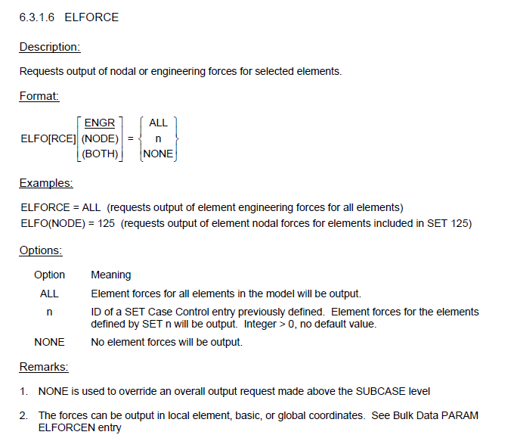
This is confusing. ELFORCE entry with remark 2 (ELFORCEN)
$GPFORCE

GPFORCE

Description:
Requests output of grid point force balance in the global coordinate system for selected grids.

Format:
GPFORCE | $$\left[\left(\left[\begin{matrix}\text{PRINT} \\ \text{PLOT}\end{matrix}\right]\right)\right]$$ | $$\text{=}\left\{\begin{matrix}\text{ALL} \\ n \\ \text{NONE}\end{matrix}\right\}$$

Examples:
See the DISPLACEMENT entry/card (Section 10.3)

Options:
See the DISPLACEMENT entry/card (Section 10.3)

Remarks:
- See the DISPLACEMENT entry/card (Section 10.3)
- GPFORCES is also acceptable (MYSTRAN only considers the first 4 characters for identification).

$LABEL

LABEL

Description:
Specifies a third text line to be printed in the output file.

Format:
LABE[L] = [optional text material up, and including, column 80]

Remarks:
1. This line of text will be printed in the output file and can be different for each subcase.

$LOAD

LOAD

Description:
Indicates what applied loads (identified in the Bulk Data) are to be used for a solution.

Format:
LOAD = n

Examples:
LOAD = 98 | Requests load set 98 be used

Options:
Option | Meaning
n | Set ID of a load (must be the ID of at least one of the following Bulk data entries: LOAD, FORCE, GRAV, MOMENT, PLOAD2). Integer > 0, no default value.

Remarks:
1. If the Case Control LOAD entry identifies a Bulk Data LOAD entry (load combining entry), then n must not appear as a set ID on any of the Bulk Data FORCE, GRAV, MOMENT or PLOAD2 entries that are in the input data file.
2. The Case Control LOAD entry must be present if a static loading is desired in a solution.

$MEFFMASS

MEFFMASS

Description:
Requests calculation and output of modal effective masses in an eigenvalue solution.

Format:
MEFFMASS

Remarks:
- This entry may appear in the Case Control section for eigenvalue extraction solutions.
- See Bulk Data PARAM MEFMLOC for the reference point to use in calculating effective masses in Craig-Bampton (SOL 31) analyses.

$METHOD

METHOD

Description:
Indicates what eigenvalue extraction method (identified in the Bulk Data on an EIGR or EIGRL entry) is to be used for an eigenvalue solution.

Format:
METHOD = n

Examples:
METHOD = 18 | requests that eigenvalue extraction method 18 be used

Options:
Option | Meaning
n | Set ID of a Bulk data EIGR or EIGRL entry. Integer > 0, no default value.

Remarks:
1. This entry must appear in the Case Control section for all eigenvalue extraction solutions.
$MPC

MPC

Description:
Indicates what multipoint constraints (identified in the Bulk Data) are to be used for a solution.

Format:
MPC = n

Examples:
MPC = 47 | requests multi point constraint set 47, defined in Bulk Data, be used

Options:
Option | Meaning
n | Set ID of an MPC and/or MPCADD Bulk data entry. Integer > 0, no default value.

Remarks:
1. There can be only one Case Control MPC entry per solution. It should appear in the Case Control section above any SUBCASE definitions.
$MPCFORCES

MPCFORCES

Description:
Requests output of multi point constraint forces in the global coordinate system for selected grids. Multi point constraint forces consist of forces due to directly defined MPC’s and also due to rigid elements (which are automated, internally in MYSTRAN, as MPC’s).

Format:
MPCFORCES | $$\left[\left(\left[\begin{matrix}\text{PRINT} \\ \text{PLOT}\end{matrix}\right]\right)\right]$$ | $$\text{=}\left\{\begin{matrix}\text{ALL} \\ n \\ \text{NONE}\end{matrix}\right\}$$

Examples:
See the DISPLACEMENT entry/card (Section 10.3)

Options:
See the DISPLACEMENT entry/card (Section 10.3)

Remarks:
1. See the DISPLACEMENT entry/card (Section 10.3)
2. MPCFORCE is also acceptable (MYSTRAN only considers the first 4 characters for identification).

$MPFACTOR

MPFACTOR

Description:
Requests calculation and output of modal participation factors in an eigenvalue solution.

Format:
MPFACTOR

Remarks:
1. This entry may appear in the Case Control section for eigenvalue extraction solutions.

$OLOAD

OLOAD

Description:
Requests output of applied loads in the global coordinate system for selected grids.

Format:
OLOAD | $$\left[\left(\left[\begin{matrix}\text{PRINT} \\ \text{PLOT}\end{matrix}\right]\right)\right]$$ | $$\text{=}\left\{\begin{matrix}\text{ALL} \\ n \\ \text{NONE}\end{matrix}\right\}$$

Examples:
See the DISPLACEMENT entry/card (Section 10.3)

Options:
See the DISPLACEMENT entry/card (Section 10.3)

Remarks:
See the DISPLACEMENT entry/card (Section 10.3)
$SET

SET

Description:
Defines sets of grid points or elements for which output is desired.

Format:
SET n = {i₁[, i₂, i₃, i₄ THRU i₅, EXCEPT i₆, i₇, i₈ THRU i₉]}

Examples:
SET 39
SET 57 = 101 THRU 298
SET 12 = 301, 305, 491 THRU 672 EXCEPT 501

Options:
Option | Meaning
n | Set ID number. Integer > 0, no default.
i₁, i₂, i_{3,} etc. | Individual grid point or element numbers.
i₄ THRU i₅ | Inclusive group of grid or element numbers.
EXCEPT | Grid or element numbers following EXCEPT (but before next THRU) will be excluded from the previous THRU group.

Remarks:
1. Any number of SETs can be defined as long as the ID numbers are unique integers. The SET logical entry can consist of multiple physical entries, each of 80 columns max. If a SET definition requires more than one physical entry each entry (except the last) must end with a “,”.
2. Ranges in THRU statements must be increasing (that is, i₄ must be less than i₅ in the above example). It is acceptable that some grid or element numbers in the THRU range do not exist. However, all grids or elements that are in the THRU range will be included in the SET.
3. Whether the set indicates grids or elements is dependent on the context in which the SET is used. If DISP = 39 output is requested, then the integers in SET 39 will be interpreted as grid point numbers. If FORCE = 39 (or ELFORCE = 39) output is requested, then the integers in SET 39 will be interpreted as element numbers.

$SPC

SPC

Description:
Indicates what single point constraints (identified in the Bulk Data) are to be used for a solution.

Format:
SPC = n

Examples:
SPC = 74 | requests single point constraint SET 74 be used

Options:
Option | Meaning
n | Set ID of at least one SPC, SPC1 and/or SPCADD Bulk data entries. Integer > 0, no default value.

Remarks:
1. There can be only one Case Control SPC entry per solution. It should appear in the Case Control section above any SUBCASE definitions.
$SPCFORCES

SPCFORCES

Description:
Requests output of single point constraint (SPC) forces in the global coordinate system for selected grids.

Format:
SPCFORCES | $$\left[\left(\left[\begin{matrix}\text{PRINT} \\ \text{PLOT}\end{matrix}\right]\right)\right]$$ | $$\text{=}\left\{\begin{matrix}\text{ALL} \\ n \\ \text{NONE}\end{matrix}\right\}$$

Examples:
See the DISPLACEMENT entry/card (Section 10.3)

Options:
See the DISPLACEMENT entry/card (Section 10.3)

Remarks:
1. See the DISPLACEMENT entry/card (Section 10.3)
2. SPCFORCE is also acceptable (MYSTRAN only considers the first 4 characters for identification).

$STRAIN

STRAIN

Description:
Requests output of strains for selected elements. ELSTRAIN is an equivalent to the STRAIN entry.

Format:

STRAIN | $$\left[\left(\left[\begin{matrix}\text{PRINT} \\ \text{PLOT}\end{matrix}\right],\left[\begin{matrix}\text{VONMISES} \\ \text{M}\text{AXS or SHEAR}\end{matrix}\right],\left[\begin{matrix}\text{STRCUR} \\ \text{F}\text{IBER}\end{matrix}\right],\left[\begin{matrix}\text{CENTER} \\ \text{CORNER}\end{matrix}\right]\right)\right]$$ | $$\text{=}\left\{\begin{matrix}\text{ALL} \\ n \\ \text{NONE}\end{matrix}\right\}$$

Examples:
STRAIN = ALL  STRA = ALL  STRAIN = 45  STRAIN(PLOT) = ALL  STRAIN(PRINT, PLOT) = ALL  STRAIN() = ALL | See the DISPLACEMENT entry/card (Section 10.3)
STRAIN(FIBER) = ALL | requests strain at the Z1, Z2 locations as opposed to the default STRCUR (reference plane strain and curvature).
STRAIN(CORNER) = ALL | requests strain at the corners (and center) for the CQUAD4 element (as opposed to just center location). See Remark 9 regarding the CTRIA3, CQUAD8, and solid elements.
STRAIN(CORNER, PRINT, PLOT) = ALL | Requests strain output to the f06 (ASCII) and OP2 file (binary) files. Strains at the corner and center locations are reported (only applicable to the CQUAD4 and CQUADK). See the Options and Remarks section for a description of the CORNER option.
STRAIN(PLOT) = ALL | requests an OP2 file (binary) for the strains. A f06 file will not be created.

Options:
Option | Meaning
ALL | Strains for all elements in the model will be output.
n | ID of a SET Case Control entry previously defined. Strains for the elements defined by SET n will be output. Integer > 0, no default value.
NONE | No strains will be output.
PRINT | The output will go to the filename.f06 file (ASCII). This file can be parsed with the f06csv program (default).
PLOT | The output will go to the filename.OP2 file (Binary)
VONMISES | Requests von Mises strain (default).
MAXS or SHEAR | Requests maximum shear strain for shell elements and octahedral strain for solid elements.
STRCUR | Strain at the reference plane and curvatures are output for plate/shell elements (default).
FIBER | Strain at locations Z1, Z2 are output for plate/shell elements.
CENTER | Requests strains at only the element center for the CQUAD4 element (default). See also the Remarks section.
CORNER | Requests strains at the element corners for the CQUAD4 element, in addition to strains at the element center. See also the Remarks section.
Remarks:
1. Optional entries are surrounded by brackets.
2. Highlighted values are the default values.
3. If no output file is requested, the only output file will be the f06 (the default output is PRINT, which creates the f06).
4. NONE is used to override an overall output request made above the SUBCASE level.
5. The first four letters are the shorthand version of the full name. For example, both STRAIN and STRA are acceptable.
6. A Neutral file (.NEU) may be requested by placing “PARAM, PRTNEU, YES” in the bulk data section of the deck.
7. The parameter PRTALL, FILES may be used to override the output requests.
8. MYSTRAN does not support a PUNCH file output. However, the MYSTRAN project developed a utility that parses a f06 file. This tool can create a customized output of the data in a format that is convenient for processing the data:https://github.com/ClassicalFEA/nastools
9. The CENTER and CORNER options are only specific to the CQUAD4 element. The CTRIA3 is a constant strain triangle (all nodes have the same strain): CENTER and CORNER are effectively the same. For solid elements and the CQUAD8, both the center and corner strains are always output.
11. The options VONMISES, MAXS (or SHEAR), CENTER and CORNER will apply for all subcases. Need to make sure this is valid for all subcases. Was this the original issue or was it just that corner was not available for solids and that’s why it was noted?
12. The f06 file can output center and corner strains for all elements. However, the OP2 may not output the corner strains for solid element (this is an action item).

$STRESS

STRESS

Description:
Requests output of stresses for selected elements. ELSTRESS is an equivalent to the STRESS entry.

Format:
STRESS | $$\left[\left(\left[\begin{matrix}\text{PRINT} \\ \text{PLOT}\end{matrix}\right],\left[\begin{matrix}\text{VONMISES} \\ \text{M}\text{AXS or SHEAR}\end{matrix}\right],\left[\begin{matrix}\text{CENTER} \\ \text{CORNER}\end{matrix}\right]\right)\right]$$ | $$\text{=}\left\{\begin{matrix}\text{ALL} \\ n \\ \text{NONE}\end{matrix}\right\}$$

Examples:
See the STRAIN card (Section 10.20) and Remark 2.

Options:
See the STRAIN card (Section 10.20) and Remark 2.

Remarks:
1. See the STRAIN card (Section 10.20)
2. For plates/shells, the stress is always at Z1, Z2. This is unlike the STRAIN option (default is STRCUR – reference plane and curvatures). To output the Z1, Z2 strains, the FIBER option is used.

$SUBCASE

SUBCASE

Description:
Beginning of the portion of the Case Control section that defines the options to be used in one subcase. Multiple subcases must be used when solution with separate static loads in one run is desired.

Format:
SUBC[ASE] = n

Examples:
SUBCASE = 361

Options:
Option | Meaning
n | Set ID of a subcase. Integer > 0, no default value.

Remarks:
1. There can be multiple subcases and there is no restriction on the integer numbers used for subcase IDs.
2. All Case Control entries following a SUBCASE entry (up to the next SUBCASE Case Control entry) identify the conditions for solution (loads and output) for this subcase. Case Control entries “above” the SUBCASE level will be used for all subcases unless specifically overridden in the subcase definition.
$SUBTITLE

SUBTITLE

Description:
Specifies a second text line to be printed in the output file.

Format:
SUBT[ITLE] = [optional text material up to, and including, column 80]

Remarks:
1. This line of text will be printed in the output file and can be different for each subcase.

$TEMPERATURE

TEMPERATURE

Description:
Indicates temperature distributions (identified in the Bulk Data) that are to be used for a statics solution.

Format:
TEMP[ERATURE] = n

Examples:
TEMP = 174 | requests temperature SET 174 be used
TEMPERATURE = 13 | requests temperature SET 13 be used

Options:
Option | Meaning
n | Set ID of Bulk Data TEMP, TEMPD, TEMPRB and/or TEMPP1 cards. Integer > 0, no default value.

Remarks:
1. Thermal loads can be used in combination with other static loads in any subcase but must be selected in Case Control with the TEMPERATURE = n card.

$TITLE

TITLE

Description:
Specifies a text line to be printed in the output file.

Format:
TITLE = [optional text material up to, and including, column 80]

Remarks:
This line of text will be printed in the output file and can be different for each subcase.

$VECTOR

VECTOR

Description:
Requests eigenvector output. What else goes here?

QUICK REFERENCE – BULK DATA
The following sections describe the input required for each of the different Bulk Data entries.

To quickly find an entry, there are two options:
- Bookmarks
- Search for “$” + “entry”. For example, search for “$crod” to find the CROD entry.

$ASET

ASET

Description:
Define degrees of freedom to go into the analysis set (A-set).

Format:
1 | 2 | 3 | 4 | 5 | 6 | 7 | 8 | 9 | 10
ASET | G1 | C1 | G2 | C2 | G3 | C3 | G4 | C4

Example:
ASET | 19 | 1 | 28 | 2345 | 37 | 124 | 46 | 134

Data Description:
Field | Contents | Type | Default
Gi | ID numbers of grids | Integer > 0 | None
Ci | Displacement component numbers | Integers 1-6 | None

Remarks:
1. The degrees of freedom defined by grids Gi, components Ci will be placed in the mutually exclusive A-set. These degrees of freedom cannot have been defined to be in any other mutually exclusive set (i.e. M, S or O-sets).
2. If there are no ASET (or ASET1) and no OMIT (or OMIT1) entries, all degrees of freedom not in the M or S-set will be placed in the A-set.
3. If ASET (or ASET1) entries are present in the input data file, then all degrees of freedom not specified on these entries and also not in the M or S-sets will be placed in the O-set.
4. If both ASET (or ASET1) and OMIT (or OMIT1) are present, then all degrees of freedom not in the M and S-sets must be explicitly defined on these ASET (or ASET1) and OMIT (or OMIT1) entries.
5. Up to four pairs of Gi, Ci can be specified on one ASET entry. For more pairs, use additional ASET entries (i.e. there is no continuation entry for ASET).

$ASET1

ASET1

Description:
Define degrees of freedom to go into the analysis set (A-set).

Format No. 1:
1 | 2 | 3 | 4 | 5 | 6 | 7 | 8 | 9 | 10
ASET1 | C | G1 | G2 | G3 | G4 | G5 | G6 | G7
 | G8 | G9 | (etc)

Format No. 2:
1 | 2 | 3 | 4 | 5 | 6 | 7 | 8 | 9 | 10
ASET1 | C | G1 | THRU | G2

Example:
ASET1 | 135 | 17934 | THRU | 19012

Data Description:
Field | Contents | Type | Default
Gi | ID numbers of grids. G2 > G1 | Integer > 0 | None
C | Displacement component numbers | Integers 1-6 | None

Remarks:
1. In Format No. 2, any grid whose ID is in the range G1 through G2 will have component C defined in the A-set.
2. The degrees of freedom defined by grids GI, components Ci will be placed in the mutually exclusive A-set. These degrees of freedom cannot have been defined to be in any other mutually exclusive set (i.e.. M, S or O-sets).
3. If there are no ASET (or ASET1) and no OMIT (or OMIT1) entries, all degrees of freedom not in the M or S-set will be placed in the A-set.
4. If ASET (or ASET1) entries are present in the input data file, then all degrees of freedom not specified on these entries and also not in the M or S-sets will be placed in the O-set.
5. If both ASET (or ASET1) and OMIT (or OMIT1) are present, then all degrees of freedom not in the M and S sets must be explicitly defined on these ASET (or ASET1) and OMIT (or OMIT1) entries.
6. Up to four pairs of Gi, Ci can be specified on one ASET entry. For more pairs, use additional ASET entries (i.e. there is no continuation entry for ASET). – Is this applicable?

$BAROR

BAROR

Description:
Define default values for the CBAR entry.

Format No.1:
1 | 2 | 3 | 4 | 5 | 6 | 7 | 8 | 9 | 10
BAROR |  | PID |  |  | V1 | V2 | V3

Format No.2:
1 | 2 | 3 | 4 | 5 | 6 | 7 | 8 | 9 | 10
BAROR |  | PID |  |  | G0

Examples:
BAROR |  | 57 |  |  | 1.3 | 3.5 | 0.7

BAROR |  | 57 |  |  | 1563

Data Description:
Field | Contents | Type | Default
PID | ID number of a PBAR Bulk data entry | Integer > 0 or blank | None
G0 | ID of a grid used to define the orientation v vector | Integer > 0 or blank | None
V1, V2, V3 | The three components of the orientation v vector specified in the global coordinate system for grid GA on the CBAR entry. | Real or blank | None

Remarks:
1. Only one BAROR entry is allowed in the input data file. Any data entered on a BAROR entry will be used unless overridden on a CBAR entry. If Format 1 is used, all three components of the v vector must be entered.
2. The orientation v vector can be specified using either a grid point, G0, or the components V1, V2, V3. Either one of these, in conjunction with the grid GA on the CBAR entry, defines the orientation vector.
3. See CBAR entry for remarks concerning the v vector.

$CBAR

CBAR

Description:
1D bar element for axial load, bending, and torsion.

Format No. 1:
1 | 2 | 3 | 4 | 5 | 6 | 7 | 8 | 9 | 10
CBAR | EID | PID | GA | GB | V1 | V2 | V3
 | PA | PB | W1A | W2A | W3A | W1B | W2B | W3B

Format No. 2:
1 | 2 | 3 | 4 | 5 | 6 | 7 | 8 | 9 | 10
CBAR | EID | PID | GA | GB | G0
 | PA | PB | W1A | W2A | W3A | W1B | W2B | W3B

Examples:
CBAR | 98 | 43 | 1234 | 56 | 78
 | 456 | 13 | 0.0 | 0.2 | 0.3 | 0.1 | 0.05 | 0.10

CBAR | 98 | 43 | 1234 | 56 | 0.5 | 1.5 | 3.2

Data Description:
Field | Contents | Type | Default
EID | Element ID number | Integer > 0 | None
PID | ID number of a PBAR Bulk data entry | Integer > 0 | EID
GA, GB | ID numbers of the grids to which the element is attached | Integer > 0 | None
G0 | ID of a grid used to define the orientation v vector | Integer > 0 | None
V1, V2, V3 | Components of the orientation v vector | Real | None
PA, PB | Pin flags for bar Ends A and B, respectively | Integers 1-6 | None
W1A, W2A, W3A | Components of the bar offset from grid GA in the displacement coordinate system of GA | Real | None
W1B, W2B, W3B | Components of the bar offset from grid GB in the displacement coordinate system of GB | Real | None

Remarks:
1. No other element in the model may have the same element ID.
2. The v vector is a vector in the direction of either (a) the vector defined by V1, V2, V3 or (b) the vector from grid GA to grid G0. These components are measured in the global coordinate system of grid GA (see GRID entry for definition of the global coordinate system for a grid). If Format 1 is used, all three components of the v vector must be entered.
3. The local x-axis of the element is a vector from End A through End B.
4. The x-axis and the v vector define a plane. On the PBAR entry, I1 is the bending moment of inertia in this plane.
5. The BAROR entry may be used to define default values for: PID, V1, V2, V3, G0.

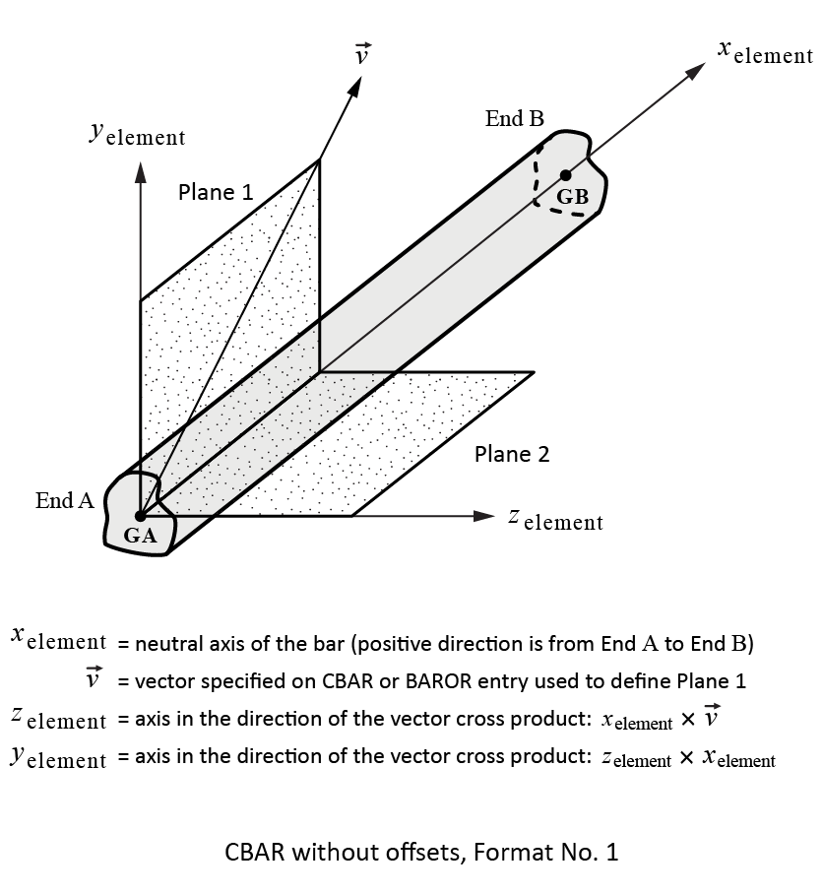

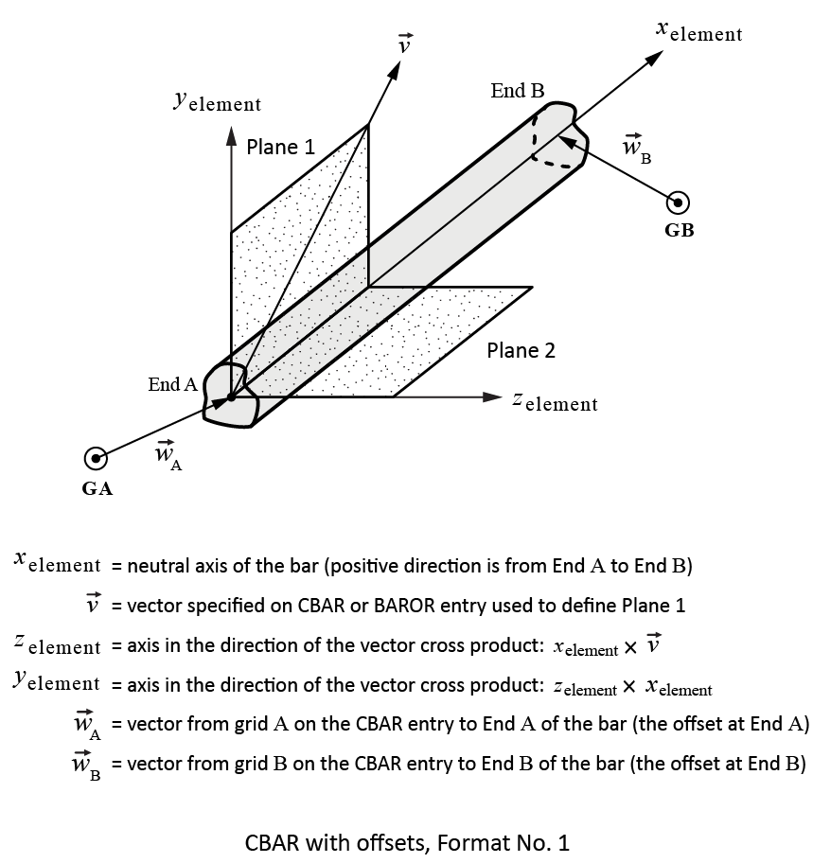
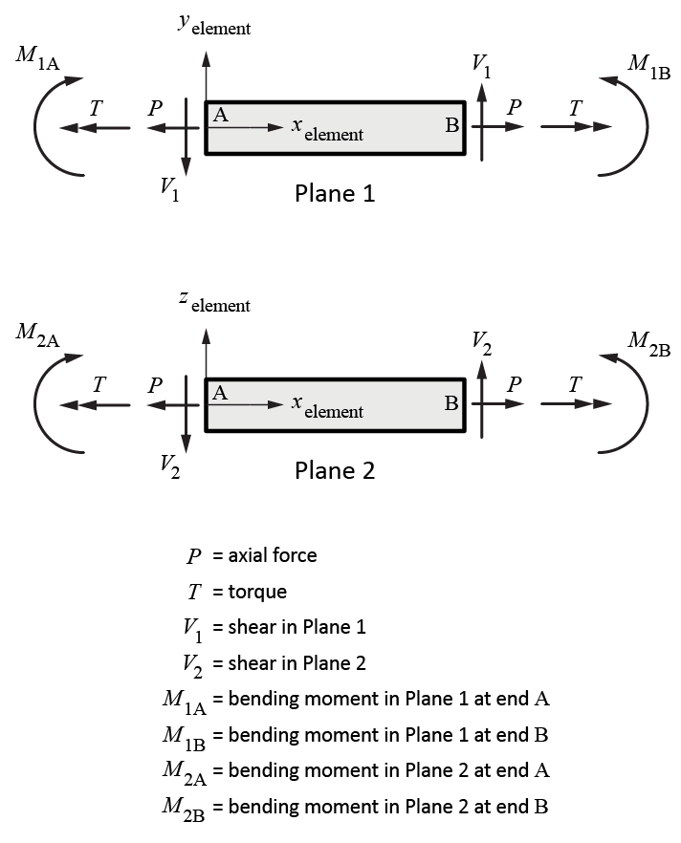

$CBUSH

CBUSH

Description:
General spring element.

Format No. 1:
1 | 2 | 3 | 4 | 5 | 6 | 7 | 8 | 9 | 10
CBUSH | EID | PID | GA | GB | V1 | V2 | V3 | CID
 | S | OCID | S1 | S2 | S3

Format No. 2:
1 | 2 | 3 | 4 | 5 | 6 | 7 | 8 | 9 | 10
CBUSH | EID | PID | GA | GB | G0 |  |  | CID
 | S | OCID | S1 | S2 | S3

Examples:
CBUSH | 98 | 43 | 1234 | 56 | 0.5 | 1.5 | 3.2

CBUSH | 98 | 43 | 1234 | 56 | 78
 | 456 | 13 | 0.0 | 0.2 | 0.3

Data Description:
Field | Contents | Type | Default
EID | Element ID number | Integer > 0 | None
PID | ID number of a PBUSH Bulk data entry | Integer > 0 | EID
GA, GB | ID numbers of the grids to which the element is attached | Integer > 0 | None
G0 | ID of a grid used to define the orientation v vector | Integer > 0 | None
V1, V2, V3 | Components of the orientation v vector, from GA, in the displacement coordinate system at GA. | Real | None
CID | Element coordinate system identification (0 is basic system) If blank, the element system is defined by V1, V2, V3 or G0. | Integer >= 0 or blank | None
S | Location of spring | 0.< Real < 1. | 0.5
OCID | ID of coordinate system used in defining the offsets. OCID = −1 indicates that the offsets are specified in the element coordinate system | Integer >= −1 | −1
S1, S2, S3 | Components of spring offset | Real | 0.

Remarks:
1. No other element in the model may have the same element ID.
2. If CID >= 0 the element x-axis is along the x-axis of coordinate system CID, etc.
3. A vector must be specified. That is, fields 6-9 cannot all be blank.
4. GB cannot be blank.
5. The following pertains to OCID:
(a) OCID = −1 (or blank) means S is used and S1, S2, S3 are ignored.
(b) OCID >= 0 means S is ignored and S1, S2, S3 are used.
6. The continuation line is optional.

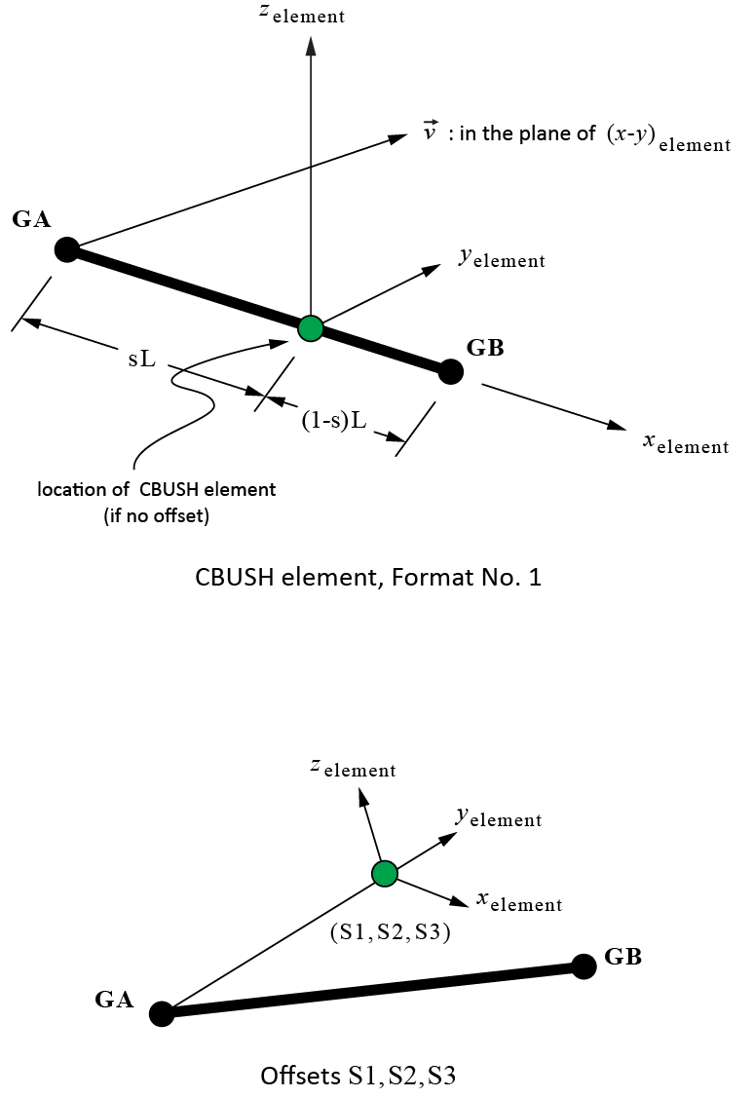

$CELAS1

CELAS1

Description:
Scalar spring element connected to 2 grid points (GRID’s) with reference to a PELAS entry to define the real values for the element.

Format:
1 | 2 | 3 | 4 | 5 | 6 | 7 | 8 | 9 | 10
CELAS1 | EID | PID | G1 | C1 | G2 | C2

Example:
CELAS1 | 789 | 32 | 3731 | 5 | 67 | 5

Data Description:
Field | Contents | Type | Default
EID | Unique element identification (ID) number | Integer > 0 | None
PID | ID number of a PELAS Bulk data entry | Integer > 0 | EID
Gi | ID numbers of the grids to which the element is attached | Integer > 0 | None
Ci | Component number (1-6) of the degree of freedom, at Gi, to which the spring element is connected | Integer 1-6 | None

Remarks:
1. No other element in the model may have the same element ID.
2. The degrees of freedom specified by Gi/Ci must be global degrees of freedom.
3. Care must be exercised that rigid body motion of the model is not restrained when using scalar springs. For example, connecting a scalar spring between two translational degrees of freedom that are not colinear may restrain rigid body motion and give erroneous results.
$CELAS2

CELAS2

Description:
Scalar spring element connected to 2 grid points (GRID’s) with the element stiffness defined.

Format:
1 | 2 | 3 | 4 | 5 | 6 | 7 | 8 | 9 | 10
CELAS2 | EID | K | G1 | C1 | G2 | C2

Example:
CELAS2 | 789 | 1.234+06 | 3731 | 5 | 67 | 5

Data Description:
Field | Contents | Type | Default
EID | Unique element identification (ID) number | Integer > 0 | None
K | Stiffness value | Real | 0.
Gi | ID numbers of the grids to which the element is attached | Integer > 0 | None
Ci | Component number (1-6) of the degree of freedom, at Gi, to which the spring element is connected | Integer 1-6 | None

Remarks:
1. No other element in the model may have the same element ID.
2. The degrees of freedom specified by Gi/Ci must be global degrees of freedom.
3. Care must be exercised that rigid body motion of the model is not restrained when using scalar springs. For example, connecting a scalar spring between two translational degrees of freedom that are not colinear may restrain rigid body motion and give erroneous results.

$CELAS3

CELAS3

Description:
Scalar spring element connected to 2 scalar points (SPOINT’s) with reference to a PELAS entry to define the real values for the element.

Format:
1 | 2 | 3 | 4 | 5 | 6 | 7 | 8 | 9 | 10
CELAS3 | EID | PID | S1 | S2

Example:
CELAS3 | 789 | 32 | 3731 | 5

Data Description:
Field | Contents | Type | Default
EID | Unique element identification (ID) number | Integer > 0 | None
PID | ID number of a PELAS Bulk data entry | Integer > 0 | EID
Si | ID numbers of the SPOINT’s to which the element is attached | Integer > 0 | None

Remarks:
1. No other element in the model may have the same element ID.
2. The degrees of freedom specified by Si must be global degrees of freedom.
3. Care must be exercised that rigid body motion of the model is not restrained when using scalar springs. For example, connecting a scalar spring between two translational degrees of freedom that are not colinear may restrain rigid body motion and give erroneous results.
$CELAS4

CELAS4

Description:
Scalar spring element connected to 2 scalar points (SPOINT’s) with the element stiffness defined.

Format:
1 | 2 | 3 | 4 | 5 | 6 | 7 | 8 | 9 | 10
CELAS4 | EID | K | S1 | S2

Example:
CELAS4 | 789 | 32 | 3731 | 5

Data Description:
Field | Contents | Type | Default
EID | Unique element identification (ID) number | Integer > 0 | None
K | Stiffness value | Real | 0.
Si | ID numbers of the SPOINT’s to which the element is attached | Integer > 0 | None

Remarks:
1. No other element in the model may have the same element ID.
2. The degrees of freedom specified by Si must be global degrees of freedom.
3. Care must be exercised that rigid body motion of the model is not restrained when using scalar springs. For example, connecting a scalar spring between two translational degrees of freedom that are not colinear may restrain rigid body motion and give erroneous results.
$CHEXA

CHEXA

Description:
3D solid hexagon element.

Format:
1 | 2 | 3 | 4 | 5 | 6 | 7 | 8 | 9 | 10
CHEXA | EID | PID | G1 | G2 | G3 | G4 | G5 | G6
 | G7 | G8 | G9 | G10 | G11 | G12 | G13 | G14
 | G15 | G16 | G17 | G18 | G19 | G20

Example:
CHEXA | 98 | 43 | 101 | 123 | 254 | 12 | 621 | 8945
 | 43 | 998

Data Description:
Field | Contents | Type | Default
EID | Unique element identification (ID) number | Integer > 0 | None
PID | ID number of a PSOLID Bulk data entry | Integer > 0 | None
G1-G20 | ID numbers of the grids to which the element is attached. Specify G1-G8 for a 8-node HEXA and all 20 for a 20-node HEXA | Integer > 0 | None

Remarks:
1. No other element in the model may have the same element ID.
2. The first continuation entry is required. The second is only needed for the 20-node element.

$CMASS1

CMASS1

Description:
Scalar mass element connected to 1 grid point (GRID) with reference to a PMASS entry to define the real values for the element.

Format:
1 | 2 | 3 | 4 | 5 | 6 | 7 | 8 | 9 | 10
CMASS1 | EID | PID | G1 | C1

Example:
CMASS1 | 789 | 32 | 3731 | 5

Data Description:
Field | Contents | Type | Default
EID | Unique element identification (ID) number | Integer > 0 | None
PID | ID number of a PMASS Bulk data entry | Integer > 0 | EID
G1 | ID number of the grid to which the element is attached | Integer > 0 | None
C | Component number (1-6) of the degree of freedom, at G1, to which the mass element is connected | Integer 1-6 | None

Remarks:
1. No other element in the model may have the same element ID.
2. The degrees of freedom specified by Gi/Ci must be global degrees of freedom.
3. For MYSTRAN, the mass can only be connected to 1 grid (not 2 as is allowed in NASTRAN).

$CMASS2

CMASS2

Description:
Scalar mass element connected to 1 grid point (GRID) with the element stiffness defined.

Format:
1 | 2 | 3 | 4 | 5 | 6 | 7 | 8 | 9 | 10
CMASS2 | EID | K | G1 | C1

Example:
CMASS2 | 789 | 1.234+06 | 3731 | 5

Data Description:
Field | Contents | Type | Default
EID | Unique element identification (ID) number | Integer > 0 | None
K | Stiffness value | Real | 0.
Gi | ID numbers of the grids to which the element is attached | Integer > 0 | None
Ci | Component number (1-6) of the degree of freedom, at Gi, to which the mass element is connected | Integer 1-6 | None

Remarks:
1. No other element in the model may have the same element ID.
2. The degrees of freedom specified by Gi/Ci must be global degrees of freedom.
3. For MYSTRAN, the mass can only be connected to 1 grid (not 2 as is allowed in NASTRAN).
$CMASS3

CMASS3

Description:
Scalar mass element connected to 1 scalar point (SPOINT) with reference to a PMASS entry to define the real values for the element.

Format:
1 | 2 | 3 | 4 | 5 | 6 | 7 | 8 | 9 | 10
CMASS3 | EID | PID | S1

Example:
CMASS3 | 789 | 32 | 3731 | 5

Data Description:
Field | Contents | Type | Default
EID | Unique element identification (ID) number | Integer > 0 | None
PID | ID number of a PMASS Bulk data entry | Integer > 0 | EID
Si | ID numbers of the SPOINT’s to which the element is attached | Integer > 0 | None

Remarks:
1. No other element in the model may have the same element ID.
2. The degrees of freedom specified by Si must be global degrees of freedom.
3. For MYSTRAN, the mass can only be connected to 1 scalar point (not 2 as is allowed in NASTRAN).
$CMASS4

CMASS4

Description:
Scalar mass element connected to 1 scalar point (SPOINT) with the element stiffness defined.

Format:
1 | 2 | 3 | 4 | 5 | 6 | 7 | 8 | 9 | 10
CMASS4 | EID | K | S1

Example:
CMASS4 | 789 | 32 | 3731 | 5

Data Description:
Field | Contents | Type | Default
EID | Unique element identification (ID) number | Integer > 0 | None
K | Stiffness value | Real | 0.
Si | ID numbers of the SPOINT’s to which the element is attached | Integer > 0 | None

Remarks:
1. No other element in the model may have the same element ID.
2. The degrees of freedom specified by Si must be global degrees of freedom.
3. For MYSTRAN, the mass can only be connected to 1 scalar point (not 2 as is allowed in NASTRAN).

$CONM2

CONM2

Description:
Concentrated mass at a grid point.

Format:
1 | 2 | 3 | 4 | 5 | 6 | 7 | 8 | 9 | 10
CONM2 | EID | G | CID | M | X1 | X2 | X3
 | I11 | I21 | I22 | I31 | I32 | I33

Example:
CONM2 | 98 | 354 | 29 | 0.5 | 0.3 | 1.2 | 0.65
 | 123. | -45. | 321. | 12. | -43. | 567.

Data Description:
Field | Contents | Type | Default
EID | Element identification (ID) number | Integer > 0 | None
G | ID number of the grid to which the mass is attached | Integer > 0 | None
CID | ID number of a coordinate system defined on a CORD2C, CORD2R or CORD2S Bulk Data entry | Integer > 0 | 0
M | Mass value | Real | 0.
Xi | Offset distances from grid G to the center of gravity of M in coordinate system CID | Real | 0.
Iij | The 6 independent moments of inertia of M about its center of gravity measured in coordinate system CID. | Real | 0.

Remarks:
1. EID must be unique among all CONM2 entries.
2. The continuation entry is optional.
3. The moments of inertia I11, I22 and I33 (if entered) must be > 0.
4. A blank entry for CID implies the basic coordinate system.
$CONROD

CONROD

Description:
1D elastic rod element for axial load and torsion with properties defined in the entry (no reference to a property entry). Note that the CROD entry references a property entry.

Format:
1 | 2 | 3 | 4 | 5 | 6 | 7 | 8 | 9 | 10
CONROD | EID | G1 | G2 | MID | A | J | C | NSM

Example:
CONROD | 98 | 43 | 1234 | 56

Data Description:
Field | Contents | Type | Default
EID | Unique element identification (ID) number | Integer > 0 | None
G1, G2 | ID numbers of the grids to which the element is attached | Integer > 0 | EID
MID | Material ID number | Integer > 0 | None
A | Bar cross-sectional area | Real | 0.
J | Torsional constant | Real | 0.
C | Torsional stress recovery coefficient | Real | 0.
MPL | Mass per unit length | Real | 0.

Remarks:
1. No other element in the model may have the same element ID.
2. The local x_{element} axis of the element is a vector from G1 through G2.
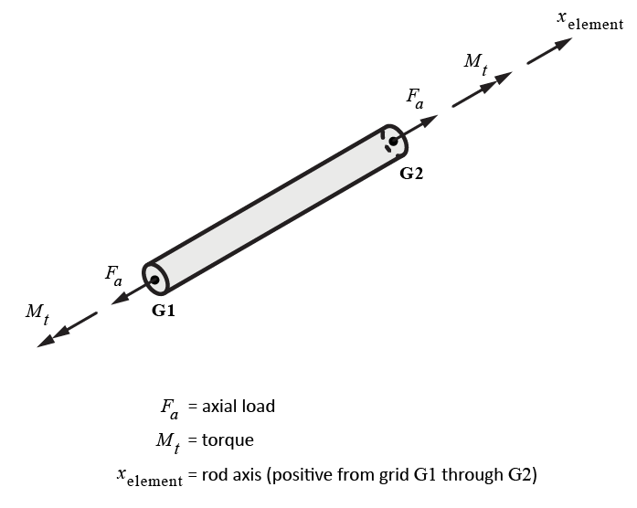
$CORD1C

CORD1C

Description:
Cylindrical coordinate system definition defined via 3 grids. TWO separate coordinate systems may be defined on one CORD1C entry. Note that CORD2C use 3 points to define the coordinate system.

Format:
1 | 2 | 3 | 4 | 5 | 6 | 7 | 8 | 9 | 10
CORD1C | CIDA | G1A | G2A | G3A | CIDB | G1B | G2B | G3B

Example:
CORD1C

Data Description:
Field | Contents | Type | Default
CID | Coordinate system ID number | Integer > 0 | None
G1A, G1B | ID’s of grid points at the origin of systems A, B respectively | Integer > 0 | None
G2A, G2B | ID’s of grid points along the z axis of systems A, B respectively | Integer > 0 | None
G3A, G3B | ID’s of grid points in the x-z plane of systems A, B respectively | Integer > 0 | None

Remarks:
1. See the following figure for the cylindrical coordinate system notation and the “defining” rectangular system.
2. CIDA, CIDB must be unique over all coordinate systems defined in the model.
3. One or two coordinate systems may be defined on a single CORD1C entry.
4. The grid points on this entry must be defined in a system that does not involve the system being defined.
5. The location of a grid point using this coordinate system is defined by the r, θ, z coordinates of a cylindrical coordinate system.

The following figure needs to be reviewed/improved to a greater degree (See CORD1R for notes).

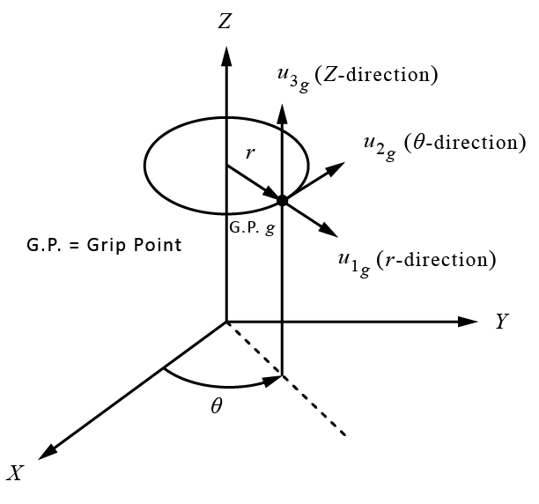
$CORD1R

CORD1R

Description:
Rectangular coordinate system definition defined via 3 grids. TWO separate coordinate systems may be defined on one CORD1R entry. Note that CORD2R use 3 points to define the coordinate system.

Format:
1 | 2 | 3 | 4 | 5 | 6 | 7 | 8 | 9 | 10
CORD1R | CIDA | G1A | G2A | G3A | CIDB | G1B | G2B | G3B

Example:
CORD1R

Data Description:
Field | Contents | Type | Default
CID | Coordinate system ID number | Integer > 0 | None
G1A, G1B | ID’s of grid points at the origin of systems A, B respectively | Integer > 0 | None
G2A, G2B | ID’s of grid points along the z-axis of systems A, B respectively | Integer > 0 | None
G3A, G3B | ID’s of grid points in the x-z plane of systems A, B respectively | Integer > 0 | None

Remarks:
1. CIDA, CIDB must be unique over all coordinate systems defined in the model.
2. One or two coordinate systems may be defined on a single CORD1R entry.
3. The grid points on this entry must be defined in a system that does not involve the system being defined.
4. The location of a grid point using this coordinate system is defined by the x, y, z coordinates of a rectangular coordinate system.

The following figure needs to be reviewed/improved to a greater degree (along with cylindrical and spherical). The following questions are applicable to rectangular, cylindrical, and spherical coordinate systems.
- Is the origin of the displacement coordinate system of a grid point at the grid point or at the origin defined in CORD?
- Are the coordinate system's axes always called x,y,z or are they r,theta,z and r,theta,phi for cylindrical/spherical? If r,theta,phi, etc. then we have to name them appropriately throughout the rest of the document whenever anything is defined in a user-specified coordinate system, which is just about everything.
- Are cylindrical/spherical coordinate systems really local rectangular systems? So is displacement in the theta direction an angle in degrees or a distance in length units?
- Why do those diagrams show displacements (u1,u2,u3)? If the CORD?? is not being used for a displacement coordinate system, then it should have nothing to do with displacements, shouldn't it?
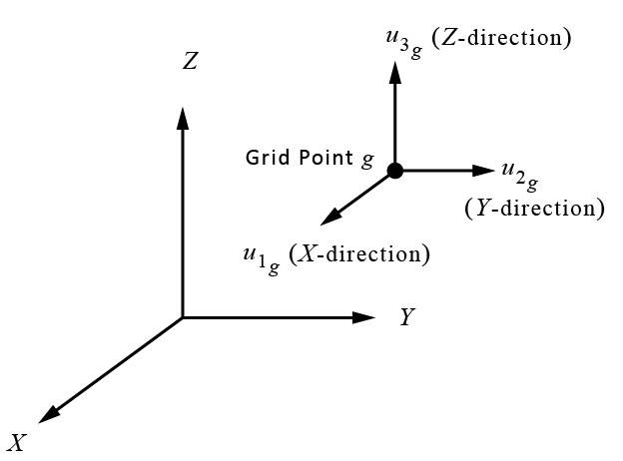
$CORD1S

CORD1S

Description:
Spherical coordinate system definition defined via 3 grids. TWO separate coordinate systems may be defined on one CORD1S entry. Note that CORD2S use 3 points to define the coordinate system.

Format:
1 | 2 | 3 | 4 | 5 | 6 | 7 | 8 | 9 | 10
CORD1S | CIDA | G1A | G2A | G3A | CIDB | G1B | G2B | G3B

Example:
CORD1S

Data Description:
Field | Contents | Type | Default
CID | Coordinate system ID number | Integer > 0 | None
G1A, G1B | ID’s of grid points at the origin of systems A, B respectively | Integer > 0 | None
G2A, G2B | ID’s of grid points along the z-axis of systems A, B respectively | Integer > 0 | None
G3A, G3B | ID’s of grid points in the x-z plane of systems A, B respectively | Integer > 0 | None

Remarks:
1. CIDA, CIDB must be unique over all coordinate systems defined in the model.
2. One or two coordinate systems may be defined on a single CORD1S entry.
3. The grid points on this entry must be defined in a system that does not involve the system being defined.
4. The location of a grid point using this coordinate system is defined by the r, θ, φ coordinates of a spherical coordinate system.
The following figure needs to be reviewed/improved to a greater degree (See CORD1R for notes).

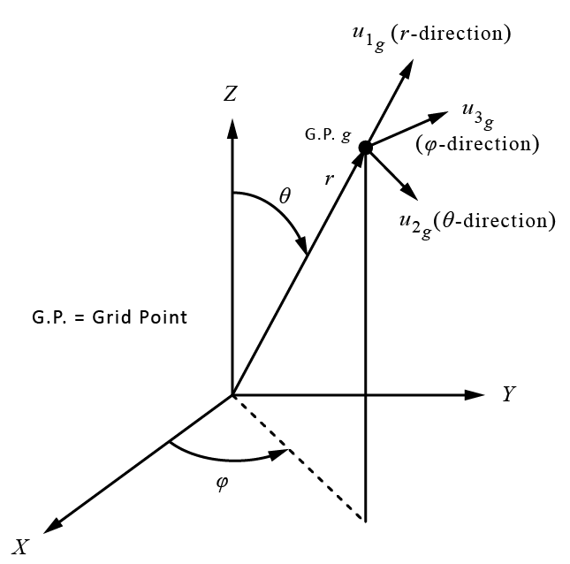
$CORD2C

CORD2C

Description:
Cylindrical coordinate system definition defined via 3 points (9 values). Note that CORD1R use 3 grids to define the coordinate system.

Format:
1 | 2 | 3 | 4 | 5 | 6 | 7 | 8 | 9 | 10
CORD2C | CID | RID | A1 | A2 | A3 | B1 | B2 | B3
 | C1 | C2 | C3

Example:
CORD2C | 26 | 41 | 4.6 | 1.9 | 13.89 | 5.76 | 11.3 | 2.7
 | 4.9 | 26.2 | 3.4

Data Description:
Field | Contents | Type | Default
CID | Coordinate system ID number | Integer > 0 | None
RID | ID number of the reference coordinate system in which the points Ai, Bi, Ci are specified | Integer >= 0  or blank | 0
Ai | Coordinates of the origin of CID (specified in RID coordinate system) | Real | None
Bi | Coordinates of a point on the z axis of the defining rectangular system of CID (specified in RID coordinate system) | Real | None
Ci | Coordinates of a point in the x-z plane of the defining rectangular system of CID (specified in RID coordinate system) | Real | None

Remarks:
1. See the following figure for the cylindrical coordinate system notation and the “defining” rectangular system.
2. CID must be unique over all coordinate systems defined in the model.
3. The continuation entry is required.
4. RID = 0 or blank means that the reference coordinate system is the basic coordinate system.
5. CID must be able to be traced, through a chain of coordinate references, back to the basic system. For example, in the example above CID 26 is defined using system 41. Coordinate system 46 can be defined using some other coordinate system, and so on, until the final RID is 0 (basic).
6. The basic system need not be defined explicitly. Its axes are implied from the model (grid point coordinates on GRID entries and coordinate system definitions of all other systems).

The following figure needs to be reviewed/improved to a greater degree (See CORD1R for notes).

$CORD2R

CORD2R

Description:
Rectangular coordinate system definition defined via 3 points (9 values). Note that CORD1R use 3 grids to define the coordinate system.

Format:
1 | 2 | 3 | 4 | 5 | 6 | 7 | 8 | 9 | 10
CORD2R | CID | RID | A1 | A2 | A3 | B1 | B2 | B3
 | C1 | C2 | C3

Example:
CORD2R | 26 | 41 | 4.6 | 1.9 | 13.89 | 5.76 | 11.3 | 2.7
 | 4.9 | 26.2 | 3.4

Data Description:
Field | Contents | Type | Default
CID | Coordinate system ID number | Integer > 0 | None
RID | ID number of the reference coordinate system in which the points Ai, Bi, Ci are specified | Integer >= 0  or blank | 0
Ai | Coordinates of the origin of CID (specified in RID coordinate system) | Real | None
Bi | Coordinates of a point on the z-axis of the defining rectangular system of CID (specified in RID coordinate system) | Real | None
Ci | Coordinates of a point in the x-z plane of the defining rectangular system of CID (specified in RID coordinate system) | Real | None

Remarks:
1. CID must be unique over all coordinate systems defined in the model.
2. The continuation entry is required.
3. RID = 0 or blank means that the reference coordinate system is the basic coordinate system.
4. CID must be able to be traced, through a chain of coordinate references, back to the basic system. For example, in the example above CID 26 is defined using system 41. Coordinate system 46 can be defined using some other coordinate system, and so on, until the final RID is 0 (basic).
5. The basic system need not be defined explicitly. Its axes are implied from the model (grid point coordinates on GRID entries and coordinate system definitions of all other systems).

The following figure needs to be reviewed/improved to a greater degree (See CORD1R for notes).
$CORD2S

CORD2S

Description:
Spherical coordinate system definition defined via 3 points (9 values). Note that CORD1S use 3 grids to define the coordinate system.

Format:
1 | 2 | 3 | 4 | 5 | 6 | 7 | 8 | 9 | 10
CORD2S | CID | RID | A1 | A2 | A3 | B1 | B2 | B3
 | C1 | C2 | C3

Example:
CORD2S | 26 | 41 | 4.6 | 1.9 | 13.89 | 5.76 | 11.3 | 2.7
 | 4.9 | 26.2 | 3.4

Data Description:
Field | Contents | Type | Default
CID | Coordinate system ID number | Integer > 0 | None
RID | ID number of the reference coordinate system in which the points Ai, Bi, Ci are specified | Integer >= 0  or blank | 0
Ai | Coordinates of the origin of CID (specified in RID coordinate system) | Real | None
Bi | Coordinates of a point on the z axis of the defining rectangular system of CID (specified in RID coordinate system) | Real | None
Ci | Coordinates of a point in the x-z plane of the defining rectangular system of CID (specified in RID coordinate system) | Real | None

Remarks:
1. See the following figure for the spherical coordinate system notation and the “defining” rectangular system.
2. CID must be unique over all coordinate systems defined in the model.
3. The continuation entry is required.
4. RID = 0 or blank means that the reference coordinate system is the basic coordinate system.
5. CID must be able to be traced, through a chain of coordinate references, back to the basic system. For example, in the example above CID 26 is defined using system 41. Coordinate system 46 can be defined using some other coordinate system, and so on, until the final RID is 0 (basic).
6. The basic system need not be defined explicitly. Its axes are implied from the model (grid point coordinates on GRID entries and coordinate system definitions of all other systems).φ

The following figure needs to be reviewed/improved to a greater degree (See CORD1R for notes).
$CPENTA

CPENTA

Description:
3D solid pentahedron element.

Format:
1 | 2 | 3 | 4 | 5 | 6 | 7 | 8 | 9 | 10
CPENTA | EID | PID | G1 | G2 | G3 | G4 | G5 | G6
 | G7 | G8 | G9 | G10 | G11 | G12 | G13 | G14
 | G15

Example:
CPENTA | 98 | 43 | 101 | 123 | 254 | 12 | 1002 | 98

Data Description:
Field | Contents | Type | Default
EID | Unique element identification (ID) number | Integer > 0 | None
PID | ID number of a PSOLID Bulk data entry | Integer > 0 | None
G1-G15 | ID numbers of the grids to which the element is attached. Specify G1-G6 for a 6 node PENTA and all 15 for a 15 node PENTA | Integer > 0 | None

Remarks:
1. No other element in the model may have the same element ID.
2. Continuation entries are only needed for the 15-node element.
$CQUAD4

CQUAD4

Description:
Thick quadrilateral plate element. This element can have membrane, bending, and transverse shear stiffness.

Format:
1 | 2 | 3 | 4 | 5 | 6 | 7 | 8 | 9 | 10
CQUAD4 | EID | PID | G1 | G2 | G3 | G4 | THETA or MCID | ZOFFS

Example:
CQUAD4 | 68 | 123 | 935 | 67 | 1357 | 2

Data Description:
Field | Contents | Type | Default
EID | Unique element identification (ID) number | Integer > 0 | None
PID | ID number of a PSHELL Bulk data entry | Integer > 0 | EID
Gi | ID numbers of the grids to which the element is attached | Integer > 0 | None
THETA | Material property orientation angle in degrees measured from axis connecting grids 1 and 2 | Real | 0.
MCID | Material coordinate system identification number. The x-axis of the material coordinate system is the projection of the 1st axis (x or r) of the MCID coordinate system onto the surface of the shell element at the element center. | Integer
ZOFFS | Offset of the grid plane to element reference plane | Real | 0.

Remarks:
1. No other element in the model may have the same element ID.
2. The grids must be numbered in a clockwise or counter clockwise direction around the quadrilateral element.
3. The z_{element} axis of the element coordinate system is in the direction of the cross-product of the diagonal from G1 to G3 with the diagonal from G2 to G4. If the element is rectangular, the x_{element} axis of the element coordinate system is the projection of the vector from G1 to G2 onto the mean plane. If not rectangular, this is rotated to split the angle between the diagonals. The y_{element} axis is in the direction of z_{element} cross x_{element}.
4. See discussion in Section 6.2 regarding the three versions of the QUAD4 element. These are controlled by the parameter QUAD4TYP (Options are MITC+, MIN4, MIN4T).

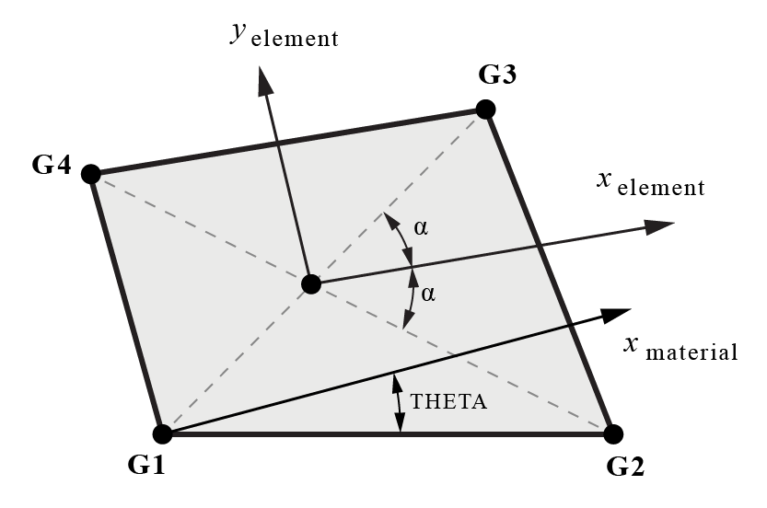

$CQUAD8

CQUAD8

Description:
Quad element with eight nodes. This element currently only supports an isotropic material with no offsets and no thermal, pressure, or gravity load (See Section 6.2).

Format:
1 | 2 | 3 | 4 | 5 | 6 | 7 | 8 | 9 | 10
CQUAD8 | EID | PID | G1 | G2 | G3 | G4 | G5 | G6
 | G7 | G8

Example:
CQUAD8 | 22 | 5 | 1005 | 1007 | 1001 | 1008 | 1003 | 1006
 | 1002 | 1004

Data Description:
Field | Contents | Type | Default
EID | Unique element identification (ID) number | Integer > 0 | None
PID | ID number of a PSHELL Bulk data entry | Integer > 0 | EID
Gi | ID numbers of the grids to which the element is attached | Integer > 0 | None

Remarks:
1. No other element in the model may have the same element ID.
2. Grids 1-4 and 5-8 must be numbered in a clockwise or counter clockwise direction around the quadrilateral element.
3. For Line 2, Field 8, “THETA or MCID” is not allowed. This element currently only supports an isotropic material.
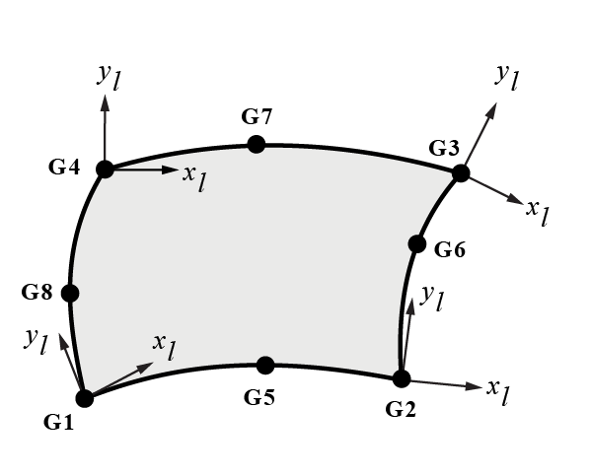

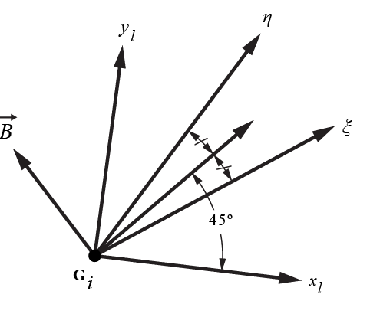
$CROD

CROD

Description:
1D elastic rod element for axial load and torsion, with reference to a property entry. Noe that the CONROD entry does not require a property entry.

Format:
1 | 2 | 3 | 4 | 5 | 6 | 7 | 8 | 9 | 10
CROD | EID | PID | G1 | G2

Example:
CROD | 98 | 43 | 1234 | 56

Data Description:
Field | Contents | Type | Default
EID | Unique element identification (ID) number | Integer > 0 | None
PID | ID number of a PROD Bulk data entry | Integer > 0 | EID
G1, G2 | ID numbers of the grids to which the element is attached | Integer > 0 | None

Remarks:
1. No other element in the model may have the same element ID.
2. The local x_{element} axis of the element is a vector from G1 through G2.

$CSHEAR

CSHEAR

Description:
Defines a quadrilateral shell element that carries only in-plane shear.

Format:
1 | 2 | 3 | 4 | 5 | 6 | 7 | 8 | 9 | 10
CSHEAR | EID | PID | G1 | G2 | G3 | G4

Example:
CSHEAR | 98 | 43 | 978 | 564 | 94 | 465

Data Description:
Field | Contents | Type | Default
EID | Unique element identification (ID) number | Integer > 0 | None
PID | ID number of a PSHEAR Bulk data entry | Integer > 0 | EID
Gi | ID numbers of the grids to which the element is attached | Integer > 0 | None

Remarks:
1. No other element in the model may have the same element ID.
2. The local x_{element} axis of the element is defined the same as for the QUAD4 element.
$CTETRA

CTETRA

Description:
3D solid tetrahedron element.

Format:
1 | 2 | 3 | 4 | 5 | 6 | 7 | 8 | 9 | 10
CTETRA | EID | PID | G1 | G2 | G3 | G4 | G5 | G6
 | G7 | G8 | G9 | G10

Example:
CTETRA | 98 | 43 | 101 | 123 | 254 | 12

Data Description:
Field | Contents | Type | Default
EID | Unique element identification (ID) number | Integer > 0 | None
PID | ID number of a PSOLID Bulk data entry | Integer > 0 | None
G1-G10 | ID numbers of the grids to which the element is attached. Specify G1-G4 for a 4 node TETRA and all 10 for a 10 node TETRA | Integer > 0 | None

Remarks:
1. No other element in the model may have the same element ID.
2. Continuation entries are only needed for the 10-node element.
$CTRIA3

CTRIA3

Description:
Thick triangular plate element. This element has membrane and bending stiffness and can include flexibility for transverse shear deformations.

Format:
1 | 2 | 3 | 4 | 5 | 6 | 7 | 8 | 9 | 10
CTRIA3 | EID | PID | G1 | G2 | G3 | THETA or MCID | ZOFFS

Example:
CTRIA3 | 68 | 123 | 935 | 67 | 1357

Data Description:
Field | Contents | Type | Default
EID | Unique element identification (ID) number | Integer > 0 | None
PID | ID number of a PSHELL Bulk data entry | Integer > 0 | EID
Gi | ID numbers of the grids to which the element is attached | Integer > 0 | None
THETA | Material property orientation angle in degrees measured from axis connecting grids 1 and 2 | Real | 0.
MCID | Material coordinate system identification number. The x-axis of the material coordinate system is the projection of the 1st axis (x or r) of the MCID coordinate system onto the surface of the shell element at the element center. | Integer
ZOFFS | Offset of the grid plane to element reference plane | Real | 0.

Remarks:
1. No other element in the model may have the same element ID
2. The local x_{element} axis of the element is in the direction from G1 to G2. The local z_{element} axis is in the direction of the cross product of the vector from G1 to G2 with the vector from G1 to G3. The local y_{element} axis is in the direction of z_{element} cross x_{element}.

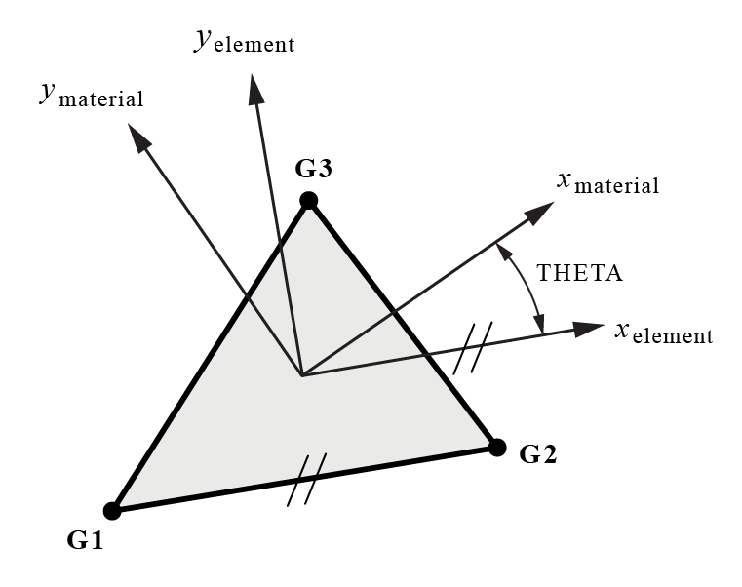

$CUSERIN

CUSERIN

Description:
User defined element for which the user will supply the mass and stiffness matrices via NASTRAN formatted INPUTT4 files.

Format 1:
1 | 2 | 3 | 4 | 5 | 6 | 7 | 8 | 9 | 10
CUSERIN | EID | PID | NG | NS | CID0
 | G1 | C1 | G2 | C2 | etc
 | S1 | S2 | S3 | etc

Format 2:
1 | 2 | 3 | 4 | 5 | 6 | 7 | 8 | 9 | 10
CUSERIN | EID | PID | NG | NS | CID0
 | G1 | C1 | G2 | C2 | etc
 | S1 | THRU | S2

Example:
CUSERIN | 32 | 123 | 3 | 8 | 198
 | 201 | 123 | 202 | 13 | 203 | 3
 | 20001 | THRU | 20008

Data Description:
Field | Contents | Type | Default
EID | Element identification (ID) number | Integer > 0 | None
PID | ID number of a PUSERIN Bulk Data entry | Integer > 0 | EID
NG | Number of grid points (GRID’s) that the element is attached to | Integer >= 0 | 0
NS | Number of scalar points (SPOINT’s) that the element is attached to | Integer >= 0 | 0
CID0 | ID of the coordinate system that defines the basic coord system of this element relative to the basic coord system of the overall model | Integer >= 0 | 0
Gi, Ci | NG grid/component numbers for the grids and components that the element connects to (Ci have to be integers 1,2,3,4,5 and/or 6) | Integer > 0 | None
Si | NS scalar points (Bulk Data SPOINT) that the element connects to | Integer > 0 | None

Remarks:
1. No other element in the model may have the same element ID.
2. An example of how this element is used is in Craig-Bampton analyses where a system model is made up of one or more substructures (generated in CB model generation solution sequence, SO.
3. Each CB model’s connection information is described by a CUSERIN element. The PUSERIN Bulk Data entry is required.

EIGR

EIGR

Description:
Eigenvalue extraction data.

Format:
1 | 2 | 3 | 4 | 5 | 6 | 7 | 8 | 9 | 10
EIGR | SID | METH | F1 | F2 | NE | ND |  | CRIT
 | NORM | G | C | SIGMA

Examples:
EIGR | 98 | GIV | 0.1 | 20. |  |  |  | 1.E-4
 | MAX

EIGR | 25 | GIV | 15. | 20. |  |  |  | 1.E-4
 | POINT | 471 | 3

Data Description:
Field | Contents | Type | Default
SID | Eigenvalue extraction set number | Integer > 0 | None
METH | Method for eigenvalue extraction: (GIV, MGIV, INV) | Character | None
F1, F2 | Frequency range of interest | Real | 0.
NE | Number of estimated eigenvalues in range (not used for GIV) | Integer | 0
ND | Number of desired eigenvalues in range (not used for GIV) | Integer | 0
CRIT | Orthogonality criteria | Real | 0.
NORM | Method of eigenvector renormalization (POINT, MAX, MASS) | Character | None
G | If NORM = POINT, the grid to be used in normalizing eigenvector to 1.0 | Integer > 0  or blank | 0
C | If NORM = POINT, the component (1-6) at G to be used in normalizing the eigenvector = 1.0 | Integer 1-6  or blank | 0
SIGMA | Shift eigenvalue (only used for METH = INV. Better convergence is obtained if this is close to the fundamental mode | Real  or blank | 0.

Remarks:
1. Givens (GIV) or Modified Givens (MGIV) methods of eigenvalue extraction are available. In addition, an Inverse Power (INV) method is also available, but only for the fundamental mode.
2. The EIGR set ID, SID, must be selected in Case Control with the entry METHOD = SID.
3. The three methods of eigenvector renormalization are:
MASS: eigenvectors are normalized to unit generalized mass (1.0)
MAX: eigenvectors are normalized to 1.0 for the largest term
POINT: eigenvectors are normalized such that the value at grid G, component C is 1.0
4. For the GIV method the mass matrix must be positive definite (thus the mass matrix can have no zeros on its diagonal). For the MGIV method, the model must have the stiffness matrix positive definite (thus modes of a model that is not restrained from rigid body motion cannot be obtained).
$EIGRL

EIGRL

Description:
Eigenvalue extraction data for Lanczos method.

Format:
1 | 2 | 3 | 4 | 5 | 6 | 7 | 8 | 9 | 10
EIGRL | SID | F1 | F2 | N | MSGLVL | NCVFACL | SIGMA | NORM
 | MODE | TYPE

Examples:
EIGRL | 98 | 0. | 50.

Data Description:
Field | Contents | Type | Default
SID | Eigenvalue extraction set number | Integer > 0 | None
F1, F2 | Frequency range of interest | Real | 0.
N | Number of desired eigenvalues | Integer | 0
MSGLVL | Output message level (0 for none, or 1 or 2 for some messaging) | Integer | 0
NCVFACL | Used to dimension several arrays in the Lanczos method. Must be > 1  eigenval | Integer | 2
SIGMA | Shift eigenvalue | Real | -1.0
NORM | Method of eigenvector renormalization (MAX, MASS) | Character | None
Mode | Lanczos mode for calculating eigenvalues | Integer | 2
Type | Lanczos matrix type (DPB, DGB) | Character | DPB

Remarks:
1. The EIGRL set ID, SID, must be selected in Case Control with the entry METHOD = SID
2. Either F1 (and F2) or N must be specified. If both are specified, N will be used.
3. Mode refers to the Lanczos mode type to be used in the solution. In mode 3 the mass matrix, M_{aa}, must be nonsingular whereas in mode 2 the matrix K_{aa} − σM_{aa} must be nonsingular (where σ = SIGMA). See Bulk Data PARAM ART_MASS for use if the mass matrix is singular.
4. TYPE = DPB uses sym storage of the matrices (preferred) whereas DGB stores all nonzero terms.
5. In general, it is not recommended to request more than about 1/4 of the possible modes. This is only a concern for problems with a small number of DOF.
6. SIGMA is the shift eigenvalue. If free modes (rigid body modes) are desired, it should be set to a small negative number (such as between -1.0 and -10.0). The default value is -1.0.
7. The Lanczos solution may not report all negative eigenvalues (especially the lower modes closer to the fundamental, or first, negative eigenvalue). This can be an issue for buckling problems (the opposite direction load is actual buckling load). However, this is not expected to be an issue for natural frequency problems. For the Lanczos method, negative eigenvalues should be treated with high caution.
8. The Lanczos method cannot find the highest 3 possible modes in a model. This is only a concern for problems with a small number of DOF.
9. If SIGMA=0.0, models with free modes (rigid body modes) may cause an error in MYSTRAN. If SIGMA > 0.0, an error may also occur. These issues require further investigation.
$FORCE

FORCE

Description:
Static concentrated force at a grid point.

Format:
1 | 2 | 3 | 4 | 5 | 6 | 7 | 8 | 9 | 10
FORCE | SID | GID | CID | F | N1 | N2 | N3

Example:
FORCE | 1234 | 567 | 89 | 1000. | 1.5 | 2.5 | 3.5

Data Description:
Field | Contents | Type | Default
SID | Load set ID number | Integer > 0 | None
GID | ID of the grid at which this concentrated force acts | Integer >0 | None
CID | ID of the coordinate system in which the Ni are specified | Integer >= 0 | 0
F | An overall scale factor for the force | Real | 0.
Ni | Components of a vector in the direction of the force | Real | 0.
Remarks:
1. The static concentrated force applied to the grid is the vector:
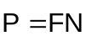
with Ni in fields 6-8 the components of the vector N
2. In order for this load to be used in a static analysis the load set ID must either be selected in Case Control by LOAD = SID, or this load set ID must be referenced on a LOAD Bulk Data entry which itself is selected in Case Control.
3. A blank entry for CID implies the basic coordinate system.
$GRAV

GRAV

Description:
Gravity load definition.

Format:
1 | 2 | 3 | 4 | 5 | 6 | 7 | 8 | 9 | 10
GRAV | SID | CID | A | N1 | N2 | N3

Example:
GRAV | 975 | 246 | 386. | 2. | 3. | 4.

Data Description:
Field | Contents | Type | Default
SID | Load set ID number | Integer > 0 | None
CID | ID of the coordinate system in which the Ni are specified | Integer >= 0 | 0
A | Acceleration value | Real | 0.
Ni | Components of a vector in the direction of the force | Real | 0.

Remarks:
1. GRAV causes a static load to be applied to the complete model that is calculated based on the acceleration vector on the GRAV entry and the mass properties of the model.
2. The acceleration vector applied to the model is the vector:
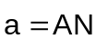
with Ni in fields 5-7 the components of the vector N
3. In order for this load to be used in a static analysis the load set ID must either be selected in Case Control by LOAD = SID, or this load set ID must be referenced on a LOAD Bulk Data entry which itself is selected in Case Control.
4. A blank entry for CID implies the basic coordinate system.
$GRDSET

GRDSET

Description:
Default values for the GRID entry.

Format:
1 | 2 | 3 | 4 | 5 | 6 | 7 | 8 | 9 | 10
GRDSET |  | CID1 |  |  |  | CID2 | PSPC

Example:
GRDSET |  | 12 |  |  |  | 42 | 245

Data Description:
Field | Contents | Type | Default
CID1 | Default value for the coordinate system ID in which grids will be located for GRID entries which have a blank in this field | Integer >= 0 | 0
CID2 | Default value for the global coordinate system for GRID entries which have a blank in this field | Integer >= 0 | 0
PSPC | Default value for permanent single point constraints for GRID entries which have a blank in this field | Integers 1-6 | 0

Remarks:
1. Only one GRDSET entry is allowed in the data file. Any data entered on a GRDSET entry will be used for the corresponding field of any GRID entry that has that field blank. Thus, if the user desires to have CIDi be the basic system on a GRID entry, and a GRDSET entry is present with nonzero value for CIDi, the GRID entry in question must have 0 (not blank) for CIDi.
2. See the GRID entry for remarks on the above fields of this entry.
3. A blank entry for CIDi implies the basic coordinate system.
$GRID

GRID

Description:
Grid point definition.

Format:
1 | 2 | 3 | 4 | 5 | 6 | 7 | 8 | 9 | 10
GRID | GID | CID1 | X1 | X2 | X3 | CID2 | PSPC

Example:
GRID | 58 | 12 | 10. | 20. | 30. | 42 | 245

Data Description:
Field | Contents | Type | Default
GID | Grid point ID number | Integer > 0 | None
CID1 | ID of the coordinate system that the Xi are defined in | Integer >= 0 | 0
Xi | Coordinates of the grid defined in coordinate system CID1 | Real | 0.
CID2 | ID of the global coordinate system for this grid point | Integer >= 0 | 0
PSPC | Permanent single point constraints at this grid point | Integers 1-6 | Blank

Remarks:
1. Grid IDs must be unique among all GRID entries.
2. The word “permanent” in regards to the single point constraints (SPC’s) defined on the GRID entry is merely a designation given to SPC’s defined on GRID entries. The PSPC field does not have to be used. Any, or all, of the zero value (i.e., not enforced displacement) single point constraints used in a model can be specified on Bulk Data SPC or SPC1 entries or as PSPC’s on the GRID entry.
3. A blank entry for CIDi implies the basic coordinate system.
$LOAD

LOAD

Description:
This entry combines loads defined on FORCE, MOMENT, PLOAD2, GRAV entries.

Format:
1 | 2 | 3 | 4 | 5 | 6 | 7 | 8 | 9 | 10
LOAD | SID | S | S1 | L1 | S2 | L2 | S3 | L3
 | S4 | L4 | (etc)

Example:
LOAD | 12345 | 1500. | 151.5 | 25 | 290.2 | 33 | 780.3 | 24
 | 2450.1 | 12

Data Description:
Field | Contents | Type | Default
SID | Load set ID number | Integer > 0 | None
S | An overall scale factor for the load combination | Real | 0.
Si | Scale factor for load set Li | Real | 0.
Li | Load set ID number for loads defined on FORCE, MOMENT, PLOAD2, GRAV entries | Integer > 0 | None

Remarks:
1. The static load applied to the model is the vector:
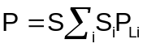

where P_{Li} is the load defined on the FORCE, MOMENT, PLOAD2 or GRAV that has Li load set ID.
2. In order for this load to be used in a static analysis the load set ID must be selected in Case Control by the command LOAD = SID.
3. Any number of continuation entries may be included.
$MAT1

MAT1

Description:
Linear isotropic material definition.

Format:
1 | 2 | 3 | 4 | 5 | 6 | 7 | 8 | 9 | 10
MAT1 | MID | E | G | NU | RHO | ALPHA | TREF | GE
 | TA | CA | SA

Example:
MAT1 | 10 | 1.E7 |  | 0.33 | 0.1 | 2.E-5 | 21.
 | 10000. | 20000. | 15000.

Data Description:
Field | Contents | Type | Default
MID | Material ID number | Integer > 0 | None
E | Young’s modulus | Real > 0. or blank | See remarks
G | Shear modulus | Real > 0. or blank | See remarks
NU | Poisson’s ratio | Real > 0. or blank | See remarks
RHO | Material mass density | Real > 0. or blank | 0.
ALPHA | Coefficient of thermal expansion | Real > 0. or blank | 0.
TREF | Reference temperature | Real > 0. or blank | 0.
GE | Damping coefficient | Real > 0. or blank | 0.
TA | Tension allowable for the material | Real > 0. or blank | 0.
CA | Compression allowable for the material | Real > 0. or blank | 0.
SA | Shear allowable for the material | Real > 0. or blank | 0.

Remarks:
1. MID must be unique among all material property entries.
2. The continuation entry is not required.
3. The following action is taken if one or more of the fields E, G and NU are blank:
a) If one of E, G or NU is blank it will be calculated using the relationship E = 2(1 + NU)G
b) If E and NU are blank or if G and NU are blank, these two are set to 0.
c) If E and G are blank (or zero) a fatal error occurs
4. A warning is given if NU < 0 or if NU > 0.5.
5. A warning is given if if E, G and NU are all input and do not satisfy the relationship:
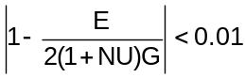

$MAT2

MAT2

Description:
Linear anisotropic material definition for 2D plate elements.

Format:
1 | 2 | 3 | 4 | 5 | 6 | 7 | 8 | 9 | 10
MAT2 | MID | G11 | G12 | G13 | G22 | G23 | G33 | RHO
 | A1 | A2 | A3 | TREF | GE | ST | SC | SS

Example:
MAT2 | 10 | 9.9+6 | 3.+6 | 2.+6 | 10.1+6 | 3.2+6 | 8.9+6 | .00025
 | 2.-5 | 3.-5 | 1.5-5 | 21. | .001 | 30000. | 20000. | 25000

Data Description:
Field | Contents | Type | Default
MID | Material ID number | Integer > 0 | None
Gij | Terms in the 3x3 material property matrix | Real | 0.
RHO | Material mass density | Real | 0.
Ai | Thermal expansion coefficients | Real | 0.
TREF | Reference temperature | Real | 0.
GE | Structural damping coefficient | Real | 0.
ST | Tension stress limit | Real | 0.
SC | Compression stress limit | Real | 0.
SS | Shear stress limit | Real | 0.

Remarks:
1. MID must be unique among all material property entries.
2. The continuation entry is not required.
3. If this entry is used for the transverse shear properties (MID3 on PSHELL) then G13, G23 and G33 are ignored.
4. The stress strain relationship for an element using the MAT2 is:
$\left\{\begin{matrix}σ_{1} \\ σ_{2} \\ σ_{3}\end{matrix}\right\}=\left[\begin{matrix}G_{11} & G_{12} & G_{13} \\ G_{12} & G_{22} & G_{23} \\ G_{13} & G_{23} & G_{33}\end{matrix}\right]\left\{\begin{matrix}ε_{1} \\ ε_{2} \\ ε_{3}\end{matrix}\right\}-(T-T_{ref})\left\{\begin{matrix}α_{1} \\ α_{2} \\ α_{3}\end{matrix}\right\}$$$and \\ \left\{\begin{matrix}τ_{xz} \\ τ_{yz}\end{matrix}\right\}=\left[\begin{matrix}G_{11} & G_{12} \\ G_{12} & G_{22}\end{matrix}\right]\left\{\begin{matrix}γ_{xz} \\ γ_{yz}\end{matrix}\right\}$$
$MAT8

MAT8

Description:
Linear orthotropic material definition for plate elements.

Format:
1 | 2 | 3 | 4 | 5 | 6 | 7 | 8 | 9 | 10
MAT8 | MID | E1 | E2 | NU12 | G12 | G1Z | G2Z | RHO
 | A1 | A2 | TREF | Xt | Yc | Yt | Yc | S
 | GE | F12 | STRN

Example:
MAT8 | 10 | 9.+6 | 11.+6 | 0.29 | 4.+6 | 3.+6 | 5.+6 | .00258
 | 20.-5 | 22.-5 | 21.0

Data Description:
Field | Contents | Type | Default
MID | Material ID number | Integer > 0 | None
E1 | Elastic modulus in longitudinal direction | Real > 0. | 0.
E2 | Elastic modulus in lateral direction | Real > 0. | 0.
G12 | In-plane shear modulus | Real >= 0. | 0.
G1Z | Transverse shear modulus in the 1-Z plane | Real >= 0. | 0.
G2Z | Transverse shear modulus in the 2-Z plane | Real >= 0. | 0.
NU12 | Poisson’s ratio | Real >= 0. | 0.
RHO | Material mass density | Real >= 0. | 0.
A1 | Coefficient of thermal expansion in the longitudinal direction | Real >= 0. | 0.
A2 | Coefficient of thermal expansion in the lateral direction | Real >= 0. | 0.
TREF | Reference temperature | Real | 0.
Xt |  | Real > 0. | 0.
Xc |  | Real > 0. | 0.
Yt |  | Real > 0. | 0.
Yc |  | Real > 0. | 0.
S |  | Real > 0. | 0.
GE | Damping coefficient | Real > 0. | 0.
F12 |  | Real > 0. | 0.
STRN | Compression allowable for the material | Real > 0. | 0.

Remarks:
1. MID must be unique among all material property entries.
2. The continuation entries are not required.
3. If G1Z and G2Z are zero (or blank) transverse shear flexibility is zero (infinite transverse shear stiffness).

$MAT9

MAT9

Description:
Linear anisotropic material definition for 3D solid elements.

Format:
1 | 2 | 3 | 4 | 5 | 6 | 7 | 8 | 9 | 10
MAT9 | MID | G11 | G12 | G13 | G14 | G15 | G16 | G22
 | G23 | G24 | G25 | G26 | G33 | G34 | G35 | G36
 | G44 | G45 | G46 | G55 | G56 | G66 | RHO | A1
 | A2 | A3 | A4 | A5 | A6 | TREF | GE

Example:
MAT9 | 10 | 8.+6 | 4.+4 | 3.2+6 | 2.5+6 |  |  | 9.+6
 |  |  |  |  | 10.+6
 | 4.+6 |  |  | 5.+6 |  | 3.+6 | .003 | 20.-5
 | 22.-5 | 18.-5

Data Description:
Field | Contents | Type | Default
MID | Material ID number | Integer > 0 | None
Gij | Elements of the 6x6 material matrix | Real > 0. | 0.
RHO | Material mass density | Real >= 0. | 0.
AI | Coefficients of thermal expansion | Real >= 0. | 0.
TREF | Reference temperature | Real | 0.
GE | Damping coefficient | Real > 0. | 0.

Remarks:
1. MID must be unique among all material property entries.
2. The first two continuation entries are required but the third continuation entry is not required.
3. The Gij are the transformation of strains to stresses as in:
$\left\{\begin{matrix}σ_{x} \\ σ_{y} \\ σ_{z} \\ τ_{xy} \\ τ_{yz} \\ τ_{zx}\end{matrix}\right\}=\left[\begin{matrix}G_{11} & G_{12} & G_{13} & G_{14} & G_{15} & G_{16} \\ & G_{22} & G_{23} & G_{24} & G_{25} & G_{26} \\ & & G_{33} & G_{34} & G_{35} & G_{36} \\ & & & G_{44} & G_{45} & G_{46} \\ & sym & & & G_{55} & G_{56} \\ & & & & & G_{66}\end{matrix}\right]\left\{\begin{matrix}ε_{x} \\ ε_{y} \\ ε_{z} \\ γ_{xy} \\ γ_{yz} \\ γ_{zx}\end{matrix}\right\}$

$MOMENT

MOMENT

Description:
Static concentrated moment at a grid point.

Format:
1 | 2 | 3 | 4 | 5 | 6 | 7 | 8 | 9 | 10
MOMENT | SID | GID | CID | M | N1 | N2 | N3

Example:
MOMENT | 1234 | 567 | 89 | 1000. | 1.5 | 2.5 | 3.5

Data Description:
Field | Contents | Type | Default
SID | Load set ID number | Integer > 0 | None
GID | ID of the grid at which this concentrated moment acts | Integer >0 | None
CID | ID of the coordinate system in which the Ni are specified | Integer >= 0 | 0
M | An overall scale factor for the moment | Real | 0.
Ni | Components of a vector in the direction of the moment | Real | 0.
Remarks:
1. The static concentrated moment applied to the grid is the vector:
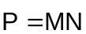
with Ni in fields 6-8 the components of the vector N
2. In order for this load to be used in a static analysis the load set ID must either be selected in Case Control by LOAD = SID, or this load set ID must be referenced on a LOAD Bulk Data entry which itself is selected in Case Control.
3. A blank entry for CID implies the basic coordinate system.
$MPC

MPC

Description:
Multi point constraints define a linear dependence of one degree of freedom (that becomes a member of the M-set) on other degrees of freedom.

Format:
1 | 2 | 3 | 4 | 5 | 6 | 7 | 8 | 9 | 10
MPC | SID | G1 | C1 | D1 | G2 | C2 | D2
 |  | G3 | C3 | S3 | G4 | C4 | D4
 |  | G6 | C5 | D6 | etc…

Example:
As an example, consider the following equation relating several degrees of freedom (in global coordinates):
$$1.2w_{101}+4.5v_{201}-0.63θ_{y_{623}}+12.7θ_{z_{76}}=0$$
where w₁₀₁ is the displacement in the global z direction at grid 101, v₂₀₁ is the displacement in the global y direction at grid 201, and the remaining two terms are the rotation about the global y and z directions at grids 623 and 76 respectively. Assuming that w₁₀₁ has been chosen as the M-set degree of freedom for this MPC equation, the input would be:

MPC | 56 | 101 | 3 | 1.2 | 201 | 2 | 4.5
 |  | 623 | 5 | -.63 | 76 | 6 | 12.7

Data Description:
Field | Contents | Type | Default
SID | ID number of the multi point constraint set | Integer > 0 | None
Gi | ID numbers of the grids involved in the constraint. Grid G1, component C1 is, by definition, the dependent (M-set) degree of freedom | Integer > 0 | None
Ci | Component numbers at grids Gi involved in the MPC equation | Integers 1-6 | None
Di | The value for coefficient D for grid Gi, component Ci | Real | 0.

Remarks:
1. Multi point constraint sets must be selected in Case Control with the entry MPC = SID in order for them to be applied.
2. Degrees of freedom defined as dependent on MPC entries will be members of the M-set and cannot be defined as being members of any other mutually exclusive set.
3. G1/C1 is the degree of freedom eliminated (M-set) due to the MPC equation and the remaining terms in the MPC equation can be for degrees of freedom belonging to any displacement set.
$MPCADD

MPCADD

Description:
Combine multi-point constraint sets defined on MPC entries.

Format:
1 | 2 | 3 | 4 | 5 | 6 | 7 | 8 | 9 | 10
MPCADD | SID | S1 | S2 | S3 | S4 | S5 | S6 | S7
 | S8 | S9 | (etc)

Example:
MPCADD | 283 | 11 | 74 | 123 | 564

Data Description:
Field | Contents | Type | Default
SID | Multi-point constraint set ID number | Integer > 0 | None
Si | Set IDs of MPC Bulk Data entries | Integer > 0 | None

Remarks:
1. Multi-point constraint sets must be selected in Case Control with the entry MPC = SID in order for them to be applied.
2. All multi-point constraints specified on MPC entries whose set IDs are the Si on the MPCADD will be applied to the model if MPC = SID is in Case Control.
$OMIT

OMIT

Description:
Define degrees of freedom to go into the omit set (O-set).

Format:
1 | 2 | 3 | 4 | 5 | 6 | 7 | 8 | 9 | 10
OMIT | G1 | C1 | G2 | C2 | G3 | C3 | G4 | C4

Example:
OMIT | 19 | 1 | 28 | 2345 | 37 | 124 | 46 | 134

Data Description:
Field | Contents | Type | Default
Gi | ID numbers of grids | Integer > 0 | None
Ci | Displacement component numbers | Integers 1-6 | None

Remarks:
1. The degrees of freedom defined by grids GI, components Ci will be placed in the mutually exclusive O-set. These degrees of freedom cannot have been defined to be in any other mutually exclusive set (i.e.. M, S or A sets).
2. If OMIT or OMIT1 are present in the data file, then all degrees of freedom not specified on these entries and also not in the M or S sets will be placed in the A-set. If both ASET (or ASET1) and OMIT (or OMIT1) are present, then all degrees of freedom not in the M and S sets must be explicitly defined on ASET (or ASET1) and OMIT (or OMIT1)
3. Up to four pairs of Gi, Si can be specified on one OMIT entry. For more pairs, use additional OMIT entries (i.e. there is no continuation entry for OMIT).
$OMIT1

OMIT1

Description:
Define degrees of freedom to go into the omit set (O-set).

Format No. 1:
1 | 2 | 3 | 4 | 5 | 6 | 7 | 8 | 9 | 10
OMIT1 | C | G1 | G2 | G4 | G4 | G5 | G6 | G7
 | G8 | G9 | (etc)

Format No. 2:
1 | 2 | 3 | 4 | 5 | 6 | 7 | 8 | 9 | 10
OMIT1 | C | G1 | THRU | G2

Example:
OMIT1 | 135 | 17934 | THRU | 19012

Data Description:
Field | Contents | Type | Default
Gi | ID numbers of grids. G2 > G1 | Integer > 0 | None
C | Displacement component numbers | Integers 1-6 | None

Remarks:
1. In Format No. 2, all grids in the range G1 through G2 will have component C defined in the O-set.
2. The degrees of freedom defined by grids GI, components C will be placed in the mutually exclusive O-set. These degrees of freedom cannot have been defined to be in any other mutually exclusive set (i.e.. M, S or A sets).
3. If OMIT or OMIT1 are present in the data file, then all degrees of freedom not specified on these entries and also not in the M or S sets will be placed in the A-set. If both ASET (or ASET1) and OMIT (or OMIT1) are present, then all degrees of freedom not in the M and S sets must be explicitly defined on ASET (or ASET1) and OMIT (or OMIT1)
$PARAM

PARAM

Description:
Provide values, other than default values, for parameters that control options during execution.

Format:
1 | 2 | 3 | 4 | 5 | 6 | 7 | 8 | 9 | 10
PARAM | NAME | V1 | V2 | V3 | V4

Example:
PARAM | PRTDOF | 2

Data Description:
Field | Contents | Type | Default
NAME | Parameter name | Char | None
Vi | Values for the parts of the parameter | Char, Integer or real | Various

Remarks:
1. See table below for a list of the various parameters and what action is taken based on their values. Unless otherwise stated, only value V1 is used. The parameter name always goes in field 2 and V1 always goes in field 3. When there is more than one Vi, the table explicitly states in what fields the Vi go.

Parameter Name | Data  Type | Function of Parameter  NOTE: Default values of parameters are:  N for Char, 0 for Int and 0.0 for real
ARP_TOL | Real | Default = 1x10⁻⁶  Tolerance to use in Lanczos eigenvalue extraction method for convergence
ART_KED  (for diff stiffness – not fully implemented) | Char | Field 3: ART_KED, default = N. If Y add artificial stiff to diag of KED stiff matrix  Field 4: ART_TRAN_MASS: value for translation degrees of freedom, default 1x10⁻⁶  Field 5: ART_ROT_MASS: value for translation degrees of freedom, default 1x10⁻⁶
ART_MASS | Char | Field 3: ART_MASS, default = N. If Y add artificial mass to diag of MGG mass matrix  Field 4: ART_TRAN_MASS: value for translation degrees of freedom, default 1x10⁻⁶  Field 5: ART_ROT_MASS: value for rotation degrees of freedom, default 1x10⁻⁶
AUTOSPC | Char  Real  Int  Char  Char | Field 3: AUTOSPC value, default = Y (AUTOSPC), N turns AUTOSPC off.  Field 4: AUTOSPC_RAT, default = 1x10⁻⁸ (See Section 6.4)  Field 5: AUTOSPC_NSET, default = 1 (See Section 6.4)  Field 6: AUTOSPC_INFO, default = N. If Y then print messages about the AUTOSPC’s  Field 7: AUTOSPC_SPCF, default = N. If Y print AUTOSPC forces of constraint
BAILOUT | Int | Default = 1  If > 0 quit if a singularity in decomposing a matrix is detected.  If <= 0 do not quit
CBMIN3 | Real | Default = 2.0  CBMIN3 is the constant C_{B} used in tuning the shear correction factor in Ref 3 for the TRIA3 plate element. The default 2.0 is the value suggested by the author.
CBMIN4 | Real | Default = 3.6  CBMIN4 is the constant C_{B} used in tuning the shear correction factor in Ref 4 for the QUAD4 plate element (QUAD4TYP = ‘MIN4 ‘). See Ref 4
CBMIN4T | Real | Default = 3.6  CBMIN4T is the constant C_{B} used in tuning the shear correction factor in Ref 4 for the QUAD4 plate element (QUAD4TYP = ‘MIN4T’).
CHKGRDS | Char | Default = Y. If N do not check that all grids for all elements exist
CRS_CCS | Char | Default = CRS (compressed row storage of matrices). Also can be CCS
CUSERIN | Char  Int  Int  Int  Int  Char  Int | If this parameter is present, Bulk Data entries for Craig-Bampton (CB) reduced models will be written to the f06 file as a CUSERIN element (including grids, coord sys, etc)  Field 3: element ID, default = 9999999  Field 4: property ID default = 9999999  Field 5: start index for SPOINT’s to represent modes of the CB model, default = 1001  Field 6: IN4 file # on the PUSERIN entry for this CUSERIN elem, default = 9999999  Field 7: Set-ID for CUSERIN elem (typically the “R”, or boundary, set), def is blank field  Field 8: Format for how to write the comp numbers (1 thru 6) for each grid of the CUSERIN elem. If 0, write them in compact form (e.g. 1356). If > 0 write them in expanded form (1 3 56), default = 0
DARPACK | Int | Default = 2  how many extra modes to find above EIG_N2 on the EIGRL entry. These few highest mode are not used due to difficulty with getting good GP force balance.
DELBAN | Int | Default 1. If equal to 1 delete the bandit output files on exit
EIGESTL | Int | Default 5000  For eigenvalue problems by the Lanczos method, if the number of L-set DOF’s exceed EIGESTL the method for specifying the search range will be changed from F1 to F2 to N (see EIGRL Bulk Data entry) to avoid excessive run times (since the code to estimate the number of eigens in the F1 to F2 range can be excessive).
EIGNORM2 | Char | Default = N. if 'Y' then eigenvectors will be renormalized a last time by multiplying by a set of scale factors (1 per eigenvector) supplied in a file with the same name as the input file and extension 'EIN' (if it exists)
ELFORCEN | Char | Default = GLOBAL  If ELFORCEN = GLOBAL, and nodal forces have been requested in Case Control, they will be output in the global coordinate system.  If ELFORCEN = BASIC, and nodal forces have been requested in Case Control, they will be output in the basic coordinate system.  If ELFORCEN = LOCAL, and nodal forces have been requested in Case Control, they will be output in the local element coordinate system.
EPSERR | Char | Default = Y. If N, do not calculate the NASTRAN like “epsilon error estimate”
EPSIL | Real | There are 3 EPSIL(i) values each of which requires a separate PAPAM EPSIL Bulk Data entry with the index (i) in field 3 and EPSIL(i) value in field 4.  These are small numbers used in MYSTRAN for the purposes indicated below:  - EPSIL(1) (default = 1x10⁻¹⁵) is used in MYSTRAN such that, in any real number comparisons, any real number whose absolute magnitude is less than EPSIL(1) is considered to be zero. If no PARAM EPSIL 1 entry is in the data file then this value is reset (from the default) in LINK1 to a value based on machine precision calculated using LAPACK BLAS function DLAMCH. If the user has a PARAM EPSIL 1 entry, this value will be used for EPSIL(1) instead of the LAPACK machine precision.  - Currently not used  - EPSIL(3) is used in the Inverse Power method of eigenvalue extraction to test convergence of an eigenvalue. The default value (% change) is 1x10⁻⁵ %  - EPSIL(4) is used to calculate the maximum warp for quadrilateral plate elements, above which a warning message will be written. This maximum warp is EPSIL(2) times the average length of the quadrilateral’s two diagonals. The default for EPSIL(2) is 1.x10⁻¹.  - EPSIL(5) (default 1.x10⁻⁶) is used in BAR and ROD margin of safety calculations. If a stress magnitude is less than EPSIL(5) a 1.x10¹⁰ margin of safety will printed out for that stress (in other words, an infinite margin of safety)  EPSIL(6) (default 1.x10⁻¹⁵) is used in BAR margin of safety calculations
EQCHECK | Int  Int  Int  Int  Int  Int  Real  Char | Field 3: Default = 0 (basic origin) or reference grid to use in calculating the rigid body displacement matrix for the equilibrium check  Field 4: If nonzero, do equilibrium check on the G-set  Field 5: If nonzero, do equilibrium check on the N-set  Field 6: If nonzero, do equilibrium check on the F-set  Field 7: If nonzero, do equilibrium check on the A-set  Field 8: If nonzero, do equilibrium check on the L-set  The value in fields 4-8 can be:  1: print loads due to rigid body displacements  2: print strain energy due to rigid body displacements  3: print both  Field 9: EQCHK_TINY, default = 1x10⁻⁵. I Do not print grid forces smaller than this  Field 10: Default = N. If Y, normalize the grid forces on diagonal stiffness
FILES |  | Equivalent to PRTALL
GRDPNT | Int | Default = -1. If > 0, then the value is interpreted as a grid number.  If GRDPNT > -1, calculate total mass properties of the model relative to the basic coordinate system origin or relative to the specified grid.
GRIDSEQ | Char  Char  Char | Field 3: GRIDSEQ value (default = INPUT). Other values are GRID and BANDIT. BANDIT is automatic grid sequencing. GRID is sequencing in grid ID numerical order. INPUT is sequencing in the grid input order.  Field 4: SEQQUIT, default = N. If Y, then quit in the sequence processor if BANDIT did not run correctly.  Field 5: SEQPRT, default = N. If Y, print SEQGP card images generated by BANDIT to the f06 output file
HEXAXIS | Char | 'SIDE12', use side 1-2 as the local elem x axis.  'SPLITD' (default), use angle that splits the 2 diags to define the elem x axis
IORQ1M | Int | Default = 2  Gaussian integration order for membrane direct stress terms for the QUAD4 quadrilateral elements
IORQ1S | Int | Default = 1  Gaussian integration order for membrane shear stress terms for all quad elements
IORQ1B | Int | Default = 2  Gaussian integration order for bending stress terms for the QUAD4K element (legacy element – no longer supported).
IORQ2B | Int | Default = 2  Gaussian integration order for bending stress terms for the QUAD4 element
IORQ2T | Int | Default = 3  Gaussian integration order for transverse shear stress terms for the QUAD4 element
ITMAX | Int | Default = 5  Max number of iterations in refining the solution when parameter UREFINE = Y
K6ROT | Real | Default = 0.0. Scale factor for springs connecting the drilling DOFs of each shell elements to the translational DOFs of their other nodes. A value of 0.0 is equivalent to turning K6ROT off. 100.0 is usually a reasonable value.
KLLRAT | Char | Default = Y to tell whether to calc ratio of max/min KLL diagonal terms
KOORAT | Char | Default = Y to tell whether to calc ratio of max/min KOO diagonal terms
LANCMETH | Char | Procedure to use for Lanczos eigenvalue extraction (Currently only ARPACK is available but it does require matrices to be stored in band form which can require an excessive amount of memory for large problems)
MATSPARS | Char | If = Y (default), use sparse matrix routines for add/multiply in all matrix operations. If N, use full matrix add/multiply (not recommended)
MAXRATIO | Real | Default =1X10⁷  Max value of matrix diagonal to factor diagonal before messages are written and BAILOUT tested for aborting run
MEFMCORD | Int | Default = 0. The coordinate system in which to calculate modal mass and participation factors
MEFMLOC | Char | Reference location for calculating modal effective mass in Craig-Bampton (SOL 31) analyses. This only affects the rotational modal effective masses. Field 3 can be GRDPNT, GRID or CG:  If field 3 = GRDPNT (default): ref point is the same as the one for PARAM GRDPNT  If field 3 = CG: use the model center of gravity as the reference point  If field 3 = GRID: use the grid point number in field 4 as the reference point  Field 4: MEFMGRID (grid to use when field 3 is GRID)
MEMAFAC | Int | Default = 0.9. Factor to multiply the size request of memory to be allocated when looping to find an allowable amount of memory to allocate. Used when the initial request for memory (in subrs ESP or EMP) cannot be met and we know that the request is conservative.
MIN4TRED | Char | Default = STC. Defines the method for how the 5th node of the MIN4T element is reduced out (to get a 4 node quad element). STC (default) is static condensation. B54 (not implemented as of Version 3.0) uses a method developed by the element author (see Reference section, this manual for the element formulation paper)
MPFOUT | Char | (1) ‘6’ (default) indicates to output modal participation factors (MPF) relative to the 6 DOF’s at grid MEFMGRID (see PARAM MEFMLOC)  (2) ‘R’ indicates to output MPF’s for all of the R-set DOF’s individually
MXALLOCA | Int | Default = 10. Max number of attempts to allow when trying to allocate memory in subroutine ALLOCATE_STF_ARRAYS
MXITERI | Int | Default = 50. Max number of iterations to use in the Inverse Power eigenvalue extraction method
MXITERL | Int | Default = 50. Max number of iterations to use in the Lanczos eigenvalue extraction method
OTMSKIP | Int | Number of lines to skip between segments of OTM text file descriptors
PBARLDEC | Int | Default = 5. Number of decimal digits when writing PBAR equivalents for PBARL entry real data
PBARLSHR | Char | Default = Y. Include K1, K2 for PBAR equiv to PBARL BAR properties
PCHSPC1 | Char  Int  Char | Field 3: PCHSPC1 value (default = N, do not punch SPC1 card images for constraints generated by the AUTOSPC feature, use Y to punch these)  Field 4: SPC1SID value (default = 9999999, the set ID to put on the SPC1 card images)  Field 5: SPC1QUIT value (default = N, do not stop after SPC!’s are punched, or Y to stop processing)
PCMPTSTM | Real | Factor to multiply composite ply thickness for effective shear thickness
PCOMPEQ | Int | Default = 0. Indicator to write equiv PSHELL, MAT2 to f06 for PCOMP's. If > 0, write the equivalent PSHELL amd MAT2 Bulk Data entries for the PCOMP. If > 1 also write the data in a format with a greater number of digits of accuracy.
POST | Int | No action taken as of 2025-09-17.  See also PARAM, PRTNEU.  The OP2 file request is controlled via the “PLOT” option. Alternatively, the parameters PARAM, PRTALL and PARAM, FILES are related to the output request.
PRTALL | Char | Default = NO  If YES, a f06, an OP2, and a NEU will be created and populated with the data requested in the case control section.  If YES, this parameter will override any other output control parameters which suppress file data output.  If NO, this param does not override any other output requests or output control parameters.  *This is a MYSTRAN exclusive param, not present in Nastran.
PRTBASIC | Int | If = 1 print grid coordinates in the basic coordinate system
PRTCGLTM | Int | If = 1 print CB matrix for C.G. LTM loads
PRTCONN | Int | If = 1, print table of elements connected to each grid. If 2, more detailed data
PRTCORD | Int | If PRTCORD = 1 print coordinate system transformation data
PRTDISP | Int | PRTDISP(I), I=1-5 go in fields 3-7 of the PARAM PRTDISP entry that prints displacement matrices for various displacement sets:  V1 = PRTDISP(1) = 1 print UG  V2 = PRTDISP(2) = 1 or 3 print UN, 2 or 3 print UM  V3 = PRTDISP(3) = 1 or 3 print UF, 2 or 3 print US  V4 = PRTDISP(4) = 1 or 3 print UA, 2 or 3 print UO  V5 = PRTDISP(5) = 1 or 3 print UL, 2 or 3 print UR
PRTDLR | Int | If = 1, the DLR matrix will be printed
PRTDOF | Int | If PRTDOF = 1 or 3 print TDOF table, in grid point ID numerical order, which gives a list of the degree of freedom numbers for each displacement set (size is number of degrees of freedom x number of displacement sets)  If PRTDOF = 2 or 3 print TDOF table, in degree of freedom numerical order, which gives a list of the degree of freedom numbers for each displacement set (size is number of degrees of freedom x number of displacement sets)
PRTFOR | Int | PRTFOR(I), I=1-5 go in fields 3-7 of the PARAM PRTFOR entry that prints sparse force matrices for various displacement sets:  V1 = PRTFOR(1) = 1 print sparse PG  V2 = PRTFOR(2) = 1 or 3 print sparse PN, 2 or 3 print PM  V3 = PRTFOR(3) = 1 or 3 print sparse PF, 2 or 3 print PS  V4 = PRTFOR(4) = 1 or 3 print sparse PA, 2 or 3 print PO  V5 = PRTFOR(5) = 1 or 3 print sparse PL, 2 or 3 print PR
PRTGMN | Int | If PRTGMN = 1, print GMN matrix
PRTGOA | Int | If PRTGOA = 1, print GOA matrix
PRTHMN | Int | If = 1 print HMN constraint matrix
PRTIFLTM | Int | If = 1 print CB matrix for Interface Forces LTM
PRTKXX | Int | If = 1 print CB matrix KXX
PRTMASSD | Int | Same as PRTMASS, except only print diagonal terms
PRTMASS | Int | PRTMASS(I), I=1-5 go in fields 3-7 of the PARAM PRTMASS entry that prints sparse mass matrices for various displacement sets:  V1 = PRTMASS(1) = 1 print sparse MGG  V2 = PRTMASS(2) = 1 or 3 print sparse MNN, 2 or 3 print MNM, MMM  V3 = PRTMASS(3) = 1 or 3 print sparse MFF, 2 or 3 print MFS, MSS  V4 = PRTMASS(4) = 1 or 3 print sparse MAA, 2 or 3 print MAO, MOO  V5 = PRTMASS(5) = 1 or 3 print sparse MLL, 2 or 3 print MLR, MRR
PRTMXX | Int | If = 1 print CB matrix MXX
PRTNEU | Char | Default = NO  If YES, a NEU file will be created and populated with the data requested in the case control section.  *This is a MYSTRAN exclusive param, not present in Nastran.
PRTOP2 | Char | Default = NO  If YES, an OP2 file will be created and populated with the data requested in the case control section.  *This is a MYSTRAN exclusive param, not present in Nastran.
PRTOU4 | Int | If > 0 write all OU4 (OUTPUT4) matrices to f06 file
PRTPHIXA | Int | If = 1 print CB matrix PHIXA
PRTPHIZL | Int | If = 1 print CB matrix PHIZL
PRTPSET | Int | If > 0 print the OUTPUT4 matrix partitioning vector sets
PRTQSYS | Int | If = 1 print matrix QSYS
PRTRMG | Int | If PRTRMG = 1 or 3, print constraint matrix RMG  If PRTRMG = 2 or 3, print partitions RMN and RMM of constraint matrix RMG
PRTSCP | Int | If PRTSCP = 1 print data generated in the subcase processor
PRTSTIFD | Int | Same as PRTSTIFF, except only print diagonal terms
PRTSTIFF | Int | Defaults = 0 for PRTSTIFF(I), I=1-5 which go in fields 3-7 of the PARAM PRTSTIFF entry that prints sparse stiffness matrices for various displacement sets:  V1 = PRTSTIFF(1) = 1 print sparse KGG  V2 = PRTSTIFF(2) = 1 or 3 print sparse KNN, 2 or 3 print KNM, KMM  V3 = PRTSTIFF(3) = 1 or 3 print sparse KFF, 2 or 3 print KFS, KSS  V4 = PRTSTIFF(4) = 1 or 3 print sparse KAA, 2 or 3 print KAO, KOO  V5 = PRTSTIFF(5) = 1 or 3 print sparse KLL, 2 or 3 print KLR, KRR
PRTTSET | Int | If PRTSET = 1 print TSET table which gives the character name of the displacement sets that each degree of freedom belongs to (size is number of grids x 6)
PRTUO0 | Int | If = 1 print UO0
PRTUSET | Int | If > 0 print the user defined set (U1 or U2) definitions
PRTYS | Int | If = 1 print matrix YS
Q4SURFIT | Int | Default = 3.  Number of terms in the polynomial surface fit for extrapolating QUAD4 stress/strain to element corners.  Q4SURFIT = 1: Constant fit  Q4SURFIT = 3: Bi-linear function without a cross term  Q4SURFIT = 6: Bi-quadratic function
QUAD4TYP | Char | Formulation for the QUAD4 element  Default = MITC4+: Mixed Interpolation of Tensorial Components (Reference 15). The MITC4+ is a newer version of the MITC4 element that offers further improvements in convergence behavior.  See Section 6.2 for a detailed description of capabilities  MIN4: Reissner-Mindlin element  This element may exhibit spurious modes  See Section 6.2 for a detailed description of capabilities
QUADAXIS | Char | Default = SIDE12  This determines how the quad element local x axis is defined. ‘SIDE12’ means that the axis between grids 1 and 2 of the quad define the local x axis. ‘SPLITD’ means that the axis is defined as the direction that splits the angle between the quad diagonals
RCONDK | Char | If RCONDK = Y, then LAPACK calculates the condition number of the A-set stiffness matrix. This is required if LAPACK error bounds on the A-set displacement solution are desired. This can require significant solution time.
SKIPMGG | Char | Default = N. 'Y', 'N' indicator to say whether to skip calculation of MGG, KGG in which case MGG, KGG will be read from previously generated, and saved, files (LINK1L for KGG, LINK1R for MGG)
SOLLIB | Char | Field 3: Denotes which library to use for matrix decomposition and equation solution. Options are:  1) SPARSE: default (matrices stored with only nonzero terms)  2) BANDED: (matrices stored in band form. Uses LAPACK/ARPACK routines)  Field 4: (only if SPARSE SOLLIB) denotes which SPARSE library to use:  - SUPERLU (default) uses the SuperLU method of sparse matrix decomp and solve.
SORT_MAX | Int | Default = 5  Max number of times to run algorithm when sorting arrays before fatal message.
SPARSTOR | Char | Default = SYM  If SYM, symmetric matrices are stored with only the terms on and above the diagonal. If NONSYM all terms are stored. SYM requires less disk storage but NONSYM can save significant time in sparse matrix partitioning and multiply operations.
STR_CID | Int | Default = -1. Indicator for the coordinate system to use ID for element stress, strain and engineering force output:  -1 is local element coordinate system (default)  0 is basic coordinate system  j (any other integer) is a defined coordinate system for output
SUPINFO | Char | Default = Y  Indicator of whether some information messages should be suppressed in the f06 output file. N indicates to suppress, Y indicates to not suppress messages in the file.
SUPWARN | Char | Default = Y  Indicator of whether warning messages should be suppressed in the f06 output file.  N indicates to suppress, Y indicates to not suppress messages in the file.
THRESHK | Real | Default = 0.1  User defined value for the threshold in deciding whether to equilibrate the A-set stiffness matrix in LAPACK subroutine DLAQSB. Default value 0.1, LAPACK suggests
TINY | Real | Do not print matrix values whose absolute value is less than this parameter value
TSTM_DEF | Real | Default = 5/6 = 0.833333  Value for TS/TM on PSHELL Bulk data entry when that field on the PSHELL is blank
USETSTR | Char | Requests output of the internal sequence order for displacement sets (e.g. G-set, etc). See section 6.6 for a discussion of displacement sets. In addition to the sets in section 6.7, the user displacement sets U1 and U2 (see Bulk Data entry USET and USET1) can also have the internal sort order output to the f06 file. As an example, to obtain a row oriented tabular output of the internal sort order for the R-set, include the Bulk data entry:  PARAM, USETSTR, R
USR_JCT | Int | User supplied value for JCT - used in shell sort subroutines. If USR_JCT = 0, internal values for JCT will be used in the shell sort.
WINAMEM | Real | Default = 2.0 GB. Max memory Windows allows for any array. If it is exceeded, a message is printed out and execution is aborted. This is used to avoid a failure which aborts MYSTRAN catastrophically (due to a system fault).
WTMASS | Real | Default = 1.0  Multiplier for mass matrix after the model total mass is output in the Grid Point Weight Generator (GPWG). This allows user to input mass terms as weight to get model mass properties in weight units and then to convert back to mass units after the GPWG has run. For example, if the model units are lb-sec²/inch for mass and inches for length and the input data file has lb for “mass” (read weight), then 1/386, or 0.002591 would be the value for WTMASS needed to convert the “mass” matrix from weight units to mass units.
$PARVEC

PARVEC

Description:
Defines a partitioning vector to be used in partitioning an OUTPUT4 matrix. See the Exec Control statements OUTPUT4 and PARTN.

Format:
1 | 2 | 3 | 4 | 5 | 6 | 7 | 8 | 9 | 10
PARVEC | NAME | G1 | C1 | G2 | C2 | G3 | C3

Example:
PARVEC | COLVEC | 101 | 3 | 201 | 2

Data Description:
Field | Contents | Type | Default
NAME | Name of a row or column partitioning vector specified in a PARTN Exec Control command | Char | None
GI | ID numbers of the grids that will be partitioned | Integer > 0 | None
C | Component numbers at grids Gi that will be partitioned | Integers 1-6 | None

Remarks:
1. The Gi, Ci must be members of the displacement set for the matrix being partitioned. For example, if the OUTPUT4 matrix being partitioned is $K_{RL}$ the row partitioning vector grid/component values must be members of the R-set and the column partitioning vector must be a member of the L-set.
$PARVEC1

PARVEC1

Description:
Defines a partitioning vector to be used in partitioning an OUTPUT4 matrix. See the Exec Control statements OUTPUT4 and PARTN.

Format No. 1:
1 | 2 | 3 | 4 | 5 | 6 | 7 | 8 | 9 | 10
PARVEC1 | NAME | C | G1 | G2 | G3 | G4 | G5 | G6
 | G7 | G8 | G9 | (etc)

Format No. 2:
1 | 2 | 3 | 4 | 5 | 6 | 7 | 8 | 9 | 10
PARVEC1 | U1 | C | G1 | THRU | G2

Examples:
PARVEC1 | 52 | 135 | 1001 | 1002 | 103 | 1004 | 2001 | 2002
 | 2003 | 2004

PARVEC1 | 52 | 135 | 1001 | THRU | 1004

Data Description:
Field | Contents | Type | Default
NAME | Name of a row or column partitioning vector specified in a PARTN Exec Control command | Char | None
Gi | ID numbers of the grids that will be partitioned | Integers 1-6 | None
C | Component numbers at grids Gi that will be partitioned | Integer > 0 | None

Remarks:
1. The Gi, Ci must be members of the displacement set for the matrix being partitioned. For example, if the OUTPUT4 matrix being partitioned is $K_{RL}$ the row partitioning vector grid/component values must be members of the R-set and the column partitioning vector must be a member of the L-set.
$PBAR

PBAR

Description:
Property definition for BAR element.

Format:
1 | 2 | 3 | 4 | 5 | 6 | 7 | 8 | 9 | 10
PBAR | PID | MID | A | I1 | I2 | J | MPL
 | Y1 | Z1 | Y2 | Z2 | Y3 | Z3 | Y4 | Z4
 | K1 | K2 | I12 | CT

Example:
PBAR | 5 | 2 | 1.44 | .144 | .1 | .005 | 0.1
 | 0.5 | 0.6 | -0.5 | 0.6 | -0.5 | -0.6 | 0.5 | -0.6
 | .833 | .833

Data Description:
Field | Contents | Type | Default
PID | Property ID number | Integer > 0 | None
MID | Material ID number | Integer > 0 | None
A | Bar cross-sectional area | Real | 0.
I1 | Section moment of inertia about the element z axis (bending in element plane x-y) | Real | 0.
I2 | Section moment of inertia about the element y axis (bending in element plane x-z) | Real | 0.
J | Torsional constant | Real | 0.
MPL | Mass per unit length | Real | 0.
Yi, Zi | Element y, z coordinates, in the bar cross-section, of four points at which to recover stresses | Real | 0.
K1, K2 | Area factors for shear in element planes x-y and x-z respectively | Real | 0.
I12 | Section cross-product of inertia | Real | 0.
CT | Torsional stress recovery coefficient | Real | 0

Remarks:
1. PID must be unique among all PBAR, PBARL property ID’s
2. Neither continuation entry is required
3. The shear center and neutral axis of the beam coincide.
4. See the figure in the CBAR entry for the bar element axes
5. Torsional stress is CT/J times the torsion load in the CBAR
6. K1 and K2 are used to calculate the transverse shear flexibility of the bar. For infinite shear stiffness (zero shear flexibility), K1 and K2 must be infinite by beam element theory. In order to implement this, and avoid dealing with very large numerical values for K1 and K2, MYSTRAN interprets zero K1 and K2 to indicate zero transverse shear flexibility
$PBARL

PBARL

Description:
Property definition for a CBAR element via reference to a cross-section shape (whose dimensions are specified).

Format:
1 | 2 | 3 | 4 | 5 | 6 | 7 | 8 | 9 | 10
PBARL | PID | MID |  | TYPE
 | DIM1 | DIM2 | DIM3 | DIM4 | DIM5 | DIM6 | DIM7 | DIM8
 | DIM9 | etc | NSM

Example:
PBARL | 5 | 2 |  | CHAN
 | 0.5 | 1.6 | 0.2 | 0.1

Data Description:
Field | Contents | Type | Default
PID | Property ID number | Integer > 0 | None
MID | Material ID number | Integer > 0 | None
TYPE | Cross section type | Char | ?
DIMi | Cross-section dimensions | Real | 0.
NSM | Nonstructural mass per unit length | Real | 0.

Remarks:
1. PID must be unique among all PBAR, PBARL property ID’s
2. If ECHO /= NONE the equivalent PBAR entries will be printed in the f06 file
3. Allowable cross-section types are:
BAR BOX BOX1 CHAN CHAN1 CHAN2
CROSS H HAT HEXA I I1
ROD T T1 T2 TUBE Z
4. The figures on the following 3 pages show the above cross-section types along with the dimension variables (DIMi) and the cross-section axes. The axes are centered on the cross-section shear center. Points C, D E F are where stresses will be recovered.
5. Complex bending is calculated. Complex bending occurs for a non-symmetric cross section in a state of bending.
6. The load/moment is assumed to be applied at the shear center for bending and the centroid for axial loads. No twisting occurs due to axial or bending loads.
7. The element coordinate system is shown to be in the upper left corner to define the basic directions for bending. Placing a coordinate system at the neutral axis, centroid, or shear center would imply an incorrect position because of the limitations noted in Remark 6.
8. If a dimension is not explicitly defined, it may be assumed based on the geometry proportions of the figure.

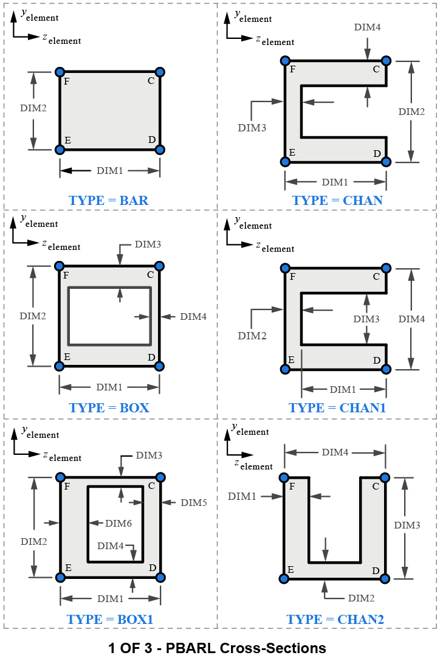
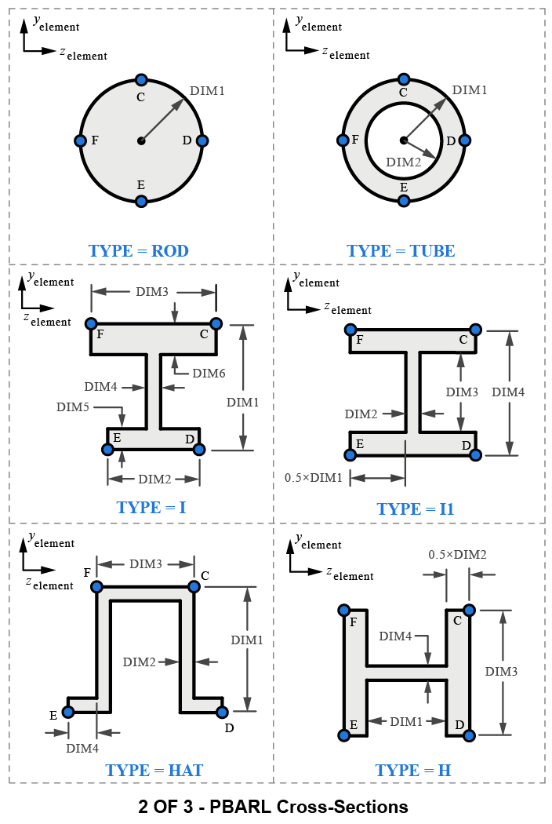
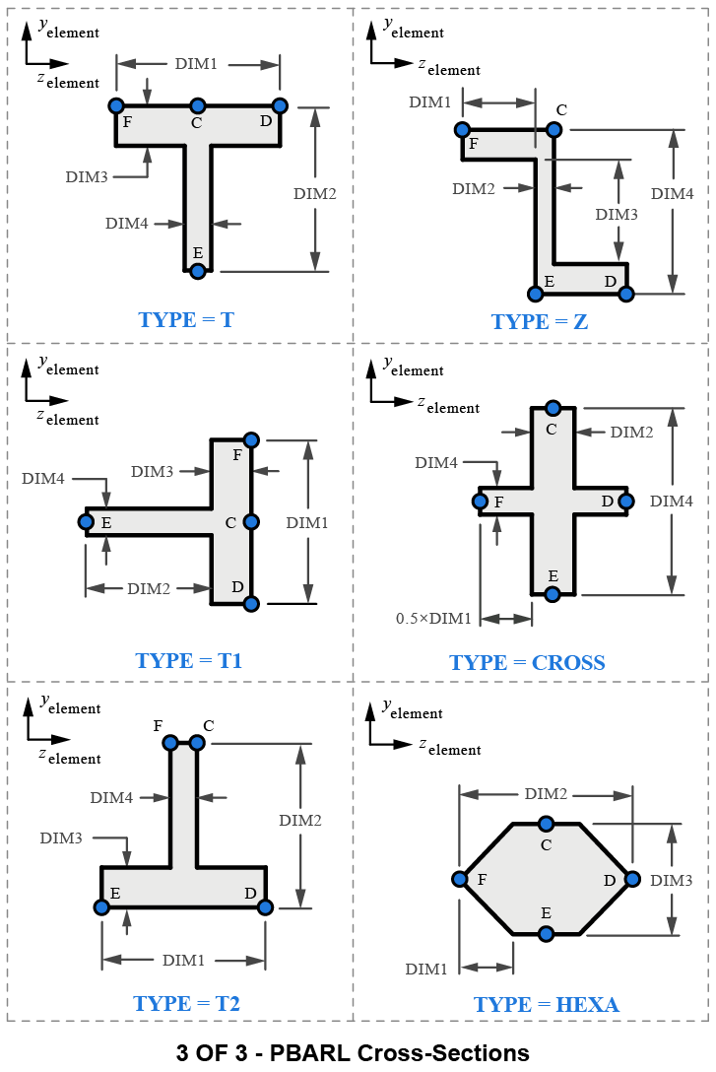
$PBUSH

PBUSH

Description:
Property definition for a spring element defined by a CBUSH entry.

Format:
1 | 2 | 3 | 4 | 5 | 6 | 7 | 8 | 9 | 10
PBUSH | PID | “K” | K1 | K2 | K3 | K4 | K5 | K6
 |  | “RCV” | SA | ST | EA | ET

Example:
PBUSH | 136 | K | 10000. | 20000. | 30000. | 4000. | 50000. | 60000.
 |  | RCV | 30. | 40. | .01 | .02

Data Description:
Field | Contents | Type | Default
PID | Property ID number | Integer > 0 | None
“K” | Indicates that the next 6 fields are stiffness values | Char | None
Ki | Stiffness values | Real | 0.
“RCV” | Indicates that the next 4 values are stress/strain recovery coefficients | Real | 0.
SA | Stress recovery coefficient in the 3 translational directions
ST | Stress recovery coefficient in the 3 rotational directions
EA | Strain recovery coefficient in the 3 translational directions
ET | Strain recovery coefficient in the 3 rotational directions

Remarks:
1. Element stresses and strains are calculated by multiplying element engineering forces times the RCV coefficients
$PCOMP

PCOMP

Description:
Property definition for a composite 2D plate/shell element made up of one or more plies.

Format:
1 | 2 | 3 | 4 | 5 | 6 | 7 | 8 | 9 | 10
PCOMP | PID | Z0 | NSM | SB | FT | TREF | GE | LAM
 | MID1 | T1 | THETA1 | SOUT1 | MID2 | T2 | THETA2 | SOUT2
 | MID3 | (etc)

Example:
PCOMP | 136 | -1.02 | .0003 | 30000 | TSAI | 21. | .002 | SYM
 | 91 | .02 | 30.

Data Description:
Field | Contents | Type | Default
PID | Property ID number | Integer > 0 | None
Z0 | Distance from reference plane to bottom surface of the element | Real | Remark 2
NSM | Non-structural mass | Real | 0.
SB | Allowable interlaminar shear stress | Real | 0.
FT | Failure theory | Char | None
TREF | Reference temperature | Real | 0.
GE | Structural damping coefficient | Real | 0.
LAM | Symmetric lamination option | Char | NONSYM
MIDi | Ply material ID (MID1 must be specified) | Integer | Last one
Ti | Ply thickness (T1 must be specified) | Real | Last one
THETAi | Material angle of ply relative to element material axis | Real | 0.
SOUTi | Not currently used in MYSTRAN

Remarks:
1. PID must be unique among all PCOMP/PSHELL property entries
2. The default for Z0 is -0.5 times the laminate thickness
3. The failure index for the interlaminar shear is the maximum transverse shear stress divided by SB.
NOTE: The interlaminar shear stresses are calculated for a “pristine” unnotched laminate, away from the boundary (Reference 17). Practical considerations must consider the boundary effects near edges and cutouts, laminates with impact damage, and interlaminar tension (Reference 7). The reported interlaminar tension may have more practical use for sandwich structures than for practical solid laminates. Solid laminates may need to consider cutouts, impact damage, repairability with fasteners, etc. (Reference 17).
4. The allowable failure theories are FT = HILL, HOFF, TSAI or STRN.
NOTE: Mixed mode ply-based failure criteria, such as TSAI, HILL, HOFF, have not been demonstrated to have accurate correlation to unnotched strength prediction for multi-directional laminates (Reference 17). Furthermore, ply-based failure criteria have no physical ability to capture the complex failure mechanisms that occur for notched laminates (such as laminates with hole) and laminates with delamination/impact damage (Reference 17). For these practical cases, the user should recognize that these failure criteria cannot represent failure in a physically consistent manner (though is it possible they may be used for semi-empirical methods) (Reference 17).
5. If LAM = SYM only plies on one side of the laminate are to be specified. If an odd number of plies are desired with LAM = SYM then the center ply should have a thickness equal to one-half the actual thickness.
6. The default for MIDi is the previous defined MID. The same holds true for Ti.
7. In order for a ply to be defined, at least one of the 4 ply fields on continuation entries must be present.

$PCOMP1

PCOMP1

Description:
Property definition for a composite 2D plate/shell element made up of one or more plies where all plies are the same thickness and same material.

Format:
1 | 2 | 3 | 4 | 5 | 6 | 7 | 8 | 9 | 10
PCOMP1 | PID | Z0 | NSM | SB | FT | MID | T | LAM
 | THETA1 | THETA2 | THETA3 | etc

Example:
PCOMP1 | 136 | -1.02 | .0003 | 30000 | TSAI | 21. | .002 | SYM
 | 91 | .02 | 30.

Data Description:
Field | Contents | Type | Default
PID | Property ID number | Integer > 0 | None
Z0 | Distance from reference plane to bottom surface of the element | Real | Remark 2
NSM | Non-structural mass | Real | 0.
SB | Allowable interlaminar shear stress | Real | 0.
FT | Failure theory | Char | None
MID | Material ID for all plies | Integer > 0 | None
T | Thickness for all plies | Real | 0.
LAM | Symmetric lamination option | Char | NONSYM
THETAi | Material angle of ply relative to element material axis | Real | 0.

Remarks:
1. PID must be unique among all PCOMP/PSHELL property entries
2. The default for Z0 is -0.5 times the laminate thickness
3. The failure index for the interlaminar shear is the maximum transverse shear stress divided by SB
4. The allowable failure theories are FT = HILL, HOFF, TSAI or STRN
5. If LAM = SYM only plies on one side of the laminate are to be specified. If an odd number of plies are desired with LAM = SYM then the center ply should have a thickness equal to one-half the actual thickness.

$PELAS

PELAS

Description:
Stiffness definition for CELAS spring elements.

Format:
1 | 2 | 3 | 4 | 5 | 6 | 7 | 8 | 9 | 10
PELAS | PID | K | GE | S

Example:
PELAS | 63 | 1.55E6 |  | .015

Data Description:
Field | Contents | Type | Default
PID | Property ID number | Integer > 0 | None
K | Spring stiffness | Real | 0.
GE | Damping coefficient | Real | 0.
S | Stress recovery coefficient | Real | 0.

Remarks:
1. PID must be unique among all PELAS property entries.
2. “Stress” output for this element is S times the force of the spring.
$PLOAD2

PLOAD2

Description:
Uniform pressure load for 2D bending plate elements.

Format No. 1:
1 | 2 | 3 | 4 | 5 | 6 | 7 | 8 | 9 | 10
PLOAD2 | SID | P | EID1 | EID2 | EID3 | EID4 | EID5 | EID6

Format No. 2:
1 | 2 | 3 | 4 | 5 | 6 | 7 | 8 | 9 | 10
PLOAD2 | SID | P | EID1 | THRU | EID2

Examples:
PLOAD2 | 267 | .05 | 12 | 23 | 56 | 124 | 9789

PLOAD2 | 345 | .167 | 269 | THRU | 9823

Data Description:
Field | Contents | Type | Default
SID | Load set ID number | Integer > 0 | None
P | Pressure value | Real | 0.
EIDi | ID numbers of elements that are to have this pressure as a load | Integer > 0 | None

Remarks:
1. A positive value of P will result in a pressure being applied in the positive direction of the local z axis for the element (perpendicular to the elements’ average midplane)
2. If the THRU option is used EID2 must be greater than EID1. All elements whose ID’s are in the range EID1 through EID2 will have the pressure load (if SID selected in Case Control directly or via the load combining LOAD Bulk Data entry).
3. In order for this load to be used in a static analysis the load set ID must either be selected in Case Control by LOAD = SID, or this load set ID must be referenced on a LOAD Bulk Data entry which itself is selected in Case Control.
4. Up to six elements can have their pressure specified on one PLOAD2 entry in Format No 1. For more elements, use additional PLOAD2 entries (i.e. there is no continuation entry for PLOAD2).
$PLOAD4

PLOAD4

Description:
Pressure load on the face of 2D bending plate elements (CTRIA3 and CQUAD4).

Format No. 1:
1 | 2 | 3 | 4 | 5 | 6 | 7 | 8 | 9 | 10
PLOAD4 | SID | EID | P1 | P2 | P3 | P4

Format No. 2:
1 | 2 | 3 | 4 | 5 | 6 | 7 | 8 | 9 | 10
PLOAD4 | SID | EID1 | P1 | P2 | P3 | P4 | THRU | EID2

Examples:
PLOAD4 | 267 | 987 | 1.1 | 1.5 | 1.25 | 1.4

PLOAD4 | 345 | 101 | 2.4 | 2.25 | 2.1 | 2.0 | THRU | 200

Data Description:
Field | Contents | Type | Default
SID | Load set ID number | Integer > 0 | None
Pi | Pressure value at up to 4 grid locations | Real | 0.
EIDi | ID numbers of elements that are to have this pressure as a load | Integer > 0 | None

Remarks:
1. A positive value of P will result in a pressure being applied in the positive direction of the local z-axis for the element (perpendicular to the elements’ average midplane)
2. If the THRU option is used EID2 must be greater than EID1. All elements whose ID’s are in the range EID1 through EID2 will have the pressure load (if SID selected in Case Control directly or via the load combining LOAD Bulk Data entry).
3. In order for this load to be used in a static analysis the load set ID must either be selected in Case Control by LOAD = SID, or this load set ID must be referenced on a LOAD Bulk Data entry which itself is selected in Case Control.
If the fields for P2, P3 and/or P4 are blank that pressure is set equal to P1. P4 has no meaning for triangular elements.
$PLOTEL

PLOTEL

Description:
1-dimensional dummy element that only serves the purpose of plotting a line. It has no elastic properties.

Format:
1 | 2 | 3 | 4 | 5 | 6 | 7 | 8 | 9 | 10
PLOTEL | EID | G1 | G2

Example:
PLOTEL | 63 | 1001 | 2365 | .

Data Description:
Field | Contents | Type | Default
EID | Element ID number | Integer > 0 | None
Gi | Grid point ID’s | Integer > 0 | None

Remarks:
1. EID must be unique among all element ID’s
2. This element does not result in any stiffness or mass. It’s purpose is only to plot a line between 2 grids

$PROD

PROD

Description:
Property definition for ROD element.

Format:
1 | 2 | 3 | 4 | 5 | 6 | 7 | 8 | 9 | 10
PROD | PID | MID | A | J | C | MPL

Example:
PROD | 49 | 2 | .175 | .093 | 1.5 | 0.0175

Data Description:
Field | Contents | Type | Default
PID | Property ID number | Integer > 0 | None
MID | Material ID number | Integer > 0 | None
A | Bar cross-sectional area | Real | 0.
J | Torsional constant | Real | 0.
C | Torsional stress recovery coefficient | Real | 0.
MPL | Mass per unit length | Real | 0.

Remarks:
1. PID must be unique among all PROD property entries
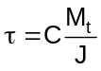2. The torsional stress is calculated as:
where M_{t} is the torsional moment in the rod element.
$PSHEAR

PSHEAR

Description:
Property definition for SHEAR element.

Format:
1 | 2 | 3 | 4 | 5 | 6 | 7 | 8 | 9 | 10
PSHEAR | PID | MID | T | NSM

Example:
PSHEAR | 49 | 2 | .175 | .093

Data Description:
Field | Contents | Type | Default
PID | Property ID number | Integer > 0 | None
MID | Material ID number | Integer > 0 | None
T | Shear panel thickness | Real > 0. | None
NSM | Non-structural mass per unit area | Real | 0.

Remarks:
1. PID must be unique among all PSHEAR property entries

$PSHELL

PSHELL

Description:
Property definition for 2D plate elements.

Format:
1 | 2 | 3 | 4 | 5 | 6 | 7 | 8 | 9 | 10
PSHELL | PID | MID1 | TM | MID2 | 12I/TM**3 | MID3 | TS/TM | MPA
 | Z1 | Z2

Examples:
PSHELL | 987 | 234 | 0.10 | 123 | 125. | 45 | 20. | .005
 | 0.5 | -0.5

PSHELL | 78 | 234 | 0.10 | 234 |  | 45

Data Description:
Field | Contents | Type | Default
PID | Property ID number | Integer > 0 | None
MID1 | Material ID number for membrane material properties | Integer > 0 or blank | None
TM | Membrane thickness | Real or blank | 0.
MID2 | Material ID number for bending material properties | Integer > 0 or blank | None
12I/TM**3 | Ratio of actual bending moment inertia (I) to bending inertia of a solid plate of thickness TM | Real or blank | 1.0
MID3 | Material ID number for transverse shear material properties | Integer > 0 or blank | None
TS/TM | Ratio of shear to membrane thickness | Real or blank | Remark 3
MPA | Mass per unit area | Real | 0.
Z1, Z2 | Distances from the neutral plane of the plate to locations where stress is calculated | Real | Remark 2

Remarks:
1. PID must be unique among all PSHELL property entries
2. Continuation entry is not required. If Z1 and Z2 are not input, then stresses are calculated at +/-TM/2.
3. Default value for TS/TM is 5/6 = 0.83333 unless a PARAM Bulk data entry with parameter name TSTM_DEF is in the data file, in which case the TSTM_DEF value on the PARAM entry is used.
4. The following holds for the cases of MIDi blank:
If MID1 is blank, no membrane stiffness is calculated
If MID2 is blank, no bending or transverse shear stiffness is calculated
If MID3 is blank, no transverse shear flexibility is included (Kirchhoff plate theory: plate is assumed infinitely stiff in transverse shear) so that normals to the mid-plane remain normal after bending)
$PSOLID

PSOLID

Description:
Property definition for 3D solid elements.

Format:
1 | 2 | 3 | 4 | 5 | 6 | 7 | 8 | 9 | 10
PSOLID | PID | MID | CORDM | IN |  | ISOP

Examples:
PSOLID | 987 | 234 | 23 | 3 |  | FULL

Data Description:
Field | Contents | Type | Default
PID | Property ID number | Integer > 0 | None
MID | Material ID number | Integer > 0 or blank | None
CORDM | Material coordinate system ID | Integer or blank | 0.
IN | Indicator for integration order (see table below) | 2, 3, TWO or THREE | See table below
ISOP | Integration scheme (whether to use FULL or REDUCED integration) | REDUCED, FULL, 0 or 1 | See table below

Remarks:
1. See table below for values of IN and ISOP to use

Allowed PSOLID entries IN and ISOP for solid elements
(bold + underline indicates default, which can also be blank)
(IN has no default for HEXA 8 node and PENTA 6 node, so it must be entered)
HEXA | IN | ISOP
8 node | TWO or 2 | REDUCED or 0
8 node | TWO or 2 | FULL or 1
8 node | THREE or 3 | REDUCED or 0
8 node | THREE or 3 | FULL or 1
20 node | TWO or 2 | REDUCED or 0
20 node | TWO or 2 | FULL or 1
20 node | THREE or 3 | REDUCED or 0
20 node | THREE or 3 | FULL or 1

PENTA | IN | ISOP
6 node | TWO or 2 | REDUCED or 0
6 node | TWO or 2 | FULL or 1
6 node | THREE or 3 | REDUCED or 0
6 node | THREE or 3 | FULL or 1
15 node | TWO or 2 | REDUCED or 0
15 node | TWO or 2 | FULL or 1
15 node | THREE or 3 | REDUCED or 0
15 node | THREE or 3 | FULL or 1

TETRA | IN | ISOP
4 node | TWO or 2 | FULL
4 node | THREE or 3 | FULL
10 node | THREE or 3 | FULL

Reduced integration is used for shear strains to avoid shear locking. For HEXA 2x2x2 (IN = 2) and PENTA 2x3 (IN = 2) integration it uses selective substitution. For HEXA 3x3x3 (IN = 3) reduced integration it uses 2x2x2 for shear. For PENTA 3x7 (IN = 3) reduced integration it uses 2x3 for shear
$PUSERIN

PUSERIN

Description:
Property definition for CUSERIN elements.

Format:
1 | 2 | 3 | 4 | 5 | 6 | 7 | 8 | 9 | 10
PUSERIN | PID | IN4_ID | KNAME | MNAME | RBNAME | PNAME

Examples:
PUSERIN | 101 | 95 | KRRGN | MRRGN

Data Description:
Field | Contents | Type | Default
PID | Property ID number | Integer > 0 | None
IN4_ID | ID of an Exec Control IN4 entry that specifies the NASTRAN formatted INPUTT4 file containing the stiffness and mass matrices (whose name are KNAME, MNAME) | Integer > 0 or blank | None
KNAME | Name of the stiffness matrix which was written to the INPUTT4 file when it was created. This can be up to 8 characters long | Char | None
MNAME | Name of the mass matrix which was written to the INPUTT4 file when it was created. This can be up to 8 characters long | Char | None
RBNAME | Name of a 6x6 rigid body mass matrix which specifies the rigid body mass relative to the C.G. of the CUSERIN element in its basic coordinate system. This can be up to 8 characters long | Char | None
PNAME | Name of the load matrix which was written to the INPUTT4 file when it was created. This can be up to 8 characters long. | Char | None

Remarks:
1. PID must be unique among all PUSERIN property entries
2. IN4_ID is required. In the example above, an Executive Control entry IN4 with ID = 234 is required
3. The matrix whose name is RBNAME is not required. However, the rigid body mass properties (PARAM GRDPNT) for the overall model will be in error unless the element has the same basic coordinate system as the overall model.
4. The matrix whose name is PNAME is only used for statics solutions.

$RBE2

RBE2

Description:
Rigid element that has specified components at a number of grids dependent on the six degrees of freedom at one other grid.

Format:
1 | 2 | 3 | 4 | 5 | 6 | 7 | 8 | 9 | 10
RBE2 | EID | GN | CM | GM1 | GM2 | GM3 | GM4 | GM5
 | GM6 | GM7 | (etc)

Example:
RBE2 | 43 | 1021 | 346 | 1031 | 1033 | 1035 | 1041 | 1043
 | 1045

Data Description:
Field | Contents | Type | Default
EID | Element ID number | Integer > 0 | None
GN | ID number of the grid that will have all 6 components as the 6 independent degrees of freedom for this rigid element | Integer > 0 | None
CM | The component numbers of the dependent degrees of freedom at grid points GMi | Integers 1-6 | None
GMi | The components CM at grids GMi are the dependent degrees of freedom that will be eliminated due to this rigid element | Integer > 0 | None

Remarks:
1. No other element in the model may have the same element ID
2. All of the degrees of freedom defined by components CM at each of the grids GMi are made members of the M-set and their displacements will be rigidly dependent on the six degrees of freedom at grid GN.
3. Dependent degrees of freedom defined by RBE2 elements cannot be defined as members of any other mutually exclusive set (i.e., cannot appear on SPC, SPC1, OMIT, OMIT1, ASET or ASET1 entries, nor can they appear as dependent degrees of freedom on other rigid elements)
$RBE3

RBE3

Description:
Element used to distribute loads or mass from one grid point (denoted as the dependent grid) to other grids in the model. The element is defined based on the grids/components that it connects. The resulting multi-point constraints (MPC’s) generated internally in MYSTRAN, will eliminate the dependent degrees of freedom and will distribute any loads or mass from the dependent grid to the remaining grids defined on the RBE3. Unlike the Nastran RBE3, the MYSTRAN RBE3 does not support the “UM” option at the current time.

Format:
1 | 2 | 3 | 4 | 5 | 6 | 7 | 8 | 9 | 10
RBE3 | EID |  | REFGRID | REFC | WT1 | C1 | G1,1 | G1,2
 | etc. | WT2 | C2 | G2,1 | G2,2 | etc. | WT3 | C3
 | G3,1 | G3,2 | etc.

Format (Alternate - Example): Blank fields are allowed after the independent grid point numbers, so that groups can be aligned for readability.
1 | 2 | 3 | 4 | 5 | 6 | 7 | 8 | 9 | 10
RBE3 | 1 |  | 1 | 123 | 1.0 | 1 | 2 |  | +
+ | 0.1 | 2 | 2 |  |  |  |  |  | +
+ | 0.1 | 3 | 2 |  |  |  |  |  | +
+ | 0.1 | 4 | 2

Example:
RBE3 | 43 |  | 9001 | 123456 | 1.0 | 123 | 1001 | 1002
 | 1003 | 1004

Data Description:
Field | Contents | Type | Default
EID | Element ID number | Integer > 0 | None
REFGRID | Grid that will be the dependent (or reference) grid | Integer > 0 | None
REFC | The component numbers of the dependent degrees of freedom at grid point REFGRID | Integers 1-6 | None
WTi | Weighting factors for the grids/components that follow | Real | None
Ci | Displacement components at the following Gi,j that have weighting factor WTi | Integers 1-6 | None
Gi,j | Grids that REFGRID depend on | Integer > 0 | None

Remarks:
1. No other element in the model may have the same element ID
2. For most applications only the translation displacement components (1,2,3) should be defined for the Ci. If REFGRID and Gi,j are coincident then rotation components (4,5,6) can be defined for Ci.
3. Dependent degrees of freedom defined by RBE3 elements can not be defined as members of any other mutually exclusive set (i.e., cannot appear on SPC, SPC1, OMIT, OMIT1, ASET or ASET1 entries, nor can they appear as dependent degrees of freedom on other rigid elements)

Format (Alternate): Blank fields are allowed after the independent grid point numbers, so that groups can be aligned for readability.
1 | 2 | 3 | 4 | 5 | 6 | 7 | 8 | 9 | 10
RBE3 | 1 |  | 1 | 123 | 1.0 | 1 | 2 |  | +
+ | 0.1 | 2 | 2 |  |  |  |  |  | +
+ | 0.1 | 3 | 2 |  |  |  |  |  | +
+ | 0.1 | 4 | 2

$RFORCE

RFORCE

Description:
Defines rigid body rotational velocity, and optional rotational acceleration, of the model about some specified grid for the purpose of generating inertia forces on the finite element model.

Format:
1 | 2 | 3 | 4 | 5 | 6 | 7 | 8 | 9 | 10
RFORCE | SID | GID | CID | V | N1 | N2 | N3
 | A

Example:
TBD

Data Description:
Field | Contents | Type | Default
SID | Load set ID number (must be selected in Case Control) | Integer > 0 | None
GID | ID of the grid through which the rotation vector acts | Integer >0 | None
CID | ID of the coordinate system in which the Ni are specified | Integer >= 0 | 0
V | An overall scale factor for the angular velocity in revolutions per unit time | Real | 0.
Ni | Components of a vector in the direction of the angular velocity and angular acceleration | Real | 0.
A | An overall scale factor for the angular acceleration in revolutions per unit time squared | Real | 0.

Remarks:
1. The force at grid i due to the angular velocity and acceleration is:
Needs close parenthesis
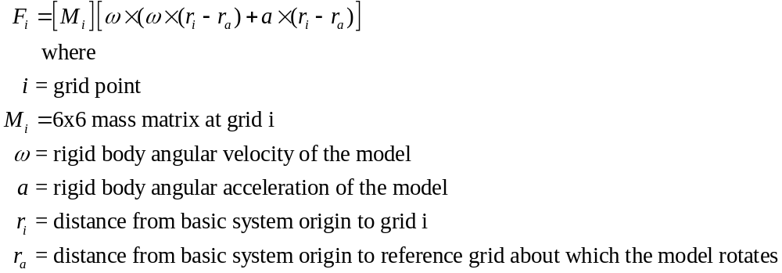
Update to below
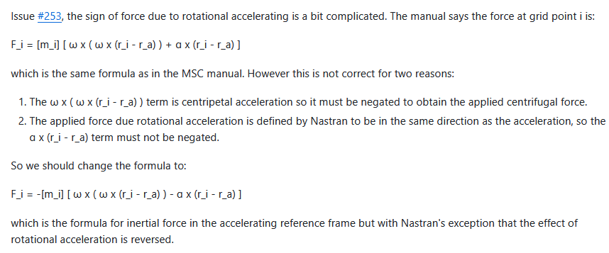
2. The load set ID (SID) is selected by the Case Control entry LOAD:
3. GID = 0 signifies that the rotation vector acts through the basic system origin.
4. CID = 0 indicates that the rotation vector is defined in the basic coordinate system
$RSPLINE

RSPLINE

Description:
Interpolation element. A spline fit using the 2 independent end points (GI1, GI2) is applied to the locations of the dependent points (defined by GDi/CDi) to rigidly constrain the GDi/CDi.

Format:
1 | 2 | 3 | 4 | 5 | 6 | 7 | 8 | 9 | 10
RSPLINE | EID |  | GI1 | GD1 | CD1 | GD2 | CD2 | GD3
 | CD3 | GD4 | CD4 | etc | GI2

Example:
RSPLINE | 43 |  | 1001 | 2001 | 123456 | 2002 | 123456 | 2003
 | 123456 | 2004 | 123456 | 2005 | 123456 | 1002

Data Description:
Field | Contents | Type | Default
EID | Element ID number | Integer > 0 | None
GIi | Grid numbers of the 2 independent end points | Integer > 0 | None
GDi | Grid numbers of the dependent grids | Integers > 0 | None
CDi | Displacement component numbers at the GDi | Integer 1-6 | None

Remarks:
1. No other element in the model may have the same element ID
2. Displacements at the GDi are interpolated using the following rules applied to the line between the 2 end points:
3. Displacements along the line and rotations about the line are linear
4. Displacements perpendicular to the line are cubic
5. Rotations normal to the line are quadratic
$SEQGP

SEQGP

Description:
Manual re-sequencing of grids.

Format:
1 | 2 | 3 | 4 | 5 | 6 | 7 | 8 | 9 | 10
SEQGP | G1 | S1 | G2 | S2 | G3 | S3 | G4 | S4

Example:
SEQGP | 1001 | 1.5 | 1011 | 1. | 1021 | 2. | 1031 | 3.5

Data Description:
Field | Contents | Type | Default
Gi | ID number of a grid point | Integer > 0 | None
Si | The sequence number for Gi | Integer or Real > 0 | None

Remarks:
1. The SEQGP entry is used to manually re-sequence grids. See the Bulk Data PARAM GRIDSEQ entry for the starting sequence MYSTRAN uses in manual grid sequencing.
2. Either integer or real sequence numbers are allowed but all are converted to real internally. Thus, if the user has two grids sequenced consecutively, say with integer sequence numbers 10 and 11, then some other grid can be inserted in the sequence between the two with a real sequence number anywhere in the range:
10. < Si < 11.
3. Up to four pairs of Gi, Si can be specified on one SEQGP entry. For more pairs, use additional SEQGP entries (i.e. there is no continuation entry for SEQGP).
4. If automatic grid point sequencing by BANDIT, any used defined SEQGP entries are ignored.
$SLOAD

SLOAD

Description:
Defines the existence of a scalar load on a scalar point.

Format:
1 | 2 | 3 | 4 | 5 | 6 | 7 | 8 | 9 | 10
SLOAD | SID | Si | FMAG

Example:
SPOINT | 56 | 101 | 125.6

Data Description:
Field | Contents | Type | Default
SID | Load set ID number | Integer > 0 | None
Si | Scalar point ID | Integer > 0 | None
FMAG | Magnitude of the force on scalar point Si | Real | 0.

Remarks:
1. In order for this load to be used in a static analysis the load set ID must either be selected in Case Control by LOAD = SID, or this load set ID must be referenced on a LOAD Bulk Data entry which itself is selected in Case Control.

$SPC

SPC

Description:
Single point constraints that are defined by specifying the degree of freedom and its displacement (either zero or some enforced nonzero value).

Format:
1 | 2 | 3 | 4 | 5 | 6 | 7 | 8 | 9 | 10
SPC | SID | G1 | C1 | D1 | G2 | C2 | D2

Example:
SPC | 56 | 101 | 3 | 1.2E-3 | 201 | 2 | 0.0

Data Description:
Field | Contents | Type | Default
SID | ID number of the single point constraint set | Integer > 0 | None
GI | ID numbers of the grids that will have component number Ci constrained | Integer > 0 | None
CI | Component numbers at grids Gi that will be constrained | Integers 1-6 | None
DI | The value for the displacement at grid Gi, component Ci | Real | 0.

Remarks:
1. Single point constraint sets must be selected in Case Control with the entry SPC = SID in order for them to be applied.
2. Degrees of freedom defined on SPC entries will be members of the S-set and cannot be defined as being members of any other mutually exclusive set.
3. Up to two gid/component pairs can be specified as being single point constrained on one SPC entry (i.e. continuation entries are not allowed). Additional SPC entries can have the same SID.
4. If a Gi/Ci pair is constrained more than once (with the same SID), the last value read for Di will be used.
5. A degree of freedom may be specified redundantly as a permanent single point constraint on a GRID Bulk Data entry and on an SPC or SPC1 Bulk Data entry. If it is defined on the GRID entry and on an SPC Bulk Data entry, Di must be zero on the SPC entry or a fatal error will occur.

$SPC1

SPC1

Description:
Single point constraints that are defined by specifying the degree of freedom to be constrained to zero displacement.

Format No. 1:
1 | 2 | 3 | 4 | 5 | 6 | 7 | 8 | 9 | 10
SPC1 | SID | C | G1 | G2 | G3 | G4 | G5 | G6
 | G7 | G8 | G9 | (etc)

Format No. 2:
1 | 2 | 3 | 4 | 5 | 6 | 7 | 8 | 9 | 10
SPC1 | SID | C | G1 | THRU | G2

Examples:
SPC1 | 52 | 135 | 1001 | 1002 | 103 | 1004 | 2001 | 2002 | +CONT
 | 2003 | 2004

SPC1 | 52 | 135 | 1001 | THRU | 1004
SPC1 | 52 | 135 | 2001 | THRU | 2004

Data Description:
Field | Contents | Type | Default
SID | ID number of the single point constraint set | Integer > 0 | None
C | Component numbers at grids Gi that will be constrained | Integers 1-6 | None
GI | ID numbers of the grids that will have component number Ci constrained | Integer > 0 | None
DI | The value for the displacement at grid Gi, component Ci | Real | 0.

Remarks:
1. Single point constraint sets must be selected in Case Control with the entry SPC = SID in order for them to be applied.
2. Degrees of freedom defined on SPC entries will be members of the S-set and cannot be defined as being members of any other mutually exclusive set.
3. For format 2, all grids in the model that are in the range G1 through G2 will have component C constrained
4. A degree of freedom may be specified redundantly as a permanent single point constraint on a GRID Bulk Data entry and on an SPC or SPC1 Bulk Data entry.
$SPCADD

SPCADD

Description:
Combine single point constraint sets defined on SPC, SPC1 entries.

Format:
1 | 2 | 3 | 4 | 5 | 6 | 7 | 8 | 9 | 10
SPCADD | SID | S1 | S2 | S3 | S4 | S5 | S6 | S7
 | S8 | S9 | (etc)

Example:
SPCADD | 283 | 11 | 74 | 123 | 564

Data Description:
Field | Contents | Type | Default
SID | Single point constraint set ID number | Integer > 0 | None
Si | Set IDs of SPC and/or SPC1 Bulk Data entries | Integer > 0 | None

Remarks:
1. Single point constraint sets must be selected in Case Control with the entry SPC = SID in order for them to be applied.
2. All single point constraints specified on the SPC and/or SPC1 entries whose set IDs are the Si on the SPCADD will be applied to the model if SPC = SID is in Case Control.
$SPOINT

SPOINT

Description:
Defines the existence of a scalar point (1 component of displacement) in the model.

Format 1:
1 | 2 | 3 | 4 | 5 | 6 | 7 | 8 | 9 | 10
SPOINT | ID1 | ID2 | ID3 | ID4 | ID5 | ID6 | ID7 | ID8

Format 2:
1 | 2 | 3 | 4 | 5 | 6 | 7 | 8 | 9 | 10
SPOINT | ID1 | THRU | ID2

Example:
SPOINT | 56 | 101 | 3 | 45

Data Description:
Field | Contents | Type | Default
IDi | ID of an SPOINT | Integer > 0 | None

Remarks:
1. SPOINT ID’s must be unique among all other SPOINT’s and among all GRID’s
2. SPOINT’s are like GRID’s but have only 1 component of displacement and their outputs are scalar, not vector, quantities. In the f06 output file, however, the output quantities are reported under the T1 headings.
$SUPORT

SUPORT

Description:
Defines degrees of freedom that are to be in the R-set (for Craig-Bampton model generation).

Format:
1 | 2 | 3 | 4 | 5 | 6 | 7 | 8 | 9 | 10
SUPORT | GID | C | GID | C | GID | C | GID | C

Example:
SUPORT | 4981 | 12 | 695 | 123 | 5647 | 456

Data Description:
Field | Contents | Type | Default
GID | ID of a grid whose components in the next field will be put into the  R-set | Integer > 0 | None
C | Displacement component numbers (digits 1 through 6) | Integer > 0 | None

Remarks:
1. This Bulk Data entry is meant for use in Craig-Bampton analyses. The degrees of freedom specified on this entry will be treated the same as Single Point Constraints (SPC’s) in all other analyses

$TEMP

TEMP

Description:
Grid point temperature definition for purposes of calculating thermal loads on the model.

Format:
1 | 2 | 3 | 4 | 5 | 6 | 7 | 8 | 9 | 10
TEMP | SID | G1 | T1 | G2 | T2 | G3 | T3

Example:
TEMP | 4 | 1011 | 25. | 1012 | 32. | 1013 | 28.

Data Description:
Field | Contents | Type | Default
SID | ID number of the temperature set | Integer > 0 | None
GI | ID numbers of the grids whose temperature is being defined | Integer > 0 | None
Ti | Temperature of grid Gi | Real | 0.

Remarks:
1. Temperature sets must be selected in Case Control with the entry TEMP = SID in order for them to be used in calculating thermal loads
2. Every element in the model must have its temperature defined for set SID, either explicitly through an element temperature entry on TEMPRB, TEMPP1 Bulk Data entry or implicitly using grid temperatures on TEMP, TEMPD Bulk Data entries. Element temperatures defined on element TEMPRB, TEMPP1 entries take precedence over any that might be defined using grid temperatures. If no element temperature is explicitly defined, the element temperature is taken to be the average of the temperatures of the grids to which the element is connected.
3. Thermal loads for the model are calculated using element temperatures defined via TEMP, TEMPD, TEMPRB, TEMPP1 Bulk data entries, the element properties and the material properties (including coefficient of thermal expansion and reference temperature). The thermal loads calculated are based on element temperatures that are the difference between those defined on TEMP, TEMPD, TEMPRB, TEMPP1 and the reference temperature defined on the material entry for the element.
4. Only three grids may have their temperature defined for set SID in one TEMP entry. Additional grid temperatures can be specified using more TEMP Bulk Data entries with the same SID.

$TEMPD

TEMPD

Description:
Default grid point temperature definition for purposes of calculating thermal loads on the model.

Format:
1 | 2 | 3 | 4 | 5 | 6 | 7 | 8 | 9 | 10
TEMPD | SID1 | T1 | SID2 | T2 | SID3 | T3 | SID4 | T4

Example:
TEMPD | 4 | 46.2 | 33 | 52.1

Data Description:
Field | Contents | Type | Default
SIDi | ID number of a temperature set | Integer > 0 | None
Ti | The default temperature for grids for set SIDi | Real | 0.

Remarks:
1. Temperature sets must be selected in Case Control with the entry TEMP = SID in order for them to be used in calculating thermal loads
2. All grids whose temperature is not defined on a TEMP Bulk Data entry will have the default temperature T, if there is one defined on a TEMPD for set SID.
3. Every element in the model must have its temperature defined for set SID, either explicitly through an element temperature entry on TEMPRB, TEMPP1 Bulk Data entry or implicitly using grid temperatures on TEMP, TEMPD Bulk Data entries. Element temperatures defined on element TEMPRB, TEMPP1 entries take precedence over any that might be defined using grid temperatures. If no element temperature is explicitly defined, the element temperature is taken to be the average of the temperatures of the grids to which the element is connected.
4. Thermal loads for the model are calculated using element temperatures defined via TEMP, TEMPD, TEMPRB, TEMPP1 Bulk data entries, the element properties and the material properties (including coefficient of thermal expansion and reference temperature). The thermal loads calculated are based on element temperatures that are the difference between those defined on TEMP, TEMPD, TEMPRB, TEMPP1 and the reference temperature defined on the material entry for the element.
5. Only four pairs of SIDi/Ti may be defined on one TEMPD entry. Additional pairs can be specified using more TEMPD Bulk Data entries.
$TEMPP1

TEMPP1

Description:
Defines temperatures and temperature gradients for 2D plate elements.

Format No. 1:
1 | 2 | 3 | 4 | 5 | 6 | 7 | 8 | 9 | 10
TEMPP1 | SID | EID1 | TBAR | TPRIME
 | EID2 | EID3 | EID4 | EID5 | (etc)

Format No. 2:
1 | 2 | 3 | 4 | 5 | 6 | 7 | 8 | 9 | 10
TEMPP1 | SID | EID1 | TBAR | TPRIME
 | EID2 | THRU | EID3 | EID4 | THRU | EID5

Examples:
TEMPP1 | 13 | 2101 | 35.7 | 10.1
 | 2679 | 3201 | 1104 | 32 | 5555

TEMPP1 | 13 | 2101 | 35.7 | 10.1
 | 2304 | THRU | 6789 | 12 | THRU | 46

Data Description:
Field | Contents | Type | Default
SID | ID number of the temperature set | Integer > 0 | None
EIDi | Element ID numbers | Integer > 0 | None
TBAR | Average temperature of the element | Real | 0.
TPRIME | Linear thermal gradient through the thickness of the element | Real | 0.

Remarks:
1. Any number of continuation entries can be used
2. For format number 2, the THRU ranges must have the second element ID greater than the first.
3. Temperature sets must be selected in Case Control with the entry TEMP = SID in order for them to be used in calculating thermal loads.
4. Every element in the model must have its temperature defined for set SID, either explicitly through an element temperature entry on TEMPRB, TEMPP1 Bulk Data entry or implicitly using grid temperatures on TEMP, TEMPD Bulk Data entries. Element temperatures defined on element TEMPRB, TEMPP1 entries take precedence over any that might be defined using grid temperatures. If no element temperature is explicitly defined, the element temperature is taken to be the average of the temperatures of the grids to which the element is connected.
5. Thermal loads for the model are calculated using element temperatures defined via TEMP, TEMPD, TEMPRB, TEMPP1 Bulk data entries, the element properties and the material properties (including coefficient of thermal expansion and reference temperature). The thermal loads calculated are based on element temperatures that are the difference between those defined on TEMP, TEMPD, TEMPRB, TEMPP1 and the reference temperature defined on the material entry for the element.
$TEMPRB

TEMPRB

Description:
Defines temperatures and temperature gradients for 1D bar elements.

Format No. 1:
1 | 2 | 3 | 4 | 5 | 6 | 7 | 8 | 9 | 10
TEMPRB | SID | EID1 | TA | TB | TP1A | TP1B | TP2A | TP2B
 | EID2 | EID3 | EID4 | EID5 | (etc)

Format No. 2:
1 | 2 | 3 | 4 | 5 | 6 | 7 | 8 | 9 | 10
TEMPRB | SID | EID1 | TA | TB | TP1A | TP1B | TP2A | TP2B
 | EID2 | THRU | EID3 | EID4 | THRU | EID5

Examples:
TEMPRB | 13 | 2101 | 35.7 | 10.1
 | 67 | 89 | 2 | 13 | 1 | 789

TEMPRB | 13 | 2101 | 35.7 | 10.1
 | 68 | THRU | 97 | 2101 | THRU | 4009

Data Description:
Field | Contents | Type | Default
SID | ID number of the temperature set | Integer > 0 | None
EIDi | Element ID numbers | Integer > 0 | None
TA | Average temperature of the element at end a | Real > 0. | 0.
TB | Average temperature of the element at end b | Real > 0. | 0.
TP1A | Linear temperature gradient in element y axis at end a | Real | 0.
TP1B | Linear temperature gradient in element y axis at end b | Real | 0.
TP2A | Linear temperature gradient in element z axis at end a | Real | 0.
TP2B | Linear temperature gradient in element z axis at end b | Real | 0.

Remarks:
1. Any number of continuation entries can be used
2. For format number 2, the THRU ranges must have the second element ID greater than the first
3. Temperature sets must be selected in Case Control with the entry TEMP = SID in order for them to be used in calculating thermal loads
4. Every element in the model must have its temperature defined for set SID, either explicitly through an element temperature entry on TEMPRB, TEMPP1 Bulk Data entry or implicitly using grid temperatures on TEMP, TEMPD Bulk Data entries. Element temperatures defined on element TEMPRB, TEMPP1 entries take precedence over any that might be defined using grid temperatures. If no element temperature is explicitly defined, the element temperature is taken to be the average of the temperatures of the grids to which the element is connected.
5. Thermal loads for the model are calculated using element temperatures defined via TEMP, TEMPD, TEMPRB, TEMPP1 Bulk data entries, the element properties and the material properties (including coefficient of thermal expansion and reference temperature). The thermal loads calculated are based on element temperatures that are the difference between those defined on TEMP, TEMPD, TEMPRB, TEMPP1 and the reference temperature defined on the material entry for the element.
6. T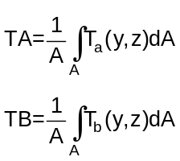he average temperatures TA and TB at ends a and b respectively are:
where A is the cross-sectional area and T_{a}(y,z) and T_{b}(y,z) are the temperature distributions at ends a and b respectively.
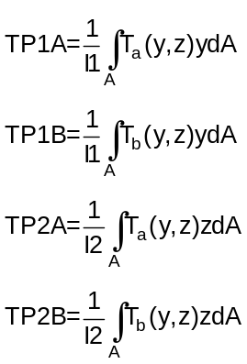7. The linear gradients through the thickness, TP1A, TP1B, TP2A and TP2B, are:

where I1 and I2 are the bending moments of inertia for the bar (on the PBAR entry) and T_{a}(y,z) and T_{b}(y,z) are the temperature distributions at ends a and b respectively.

$USET

USET

Description:
Defines a set of degrees of freedom that belong to a user defined set (named either “U1” or “U2”). The purpose is for the user to get an output listing that defines the internal degree of freedom order for the members of the set.

Format:
1 | 2 | 3 | 4 | 5 | 6 | 7 | 8 | 9 | 10
USET | NAME | G1 | C1 | G2 | C2 | G3 | C3

Example:
USET | U1 | 101 | 3 | 201 | 2

Data Description:
Field | Contents | Type | Default
NAME | A user defined set. The name must be either “U1” or “U2” | Char | None
GI | ID numbers of the grids that the user wants to be members of the set | Integer > 0 | None
CI | Component numbers at grid Gi that will be members of the set | Integers 1-6 | None

Remarks:
1. The Gi, Ci are defined as members of the displacement set named SNAME.
2. A row oriented tabular output showing the internal sort order of the members of the set (named SNAME) can be output if a PARAM, USETSTR, Ui Bulk Data entry is present (I = 1 or 2).
3. In order to get a listing of the internal sort order, a Bulk Data PARAM, USETSTR, Ui (i=1 or 2) must be included.

$USET1

USET1

Description:
Defines a set of degrees of freedom that belong to a user defined set (named either “U1” or “U2”). The purpose is for the user to get an output listing that defines the internal degree of freedom order for the members of the set.

Format No. 1:
1 | 2 | 3 | 4 | 5 | 6 | 7 | 8 | 9 | 10
USET1 | SNAME | C | G1 | G2 | G3 | G4 | G5 | G6
 | G7 | G8 | G9 | (etc)

Format No. 2:
1 | 2 | 3 | 4 | 5 | 6 | 7 | 8 | 9 | 10
USET1 | SNAME | C | G1 | THRU | G2

Examples:
USET1 | U2 | 135 | 1001 | 1002 | 103 | 1004 | 2001 | 2002
 | 2003 | 2004

USET1 | U2 | 135 | 1001 | THRU | 1004

Data Description:
Field | Contents | Type | Default
SNAME | A user defined set. The name must be either “U1” or “U2” | Char | None
GI | ID numbers of the grids that are members of the user defined set | Integers 1-6 | None
C | Component numbers at grids Gi that are part of the user defined set | Integer > 0 | None

Remarks:
1. The Gi, C are defined as members of the displacement set named SNAME.
2. A row oriented tabular output showing the internal sort order of the members of the set (named SNAME) can be output if a PARAM, USETSTR, Ui Bulk Data entry is present (I = 1 or 2).
3. In order to get a listing of the internal sort order, a Bulk Data PARAM, USETSTR, Ui (i=1 or 2) must be included

REFERENCES
- LAPACK Users’ Guide, 3rd edition, SIAM, 1999
(see website at http://www.netlib.org/lapack).
- ARPACK Users’ Guide, 3rd edition, SIAM, 1998
(see website at http://www.caam.rice.edu/software/ARPACK/).
- Everstine, G. C., “Recent improvements to Bandit”, NASTRAN: Users’ Experiences, Volume NASA TM X-3278 pages 511-521, Washington, DC, 1975. National Aeronautics and Space Administration.
- Tessler, A. and Hughes, T.J.R., “A three-node Mindlin plate element with improved transverse shear”, Computer Methods In Applied Mechanics And Engineering 50 (1985) 71-101.
- Tessler, A. and Hughes, T.J.R., “An improved treatment of transverse shear in the Mindlin-type four-node quadrilateral element”, Computer Methods In Applied Mechanics And Engineering 39 (1983) 311-335.
- Batoz, J., “An explicit formulation for an efficient triangular plate-bending element”, International Journal For Numerical Methods In Engineering, Vol. 18 (1982), 1077-1089.
- Batoz, J. and Tahar, M.B., “Evaluation of a new quadrilateral thin plate”, International Journal For Numerical Methods In Engineering, Vol. 18 (1982), 1655-1677.
- Case, William R., “A NASTRAN DMAP procedure for calculation of base excitation modal participation factors”, 11th NASTRAN User’s Colloquium, May 5-6, 1983. Not referenced – section 8?
- Liu, J., Riggs, H.R. and Tessler, A., “A four-node, shear-deformable shell element developed via explicit Kirchhoff constraints”, International Journal For Numerical Methods In Engineering, Vol. 49, 2000, pp 1065-1086.
- MacNeal, Richard H., “Finite Elements. Their Design and Performance”, Marcel Dekker, 1993.
- Case, William R., DMAP for generating Craig-Bampton Models, notes from a course given at the Goddard Space Flight Center (contact author for copy of paper).
- MYSTRAN-Demo-Problem-Manual (contained in the MYSTRAN setup file downloaded from www.MYSTRAN.com along with this manual.
- Li, X.S. et al. “SuperLU Users Guide”, Sept 1999. (https://portal.nersc.gov/project/sparse/superlu/)
- Ashton, J.E., “Approximate Solutions for Unsymmetrically Laminated Plates”, General Dynamics Corporation, Fort Worth, Texas, October 28, 1968.
- Yeongbin Ko, Phill-Seung Lee, Klaus-Jürgen Bathe, “A New MITC4+ Shell Element”, Computers and Structures, 182, 2017.
- Bathe, Klaus-Jürgen, “A formulation of general shell elements—the use of mixed interpolation of tensorial components”, International Journal for Numerical Methods in Engineering, Vol. 22, Issue 3, pp. 697–722, March 1986.
- Esp, Brian, “Practical Analysis of Aircraft Composites”, Grand Oak Publishing, 2017.
- Erhart, T., Borrvall, T., “Drilling rotation constraint for shell elements in implicit and explicit analyses”, 9th European LS-DYNA Conference, 2013.

DEBUG – FOR DEVELOPERS
The DEBUG card is/was used by developers, but much of it is not obsolete, having served its purpose. It is provided for reference.
$DEBUG

DEBUG

Description:
Define debug parameters.

Format:
1 | 2 | 3 | 4 | 5 | 6 | 7 | 8 | 9 | 10
DEBUG | i | VALUE

Example:
DEBUG | 31 | 1

Data Description:
Field | Contents | Type | Default
i | Debug number (index in DEBUG array) | 0 < Integer | None
VALUE | The value for DEBUG(i) | Integer | 0

Remarks:
1. See DEBUG_PARAMETERS.f90 for actions taken based on the various debug values. Unless otherwise stated, DEBUG(i) = 0 is the default and, for the “print” parameters, no printing is done.

“entry” is used to mean a single line of entry in the data section. It is a holdover from the familiar 80 column punched entries used to enter data into computers long ago. The MYSTRAN data section does consist of lines of entry that can contain data in columns 1 through, possibly, column 80 (each denoted as a physical entry). A logical entry can, in some instances, consist of more than one physical entry.
The various files (output and scratch) generated by MYSTRAN are described in a later section. BUG is the extension of one of those files.
See Section 6.6 for a definition of displacement sets

