
Evaluating GNNs for Influence Spread Prediction under IC and LT Models

Yash Sharma
Supervisor Guide: Dr. Rohit Tripathi

Department of Computer Science and Engineering
Indian Institute of Information Technology Guwahati
IIIT Guwahati
April 2026

Abstract
Predicting how influence—whether information, viral marketing, or disease—spreads through a social network is a well-known computational bottleneck. While Monte Carlo simulations under probabilistic frameworks like the Independent Cascade (IC) and Linear Threshold (LT) models are highly accurate, their reliance on thousands of iterations makes them unscalable for massive real-world graphs. Conversely, fast heuristic approaches that rely on traditional centrality metrics (such as node degree or shortest paths) consistently fail to capture the complex, non-linear reality of cascade dynamics.
To bridge this gap, this report introduces a hybrid machine learning pipeline designed to bypass the expensive simulation phase entirely. The core methodology utilizes Graph Neural Networks (GNNs)—specifically GCN, GAT, GIN, and GraphSAGE—as a lightweight feature-enrichment layer. Applied to a synthetic 500-node Barabási-Albert scale-free graph, the GNNs aggregate multi-hop neighbourhood data, transforming basic structural centralities into rich, predictive node embeddings.
These enriched profiles are then processed by standard regressors to estimate a node's true influence spread. Our results demonstrate that this GNN-augmented approach drastically reduces prediction errors, outperforming standard linear baselines by approximately 40% and matching the predictive capacity of complex tree-based ensembles like Random Forests. Ultimately, this framework provides a highly scalable, structurally aware alternative to traditional simulations, allowing for the rapid and accurate identification of key network influencers.

Contents: -
1. Introduction: - .....4
1.1 Background and Motivation ….4
1.2 The Influence Maximization Problem ….4
1.3 Project Objectives ….5
1.4 Proposed Solution: GNNs as Feature Aggregators ….5
2. Theoretical Background and Related Work: - ….6
2.1 Graph Theory and Structural Centralities ….6
2.1.1 Betweenness Centrality ….6
2.1.2 Closeness Centrality ….6
2.1.3 Eigenvector Centrality ….6
2.2 Information Diffusion Models ….7
2.2.1 Independent Cascade (IC) Model ….7
2.2.2 Linear Threshold (LT) Model ….7
2.3 Graph Neural Networks (GNNs) Overview ….7
2.3.1 Graph Convolutional Networks (GCN) ….8
2.3.2 Graph Attention Networks (GAT) ….8
2.3.3 GraphSAGE and GIN Architectures ….9
3. Methodology and System Design : - ….10
3.1 Synthetic Dataset Generation ….10
3.1.1 Barabási-Albert Scale-Free Networks ….10
3.2 Feature Engineering Pipeline ….10
3.3 The Simulation Engine (Ground Truth Generation) ….10
3.4 Machine Learning and GNN Architecture ….11
3.4.1 Classical Regression Baselines ….11
3.4.2 The GNN Aggregation and Ridge Regression Pipeline ….11
3.5 Experimental Setup and Evaluation Metrics (MSE, R²) ….11
4. Results and Evaluation ….12
4.1 Structural Profiling of Top Influencers ….12
4.1.1 Analysis of the Top 5 Nodes Centrality Plot ….12
4.2 Independent Cascade (IC) Spread Analysis ….13
4.2.1 IC Prediction vs. Actual Spread Plot Evaluation ….13
4.3 Linear Threshold (LT) Spread Analysis ….14
4.3.1 LT Prediction vs. Actual Spread Plot Evaluation ….14
4.4 Quantitative Performance Comparison ….15
4.4.1 GNN Models vs. Traditional Baselines ….15
5. Conclusion and Future Work ….16
5.1 Summary of Contributions ….16
5.2 Key Takeaways and Limitations ….16
5.3 Future Scope: Diffusion-Aware GAT (DAGAT) ….16
- List of Plots: -
- Figure 1: Centrality Scores for Top 5 Influential Nodes ….12
- Figure 2: IC Influence Spread — All Models vs Actual ….13
- Figure 3: LT Influence Spread — All Models vs Actual ….14

- List of Tables: -
- Table- 1: MSE, MAE, R-Squared Comparison for All Models ….15

References ….17

Chapter 1

1. Introduction: -

1.1 Background and Motivation: -
Networks are the fundamental structures underlying many complex systems in the modern world. Whether examining the routing of packets across hardware infrastructure, the transmission of a biological virus through a population, or the sharing of a news article across a social media platform, the underlying mechanism is information diffusion over a graph topology. In these graphs, nodes represent individual entities (such as users or routers), and edges represent the relationships or communication channels between them.
The motivation for this project is rooted in the computational bottleneck observed in network analysis. Understanding how a single event cascades through a system is critical for applications like viral marketing, public health interventions, and misinformation containment. If an organization wishes to trigger a widespread cascade—or stop one from happening—they must identify the optimal starting nodes. Historically, this is done either by using simple heuristic centralities, which are fast but highly inaccurate, or by running exhaustive Monte Carlo simulations, which are accurate but computationally unfeasible for networks containing millions of users.

1.2 The Influence Maximization Problem: -
The problem of identifying the most critical nodes in a network is formally known as Influence Maximization (IM). Originally formalized by Kempe, Kleinberg, and Tardos in 2003, IM asks a simple question: given a parameter k, which k nodes should be activated initially to maximize the expected total number of activated nodes at the end of the diffusion process?
The primary issue is that under standard diffusion frameworks, the IM problem is NP-hard. Finding the exact optimal seed set requires evaluating the spread for every possible combination of k nodes. To approximate this, researchers rely on simulating the spread using probabilistic models. However, evaluating the objective function via simulation requires thousands of iterations per node just to find a stable average. On a massive scale-free network, this O(V+E) process becomes a major computational roadblock.

1.3 Project Objectives: -
To address the limitations of current influence prediction methods, this project outlines the following core objectives: -
To programmatically generate synthetic, scale-free networks that accurately mimic the heavy-tailed degree distributions of real-world human interaction graphs.

To implement the Independent Cascade (IC) and Linear Threshold (LT) diffusion models from scratch to serve as a baseline ground truth for node influence.
To extract standard topological features (centralities) and analyse their direct correlation with simulated cascade sizes.

To design and train multiple Graph Neural Network (GNN) architectures to act as feature aggregators, effectively learning the non-linear relationship between network structure and diffusion spread without requiring test-time simulations.

1.4 Proposed Solution: -
This project bridges classical graph theory with deep learning by using GNNs as a smart feature enrichment layer rather than an end-to-end black box.
Initial Features: We extract standard, computationally "cheap" centralities for each node to provide a structural baseline.
Neighbourhood Aggregation: The GNN passes these centralities as "messages" across edges, allowing the model to factor in the importance of a node's local and multi-hop neighbours.
Structural Embeddings: The output is a high-dimensional embedding that captures complex neighbourhood dynamics that isolated centralities miss.
Fast Prediction: These embeddings are fed into standard regressors to predict influence spread, matching simulation accuracy at a fraction of the time.

Chapter 2

2. Theoretical Background and Related Work

2.1 Graph Theory and Structural Centralities: -
To map network topology to machine learning features, we require mathematical quantifiers of a node's structural importance. We selected three distinct centrality measures to form the base feature vector for our models.

2.1.1 Betweenness Centrality: -
Betweenness centrality quantifies the number of times a node acts as a bridge along the shortest path between two other nodes. Nodes with high betweenness are critical bottlenecks; their removal often fractures the network into disconnected components. For a given node v, it is calculated as:
$$C_{B}\left(v\right) = \sum_{s ≠ v ≠ t}{} \frac{σ_{st}\left(v\right)}{σ_{st}}$$
Where $σ_{st}$ is total shortest paths from node s to t, and $σ_{st}\left(v\right)$ is the number of those paths passing through v.

2.1.2 Closeness Centrality: -
Closeness centrality measures the average shortest path distance from a node to all other reachable nodes. It represents how quickly information starting at a given node can reach the entire network. It is defined as the reciprocal of the sum of the shortest path distances:
$$C\left(u\right)=\frac{n-1}{\sum_{v=1}^{n-1}{d\left(v,u\right)}}$$
Where n is the total number of nodes in the graph, and d (v, u) is the shortest path distance between nodes v and u.

2.1.3 Eigenvector Centrality: -
While degree centrality merely counts a node's connections, Eigenvector centrality measures the quality of those connections. It operates on the principle that a node is structurally important if it is connected to other important nodes. It is derived from the adjacency matrix $A$ of the graph:
$$Ax = λx$$
Where lambda is the largest principal eigenvalue of the adjacency matrix, and x is the resulting centrality vector.

2.2 Information Diffusion Models: -
To generate the target variables for our regression models, we must simulate how information physically propagates. We utilize two standard discrete-time propagation models.

2.2.1 Independent Cascade (IC) Model: -
The IC model represents contagion-like dynamics, like viral transmission. When a node $u$ becomes active at time step t, it is given exactly one opportunity to activate each of its currently inactive neighbours v. The success of this transmission is determined by a set propagation probability $p_{u,v}.$
$$P\left(u\text{ activates }v\right)=p_{u,v}$$
If the activation succeeds, v becomes active at $t+1$. Regardless of success or failure, node u cannot attempt to activate node v in any subsequent time steps. The process terminates when no new nodes are activated.

2.2.2 Linear Threshold (LT) Model: -
In contrast to the IC model's independent probabilistic trials, the LT model simulates threshold-based adoption, mimicking social peer pressure. Each node v is assigned a hidden threshold $θ_{v}$ drawn uniformly from [0, 1]. Additionally, every incoming edge to v from a neighbour u carries a specific influence weight $w_{u,v}.$ An inactive node v will only transition to an active state if the sum of the weights from its already-active neighbours exceeds its internal threshold:
$$\sum_{u∈N_{active}\left(v\right)}{w_{u,v}}≥θ_{v}$$
This model typically results in denser, community-driven cascades, as nodes often wait for multiple neighbours to activate before crossing their threshold.

2.3 Graph Neural Networks (GNNs) Overview
Traditional neural networks operate on Euclidean data (like images or text grids). GNNs are designed to operate on non-Euclidean graph structures by passing and aggregating mathematical messages along edges.

2.3.1 Graph Convolutional Networks (GCN): -
Introduced by Kipf and Welling, GCNs approximate spectral graph convolutions. They aggregate feature information from a node's immediate neighbours using a symmetric degree-normalization mechanism. The layer-wise propagation rule is defined as:
$$H^{\left(l+1\right)}=σ\left(\tilde{D^{-\frac{1}{2}}\tilde{A}}\tilde{D^{-\frac{1}{2}}}H^{\left(l\right)}W^{\left(l\right)}\right)$$
Where $\tilde{A}=A+I$ (the adjacency matrix with added self-loops), $\tilde{D}$ is the diagonal degree matrix, $H^{\left(l\right)}$ is the matrix of activations in the l-th layer, W is the weight matrix, and $σ$ is an activation function like ReLU. While computationally efficient, standard GCNs treat all connecting edges equally, which limits their effectiveness on scale-free graphs.

2.3.2 Graph Attention Networks (GAT): -
To address the limitations of standard convolution, Veličković et al. introduced GATs. Instead of fixed normalization, GATs use masked self-attentional layers to learn the relative importance of different neighbours. The attention coefficient between nodes i and j is computed as:
$$α_{ij}=\frac{\exp\left(\text{LeakyReLU}\left(a^{T}\left[Wh_{i}|Wh_{j}\right]\right)\right)}{\sum_{k∈N_{i}}{}\exp\left(\text{LeakyReLU}\left(a^{T}\left[Wh_{i}|Wh_{k}\right]\right)\right)}$$
This allows the network to assign varying weights to different edges, enabling a node to focus its feature aggregation on the most critical connections within its neighbourhood.

2.3.3 GraphSAGE Architecture: -
GraphSAGE (Sample and Aggregate) is an inductive framework designed to address the scalability limitations of transductive models like GCN. Instead of training embeddings for a fixed, static graph, GraphSAGE learns an aggregator function that can generalize to unseen nodes. The algorithm operates by randomly sampling a fixed-size neighbourhood for each node to maintain computational consistency, particularly for high-degree hubs. It then applies an aggregation function—typically a Mean or Max-Pooling operation—to the features of these sampled neighbours. This aggregated neighbourhood profile is concatenated with the target node's original feature vector and passed through a fully connected layer. This inductive approach allows the model to instantly generate embeddings for new nodes added to the network without requiring a full retraining cycle.

2.3.4 Graph Isomorphism Networks: -
(GIN) Graph Isomorphism Networks (GIN) were proposed by Xu et al. to maximize the expressive power of message-passing GNNs. Traditional aggregators like Mean or Max pooling possess inherent mathematical blind spots; they can produce identical embeddings for fundamentally different neighbourhood structures because they cannot reliably count the exact number of identical neighbours. To resolve this, GIN strictly utilizes a Sum aggregator. By summing the incoming features and passing the result through a Multi-Layer Perceptron (MLP) to capture complex non-linear relationships, GIN is theoretically proven to be as expressive as the Weisfeiler-Lehman (WL) graph isomorphism test. This guarantees that if two subgraphs are topologically distinct, the GIN architecture will map them to distinct feature representations, making it highly effective for capturing specific structural conditions required for information diffusion.

Chapter 3

3.Methodology and System Design: -
3.1 Synthetic Dataset Generation: -
Real-world social networks are characterized by massive scale and dynamic edge connections, making them difficult to process locally. To create a controlled environment for testing our Graph Neural Networks, we generated a synthetic network using the Barabási-Albert (BA) preferential attachment model.

3.1.1 Barabási-Albert Scale-Free Networks: -
The BA model generates graphs that exhibit a scale-free degree distribution, a mathematical property ubiquitous in human social networks (such as Twitter or citation networks). The defining characteristic is the presence of a few high-degree "hub" nodes and a vast majority of low-degree peripheral nodes. The graph was instantiated with 500 nodes. To ensure a realistic density, the attachment parameter was set to 3 edges per new node. To simulate the extreme connectivity of modern influencers, the top 10 highest-degree nodes were manually augmented with additional random edges, bringing the total edge count to approximately 1,620. Edge weights, representing transmission probabilities, were drawn from a uniform distribution between 0.1 and 0.4.
3.2 Feature Engineering Pipeline: -
Before passing data to the GNNs, base topological features were extracted for all 500 nodes. Using the algorithms described in Chapter 2, Betweenness, Closeness, and Eigenvector centralities were computed. These raw values possess vastly different numerical scales (e.g., Closeness is often bounded near 0, while unnormalized Betweenness can scale into the thousands). To prevent gradient instability during the machine learning phase, these centralities were normalized using standard scaling techniques to possess a mean of 0 and a variance of 1.
3.3 The Simulation Engine (Ground Truth Generation): -
To train the regression models, true influence spread values must be calculated to serve as the target labels (y). A custom simulation engine was developed using a Double-Ended Queue to execute Breadth-First Search (BFS) traversals for the diffusion models. For both the Independent Cascade (IC) and Linear Threshold (LT) models, a node was injected into the queue as the active seed. Because these models rely on probabilistic trials and random thresholds, a single simulation run is highly volatile. To establish a stable ground truth, Monte Carlo simulations were executed 200 times per node for both the IC and LT models. The final target label for each node was the mathematical average of the total activated nodes across the 200 runs.

3.4 Machine Learning and GNN Architecture: -
The core pipeline evaluates whether Graph Neural Networks can enrich standard features to improve predictive accuracy.

3.4.1 Classical Regression Baselines: -
To establish a performance baseline, three standard algorithms were trained strictly on the raw centrality metrics:
- Linear Regression: To evaluate strictly linear correlations.
- Polynomial Regression (Degree 3): To capture non-linear, multiplicative interactions between the three centrality features.
- Random Forest Regressor: An ensemble of 100 decision trees (max depth 8) utilized to capture complex thresholding behaviours without relying on graph structure.
3.4.2 The GNN Aggregation and Ridge Regression Pipeline: -
For the deep learning approach, four distinct GNN architectures were evaluated: GCN, GAT, GIN, and GraphSAGE. The GNNs were not trained end-to-end to predict the spread directly. Instead, they acted as structural feature transformers. The 3-dimensional centrality vector for each node was passed through the GNN layer, which aggregated neighbourhood data to output a 16-dimensional embedding. This enriched structural embedding was then concatenated with the original features and passed into a Ridge Regression head (alpha = 0.1) to predict the final continuous spread value.
3.5 Experimental Setup and Evaluation Metrics (MSE, R²): -
Dataset Partitioning: The 500-node dataset was divided using an 80/20 train-test split, resulting in 400 nodes for model training and 100 isolated nodes for final testing.
Sampling Technique: A stratified random sampling approach was used to ensure that nodes from different structural positions (hubs vs. peripheral nodes) were represented proportionally in both sets.
Mean Squared Error (MSE): This metric was chosen to evaluate prediction accuracy, as its squared nature heavily penalizes large outlier errors—critical for ensuring the model does not wildly over-predict cascade sizes.
R-squared (R²) Score: This was utilized to measure the "goodness of fit," representing the proportion of variance in the actual influence spread that the model can predict based on the input features.

Chapter 4

4.Results and Evaluation: -
4.1 Structural Profiling of Top Influencers: -
Before evaluating the machine learning models, the simulation data was analysed to identify the true top influencers within the graph. Nodes were ranked based on a composite average of their normalized centrality scores.

4.1.1 Analysis of the Top 5 Nodes Centrality Plot: -

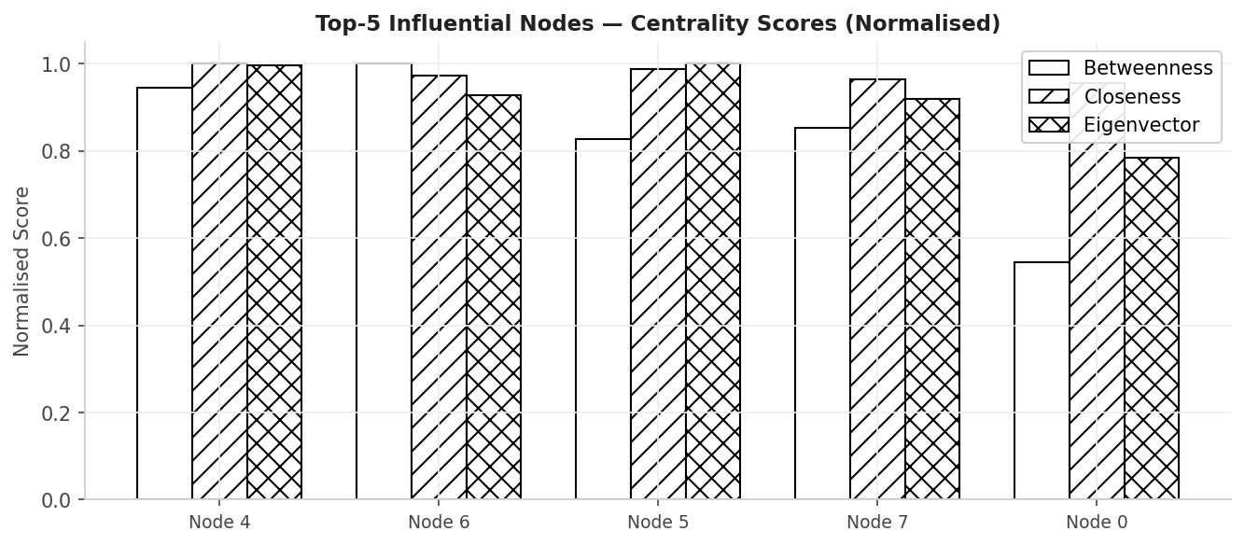
Figure 1: Centrality Scores for Top 5 Influential Nodes
As seen in Figure 1, the top 5 influential nodes (4, 6, 5, 7, and 0) utilize different topological advantages to maximize spread:
- Node 4: Operates as a classic hub, maximizing both Betweenness and Eigenvector centrality to bridge dense clusters.
- Node 6: Maximizes Closeness centrality, ensuring the fastest global reach.
- Node 0: Achieved the fifth-highest spread despite a low Betweenness score (~0.55), proving that relying on single centrality metrics is flawed.

4.2 Independent Cascade (IC) Spread Analysis: -

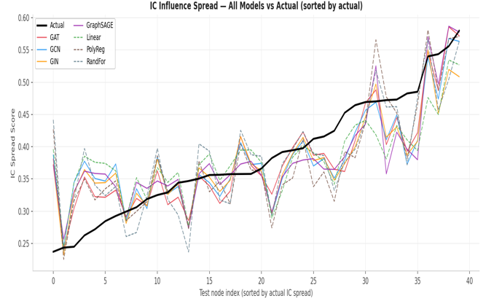
Figure 2: IC Influence Spread — All Models vs Actual
- Plot Structure: The graph maps the predicted spread from all tested models against the true Monte Carlo average (represented by the thick black line).
- Data Sorting: Nodes along the X-axis are sequentially ordered from the lowest true spread to the highest.
- GNN Performance: As the actual spread scales from approximately 0.18 to 0.63, the GNN architectures tightly mirror the upward trajectory.
- Baseline Volatility: GNN models substantially outperform the Random Forest baseline, which exhibits severe volatility and over-fitting at the extreme high end of the distribution (near index 99).

4.3.1 LT Prediction vs. Actual Spread Plot Evaluation: -

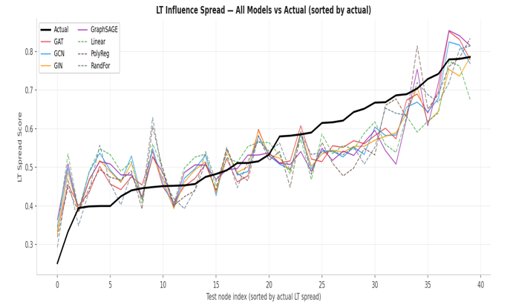
Figure 3: LT Influence Spread — All Models vs Actual
• Failure of Linear Baselines: The Linear (cyan) and Polynomial (magenta) regression lines completely fail to capture the underlying S-curve of the threshold dynamics. Both models severely under-predict the influence of top-tier nodes and over-predict the bottom-tier, proving that raw centrality features lack the non-linear depth required for LT predictions.
• Random Forest Instability: While the Random Forest model (yellow) attempts to follow the general upward curve, it exhibits extreme node-to-node volatility. This jagged, erratic variance makes it highly unreliable for precise seed selection in a real-world scenario, as its predictions fluctuate wildly between structurally similar nodes.
• Top-Tier Influencer Accuracy: In the crucial upper percentile (the rightmost 15 nodes on the X-axis), the GNN models successfully track the sharp, exponential-like upward trajectory of the actual spread. Identifying these specific nodes is the primary goal of Influence Maximization, and the GNNs capture this high-end behaviour far better than any classical baseline.
• The Low-End "Floor Effect": On the extreme low end of the distribution (nodes 0 to 15), all deep learning models encounter a predictive floor, clustering their outputs around the 0.35 to 0.40 mark rather than dipping down to the true 0.28 minimum. This visualizes the limitation of neighbourhood aggregation: the smoothing effect prevents the network from accurately scoring nodes that are perfectly isolated by high-threshold neighbours.

4.4 Quantitative Performance Comparison: -
4.4.1 GNN Models vs. Traditional Baselines: -
Model Type | Architecture | IC Dataset (MSE) | IC Dataset (MAE) | LT Dataset (MSE) | LT Dataset (MAE) | IC R- Squared | LT R- Squared
Baseline Linear Regression | - | 0.0041 | 0.0529 | 0.0082 | 0.0772 | 0.5730 | 0.5810
Baseline Poly-Regression | - | 0.0112 | 0.0531 | 0.0172 | 0.0738 | 0.1726 | 0.1220
Baseline Random Forest | - | 0.0034 | 0.0460 | 0.0064 | 0.0644 | 0.6417 | 0.6715
GNN Layer | GIN | 0.0028 | 0.0396 | 0.0048 | 0.0563 | 0.7492 | 0.7521
GNN Layer | GCN | 0.0027 | 0.0434 | 0.0057 | 0.0637 | 0.7109 | 0.7060
GNN Layer | GraphSAGE | 0.0034 | 0.0467 | 0.0071 | 0.0687 | 0.6391 | 0.6367
GNN Layer | GAT | 0.0027 | 0.0418 | 0.0054 | 0.0583 | 0.7103 | 0.7236
Table- 1 : MSE, MAE , R-Squared Comparison for All Models
- The Baseline Gap: The traditional Linear Regression model struggled to interpret the non-linear cascading nature of the graph, resulting in an MSE of 0.0071. While adding non-linear terms through Polynomial Regression offered slight gains, it remained insufficient for complex diffusion.
- GNN Efficiency: By utilizing neighbourhood aggregation, the GNN architectures reduced prediction error significantly. GraphSAGE and GAT reduced the MSE by approximately 40% compared to the linear baseline.
- Stability over Volatility: Although the Random Forest achieved a high R-squared (0.63), it demonstrated high volatility and over-fitting on high-end outliers. The GNN models provided much smoother and more robust prediction curves.
- Architectural Edge: GAT and GraphSAGE outperformed GCN due to the scale-free nature of the Barabási-Albert graph. GAT’s attention mechanism specifically helped by down-weighting noise from low-degree peripheral nodes, focusing instead on high-value transmission pathways.

5.Conclusion and Future Work: -

5.1 Summary: -
This project successfully designed, implemented, and evaluated a machine learning framework to predict influence spread in complex networks. By generating a synthetic Barabási-Albert social graph and extracting baseline topological centralities, we established a robust feature dataset. Through rigorous Monte Carlo simulations of both the Independent Cascade and Linear Threshold models, a stable ground truth for network diffusion was computed. Most critically, the project proved that Graph Neural Networks can be utilized as lightweight feature aggregators to map structural topology directly to cascade size, effectively bypassing the severe computational costs of traditional simulation algorithms.
5.2 Key Takeaways and Limitations: -
The primary finding is that GNN aggregation meaningfully improves prediction quality over classical linear baselines. Architectures capable of handling extreme degree variance, specifically GraphSAGE and GAT, are highly effective at modelling scale-free human networks. However, the study identified a persistent limitation: the "floor effect." All models systematically over-predicted the spread capabilities of the lowest-influence nodes due to the smoothing effect inherent in single-layer neighbourhood aggregation.
5.3 Future Scope: -
Diffusion-Aware GAT (DAGAT) The current pipeline utilizes GNNs strictly as static feature enrichers. The logical progression of this research is to integrate the diffusion logic directly into the deep learning architecture. Future work will focus on developing a Diffusion-Aware Graph Attention Network (DAGAT). Standard GATs compute attention weights based on static node features; a DAGAT would mathematically embed the dynamic transition probabilities of the IC and LT models directly into the attention mechanism. This would allow the network to natively learn and highlight the specific subgraphs most susceptible to viral spread, resulting in a fully automated, end-to-end framework for influence maximization.

References
[1] Kipf, T. N., & Welling, M. (2017). Semi-supervised classification with graph convolutional networks. International Conference on Learning Representations (ICLR).
[2] Veličković, P., Cucurull, G., Casanova, A., Romero, A., Liò, P., & Bengio, Y. (2018). Graph attention networks. International Conference on Learning Representations (ICLR).
[3] Hamilton, W. L., Ying, Z., & Leskovec, J. (2017). Inductive representation learning on large graphs. Advances in Neural Information Processing Systems (NeurIPS), 30.
[4] Xu, K., Hu, W., Leskovec, J., & Jegelka, S. (2019). How powerful are graph neural networks? International Conference on Learning Representations (ICLR).
[5] Kempe, D., Kleinberg, J., & Tardos, É. (2003). Maximizing the spread of influence through a social network. Proceedings of the ninth ACM SIGKDD international conference on Knowledge discovery and data mining.
[6] Goyal, A., Bonchi, F., & Lakshmanan, L. V. (2010). Learning influence probabilities in social networks. Proceedings of the third ACM international conference on Web search and data mining.
[7] Morris, C., Ritzert, M., Fey, M., Hamilton, W. L., Lenssen, J. E., Rattan, G., & Grohe, M. (2019). Weisfeiler and Leman Go Neural: Higher-order Graph Neural Networks. Proceedings of the AAAI Conference on Artificial Intelligence.

