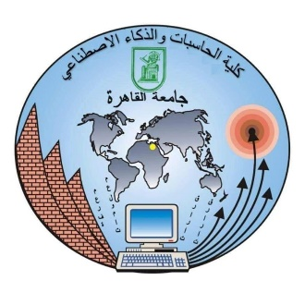

**Cairo University**

**Facility of Computer and Artificial Intelligence**

**IS231 - Web Technology**

Project: Job Portal

Project Number: 4

Phase-3

**Team Members**

**Eyad Ahmed Taimour – 20220073 (S13)**

**Hussam Eldin Hesham - 20220109 (All-B)**

**Huda Mohamed Abood - 20200621 (All-B)**

**Abobakr Khaled Amin - 20210004 (S15)**

**Maya Mohamed Noshy - 20220271 (S5)**

**Spring 2023/2024**