1)Create a docker for spring pet clinic

>create a VM

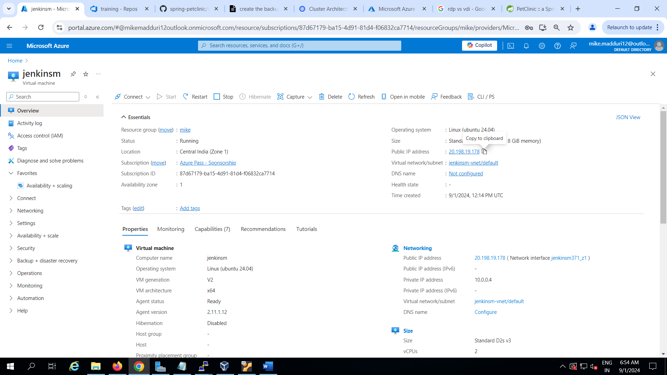

>connect to putty

>login as root user

>install Docker for ubuntu

>clone the spring pet clinic repository

git clone <https://github.com/Mythilee12/spring-petclinic>

>navigate to the project and create a Dockerfile

>FROM openjdk:17-jdk-slim

WORKDIR /app

COPY target/spring-petclinic-\*.jar app.jar

EXPOSE 8080

ENTRYPOINT ["java", "-jar", "app.jar"]

>build the docker image and run

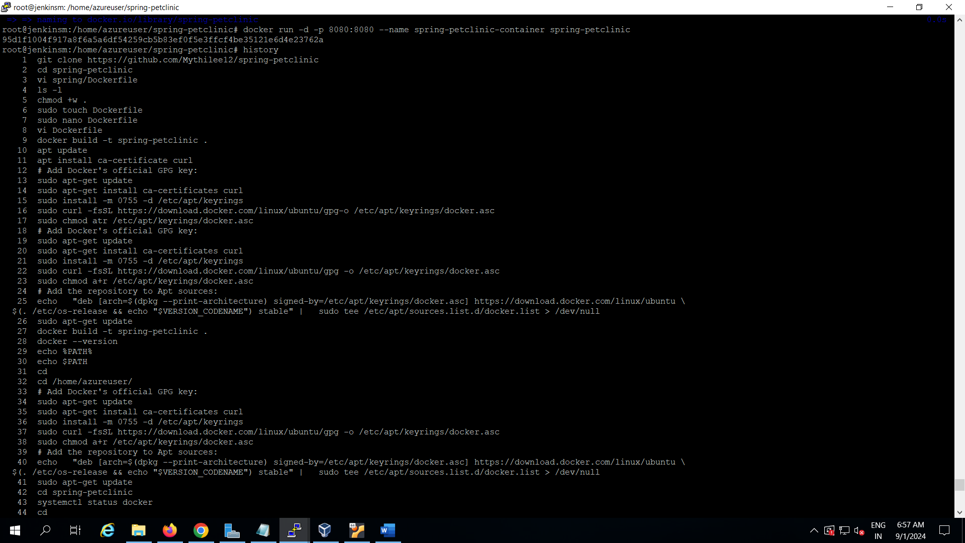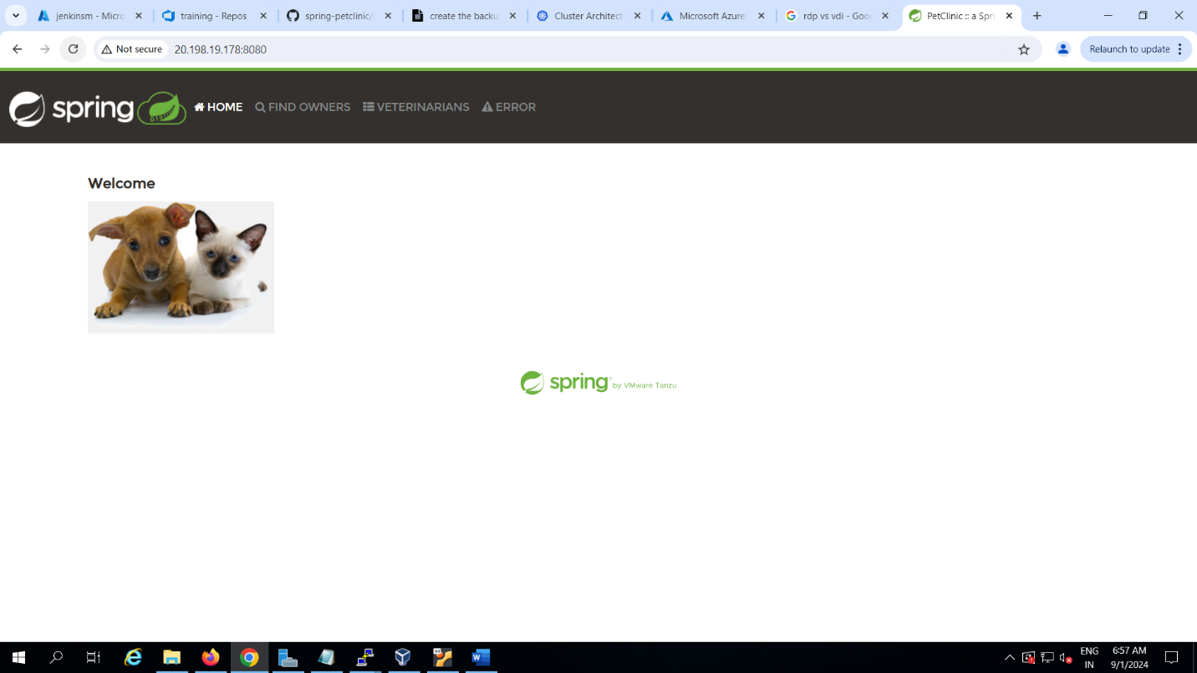

2)host spring pet clinic in Kubernetes

