1)Create and Configure an Azure SQL Database:

Create a new Azure SQL Database.

Configure firewall rules to allow access to your database from specific IP addresses.

Create tables, insert sample data, and run basic SQL queriess

Configure automated backups and test restoring a database from a backup

Set up and configure geo-replication to create readable secondary replicas in different regions.

>go to query editor

SELECT name FROM sys.databases;

SELECT table_name FROM information_schema.tables

SELECT * FROM [SalesLT].[Customer]

CREATE TABLE [SalesLT].[Department2] (

  Dep_ID INT PRIMARY KEY ,

  DepartmentName VARCHAR(100)

);

CREATE TABLE [SalesLT].[Employee2] (

  Emp_ID INT PRIMARY KEY ,

  Emp_Name NVARCHAR(50),

  Dep_ID INT,

  Salary DECIMAL(18, 2)

);

INSERT INTO [SalesLT].[Department2]  ( Dep_ID, DepartmentName)

VALUES (1, 'HR'),

(2, 'IT'),

(3, 'Finance'),

(4, 'Marketing');

INSERT INTO [SalesLT].[Employee2]  (Emp_ID, Emp_Name, Dep_ID, Salary)

VALUES (101, 'Meera', 1, 12000),

(102, 'Saara', 2, 10000),

(103, 'Keera', 2, 10000),

(104, 'jk', 3, 15000),

(105, 'Bob', 4, 20000);

select Employee2.Emp_Name, Department2.DepartmentName

from Employee2

inner join Department2 on Employee2.Dep_ID = Department2.Dep_ID;

select Employee2.Emp_Name, Department2.DepartmentName

from Employee2

left outer join Department2 on Employee2.Dep_ID = Department2.Dep_ID;

select Employee2.Emp_Name, Department2.DepartmentName

from Employee2

right outer join Department2 on Employee2.Dep_ID = Department2.Dep_ID;

2) Create and Configure an Azure MYSQL Database:

Create a new Azure SQL Database.

Configure firewall rules to allow access to your database from specific IP addresses.

Create tables, insert sample data, and run basic SQL queries

Create Employees and Departments tables and demostorate INNER JOIN, LEFT OUTER JOIN and RIGHT OUTER JOIN

Configure automated backups and test restoring a database from a backup

Set up and configure geo-replication to create readable secondary replicas in different regions.

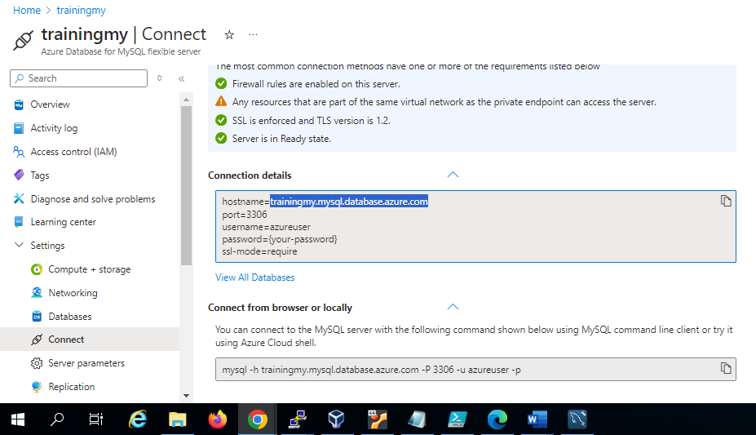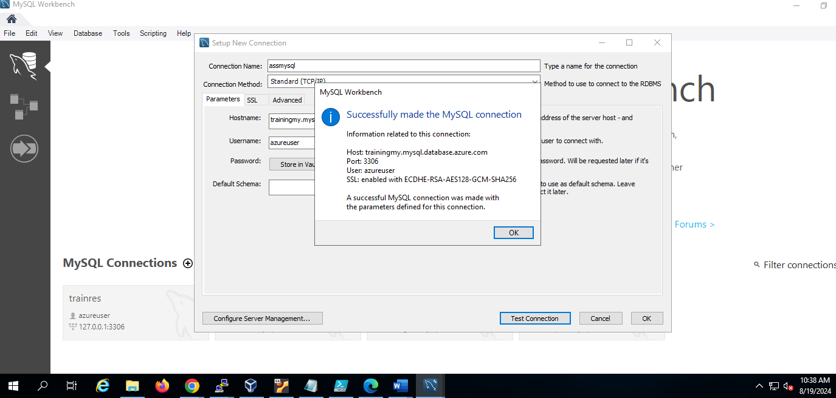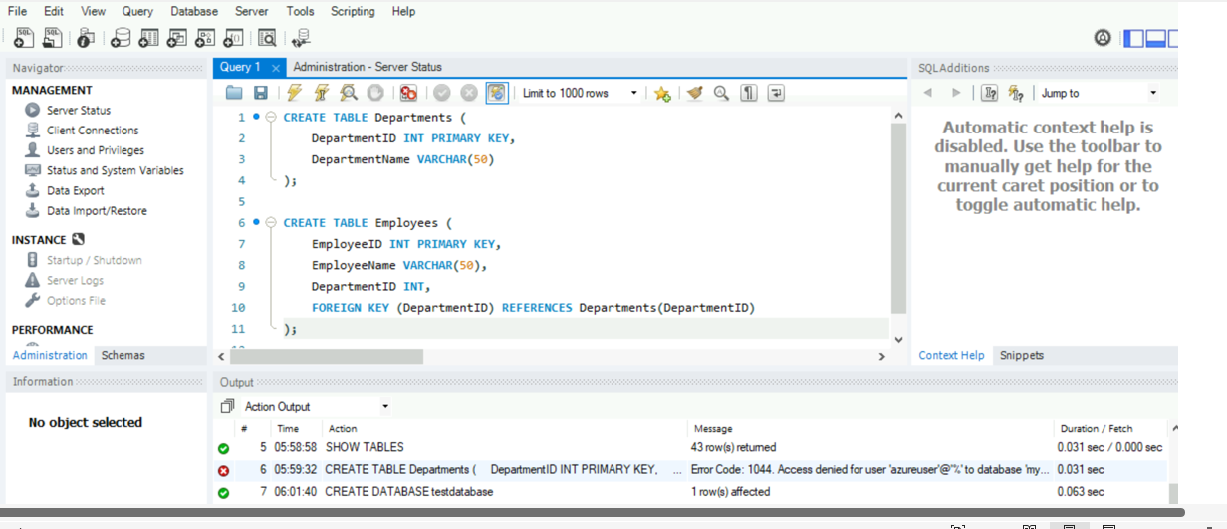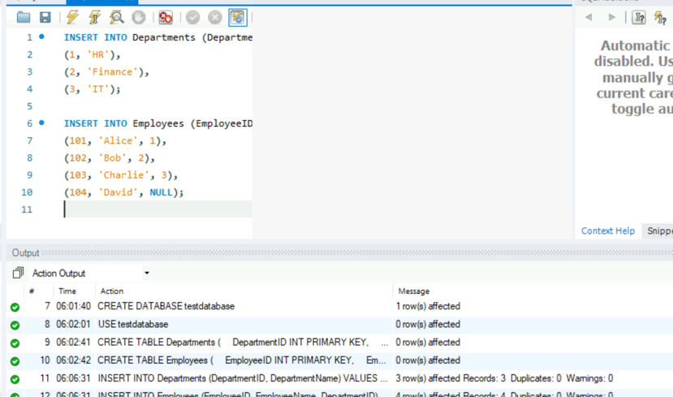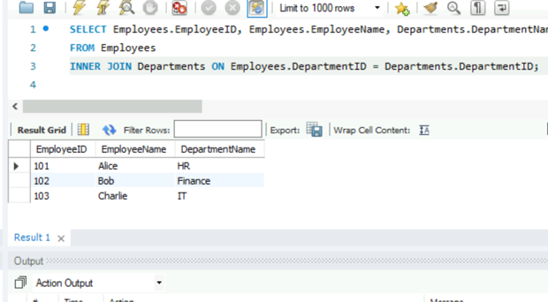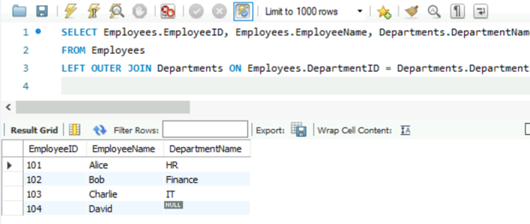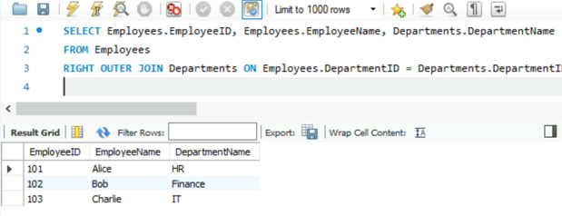

3) Host a jenkins image on azure container instance

>create a container instance with image source as other registry and image as Jenkins/jenkins

>add port 8080 , TCP in networking

>after container is created copy the ip address and browse

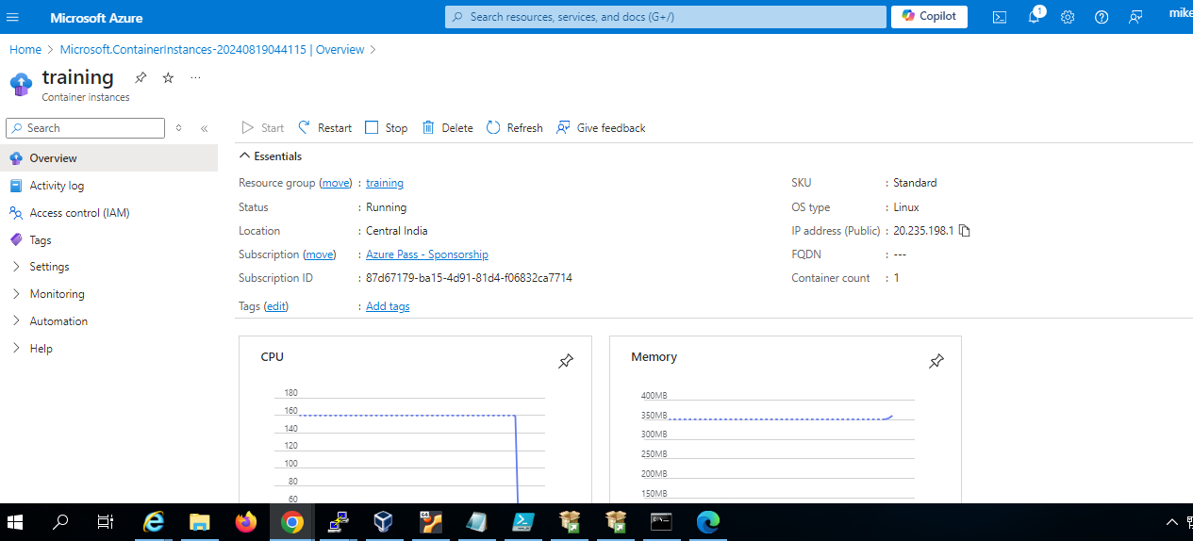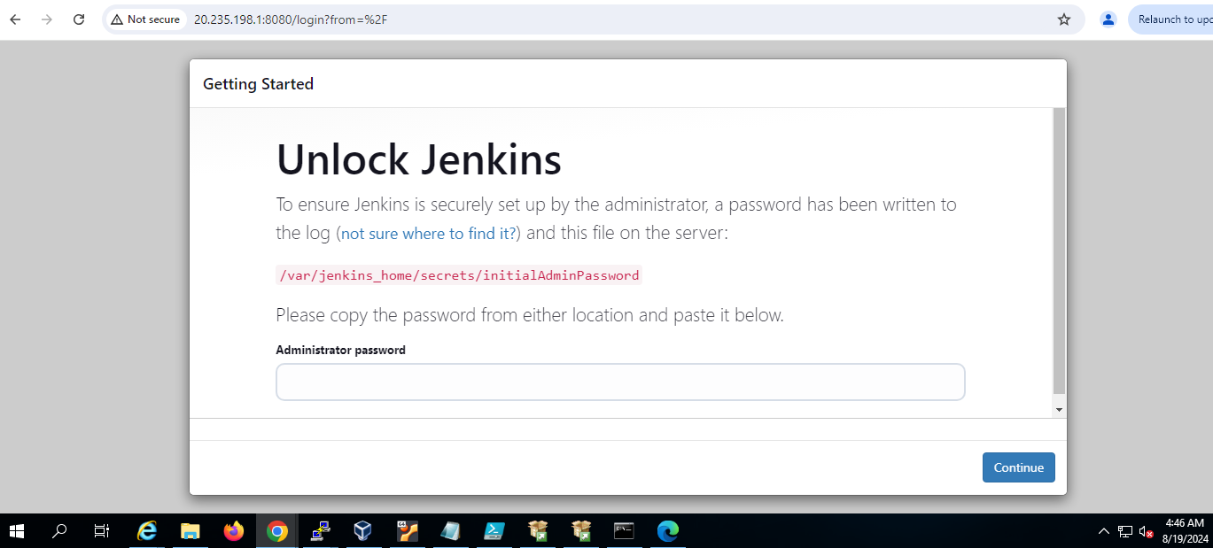

4) Create and Configure a Cosmos DB Account and demonstrate CRUD (Create, Read, Update, Delete) operations.

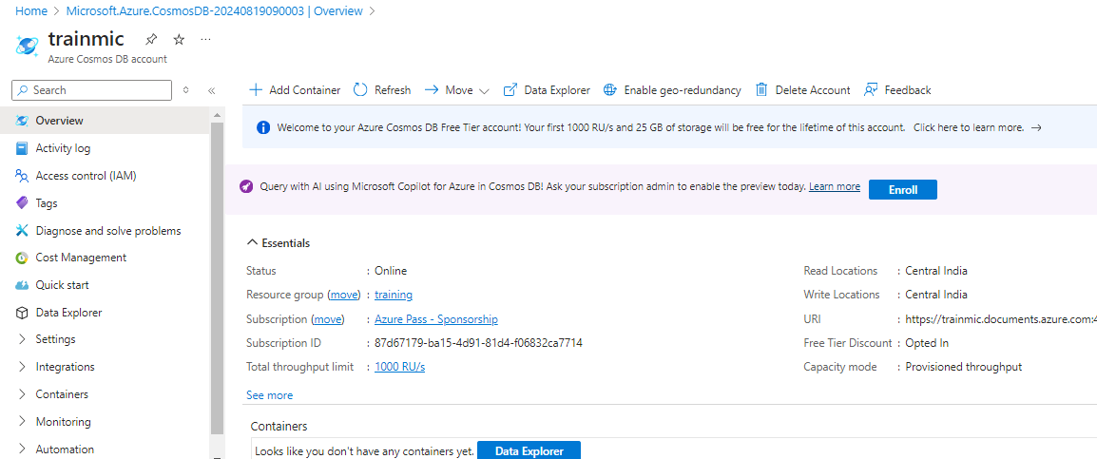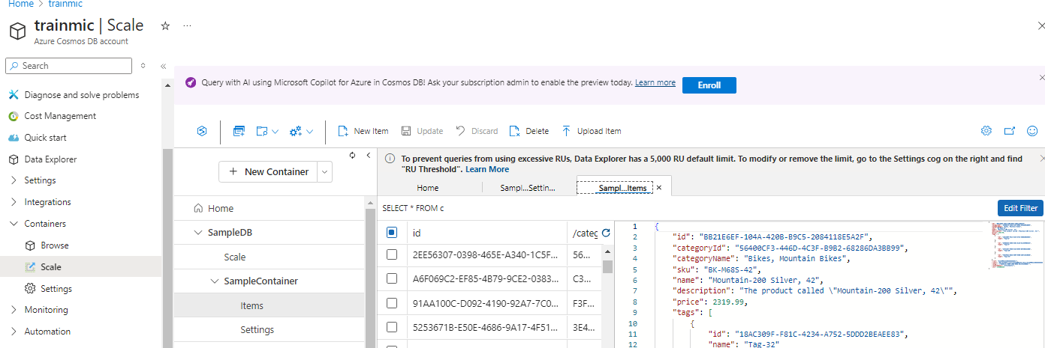

5) Create a alert for the high cpu usage with email notification on windows server



