Ex.no:5b | DATA VISUALIZATION USING MATPLOTLIB –  SALES DATA

AIM

To visualize and analyze the E-Commerce dataset using Line Chart, Bar Chart, and Pie Chart with Matplotlib to understand unit price trends, country-wise comparisons, and product category distribution.

ALGORITHM
- Import Pandas and Matplotlib libraries.
- Upload and load the E-Commerce dataset into a DataFrame.
- Convert the order_date column into date format.
- Group the data by order date and calculate the average unit price.
- Plot the average unit price over time using a Line Chart.
- Group the data by country and calculate the average unit price.
- Plot the country-wise average unit price using a Bar Chart.
- Count the products according to category.
- Plot the category distribution using a Pie Chart.
- Add suitable titles, axis labels, legends, and display the visualizations

CODE
from google.colab import files
import pandas as pd
import matplotlib.pyplot as plt
uploaded = files.upload()
file_name = list(uploaded.keys())[0]
df = pd.read_csv(file_name)
print(df.head())

df["order_date"] = pd.to_datetime(
df["order_date"],
errors="coerce"
)
daily_price = (
df.groupby("order_date")["unit_price"]
plt.figure(figsize=(12, 5))
plt.plot(
daily_price.index,
daily_price.values,
marker="o"
)
plt.title("Average Unit Price Over Time")
plt.xlabel("Order Date")
plt.ylabel("Average Unit Price")
plt.xticks(rotation=45)
plt.tight_layout()
plt.show()
country_avg = (
df.groupby("country")["unit_price"]
.mean()
.sort_values(ascending=False)
.head(10)
)
plt.figure(figsize=(10, 5))

plt.bar(
country_avg.index,
country_avg.values
)
plt.title("Top Countries by Average Unit Price")
plt.xlabel("Country")
plt.ylabel("Average Unit Price")
plt.xticks(rotation=45)
plt.tight_layout()
plt.show()
category_count = df["category"].value_counts()
plt.figure(figsize=(8, 8))
plt.pie(
category_count.values,
labels=category_count.index,
autopct="%1.1f%%",
startangle=90
)
plt.title("Product Category Distribution")
plt.show()

OUTPUT
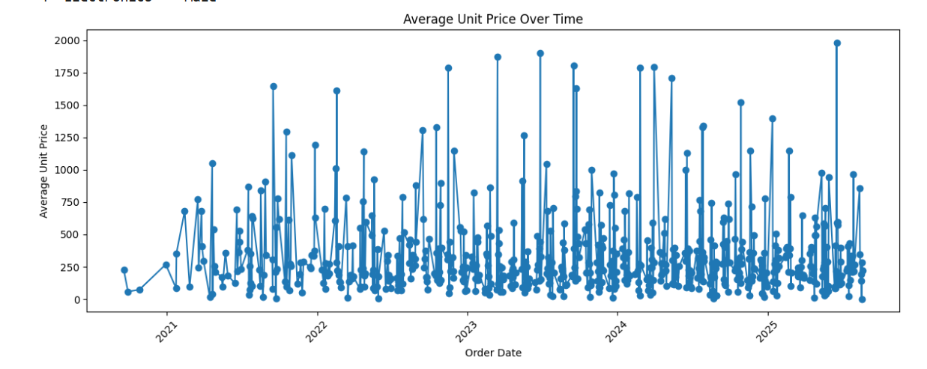
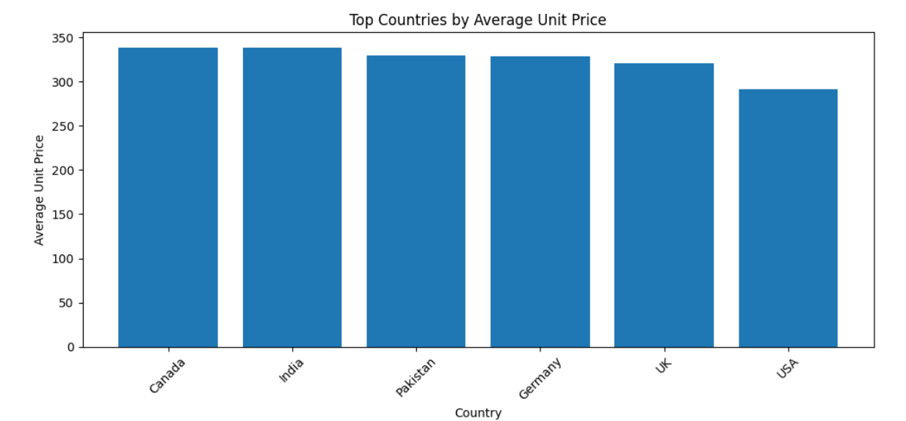
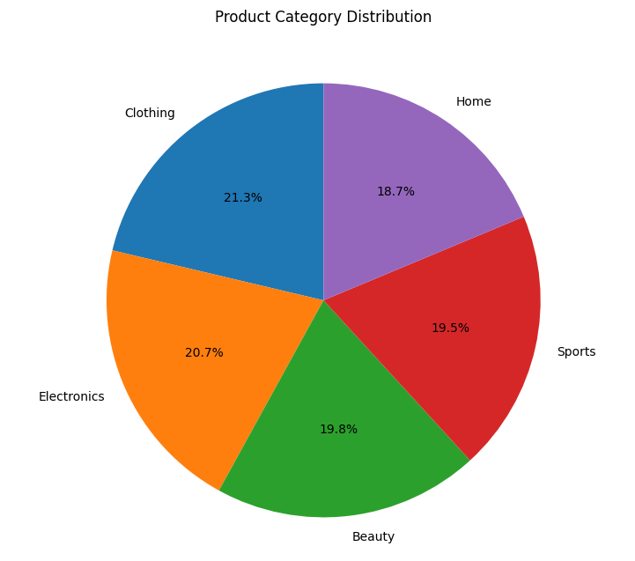

RESULT

