Ex.no:3 | DATA CLEANING

Aim:
To clean and preprocess the E-Commerce dataset by identifying and handling missing values, removing duplicate records, detecting outliers, scaling numerical data, encoding categorical data, and preparing a clean dataset for further analysis.

Algorithm:
Check Missing Values
- Start.
- Import the required libraries such as Pandas, NumPy, Matplotlib, Seaborn, and Scikit-learn.
- Upload and load the E-Commerce dataset into a DataFrame.
- Display the first few records, dataset shape, and information.
- Check for missing values in each column.
- Fill missing numerical values using the median of the respective columns.
- Identify and remove duplicate records.
- Detect outliers in the unit_price column using the IQR method.
- Visualize the outliers using a boxplot.
- Apply Min-Max scaling to the unit_price column.
- Apply Label Encoding to categorical columns.
- Apply One-Hot Encoding to the category column.
- Save the cleaned dataset as a CSV file.
- Stop.
Program:
import pandas as pd
import numpy as np
import matplotlib.pyplot as plt
import seaborn as sns
from sklearn.preprocessing import MinMaxScaler, LabelEncoder
from google.colab import files

uploaded = files.upload()

file_name = list(uploaded.keys())[0]
df = pd.read_csv(file_name)

print(df.head())

print("\nDataset Shape")
print(df.shape)

print("\nDataset Information")
df.info()

print("\nMissing Values")
print(df.isnull().sum())

numeric_cols = df.select_dtypes(include=np.number).columns

df[numeric_cols] = df[numeric_cols].fillna(
df[numeric_cols].median()
)

print("\nMissing Values After Filling")
print(df.isnull().sum())

print("\nDuplicate Rows:", df.duplicated().sum())

df.drop_duplicates(inplace=True)

print("After Removal:", df.shape)

Q1 = df["unit_price"].quantile(0.25)
Q3 = df["unit_price"].quantile(0.75)

IQR = Q3 - Q1

lower = Q1 - 1.5 * IQR
upper = Q3 + 1.5 * IQR

outliers = df[
(df["unit_price"] < lower) |
(df["unit_price"] > upper)
]

print("\nOutliers")
print(outliers.head())

print("Number of outliers:", len(outliers))

plt.figure(figsize=(8, 5))

sns.boxplot(x=df["unit_price"])

plt.title("Unit Price Outliers")
plt.xlabel("Unit Price")

plt.show()

scaler = MinMaxScaler()

df[["unit_price"]] = scaler.fit_transform(
df[["unit_price"]]
)

print("\nScaled Unit Price")
print(df[["unit_price"]].head())

encoder = LabelEncoder()

categorical_columns = [
"country",
"preferred_category",
"product_name",
"category",
"gender"
]

for col in categorical_columns:
df[col] = encoder.fit_transform(
df[col].astype(str)
)

print("\nEncoded Categorical Columns")
print(df[categorical_columns].head())

category_dummies = pd.get_dummies(
df["category"],
prefix="Category"
)

df = pd.concat(
[df, category_dummies],
axis=1
)

print("\nOne-Hot Encoded Category")
print(category_dummies.head())

df.to_csv(
"/content/E_Commerce_Customer_Cleaned.csv",
index=False
)

print("\nCleaned dataset saved successfully.")
Output:
Original DataFrame:
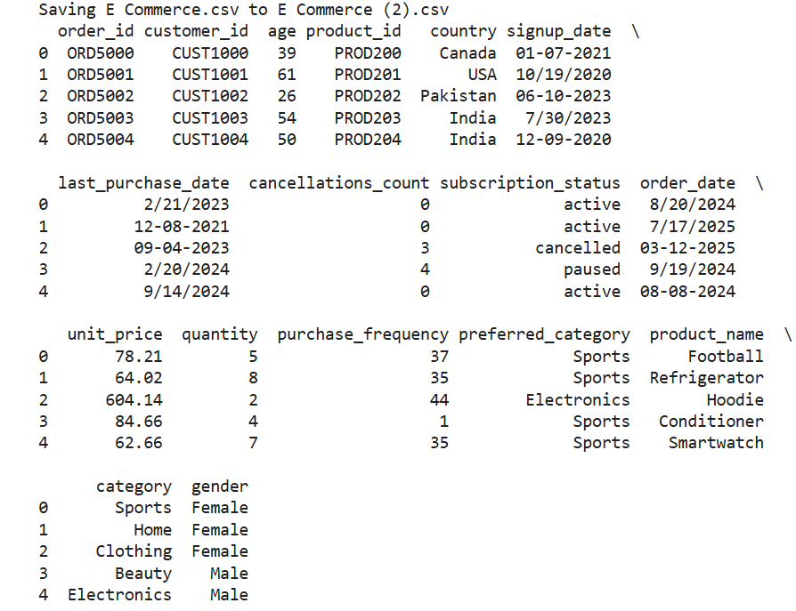

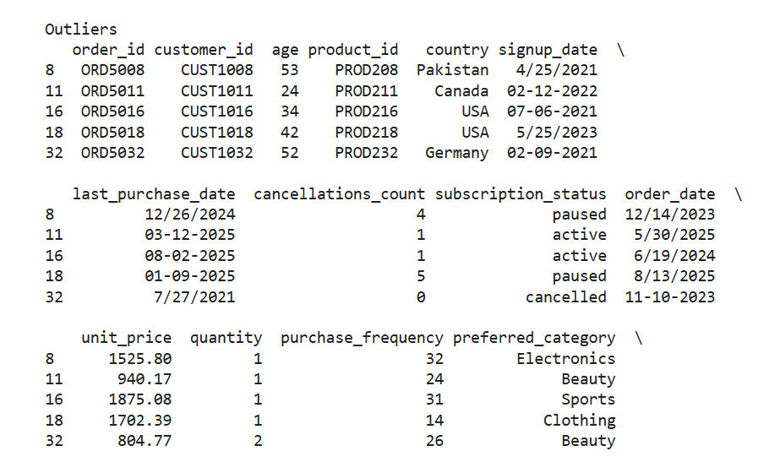
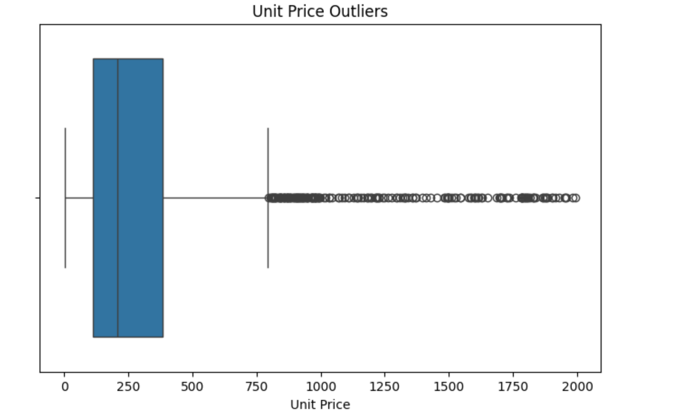
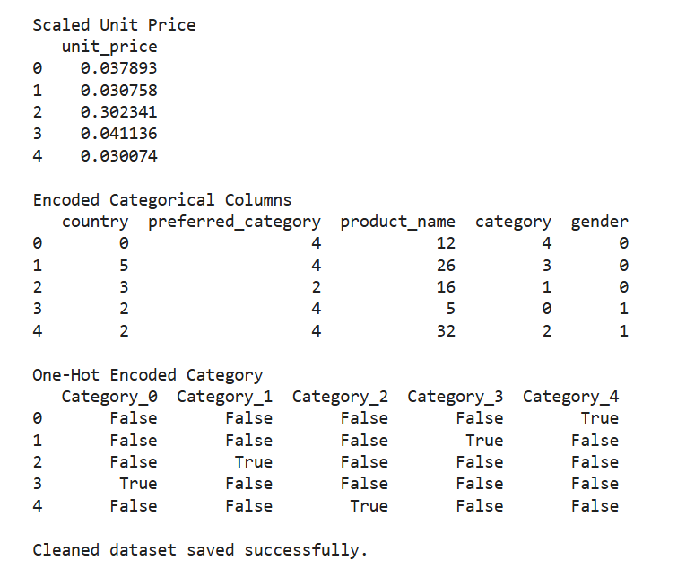

Result:

