EX No:1b | EDA DATA CLEANING

AIM

To perform exploratory data analysis on the E-Commerce Customer Insights and Churn Dataset by examining the dataset structure, dimensions, data types, statistical characteristics, missing values, country-wise and category-wise purchase distributions, product-wise purchase patterns, temporal purchase trends, purchase amount analysis, interactive filters, parameter-based analysis, and creating an interactive dashboard

ALGORITHM
- Import the required libraries such as Pandas, NumPy, Matplotlib, and Seaborn.
- Load the E-Commerce Customer Insights and Churn Dataset into a Pandas DataFrame.
- Display the first five and last five records of the dataset.
- Display the dataset information, shape, column names, and data types.
- Generate descriptive statistical information for numerical attributes.
- Identify the number of missing values in each column.
- Remove blank rows and duplicate records from the dataset.
- Perform data cleaning and standardization on the required categorical and numerical attributes.
- Calculate the Total Purchase Amount using unit_price and quantity.
- Analyze the distribution of purchases across different countries and categories.
- Analyze the distribution of purchases across different products.
- Analyze the purchase trend over time using the order_date attribute.
- Calculate and analyze the Purchase Amount Percentage for the different categories or countries.
- Create interactive visualizations including bar charts, pie charts, line charts, Country Filter, Minimum Purchase Amount Parameter, and an interactive Retail Sales Analysis Dashboard.
- Export the cleaned dataset into CSV format and display a confirmation message after successful file creation.

CODE

import pandas as pd
from google.colab import files
from sklearn.model_selection import train_test_split
from sklearn.preprocessing import LabelEncoder, StandardScaler
from sklearn.ensemble import RandomForestClassifier
from sklearn.metrics import accuracy_score

uploaded = files.upload()
df = pd.read_csv(list(uploaded.keys())[0])

print("First 5 Records")
print(df.head())

print("\nDataset Information")
df.info()

print("\nMissing Values")
print(df.isnull().sum())

print("\nStatistical Summary")
print(df.describe())

print("\nDataset Shape:", df.shape)
print("Column Names:", df.columns.tolist())
date_columns = ["signup_date", "last_purchase_date", "order_date"]

for col in date_columns:
df[col] = pd.to_datetime(df[col], errors="coerce")
df["signup_year"] = df["signup_date"].dt.year
df["signup_month"] = df["signup_date"].dt.month
df["last_purchase_year"] = df["last_purchase_date"].dt.year
df["last_purchase_month"] = df["last_purchase_date"].dt.month
df["order_year"] = df["order_date"].dt.year
df["order_month"] = df["order_date"].dt.month
df["order_day"] = df["order_date"].dt.day
df["order_weekday"] = df["order_date"].dt.weekday

df["customer_lifetime_days"] = (
df["last_purchase_date"] - df["signup_date"]
).dt.days

df.drop(date_columns, axis=1, inplace=True)
df["Churn"] = (
df["subscription_status"].str.lower().str.strip() == "cancelled"
).astype(int)

print("\nChurn Distribution")
print(df["Churn"].value_counts())
df.drop("subscription_status", axis=1, inplace=True)
df.drop(["order_id", "customer_id", "product_id"], axis=1, inplace=True)
for col in df.columns:
if col != "Churn":
if df[col].dtype == "object":
df[col] = df[col].fillna(df[col].mode()[0])
else:
df[col] = df[col].fillna(df[col].median())
encoder = LabelEncoder()

for col in df.select_dtypes(include="object").columns:
df[col] = encoder.fit_transform(df[col].astype(str))
X = df.drop("Churn", axis=1)
y = df["Churn"]

print("\nNumber of Features:", X.shape[1])
print("Number of Records:", X.shape[0])
X = StandardScaler().fit_transform(X)
X_train, X_test, y_train, y_test = train_test_split(
X, y, test_size=0.20, random_state=42
)
print("Training Records:", X_train.shape[0])
print("Testing Records:", X_test.shape[0])

model = RandomForestClassifier(n_estimators=100, random_state=42)
model.fit(X_train, y_train)

y_pred = model.predict(X_test)
accuracy = accuracy_score(y_test, y_pred)

print("\nCRISP-DM Accuracy:", round(accuracy * 100, 2), "%")

OUTPUT

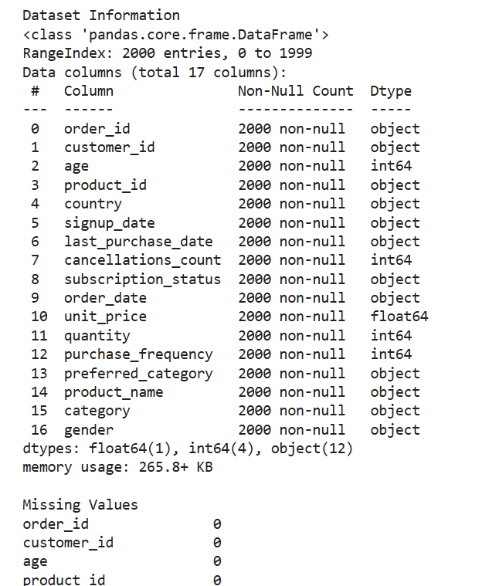

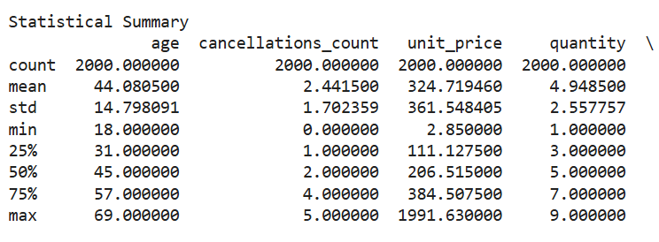

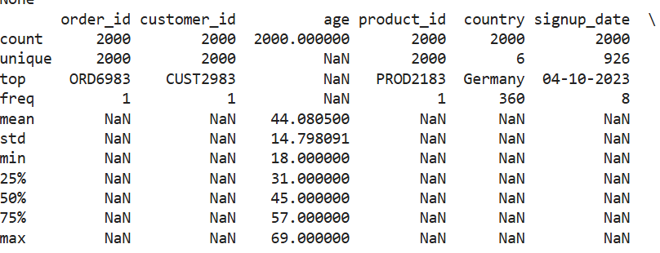

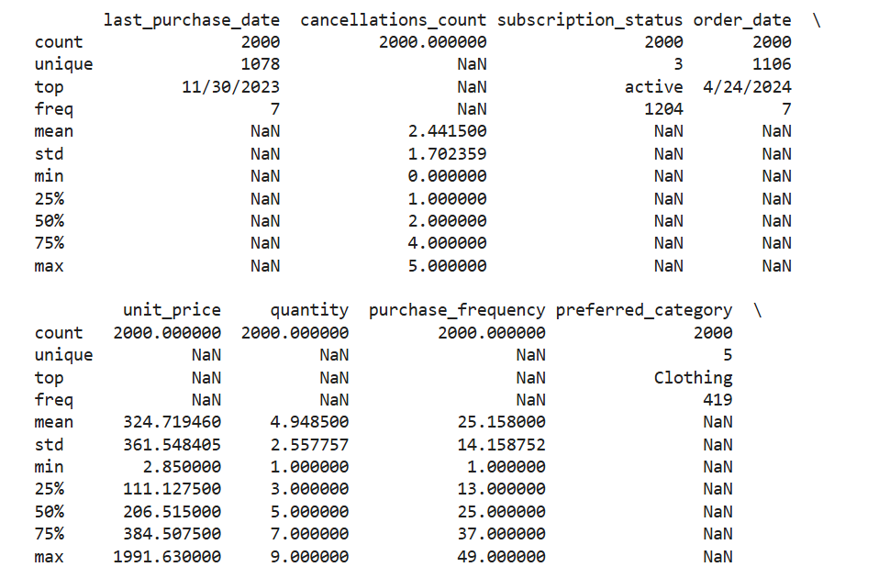

RESULT

