Ex.no:2 | EDA-DATA IMPORT AND EXPORT

Aim:
To inspect dataset features, detect null values, and export data into CSV, Excel, and SQLite database formats.
Algorithm:
- Import pandas and sqlite3 libraries.
- Read Food_Waste_Output.csv using pd.read_csv().
- Inspect the data structure using .head(), .tail(), .info(), .describe(), and .isnull().sum().
- Export the DataFrame to .csv and .xlsx formats using .to_csv() and .to_excel().
- Connect to food_waste.db using sqlite3 and write the data into an SQL table using .to_sql().
- Close the database connection and end execution.
Program:
import os
import pandas as pd
import sqlite3
from google.colab import files

uploaded = files.upload()

df = pd.read_csv("E Commerce.csv")

print("First 5 records:")
print(df.head())

print("\nLast 5 records:")
print(df.tail())

print("\nDataset information:")
df.info()

print("\nDataset shape:")
print(df.shape)

print("\nColumns:")
print(df.columns.tolist())

print("\nData types:")
print(df.dtypes)

print("\nStatistical summary:")
print(df.describe(include="all"))

print("\nMissing values:")
print(df.isnull().sum())

df.to_csv("e_commerce_data.csv", index=False)

df.to_excel("e_commerce_data.xlsx", index=False)

conn = sqlite3.connect("e_commerce.db")

df.to_sql("e_commerce", conn, if_exists="replace", index=False)

conn.close()

print("\nCSV, Excel and SQLite files created successfully.")

Output:
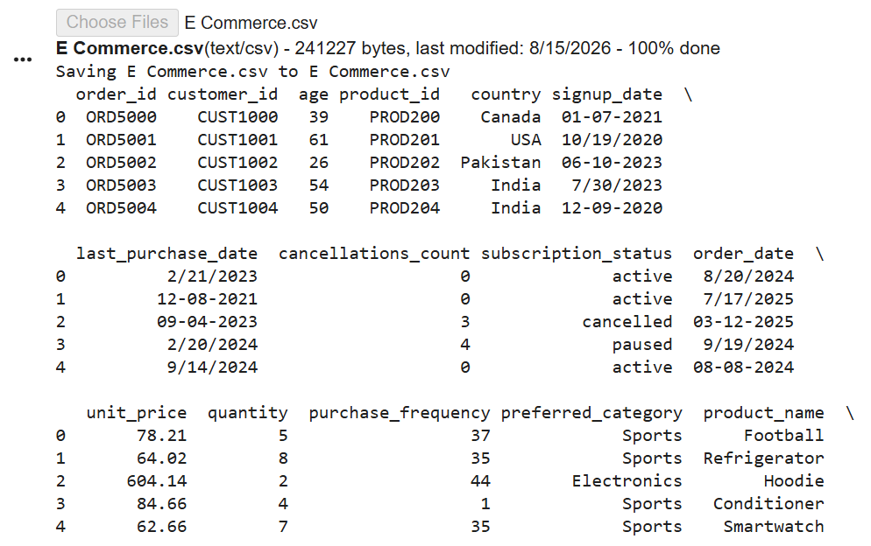

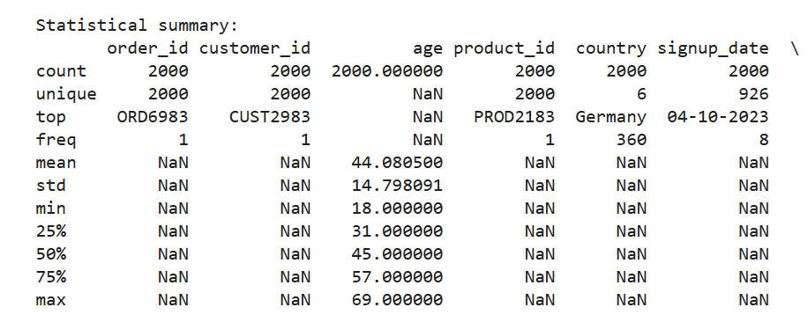

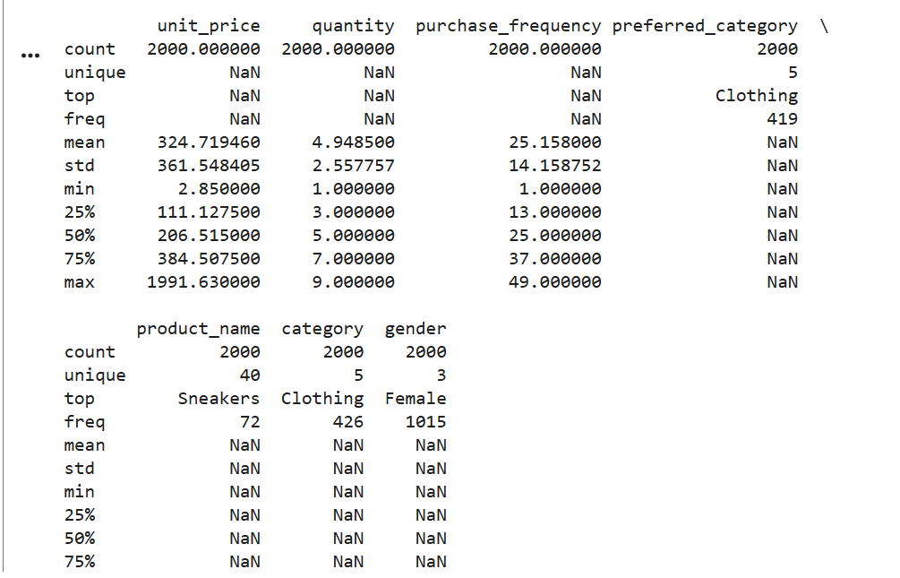
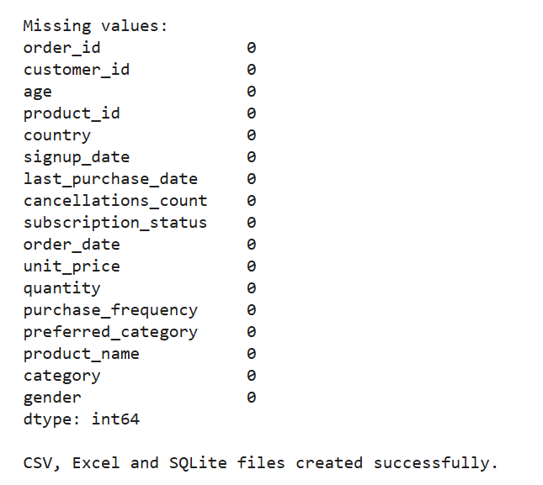

Result:

