Ex.no:4b | EXPLORATORY DATA ANALYSIS (EDA) – DATA INSPECTION, FILTERING, STATISTICAL ANALYSIS AND CORRELATION

Aim:
To perform exploratory data analysis on the E-Commerce dataset by inspecting, filtering, sorting, grouping, performing statistical and correlation analysis, and visualizing the results using Pandas, Matplotlib, and Seaborn.
Algorithm:
- Import the required Pandas, NumPy, Matplotlib, and Seaborn libraries.
- Upload and read the E-Commerce dataset into a DataFrame.
- Display the first few records, dataset shape, and data types.
- Generate the statistical summary of the dataset.
- Filter products based on unit price and customers based on country.
- Sort the records based on unit price in descending order.
- Group the data by country and calculate the average unit price.
- Calculate the mean, median, mode, and standard deviation of unit price.
- Calculate the correlation between selected numerical variables.
- Display the correlation matrix using a heatmap.
- Create a bar chart showing average unit price by country.
- Create a scatter plot to analyze the relationship between quantity and unit price.
- Display and interpret the obtained results.
Program:
# Import libraries
import pandas as pd
import matplotlib.pyplot as plt
import seaborn as sns
from google.colab import files

uploaded = files.upload()

file_name = list(uploaded.keys())[0]

df = pd.read_csv(file_name)

print(df.head())

print("\nDataset Shape")
print(df.shape)

print("\nData Types")
print(df.dtypes)

print("\nStatistical Summary")
print(df.describe())

high_price = df[df["unit_price"] > 500]

print("\nHigh Unit Price Products")
print(high_price.head())

india = df[df["country"] == "India"]

print("\nCustomers from India")
print(india.head())

sorted_df = df.sort_values(
by="unit_price",
ascending=False
)

print("\nTop Products by Unit Price")
print(sorted_df.head())

print("\nMean:", df["unit_price"].mean())

print("Median:", df["unit_price"].median())

print("Mode:")
print(df["unit_price"].mode())

print(
"Standard Deviation:",
df["unit_price"].std()
)

country_avg = (
df.groupby("country")["unit_price"]
.mean()
.sort_values(ascending=False)
.head(10)
)

print("\nAverage Unit Price by Country")
print(country_avg)

country_avg.sort_values(
ascending=False
).plot(kind="bar")

plt.title("Top Countries by Average Unit Price")
plt.xlabel("Country")
plt.ylabel("Average Unit Price")

plt.show()

corr = df[
[
"age",
"cancellations_count",
"unit_price",
"quantity",
"purchase_frequency"
]
].corr()

print("\nCorrelation Matrix")
print(corr)

print(
"\nCorrelation between Quantity and Unit Price:",
df["quantity"].corr(df["unit_price"])
)

plt.figure(figsize=(10, 6))

sns.heatmap(
corr,
annot=True,
cmap="coolwarm",
fmt=".2f"
)

plt.title("Correlation Matrix of E-Commerce Factors")

plt.show()

sns.scatterplot(
data=df,
x="quantity",
y="unit_price"
)

plt.title("Quantity vs Unit Price")
plt.xlabel("Quantity")
plt.ylabel("Unit Price")

plt.show()

plt.figure(figsize=(10, 5))

plt.plot(
df.index[:20],
df["unit_price"].head(20),
marker="o"
)

plt.title("Unit Price Trend")
plt.xlabel("Product Record")
plt.ylabel("Unit Price")

plt.show()

plt.figure(figsize=(8, 5))

plt.hist(
df["unit_price"],
bins=10
)

plt.title("Unit Price Distribution")
plt.xlabel("Unit Price")
plt.ylabel("Number of Products")

plt.show()

plt.figure(figsize=(8, 5))

plt.boxplot(df["unit_price"])

plt.title("Unit Price Box Plot")
plt.ylabel("Unit Price")

plt.show()

Output:
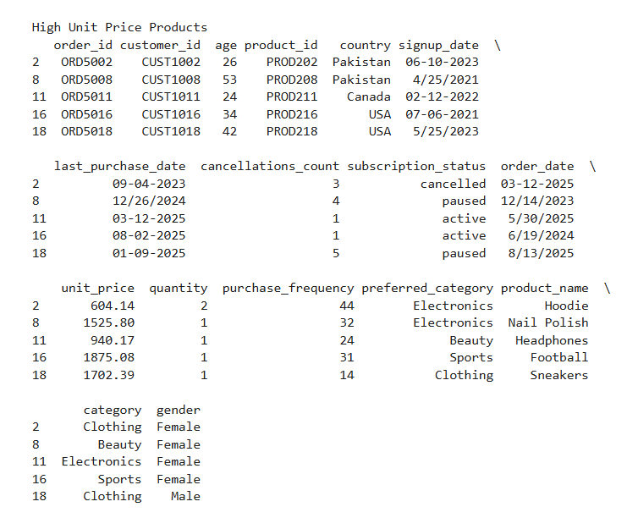
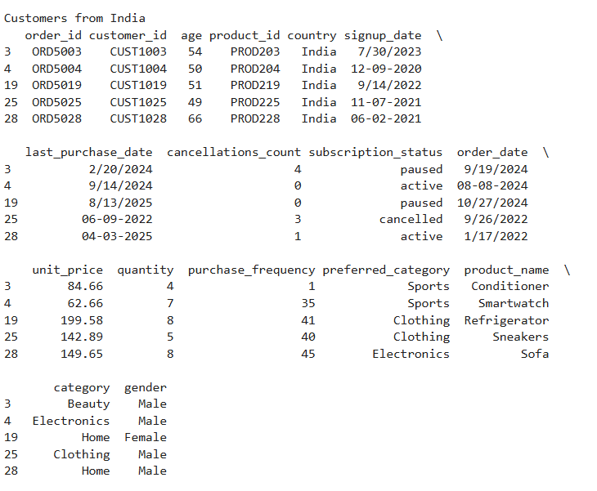

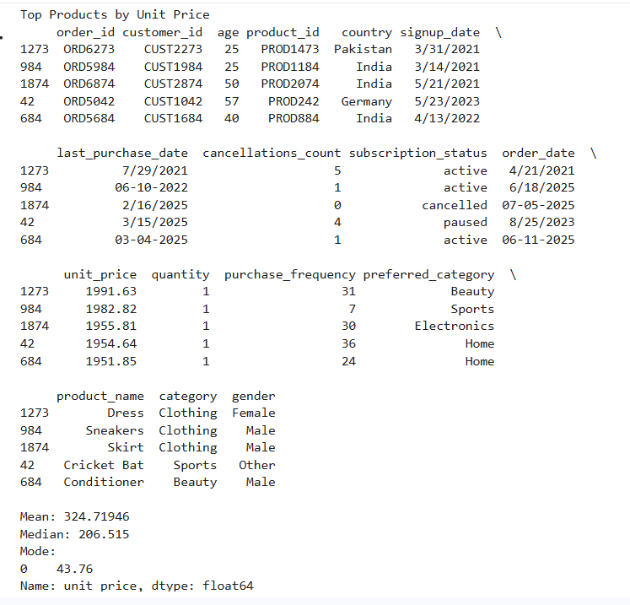

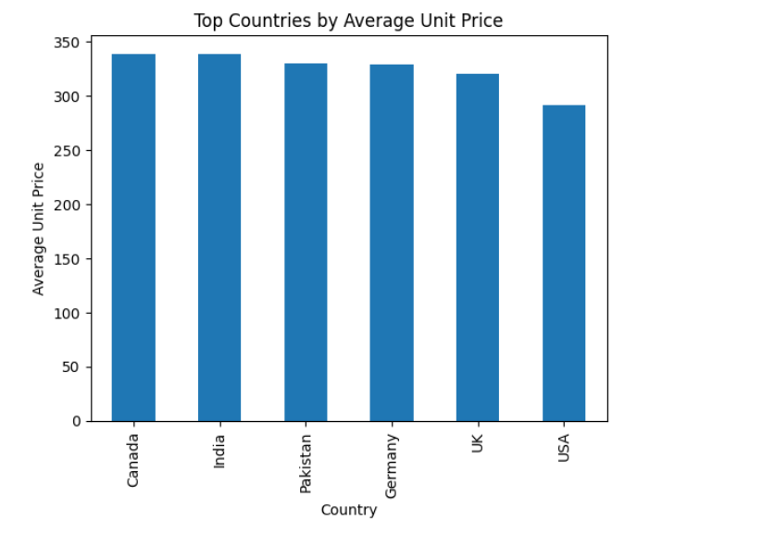

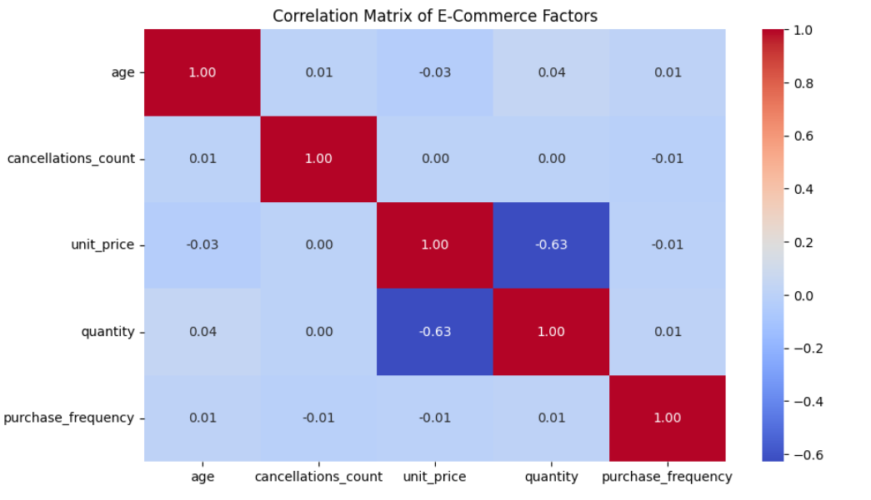

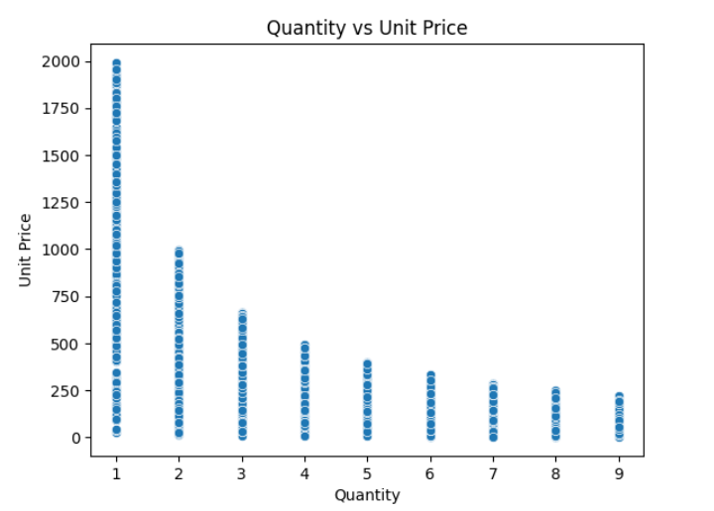
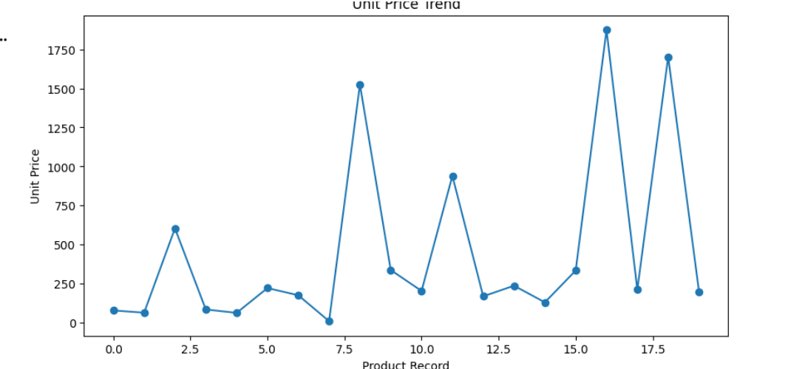

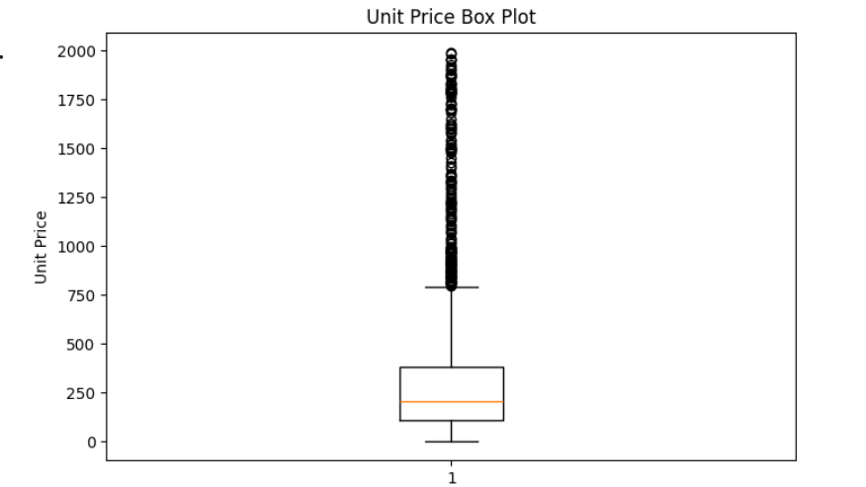
Result:

