Zero Trust Network Access (ZTNA) with
Zscaler: Securing Remote Workforce Access

TEAM MEMBER

- NO | NAME | COLLEGE NAME | CONTACT
1. | MYTHILI.M | SRI KRISHNA ADITHYA COLLEGE OF ARTS AND SCIENCE | 23bscs131mythilim@skacas.ac.in

Project details

Title: Implementing Zero Trust Network Access (ZTNA) using Zscaler for Securing Remote Workforce Access details

• AI-Enhanced User Protection (AIUP)

AI-Enhanced User Protection (AIUP) refers to the use of artificial intelligence and advanced analytics to improve security by continuously monitoring user behavior, device posture, and access patterns. In a Zero Trust environment, AIUP helps detect unusual activities, unauthorized access attempts, and potential threats in real time.
By integrating AI with Zscaler’s security framework, organizations can automatically identify suspicious behavior, enforce adaptive access policies, and prevent cyber attacks before they impact the system. AIUP enhances security by ensuring that every user request is analyzed intelligently before granting application access.
This approach not only improves threat detection but also strengthens identity verification, making remote access environments safer and more resilient against modern cyber threats.

Abstract:
The rapid growth of remote working environments has increased the need for secure access to organizational applications. Traditional network security models such as VPN often provide broad network access once a user is authenticated, which can increase the risk of unauthorized access and cyber attacks.This project focuses on implementing Zero Trust Network Access (ZTNA) using the Zscaler security platform to provide secure and controlled connectivity for remote employees. The Zero Trust model operates on the principle of “Never Trust, Always Verify,” where every user, device, and connection request must be authenticated and validated before access is granted.The project also includes web application vulnerability testing based on OWASP Top 10 security risks and vulnerability scanning using Nessus to identify potential weaknesses in web applications. By integrating ZTNA with identity verification, device validation, and security policies, organizations can ensure that users only access the resources they are authorized to use.The implementation of this model helps reduce attack surfaces, improve data protection, and provide a secure environment for remote workforce access to enterprise applications.

Use Case Scenarios

Scenario 1: Remote Employee Accessing HR Management System
A remote employee working from home needs to access the organization’s HR management portal to update personal records and submit leave requests. Using Zscaler Private Access (ZPA), the employee connects securely without accessing the internal corporate network. The system verifies the employee’s identity using multi-factor authentication (MFA) and checks device compliance before allowing access. Only the HR application is made available through a secure connection.
Output:
• Employee identity verified through MFA authentication
• Device posture validated (updated OS and antivirus active)
• Secure micro-tunnel established to HR application only
• Internal corporate network remains hidden from the user

Scenario 2: Remote Developer Accessing Source Code Repository
A software developer working remotely needs to access the organization’s internal Git repository to push code updates. Through ZTNA with Zscaler, the developer is authenticated and granted access only to the repository server. The system continuously monitors the session to ensure compliance with security policies. Any attempt to access unrelated servers or applications is automatically blocked.
Output:
• Developer identity verified through secure login authentication
• Access restricted only to the source code repository
• Unauthorized attempts to reach other servers automatically blocked
• Session activity monitored and logged for security auditing

Scenario 3: Remote Support Staff Accessing Customer Service Portal
A support team member working remotely needs access to the internal customer support application to resolve service tickets. ZTNA ensures that the user can securely connect to the support portal without exposing other internal systems. The system validates both user credentials and device security posture before granting access. This helps maintain secure and controlled connectivity.
Output:
• Support staff identity verified via authentication policy
• Device compliance verified before granting access
• Secure micro-tunnel created to the customer service portal only
• Access to other internal systems completely restricted

Scenario 4: Remote Finance Manager Accessing Financial Database
A finance manager working remotely needs to review financial records stored in the organization’s internal database. Using ZTNA through Zscaler, the manager securely connects to the database application without exposing the internal network. Strict access policies ensure that only authorized financial personnel can access sensitive financial data.
Output:
• Finance manager identity verified through role-based authentication
• Access restricted to financial database application only
• Sensitive financial data protected through encrypted connection
• Unauthorized access attempts automatically denied

Scenario 5: Temporary Employee Accessing Project Management Tool
A temporary employee hired for a short-term project needs access to the organization’s project management platform. The administrator creates a time-limited access policy using Zscaler. The user can only access the project management application during the allowed time period. Once the project duration ends, access is automatically revoked.
Output:
• Temporary user identity verified with assigned credentials
• Access limited to project management application only
• Time-based access control policy enforced
• Access automatically revoked after project completion

Scenario 6: Remote Employee Accessing Cloud Storage System
An employee working remotely needs to access organizational files stored in a cloud-based storage system. ZTNA ensures that the user is authenticated and their device security posture is verified before granting access. The employee can only interact with the authorized cloud storage service without visibility into other network resources.
Output:
• User identity verified through secure authentication process
• Device posture checked for security compliance
• Secure connection established to cloud storage application
• Internal network infrastructure remains completely hidden

Stage-1

Title Of The Project: -

Zero Trust Network Access (ZTNA) with Zscaler: Securing Remote Workforce Access

Overview: -
The project aims to develop an AI-driven identity verification and secure access system that enhances remote workforce security by continuously analyzing and validating user identities and device posture. The system is designed to provide secure connectivity between remote employees and enterprise applications while preventing unauthorized access to internal networks. By implementing Zero Trust Network Access (ZTNA) using the Zscaler platform, the system ensures that every access request is authenticated and verified before granting permission.
The primary objective of this project is to strengthen cybersecurity by enforcing the Zero Trust principle of “Never Trust, Always Verify.” Instead of granting full network access as traditional VPN solutions do, ZTNA allows users to connect only to specific applications based on their identity, role, and device security status. The system evaluates multiple security parameters including user credentials, device compliance, and access policies before establishing a secure connection.
Multi-factor authentication (MFA) is implemented to provide an additional layer of protection. Whenever suspicious activity or anomalies are detected, the system triggers additional verification steps and generates alerts for administrators. Monitoring and logging mechanisms are also integrated to track user activity, ensuring transparency and enabling quick response to potential security incidents.
The system also includes centralized policy management that allows administrators to define access rules based on user roles, departments, and application requirements. Security policies ensure that users can only access the resources necessary for their work, minimizing the risk of insider threats and data breaches. Encryption mechanisms are used to protect data in transit, ensuring secure communication between users and applications.
Cloud infrastructure support further improves scalability and reliability of the system. Zscaler’s cloud security platform enables secure remote connectivity from any location without exposing the organization’s internal network to the internet. Continuous monitoring and optimization ensure that the system remains effective against evolving cyber threats while maintaining performance and security for remote workforce environments.

List of Vulnerability Table:

S.NO | Vulnerability Name | CWE.NO
01 | Relative Path Traversal | CWE-23
02 | Password in Configuration File | CWE-260
03 | Dependency on Vulnerable Third-Party Component | CWE-1395
04 | Use of a One-Way Hash without a Salt | CWE-759

05 | Improper Input Validation | CWE-20
06 | Incorrect Privilege Assignment | CWE-266
07 | Improper Authentication | CWE-287
08 | Insufficient Verification of Data Authenticity | CWE-345
09 | Insufficient Verification of Data Authenticity | CWE-345
10 | Insertion of Sensitive Information Into Debugging Code | CWE-215

REPORT:

1) Vulnerability Name: Relative Path Traversal
CWE – 23: Relative Path Traversal
OWASP Category: A01:2025 – Broken Access Control
Description:
Relative Path Traversal occurs when an application allows user-controlled input to access files and directories outside the intended directory structure. Attackers can manipulate file paths using special characters such as "../" to navigate through directories and access restricted files. This vulnerability arises when proper input validation and access controls are not implemented.
Business Impact:
Attackers may gain unauthorized access to sensitive files such as configuration files, system credentials, or application source code. This can lead to data exposure, system compromise, or further exploitation of the application environment.
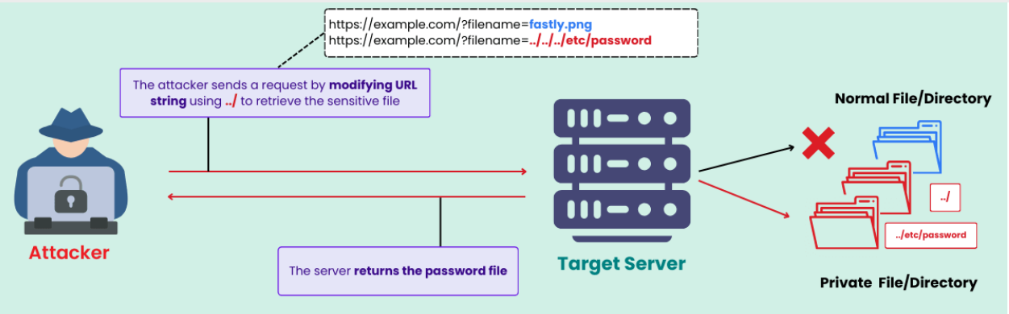

2) Vulnerability Name: Password in Configuration File
CWE – 260: Password in Configuration File
OWASP Category: A02:2025 – Security Misconfiguration
Description:
This vulnerability occurs when passwords or sensitive credentials are stored in plaintext within configuration files. If these files are exposed or accessed by unauthorized users, attackers may retrieve the stored credentials and gain unauthorized access to systems or databases.
Business Impact:
Exposure of configuration files containing passwords may allow attackers to access internal systems, databases, or administrative accounts. This can lead to unauthorized data access, system compromise, and potential data breaches.
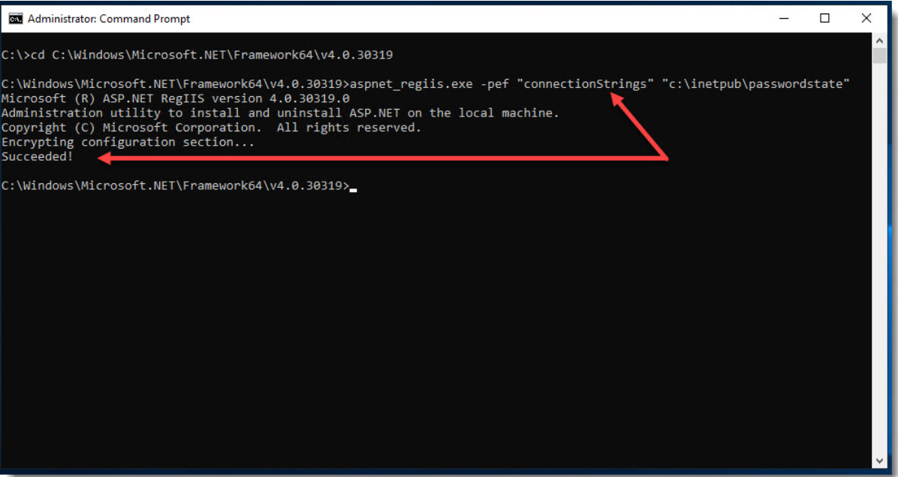

3) Vulnerability Name: Dependency on Vulnerable Third-Party Component
CWE – 1395: Dependency on Vulnerable Third-Party Component
OWASP Category: A03:2025 – Software Supply Chain Failures
Description:
Applications often rely on third-party libraries or components to provide additional functionality. If these components contain known vulnerabilities and are not updated regularly, attackers may exploit them to compromise the application or underlying systems.
Business Impact:
Using vulnerable third-party components can expose the application to various security risks such as remote code execution, data leaks, or unauthorized system access. Organizations may also face security compliance issues and reputational damage.

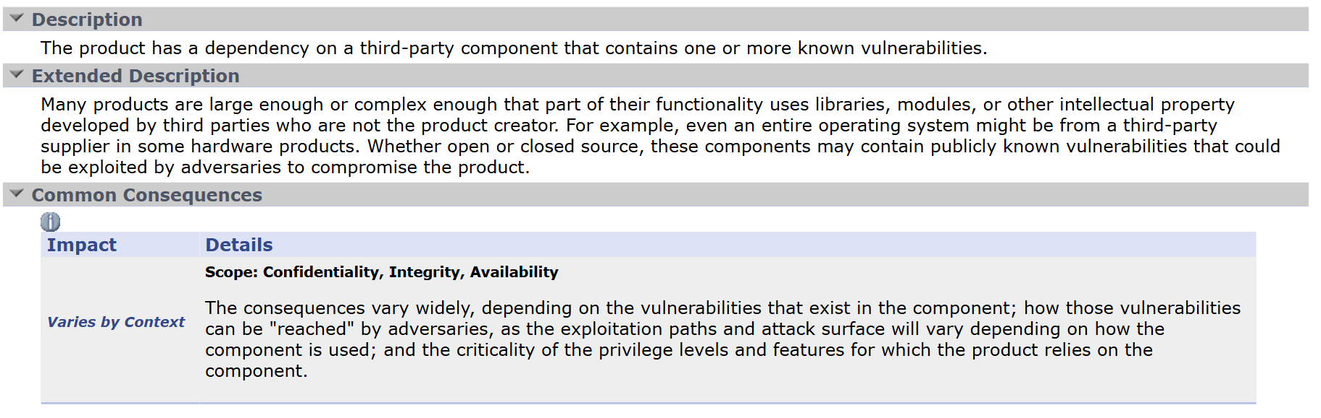

4) Vulnerability Name: Use of a One-Way Hash without a Salt
CWE – 759: Use of a One-Way Hash without a Salt
OWASP Category: A04:2025 – Cryptographic Failures
Description:
This vulnerability occurs when passwords or sensitive data are hashed without using a unique salt value. Without salting, attackers can use precomputed tables such as rainbow tables to quickly crack hashed passwords and retrieve the original values.
Business Impact:
If attackers successfully crack hashed passwords, they may gain unauthorized access to user accounts or administrative systems. This can result in data breaches, identity theft, and compromise of sensitive organizational information.
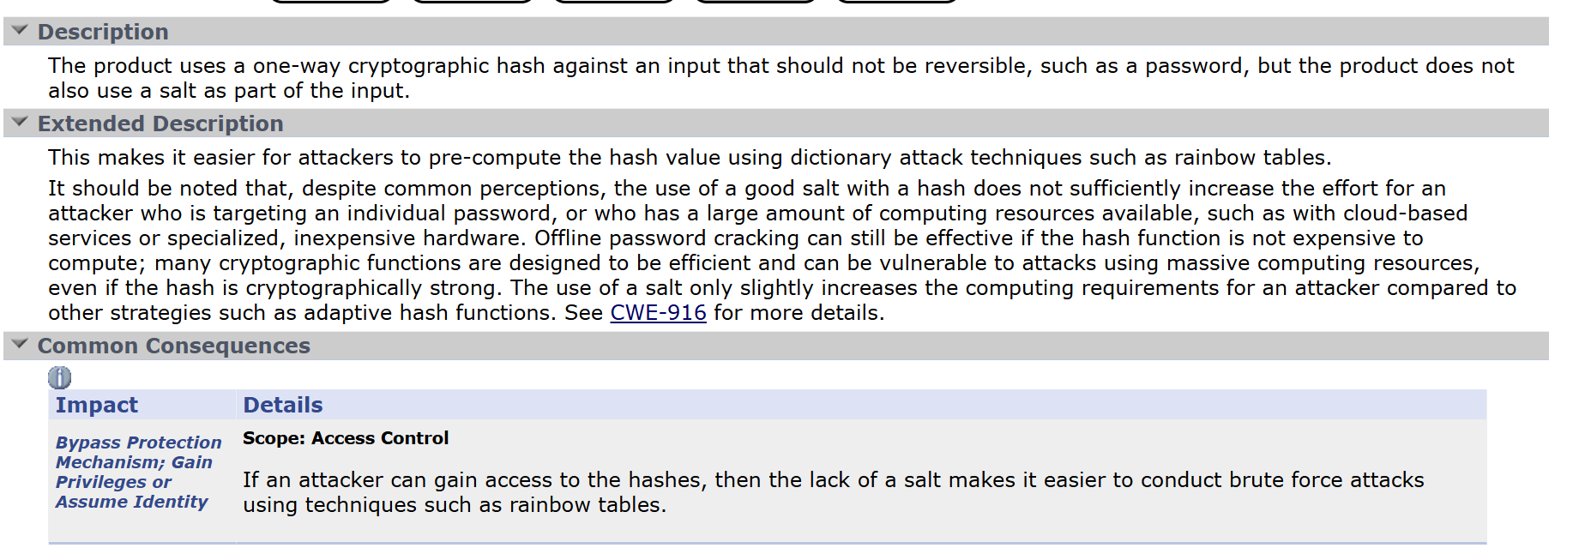

5) Vulnerability Name: Improper Input Validation
CWE – 20: Improper Input Validation
OWASP Category: A05:2025 – Injection
Description:
Improper Input Validation occurs when an application fails to properly validate or sanitize user input before processing it. Attackers may exploit this vulnerability to inject malicious data or commands into the application, leading to unauthorized operations or system compromise.
Business Impact:
Exploiting this vulnerability may allow attackers to execute malicious commands, manipulate application data, or disrupt services. It can lead to serious consequences such as unauthorized database access, data corruption, or service downtime.
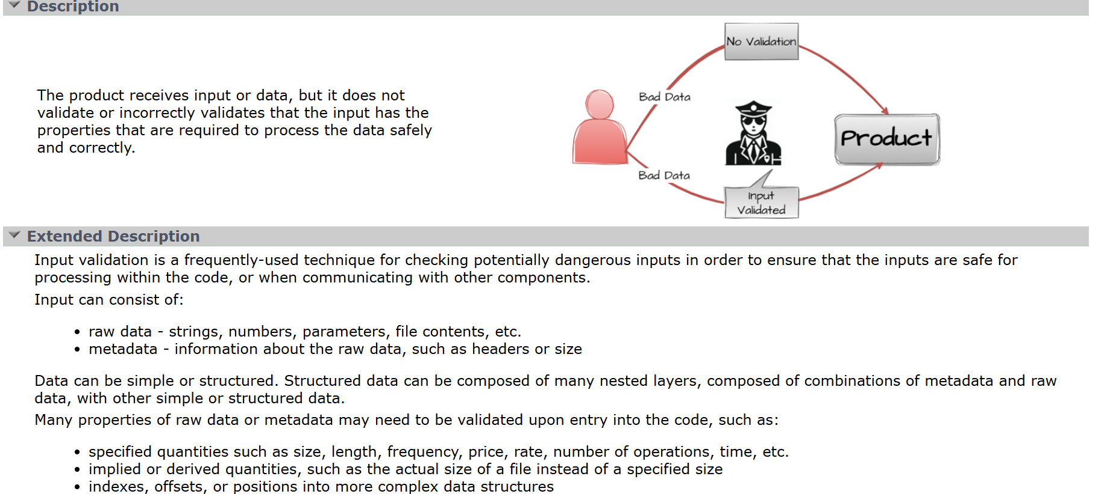

6) Vulnerability Name: Incorrect Privilege Assignment
CWE – 266: Incorrect Privilege Assignment
OWASP Category: A06:2025 – Insecure Design
Description:
Incorrect Privilege Assignment occurs when users are granted higher access privileges than required for their roles. This vulnerability often results from poor system design or improper role-based access control implementation.
Business Impact:
Users with excessive privileges may access sensitive resources or perform unauthorized actions within the system. This can increase the risk of insider threats, data leaks, and system misuse.
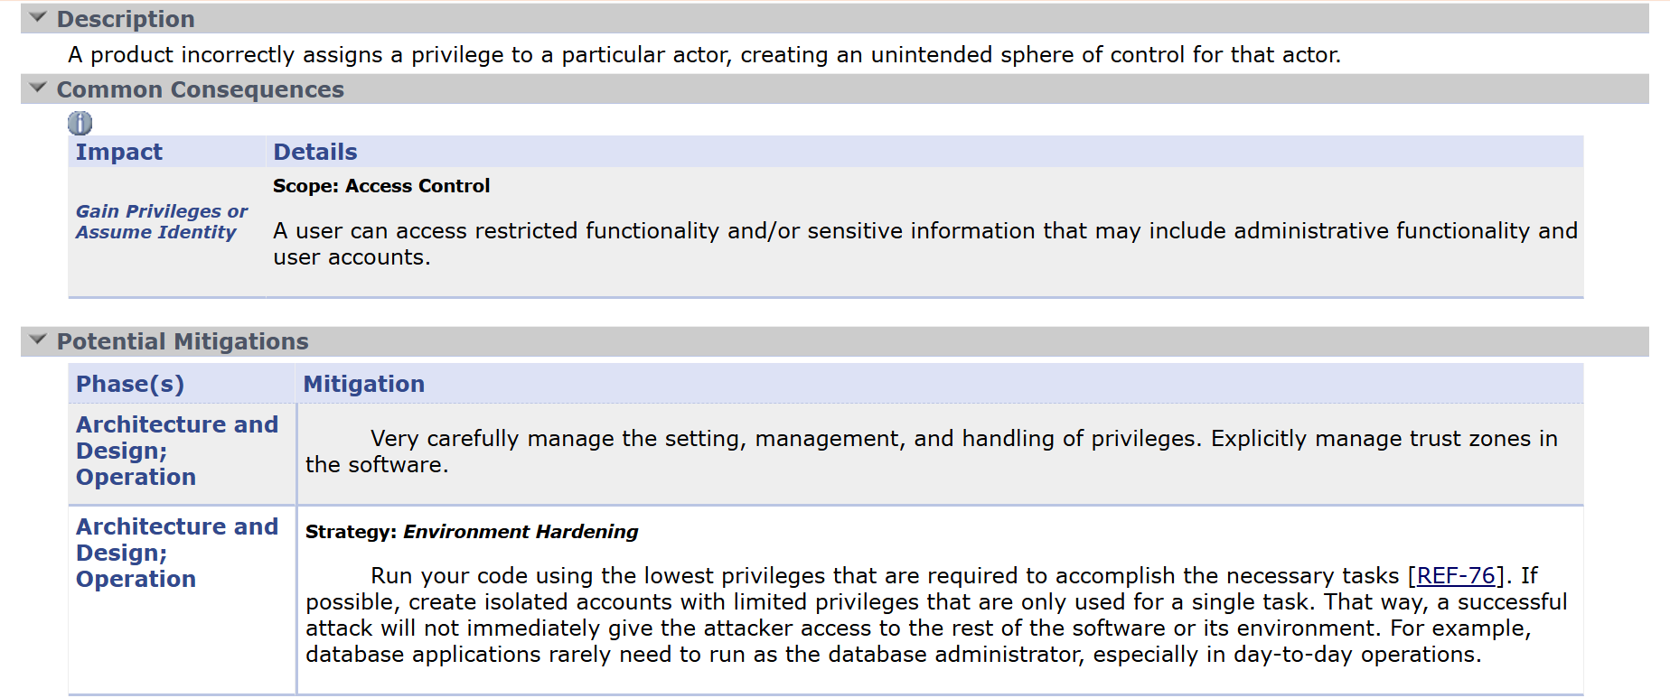

7) Vulnerability Name: Improper Authentication
CWE – 287: Improper Authentication
OWASP Category: A07:2025 – Authentication Failures
Description:
Improper Authentication occurs when an application does not correctly verify the identity of users before granting access. Weak authentication mechanisms, lack of multi-factor authentication, or improper session management can lead to this vulnerability.
Business Impact:
Attackers may bypass authentication mechanisms and gain unauthorized access to user accounts or administrative systems. This can lead to data breaches, unauthorized transactions, and compromise of sensitive information.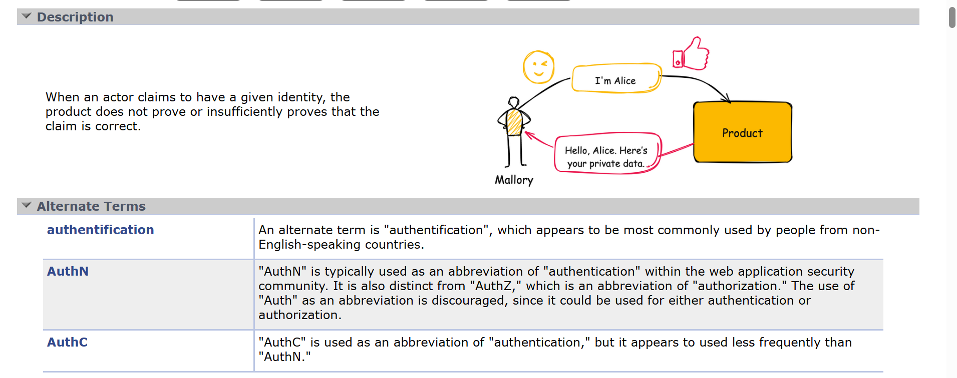

8) Vulnerability Name: Insufficient Verification of Data Authenticity
CWE – 345: Insufficient Verification of Data Authenticity
OWASP Category: A08:2025 – Software or Data Integrity Failures
Description:
This vulnerability occurs when an application fails to verify the authenticity or integrity of received data. Without proper validation mechanisms such as digital signatures or integrity checks, attackers may modify or inject malicious data into the system.
Business Impact:
Failure to verify data authenticity can allow attackers to manipulate critical system data or distribute malicious content. This may result in compromised application functionality, data corruption, and security breaches.
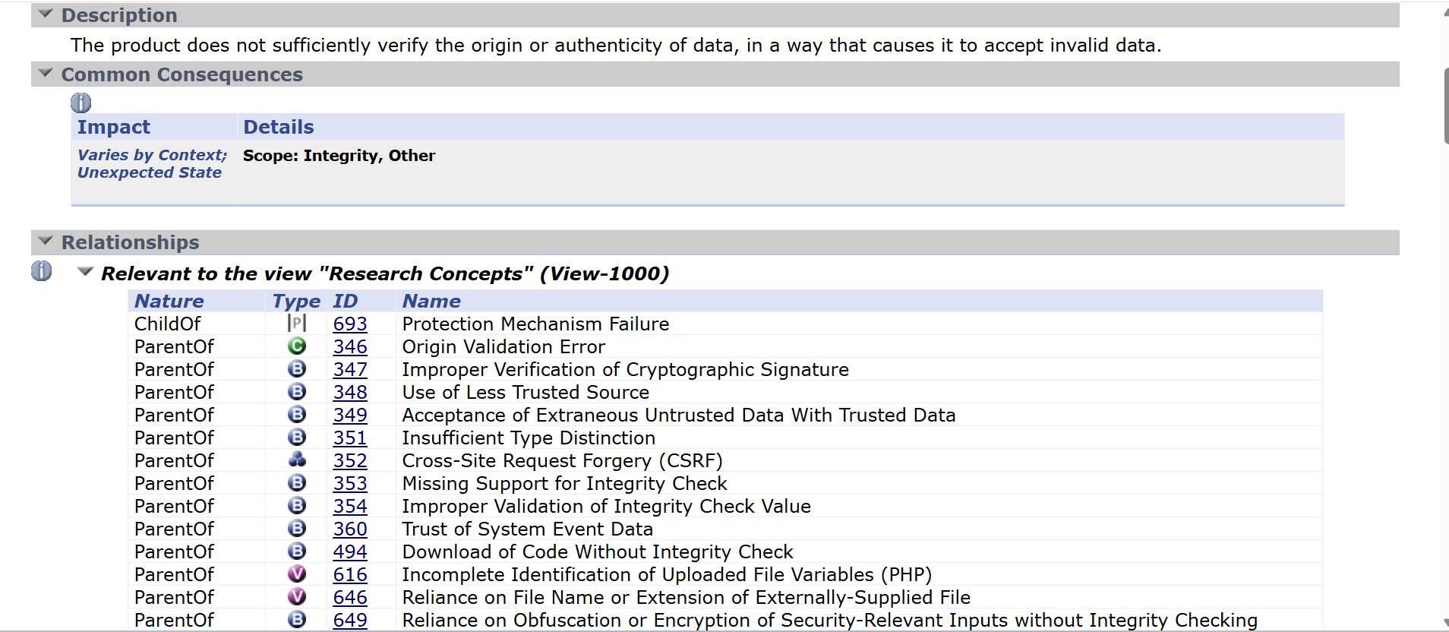

9) Vulnerability Name: Information Loss Through Omission
CWE – 221: Information Loss Through Omission
OWASP Category: A09:2025 – Security Logging and Alerting Failures
Description:
Information Loss Through Omission occurs when an application fails to record or log important security-related events. This may happen when certain activities such as failed login attempts, configuration changes, or unauthorized access attempts are not properly captured in system logs. As a result, security monitoring systems may not detect suspicious or malicious activities within the application environment.
Business Impact:
The absence of proper logging and monitoring can make it difficult for administrators to identify security incidents or investigate attacks. Attackers may exploit this weakness to perform unauthorized actions without being detected. This can lead to delayed response to security threats, potential data breaches, and loss of system integrity.

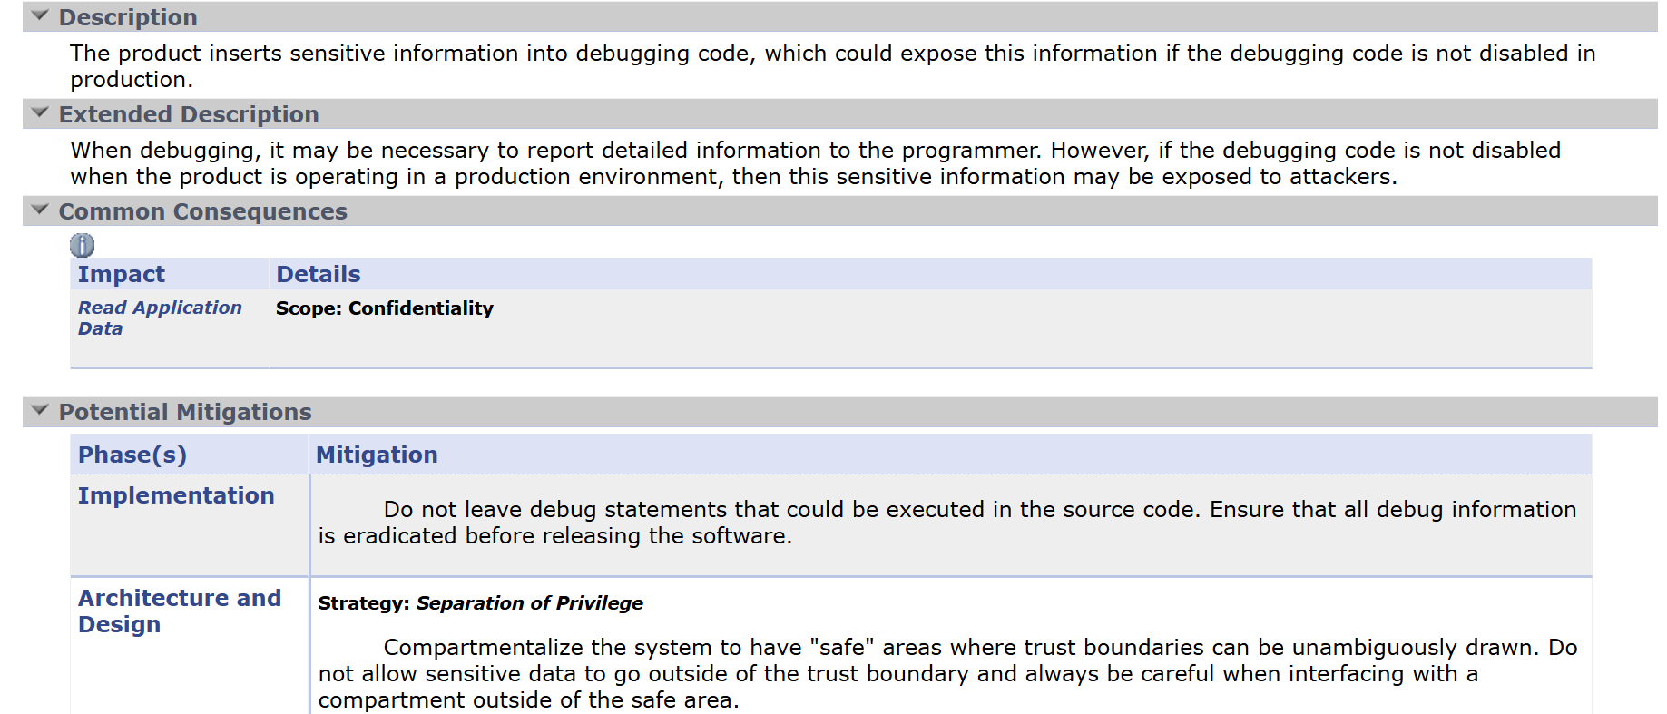

10) Vulnerability Name: Insertion of Sensitive Information Into Debugging Code
CWE – 215: Insertion of Sensitive Information Into Debugging Code
OWASP Category: A09:2025 – Security Logging and Alerting Failures
Description:
This vulnerability occurs when developers include sensitive information such as passwords, API keys, or internal system details within debugging or log statements. If these logs are exposed, attackers may gain access to confidential information.
Business Impact:
Exposure of sensitive information through debugging logs can allow attackers to gather critical system details, leading to unauthorized access or further exploitation of the application environment.
Stage 2
Overview :-

Nessus is a vulnerability scanner developed by Tenable, Inc. It is a remote scanner, meaning that it does not need to be installed on the target host to scan it. Nessus works by sending a variety of probes to the target host in order to identify vulnerabilities. These probes can include network
traffic, operating system commands, and application requests.

Nessus uses a plugin-based architecture. Plugins are small pieces of code that are designed to identify specific vulnerabilities. There are over 1200 plugins available for Nessus, covering a wide range of vulnerabilities in operating systems, applications, and network devices.

When Nessus scans a host, it first uses a discovery plugin to identify the operating system and services running on the host. Once the host has been discovered, Nessus runs a series of plugins to test for vulnerabilities. For each vulnerability that Nessus finds, it provides a detailed report
that includes the severity of the vulnerability, the steps to reproduce the vulnerability, and the steps to remediate the vulnerability.

Nessus can be used to scan a variety of targets, including single hosts, networks, and web applications. It can also be used to scan specific ports and services. Nessus can be configured to run scans on a schedule or manually.

Here is a step-by-step explanation of how Nessus works:
1. Nessus connects to the target host using a variety of protocols, including TCP, UDP, and
ICMP.
2. Nessus sends a series of probes to the target host in order to identify its operating system
and services.
3. Nessus runs a series of plugins to test for vulnerabilities.
4. Nessus generates a report that includes the severity of each vulnerability, the steps to reproduce the vulnerability, and the steps to remediate the vulnerability.
5.Nessus is a valuable tool for security professionals who need to identify and remediate vulnerabilities in their networks. It is easy to use and provides comprehensive reports that can be used to prioritise remediation efforts.

Here are some of the benefits of using Nessus:
● Comprehensive vulnerability coverage: Nessus has over 1200 plugins available, covering
a wide range of vulnerabilities in operating systems, applications, and network devices.

● Easy to use: Nessus has a user-friendly interface that makes it easy to configure and run
scans.

● Comprehensive reporting: Nessus provides detailed reports that include the severity of
each vulnerability,the steps to reproduce the vulnerability, and the steps to remediate the
vulnerability.

● Scalability: Nessus can be used to scan a variety of targets, including single hosts, networks, and web applications.

● Flexibility: Nessus can be configured to run scans on a schedule or manually.
Nessus is a powerful tool that can be used to improve the security of any network. It is a valuable
asset for any security professional.

Nessus Vulnerability Assessment and Security Monitoring Workflow

1. Preparation:
Define Objectives:
Determine the scope and objectives of the secure access management system. Identify which applications, users, and network resources need secure access and what level of protection is required.
System Access:
Ensure that administrators have the necessary permissions and configurations to deploy ZPA and integrate AI-based security monitoring mechanisms.

2. Configuration
SetUpAccessPolicies:
Create security and access policies using ZPA to control how users connect to internal applications. AI models can assist in identifying unusual access patterns and enforcing adaptive security policies.
DefineProtectedApplications:
Specify the internal applications, servers, and services that need to be protected and accessed securely through the ZPA platform.

3. Secure Access Implementation
DeployZPAConnectors:
Install ZPA connectors within the internal network environment to establish a secure connection between users and applications without exposing the internal network.
AI-BasedMonitoring:
AI technologies analyze user behavior and access patterns to detect anomalies and potential threats in real time.

4. Threat Detection and Access Control
The system continuously monitors user activities and application access requests. AI-based analytics help detect suspicious behavior, unauthorized access attempts, and abnormal traffic patterns. Based on severity and risk level, the system can automatically enforce stricter access controls or block malicious activity.

5. Reporting
The system generates detailed reports on user access activities, detected threats, and security events. These reports include severity levels, recommended mitigation strategies, and evidence of suspicious activity. Reports can be exported in formats such as PDF, CSV, or dashboards for security monitoring.

6. Remediation
ReviewSecurityFindings:
Security teams analyze alerts and reports generated by the AI monitoring system and ZPA platform.
CorrectiveActions:
Take appropriate actions such as modifying access policies, blocking malicious users, updating security configurations, or strengthening authentication mechanisms.

7. Follow-Up and Continuous Monitoring
ContinuousMonitoring:
Regular monitoring ensures that the system detects new threats and unauthorized access attempts.
Integration:
Integrate the system with other security tools such as SIEM platforms or identity management systems to enhance the overall security posture.

8. Compliance Management
If compliance requirements are applicable, review security policies and access logs to ensure adherence to regulatory standards and organizational security policies.

9. Documentation
Maintain detailed records of system configurations, access logs, detected threats, and remediation actions. Proper documentation helps in auditing, compliance verification, and improving the system.

10. User Awareness and Training
Ensure that IT administrators and users understand how the secure access system works, including authentication procedures and security best practices to prevent unauthorized access.

Target website :- ginandjuice.shop
Target IP Address :- 34.246.169.179

List of vulnerability:

S. No | Vulnerability Name | Severity | Plugins
1. | Service Detection | Info | 22964
2. | Nessus SYN scanner | Info | 11219
3. | Host Fully Qualified Domain Name (FQDN) Resolution | Info | 12053
4. | Additional DNS Hostnames | Info | 46180
5. | HSTS Missing From HTTPS Server | Medium | 142960
6. | Device Type | Info | 54615
7. | Host Fully Qualified Domain Name (FQDN) Resolution | Info | 12053
8. | OS Fingerprints Detected | Info | 209654
9. | OS Identification | Info | 11936
10. | Remote Services Not Using Post-Quantum Ciphers | Info | 277650

Report:
- VULNERABILITY NAME: Service Detection SEVERITY:Info
PLUGIN : 22964
PORT: 80 / tcp / www

Description:
Nessus was able to identify the remote service running on the target system by analyzing the service banner or the response generated when an HTTP request was sent. This means the server is revealing information about the service or software running on the system.

Solution:
• Disable unnecessary services that are not required on the server.
• Configure the web server to hide or limit banner information that reveals server details.
• Use security configurations to prevent detailed error messages from being displayed.
• Regularly update and patch the web server software to reduce the risk of vulnerabilities.
• Implement firewall rules to restrict unauthorized access to open ports and services.

Business Impact:
If attackers are able to identify the Fully Qualified Domain Name of a system, it may reveal useful information about the organization’s network structure and domain environment. This information can assist attackers in mapping the network and identifying potential targets for further attacks.

- VULNERABILIY NAME: Nessus SYN scanner
SEVERITY: Info
PLUGIN: 11219
PORT: 80 / tcp / www

Description:
The Nessus SYN scanner is used to identify open TCP ports on the target system by sending SYN packets and analyzing the responses. This type of scan helps determine which services are running on the system and whether those services are accessible from the network.

Solution:
• Disable or close unnecessary ports and services that are not required for the system’s operation.
• Configure firewall rules to restrict access to critical services and limit connections from unauthorized sources.
• Use intrusion detection or intrusion prevention systems (IDS/IPS) to monitor suspicious scanning activities.
• Regularly review open ports and network services to ensure that only essential services are exposed.
• Implement network segmentation to reduce the exposure of internal systems.

Business Impact:
Open ports and exposed services may provide attackers with information about the system’s network structure and running services. This information can be used by attackers to identify potential vulnerabilities and plan further attacks. If sensitive services are exposed, it could lead to unauthorized access, exploitation of known vulnerabilities, and compromise of system security.

- VULNERABILITY NAME: Host Fully Qualified Domain Name (FQDN) Resolution
SEVERITY: Info
PLUGIN: 12053
PORT: port 80/443

Description:

Nessus was able to determine the Fully Qualified Domain Name (FQDN) of the target host. The FQDN is the complete domain name that uniquely identifies a host within the Domain Name System (DNS). This information can help identify the system’s role in the network and the domain it belongs to.

Solution:

• Restrict unnecessary DNS information exposure to external users or networks.
• Configure DNS servers and network devices to limit domain name information disclosure.
• Implement firewall rules to control external access to internal network services.
• Ensure proper network segmentation to prevent attackers from gathering detailed system information.
• Regularly review system configurations to avoid revealing sensitive network details.

Business Impact:
If attackers are able to identify the Fully Qualified Domain Name of a system, it may reveal useful information about the organization’s network structure and domain environment. This information can assist attackers in mapping the network and identifying potential targets for further attacks. Although this issue is informational, it can still contribute to reconnaissance activities that may lead to more serious security threats.

- VULNERABILIY NAME:AdditionlDNS Hostnames
SEVERITY:Info
PLUGIN: 46180
PORT: N/A

Description:
Nessus discovered additional DNS hostnames that resolve to the target system. These hostnames may represent alternative domain names or aliases associated with the same host. This information can reveal additional details about the network structure or services related to the target system.

Solution:
• Limit unnecessary DNS information exposure to external networks.
• Configure DNS servers to restrict public access to internal hostname records.
• Use firewall rules to control access to internal network services.
• Regularly review DNS configurations and remove unused or unnecessary hostnames.
• Implement network monitoring tools to detect suspicious DNS queries.

Business Impact:
If additional DNS hostnames are publicly accessible, attackers may gain insights into the organization’s network infrastructure and discover related systems or services. This information can assist attackers in reconnaissance activities, helping them identify potential targets for further attacks. Although this vulnerability is informational, it may increase the risk of targeted attacks if sensitive network details are exposed.

- VULNERABILITY NAME: Device Type
SEVERITY: Info
PLUGIN: 54615
PORT: N/A

Description:
Nessus was able to determine the type of device running on the target system. The scanner identifies whether the host is a server, workstation, network device, printer, or another type of system based on its responses and detected services. This information helps in understanding the role of the system within the network.

Solution:
• Limit unnecessary information disclosure about system configuration and device details.
• Configure network security controls such as firewalls to restrict unauthorized scanning activities.
• Regularly review system and network configurations to ensure sensitive information is not publicly exposed.
• Implement network monitoring tools to detect suspicious reconnaissance or scanning attempts.

Business Impact:
If attackers can identify the type of device running on a system, it may help them understand the role of the system in the network and plan targeted attacks. For example, knowing that a system is a database server or network device may allow attackers to search for specific vulnerabilities related to that device. Although this issue is informational, it may assist attackers during the reconnaissance phase of an attack.

- VULNERABILITY NAME: Host Fully Qualified Domain Name (FQDN) ResolutionForgery
SEVERITY: Info
PLUGIN: 12053
PORT: N/A

Description:
Nessus was able to determine the Fully Qualified Domain Name (FQDN) of the target host. The FQDN represents the complete domain name of a system in the Domain Name System (DNS), which uniquely identifies the host within a network. This information can reveal details about the system’s domain structure and its role within the organization’s network.

Solution:
• Restrict unnecessary exposure of DNS information to external networks.
• Configure DNS servers to limit access to internal domain information.
• Use firewall rules to control external access to internal systems and services.
• Regularly review DNS records and remove unused or unnecessary domain entries.
• Implement network monitoring tools to detect suspicious reconnaissance or scanning activities.

Business Impact:
If attackers are able to identify the Fully Qualified Domain Name of a system, it may provide useful information about the organization’s domain structure and network environment. This information can assist attackers during the reconnaissance phase of an attack, helping them map the network and identify potential targets. Although this vulnerability is informational, it may increase the risk of further attacks if sensitive network details are exposed.

- VULNERABILITY NAME:
HSTS Missing From HTTPS Server (RFC 6797)
SEVERITY: Medium
PLUGIN: 142960
PORT: 443 / tcp / www

Description
The remote HTTPS server does not send the HTTP Strict Transport Security (HSTS) header. HSTS is a security feature that forces browsers to communicate with the server only over secure HTTPS connections. Without HSTS, users may still connect to the website using insecure HTTP connections, which could expose them to man-in-the-middle attacks.

Solution
- Configure the web server to enable the HTTP Strict Transport Security (HSTS) header.
- Ensure that all HTTP requests are automatically redirected to HTTPS.
- Use strong SSL/TLS configurations to secure communication between the client and the server.
- Regularly review web server security configurations to ensure secure transport protocols are enforced.
Business Impact
If HSTS is not enabled, users may accidentally access the website over insecure HTTP connections. Attackers could intercept or manipulate the communication between the user and the server through man-in-the-middle attacks. This could lead to the exposure of sensitive information such as login credentials, personal data, or session cookies, potentially resulting in data breaches and loss of user trust.

- VULNERABILITY NAME: OS Fingerprints Detected
SEVERITY: Info
PLUGIN: 209654
PORT: N/A

Description:
Nessus detected operating system fingerprints on the target host. By analyzing network responses and system characteristics, the scanner was able to identify the probable operating system running on the device. This information may include details about the operating system type, version, or platform used by the host.

Solution:
• Limit unnecessary exposure of system information that may reveal operating system details.
• Configure firewalls and security devices to restrict unauthorized network scanning activities.
• Keep the operating system updated with the latest security patches and updates.
• Implement network monitoring tools to detect suspicious reconnaissance or fingerprinting attempts.
• Apply security hardening techniques to minimize system information disclosure.

Business Impact:
If attackers are able to identify the operating system running on a system, they may use this information to search for known vulnerabilities related to that specific OS version. This can help attackers plan targeted attacks against the system. Although this issue is informational, it may assist attackers during the reconnaissance phase and increase the likelihood of further exploitation attempts.

- VULNERABILITY NAME: OS Identification
SEVERITY: Info
PLUGIN: 11936
PORT: N/A

Description:

Nessus was able to identify the operating system running on the remote host. This is achieved by analyzing network responses, service banners, and system characteristics. The identified information may include the operating system type, platform, or version used by the target system.

Solution:

• Limit unnecessary disclosure of system and operating system information.
• Configure firewalls and network security devices to block unauthorized scanning attempts.
• Apply operating system security hardening techniques to reduce information exposure.
• Keep the operating system updated with the latest security patches and updates.
• Monitor network traffic to detect suspicious scanning or reconnaissance activities.

Business Impact:

If attackers can identify the operating system running on a system, they may use this information to search for known vulnerabilities associated with that OS version. This can help attackers plan targeted attacks or exploit specific weaknesses in the system. Although this vulnerability is informational, it may assist attackers in the reconnaissance phase of an attack.

- VULNERABILITY NAME:
Remote Services Not Using Post-Quantum Ciphers
SEVERITY: Info
PLUGIN: 277650
PORT: 443 / tcp / www

Description:
The remote service supports standard TLS encryption but does not use post-quantum cryptographic ciphers. Post-quantum cryptography refers to encryption algorithms designed to remain secure even against attacks from quantum computers. The absence of such ciphers does not currently pose an immediate risk, but it indicates that the system may not be prepared for future cryptographic threats.

Solution:
• Monitor developments in post-quantum cryptography standards and update cryptographic implementations when supported.
• Keep TLS configurations updated with modern and secure cipher suites.
• Regularly update server software and security libraries to support newer cryptographic algorithms.
• Follow security recommendations from standards organizations and vendors regarding quantum-resistant encryption.

Business Impact:
Currently, this issue has minimal immediate impact because most systems today still rely on traditional encryption algorithms. However, as quantum computing technology evolves, traditional cryptographic methods may become vulnerable to advanced attacks. Organizations that do not adopt future-ready encryption standards may face long-term risks related to data confidentiality and security.

Stage-3

REPORT:-

Title:
Implementing Zero Trust Network Access (ZTNA) using Zscaler for Securing Remote Workforce Access

• Zero Trust Network Access (ZTNA)
Zero Trust Network Access (ZTNA) is a modern cybersecurity framework designed to provide secure access to internal applications without exposing the internal network infrastructure. Unlike traditional security models that assume users inside the network are trusted, ZTNA follows the principle of “never trust, always verify.” Every access request must be verified based on identity, device security posture, and contextual information.
In traditional Virtual Private Network (VPN) environments, once a user connects to the network, they may gain broad access to multiple systems. This creates potential security risks if the user device becomes compromised. ZTNA eliminates this risk by granting access only to specific applications rather than the entire network.
ZTNA is especially important in organizations that support remote work environments. Employees working from home, different offices, or public networks require secure access to enterprise applications without increasing cybersecurity risks. ZTNA ensures that users are connected only to authorized services through encrypted connections.
By implementing ZTNA, organizations can reduce the attack surface, prevent unauthorized lateral movement within networks, and ensure that only authenticated users and secure devices are allowed to access sensitive resources.

• The ZTNA Access Cycle
The ZTNA model follows a continuous verification cycle that ensures secure connectivity between users and applications. The process generally includes the following stages:

1. User Access Request
A remote employee attempts to access an internal enterprise application such as HR systems, databases, or collaboration platforms from a remote location.

2. Identity Authentication
The system verifies the user’s identity using authentication methods such as username/password combinations and multi-factor authentication (MFA). This step ensures that the requesting user is legitimate.

3. Device Security Verification
The security system checks the device posture to confirm that the device meets organizational security policies. This includes verifying antivirus status, operating system updates, and firewall protection.

4. Policy Evaluation
The ZTNA platform evaluates predefined access policies to determine whether the authenticated user is permitted to access the requested application.

5. Secure Connection Establishment
If the request is authorized, an encrypted connection is created between the user device and the specific application without exposing the internal network.

6. Continuous Monitoring
The system continuously monitors the connection for suspicious activity. If abnormal behaviour is detected, the connection can be immediately terminated to protect the system.

Zscaler Platform (Zscaler Internet Access and Zscaler Private Access)
Zscaler is a cloud-based cybersecurity platform that delivers security services through the cloud rather than relying on traditional on-premise infrastructure. It enables organizations to securely connect users to applications regardless of their location.
For implementing ZTNA, Zscaler provides a solution called Zscaler Private Access (ZPA). ZPA allows secure access to internal applications without placing users directly on the corporate network. Instead, the platform connects users to applications through the Zscaler cloud infrastructure.
Zscaler gathers data from several important sources to enforce security policies effectively. These include identity providers that verify user credentials, endpoint security solutions that check device posture, and application servers that host internal services.
The platform also uses lightweight software components known as App Connectors, which are deployed inside the organization’s data center or cloud environment. These connectors establish outbound connections to the Zscaler cloud, ensuring that internal applications remain hidden from the public internet.
By enforcing identity-based policies, Zscaler ensures that users receive access only to the applications required for their work responsibilities.

The Zscaler ZTNA Cycle
The Zscaler ZTNA cycle describes how the Zscaler platform implements Zero Trust principles in a real environment.

1. User Authentication
A remote worker attempts to access a corporate application and is redirected to the organization’s identity provider for authentication and MFA verification.

2. Device Posture Assessment
Zscaler checks the device security status using integrated endpoint security solutions to ensure compliance with organizational policies.

3. Access Policy Evaluation
The Zscaler cloud evaluates the request by analysing user identity, device posture, location, and access policies configured by administrators.

4. Secure Micro-Tunnel Creation
If the request is authorized, Zscaler creates an encrypted micro-tunnel between the user device and the target application.

5. Traffic Inspection
Zscaler can optionally inspect the network traffic for potential threats such as malware, suspicious downloads, or unauthorized data transfer.

6. Activity Logging and Analytics
All access events are recorded within the Zscaler cloud platform. These logs help administrators monitor security activities, perform audits, and detect potential threats.

Threat Intelligence Integration
Threat intelligence plays a significant role in strengthening ZTNA environments. It helps organizations identify malicious activities and potential cyber threats before they cause damage.
Threat intelligence data may come from internal system logs, external threat intelligence feeds, and identity provider security reports. These sources provide information about suspicious IP addresses, malicious domains, and abnormal login activities.
Security teams can analyse this data to identify compromised accounts or malicious behaviour patterns. If a remote worker attempts to access resources from a suspicious location or interacts with a malicious domain, the system can automatically block the connection.
Integrating threat intelligence into ZTNA solutions improves the ability to detect cyber threats and respond to them quickly.

Remote Workforce Network Infrastructure
In organizations that support remote work environments, the network infrastructure typically includes several components that support secure communication and application access.
These components include core routers, switches, wireless access points, firewalls, and intrusion detection systems. Internal application servers host important services such as enterprise resource planning systems, document management systems, and collaboration platforms.
Previously, many organizations relied on VPN technology to provide remote access to these services. However, VPN solutions often grant broad network access, which increases the risk of security breaches if a user device becomes compromised.
ZTNA solutions such as Zscaler eliminate this risk by providing secure, application-level connectivity. This ensures that remote workers can access necessary resources without exposing the entire network.

Deployment of ZTNA Using Zscaler for Remote Workforce Access
To deploy ZTNA using Zscaler for securing remote workforce access, organizations must follow several implementation steps.
First, administrators identify all internal applications that require secure remote access. These may include HR portals, document servers, collaboration tools, and internal databases.
Next, users are segmented into different groups based on their roles within the organization. For example, employees, managers, IT administrators, and external partners may have different access permissions.
App Connectors are then deployed inside the organization’s data center or cloud infrastructure. These connectors establish secure outbound connections to the Zscaler cloud.
The Zscaler platform is integrated with the organization’s identity provider so that existing authentication mechanisms can be used for secure login.
Finally, administrators define access policies that determine which users can access specific applications based on identity, device status, and contextual information.

Incident Response in a ZTNA Environment
Incident response becomes more efficient in a Zero Trust environment because access to resources is tightly controlled.
When suspicious activity is detected, security teams can immediately identify the user account, device, and application involved. This visibility helps security analysts respond quickly to potential threats.
If an account appears to be compromised, administrators can instantly disable access through the Zscaler dashboard. Since users are not connected to the internal network, this action immediately stops access to all protected applications.
Security teams can then investigate the incident, analyse system logs, and identify the root cause of the attack. Once the issue is resolved, access permissions can be restored.
This approach prevents attackers from moving laterally within the network and helps maintain the integrity of organizational systems.

• Understanding the Zscaler ZPA Tool
Zscaler Private Access (ZPA) is a cloud-delivered security service designed to connect users directly to applications rather than networks.
One of the most important characteristics of ZPA is that it is application-centric rather than network-centric. Security policies are built around applications and user identities instead of IP addresses or network segments.
Another key advantage is that internal applications remain hidden from the public internet. Since App Connectors only create outbound connections, attackers cannot discover internal servers using network scanning techniques.
The Zscaler platform also provides an improved user experience because employees do not need to manually connect to VPN services. The Zscaler client connector runs in the background and automatically routes traffic securely.
Additionally, the cloud-based architecture allows the platform to scale efficiently as the number of users increases, making it suitable for large organizations with distributed workforces.

Conclusion

Stage 1:
In conclusion, securing remote workforce access has become a critical requirement for modern organizations that rely on digital infrastructure, cloud platforms, and distributed work environments. Traditional remote access solutions such as Virtual Private Networks (VPNs) often provide broad network-level access, which increases the risk of unauthorized access, data breaches, and internal network exposure. As organizations continue to support employees working from various locations, there is a growing need for more advanced and secure access control mechanisms that can protect internal resources without compromising productivity.
The implementation of Zero Trust Network Access (ZTNA) using Zscaler technologies provides a strong foundation for securing remote workforce environments. Instead of allowing users to connect directly to the internal network, ZTNA ensures that users are granted access only to the specific applications they are authorized to use. By verifying user identity, device security posture, and contextual information before granting access, organizations can significantly reduce security risks and prevent unauthorized activities. This approach strengthens overall security, protects sensitive enterprise data, and enables organizations to maintain secure and efficient access to internal resources for remote employees.

Stage 2:
The adoption of Zscaler Private Access (ZPA) enables organizations to implement a scalable and secure framework for managing application access for remote workers. By replacing traditional VPN connectivity with a Zero Trust model, ZPA ensures that users receive only the minimum level of access required to perform their tasks. This least-privilege approach reduces the attack surface and minimizes the risk of cyber threats targeting internal networks.
ZPA allows administrators to define granular access policies based on several contextual factors, including user identity, device security status, and network location. These context-aware policies dynamically evaluate each access request to determine whether the user should be granted access to the requested application. In addition, ZPA provides comprehensive monitoring and logging capabilities that help security teams track user activity, detect suspicious behaviour, and respond quickly to potential threats. Continuous monitoring and integration with other enterprise security tools ensure that organizations maintain strong protection against evolving cyberattacks.

Stage 3:
The implementation of Zero Trust Network Access using Zscaler technologies represents a significant shift from traditional network-based security models to an identity-driven and application-focused security architecture. By enforcing strict access verification and limiting user connectivity to specific applications, ZTNA helps organizations protect their internal systems from unauthorized access and potential cyber threats.
Beyond enhancing security, ZTNA also improves operational efficiency by simplifying remote access management and reducing dependency on legacy VPN infrastructure. Employees can securely access enterprise applications from any location while maintaining strong security controls. The centralized management and visibility offered by Zscaler allow IT teams to monitor user activity, enforce security policies, and respond effectively to security incidents. Overall, the deployment of ZTNA using Zscaler provides a secure, scalable, and future-ready solution that supports modern remote workforce environments while protecting critical organizational resources.

Future Scope

Stage 1: Future Scope of Remote Workforce Security
The future scope of securing remote workforce access using Zero Trust architecture will continue to grow as organizations increasingly adopt cloud-based systems and distributed work environments.
Some important future developments include:
▪ Expansion of Zero Trust Security Models: Organizations will continue to adopt Zero Trust frameworks to secure access to applications and protect sensitive business data.
▪ Cloud-Based Application Protection: As more applications move to cloud environments, secure access solutions like ZTNA will become essential for protecting cloud-hosted services.
▪ Improved User Experience: Future systems will focus on delivering strong security while ensuring seamless and convenient access for remote employees.
▪ Secure Remote Collaboration: As remote work becomes more common, organizations will require advanced security mechanisms that allow employees to collaborate securely from different locations.

Stage 2: Future Scope of Zero Trust Access Management
Zero Trust access management technologies will continue to evolve with advancements in cybersecurity solutions and the growing complexity of digital infrastructures.
Key future developments may include:
▪ AI-Based Security Analytics: Artificial intelligence and machine learning will be used to analyse user behaviour patterns and detect abnormal access activities more effectively.
▪ Advanced Device Security Validation: Future access systems will perform deeper device security assessments using endpoint detection and response technologies.
▪ Integration with Cloud Security Platforms: Zero Trust solutions will integrate with cloud-native security services to protect applications across hybrid and multi-cloud environments.
▪ Automated Policy Enforcement: Security policies will automatically adapt based on risk levels, reducing the need for manual security management.
▪ Improved Threat Detection Mechanisms: Advanced analytics and threat intelligence will enable organizations to detect cyber threats earlier and respond more effectively.

Stage 3: Future Scope of ZTNA for Remote Workforce Security
The successful implementation of Zero Trust Network Access using Zscaler technologies creates opportunities for building more advanced and integrated cybersecurity systems in the future.
Possible improvements may include:
▪ Integration with Secure Access Service Edge (SASE): Combining ZTNA with other cloud security services to create a unified security framework for both internet and private application access.
▪ Advanced Device Posture Verification: Real-time endpoint security checks will help block compromised devices from accessing enterprise applications.
▪ Privileged Access Management: ZTNA can be extended to manage privileged access for administrators, vendors, and third-party partners.
▪ IoT and Smart Device Security: Zero Trust principles can be applied to secure Internet of Things (IoT) devices and industrial systems.
▪ AI-Based Behaviour Monitoring: Machine learning models will analyse user behaviour patterns to identify suspicious activities and potential threats.
▪ Cloud Workload Security: ZTNA technologies will be used to protect communication between cloud workloads, microservices, and containers.
▪ Automated Access Management: Identity management systems will automatically grant or revoke access when employee roles change.
▪ Digital Experience Monitoring: Organizations will monitor application performance and user experience while maintaining strong security policies.

Topics Explored
- Zscaler
2. Zero Trust Network Access
3. ZPA (Zscaler Private Access)
4. VPN
5. MISP
6. Remote Workforce Network Infrastructure
7. Deployment of ZTNA in Organizational Network
8. Threat Intelligence
9. Incident Response

Tools Explored
▪ Nessus Vulnerability Scanner

