Code base link: https://github.com/MythiliOP/AI_Phase2_Learning/tree/bf9ffca60397b00bce9f9053df1a57076218e8ba/Week1

All below are captured in the document and changes are pushed to above git with individual commit
Step | What you do | Details / exact actions
1 | Confirm Copilot is on | Open the team repo in Visual Studio 2022 or VS Code with the GitHub Copilot + Copilot Chat extensions enabled (sign in with your org GitHub account). Confirm inline suggestions work in a .cs file.
2 | Create the instructions file | At the repo root create: .github/copilot-instructions.md (exact path - this is what Copilot auto-loads). Start from the shipped 'copilot-instructions.TEMPLATE.md'.
3 | Fill the stack-specific sections | Per the guide (sections 6-13) fill: Project Overview; Technology Stack (.NET 8, ASP.NET Core Minimal APIs, Angular/React + TypeScript, Amazon Bedrock, AWS Lambda, SQL Server/PostgreSQL, xUnit, Playwright); Architecture (thin controllers, logic in services, DI everywhere, async I/O); Coding Standards; Security (never hardcode credentials - use AWS Secrets Manager, validate input, IAM least-privilege, Bedrock Guardrails); Testing; Output Preferences. Keep it concise and actionable - avoid wiki dumps (guide section 18).
4 | Try it - Generation Mode | In Copilot Chat type the guide's own example prompt: 'Create an API endpoint to search customers.' Observe that Copilot now returns an ASP.NET Core Minimal API in C# with DI and async - matching your stack - instead of generic/other-language code.
5 | A/B prove it works | Temporarily rename .github/copilot-instructions.md to .bak, ask the SAME prompt, and compare the output. Restore the file. Paste both results into the shared notes doc - this is the Week-1 'Learn' deliverable.
6 | Add path-specific instructions (Wk5) | The guide shows folder-level guidance (e.g. src/api, src/ui, tests). The current GitHub mechanism is files under .github/instructions/<name>.instructions.md with an 'applyTo:' glob in front-matter (e.g. applyTo: 'src/ui/**'). Add one for the Angular/React UI and one for the test project.
7 | Generation vs Review Mode | Use Generation Mode ('Generate production-ready code following repository standards') for new endpoints/services. Use Review Mode ('Analyze existing implementation before proposing changes') for refactors and PR review (guide section 14).
8 | Generate & analyse tests | When writing your own tests, use Copilot (guide section 15) to draft happy-path / negative / edge / boundary cases; for defect analysis ask it to suggest root causes, recommend regression tests, and identify risk areas. Always review critically - instructions influence, they are not strict rules (guide section 5).

Confirm Copilot is on:
Inline Suggestions works in project created:
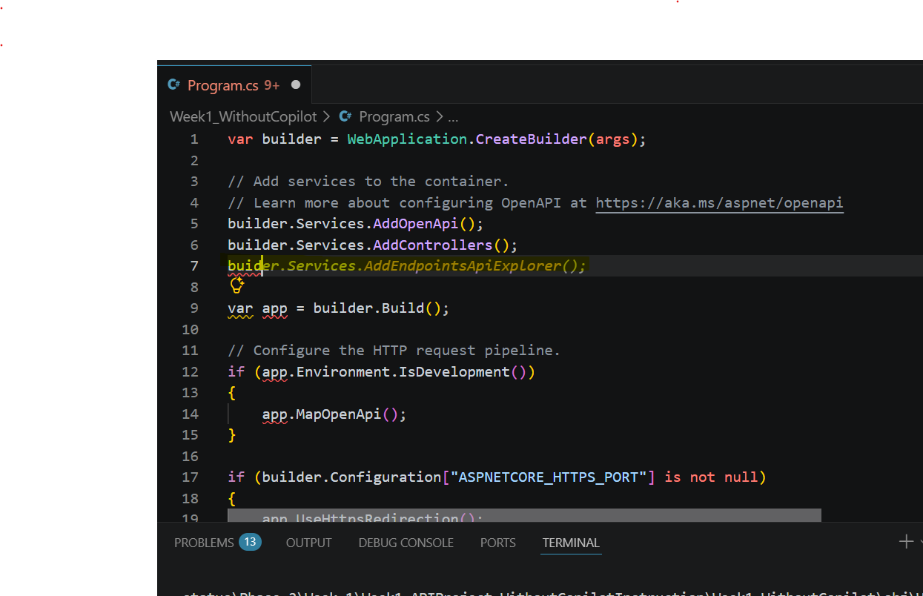

Without copilot instruction file
No structure created. Directly added the endpoint in program.cs file
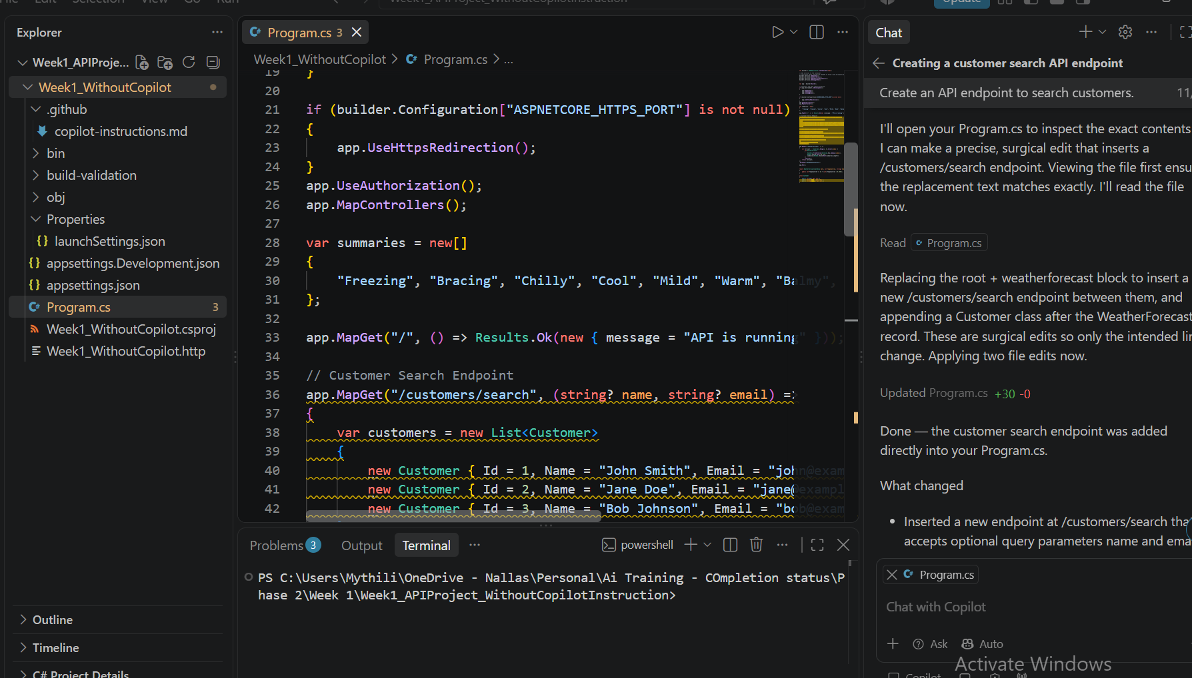

Create the instructions file
Created .github folder and uploaded copilot-instruction.md file shared
Attached is the instruction file created ->

Create endpoint after copilot instruction added
Code is created based on instruction following Minimal API
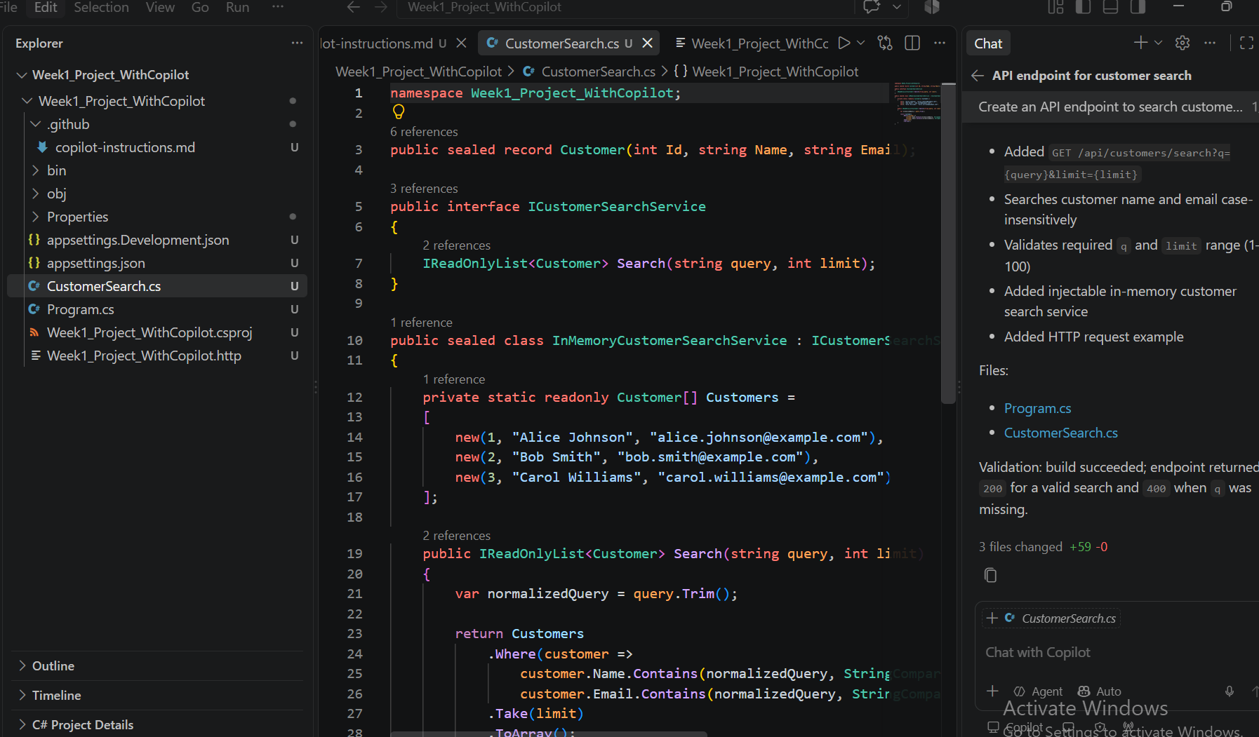

Asked copilot to follow instruction on architectural pattern. Created controllers and followed as instruction suggested
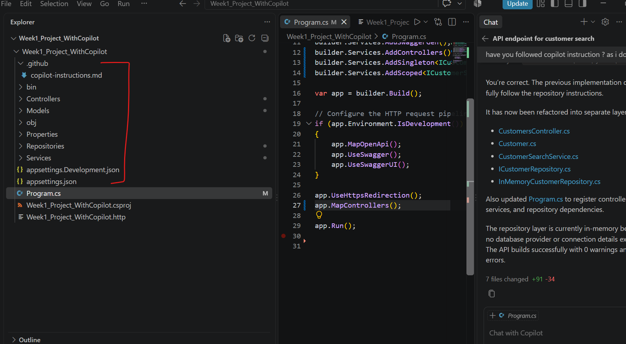

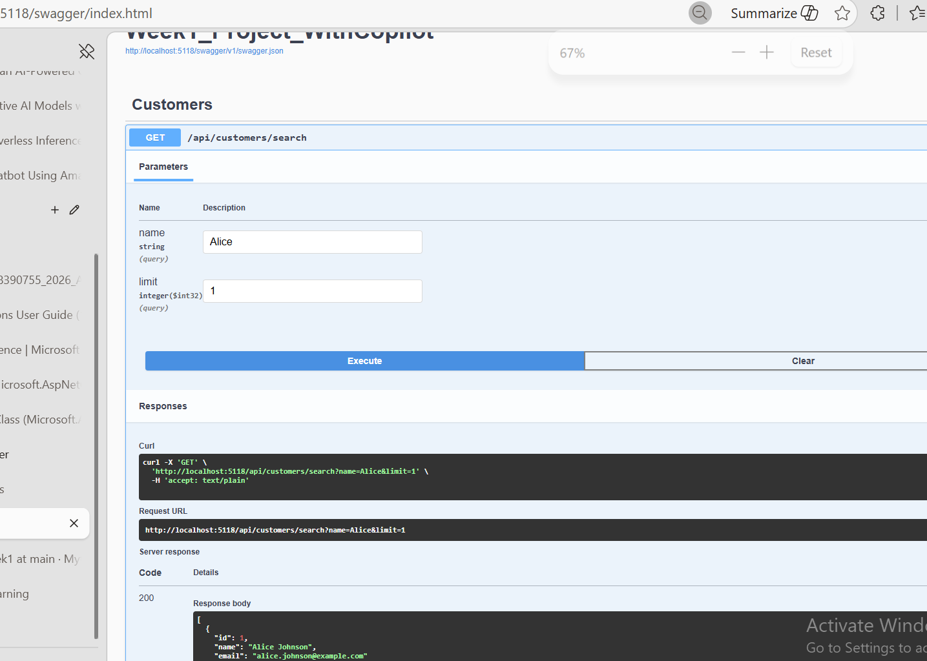

Path Specific instruction
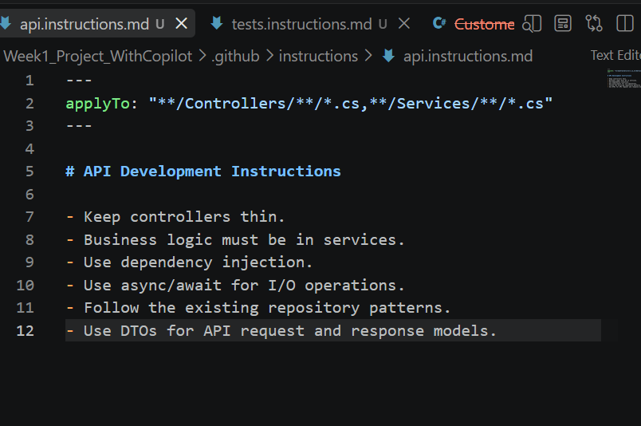

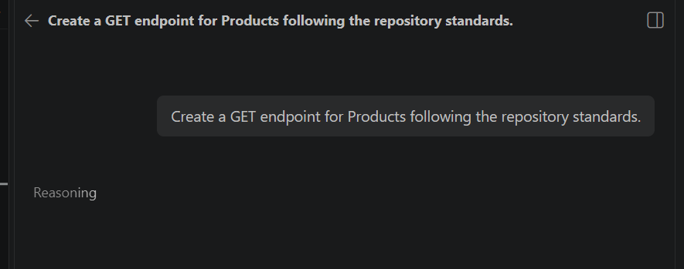
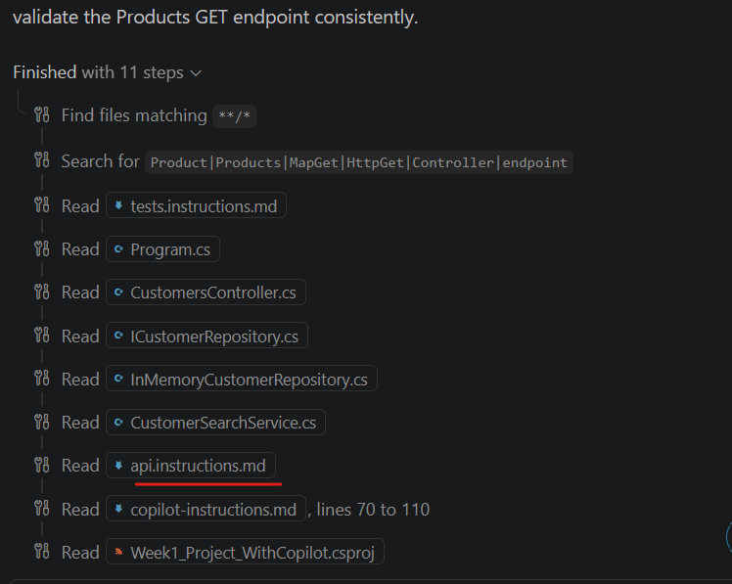
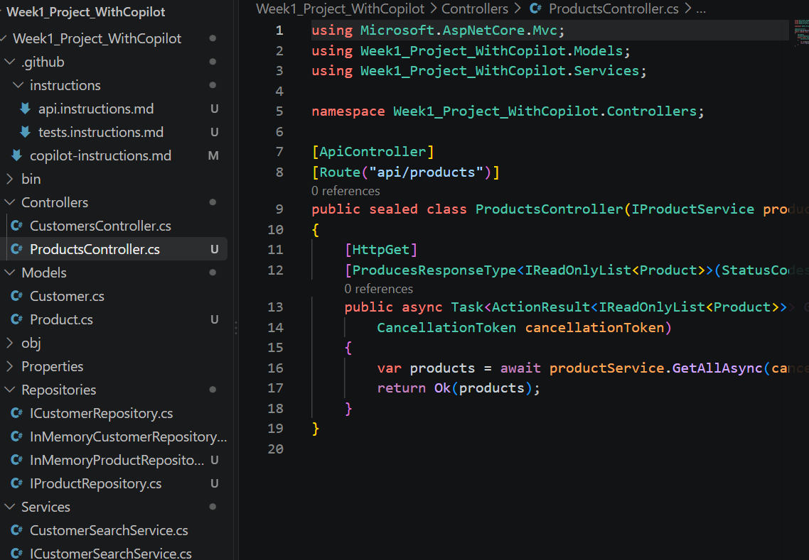
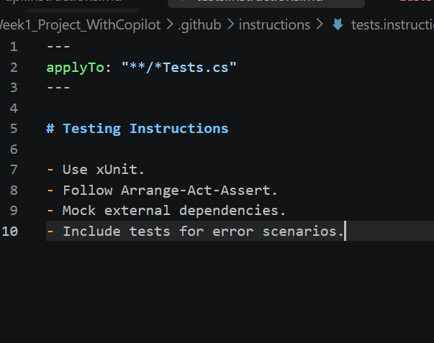

Generate Mode
Generate production-ready code following repository standards.
Create a new user API endpoint for:
GET /api/user
Before implementing it, inspect the existing Controllers and Services in this repository.
Follow the repository's existing architecture and coding patterns.
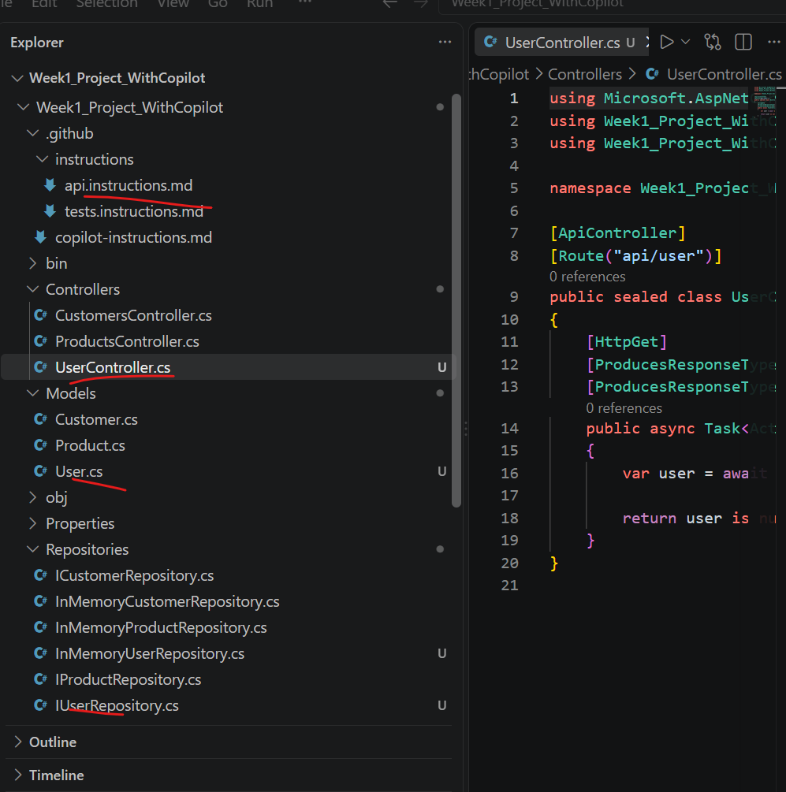

Review Mode
Analyze the existing implementation before proposing changes.
Review the currently open controller against the repository standards.
Check for:
- Controller responsibility
- Dependency injection
- Async/await usage
- Error handling
- Logging
- DTO usage
- HTTP status codes
- Maintainability
- Security concerns

Do not modify any files.

First provide:
1. Issues found
2. Why each issue matters
3. Recommended changes
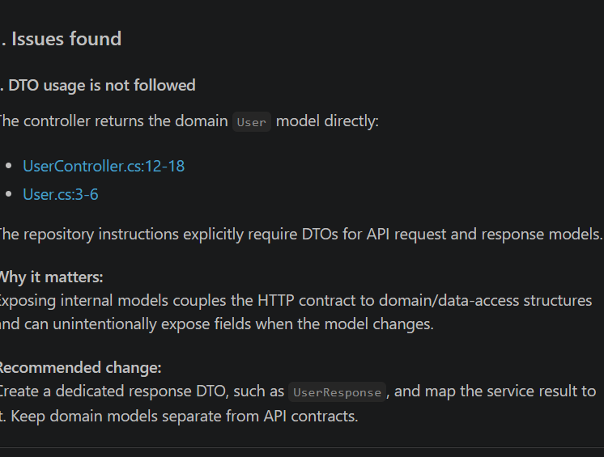
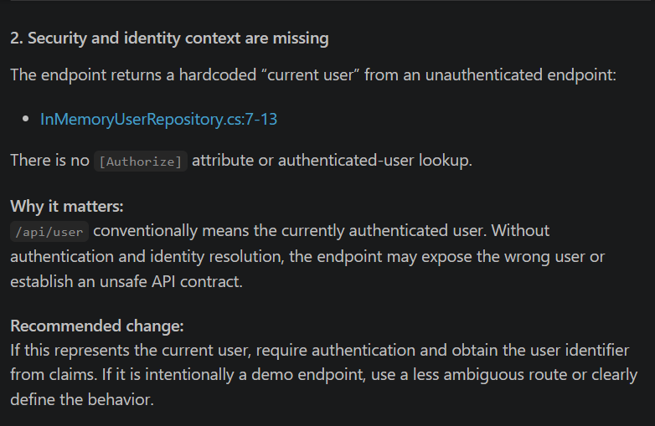

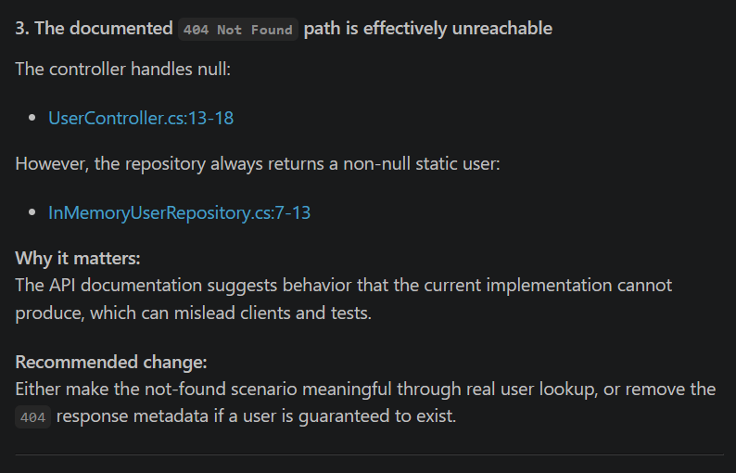
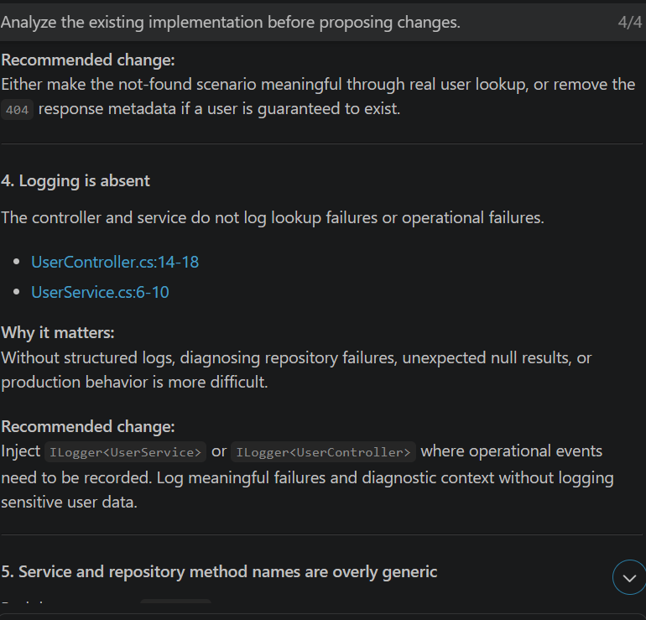

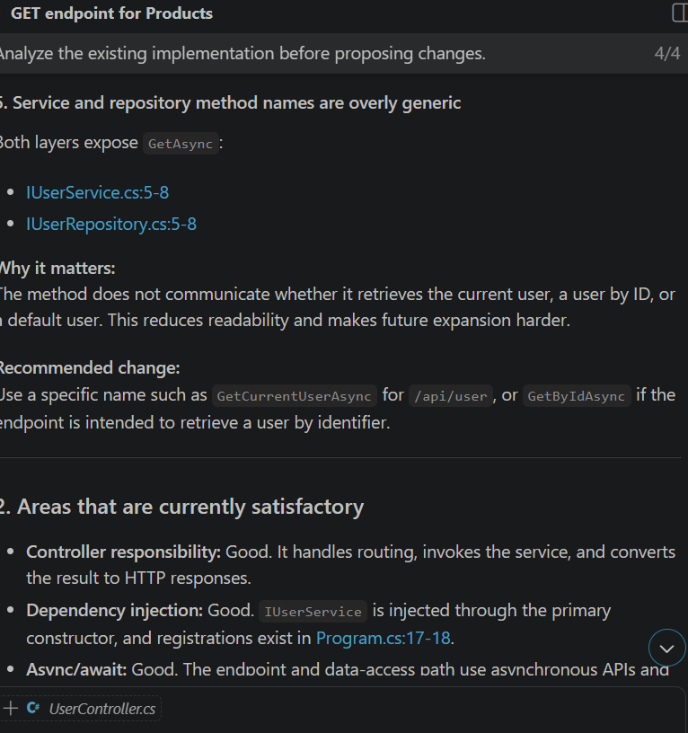

Generate and Analyze Test
Write unit test for all three controlled based on instruction
