Code base link: https://github.com/MythiliOP/AI_Phase2_Learning/tree/bf9ffca60397b00bce9f9053df1a57076218e8ba/Week1
Confirm Copilot is on:
Inline Suggestions works in project created:
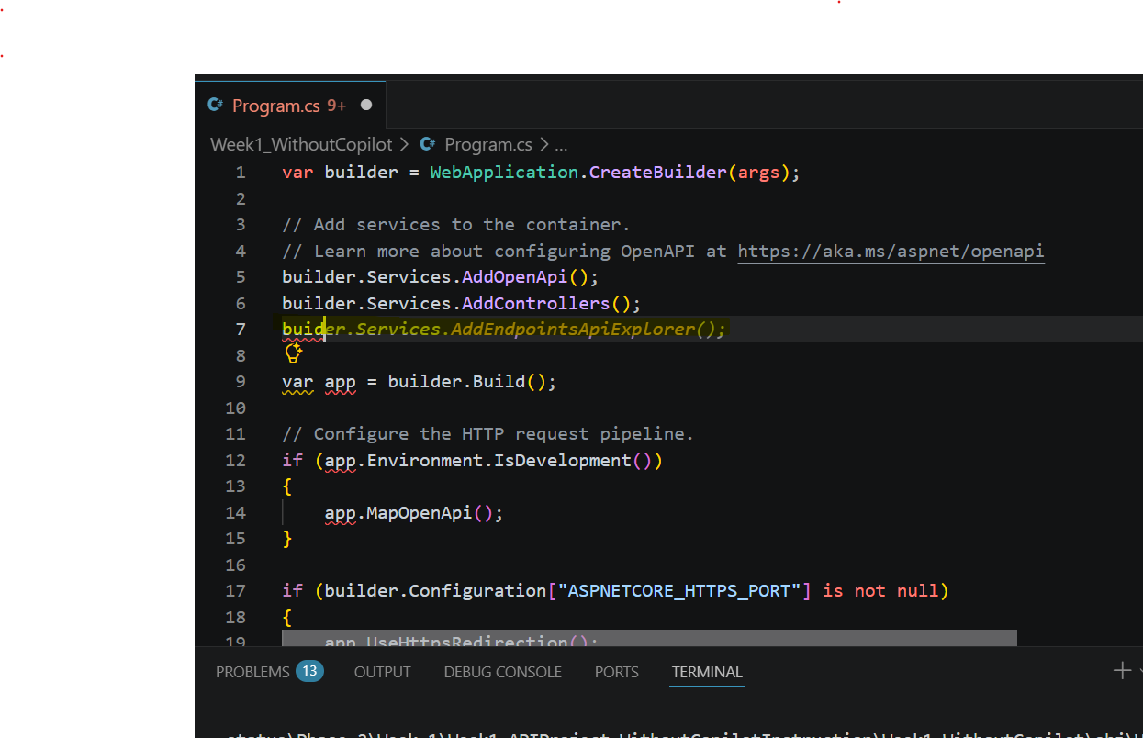

Without copilot instruction file
No structure created. Directly added the endpoint in program.cs file
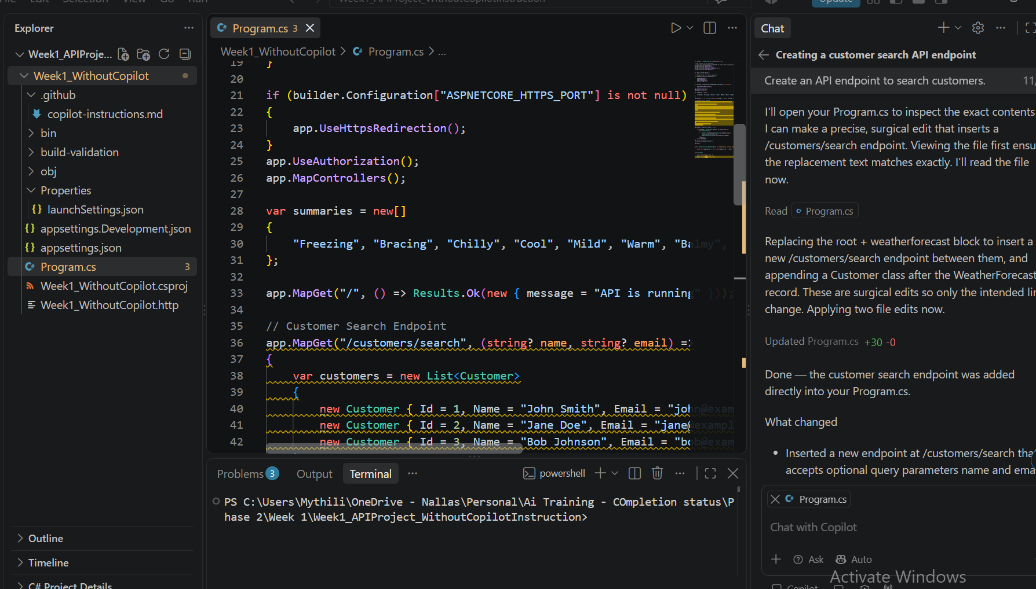

Create the instructions file
Created .github folder and uploaded copilot-instruction.md file shared
Attached is the instruction file created ->

Create endpoint after copilot instruction added
