**PYTHON**

**LOOPS:**

execute a block of code repeatedly based on a condition.

* **For Loop**

A for loop is used when you know in advance how many times you want to execute a `statement or a block of statements.

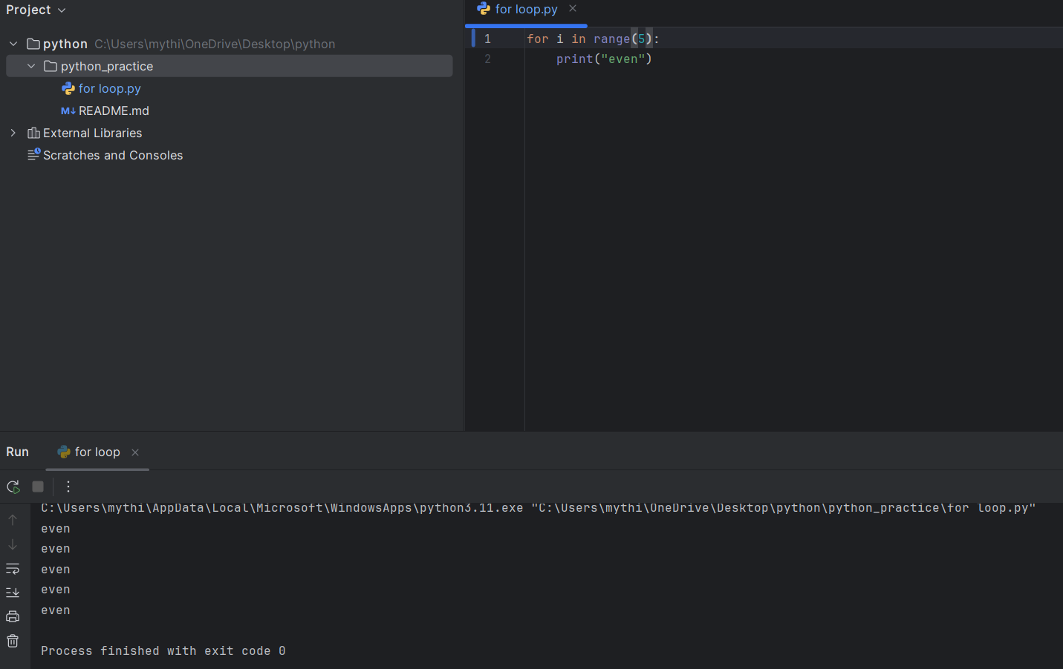

* **While Loop**

A while loop is used when you want to execute a block of code as long as a specified condition is true.

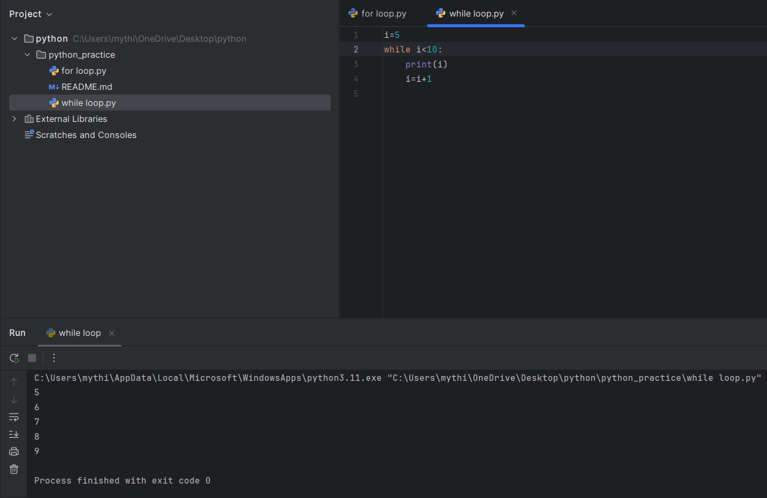

**Type conversion:**

Converting one data type into another data type

**implicit type**: python automatically convert one data type into another data type  
**explicit type**: manually convert

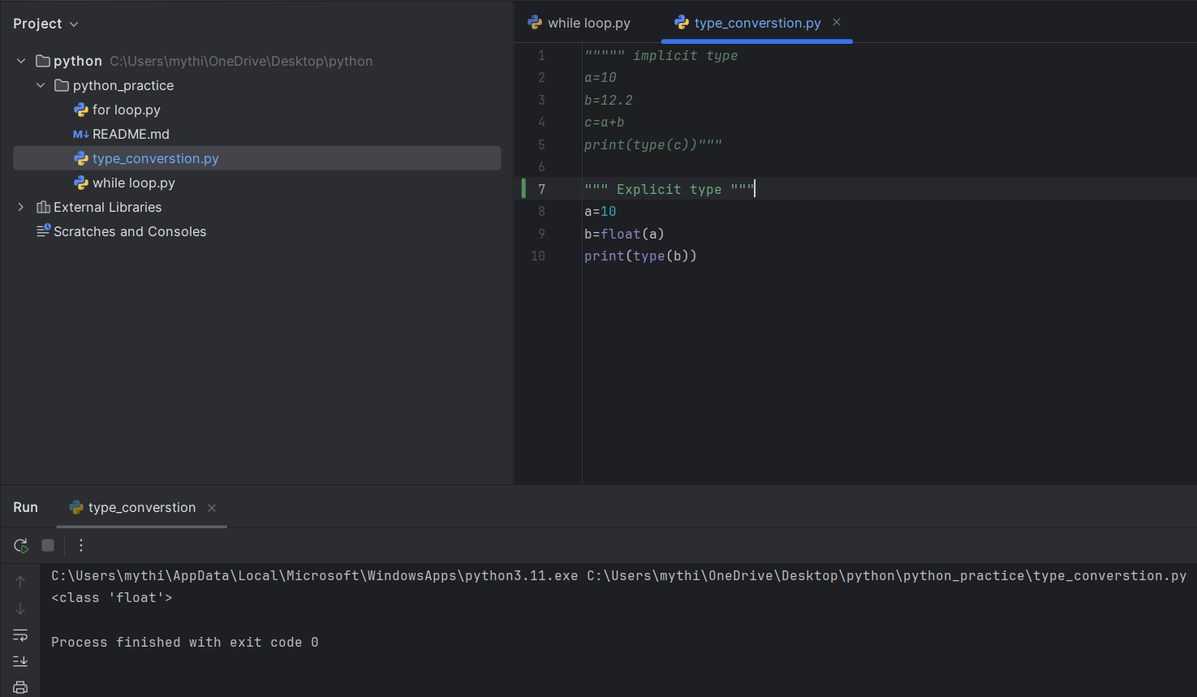

**Data Types:**

That specifies which type of value a variable can hold

**Numeric:**

Int, float, complex  
  
**Sequence:**  
List, tuple, string  
  
**mapping:**

Dictionary  
  
**Set type**

**Boolean type  
None**

**List:**

* Store multiple items in a single variable.
* Ordered collection of items.
* Mutable (can be changed after creation).
* Allow duplicates

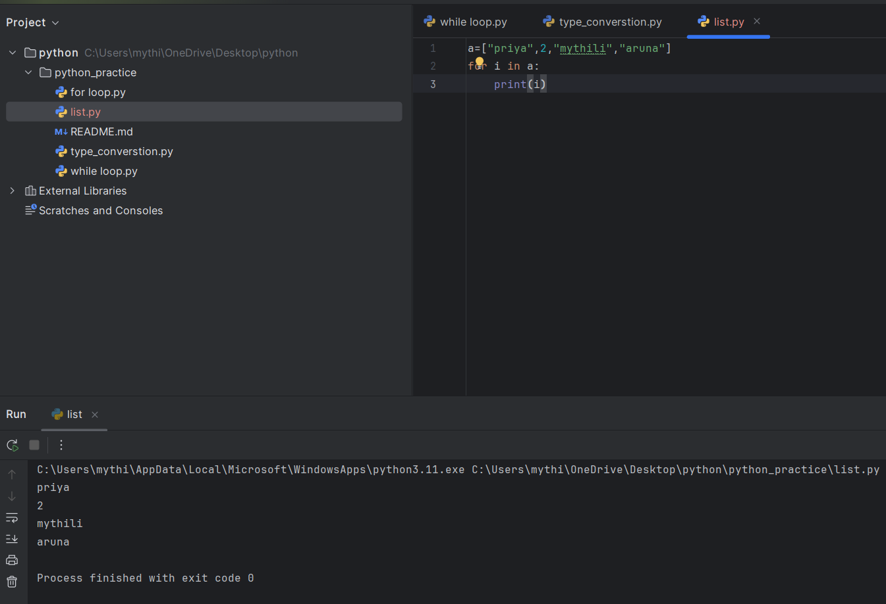

**List methods**: (count, copy, append, index, pop, remove, extend, insert, clear, reverse, sort)

**Tuples:**

* tuple is a collection of items that are grouped together
* Immutable
* Ordered
* Allow duplicates

**Set**:

* used to store multiple items in a single variable.
* Unordered
* Mutable
* Does not allow duplicates

**Dictionary:**

* used to store data values in key:value pairs.
* Ordered
* Mutable
* do not allow duplicates

**if and else:**

* if: Checks a condition and runs some code if that condition is true.
* else: Runs some code if the condition in the if statement is not true

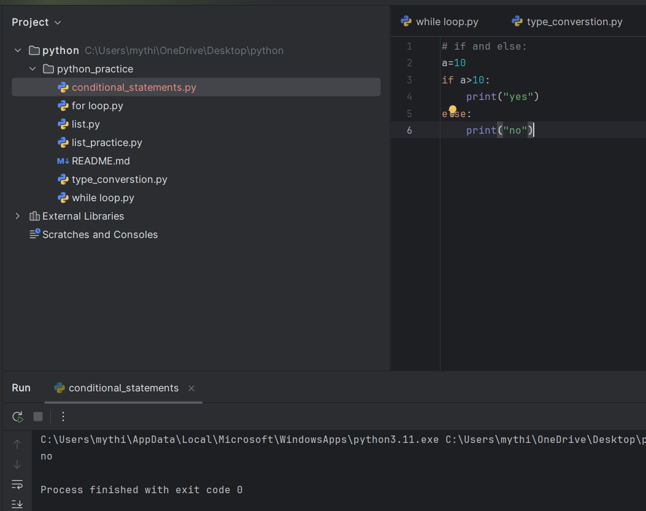

**Nested if :**

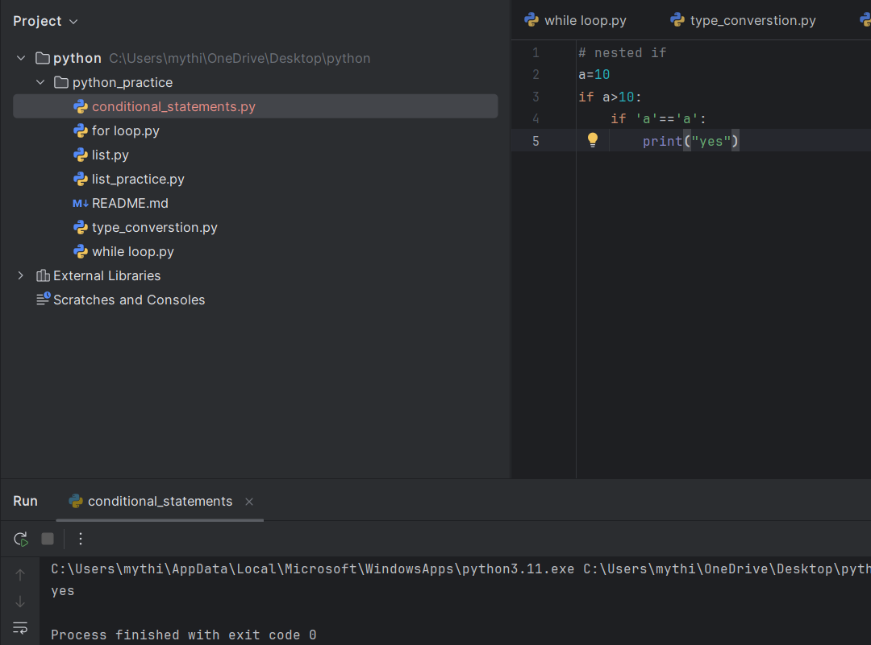if statements inside other if statements. They allow you to check multiple conditions in a structured way.

**Elif:**

used to check multiple conditions in sequence after an initial if statement.

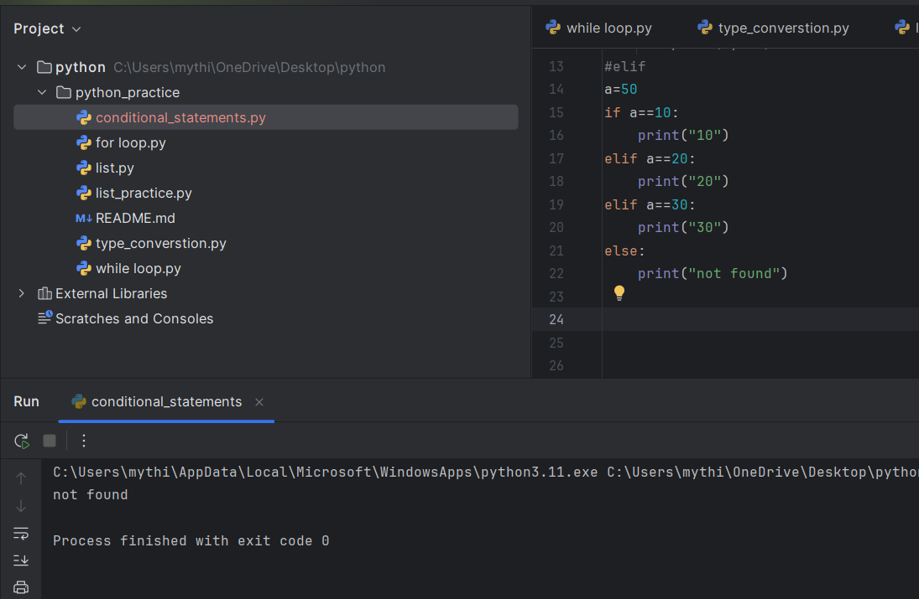

**User defined function:**

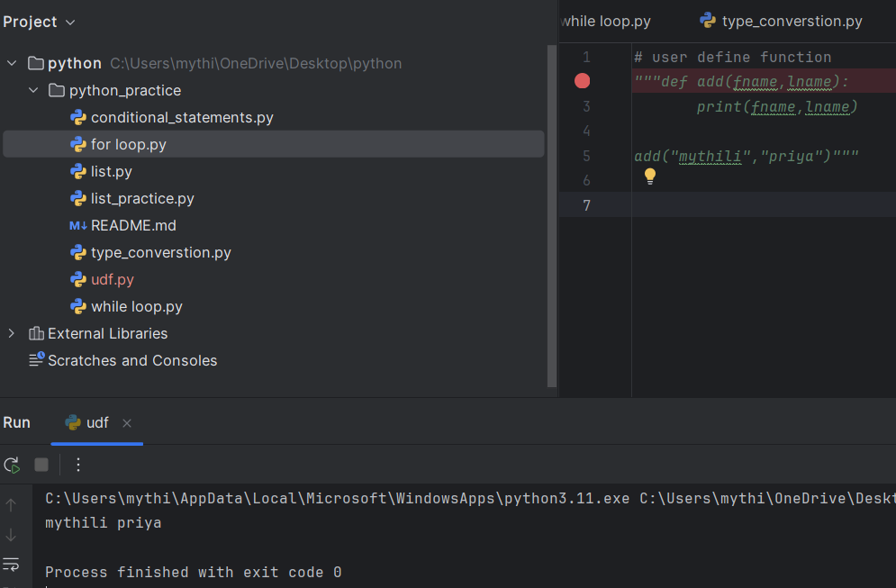Used to give a input value to the function

**Lambda function:**

Used to create a small and anonymous function

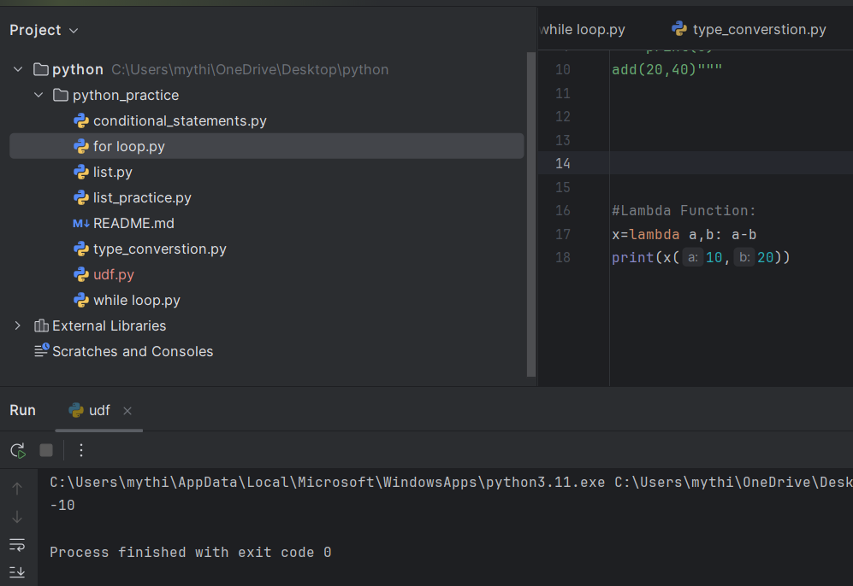

**Arbitrary Function:**

Is used to pass many arguments

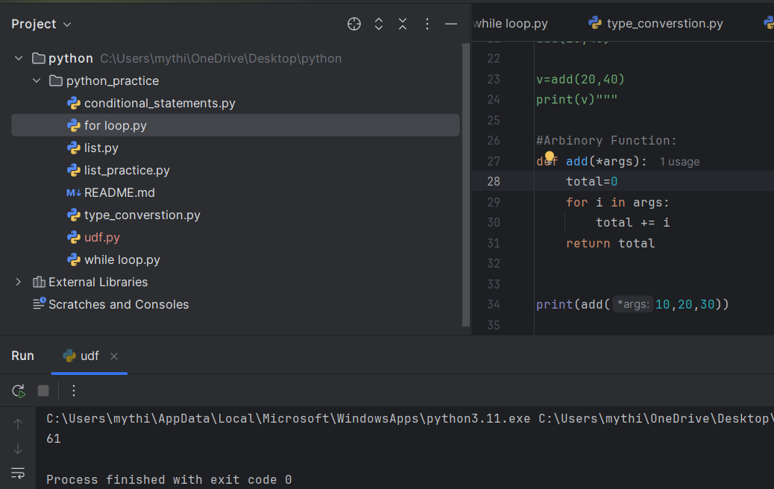

**String:**

String is a immutable data type

**String Method:**

(casefold, swapcase, isupper, islower, count, strip, join, split, upper, lower, )

**String format:**

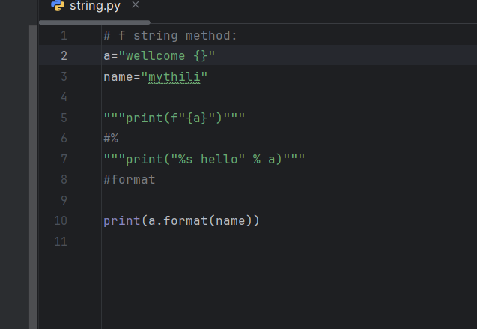

**Map:**

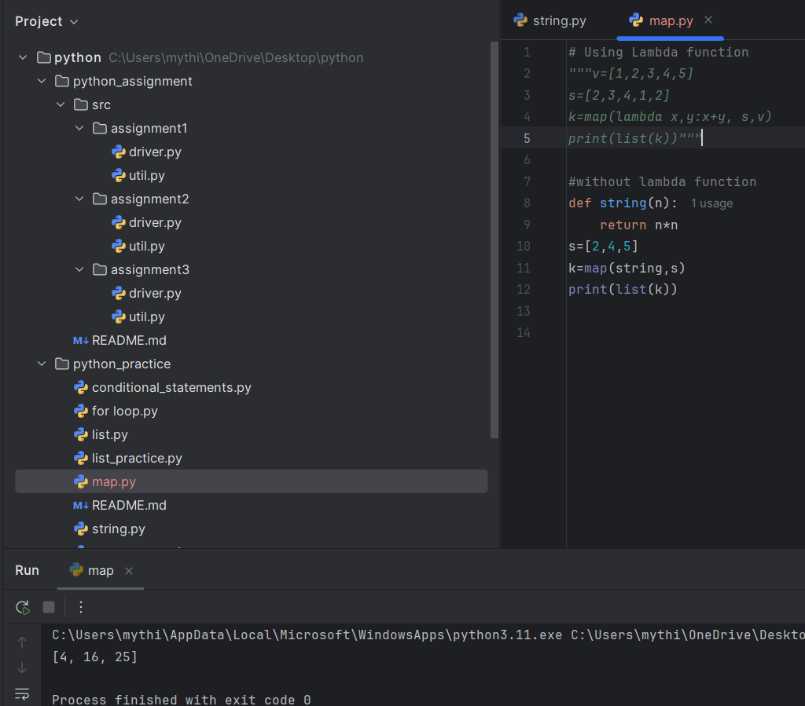 Changes each item in a list using a function

**Reduce:**

Combines all items in a list into one value.

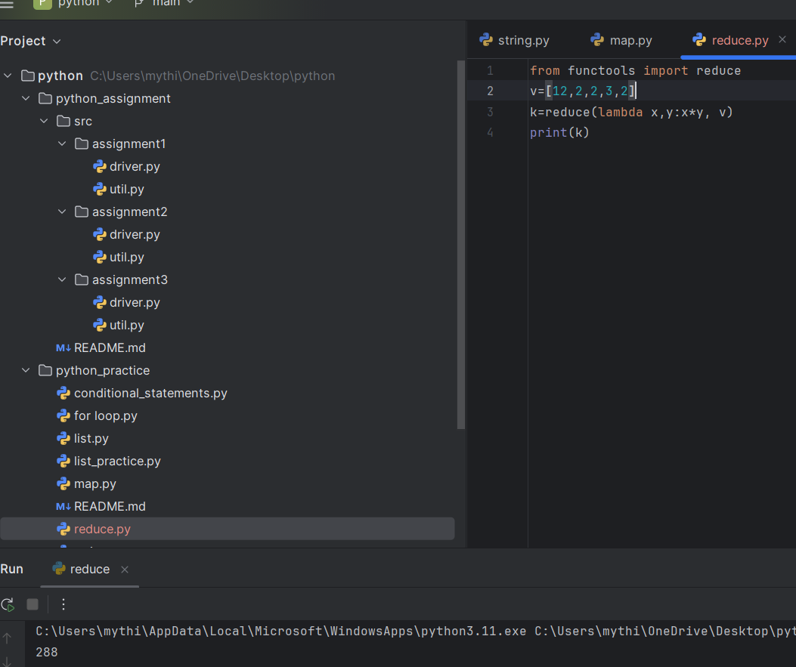

**Filter:**

Keeps only the items in a list that meet a condition

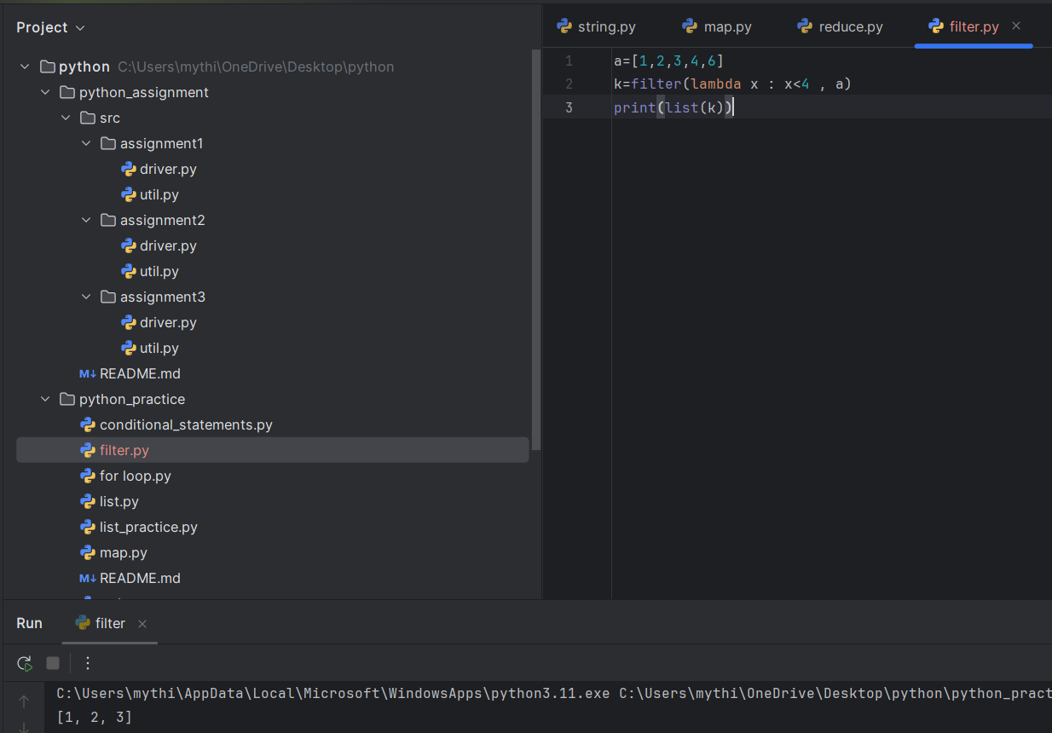

**Exception Handling:**

* try
* except
* else
* finally

manage errors that occur during program execution

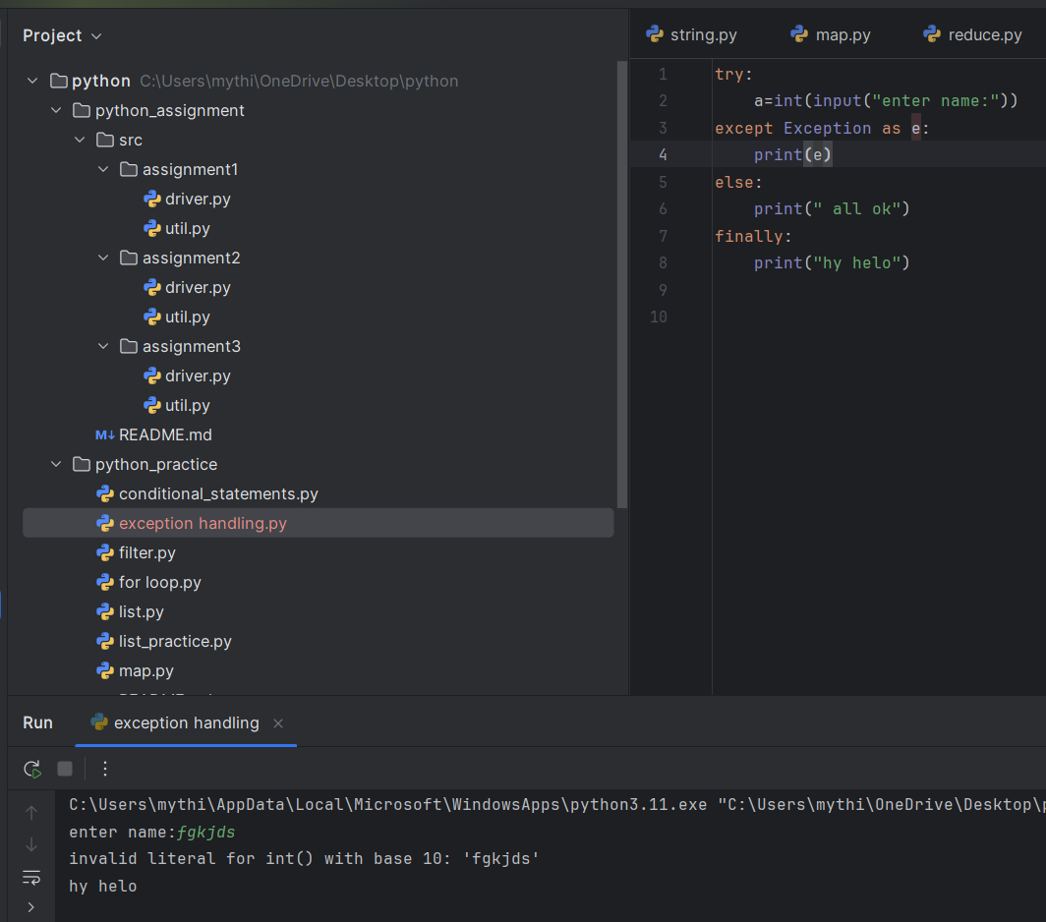

**Oops:**

**Inhertence:**

It’s a method which allows to inherit the class from the parent class

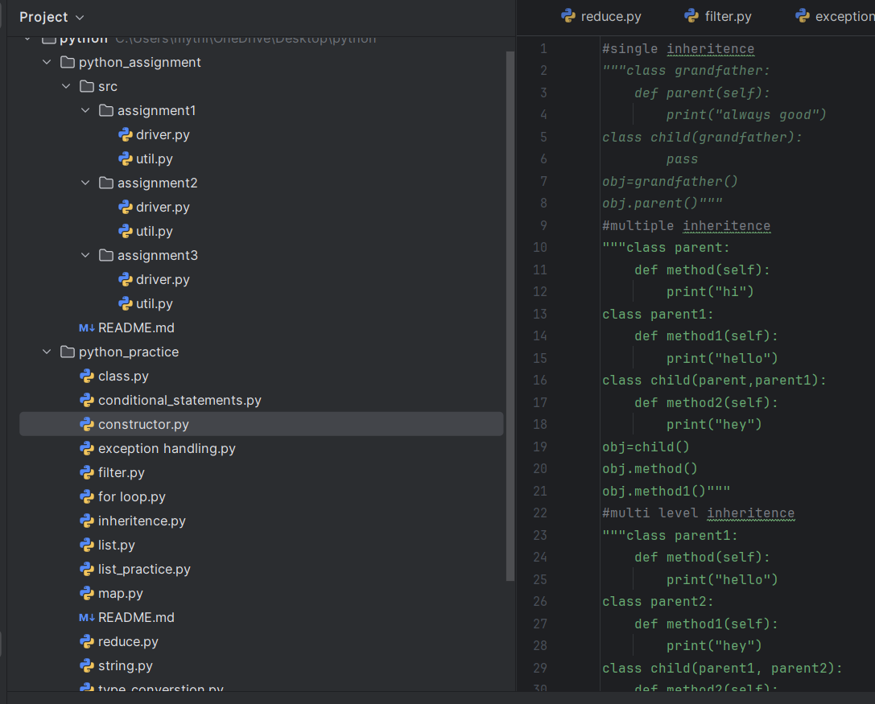

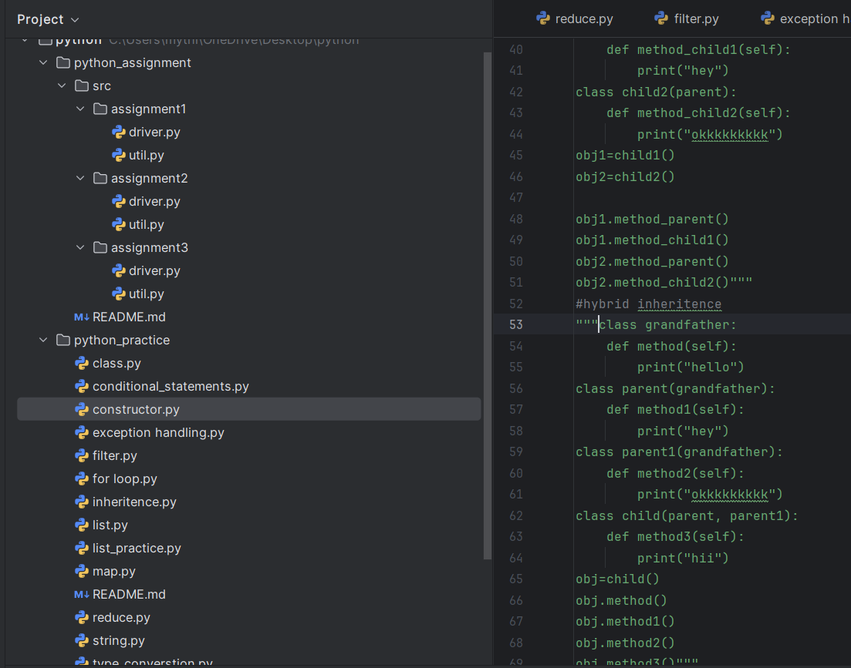

**Constructor:**

The constructor is used to initialize variables (attributes) in a class function

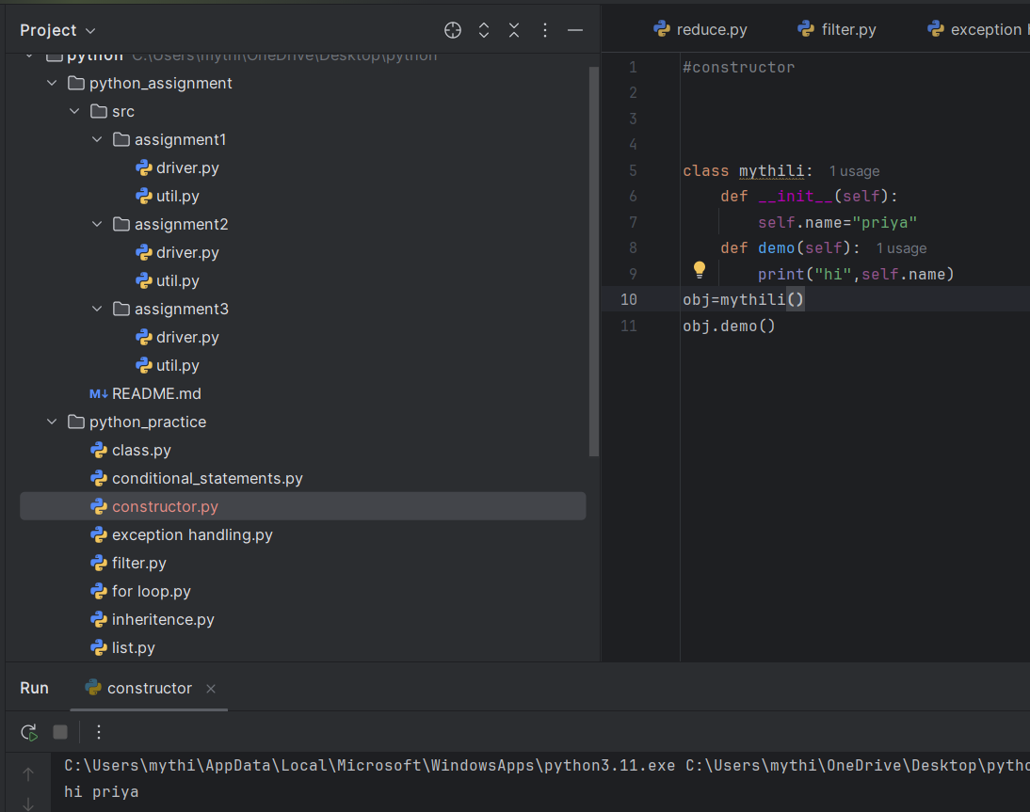

**Polymorphism:** Is ability to exit in many forms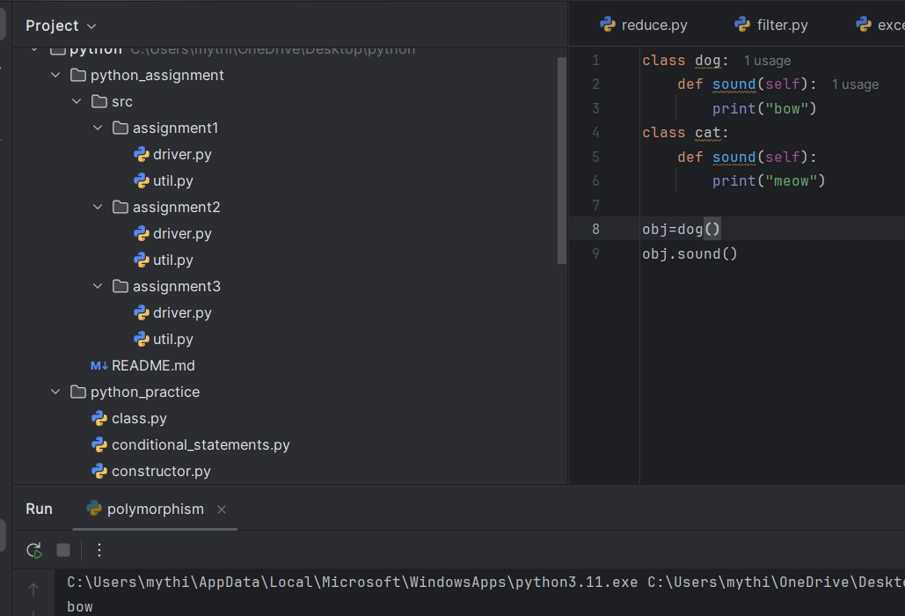

**Abstraction:**

It show’s only essential information and hide unnessary details

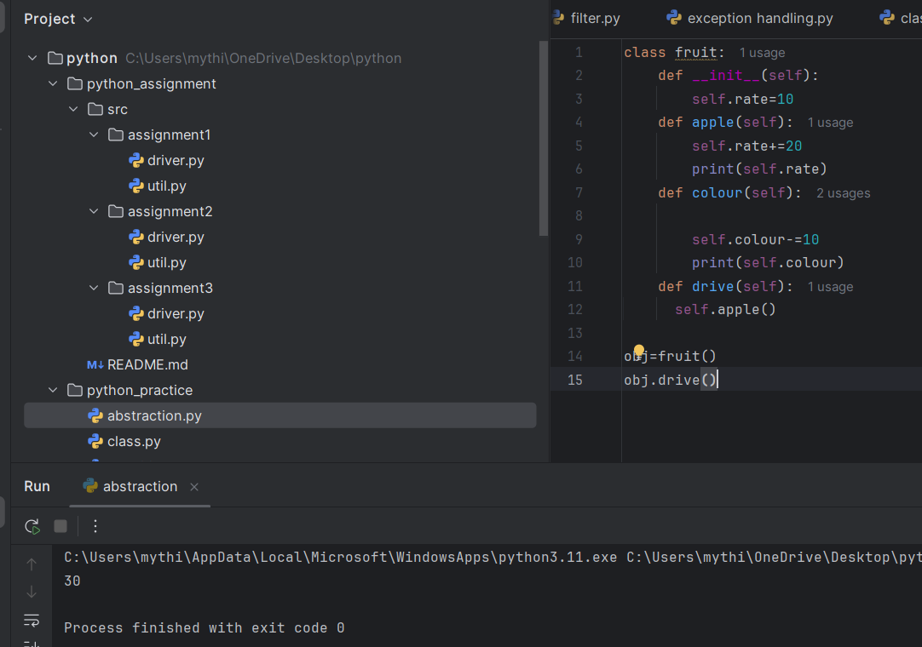

**Encapsulation:**

Refers to the building of data and code together into a single unit

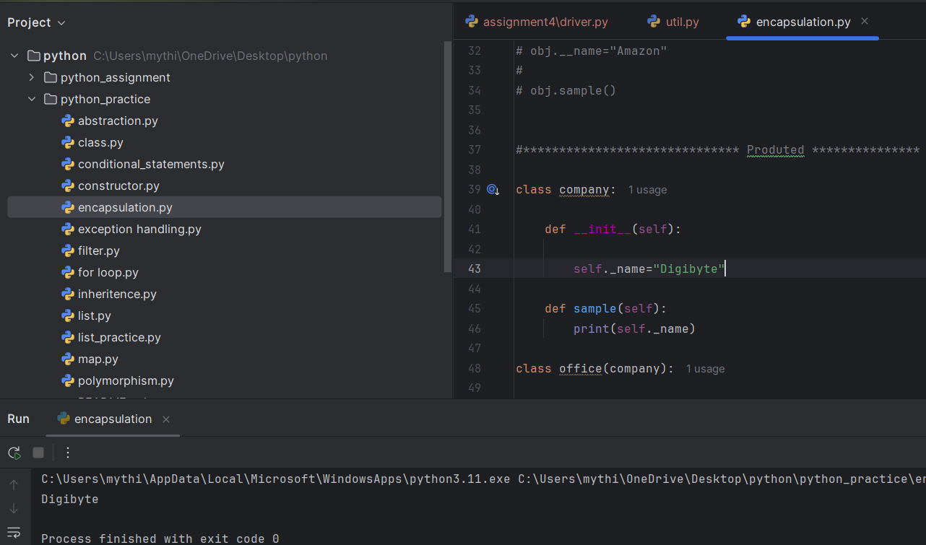

**Overriding**:

a child class can replace or change a method that it inherits from its parent class.

**Loggers:**

loggers are tools used to record messages about your program’s execution

They allow you to see what’s happening in your code while it runs.

**Unit testing:**

process of testing individual units of code, like functions or methods, to ensure they work correctly