CAD

The chassis is made up of Aluminium Rectangular Tubes, which are welded into form, and encompasses the drill, sensor system and houses the electronic components of the rover. Its main aim is to provide structural integrity to the rover and act as a protective housing for all other subsystems.

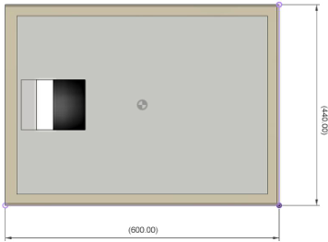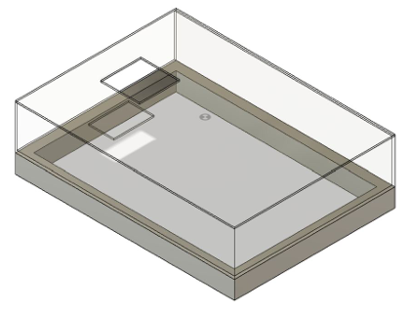

The rover's Rocker-Bogie Suspension system is crucial for moving smoothly on bumpy ground. The Rocker-Bogie Suspension is made for flexibility and adaptability. 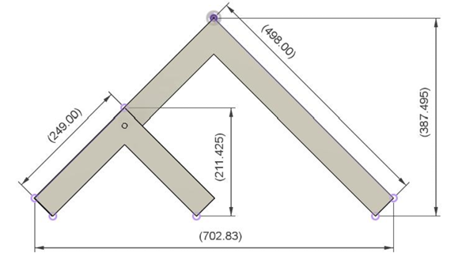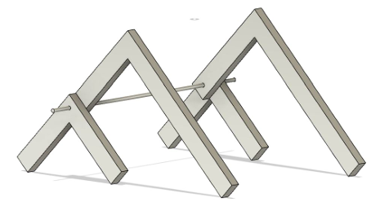

**Advantages**

**Obstacle Surmounting:** The rocker-bogie design allows rovers to climb obstacles

**Stability**: The system provides exceptional stability, allowing rovers to withstand significant tilts without overturning.

**Maneuverability**: The independent motors for each wheel and the ability to turn in place grant the rover excellent maneuverability and agility

The differential bar is a pivotal component of the rover, ensuring that the vehicle maintains balance on uneven terrain and the base remains nearly horizontal. It operates on a principle of balance and counterbalance, crucial for the rover’s ability to navigate challenging landscapes. Its function is to act as a balancing scale, responding to shifts in the rover’s weight as it climbs over rocks or dips

The point of axis where one end of the spring connects to the rod acts as a lever for both the right and left suspension systems to work independently, while the spring helps maintain the chassis’s stability

