JustMadeIt

A. Aim
The aim of this project is to design, fabricate, and demonstrate arena with gates, LED display and;
- SARM (Single Arm Robot on Omni-Wheeled Platform) — remotely controlled via Bluetooth to detect, pick, and remove obstacles from the ALFR path.
- ALFR (Advanced Line Follower Robot) — autonomously navigates the arena, interacts with gates, triggers the peristaltic pump, LAM LED system, and completes the sequence with a final weight measurement.
The objective is to perform the entire workflow within 10 minutes, while demonstrating robotics integration, embedded systems, sensing, fluid control, and mechanical design.

B. Description
Serial Bluetooth communication was used for ESP32 and phone communication. Open source libraries were used for Arduino NANO codes to use IR and Ultrasonic sensors to control ALFR; and to manipulated servo’s using Arduino. MIT app maker was used to make app for android to control SARM.

C. Hardware Components

1. 3D Printing and Fabrication

This stuff was the hardest part due to issue of lack of 3-D printers and a lot of teams, but still we managed to get it done. We had one working and functional at our Electronics club but it failed mid printing of ALFR chassis.

Then we had to contact our professors at Design Ajeet Sir and Abhisekh Sir for obtaining better printers to print larger parts of SARM. We had to adjust for the tolerances during 3-D printers so that bolt holes be printed.

Some cases it was physically impossible to achieve tolerances need so we had to drill holes into 3-D prints and ensure that just the right amount of force is used to ensure we drill holes and not break a part. Still we figured out how to get those bolts in.
And making motion smooth required cutting off a few layers of 3-D print which helped in loosing the parts to permit easier motion. Overall tolerance adjustment done further helped a lot, in further prints of leftover parts of SARM and gates, which led to smoother motion and no issues in getting those bolts in.

All 3-D prints made for SARM, ALFR, gates, mount were modified in Fusion 360, Solidworks, Ultimaker Cura, and fabricated using:
- Printer Used: Ender 3, Bambu Labs
- Filament Type: PLA 1.75mm
PLA cost – Rs.2910

2. Robots Included

a) SARM — Single Arm Robot on Omni-Wheeled Base
- Uses omnidirectional wheels for full mobility.
- Controlled manually using a mobile app over Serial Bluetooth.
- Driven by an ESP32 with independent motor PWM control.
- Individual controls for each servo motor using mobile app via Bluetooth.
- Main tasks:
  - Use the arm remove obstacles from ALFR path by pushing them off.
  - Coordinate movement around arena
Key Features Built:
- Independent 4-wheel PWM control
- Diagonal, lateral, forward, backward, rotation movements
- 3D-printed arm
Issues we faced and overcame:
- Fitting bolts in we had to drill holes for our mistakes of tolerance issues in base of bot. Later adjusted for CAD files accordance to tolerance to fit the bolts in place different for each printer according to it’s tolerances
- PCB was dysfunctional thus we had to make circuit without using PCB and understand how power distribution works, and even take in threshold current values for servo’s activation to ensure we get our desired power output and make parts move while using motors.
- One of the servo’s failed led to failure of gripper functionality. So instead of moving by lifting objects with gripper we had to use alternative way of moving objects by pushing them with arm.
- For mobile app we were using BLE(i.e low energy bluetooth signals) which had us find serviceUuid , Writing Characteristic of ESP using nRFconnect application of phone. But then we switched to simpler approach of using Serial Bluetooth communication due to issues using flutter. But it didn’t work due to incompatibility of libraries and version issues in flutter. Thus instead of using flutter we had to use MIT App Inventor to make our app work which ended up working well with our app effortlessly.
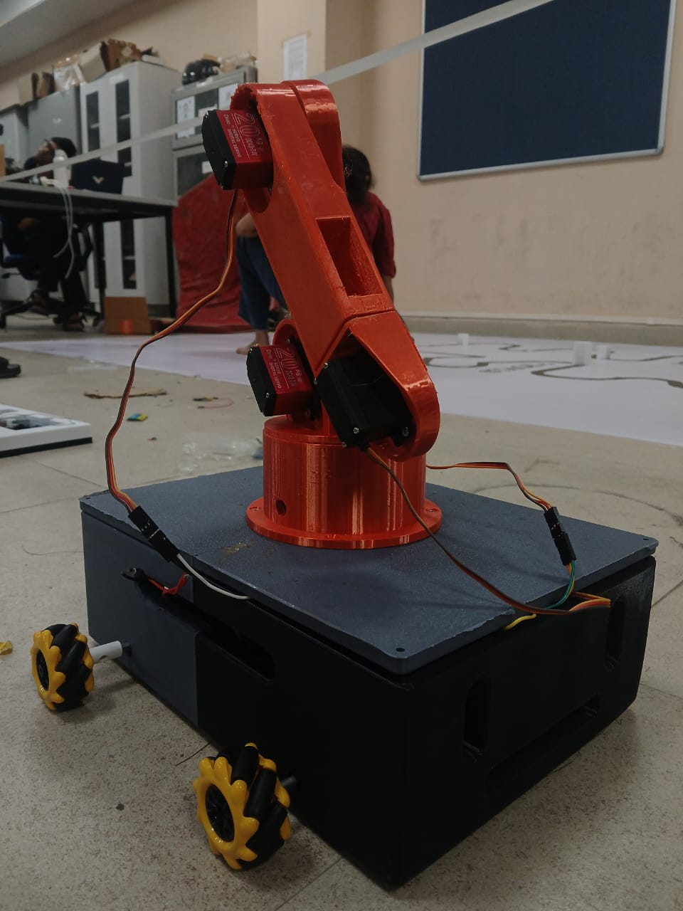

b) ALFR — Autonomous Line Follower Robot
- 3D-printed robot base with dual DC motor differential drive.
- Sensors:
  - 8-sensor IR array for high-precision line following
  - Ultrasonic sensor for obstacle detection
- Logic:
  - Stops and waits at blocked junctions
  - Continues only after SARM clears the path
  - Difference of proportion of white on left and right. Turn in the direction where there is less white. As there is black colored path.
Issues we faced and overcame:
- Issue of turning without Rack and pinion system. Led us to using differential turning similar to what planes and drones use. By slowing down one wheel we can turn down to that direction.
- Tolerances issues of Ender 3 printer led to smaller holes than bolt thickness causing problems in fitting PCB and battery pack to it. We melted off PLA to expand holes using solder and in some places drilled holes.

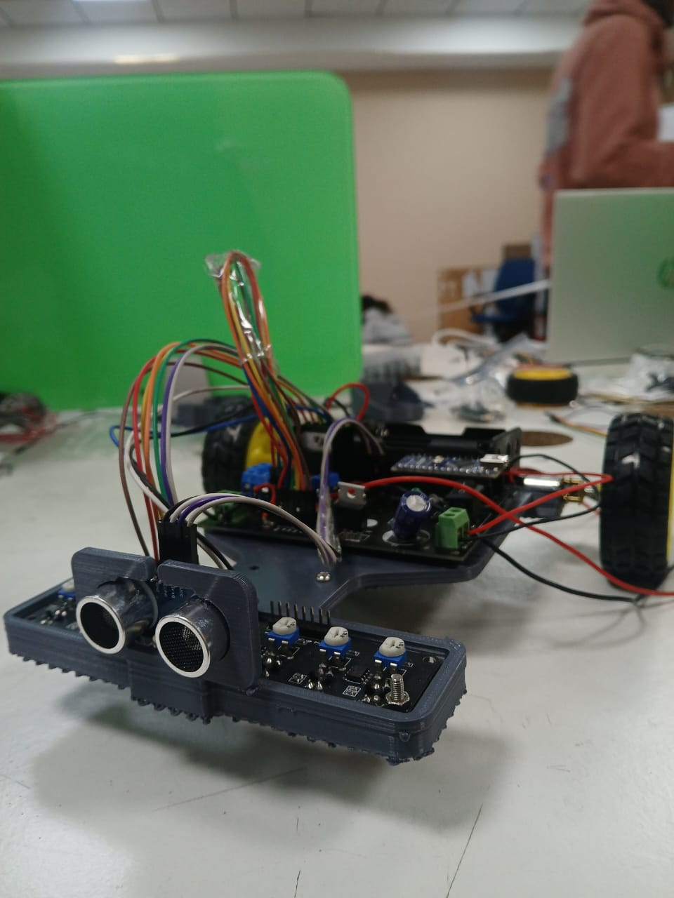
3. Gates
- Gate 1: Activates pump then Dispenses 125 ml
- Gate 2: Triggers LAM LED glow
- Gate 3: Load cell measurement then LCD display logic

D. Software Components

1. Mobile Application
A custom mobile app was developed to send Bluetooth command values to ESP32:
- Motion commands
  - 5 Servo Motor angle setting inputs
  - D-pad to command motion of wheels
- Single speed input to bot

2. SARM ESP32 Firmware
Handles:
- Bluetooth commands
- Motion across all orders of mobility
- Speed updates via Bluetooth
- Complete all directional movement control via Bluetooth
ESP32 code used:

#include "BluetoothSerial.h"
#include "ESP32Servo.h"
#include "driver/ledc.h" // Explicitly include for LEDC functions (PWM for motors)

// --- BLUETOOTH CONFIGURATION ---
#define BT_DEVICE_NAME "123"

// --- SERVO CONFIGURATION (5 Servos) ---
// **Using safe GPIO output pins for all servos**
const int PIN_SERVO1 = 32;
const int PIN_SERVO2 = 33;
const int PIN_SERVO3 = 27;
const int PIN_SERVO4 = 13;
const int PIN_SERVO5 = 16; // Changed from 35 (Input Only) to a safe output pin (16)

// --- MOTOR CONFIGURATION (4 DC Motors/Mecanum Wheels) ---
// Motor 1 Pins
const int M1_IN1 = 14;
const int M1_IN2 = 15;
const int M1_EN = 12; // Speed Control (PWM)
// Motor 2 Pins
const int M2_IN1 = 2;
const int M2_IN2 = 0;
const int M2_EN = 4;
// Motor 3 Pins
const int M3_IN1 = 21;
const int M3_IN2 = 19;
const int M3_EN = 3; // Note: Pin 3 is usually RX, but safe to use as output if not using hardware Serial RX
// Motor 4 Pins
const int M4_IN1 = 18;
const int M4_IN2 = 5;
const int M4_EN = 17;

// PWM Properties for Motors
const int MOTOR_PWM_FREQ = 30000;
const int MOTOR_PWM_RESOLUTION = 8; // Max speed is 2^8 - 1 = 255

// --- GLOBAL OBJECTS & STATE ---

// Bluetooth and Servo objects
BluetoothSerial SerialBT;
Servo servo1;
Servo servo2;
Servo servo3;
Servo servo4;
Servo servo5;

// Variables for Servo string parsing
String commandString = "";

// Variables for Motor control
int wheelSpeed = 200; // Default speed
int motorCommand = 0; // 0=Stop, 1-10=Movement functions

// --- FUNCTION DECLARATIONS ---
void parseAndControlIndividualServo(String command);
void setMotor(int motorId, int speed, int direction);

// --- MOTOR MOVEMENT FUNCTIONS ---
// These functions map the raw motorCommand (0-10) to actual motor control
void stopMoving() {
setMotor(1, 0, 0);
setMotor(2, 0, 0);
setMotor(3, 0, 0);
setMotor(4, 0, 0);
}
void moveForward() {
setMotor(1, wheelSpeed, 1);
setMotor(2, wheelSpeed, 1);
setMotor(3, wheelSpeed, 1);
setMotor(4, wheelSpeed, 1);
}
void moveBackward() {
setMotor(1, wheelSpeed, -1);
setMotor(2, wheelSpeed, -1);
setMotor(3, wheelSpeed, -1);
setMotor(4, wheelSpeed, -1);
}
void moveSidewaysRight() {
setMotor(1, wheelSpeed, -1);
setMotor(2, wheelSpeed, 1);
setMotor(3, wheelSpeed, -1);
setMotor(4, wheelSpeed, 1);
}
void moveSidewaysLeft() {
setMotor(1, wheelSpeed, 1);
setMotor(2, wheelSpeed, -1);
setMotor(3, wheelSpeed, 1);
setMotor(4, wheelSpeed, -1);
}
void rotateLeft() {
setMotor(1, wheelSpeed, 1);
setMotor(2, wheelSpeed, 1);
setMotor(3, wheelSpeed, -1);
setMotor(4, wheelSpeed, -1);
}
void rotateRight() {
setMotor(1, wheelSpeed, -1);
setMotor(2, wheelSpeed, -1);
setMotor(3, wheelSpeed, 1);
setMotor(4, wheelSpeed, 1);
}
void moveRightForward() {
setMotor(1, wheelSpeed, 0);
setMotor(2, wheelSpeed, 1);
setMotor(3, wheelSpeed, 0);
setMotor(4, wheelSpeed, 1);
}
void moveRightBackward() {
setMotor(1, wheelSpeed, -1);
setMotor(2, wheelSpeed, 0);
setMotor(3, wheelSpeed, -1);
setMotor(4, wheelSpeed, 0);
}
void moveLeftForward() {
setMotor(1, wheelSpeed, 1);
setMotor(2, wheelSpeed, 0);
setMotor(3, wheelSpeed, 1);
setMotor(4, wheelSpeed, 0);
}
void moveLeftBackward() {
setMotor(1, wheelSpeed, 0);
setMotor(2, wheelSpeed, -1);
setMotor(3, wheelSpeed, 0);
setMotor(4, wheelSpeed, -1);
}

// --- HELPER FUNCTION: MOTOR CONTROL ---
/**
* @brief Controls the speed and direction of an individual motor.
* @param motorId Motor ID (1-4).
* @param speed Speed (0-255).
* @param direction 1=Forward, -1=Backward, 0=Stop/Brake.
*/
void setMotor(int motorId, int speed, int direction) {
int in1, in2, enPin;

if (motorId == 1) { in1 = M1_IN1; in2 = M1_IN2; enPin = M1_EN; }
else if (motorId == 2) { in1 = M2_IN1; in2 = M2_IN2; enPin = M2_EN; }
else if (motorId == 3) { in1 = M3_IN1; in2 = M3_IN2; enPin = M3_EN; }
else if (motorId == 4) { in1 = M4_IN1; in2 = M4_IN2; enPin = M4_EN; }
else return;

// Set the PWM speed
ledcWrite(enPin, speed);

if (direction == 1) { // Forward
digitalWrite(in1, HIGH);
digitalWrite(in2, LOW);
} else if (direction == -1) { // Backward
digitalWrite(in1, LOW);
digitalWrite(in2, HIGH);
} else { // Stop/Release (direction == 0)
digitalWrite(in1, LOW);
digitalWrite(in2, LOW);
}
}

// --- SERVO PARSING AND CONTROL FUNCTION ---
/**
* @brief Parses the command string and controls the specified servo.
* @param command A string in the format "S<ID>,<ANGLE>", e.g., "S1,90"
*/
void parseAndControlIndividualServo(String command) {
command.trim();

// Validation check
if (command.length() < 3 || command.charAt(0) != 'S') {
Serial.println("ERROR: Invalid servo command format.");
return;
}

int commaIndex = command.indexOf(',');
if (commaIndex == -1) {
Serial.println("ERROR: Missing comma separator in servo command.");
return;
}

String idStr = command.substring(0, commaIndex);
String angleStr = command.substring(commaIndex + 1);
int servoAngle = angleStr.toInt();

if (servoAngle < 0 || servoAngle > 180) {
Serial.printf("ERROR: Servo angle out of range (received %d, expected 0-180).\n", servoAngle);
return;
}

// Control Logic
if (idStr.equals("S1")) {
servo1.write(servoAngle);
Serial.printf("✅ Moving Servo 1 to %d degrees (Cmd: %s).\n", servoAngle, command.c_str());
} else if (idStr.equals("S2")) {
servo2.write(servoAngle);
Serial.printf("✅ Moving Servo 2 to %d degrees (Cmd: %s).\n", servoAngle, command.c_str());
} else if (idStr.equals("S3")) {
servo3.write(servoAngle);
Serial.printf("✅ Moving Servo 3 to %d degrees (Cmd: %s).\n", servoAngle, command.c_str());
} else if (idStr.equals("S4")) {
servo4.write(servoAngle);
Serial.printf("✅ Moving Servo 4 to %d degrees (Cmd: %s).\n", servoAngle, command.c_str());
} else if (idStr.equals("S5")) {
servo5.write(servoAngle);
Serial.printf("✅ Moving Servo 5 to %d degrees (Cmd: %s).\n", servoAngle, command.c_str());
} else {
Serial.printf("ERROR: Servo ID not recognized (received %s, expected S1-S5).\n", idStr.c_str());
}
}

// ==========================================================
// SETUP FUNCTION
// ==========================================================
void setup() {
Serial.begin(115200);
Serial.println("\n--- ESP32 Unified Controller Ready ---");

// Initialize Bluetooth Serial
SerialBT.begin(BT_DEVICE_NAME);
Serial.printf("Bluetooth Device Name: %s\n", BT_DEVICE_NAME);
Serial.println("Waiting for a Bluetooth connection...");

// 1. SERVO SETUP
// Attach Servos and set initial position
servo1.attach(PIN_SERVO1);
servo2.attach(PIN_SERVO2);
servo3.attach(PIN_SERVO3);
servo4.attach(PIN_SERVO4);
servo5.attach(PIN_SERVO5);

servo1.write(90);
servo2.write(90);
servo3.write(90);
servo4.write(90);
servo5.write(90);
Serial.println("5 Servos initialized to 90 degrees.");

// 2. MOTOR SETUP
// Set up Motor Direction Pins (IN1, IN2)
pinMode(M1_IN1, OUTPUT); pinMode(M1_IN2, OUTPUT);
pinMode(M2_IN1, OUTPUT); pinMode(M2_IN2, OUTPUT);
pinMode(M3_IN1, OUTPUT); pinMode(M3_IN2, OUTPUT);
pinMode(M4_IN1, OUTPUT); pinMode(M4_IN2, OUTPUT);

// Configure PWM/Speed Control Pins (EN)
ledcAttach(M1_EN, MOTOR_PWM_FREQ, MOTOR_PWM_RESOLUTION);
ledcAttach(M2_EN, MOTOR_PWM_FREQ, MOTOR_PWM_RESOLUTION);
ledcAttach(M3_EN, MOTOR_PWM_FREQ, MOTOR_PWM_RESOLUTION);
ledcAttach(M4_EN, MOTOR_PWM_FREQ, MOTOR_PWM_RESOLUTION);
Serial.println("4 Motors initialized with PWM control.");
}

// ==========================================================
// LOOP FUNCTION (Unified Command Handling)
// ==========================================================
void loop() {
// Check for incoming data from Bluetooth
while (SerialBT.available()) {
// Read the incoming byte as an integer (important for motor control byte values)
int incomingData = SerialBT.read();

// --- PROTOCOL 1: Single-Byte Motor Command/Speed (0-10 for command, 16+ for speed) ---
if (incomingData >= 0 && incomingData <= 10) {
// Movement command: 0-10
motorCommand = incomingData;
// Clear any partial servo command, as this is a new type of command
commandString = "";
Serial.printf("RAW CMD (Motor): New movement command = %d\n", motorCommand);

} else if (incomingData >= 16 && incomingData <= 255) {
// Speed command: 16-255
wheelSpeed = incomingData;
// Clear any partial servo command
commandString = "";
Serial.printf("RAW CMD (Speed): New wheel speed = %d\n", wheelSpeed);
}

// --- PROTOCOL 2: Multi-Character Servo Command (S<ID>,<ANGLE>\n) ---
else {
char incomingChar = (char)incomingData; // Treat the byte as a character

if (incomingChar == '\n') {
// End of Servo command string reached. Process it.
if (commandString.length() > 0 && commandString.charAt(0) == 'S') {
parseAndControlIndividualServo(commandString);
} else {
// It was a newline but the string buffer was empty or didn't start with 'S'
Serial.printf("WARN: Non-Servo command string received: [%s]\n", commandString.c_str());
}
commandString = ""; // Clear the command string for the next command

} else if (incomingChar != '\r') {
// Append the received character to the current command string (ignore \r)
commandString += incomingChar;
}
}
}

// --- MOTOR EXECUTION LOGIC (Always running based on the last 'motorCommand' value) ---
// This logic is separate from the input parsing and runs continuously in the loop.
if (motorCommand == 0) stopMoving();
else if (motorCommand == 1) moveRightForward();
else if (motorCommand == 2) moveForward();
else if (motorCommand == 3) moveLeftForward();
else if (motorCommand == 4) moveSidewaysRight();
else if (motorCommand == 5) moveSidewaysLeft();
else if (motorCommand == 6) moveRightBackward();
else if (motorCommand == 7) moveBackward();
else if (motorCommand == 8) moveLeftBackward();
else if (motorCommand == 9) rotateLeft();
else if (motorCommand == 10) rotateRight();

delay(5); // Small delay
}

3. ALFR Arduino NANO Firmware
Handles:
- 8-sensor line tracking
- Obstacle stop logic
- Differential speed adjustment
- Pump ,LED ,Load cell sequence
Final Arduino NANO code used:
const int irPins[8] = {A0, A1, A2, A3, A4, A5, A6, A7};
const int trigPin = 3;
const int echoPin = 4;
const int obstacleDistanceCM = 5;
const int leftPWM = 10;
const int leftIn1 = 9;
const int leftIn2 = 8;
const int rightPWM = 5;
const int rightIn1 = 7;
const int rightIn2 = 6;
const int BLACK_THR = 90;
const int WHITE_THR = 80;
const int TH = 10;
int straightSpeed = 160;
const int reduction_factor = -0.2;

void setup() {
Serial.begin(115200);
pinMode(trigPin, OUTPUT);
pinMode(echoPin, INPUT);
pinMode(leftPWM, OUTPUT);
pinMode(leftIn1, OUTPUT);
pinMode(leftIn2, OUTPUT);
pinMode(rightPWM, OUTPUT);
pinMode(rightIn1, OUTPUT);
pinMode(rightIn2, OUTPUT);
stopMotors();
delay(300);
}

void loop() {
long d = readUltrasonicCM();
if (d > 0 && d <= obstacleDistanceCM) {
stopMotors();
Serial.print("Obstacle at: "); Serial.println(d);
while (true) {
delay(200);
long dd = readUltrasonicCM();
if (dd > obstacleDistanceCM + 5) break;
}
delay(20);
}
int s[8];
for (int i = 0; i < 8; i++) s[i] = analogRead(irPins[i]);
for (int i = 0; i < 8; i++) { Serial.print(String(s[i]) + " "); }
Serial.println();
bool AllWhite = (((s[4]+s[3])/2 < WHITE_THR) && (s[7] + s[6] + s[5])/3 < WHITE_THR && (s[2] + s[1] + s[0])/3<WHITE_THR);
bool AllBlack = (
((s[4] + s[3]) / 2 > BLACK_THR) &&
((s[7] + s[6] + s[5]) / 3 > BLACK_THR) &&
((s[2] + s[1] + s[0]) / 3 > BLACK_THR)
);
if (AllWhite) {
Serial.println("ALL WHITE → BACKWARD");
digitalWrite(leftIn1, LOW);
digitalWrite(leftIn2, HIGH);
analogWrite(leftPWM, 140);
digitalWrite(rightIn1, LOW);
digitalWrite(rightIn2, HIGH);
analogWrite(rightPWM, 140);
delay(200);
return;
}
int sumLeft = s[7] + s[6] + s[5];
int sumRight = s[2] + s[1] + s[0];
int diff = sumLeft - sumRight;
if (diff > TH) {
turnLeftSharp(straightSpeed, straightSpeed*reduction_factor);
Serial.print("TURN LEFT | diff="); Serial.println(diff);
}
else if (diff < -TH) {
turnRightSharp(straightSpeed*reduction_factor, straightSpeed);
Serial.print("TURN RIGHT | diff="); Serial.println(diff);
}
else {
forward(straightSpeed, straightSpeed);
Serial.print("STRAIGHT | diff="); Serial.println(diff);
}
delay(100);
}
void forward(int L, int R) {
digitalWrite(leftIn1, HIGH);
digitalWrite(leftIn2, LOW);
analogWrite(leftPWM, L);
digitalWrite(rightIn1, HIGH);
digitalWrite(rightIn2, LOW);
analogWrite(rightPWM, R);
delay(20);
}

void turnRightSharp(int Lspeed, int Rspeed) {
digitalWrite(leftIn1, LOW);
digitalWrite(leftIn2, HIGH);
analogWrite(leftPWM, Lspeed);
digitalWrite(rightIn1, HIGH);
digitalWrite(rightIn2, LOW);
analogWrite(rightPWM, Rspeed);
delay(20);
}

void turnLeftSharp(int Lspeed, int Rspeed) {
digitalWrite(leftIn1, HIGH);
digitalWrite(leftIn2, LOW);
analogWrite(leftPWM, Lspeed);
digitalWrite(rightIn1, LOW);
digitalWrite(rightIn2, HIGH);
analogWrite(rightPWM, Rspeed);
delay(20);
}

void stopMotors() {
analogWrite(leftPWM, 0);
analogWrite(rightPWM, 0);
digitalWrite(leftIn1, LOW);
digitalWrite(leftIn2, LOW);
digitalWrite(rightIn1, LOW);
digitalWrite(rightIn2, LOW);
delay(20);
}

long readUltrasonicCM() {
digitalWrite(trigPin, LOW);
delayMicroseconds(2);
digitalWrite(trigPin, HIGH);
delayMicroseconds(10);
digitalWrite(trigPin, LOW);
long dur = pulseIn(echoPin, HIGH, 30000);
if (dur == 0) return -1;
return dur / 58;
}

4. Arena Code
Arena was built strictly according to rule book dimensions:
- Working LCD to show weights
- Functional pump delivering liquid
- LAM LED works
The arena PCB was integrated with the required gate sensors.

Gate Logic Summary
Gate | Trigger Event | Action Performed
Gate 1 | ALFR crosses | Peristaltic pump ON then Dispense 125 ml then OFF
Gate 2 | ALFR crosses | LAM LED ON
Gate 3 | ALFR parks | Load cell measurement then LCD display
LCD shows: Weight detected by Load Cell

#include <Adafruit_GFX.h>
#include <Adafruit_ST7735.h>
#include <SPI.h>
#include "HX711.h"
#include "team_photo.h" // contains lcd_test_pic_1

// ==========================================
// --- LCD PINS (Your Config) ---
#define TFT_CS 26
#define TFT_RST 33
#define TFT_DC 32
#define TFT_MOSI 23
#define TFT_SCLK 18
#define TFT_LED 27

// --- SENSOR PINS (IR GATES) ---
#define PIN_IR_GATE_1 16 // Detects car at Pump Station (active-LOW => 0 when detected)
#define PIN_IR_GATE_2 14 // Detects car at LAM LED Station
#define PIN_IR_GATE_3 17 // Detects car at Load Cell Station

// --- ACTUATOR PINS ---
// NOTE: Pump and LAM are active-LOW in this version. Drive LOW to turn ON.
#define PIN_PUMP 13 // Controls the DC Pump (use MOSFET/driver!)
#define PIN_LAM_LED 4 // Controls the LAM LED

// --- LOAD CELL PINS ---
#define PIN_LOADCELL_DT 21
#define PIN_LOADCELL_SCK 22

// ==========================================
// SETTINGS
// ==========================================
const unsigned long DEFAULT_PUMP_RUN_TIME_MS = 3000UL; // default pump runtime
unsigned long pumpRunTimeMs = DEFAULT_PUMP_RUN_TIME_MS; // can be changed via serial

const float LOADCELL_CALIBRATION_FACTOR = 2280.0; // calibrate this
const float TARGET_WEIGHT_MIN = 120.0; // grams
const float TARGET_WEIGHT_MAX = 130.0; // grams

// Debounce settings for IR gates
const unsigned long DEBOUNCE_MS = 50;

// HX711 reading settings
const uint8_t HX711_SAMPLES = 10;
const unsigned long HX711_READY_TIMEOUT_MS = 1500UL;

// ==========================================
// GLOBAL OBJECTS
// ==========================================
Adafruit_ST7735 tft = Adafruit_ST7735(TFT_CS, TFT_DC, TFT_MOSI, TFT_SCLK, TFT_RST);
HX711 scale;

// Sensor state tracking for edge detection + debounce
const uint8_t NUM_GATES = 3;
const int gatePins[NUM_GATES] = {PIN_IR_GATE_1, PIN_IR_GATE_2, PIN_IR_GATE_3};
int gateStableState[NUM_GATES];
int gateLastRaw[NUM_GATES];
unsigned long gateLastChangeMs[NUM_GATES];

// Actuator non-blocking control
bool pumpActive = false;
unsigned long pumpStartMs = 0;
unsigned long pumpDurationMs = 0;

bool lamActive = false;
unsigned long lamStartMs = 0;
unsigned long lamDurationMs = 0;

// Stage flags (logical sequence)
bool gate1Done = false;
bool gate2Done = false;
bool gate3Done = false;

// For result display
float lastMeasuredWeight = 0.0;
bool weightValid = false;

// System states (for clarity)
enum SysState {S_IDLE, S_PUMPING, S_LAM, S_WEIGHING, S_RESULT};
SysState currentState = S_IDLE;

// -------- Splash (non-blocking) ----------
bool splashActive = false;
unsigned long splashStartMs = 0;
unsigned long splashDurationMs = 0;

// -------- Result display (non-blocking) ----
bool resultActive = false;
unsigned long resultStartMs = 0;
unsigned long resultDurationMs = 0;

// ==================== FUNCTION DECLARATIONS ====================
void initLCD();
void startSplash(unsigned long ms);
void handleSplash();
void lcdStatus(const char* line1, const char* line2 = nullptr);
void lcdResult(bool pass, float weight);

void initLoadCell();
float readWeightAverage(uint8_t samples, unsigned long timeoutMs = HX711_READY_TIMEOUT_MS);

void initSensors();
void handleDebounce();

bool gateFallingEdge(uint8_t gateIndex); // returns true when stable HIGH->LOW (active low)
void handleStages();

void startPump(unsigned long durationMs);
void stopPump();
void handlePump();

void startLam(unsigned long durationMs);
void stopLam();
void handleLam();

void resetSystem();
void scheduleResultTimeout(unsigned long ms);
void handleResultTimeout();

void processSerialCommands();

// ==================== SETUP ====================
void setup() {
Serial.begin(115200);
Serial.println("System Initializing...");

// Pins
pinMode(TFT_LED, OUTPUT);
pinMode(PIN_PUMP, OUTPUT);
pinMode(PIN_LAM_LED, OUTPUT);

// IR inputs: use INPUT_PULLUP because sensors pull LOW when active
for (uint8_t i = 0; i < NUM_GATES; ++i) {
pinMode(gatePins[i], INPUT_PULLUP);
gateLastRaw[i] = digitalRead(gatePins[i]);
gateStableState[i] = gateLastRaw[i];
gateLastChangeMs[i] = millis();
}

// Initial actuator states: since pump & LAM are active-LOW, drive HIGH to keep them OFF
digitalWrite(TFT_LED, HIGH);
digitalWrite(PIN_PUMP, HIGH); // OFF (active-LOW)
digitalWrite(PIN_LAM_LED, HIGH); // OFF (active-LOW)

// Initialize subsystems
initLCD();
startSplash(1200); // non-blocking splash
initLoadCell();

lcdStatus("System Ready", "Waiting for Car...");
Serial.println("Setup Complete.");
}

// ==================== MAIN LOOP ====================
void loop() {
processSerialCommands(); // allow runtime commands

handleSplash(); // non-blocking splash display
handleDebounce(); // update gateStableState[] based on debounce
handlePump(); // pump timing
handleLam(); // lam timing
handleStages(); // check gates and advance sequence
handleResultTimeout(); // non-blocking result timeout -> reset
}

// ==================== SUBSYSTEM IMPLEMENTATIONS ====================

// LCD helpers
void initLCD() {
tft.initR(INITR_BLACKTAB);
tft.fillScreen(ST7735_BLACK);
tft.setRotation(0);
tft.setTextWrap(true);
}

void startSplash(unsigned long ms) {
splashActive = true;
splashStartMs = millis();
splashDurationMs = ms;
tft.fillScreen(ST7735_BLACK);
// draw bitmap now
tft.drawRGBBitmap(0, 0, lcd_test_pic_1, 128, 160);
// we keep the bitmap visible until splashDurationMs elapses; no blocking here
}

void handleSplash() {
if (!splashActive) return;
if (millis() - splashStartMs >= splashDurationMs) {
splashActive = false;
// After splash, show Ready screen (but do not block)
lcdStatus("Ready for", "Next Car");
}
}

void lcdStatus(const char* line1, const char* line2) {
tft.fillScreen(ST7735_BLACK);
tft.setCursor(8, 10);
tft.setTextSize(1);
tft.setTextColor(ST7735_WHITE);
tft.println(line1);
if (line2) {
tft.setCursor(8, 30);
tft.setTextColor(ST7735_CYAN);
tft.println(line2);
}
}

void lcdResult(bool pass, float weight) {
tft.fillScreen(ST7735_BLACK);
tft.setTextSize(2);
if (pass) {
tft.setTextColor(ST7735_GREEN);
tft.setCursor(10, 30);
tft.println("PASS");
} else {
tft.setTextColor(ST7735_RED);
tft.setCursor(10, 30);
tft.println("FAIL");
}
tft.setTextSize(1);
tft.setCursor(10, 70);
tft.setTextColor(ST7735_WHITE);
if (!isnan(weight)) {
tft.print("Vol: "); tft.print(weight); tft.println(" g");
} else {
tft.println("Vol: N/A");
}
}

// Load cell
void initLoadCell() {
Serial.println("Initializing Load Cell...");
scale.begin(PIN_LOADCELL_DT, PIN_LOADCELL_SCK);
scale.set_scale(LOADCELL_CALIBRATION_FACTOR);
scale.tare();
}

float readWeightAverage(uint8_t samples, unsigned long timeoutMs) {
unsigned long start = millis();
// Wait for HX711 ready with non-blocking timeout; also allow serial processing while waiting
while (!scale.is_ready()) {
if (millis() - start >= timeoutMs) {
return NAN; // timeout
}
processSerialCommands(); // keep serial responsive while waiting
// do NOT call delay() here
}
// hx711 get_units may internally block briefly while reading samples; library function used here
float val = scale.get_units(samples);
return val;
}

// Debounce handler: updates gateStableState[]
void handleDebounce() {
for (uint8_t i = 0; i < NUM_GATES; ++i) {
int raw = digitalRead(gatePins[i]);
if (raw != gateLastRaw[i]) {
// raw changed, restart debounce timer
gateLastChangeMs[i] = millis();
gateLastRaw[i] = raw;
} else {
// raw is stable; update stable state after debounce interval
if ((millis() - gateLastChangeMs[i]) >= DEBOUNCE_MS) {
gateStableState[i] = raw; // 0 or 1
}
}
}
}

// Sensor: returns true only when stable edge HIGH -> LOW detected (active-low sensors)
bool gateFallingEdge(uint8_t gateIndex) {
static int prevStable[NUM_GATES] = {HIGH, HIGH, HIGH}; // assume HIGH at start (no car)
int stable = gateStableState[gateIndex];
bool falling = (prevStable[gateIndex] == HIGH) && (stable == LOW);
prevStable[gateIndex] = stable;
return falling;
}

// Central stage handler (non-blocking)
void handleStages() {
// Stage 1: Pump station (waiting for falling edge on gate1)
if (!gate1Done) {
if (gateFallingEdge(0)) {
Serial.println("Gate 1 Triggered (Pump)");
lcdStatus("PUMP ON:", "Filling...");
startPump(pumpRunTimeMs);
gate1Done = true; // ensure sequence advances
currentState = S_PUMPING;
}
}

// Stage 2: LAM LED station
if (gate1Done && !gate2Done) {
if (gateFallingEdge(1)) {
Serial.println("Gate 2 Triggered (LAM)");
lcdStatus("LAM LED ON", nullptr);
startLam(3000); // 3 seconds
gate2Done = true;
currentState = S_LAM;
}
}

// Stage 3: Weighing station
if (gate2Done && !gate3Done) {
if (gateFallingEdge(2)) {
Serial.println("Gate 3 Triggered (Weighing)");
lcdStatus("Weighing...", nullptr);
currentState = S_WEIGHING;

// Perform weight read (this does a readiness wait but yields to serial)
float w = readWeightAverage(HX711_SAMPLES, HX711_READY_TIMEOUT_MS);
if (isnan(w)) {
Serial.println("HX711 read failed or timed out.");
lcdStatus("HX711 Error", "Check wiring/calib");
lastMeasuredWeight = NAN;
weightValid = false;
} else {
Serial.print("Weight Detected: "); Serial.println(w);
lastMeasuredWeight = w;
weightValid = true;
bool pass = (w >= TARGET_WEIGHT_MIN && w <= TARGET_WEIGHT_MAX);
lcdResult(pass, w);
}

gate3Done = true;
currentState = S_RESULT;

// Start non-blocking result timer (10 seconds) and return to loop
scheduleResultTimeout(10000UL);
}
}
}

// Pump control (non-blocking)
// Active-LOW: drive LOW to turn ON, HIGH to turn OFF
void startPump(unsigned long durationMs) {
if (pumpActive) return; // already running
digitalWrite(PIN_PUMP, LOW); // ON (active-LOW)
pumpActive = true;
pumpStartMs = millis();
pumpDurationMs = durationMs;
Serial.print("Pump started (ACTIVE-LOW) for "); Serial.print(durationMs); Serial.println(" ms");
}

void stopPump() {
digitalWrite(PIN_PUMP, HIGH); // OFF
pumpActive = false;
pumpStartMs = 0;
pumpDurationMs = 0;
Serial.println("Pump stopped (OFF -> HIGH)");
}

void handlePump() {
if (pumpActive) {
if (millis() - pumpStartMs >= pumpDurationMs) {
stopPump();
// After pump done, update LCD
lcdStatus("Fill Complete", nullptr);
}
}
}

// LAM control (non-blocking)
// Active-LOW: drive LOW to turn ON, HIGH to turn OFF
void startLam(unsigned long durationMs) {
if (lamActive) return;
digitalWrite(PIN_LAM_LED, LOW); // ON
lamActive = true;
lamStartMs = millis();
lamDurationMs = durationMs;
Serial.print("LAM ON (ACTIVE-LOW) for "); Serial.print(durationMs); Serial.println(" ms");
}

void stopLam() {
digitalWrite(PIN_LAM_LED, HIGH); // OFF
lamActive = false;
lamStartMs = 0;
lamDurationMs = 0;
Serial.println("LAM OFF (HIGH)");
}

void handleLam() {
if (lamActive) {
if (millis() - lamStartMs >= lamDurationMs) {
stopLam();
}
}
}

// Schedule and handle the non-blocking result timeout
void scheduleResultTimeout(unsigned long ms) {
resultActive = true;
resultStartMs = millis();
resultDurationMs = ms;
Serial.print("Result displayed for "); Serial.print(ms); Serial.println(" ms");
}

void handleResultTimeout() {
if (!resultActive) return;
if (millis() - resultStartMs >= resultDurationMs) {
resultActive = false;
resetSystem();
currentState = S_IDLE;
}
}

// Reset system for next car
void resetSystem() {
gate1Done = gate2Done = gate3Done = false;
// ensure actuators are off (active-LOW => HIGH is off)
if (pumpActive) stopPump();
if (lamActive) stopLam();

lastMeasuredWeight = 0.0;
weightValid = false;

// re-draw splash and ready message non-blocking
startSplash(800);
lcdStatus("Ready for", "Next Car");
Serial.println("System reset and ready.");
}

// Serial command handling (simple)
// Commands:
// 'p' -> print current weight reading
// 'c' + number -> run pump for given ms for calibration (e.g. "c1500" runs pump 1500ms)
// 'r' -> reset system
// 's' + number -> set default pump runtime
void processSerialCommands() {
while (Serial.available()) {
String s = Serial.readStringUntil('\n');
s.trim();
if (s.length() == 0) return;
char cmd = s.charAt(0);
if (cmd == 'p') {
float w = readWeightAverage(HX711_SAMPLES, 1000);
if (isnan(w)) Serial.println("Weight read failed");
else {
Serial.print("Weight: "); Serial.print(w); Serial.println(" g");
}
} else if (cmd == 'c') {
// calibrate pump runtime quickly by running for given ms
String num = s.substring(1);
num.trim();
unsigned long msVal = num.toInt();
if (msVal == 0) {
Serial.println("Usage: c<ms> e.g. c1500 to run pump 1500ms");
} else {
Serial.print("Calibration run: pump for "); Serial.print(msVal); Serial.println(" ms");
startPump(msVal);
}
} else if (cmd == 'r') {
resetSystem();
} else if (cmd == 's') {
// set pump default runtime: s<ms>
String num = s.substring(1);
pumpRunTimeMs = num.toInt();
if (pumpRunTimeMs == 0) pumpRunTimeMs = DEFAULT_PUMP_RUN_TIME_MS;
Serial.print("Set default pump runtime: "); Serial.print(pumpRunTimeMs); Serial.println(" ms");
} else {
Serial.print("Unknown cmd: "); Serial.println(s);
}
}
}

E. Circuit Images
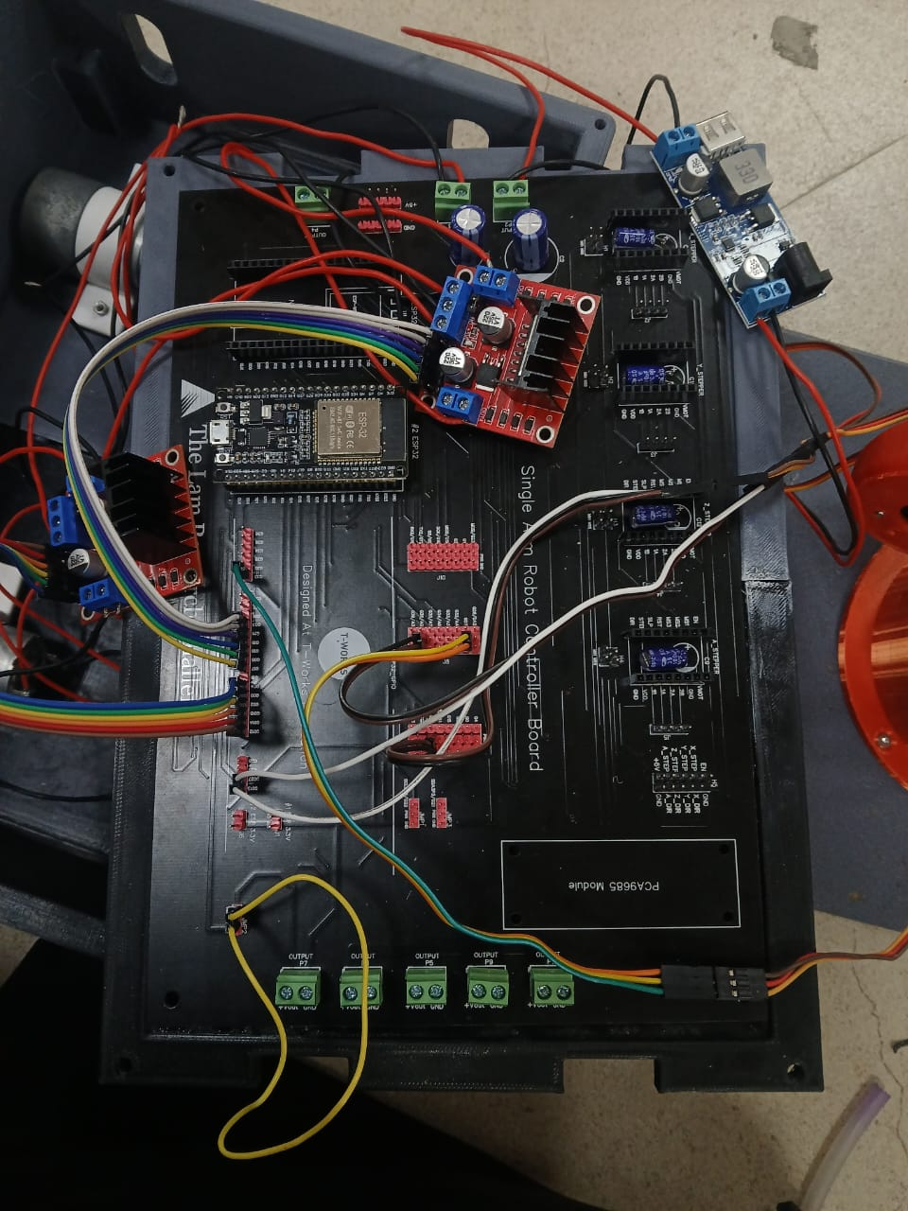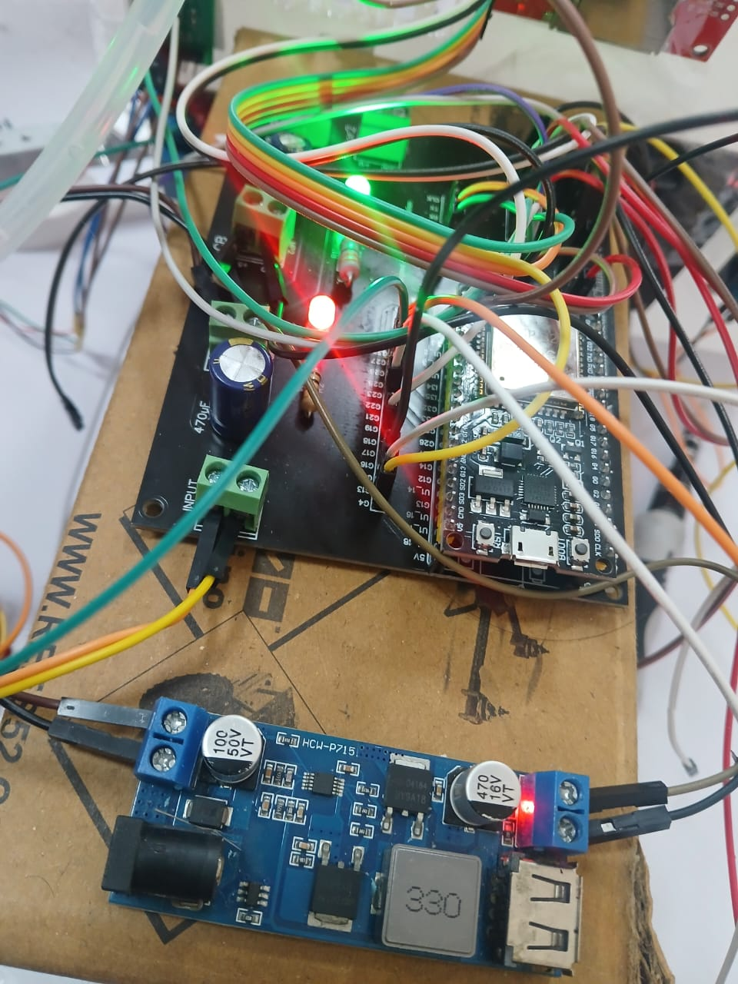
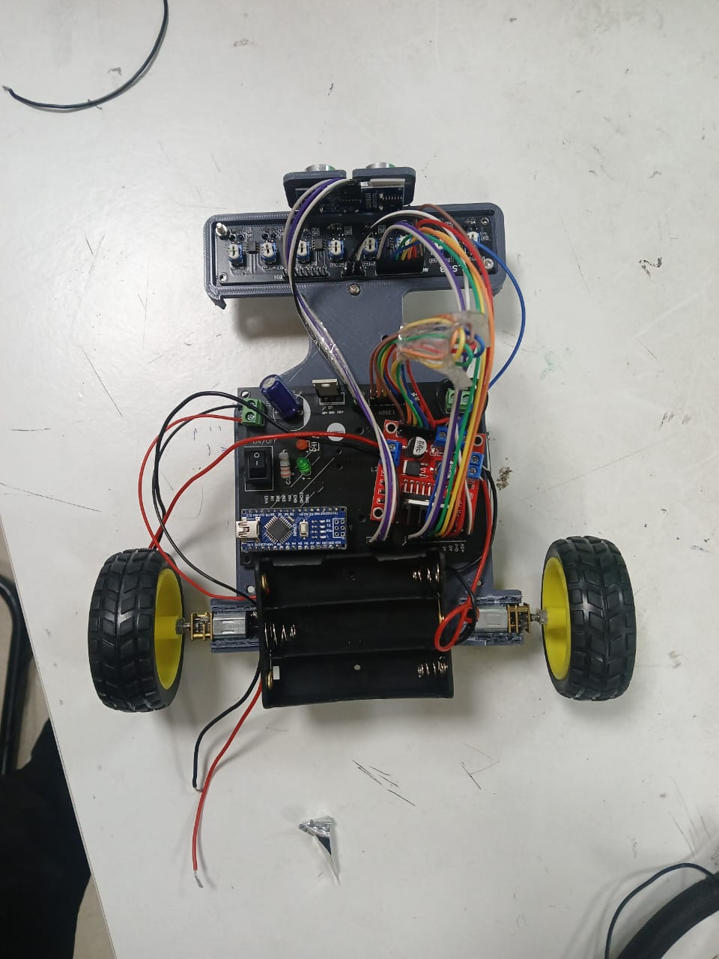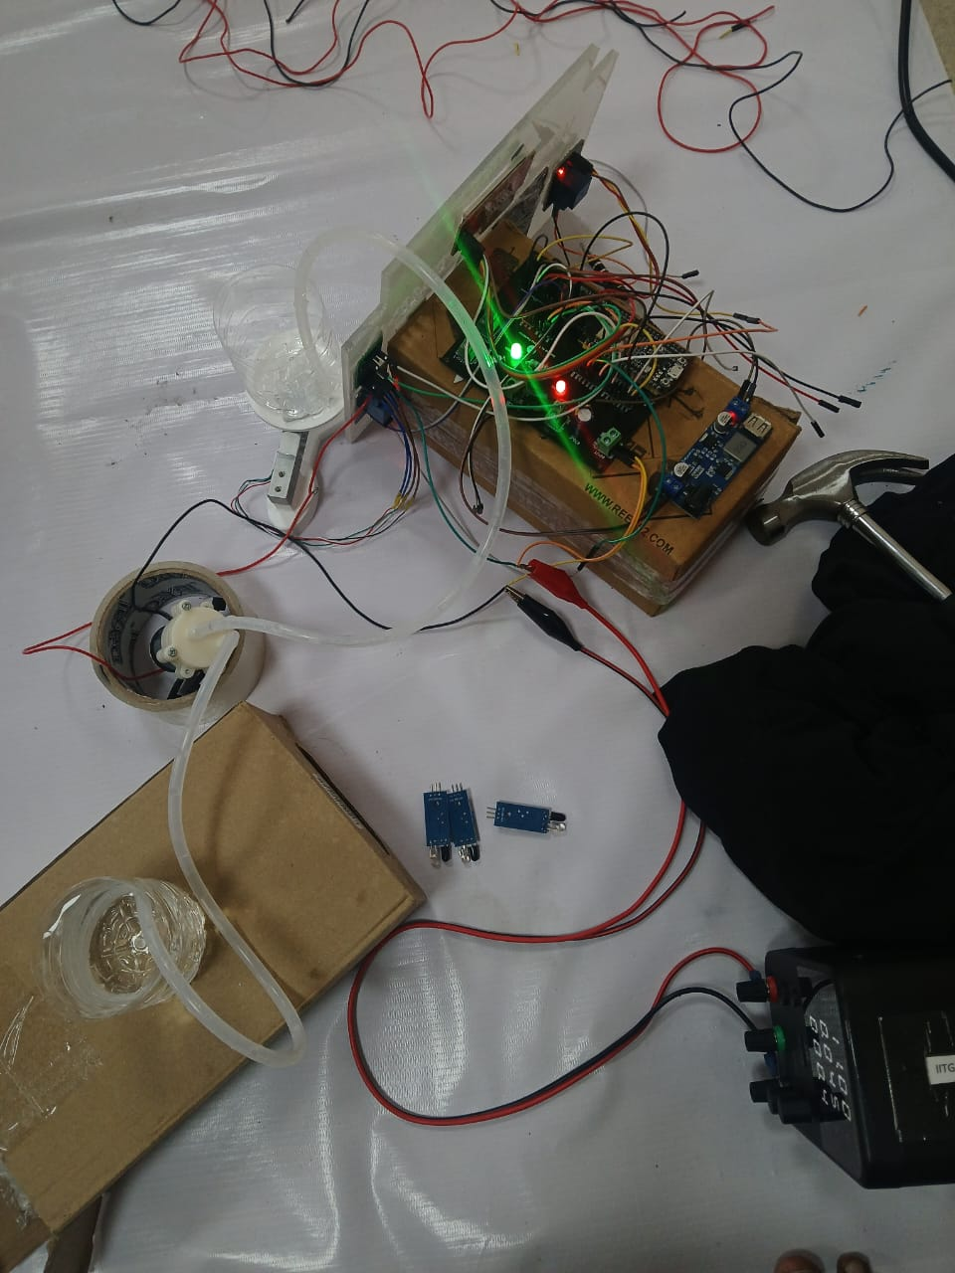

F. Working Photos
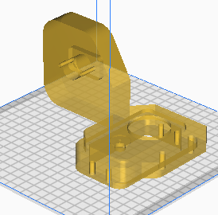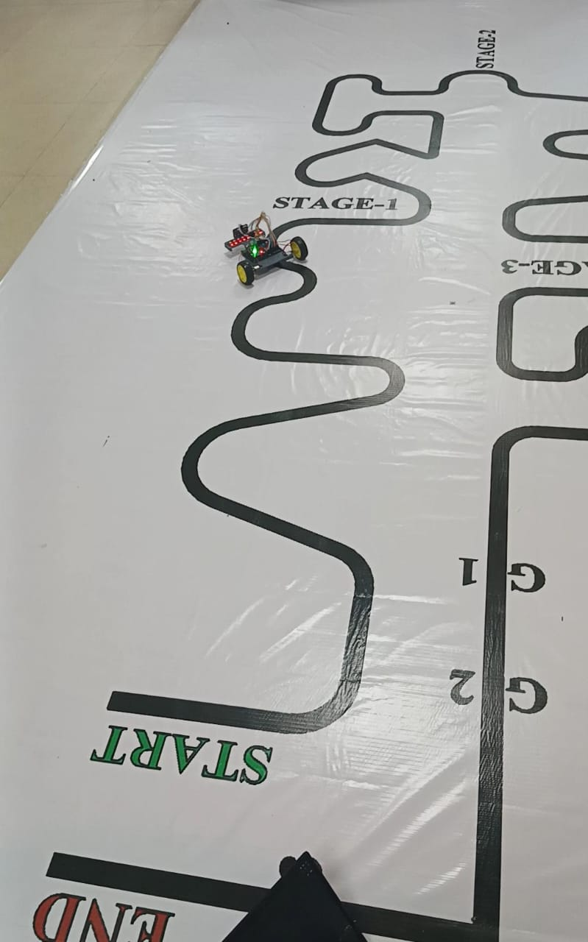

G. Results and Outcomes
  - SARM Results
    - Got all directional movement.
    - Able to pick and remove obstacles reliably.
    - Bluetooth controlled using app
  - ALFR Results
    - Successfully followed the complete line.
    - Threshold-based turns with differential PWM for differential turning.
    - Successfully stopped at obstacles and resumed after SARM clearance.
  - Gate System Results
    - Gate 1: Pump dispensed
    - Gate 2: LAM LED activated
    - Gate 3: Final load cell measurement displayed onscreen

H. Final Outcome
- Full challenge completed within _____ minutes, earning time bonus.
- All mandatory tasks demonstrated per the scoring table.
- System shows robust integration of:
  - Mechanical design
  - Embedded control
  - Sensor fusion
  - Fluid mechanics
  - Wireless communication

