**Assignment 1**

Name: Mythresh Maddina

Uid No: 700741162

Video link:

<https://drive.google.com/file/d/1BuBz2YrbX37-F_I_Da-DKmf3rK_29G7Q/view?usp=share_link>

Github Link:<https://github.com/MythreshM/CS5710_Assignment1>

Document Link:

https://docs.google.com/document/d/1Kuq-Su6bbsePuQEmh5sJ7ymqP4uwFyHDGTJEtgJaTms/edit?usp=sharing

Question 1:

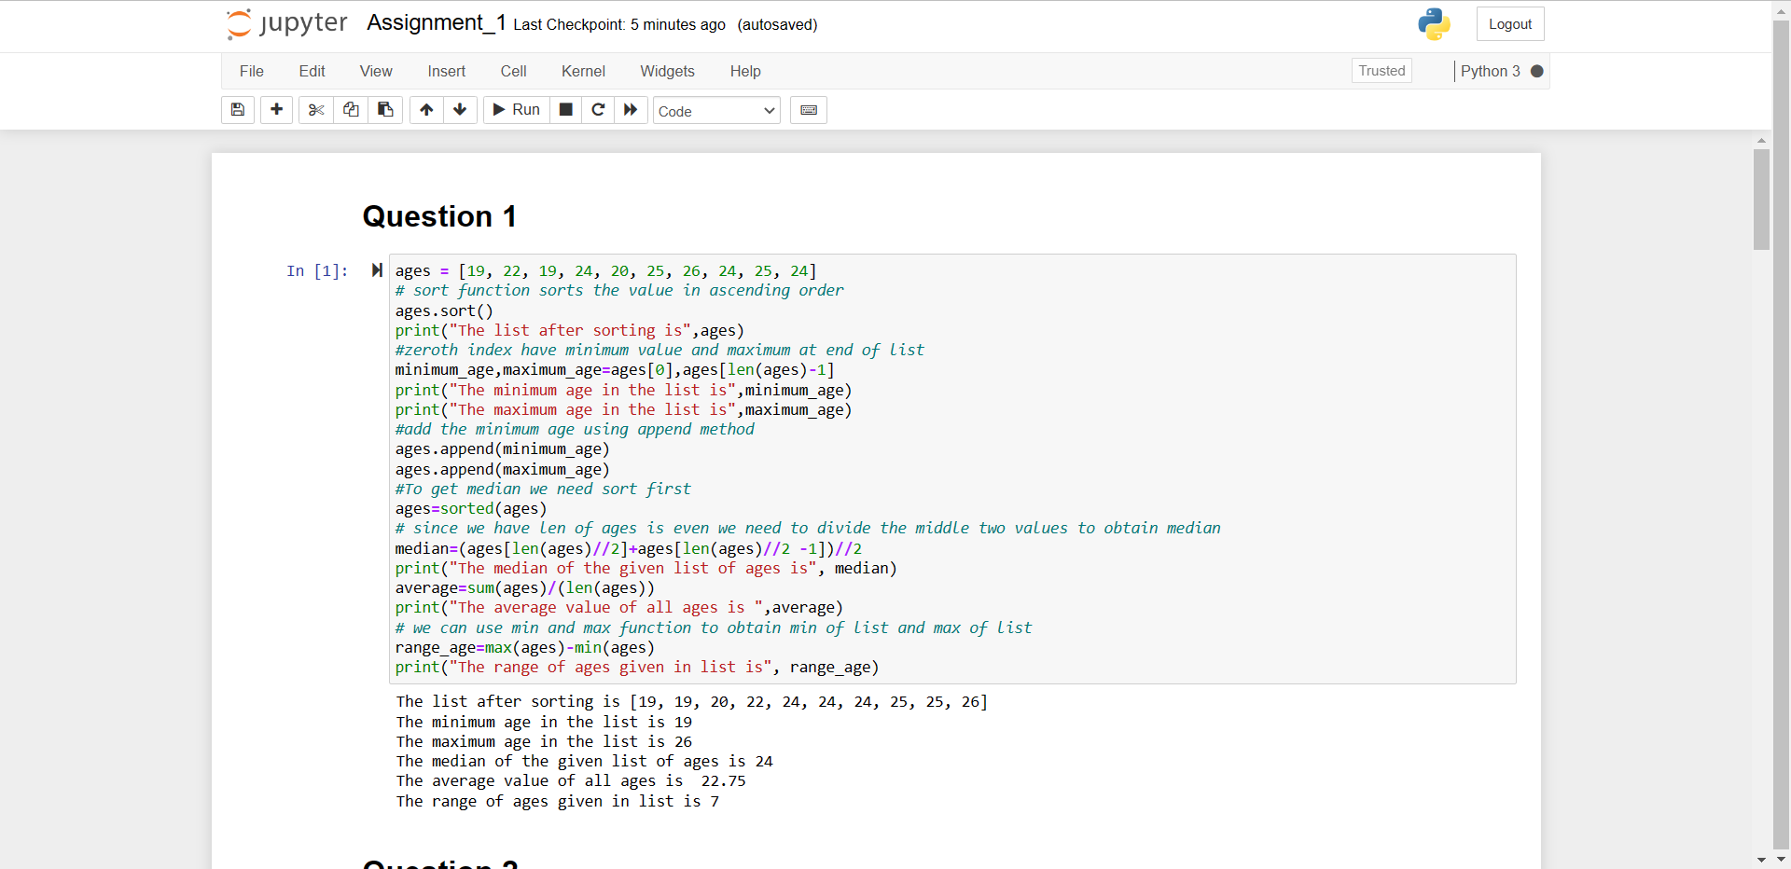

Question 2:

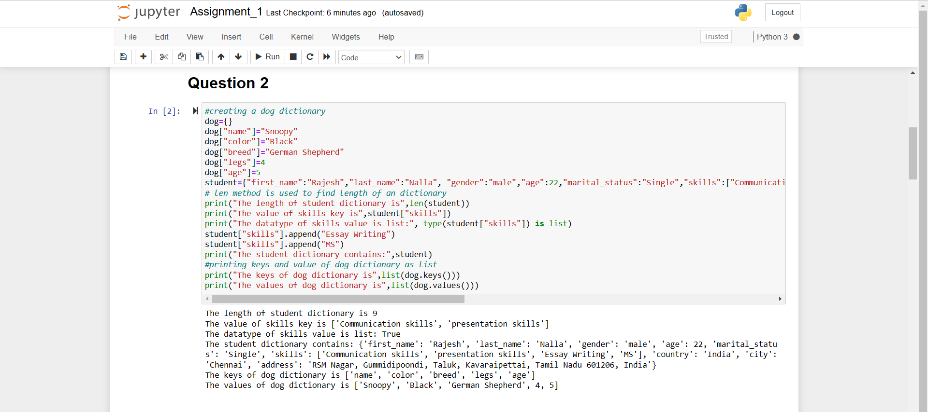

Question 3:

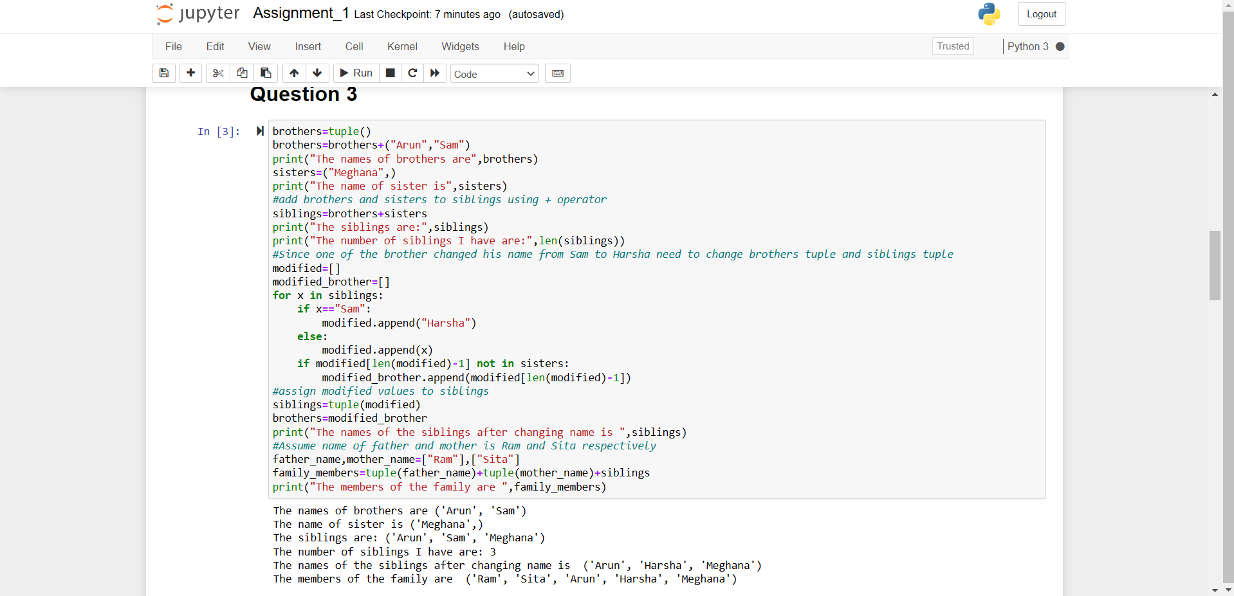

Question 4:

Code:

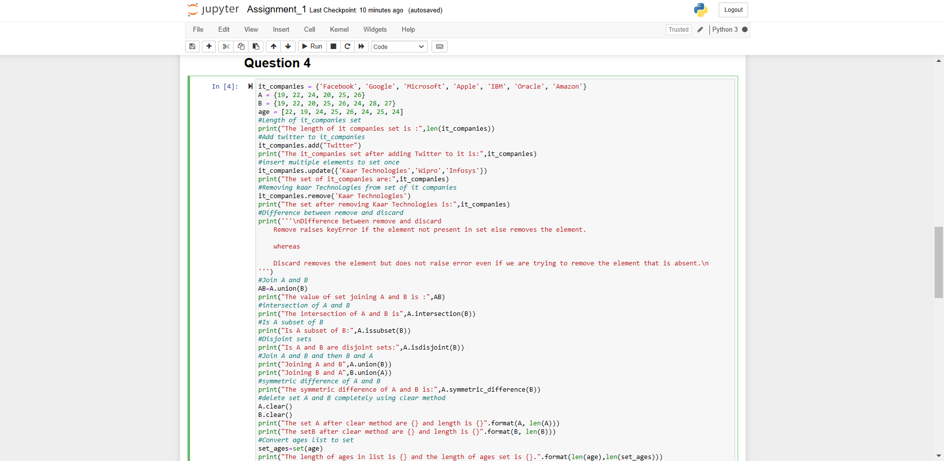

Output:

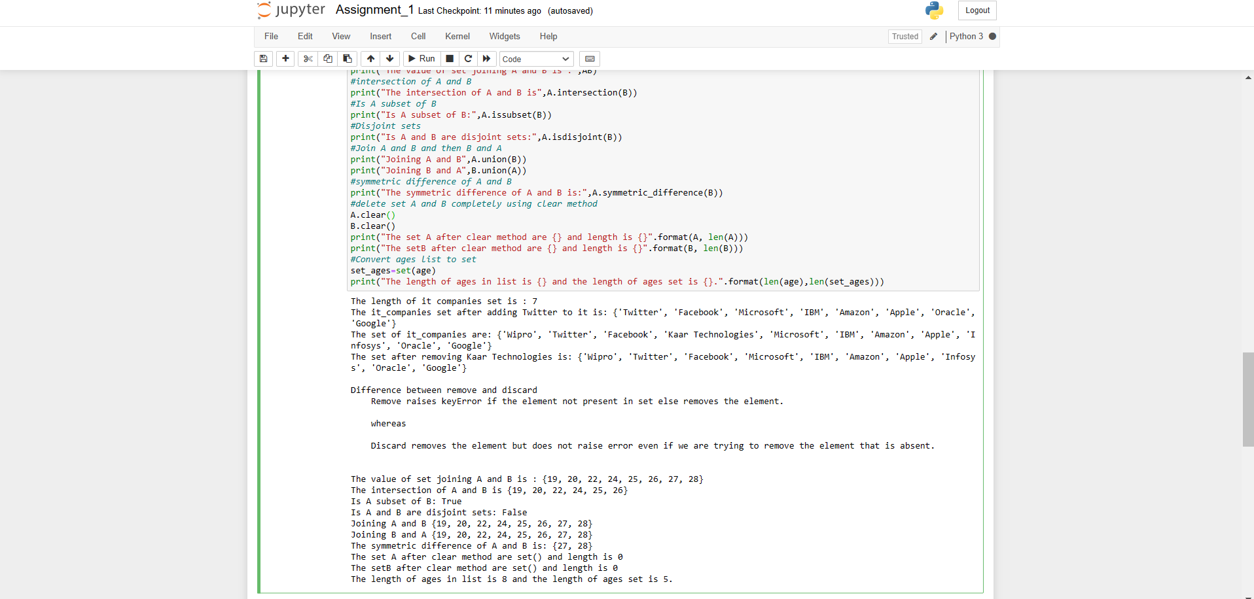

Question 5:

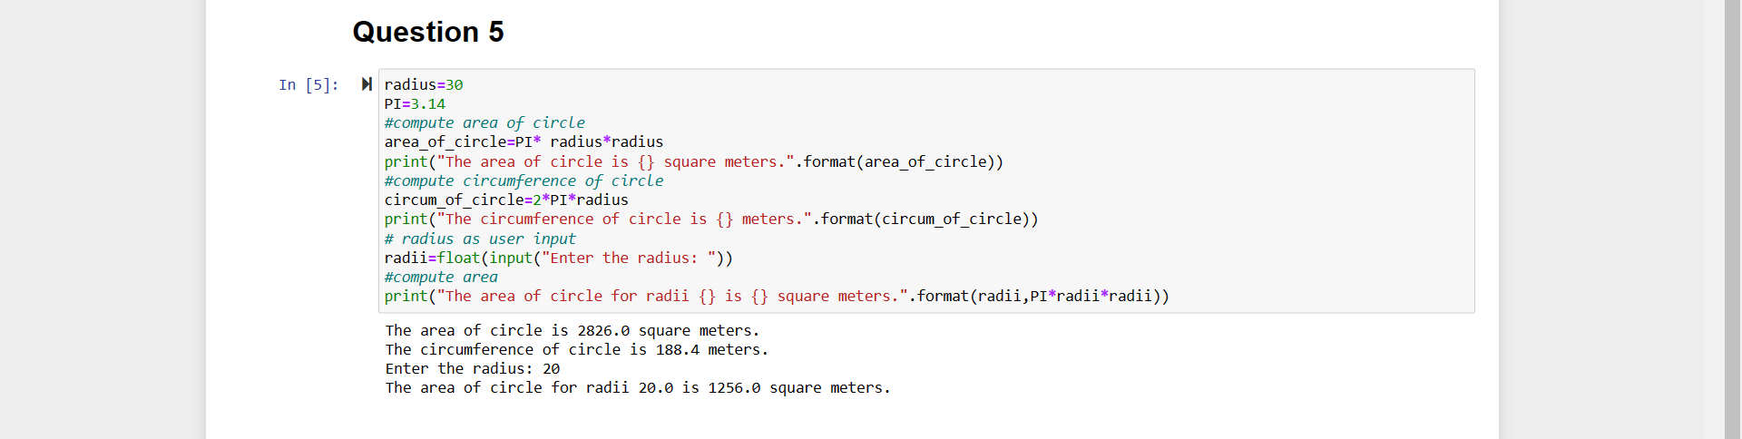

Question 6:

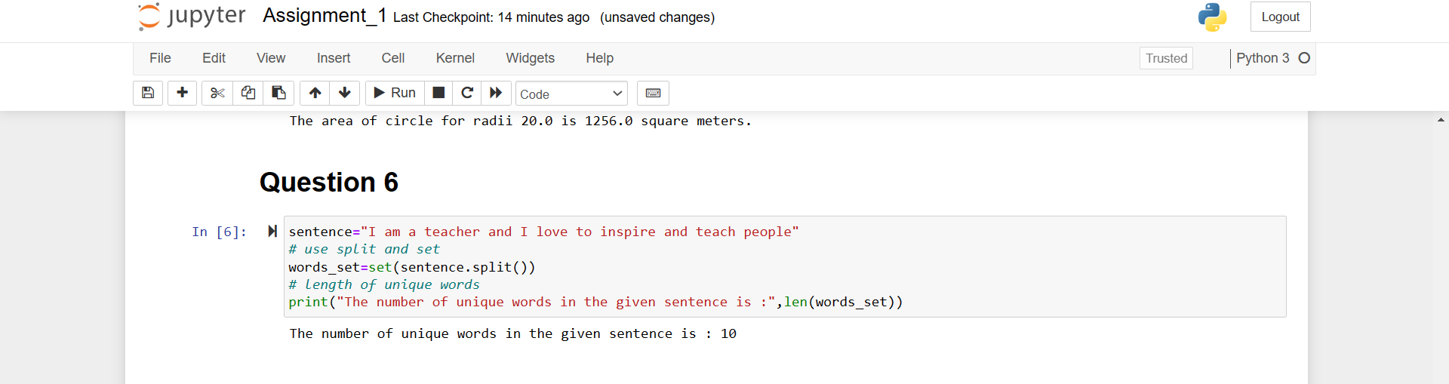

Question 7:

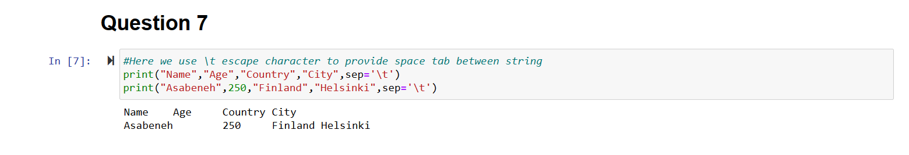

Question 8:

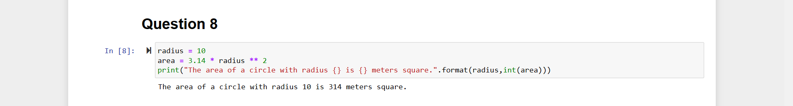

Question 9:

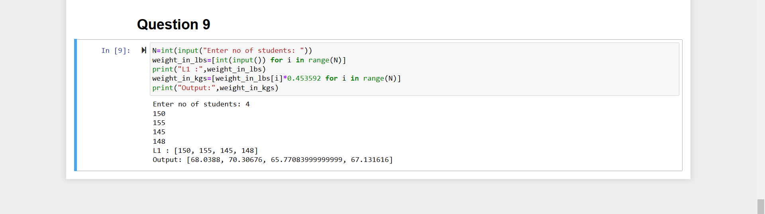

Question 10:

* Given there are 2 classes and 8 datasets with feature value f.
* The class with “**O**” is taken as zero and the class with “**X**” is taken as 1.

DataSet:

| S.No | Feature Value | Class | ClassValue |
| --- | --- | --- | --- |
| 1 | 1 | O | 0 |
| 2 | 2 | O | 0 |
| 3 | 3 | X | 1 |
| 4 | 6 | X | 1 |
| 5 | 6 | X | 1 |
| 6 | 7 | O | 0 |
| 7 | 10 | O | 0 |
| 8 | 11 | O | 0 |

1.

Put the first 4 data points as a training set.

Training Set:

| S.No | Feature Value | Class | Class Value |
| --- | --- | --- | --- |
| 1 | 1 | O | 0 |
| 2 | 2 | O | 0 |
| 3 | 3 | X | 1 |
| 4 | 6 | X | 1 |

Testing set:

| S. No | Feature Value |
| --- | --- |
| 1 | 6 |
| 2 | 7 |
| 3 | 10 |
| 4 | 11 |

* Here we use KNN classifier with value K value K=3

For Feature Value f=6:

* F=2, F=3 and F=6 are the nearest three neighbors.
* Now calculate distance b/w testing value and its neighbors.

| Feature Value(F) | Distance |
| --- | --- |
| 2 | (2-6)^2=4^2=16 |
| 3 | (3-6)^2=3^2=9 |
| 6 | (6-6)^2=0 |

The feature value 6 is near to the testing data point.So, it is predicted to be class value 1.

For Feature Value f=7:

* F=2, F=3 and F=6 are the nearest three neighbors.
* Now calculate distance b/w testing value and its neighbors.

| Feature Value(F) | Distance |
| --- | --- |
| 2 | (2-7)^2=5^2=25 |
| 3 | (3-7)^2=4^2=16 |
| 6 | (6-7)^2=1 |

The feature value 6 is near to the testing data point.So, it is predicted to be class value 1.

For Feature Value f=10:

* F=2, F=3 and F=6 are the nearest three neighbors.
* Now calculate distance b/w testing value and its neighbors.

| Feature Value(F) | Distance |
| --- | --- |
| 2 | (2-10)^2=8^2=64 |
| 3 | (3-10)^2=7^2=49 |
| 6 | (6-10)^2=4^2=16 |

The feature value 6 is near to the testing data point.So, it is predicted to be class value 1.

For Feature Value f=11:

* F=2, F=3 and F=6 are the nearest three neighbors.
* Now calculate distance b/w testing value and its neighbors.

| Feature Value(F) | Distance |
| --- | --- |
| 2 | (2-11)^2=9^2=81 |
| 3 | (3-11)^2=8^2=64 |
| 6 | (6-11)^2=5^2=25 |

The feature value 6 is near to the testing data point.So, it is predicted to be class value 1.

| Feature Value | Original Class | Predicted Class |
| --- | --- | --- |
| 6 | 1 | 1 |
| 7 | 0 | 1 |
| 10 | 0 | 1 |
| 11 | 0 | 1 |

2.

Three values of class 1 of type O are predicted as false and one value of class X is predicted as true.



True Positive(TP)=1

False Positive(FP)=3

True Negative(TN)=0

False Negative(FN)=0

Accuracy=(TP+FN)/(TP+FP+TN+FN)=¼=25%

Sensitivity=TP/(TP+FN)=1/(1+0)=100%

Specificity=(TN)/(TN+FP)=(0)/(0+3)=0