Name: Mythresh Maddina

700 Number:700741162

Video Link: https://drive.google.com/file/d/1-VXOmvBspL3HG_jAaPIjClOgJ9SqUC64/view?usp=share_link

Question 1:

Question 2:

Question 3:

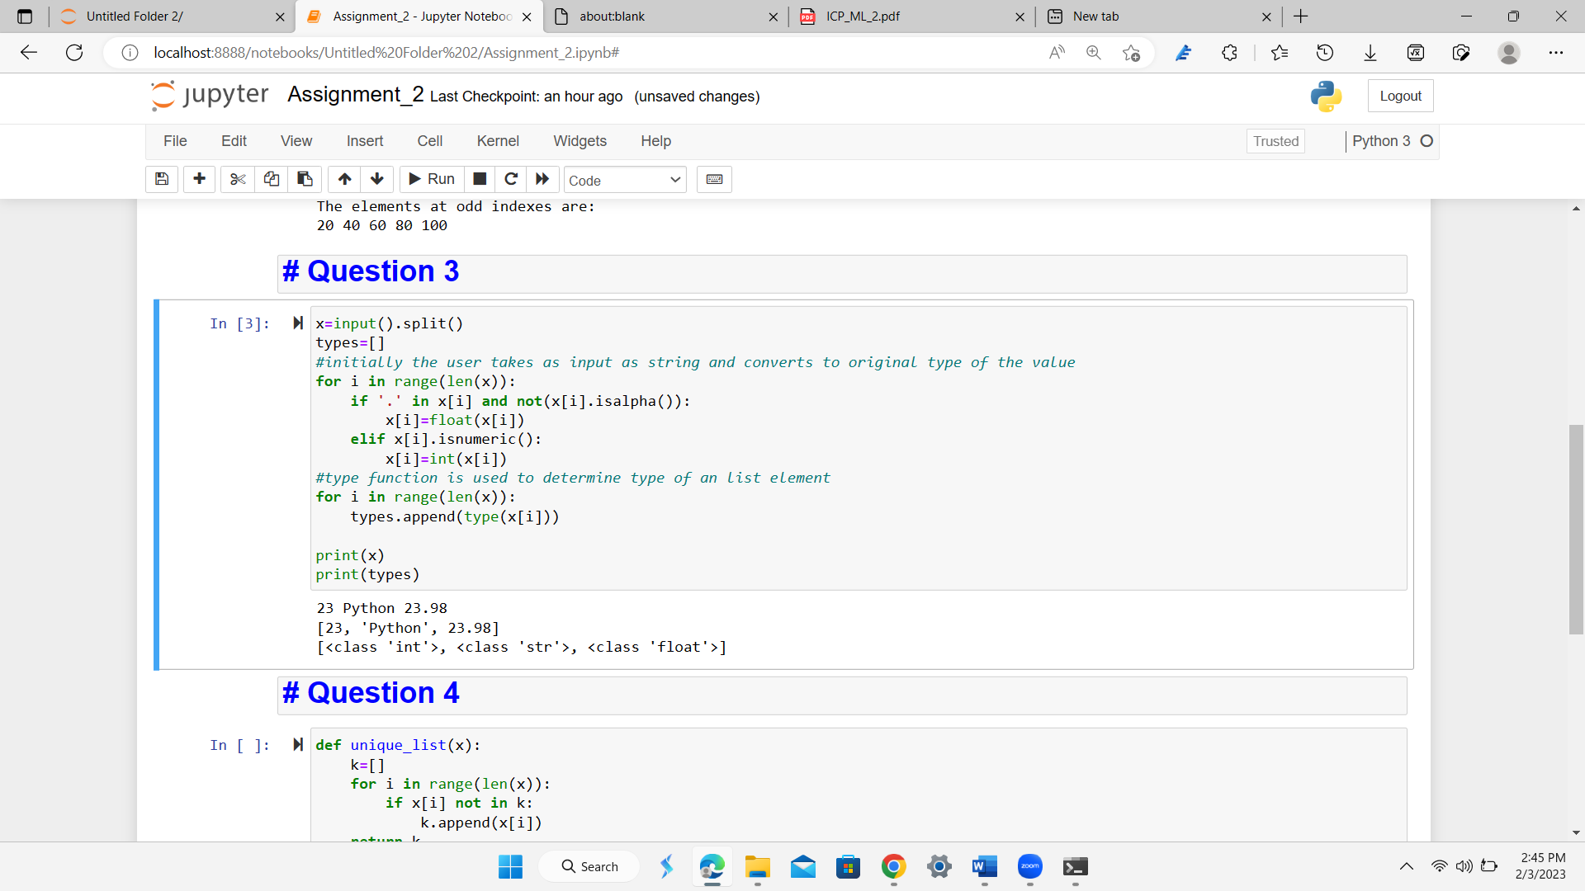

Question 4:

Question 5:

