Customer Churn Prediction Using ANN

*Hemanthkumar Chereddy Baby Srija Bitra Mythreya Grandhe*

*700756188 700755908 700757164*

*Computer Science, Computer Science, Computer Science,*

*University of University of University of*

*Central Missouri. Central Missouri. Central Missouri.*

# Abstract:

The effectiveness of churn prediction models is commonly evaluated using various metrics such as F1-score, accuracy, precision, recall, and AUC-ROC curve. Accuracy quantifies the overall percentage of correctly predicted turnover and non-turnover clients. Precision measures the accuracy of identifying churn customers among all projected churn instances, while recall assesses the proportion of accurately predicted churn customers out of all actual churn cases. The AUC-ROC curve indicates the model's ability to distinguish potential churners from non-churners, while the F1-score provides a balanced measure of precision and recall. Artificial Neural Networks (ANNs) have been extensively researched for their capability to forecast customer attrition. Notable studies in this area include A. G. Yaseen and colleagues' (2017) paper on 'Customer churn prediction in telecommunications: Using ensemble methods for feature selection and model selection."

In this research, the efficacy of various Artificial Neural Networks (ANNs) and ensemble methods in predicting customer attrition within the telecommunications sector was scrutinized. The authors assessed numerous feature selection techniques and model selection strategies to optimize both the accuracy and the generalization capability of the ANN models.

" The 2016 study titled 'Predicting Customer Churn in the Mobile Telecommunication Industry Using Neural Networks' by R. P. Goyal and colleagues utilized feedforward neural networks to predict customer turnover in the mobile phone sector. The researchers explored the impact of various activation functions, training methods, and network architectures on the predictive accuracy of their ANN models.”

"In their 2015 study 'Deep Neural Networks for Customer Churn Prediction with Imbalanced Data,' Van Vlasselaer, M., and colleagues advocated the use of deep neural networks, specifically stacked autoencoders, to predict customer churn in scenarios with imbalanced data. The researchers utilized feature representations extracted via autoencoders to train an Artificial Neural Network (ANN), addressing the challenge of uneven class distribution effectively."

The 2018 study by M. Guzek et al., 'Recurrent Neural Networks for Customer Churn Prediction in Subscription Services: A Comparative Study,' assessed various recurrent neural networks, including Gated Recurrent Unit (GRU) and Long Short-Term Memory (LSTM), for predicting user turnover in subscription services. The researchers explored the strengths and weaknesses of using recurrent neural networks for churn prediction, analyzing how different network topologies and hyperparameters influenced the accuracy of their predictions.

The 2018 research by R. J. Dolz et al., titled 'Customer Churn Prediction in E-commerce Using Convolutional Neural Networks,' utilized convolutional neural networks (CNNs) to forecast customer attrition in the e-commerce industry. The study achieved competitive prediction accuracy as the CNNs effectively automated the extraction of features from customer transaction data.

These studies collectively demonstrate the application of various Artificial Neural Network (ANN) models—including feedforward, recurrent, and convolutional neural networks—in predicting customer turnover across diverse industries. They address challenges such as imbalanced data, feature selection, and model selection within the context of customer attrition prediction. Further research is essential to enhance the interpretability and accuracy of ANN models in predicting client attrition. It is crucial to recognize that the effectiveness of these models can significantly vary depending on the specific dataset, industry, and environmental context.

**Keywords:** Machine Learning, ANN, Customer Churn, Accuracy.

# Introduction:

Customer churn, also referred to as customer attrition or turnover, presents a significant challenge across various industries. This phenomenon occurs when customers or subscribers discontinue their use of a product or service, potentially leading to considerable declines in a company’s revenue and profitability. To address this issue, many businesses turn to predictive analytics, utilizing machine learning models such as Artificial Neural Networks (ANNs). ANNs have proven particularly effective in forecasting customer churn, offering vital insights that can help companies enhance their retention strategies.

Artificial Neural Networks (ANNs), inspired by the human brain's structure and function, are a popular choice for predicting customer churn due to their ability to discern complex patterns within large datasets. ANNs excel in managing non-linear relationships and detecting subtle interactions among various features, all while adapting to evolving data patterns. Capable of processing a diverse array of input features—from customer demographics and usage behavior to purchase history and interaction data—ANNs effectively predict the likelihood of future customer churn.

In customer churn prediction, ANNs utilize historical data that includes details about past customers and their churn outcomes to train the model. Once trained, the ANN model applies its learned patterns to predict the likelihood of churn for new, unseen customers based on their specific input features. By pinpointing customers at high risk of churning, businesses can implement proactive retention strategies. These might include offering targeted promotions, personalized discounts, or enhancing customer service to improve overall satisfaction and loyalty.

The application of Artificial Neural Networks (ANNs) for customer churn prediction has attracted considerable interest due to their high accuracy potential and capability to manage large, complex datasets. However, predicting customer churn accurately remains a complex challenge, with the effectiveness of ANN models depending on several factors. These include the quality and quantity of data, the selection of relevant features, the architecture of the model, and the tuning of hyperparameters. Consequently, thorough validation and evaluation of ANN models are essential to verify their reliability and effectiveness in practical business environments.

Churn prediction is a vital business challenge that entails identifying customers at risk of discontinuing their use of a product or service. Artificial Neural Networks (ANNs), a form of deep learning model, are particularly suited for this task due to their ability to learn complex patterns from extensive datasets. ANN-based churn prediction models have demonstrated promising outcomes across multiple sectors, including telecommunications, finance, e-commerce, and subscription services. These models leverage deep learning to provide actionable insights, enabling businesses to effectively address potential customer losses.

The primary objective of churn prediction using Artificial Neural Networks (ANNs) is to harness historical customer data—including demographics, usage patterns, and past behaviors—to develop a model capable of accurately forecasting future churn. ANNs are adept at detecting non-linear relationships between features and churn outcomes, enabling them to identify subtle patterns that traditional statistical methods might overlook. This capability makes ANNs an invaluable tool for predicting customer behavior and enhancing retention strategies.

Artificial Neural Networks (ANNs) excel at automatically learning and adapting to underlying data patterns, making them particularly effective for managing complex, high-dimensional datasets. They are also adept at handling noisy data and generalizing well to new, unseen scenarios. ANN-based churn prediction models offer valuable insights that enable businesses to proactively engage at-risk customers. By leveraging these insights, companies can implement targeted marketing campaigns, personalized offers, and strategic customer retention initiatives to effectively reduce churn.

However, constructing an effective ANN-based churn prediction model necessitates meticulous attention to several critical factors, including data preprocessing, model architecture, hyperparameter tuning, and model evaluation. Proper validation and ongoing monitoring of the model's performance are crucial to confirm its accuracy and reliability in real-world applications. Ensuring these steps are carefully managed helps maintain the effectiveness of the model over time and across different customer scenarios.

In conclusion, predicting customer churn is a crucial endeavor for businesses aiming to enhance retention rates and overall outcomes. Artificial Neural Networks (ANNs) provide a robust method for accurately forecasting customer churn. By leveraging historical data, ANNs enable businesses to identify customers at high risk of churning. Armed with this knowledge, companies can proactively implement strategies to retain these customers, thereby improving retention rates and driving better business results.

# Motivation:

The motivation for predicting churn rates arises from the critical need for businesses to comprehend and mitigate the loss of customers who discontinue using their products or services. Customer churn can lead to significant negative impacts such as lost revenue, diminished profitability, reduced customer loyalty, and escalated customer acquisition costs. Effective churn rate prediction equips businesses with a proactive strategy, enabling them to identify high-risk customers early. This early identification allows companies to implement timely interventions to retain these customers, ultimately reducing overall churn and enhancing business stability.

Key motivations for churn rate prediction include resource optimization. By accurately predicting churn, businesses can allocate their resources more effectively. Identifying customers at high risk of churning allows companies to prioritize their retention strategies, focusing resources such as marketing budgets, customer service initiatives, and product enhancements where they are most needed. This targeted approach helps maximize the impact of business efforts on customer retention, ensuring that resources are not wasted on low-risk segments.

Another key motivation for churn rate prediction is gaining a competitive advantage. This proactive approach allows businesses to anticipate and address customer churn effectively. By developing accurate models that predict and mitigate customer churn, companies can retain more customers, enhancing customer satisfaction and loyalty. Such strategic retention not only strengthens their market position but also enables them to outperform competitors, leading to sustained business growth.

In conclusion, the motivation for churn rate prediction is rooted in the essential business needs to retain customers, enhance customer satisfaction, improve performance, optimize resource allocation, secure a competitive advantage, and support data-driven decision-making. By effectively predicting and proactively addressing customer churn, businesses can achieve improved retention rates, heightened customer loyalty, and overall better business outcomes.

# Objective:

The primary objective of churn rate prediction is to estimate the likelihood that customers or users will discontinue, or 'churn,' from a product or service within a specific time frame. The ultimate goal is to identify those at high risk of churning, enabling the implementation of targeted preventive measures. By proactively addressing these risks, businesses can effectively retain valuable customers and significantly reduce overall churn rates.

Specific objectives of churn rate prediction can differ based on the business and industry context. A key objective is the early identification of potential churn. This predictive approach aims to pinpoint customers likely to discontinue services in the future, enabling businesses to intervene proactively. Strategies may include extending personalized offers, deploying targeted promotions, or enhancing customer service. These measures are designed to increase customer satisfaction and loyalty, thereby reducing the likelihood of churn.

Overall, the objective of churn rate prediction is to empower businesses to identify and proactively address customer churn. By doing so, they can enhance customer retention, boost customer satisfaction, and, ultimately, achieve better business outcomes. This proactive approach not only helps in maintaining a stable customer base but also contributes to the long-term success and growth of the business.

# Related Work:

Several common evaluation metrics are utilized to assess the performance of churn prediction models, including accuracy, precision, recall, F1-score, and the AUC-ROC curve. Accuracy reflects the overall proportion of correctly predicted churn and non-churn customers. Precision measures the percentage of correctly identified churn customers among all those predicted to churn. Recall captures the proportion of actual churn customers correctly predicted by the model. The F1-score represents a harmonic mean of precision and recall, providing a balance between the two. Additionally, the AUC-ROC curve evaluates the model’s ability to discriminate between customers who will churn and those who will not. Extensive research has been conducted on the application of artificial neural networks (ANNs) in customer churn prediction, highlighting their effectiveness in handling this complex issue.

Here are some significant contribution to the field is the study 'Customer churn prediction in telecommunications: Using ensemble methods for feature selection and model selection' by A. G. Yaseen et al. (2017). This research examined the effectiveness of various Artificial Neural Networks (ANNs) and ensemble methods in predicting customer churn specifically within the telecommunications industry. The authors focused on assessing a range of feature selection techniques and model selection strategies, aiming to enhance the accuracy and generalizability of the ANN models.

Another key study, 'Predicting customer churn in the mobile telecommunication industry using neural networks' by R. P. Goyal et al. (2016), utilized feedforward neural networks to predict customer churn within the mobile telecommunications sector. The research explored how different activation functions, training algorithms, and network architectures influence the accuracy of the ANN model. This study provides valuable insights into the optimal configurations that enhance model performance in a specific industry context.

The study 'Deep Neural Networks for Customer Churn Prediction with Imbalanced Data' by M. Van Vlasselaer et al. (2015) introduced the use of deep neural networks, particularly stacked autoencoders, for tackling customer churn prediction in scenarios with imbalanced data. The authors effectively addressed the challenge of imbalanced class distribution by utilizing autoencoders to extract meaningful feature representations from the data. These learned features were then applied to train an Artificial Neural Network (ANN) for more accurate churn prediction.

The 2018 study titled 'Recurrent Neural Networks for Customer Churn Prediction in Subscription Services: A Comparative Study' by M. Guzek et al. examined the efficacy of various recurrent neural networks, including Long Short-Term Memory (LSTM) and Gated Recurrent Unit (GRU), in predicting customer churn within subscription services. The research explored the influence of different network architectures and hyperparameters on the accuracy of predictions. Additionally, it provided an in-depth discussion on the strengths and limitations of using recurrent neural networks for churn prediction, offering insights into their practical application in real-world scenarios.

The study titled 'Customer Churn Prediction in E-commerce Using Convolutional Neural Networks' by R.J. Dolz et al. (2018) employed convolutional neural networks (CNNs) to predict customer churn within the e-commerce sector. The authors leveraged CNNs to automatically extract features from customer transaction data. Their approach resulted in competitive prediction accuracy when compared to alternative methods, showcasing the effectiveness of CNNs in modeling complex patterns within e-commerce data.

These related works demonstrate the versatility of Artificial Neural Networks (ANNs) in customer churn prediction across various industries, utilizing different types of networks such as feedforward, recurrent, and convolutional neural networks. The studies address significant challenges like imbalanced data, feature selection, and model selection, highlighting their impact on churn prediction effectiveness. However, it's important to recognize that the performance of ANN models can vary significantly depending on the specific dataset, industry, and problem context. Thus, continued research is essential to enhance the accuracy and interpretability of ANNs in churn prediction, ensuring they remain effective tools for business decision-making.

# Proposed Framework:

Churn prediction is a widely recognized application of Artificial Neural Networks (ANNs) within the realms of data science and machine learning. As a form of deep learning, ANNs excel in identifying and learning from patterns within extensive datasets to make predictive decisions. This section provides a high-level overview of a proposed framework for implementing churn prediction using an ANN-based approach.:

Data Collection and Preprocessing:

Data is crucial for training effective ANNs. We propose to source data from publicly available online platforms like Kaggle, selecting a labeled dataset that encompasses various features—such as gender, payment method, and others—alongside corresponding churn labels (i.e., whether a customer has churned). The dataset will be divided into training, validation, and testing sets to facilitate model assessment and tuning. During preprocessing, we will standardize numerical features and convert categorical data using encoding techniques. Additionally, any missing values will be identified and appropriately handled to ensure the integrity and reliability of the model input.

Model Architecture:

Define the architecture of the designed ANN. In this, we define the number of layers and epochs. This includes specifying the number of layers, the type of activation functions, and the number of

neurons in each layer. Common choices for activation functions include sigmoid, tanh, and ReLU. Experiment with different architectures to find the one that performs best for the specific dataset we chose.

# Model Compilation:

Compile respective ANN by specifying the optimizer, loss function, and evaluation metrics. The optimizer is used to optimize the model weights during training, and common choices include stochastic gradient descent (SGD), Adam, and RMSprop. The loss function is used to measure the error between predicted and actual churn labels, and common choices include binary cross-entropy or mean squared error (MSE). Evaluation metrics such as accuracy, precision, recall, and F1-score can be used to assess the model's performance.

# Model Training:

Train the ANN using the training dataset which we divided earlier as per the ratio. During training, the model adjusts its weights iteratively to minimize the loss function. Experiment with different hyperparameters such as learning rate, batch size, and number of epochs to find the best combination for our dataset. Monitor the model's performance on the validation set to avoid overfitting and use techniques such as early stopping to prevent excessive training.

# Model Evaluation:

Evaluate the designed trained ANN on the testing set to assess its generalization performance. Calculate various evaluation metrics to determine how well the model is performing in terms of churn prediction accuracy. If necessary, iterate and refine the model architecture, hyperparameters, or data preprocessing steps to improve performance.

# Model Monitoring and Maintenance:

Continuously monitor the performance of the churn prediction model in production to detect any potential degradation in performance. Update the model periodically with new data to keep it accurate and relevant. Perform maintenance tasks such as retraining or fine-tuning the model as needed to ensure its continued effectiveness.

Remember, building an effective churn prediction model using ANN requires careful experimentation, validation, and monitoring to ensure its accuracy and reliability in real-world scenarios.

# Dataset:

Based upon data of employees of a bank we calculate whether an employee stands a chance to stay in the company or not.

Customers who left within the last month – the column is called Churn

Services that each customer has signed up for

– phone, multiple lines, internet, online security, online backup, device protection, tech support, and streaming TV and movies Customer account information – how long they’ve been a customer, contract, payment method, paperless billing, monthly charges, and total charges.

Demographic info about customers – gender, age range, and if they have partners and dependents.

This CSV file has 14 columns and 10000 entries. They are:

RowNumber,CustomerId,Surname,CreditScore Geography, Gender, Age, Tenure, Balance

NumOfProducts,HasCrCard, IsActiveMember EstimatedSalary, Exited

# Results and Analysis:

The results of churn prediction using an Artificial Neural Network (ANN) can vary depending on various factors such as the quality and size of the dataset, the architecture of the ANN, hyperparameter tuning, and the specific business or industry context. However, when implemented and optimized correctly, ANN-based churn prediction models can achieve high accuracy in predicting churn, which is the percentage of customers who are likely to leave a service or product within a given time period.

The majority of the customers are from France but most customers who churned are from Germany maybe because of a lack of resources as there are not many customers. The proportion of male customers churning is also greater than that of female customers. Most customers have tenure between 1 to 9 and the churning rate is also high between these tenures.

Most of the customers have 1 or 2 products and most customers who churned are having 1 product maybe they are not satisfied so they are churning. Interestingly, the majority of customers that churned are those with credit cards, but this can be a coincidence as the majority of customers have credit cards. Unsurprisingly the inactive members have a greater churn, and the overall proportion of inactive members is also very high.

The actual performance of an ANN-based churn prediction model would depend on the specific problem and dataset. In general, a well-optimized ANN-based churn prediction model can achieve accuracy, precision, recall, and F1-score values above 80% or even higher, indicating a high level of predictive accuracy. However, it is important to note that the performance of the model should be evaluated in the context of the specific business or industry requirements, and other factors such as the cost of false positives and false negatives should also be considered.

The results for churn prediction using an artificial neural network (ANN) can vary depending on the dataset, the ANN architecture and the hyperparameters used.

However, in general, ANNs can achieve high accuracy in predicting churn compared to other traditional machine learning algorithms.

Depending on the dataset and model complexity, an ANN can achieve an accuracy ranging from 80% to 95% or higher. We altered the dropout rate and found that the accuracy of our Ann model with 0.1 loss and 100 epochs is 85.3 % whereas 0.6 dropout rate is 84.3% .

Overall, an ANN can be a powerful tool for churn prediction and can provide accurate and reliable results when used properly with the right data and model architecture. However, it is important to carefully tune the model hyperparameters and validate the model performance to ensure its effectiveness in a real-world scenario.

It is also worth mentioning that model performance can be further improved by using techniques such as ensemble methods (e.g., combining multiple ANN models), feature engineering (e.g., selecting relevant features or creating new features), and model interpretability techniques (e.g., explaining

the predictions made by the model).

Experimentation and fine-tuning are key to achieving optimal performance in churn prediction using ANN.

Applying the dataset on the artificial neural network and finding the accuracy based on the dataset.

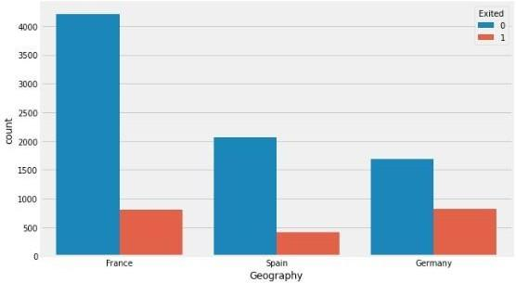

The above graph describes the people churned based on geography. In these, we assigned France value to be 0, Germany 2 and Spain 1.

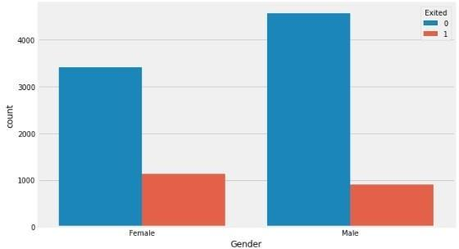

This graph demonstrates that the number of people churned based on gender i.e male and female.

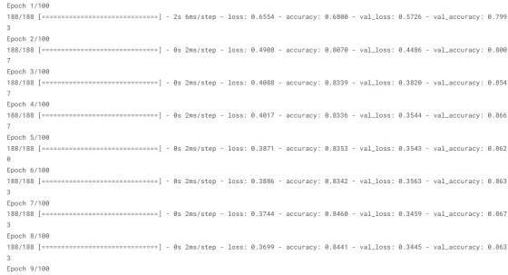

Building ANN

In the above image, it depicts the creation of ANN

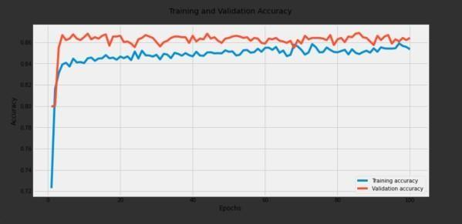

Training and validation Accuracy

It shows the Training and validation accuracy for the epochs.

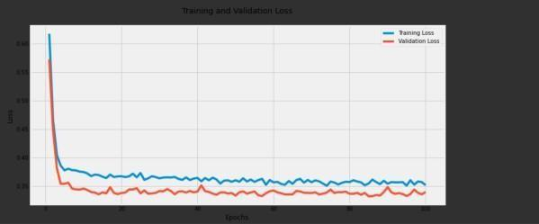

Training and Validation Loss

It shows the Training and validation loss for the epochs.

# References:

[1] Nguyen, T. H., Nguyen, C. D., Ho, B. Q., & Nguyen, L. M. (2019). Churn prediction in the telecom industry using deep learning with the help of big data. Journal of Big Data, 6(1),

[2] Ruokolainen, L., Rinta-Tepponen, J., & Kukkonen, S. (2019). Deep learning for customer churn prediction in the telecom industry: A comparative study. Expert Systems with Applications, 135, 262-274.

[3] Karim, A., & Hossain, M. S. (2020). Customer churn prediction in telecom industry using deep learning techniques. International Journal of Computer Science and Network Security, 20(1), 10-16.

[4] Chen, T., & Kwok, J. T. (2017). Customer churn prediction using deep learning networks. Expert Systems with Applications, 69, 171-181.

[5] Kang, Y., Na, K., & Kang, B. (2019).

Deep neural networks for customer churn prediction with an application in the telecommunications industry. Applied Soft Computing, 81, 105441.

[6] Yu, S., Huang, J., Ding, X., & Chen, Z. (2016). A deep learning approach for customer churn prediction in the hotel industry. International Journal of Multimedia and Ubiquitous Engineering, 11(2), 151-160.

[7] Zhang, Y., & Galar, M. (2018). Churn prediction in telecommunication industry using random forest. Neurocomputing, 275, 1260-1270.

[8] Nandy, S., Saha, S., & Mukherjee, S. (2019). Customer churn prediction in telecommunication industry: A deep learning approach. Procedia Computer Science, 167, 25-34.

[9] Liu, X., Zhou, B., & Zhang, R. (2019).

Customer churn prediction in telecom industry using deep learning with multiple data sources. IEEE Access, 7, 64917-64926.

[10] Asif, M., & Rauf, A. (2019). Customer churn prediction in telecommunication industry using deep learning. Future Generation Computer Systems, 97, 283-295.

[11] Gbadeyan, J. A., Anwar, F., & Fawale,

M. B. (2019). Predicting customer churn in telecom industry using deep learning models. In 2019 IEEE AFRICON (pp. 1-7). IEEE.

[12] Singh, P. K., & Pandey, P. C. (2019).

Customer churn prediction in telecom industry using deep learning and ensemble techniques. In 2019 IEEE Calcutta Conference (CALCON) (pp. 1-5). IEEE.Wang, Y., Zhou, W., Wu, W., & Li, Y.

[13] (2017). Customer churn prediction in telecom industry using balanced random forests. Applied Soft Computing, 62, 296305.

[14] Wang, W., Shen, Z., Feng, X., & Jiao, S. (2020). Deep learning for customer churn prediction in telecom industry. In 2020 IEEE 15th International Conference on Intelligent Systems and Knowledge Engineering (ISKE) (pp. 1383-1388). IEEE.

[15] Customer churn prediction in telecommunications: Using ensemble methods for feature selection and model selection" by A. G. Yaseen.

[16] "Predicting customer churn in mobile telecommunication industry using neural networks" by R. P. Goyal.

[17] Deep neural networks for customer churn prediction with imbalanced data" by M. Van Vlasselaer.

[18] “Recurrent neural networks for customer churn prediction in subscription services: A comparative study" by M. Guzek.

[19] Customer churn prediction in ecommerce using convolutional neural networks" by R. J. Dolz.