**ASSIGNMENT-5**

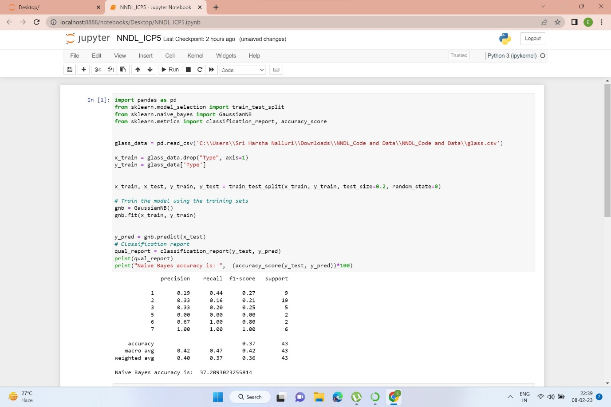

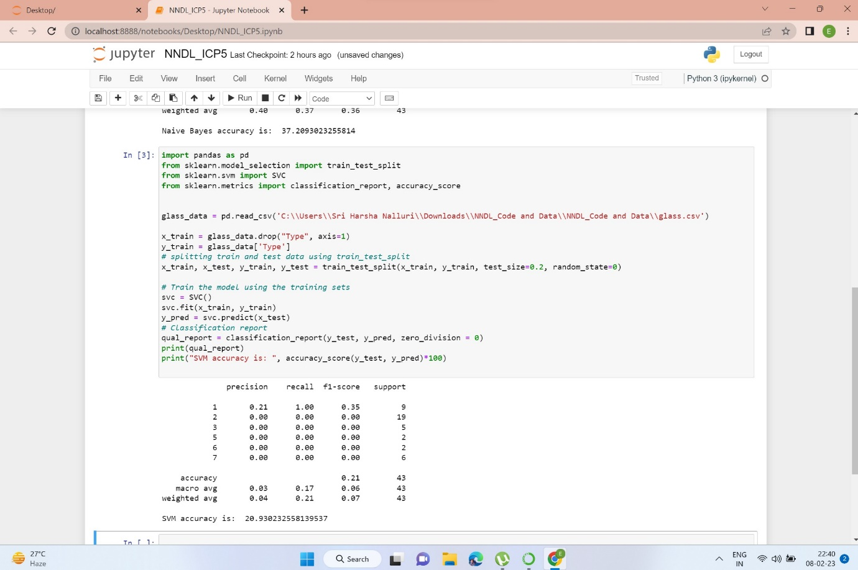

The accuracy of the Gaussian algorithm is higher. Since gaussian training improved our accuracy more than svm training.

Video link:

<https://drive.google.com/file/d/1m5LtJqbZEOJBkz6OqgrRR_18AIatD2MI/view?usp=sharing>