**Assignment 1**

**Question 1**

Used variable named str to store the string and length to store its length and removed two characters and printed it.

Used num1 and num2 variables to take input from user and store them and performed addition, subtraction, multiplication and division to that numbers using +,-,*,/ operators and printed them.

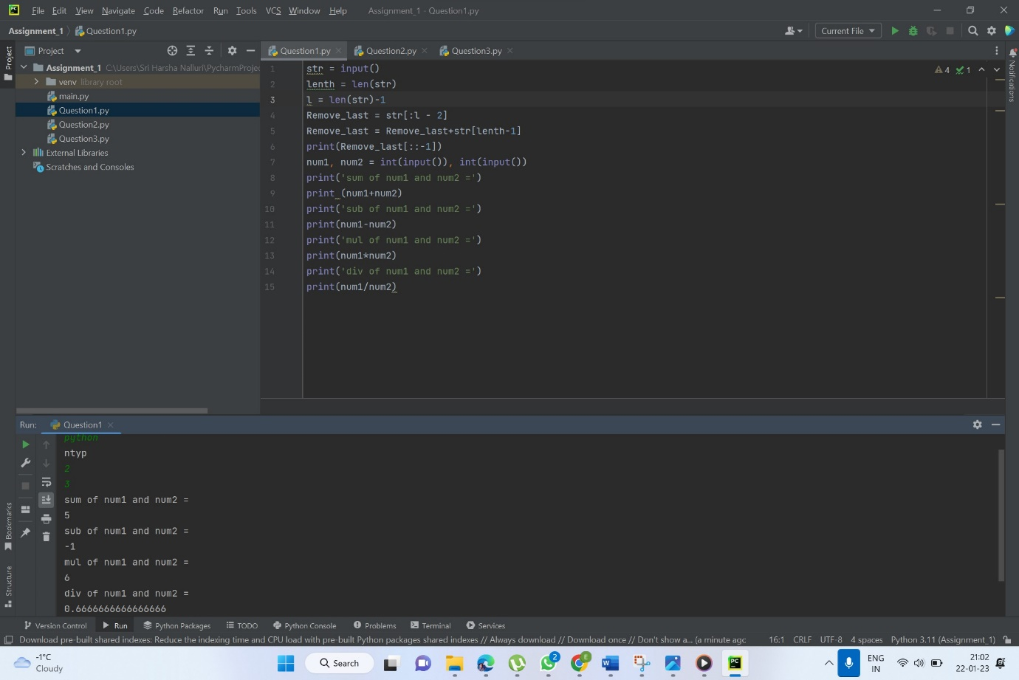

**Question 2**

Used str to store the line “I love playing with python” and replaced the word ‘python’ with ‘pythons’ using the function str.replace() and printed it.

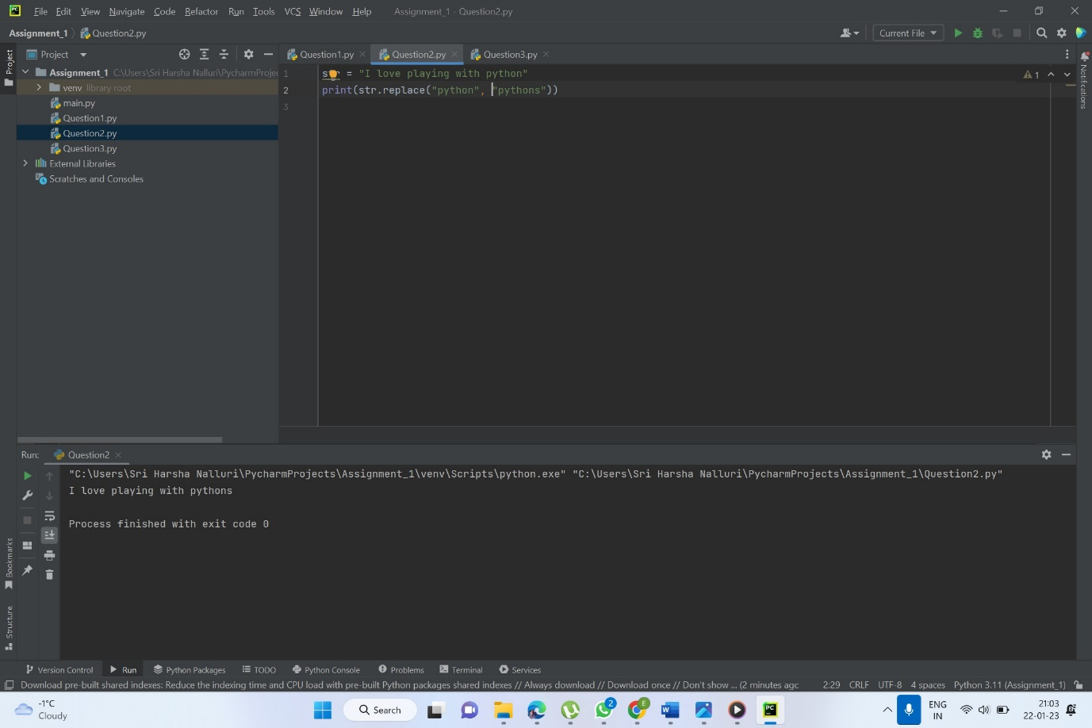

**Question 3**

Used if and elsif for print according to the marks.

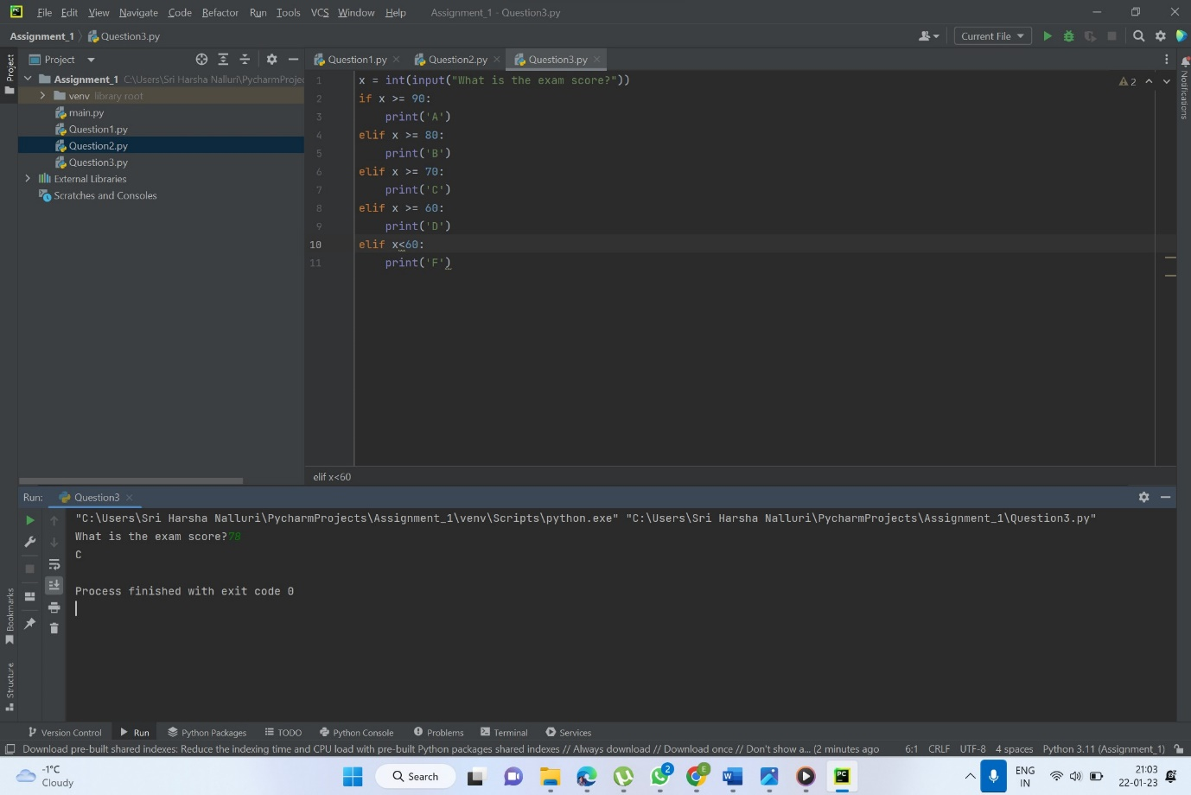

Video link: <https://drive.google.com/file/d/1PYaIJnVMkWjDrc60L7rkZjCNM4GTCs9C/view?usp=sharing>