Assignment-8

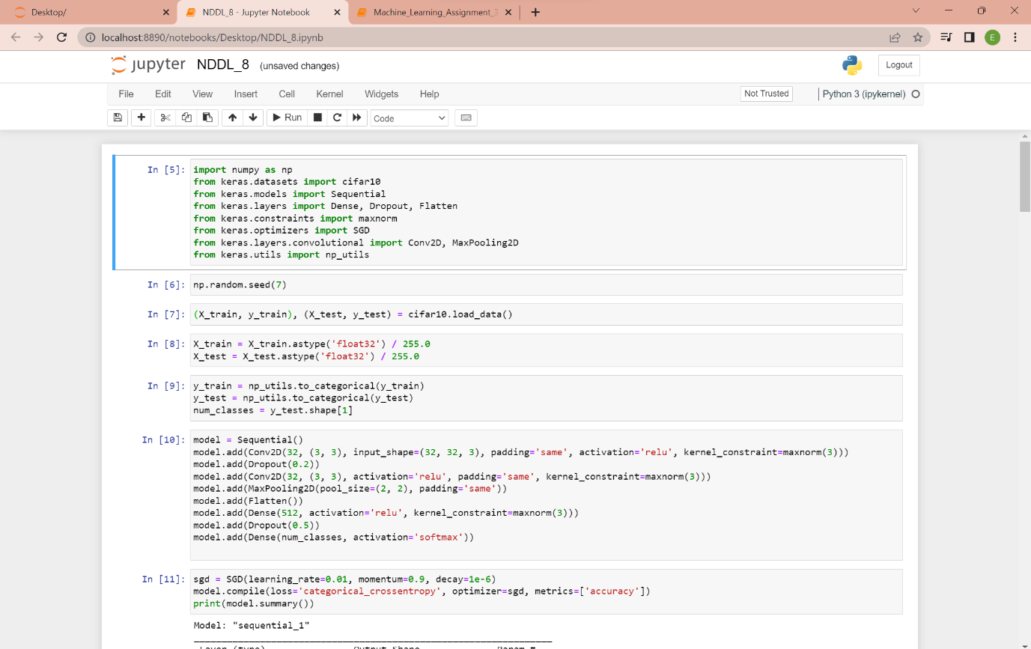

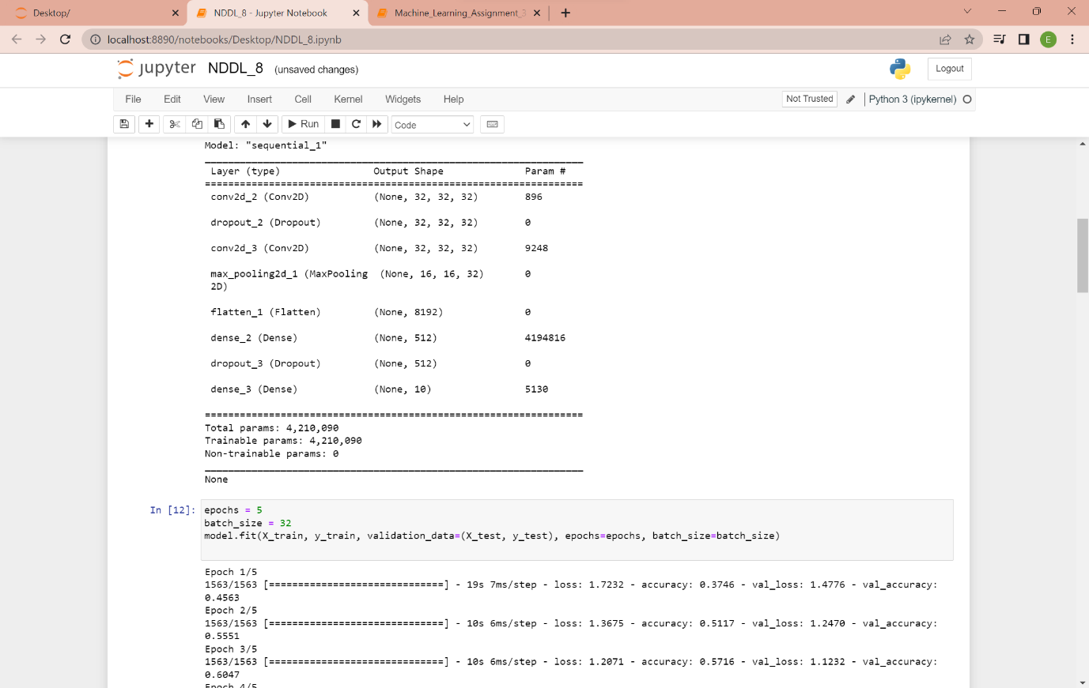

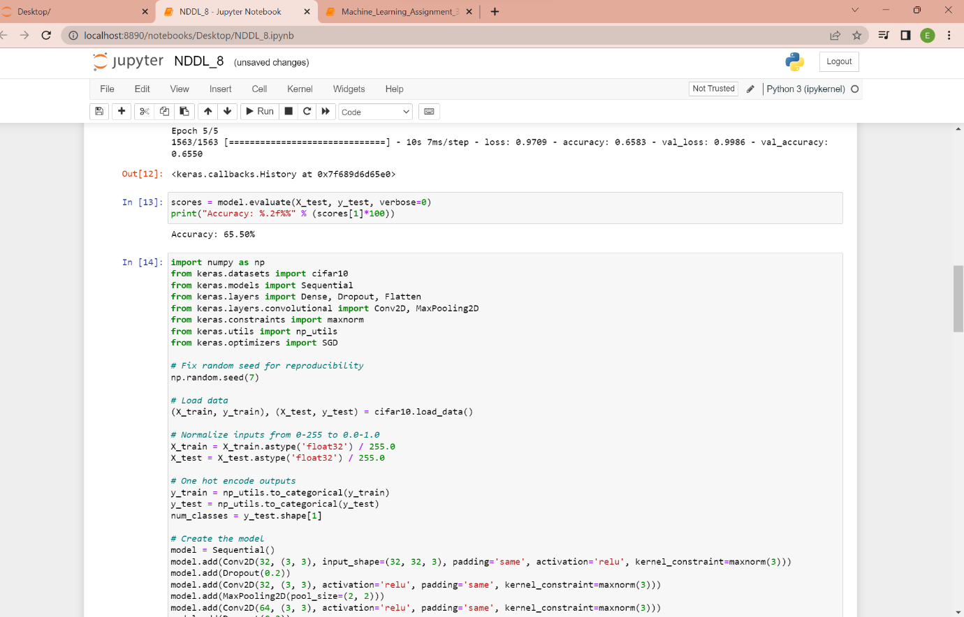

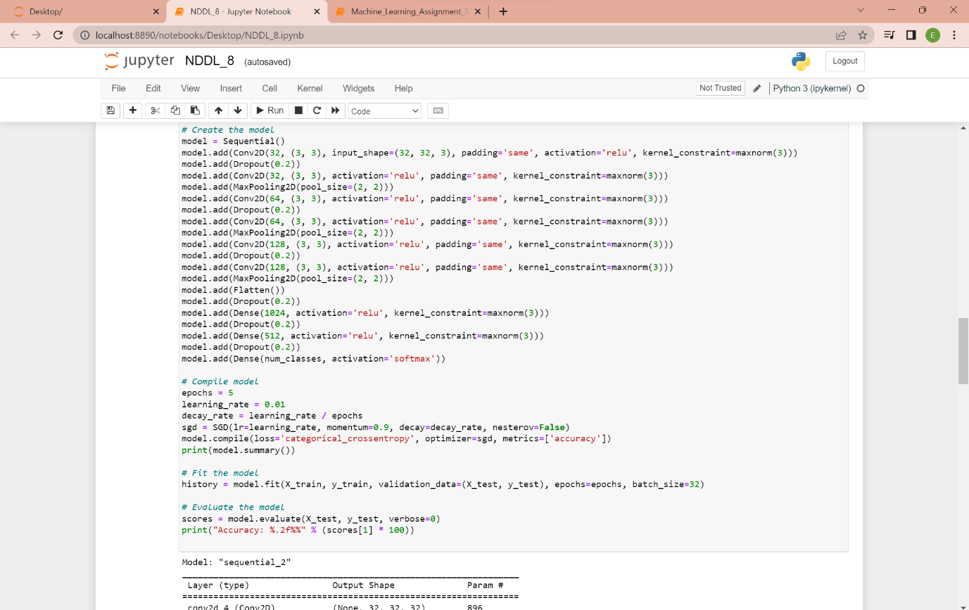

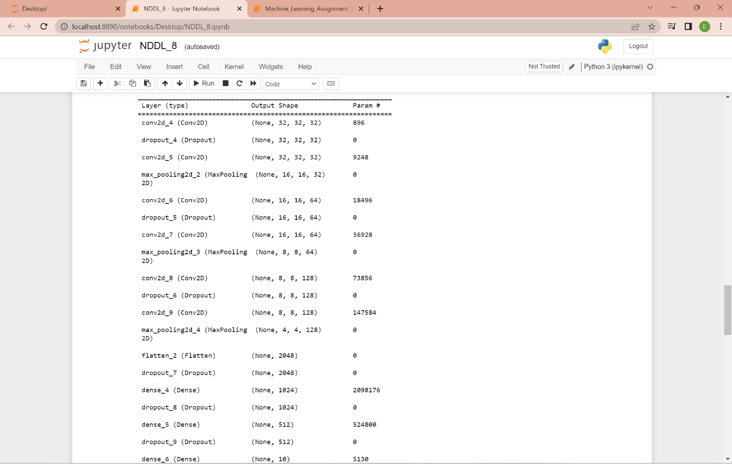

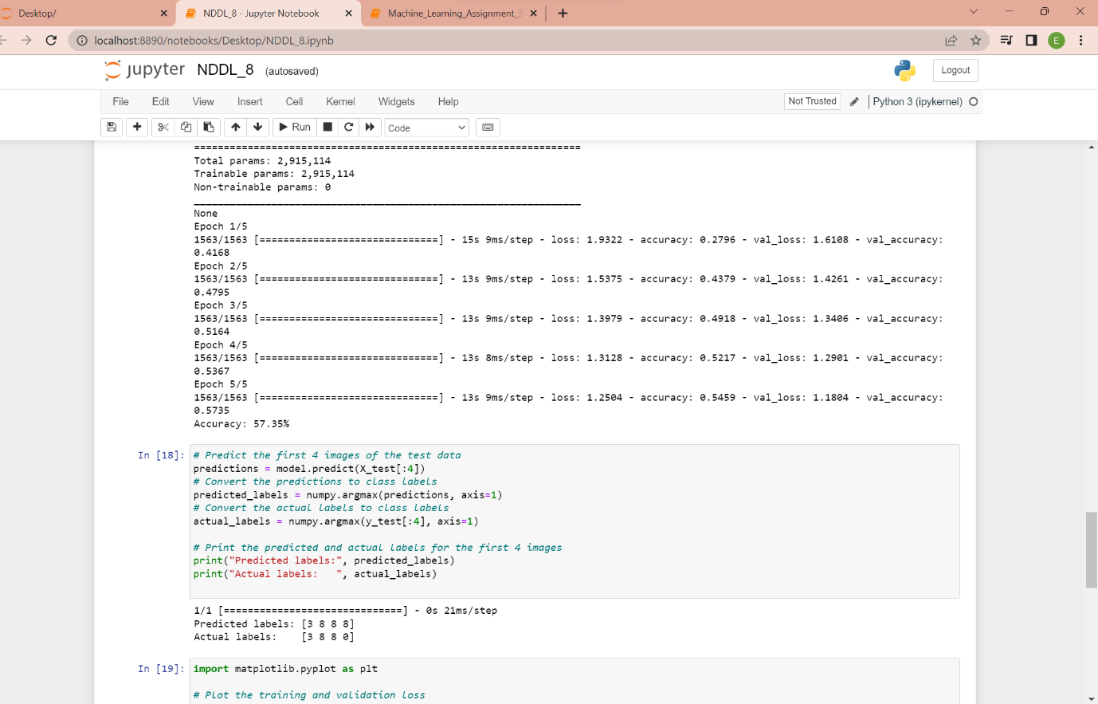

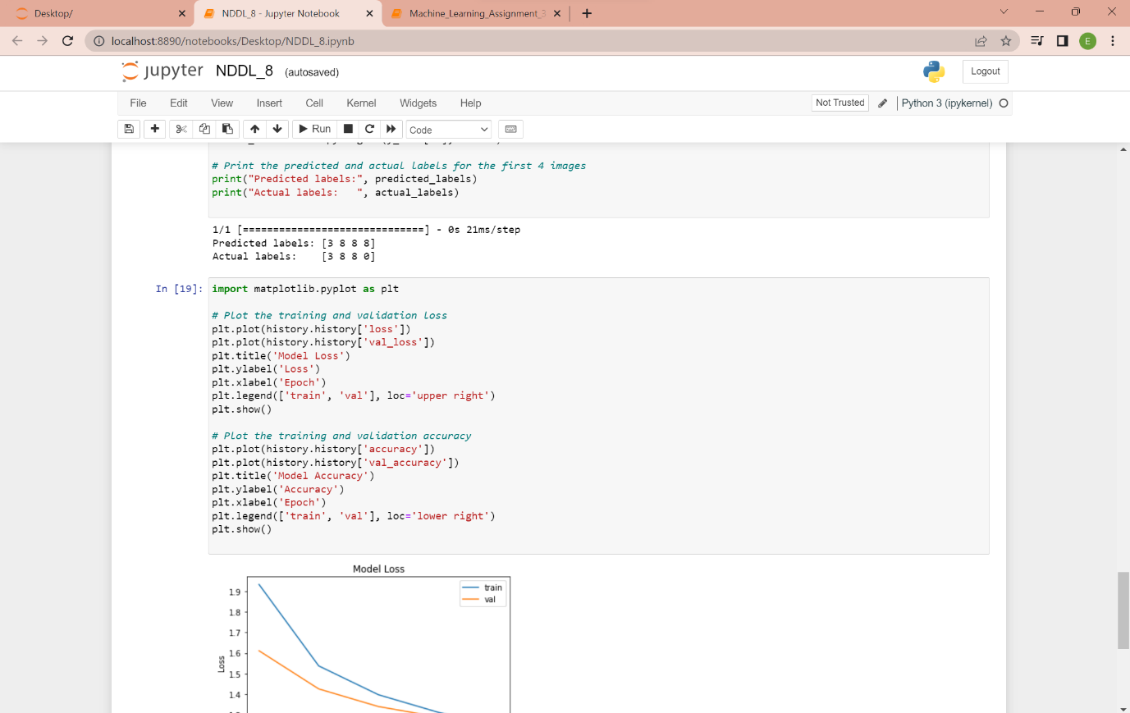

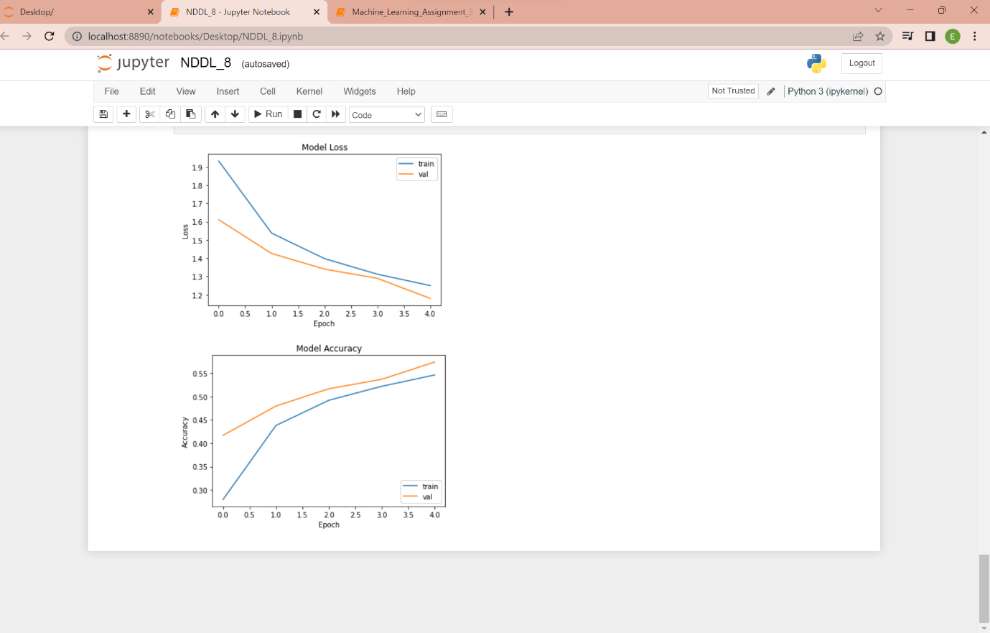

Git-Hub Link: [MythreyiNalluri/Assignment_8-NNDL- (github.com)](https://github.com/MythreyiNalluri/Assignment_8-NNDL-)

Video Link: https://drive.google.com/file/d/15Jmk8qfr8XVWarpeleTGhRTd5rjKDxdV/view?usp=sharing