**CS 5710**

**Machine Learning (Assignment # 1)**

E-mail: [mxn10750@ucmo.edu](mailto:mxn10750@ucmo.edu)

Name: Mythreyi Nalluri

Course: CS 5710

Assignment: Assignment 1

Video Demo: https://drive.google.com/file/d/1iu2Km4L9Xq17YtNdUp1FZBQ6m-Ku-5mg/view?usp=sharing

**Question 1**

*Sorted the list and done the min and max age, again added min and max age to the list. Now identified the median, average and range of the ages.

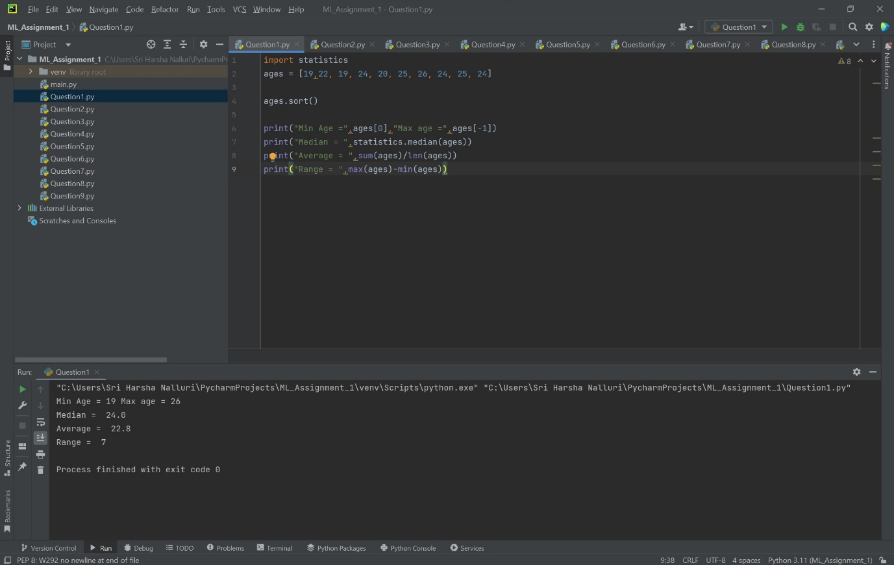

**Question 2**

**\***Created dog, which is empty dictionary and added name, color, breed, legs, age to the dog dictionary. Created student dictionary and add first_name, last_name, gender, age, marital status, skills, country, city and address as keys for the dictionary. Identified the key values and length of the student dictionary.

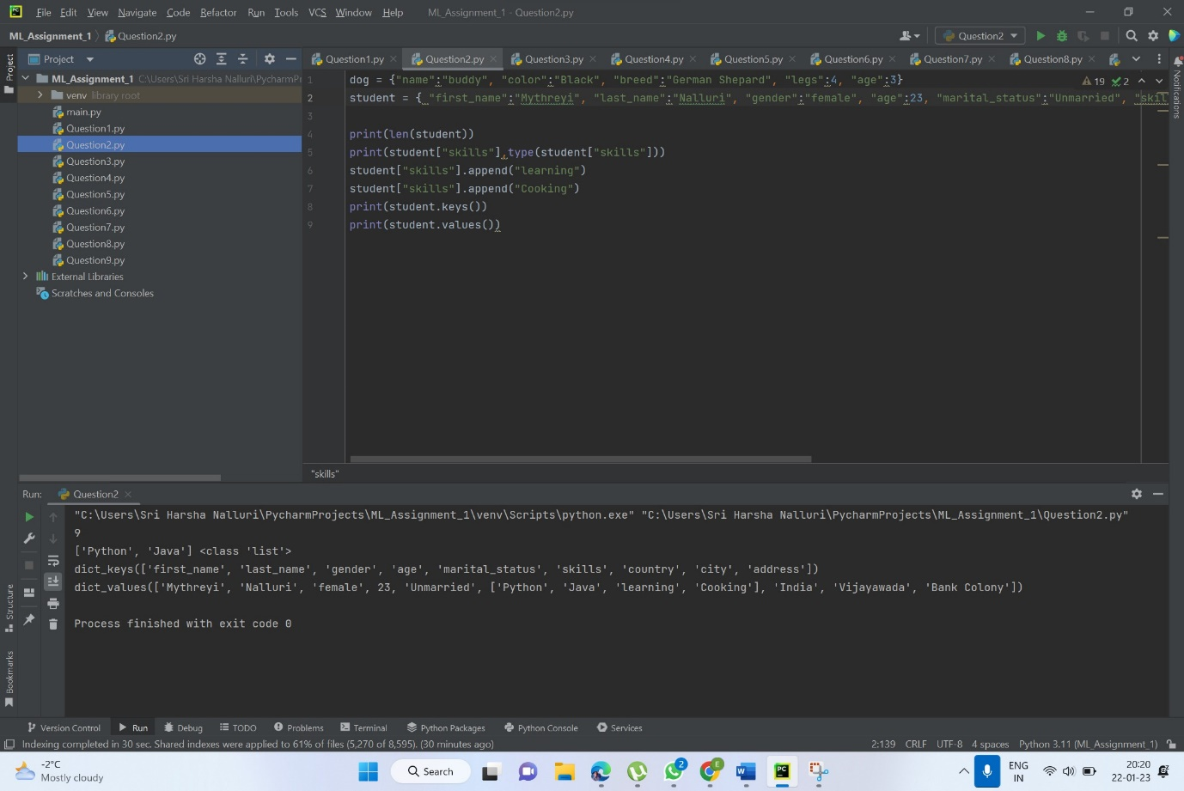

**Question 3**

*Created tuple containing names of sisters and brothers and Joined brothers and sisters tuples and assigned it to siblings and modified the siblings tuple and added the name of father and mother and assigned to family_members

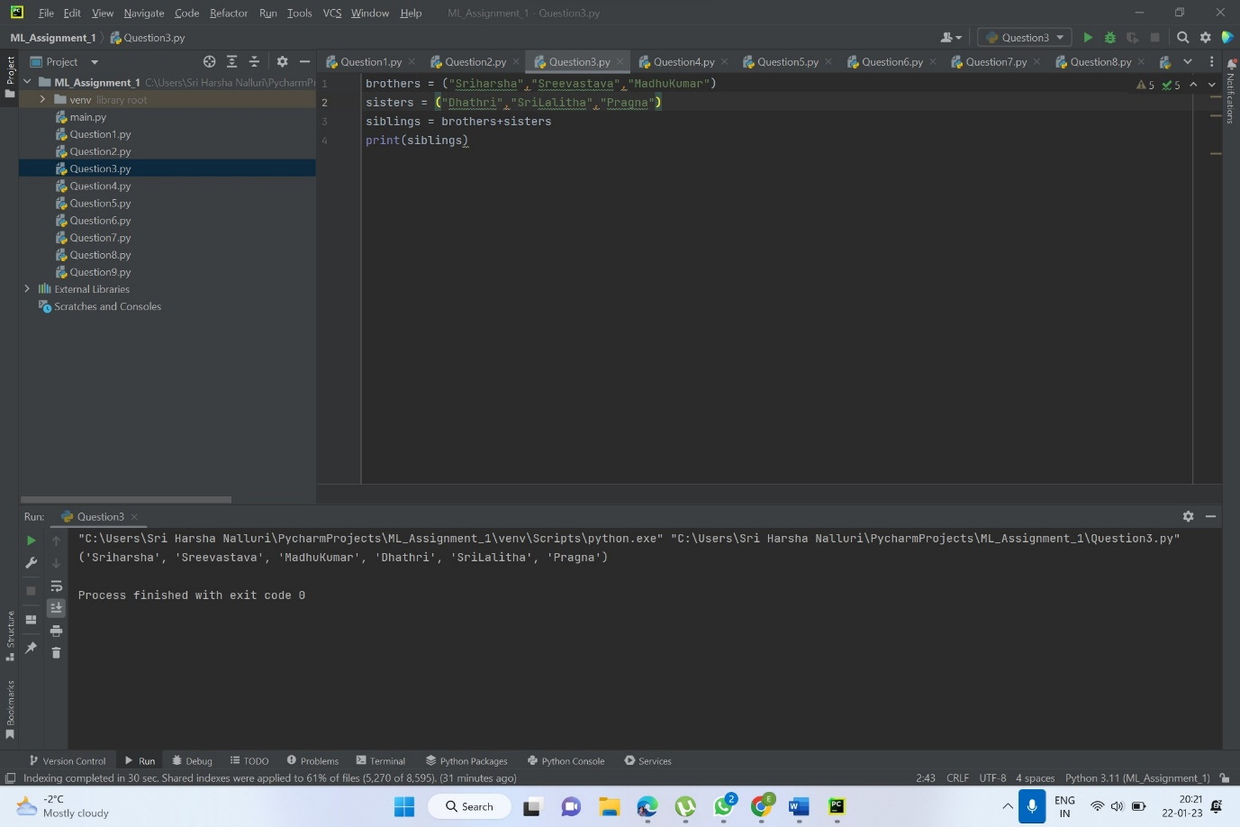

**Question 4**

**\***Identified the length of the set it_companies added twitter and inserted multiple companies to the set it_companies and joined A and B done the below details and at the end found symmetric difference between A and B and deleted the sets completely and converted the ages to a set and compared the length of the list and the set.

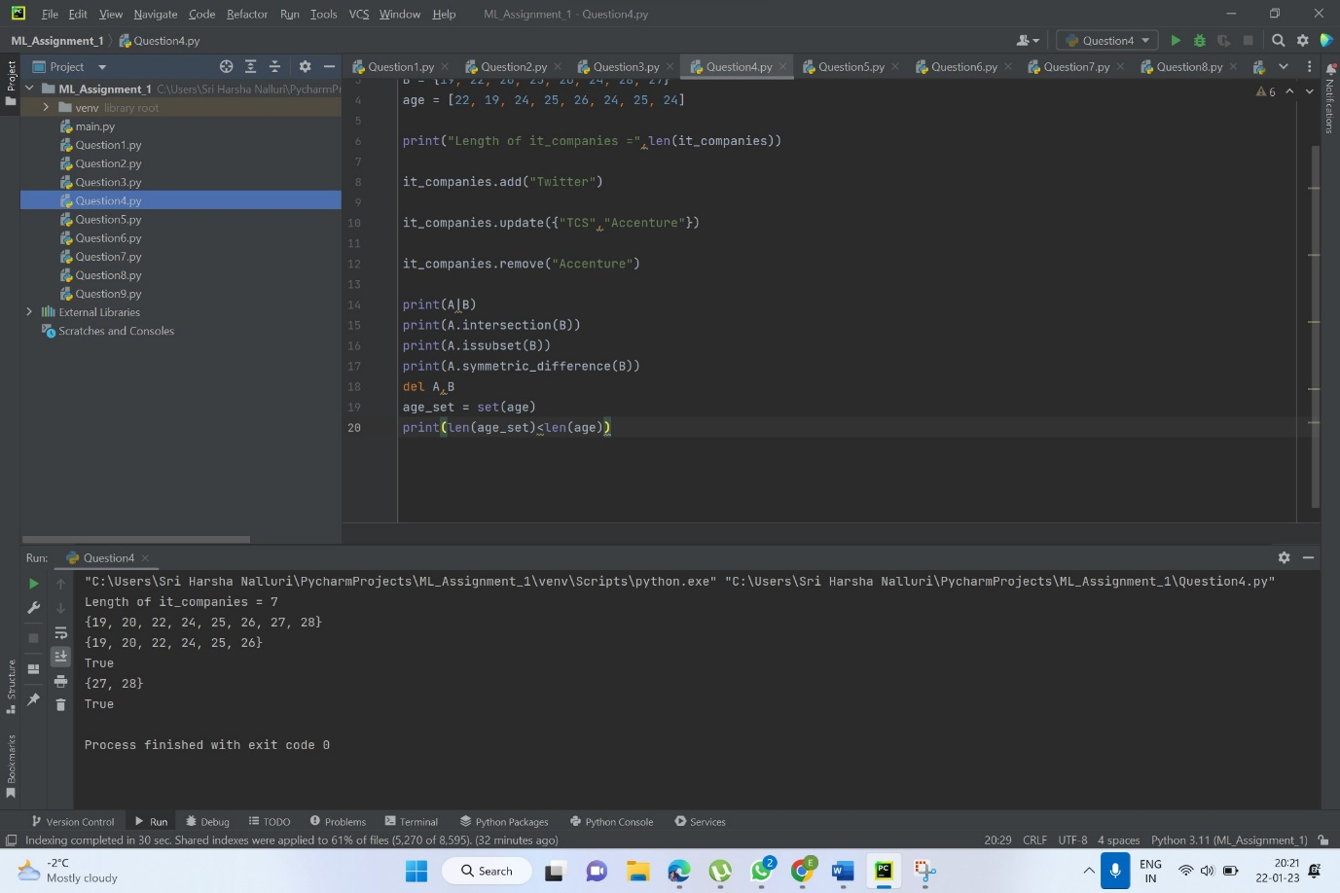

**Question 5**

*Given radius of a circle is 30 meters. And calculated the area of a circle and assigned the value to a variable name of _area_of_circle_

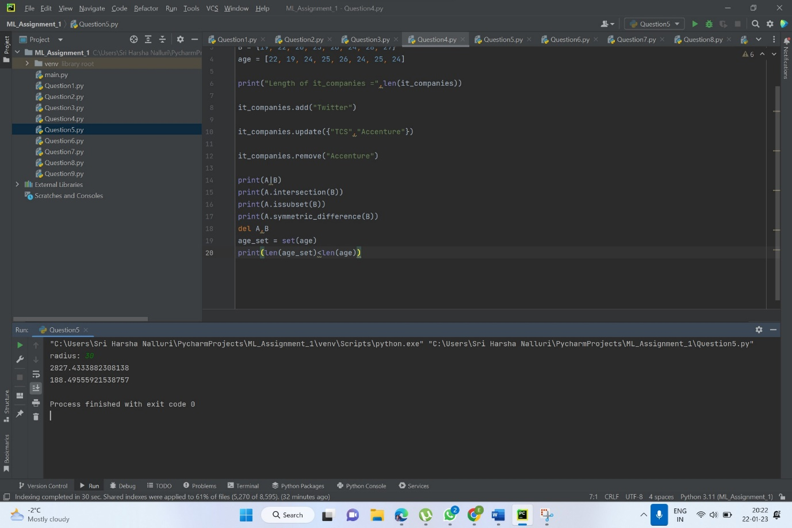

**Question 6**

**\***I am a teacher and I love to inspire and teach people” This is the given sentence. Used the split methods and set to get the unique words.

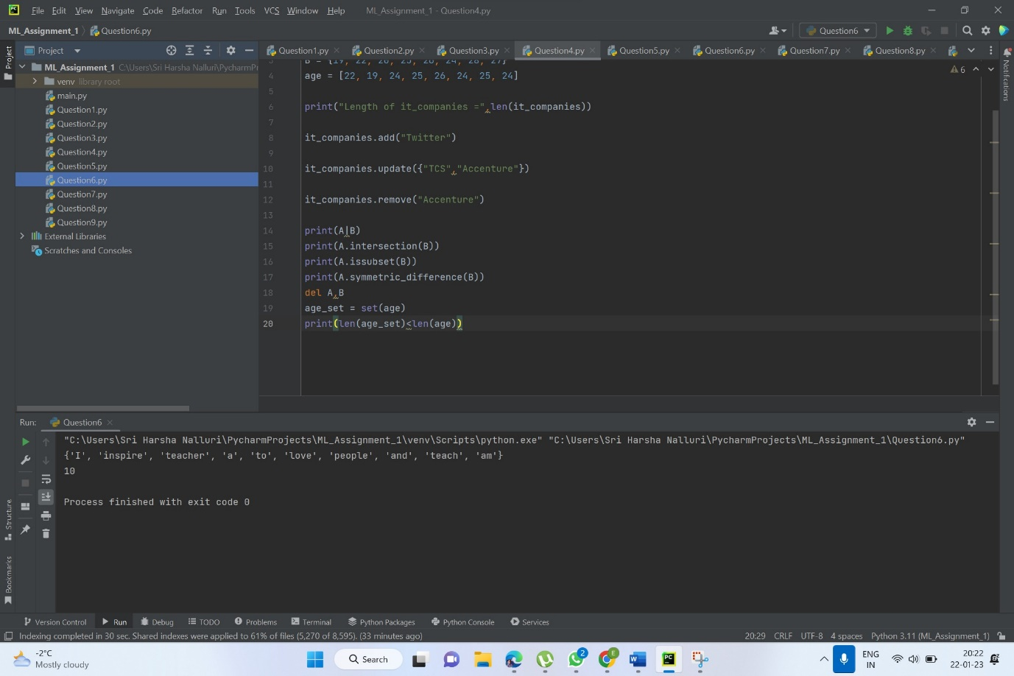

**Question 7**

**\***Used a tab escape sequence to get the following output.

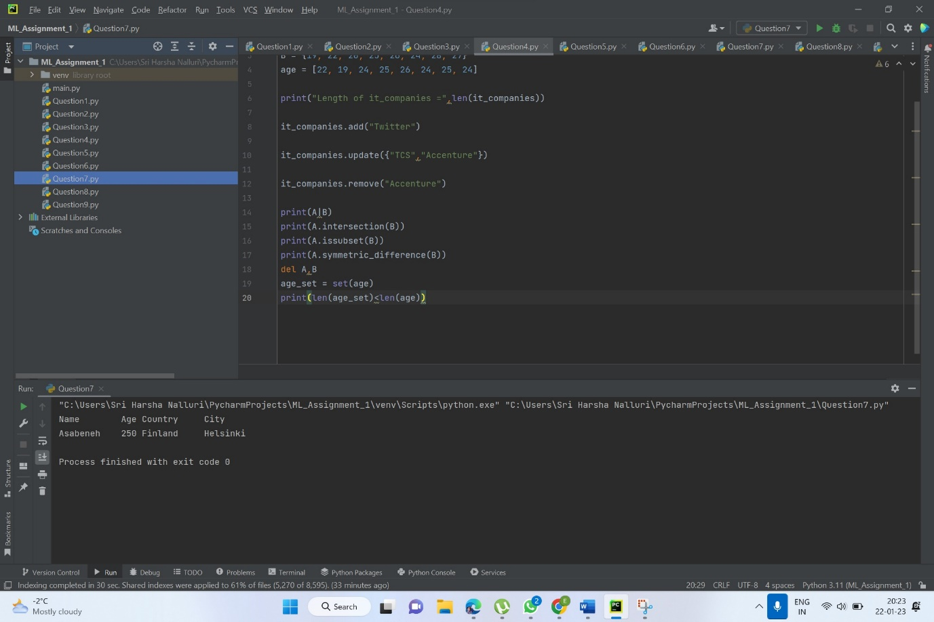

**Question 8**

**\***Using the string formatting method I have displayed the following: radius = 10 area = 3.14 * radius ** 2 and given the area of a circle with radius 10 is 314 meters square.

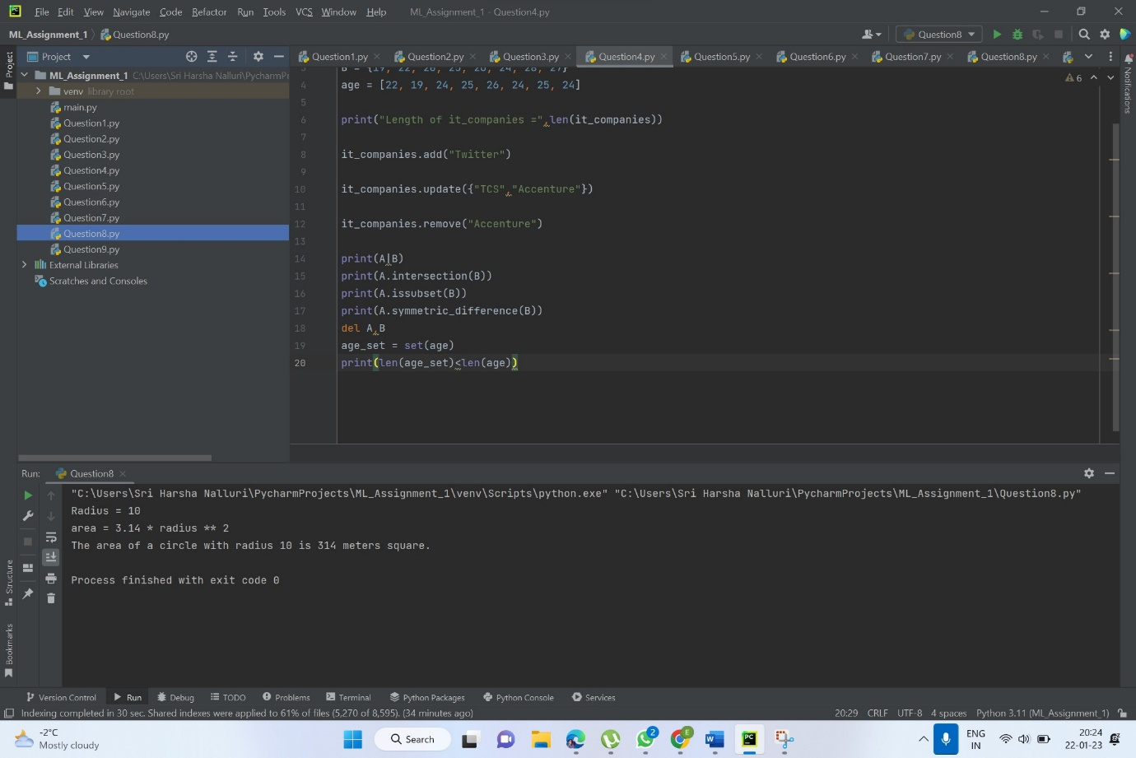

**Question 9**

**\***Executed the program, which reads weights (lbs.) of N students into a list and convert these weights to kilograms in a separate list using Loop. N: No of students (Read input from user)

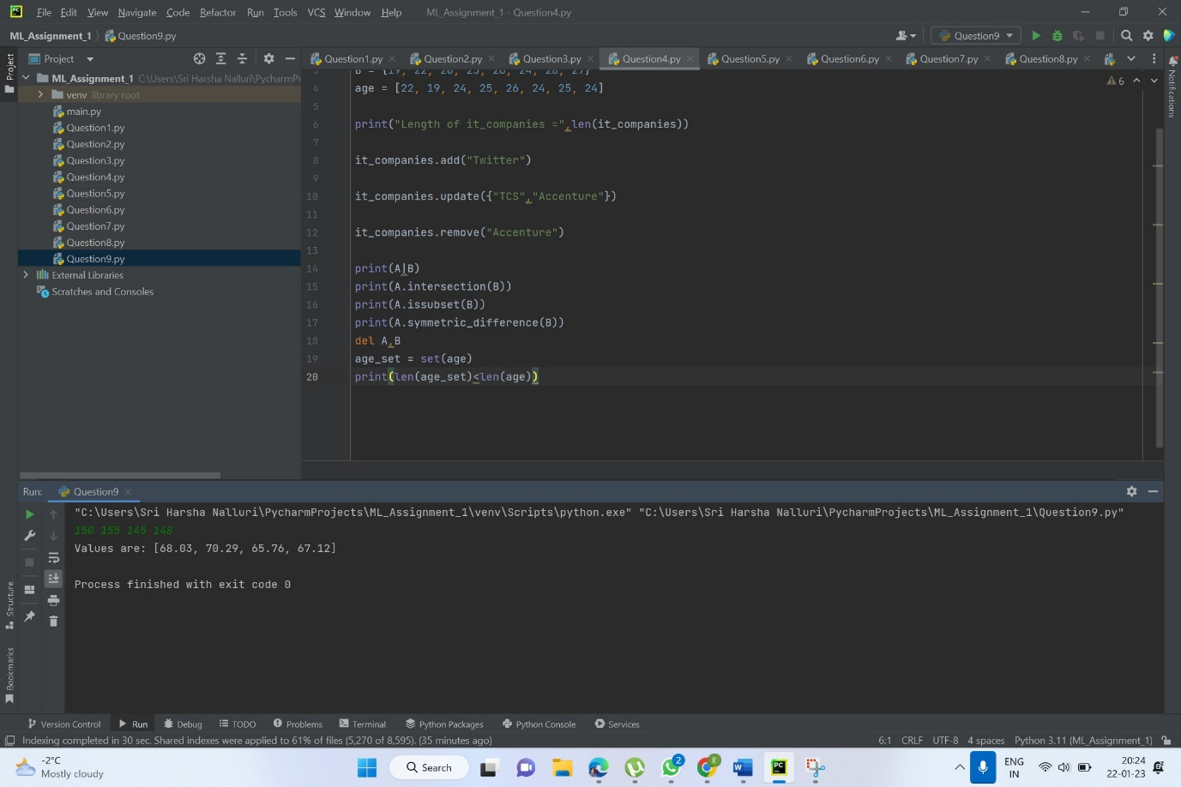

**Question 10**

