Machine Learning

Assignment-3

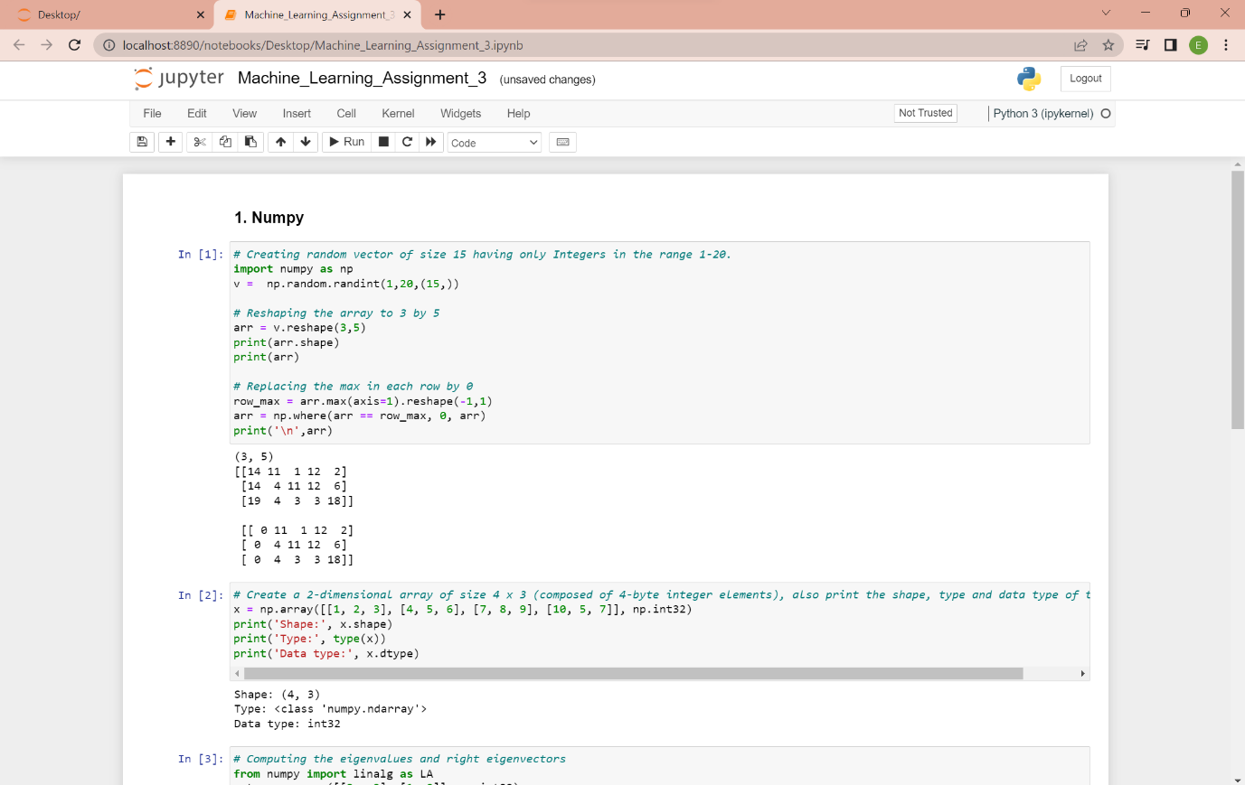

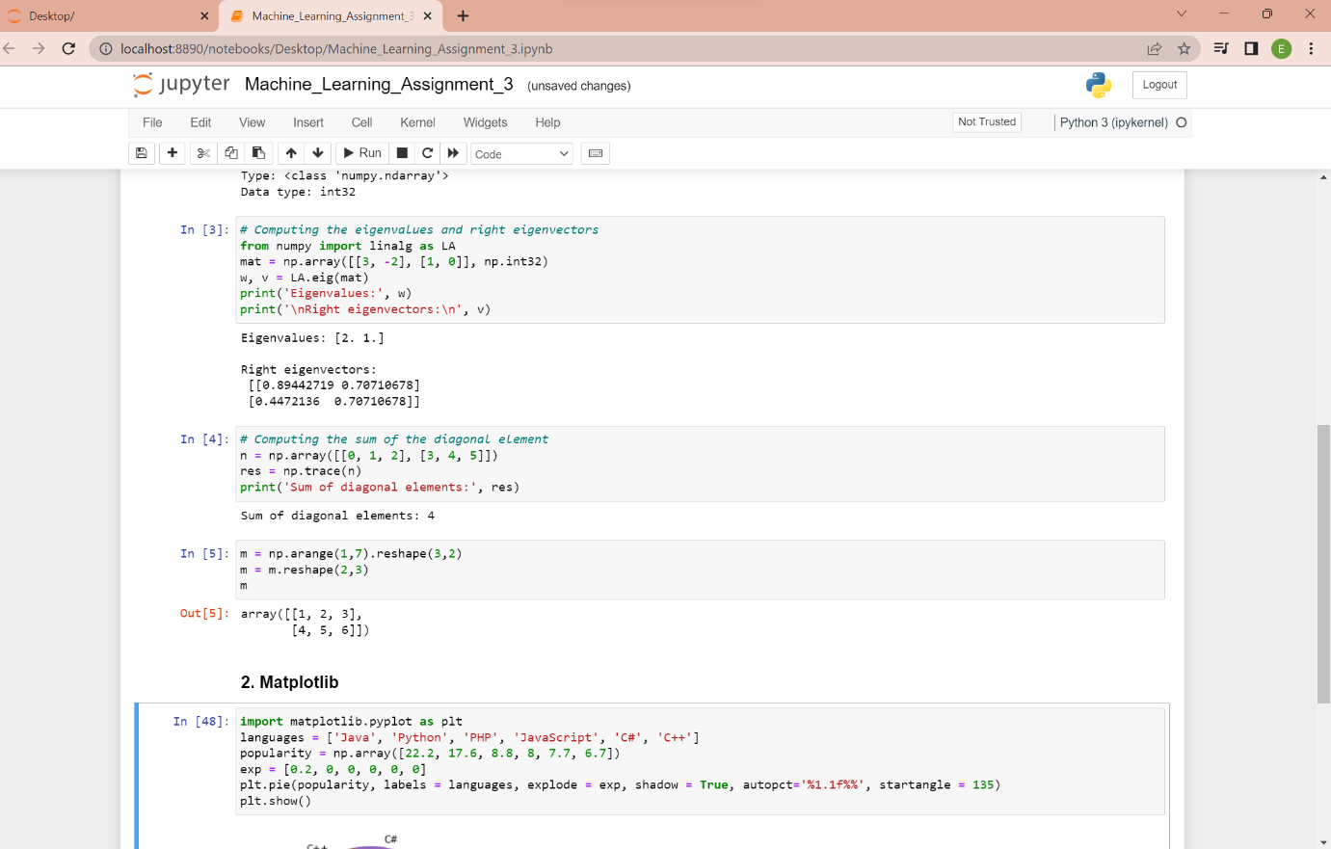

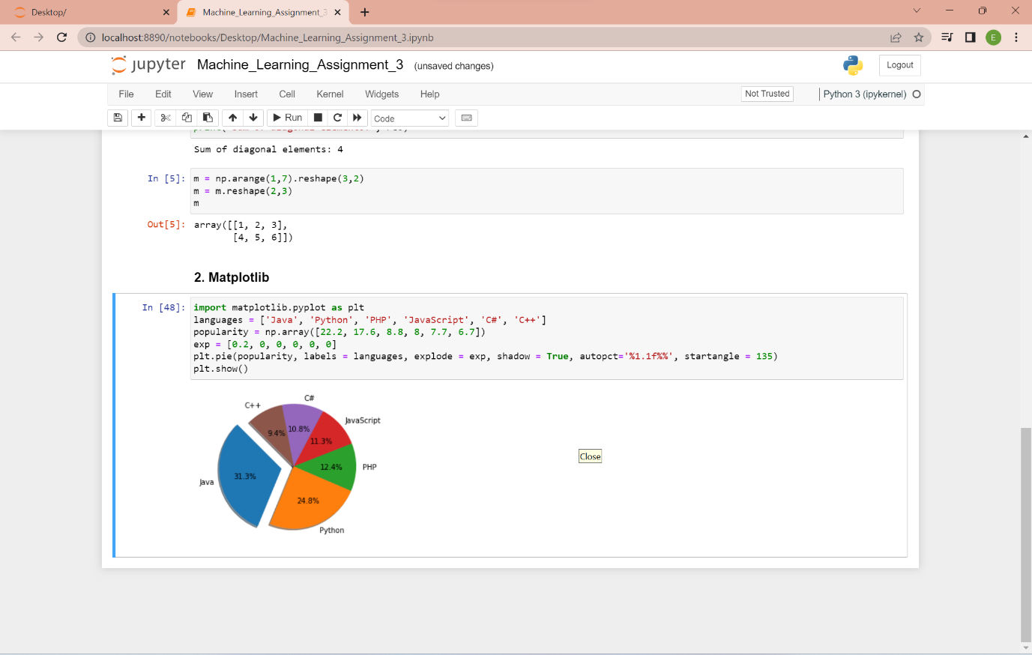

Git-Hub link: [MythreyiNalluri/ML_Assignment3 (github.com)](https://github.com/MythreyiNalluri/ML_Assignment3)

Video Link: <https://drive.google.com/file/d/1-PvgP8VZNyUo2E_Tnx_kZL0ce5qpylJb/view?usp=sharing>