Assignment-9

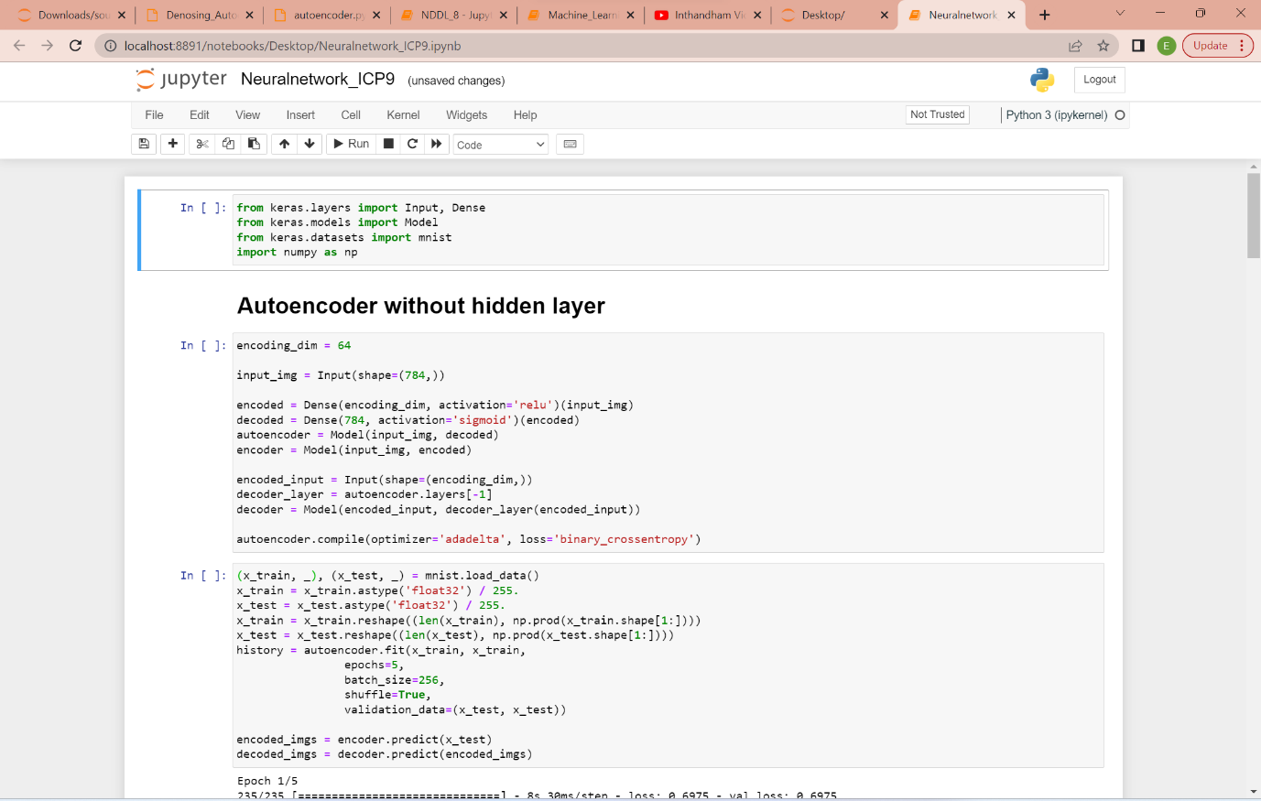

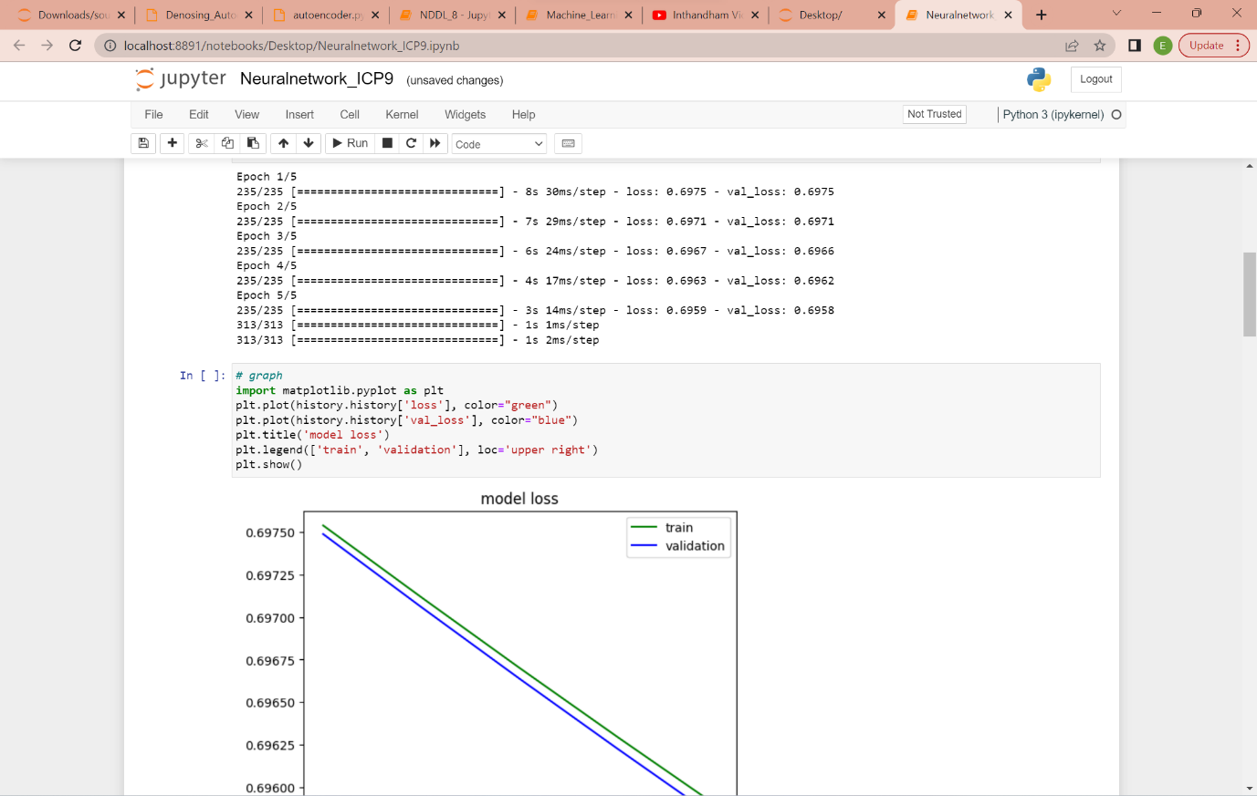

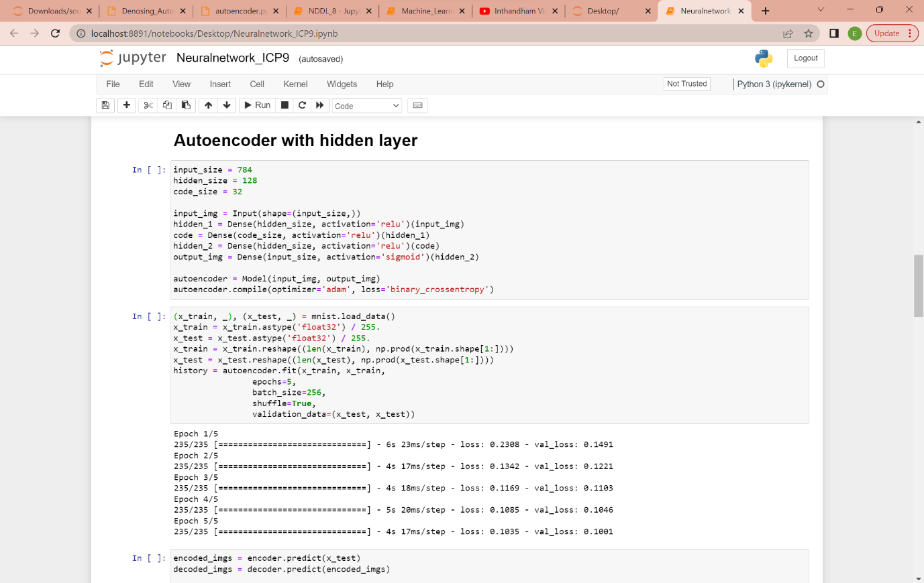

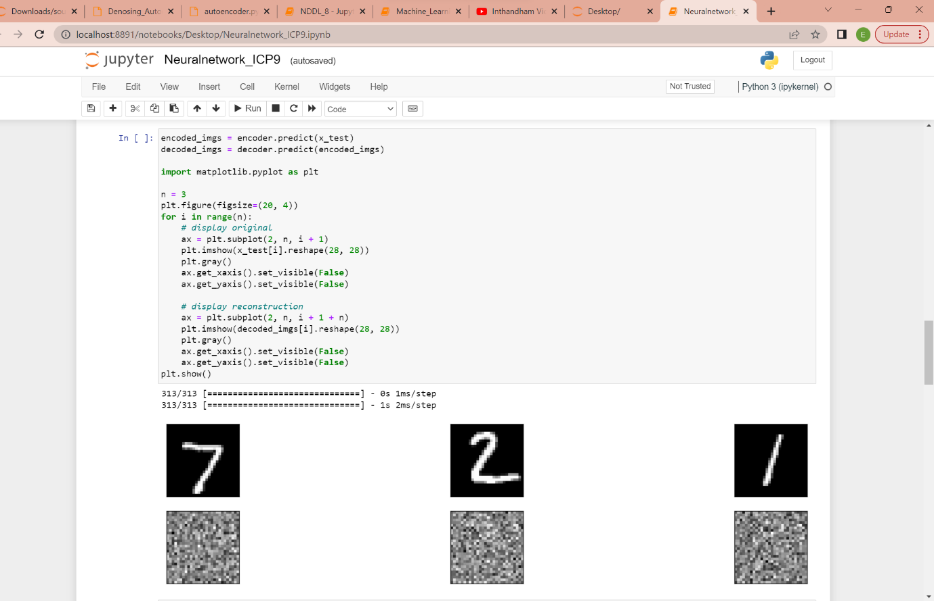

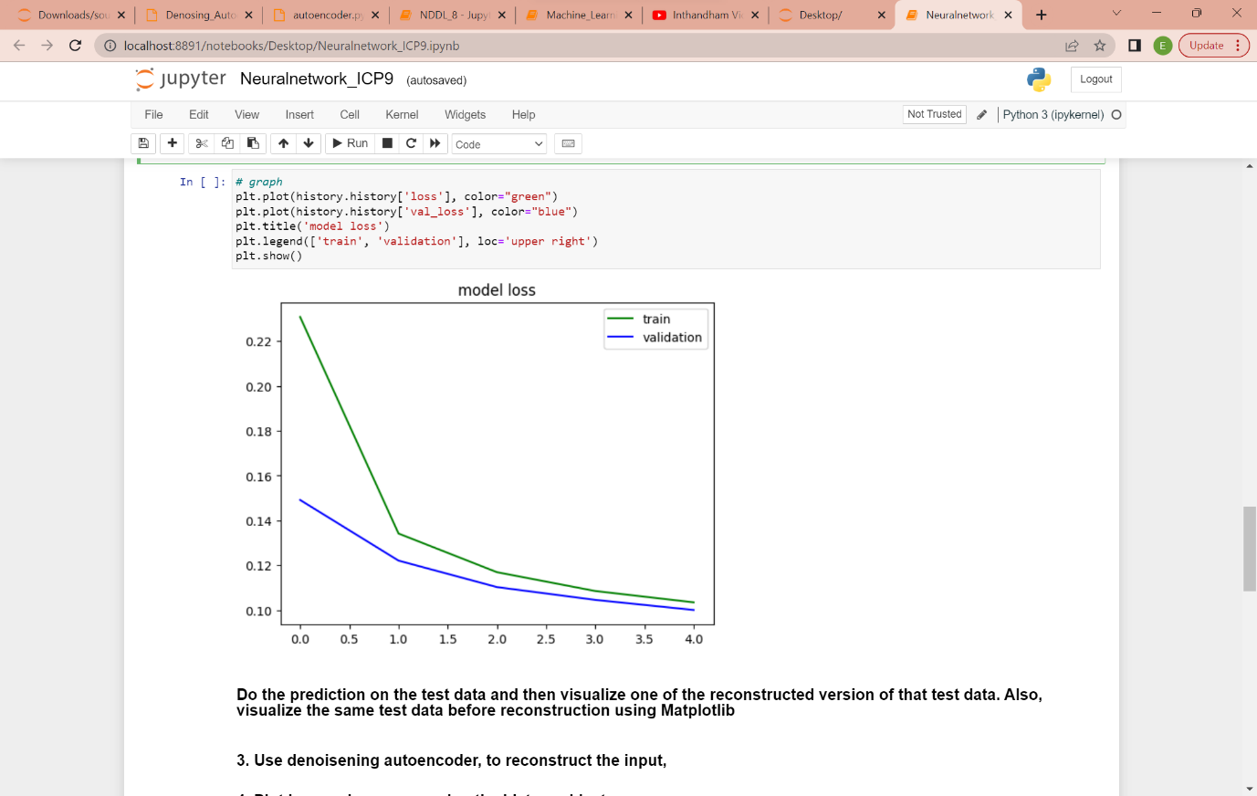

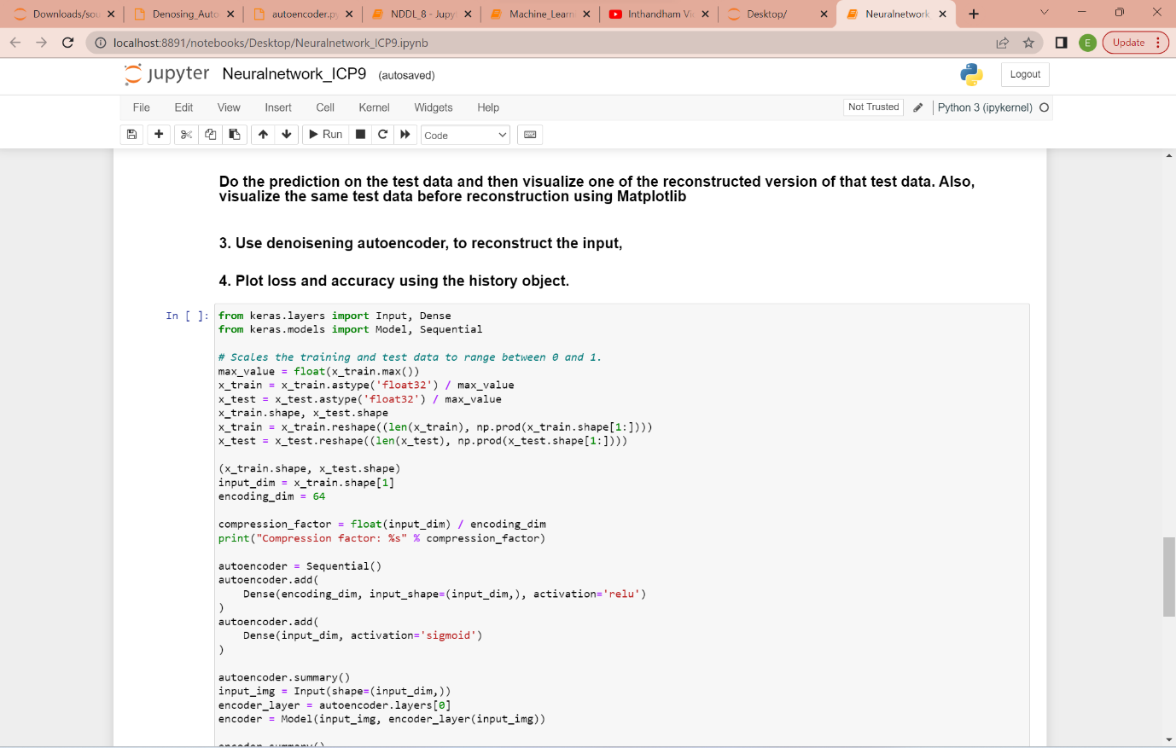

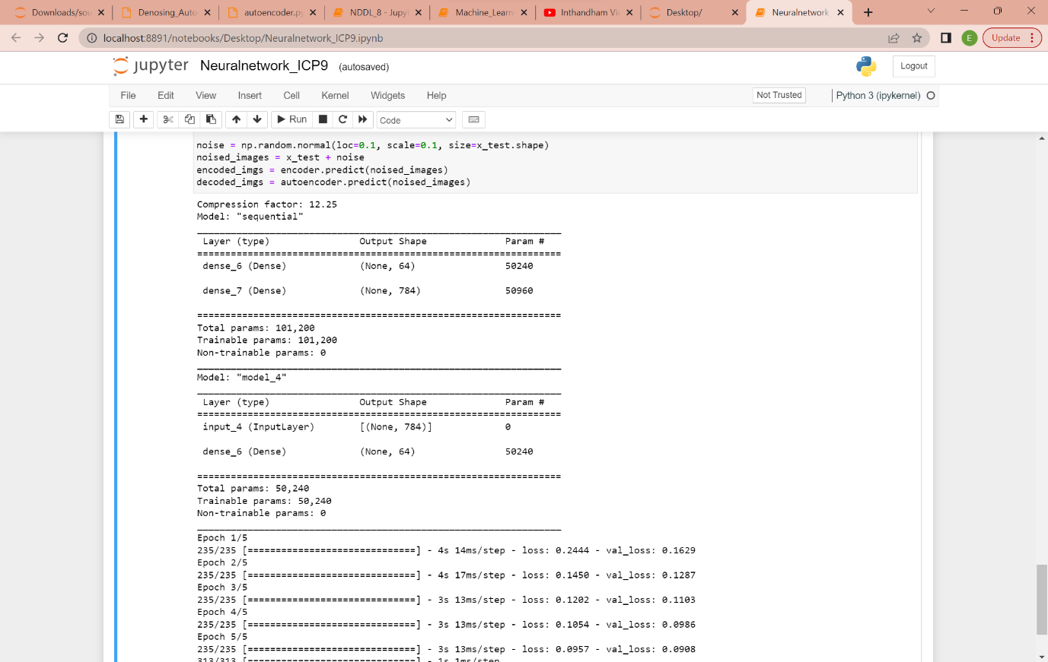

Video Link : <https://drive.google.com/file/d/1Gfq2SoIy0ml4yfX0_NFQBuvuUNdOFyaJ/view?usp=sharing>

GitHub Link: [MythreyiNalluri/NDDL_Assignment_9 (github.com)](https://github.com/MythreyiNalluri/NDDL_Assignment_9)