Data augmentation:
In order to rebuild a more realistic scene, the author made data augmentation to the acquired training data, which is based on randomly providing the background for the training data and the corresponding occlusion of the 3D virtual object.
Since the author did not provide the corresponding data,so readers need to download it by yourself.
1)For 3-dimensional coverings:
You can download a random occlusion from http://graphics.stanford.edu/data/3Dscanrep/.

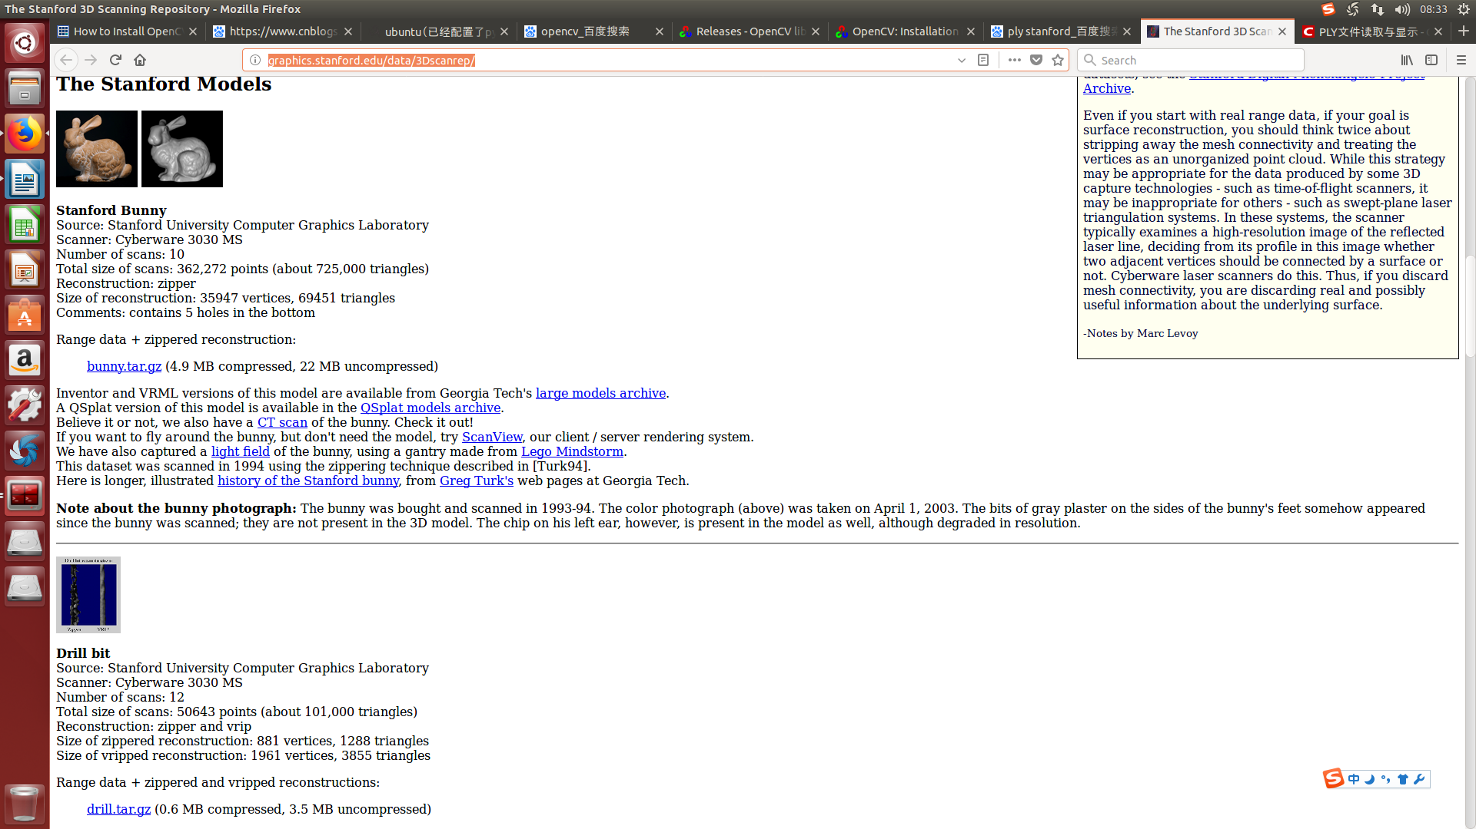

2)For background image:
As the background image required to be consistent with the format of the pictures provided by the author(raw_training dataset), so we just selected sun3d database as mentioned in the author's paper,
Readers can go to the official website: http://sun3d.cs.princeton.edu/ download
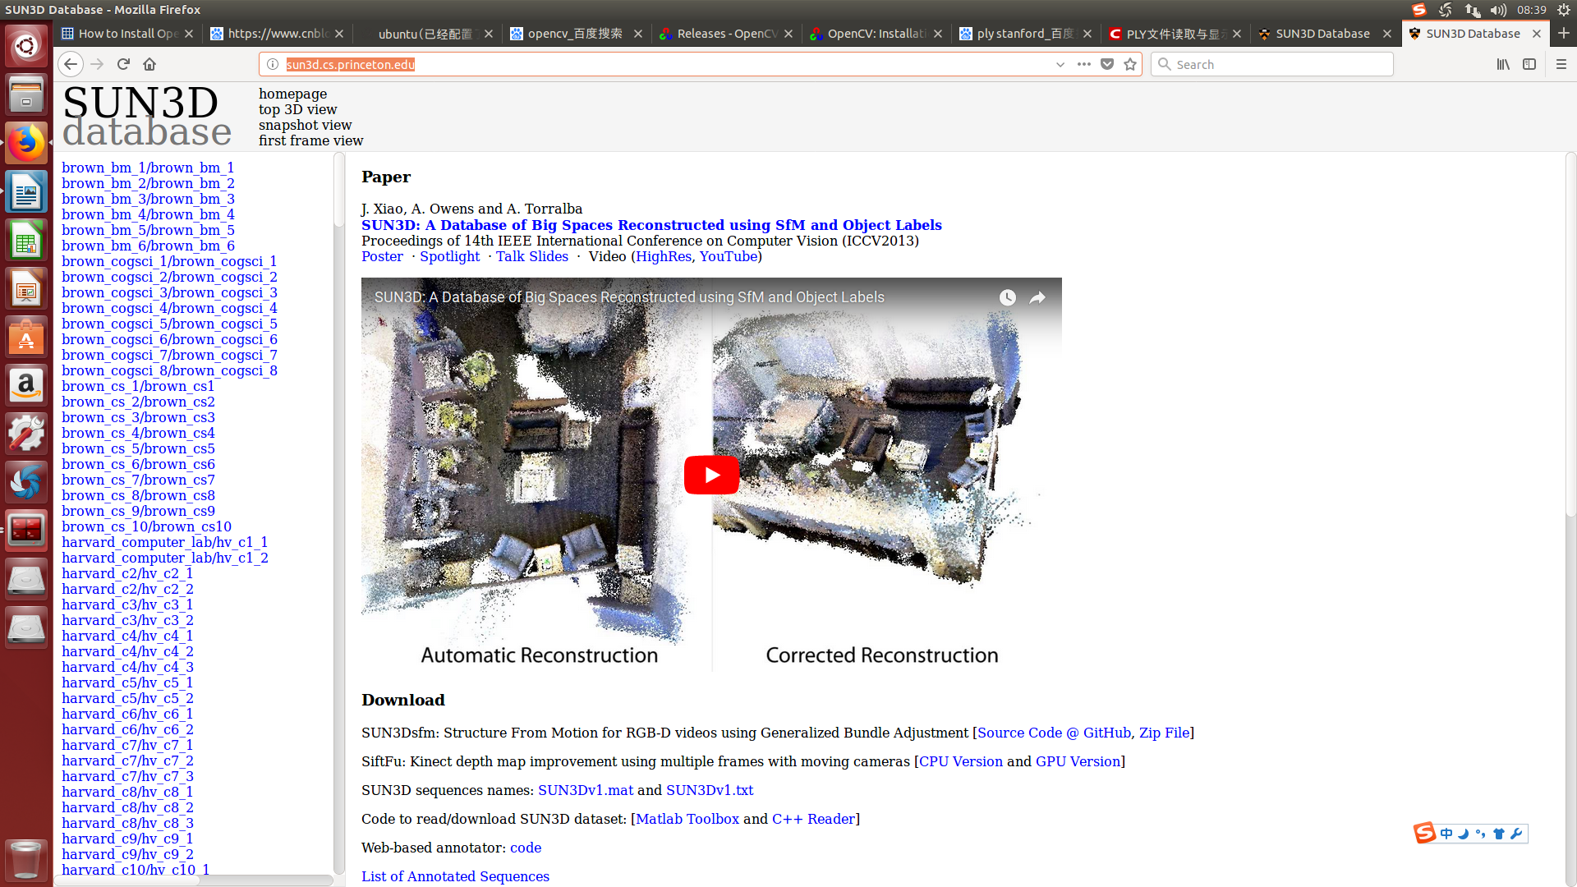
BTW,you also need special tools to download data sets from this website

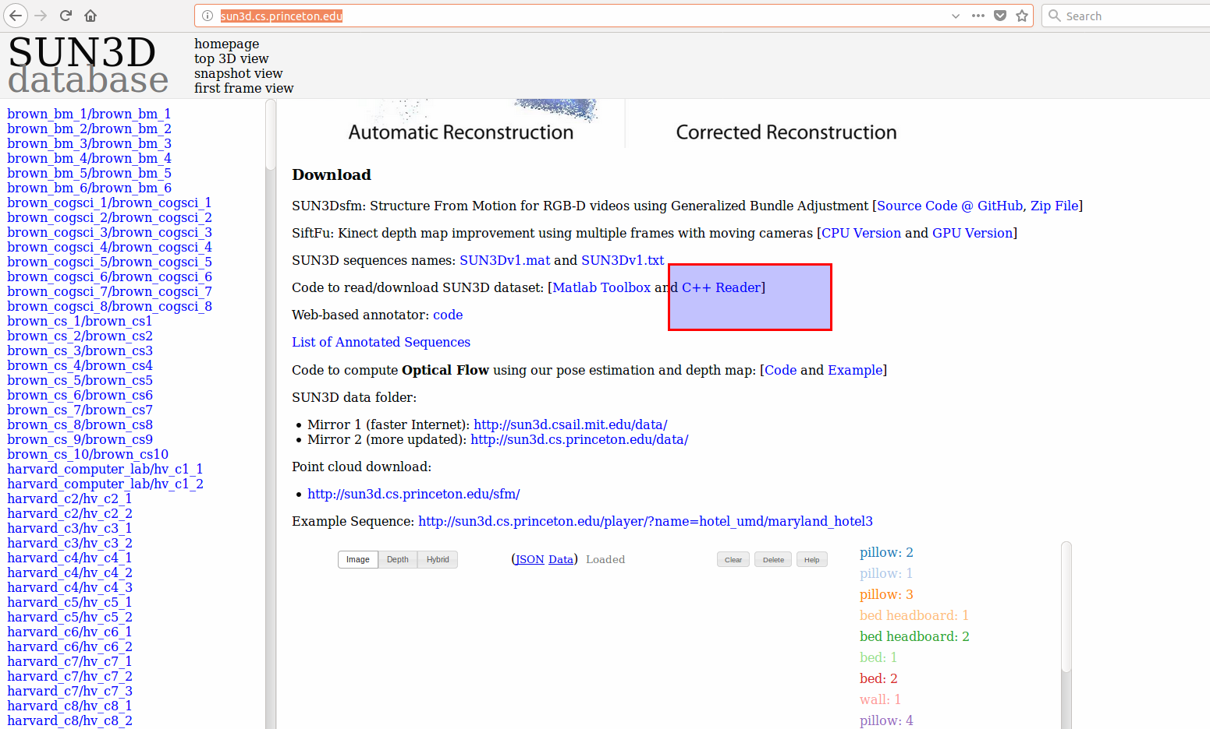
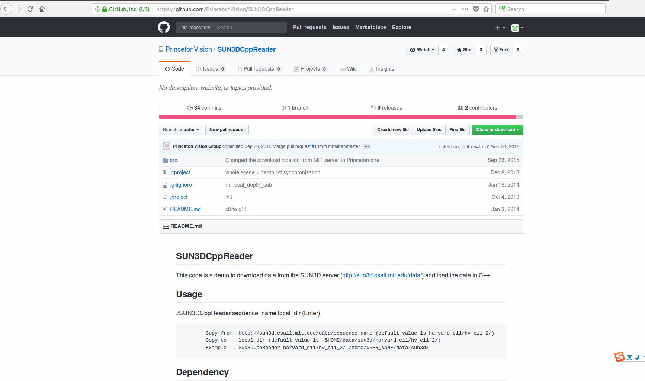
At this point, the data required for data augmentation on the completion of the introduction.
My original, declined reproduced, if necessary, contact the author: Myzhencai@hotmail.com

