1. Graphics driver for navida
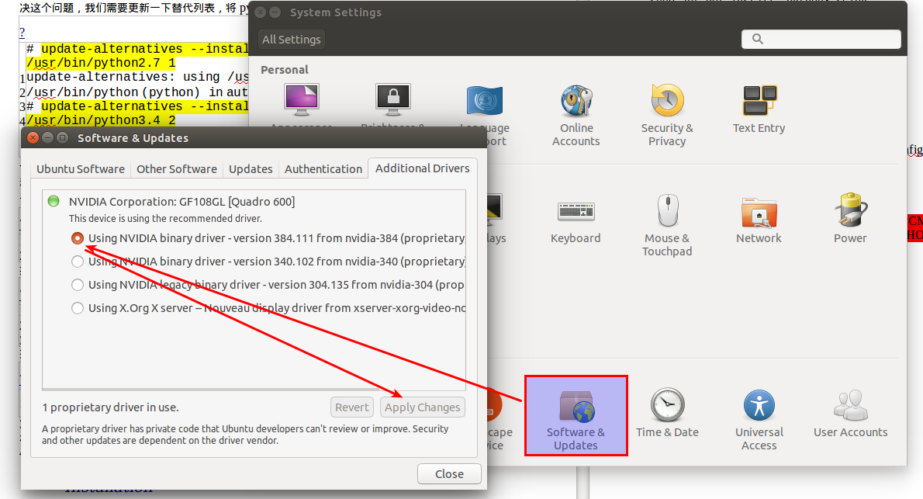
The default is python3 (the author uses python3 programming)
1# update-alternatives --list python
2update-alternatives: error: no alternatives for python
If the above error message appears, it means that an alternate version of Python has not been recognized by the update-alternatives command. Want to solve this problem, we need to update the alternative list, put python2.7 and python3.4 into it.
1# update-alternatives --install / usr / bin / python python /usr/bin/python2.7 1
2update-alternatives: using /usr/bin/python2.7 to provide / usr / bin / python (python) in auto mode
3# update-alternatives --install / usr / bin / python python /usr/bin/python3.4 2
4update-alternatives: using /usr/bin/python3.4 to provide / usr / bin / python (python) in auto mode
The --install option uses several parameters for creating symbolic links. The last parameter specifies the priority of this option. If we do not set alternative options manually, the one with the highest priority will be selected. In this example, we set the priority for /usr/bin/python3.4 to 2, so the update-alternatives command will automatically set it to the default Python version.
1# python --version
2Python 3.4.2
Next, we again list the available Python alternatives.
1# update-alternatives --list python
2/usr/bin/python2.7
3/usr/bin/python3.4
Now, we can use the command below at any time in the listed Python alternative version of the arbitrary switch.
1# sudo update-alternatives --config python
set the python3 as default.

3.Install pip
In the official website to download. Py file sudo python can install it to python3
4. install tqdm
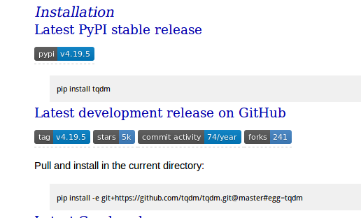

5.numpy
sudo apt-get install python3-numpy
6.opengl and glfw installed in accordance with libfreenect2
Then :
6.1 Install libfreenect2 + py3freenect2
First of all, to install libfreenect2 Because of the subsequent installation process will use one of these very important library opengl and glfw (follow-up by pip install their respective python parser so that can be import in Python)
libfreenect2: https://github.com/OpenKinect/libfreenect2.git

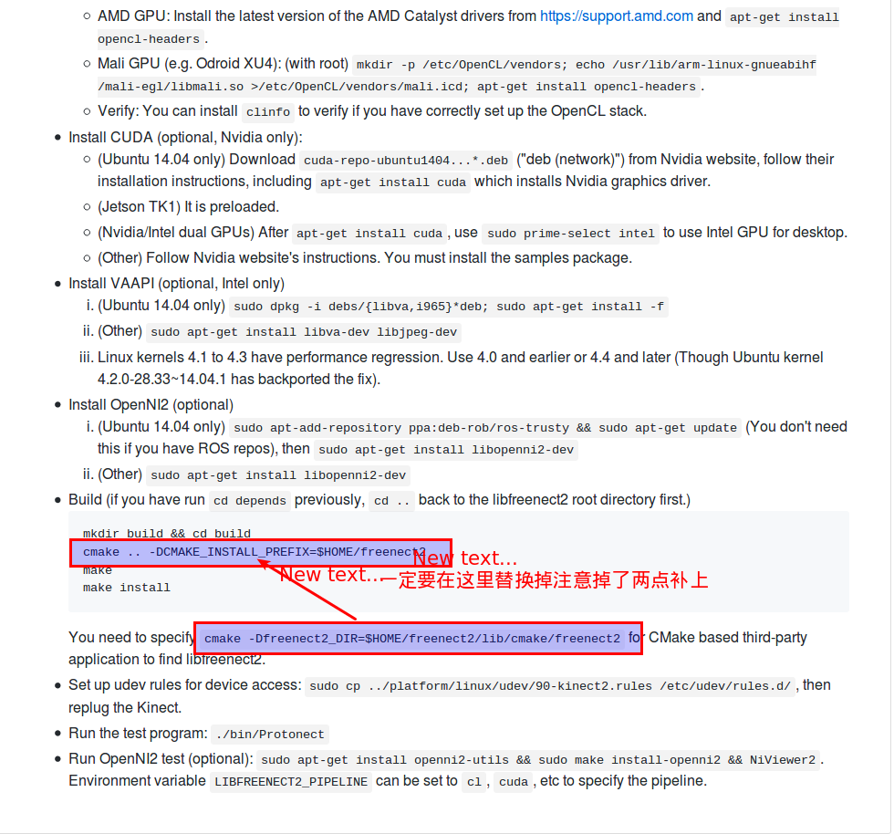

py3freenect:https://github.com/MathGaron/py3freenect2.git
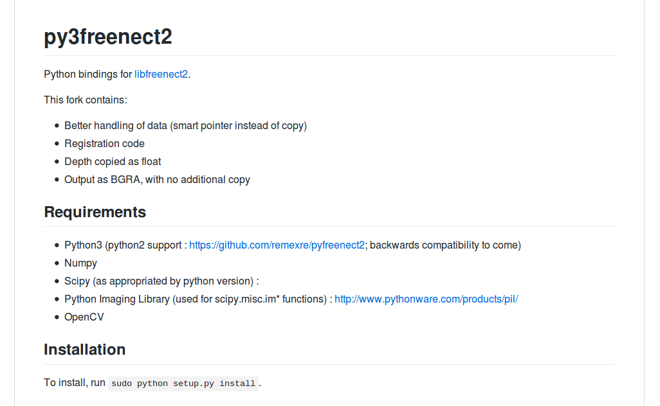
afer all do:
pip install PyOpenGL PyOpenGL_accelerate
pip install glfw
7.plyfile

pip install plyfile
8.scipy
sudo apt-get install python3-scipy
9.numpngw，pandas，skimage,slackclient

sudo pip install numpngw
sudo pip install pandas
sudo pip install scikit-image
sudo pip install slackclient
10.PIL
sudo apt-get install python3-pil
11.opencv3.4
Official website and this can be installed crrectly due to follow-up to install python-aruco (very tedious requirements are highly easy to install the wrong, I remember must be 1.3.0 version !!!!!!) (red is a required item)
All in accordance with the official website document install in linux operation, in addition to cmake part
sudo apt-get install build-essential
sudo apt-get install cmake git libgtk2.0-dev pkg-config libavcodec-dev libavformat-dev libswscale-dev
cd ~ / opencv
mkdir build
cd build
cmake -D CMAKE_BUILD_TYPE = RELEASE -D CMAKE_INSTALL_PREFIX = / usr / local -D BUILD_NEW_PYTHON_SUPPORT = ON -D PYTHON_EXECUTABLE = $ (which python3) ..
make -j7
sudo make install
12.Python-aruco (error prone)

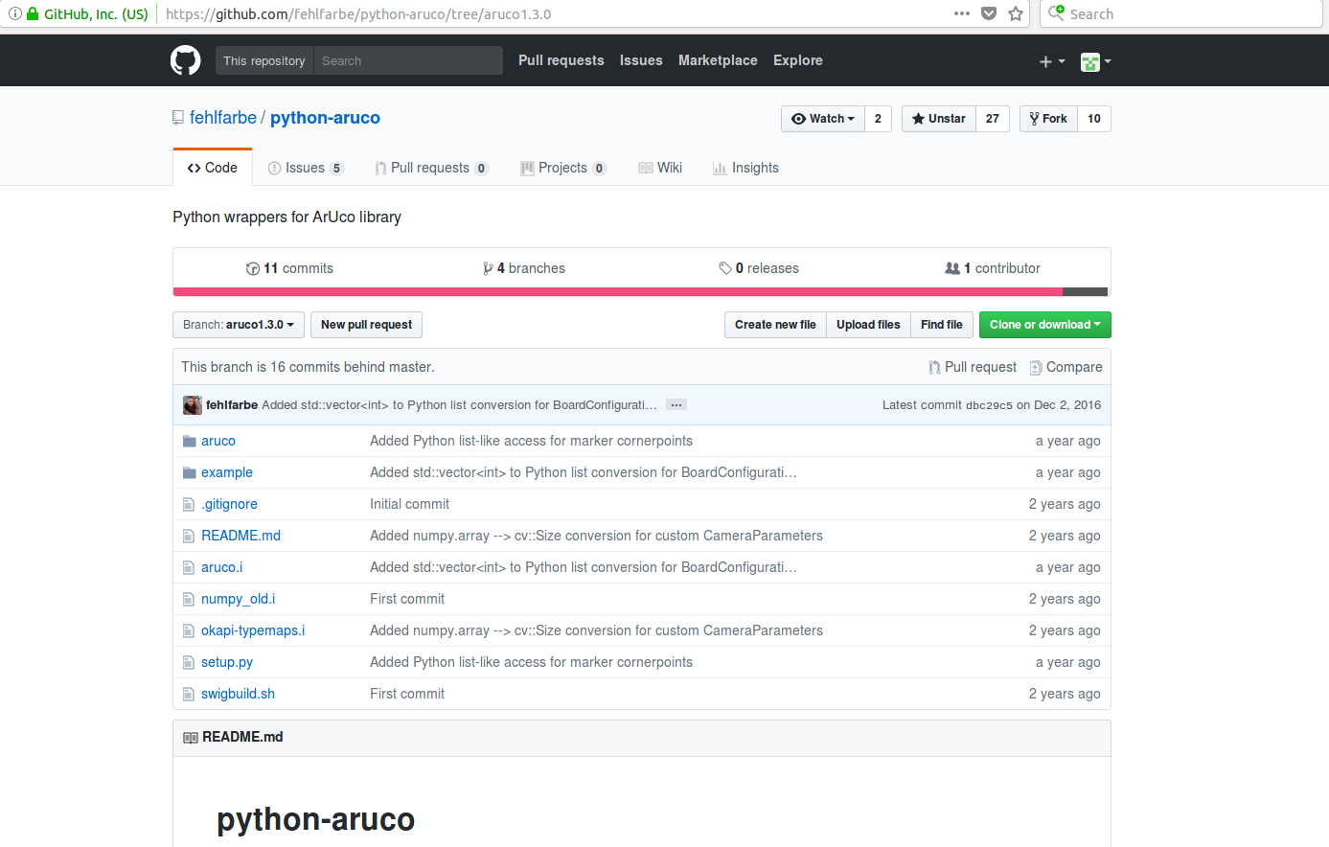

After installing opencv3.4 you need to install aruco1.3.0:
The official website to download version 1.3.0 unzip then go into the package to install it according to readme, then follow the link to operate: https://github.com/fehlfarbe/python-aruco/tree/aruco1.3.0 Note that you can skip over numpy Installation If there is a problem in the implementation of swigbuild.sh In the issue to find the answer Eg EIGEN, arrayobject some of the first document can not find the issue in the issue of the answer, if not in accordance with the software installed on it will be incorrect, Be patient and try it several times, later may also need: export LD_LIBRARY_PATH = / usr / local / lib /: $ LD_LIBRARY_PATH can be imported in Python.
13.pytorch (because of my python3.4 so github source is installed)
https://github.com/pytorch/pytorch.git

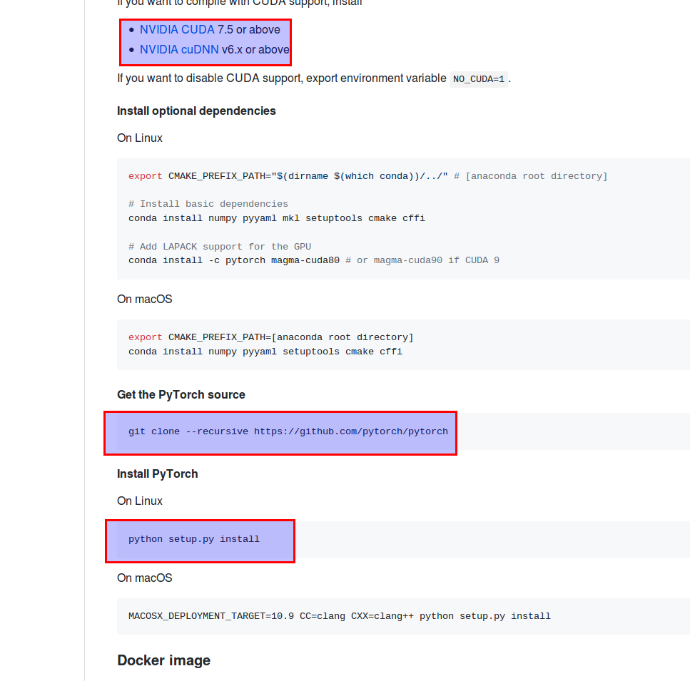
14. Hugh Perkins's pytorch
The general process is Figure 1, of course, will jump to install torch: https://github.com/torch/distro.git
Click the link in Figure 2 to get it: http://torch.ch/docs/getting-started.html#_
Torch installed, and then return to the first figure in the process to go.

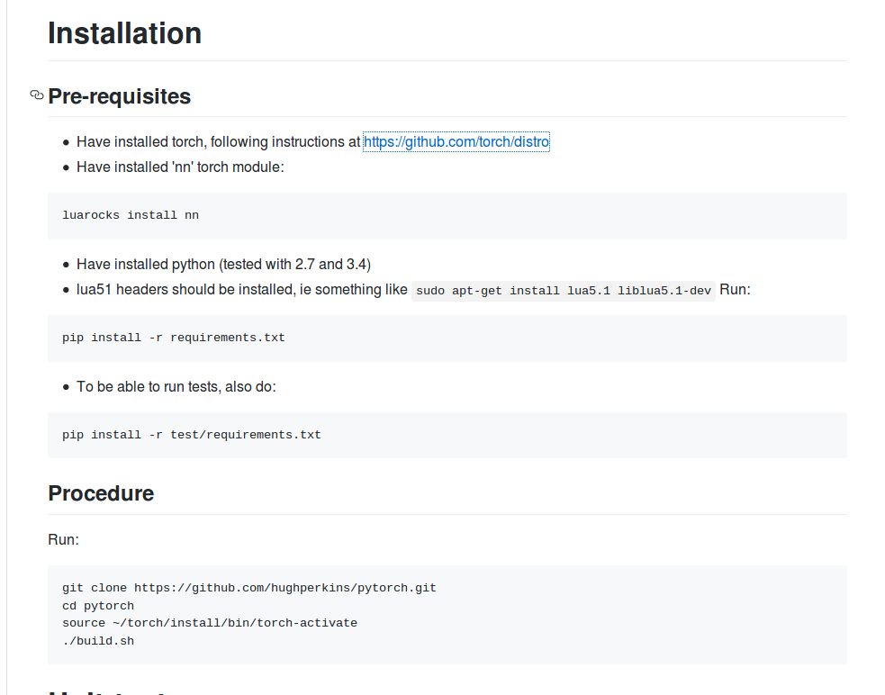
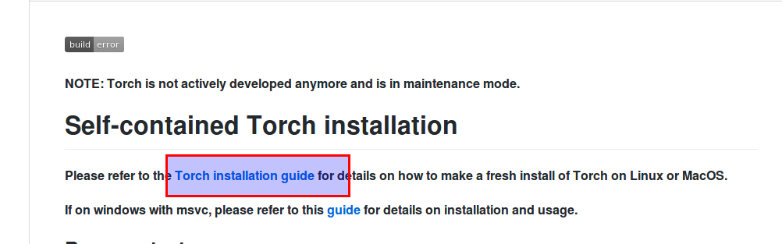
All dependencies are generally set up. Of course, the author provided the docker file, but the fatal error was that it could not be configured with python-aruco (tried n different builds).
This article original, declined reproduced, for reprint, please contact the author Myzhencai@hotmail.com

