**Assignment 1**

1. C:\Users\USER>aws configure

AWS Access Key ID [****************V4WE]:

AWS Secret Access Key [****************EpBl]:

Default region name [us-east-1]:

Default output format [json]:

2. C:\Users\USER>aws --version

aws-cli/2.16.6 Python/3.11.8 Windows/10 exe/AMD64

3. C:\Users\USER>aws iam list-users

{

"Users": [

{

"Path": "/",

4. C:\Users\USER>aws s3api create-bucket --bucket jennifer-scalagos --region us-east-1

{

"Location": "/jennifer-scalagos"

}

5. C:\Users\USER>aws s3 ls

2024-06-12 13:49:12 jennie-clitest

2024-06-12 15:33:59 jennifer-scalagos

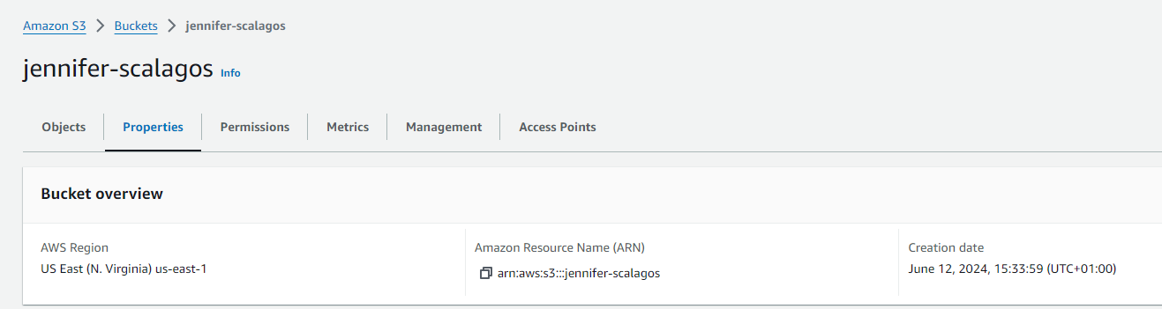

**Assignment 2**

6. C:\Users\USER>aws iam create-user --user-name jennie2-scalagos

{

"User": {

"Path": "/",

"UserName": "jennie2-scalagos",

"UserId": "**",

"Arn": "**:user/jennie2-scalagos",

"CreateDate": "2024-06-12T15:37:58+00:00"

}

}

7. C:\Users\USER>aws iam create-access-key --user-name jennie2-scalagos

{

"AccessKey": {

"UserName": "jennie2-scalagos",

"AccessKeyId": "**",

"Status": "Active",

"SecretAccessKey": "**",

"CreateDate": "2024-06-12T15:40:06+00:00"

}

}

8. C:\Users\USER>aws iam attach-user-policy --user-name jennie2-scalagos --policy-arn arn:aws:iam::aws:policy/AmazonS3ReadOnlyAccess

