# CSE 472 (Machine Learning Sessional)

# Assignment 3: Dimensionality Reduction using Principal Component Analysis and Clustering using Expectation-maximization Algorithm

## **Moaz Mahmud (1505064)**

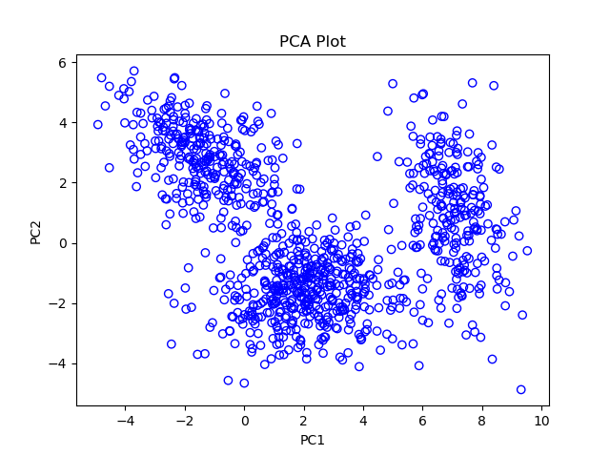 **PCA implementation**

**EM implementation**

From PCA, number of clusters in the data in two principal components,

$$\boxed{k=3}$$

|  |  |
| --- | --- |
| $$μ_{1}=\left({7.07860183 \atop 0.99051031}\right)$$ | $$Σ_{1}=\left(\begin{matrix}0.82725394 & -0.57770596 \\ -0.57770596 & 3.36105752\end{matrix}\right)$$ |
| $$μ_{2}=\left({2.1049187 \atop -1.63644085}\right)$$ | $$Σ_{2}=\left(\begin{matrix}2.5259442 & 0.16589947 \\ 0.16589947 & 1.09054177\end{matrix}\right)$$ |
| $$μ_{3}=\left({-1.30281985 \atop 2.79003276}\right)$$ | $$Σ_{3}=\left(\begin{matrix}1.99641987 & -0.87684847 \\ -0.87684847 & 1.47243505\end{matrix}\right)$$ |
| $$w_{1}=0.24037177 w_{2}=0.45676345 { w}_{3}=0.30286478$$ | |

**Python Format**

np.array([[ 7.07860183, 0.99051031],

[ 2.1049187 , -1.63644085],

[-1.30281985, 2.79003276]])

np.array([[[ 0.82725394, -0.57770596],

[-0.57770596, 3.36105752]],

[[ 2.5259442 , 0.16589947],

[ 0.16589947, 1.09054177]],

[[ 1.99641987, -0.87684847],

[-0.87684847, 1.47243505]]])

np.array([0.24037177, 0.45676345, 0.30286478])