**SPECIAL ISSUE**

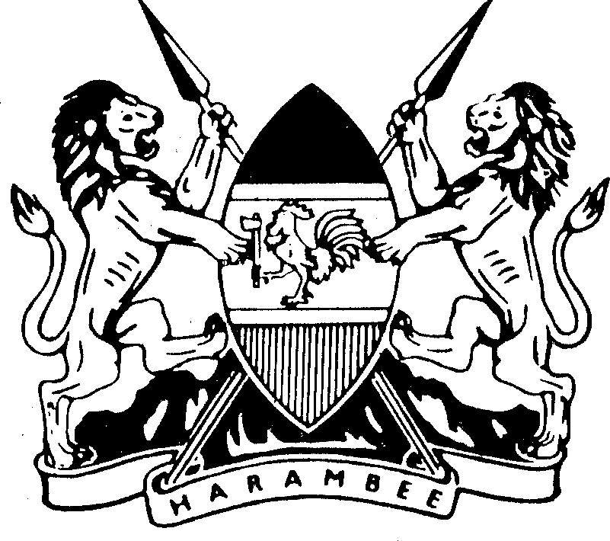*Kenya Gazette Supplement No. 184 (Senate Bills No. 53)*

REPUBLIC OF KENYA

–––––––

KENYA GAZETTE SUPPLEMENT

# SENATE BILLS, 2021

**NAIROBI, 6th October, 2021**

CONTENT

Bill for Introduction into the Senate—

PAGE

The Kenya Medical Supplies Authority (Amendment) Bill, 2021 ............... 1275

PRINTED AND PUBLISHED BY THE GOVERNMENT PRINTER, NAIROBI

1275

# THE KENYA MEDICAL SUPPLIES AUTHORITY (AMENDMENT) BILL, 2021

**A Bill for**

# AN ACT of Parliament to amend the Kenya Medical Supplies Authority Act, 2013.

**ENACTED** by the Parliament of Kenya, as follows—

1. This Act may be cited as the Kenya Medical Supplies Authority (Amendment) Act, 2021.
2. The Kenya Medical Supplies Authority Act, 2013, hereinafter referred to as the principal Act is amended in section 4 by –
3. deleting subsection (3)G and
4. deleting subsection (4).

1276

*The Kenya Medical Supplies Authority (Amendment) Bill, 2021*

# MEMORANDUM OF OBJECTS AND REASONS

1276

**Statement of the Objects and Reasons for the Bill**

Article 43 (1) (a) of the Constitution guarantees every person the right to the highest attainable standard of health. In order to fulfil this obligation, the county health facilities must be supplied with drugs and medical supplies in adequate quantities and in a timely manner.

The fill rate of the Kenya Medical Supplies Authority has only been up to sixty per centum over time and this has resulted the constrained ability of county governments to ensure that the county health facilities have adequate drugs and medical supplies to efficiently and effectively ensure the highest attainable standard of health for the citizens of each county.

It is for this reason that this Bill seeks to amend the Kenya Medical Supplies Authority Act, No. 20 of 2013, by deleting the provision that requires county governments to procure drugs and medical supplies from the Authority as the first point of call. The repeal of the provision will allow county governments to procure drugs and medical supplies from suppliers other than the Authority thereby ensuring adequate fill rates for both drugs and medical supplies.

Repealing of section 4 of the Kenya Medical Supplies Authority Act, No. 20 of 2013 shall not create a lacuna in the law since section 67 (3) of the Health Act provides—

(3) The Kenya Medical Supplies Authority may be the point of first call for procurement of health products at the county referral level and it shall endeavor to establish branches within each county at such locations as it may determine.

# Statement on the delegation of legislative powers and limitation of fundamental rights and freedoms

This Bill does not delegate legislative powers nor does it limit fundamental rights and freedoms.

# Statement on how the Bill concerns county governments

Health Services are devolved under Paragraph 2 of Part 2 of the Fourth Schedule of the Constitution and the county governments are mandated to ensure delivery of health services under the county health system. In order to provide services that guarantee the highest attainable standard of health, the counties are required to ensure that the county health facilities have adequate drugs and medical supplies.

*The Kenya Medical Supplies Authority (Amendment) Bill, 2021* 1277

This Bill therefore affects functions of county governments in terms of Article 110 (1) (a) of the Constitution.

# Statement that the Bill is not a money Bill, within the meaning of Article 114 of the Constitution.

This Bill is not a money Bill within the meaning of Article 114 of the Constitution.

Dated the 9th, September, 2021.

NAOMI MATITSA SHIYONGA,

*Senator.*

1278

*The Kenya Medical Supplies Authority (Amendment) Bill, 2021*

*Section 5 of No. 20 of 2013 which it is proposed to amend—*

1278

# Functions of the Authority

* 1. The functions of the Authority shall be to—

1. procure, warehouse and distribute drugs and medical supplies for prescribed public health programmes, the national strategic stock reserve, prescribed essential health packages and national referral hospitalsY
2. establish a network of storage, packaging and distribution facilities for the provision of drugs and medical supplies to health institutionsY
3. enter into partnership with or establish frameworks with county Governments for purposes of providing services in procurement, warehousing, distribution of drugs and medical suppliesY
4. collect information and provide regular reports to the national and county governments on the status and costZeffectiveness of procurement, the distribution and value of prescribed essential medical supplies delivered to health facilities, stock status and on any other aspects of supply system status and performance which may be required by stakeholdersY
5. support county governments to establish and maintain appropriate supply chain systems for drugs and medical supplies.
   1. The Cabinet Secretary shall, in consultation with the Authority and the appropriate county government organs, determine the requirement of drugs and medical supplies in public health facilities.
   2. A national or county public health facility shall, in the procurement and distribution of drugs and medical supplies, obtain all such drugs and medical supplies from the Authority subject to—
6. the drug being duly registered by the BoardY and
7. the drugs and medical supplies meet the standards of quality and are efficacious as authorized by the Board.
   1. A person responsible for the procurement and distribution of drugs and medical supplies in a national or county public health facility and who contravenes provisions of this section, commits an offence and is liable on conviction to a fine not exceeding two million shillings or to imprisonment for a term not exceeding five years, or to both.