*Kenya Gazette Supplement* *No. 217{Senate* Bill No. )

## REPUBLIC OF KENYA







The Wildlife Conservation and Management(Amendment) Bill, 2020.....



807

THE WILDLIFE CONSERVATION AND

**MANAGEMENT (AMENDMENT) BILL, 2020**

**An ACT of Parliament to amend the Wildlife Conservation and Management Act and for connected purposes.**

**ENACTED** by the Parliament of Kenya, as follows—

1. This Act may be cited as the Wildlife Conservation and

Management (Amendment) Act, 2020.

2. The Wildlife Conservation and Management Act, in this Act referred to as “the principal Act”, is amended by inserting the **following new** section immediately after section 21 —

A. (1) The Cabinet Secretary shall, as the

case may be and in each financial year, provide adequate funds for the management of the affairs

of each Community Wildlife Conservation Committee.

(2) The Cabinet Secretary shall, where no appeal has been lodged under this Act, ensure that compensation required to be paid under this Act is undertaken within twelve months of a determination of the respective Community Wildlife Conservation Committee.

1. Section 23 of the principal Act is amended in subsection

(4) by inserting the following new paragraph immediately after paragraph (f)-

(fa) provide support to local communities negatively affected by activities undertaken with respect to wildlife conservation and management;

1. Section 24 of the principal Act is amended in subsection
2. by—
   1. deleting the word “Government” appearing in the introductory clause in subsection (1) and substituting therefor the words “Cabinet Secretary”;
   2. deleting paragraph (a) and substituting therefor the following new paragraph —
      1. monies annually allocated for this purpose by the National Assembly;
3. Section 25 of the principial Act is amended
4. In subsection (3) by inserting the words "within twelve months of the recommendations" immediately after the words "and when appropriate" in the introductory
5. in subsection (4) by deleting the words "due consideration" appearing immediately after the words "the service for" end substituting therefor the words “the purpose of processing the payment for compensation" ;
6. in subsection (5) by Inserting the words “within twelve months” immediately after the words "award and pay" in the introductory clause: and
7. in subsection (6) by-
   1. deleting the word "either" appearing immediately after the words "of compensation by"; and
   2. deleting the words "or the Service" appearing immediately after the words "and Compensation Committee".
8. Section 76 of the principal Act is amended—

### (a) by deleting subsection (4) and substituting therefor the

following new sub8ection—

(4) The Cabinet Secretary shall, in formulating the guidelines, ensure that the guidelines comply with the condition that a minimum of five percent of the benefits from national parks and national reserves shall be allocated to local communities neighboring or negatively affected by activities undertaken for the preservation of the national parks.

 by inserting the (following new subsection immediately

#### after subsection (4)—

(4A) The determination of the minimum percentage of the benefits to be allocated to local communities under subsection (4) shall be based on the gross total revenue and fees collected with respect to the protected

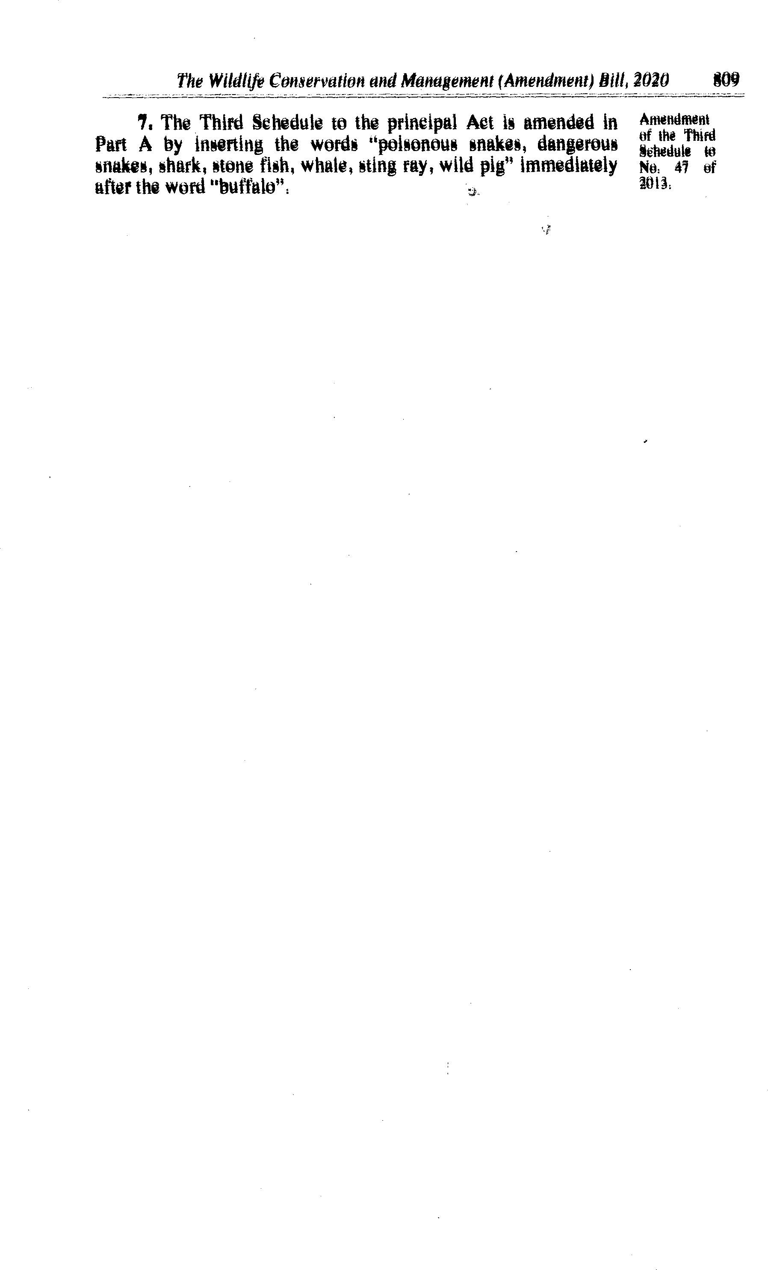

8t0 *the Wildlife Conservation and Management (Amendment) BIII, 2020*

**MEMORANDUM OF OBJECTS AND REASONS**

**Statement of the objects and reasons for the Bill**

The Bill seeks to amend the Wildlife Conservation and Management Act, No. 47 of 2013, in order to make further provision for the allocation of adequate facilities to County Wildlife Conservation and Compensation Committees established under the Act. It also provides a timeline of twelve months for the compensation for human death, human injury or crop and property damage caused by wildlife in accordance with the Act.

The Bill makes further provision for the payment of compensation and other entitlements due to local communities affected by wildlife inaccordance with the Act. This is essential to enable counties perform their county functions us provided under Part 2 of the Fourth Schedule to the Constitution.

### **Statement on the delegation of legislative powers and limitation of fundamental rights and freedoms**

This Bill does not delegate legislative power nor does it limit fundamental

rights and freedoms.

**Statement on how the Bill concerns county governments**

The Bill concerns county governments in that it makes further provision for the allocation of adequate facilities to County Wildlife Conservation and Compensation Committees in each county. It also provides timelines for the compensation by the Committees to victims of injury caused by wildlife in accordance with the Act. This will affect counties in the performance of their functions as listed under Pan 2 of the Fourth Schedule of the Constitution.

The Bill makes further provision for the payment of compensation to local communities affected by wildlife in accordance with the Act. This is essential to enable counties perform their county functions as provided above. It also facilitates counties to perform their functions tinder paragraph 14 of the said Pan 2 of the Fourth Schedule to the Constitution. The Bill therefore affects the functions and powers of county governments in terms of 110(l H ) of the

Constitution.

**Statement that the Bill is not a money Bill, within the meaning of Article**

The Bill deals with matters other than those listed in the definition of a money Bill under Article 114 (3) of the Constitution and is therefore not a money Bill within the meaning of Article 114 of the Constitution.

Dated the 26th November, 2020.

JOHNES MWARUMA,

*Senator.*

*Section 23 of No. 47 of 20l3 that the Bill proposes to amend-*

**The Wildlife Endowment Fuad**

#### *(1)* The Service shall establish a Wildlife Endowment Fund, and which shall be vested in the Board of Trustees.

1. There shall be paid into the Endowment Fund —
2. moneys appropriated by Parliament for purposes of the Endowment

Fund;

1. a proportion of such moneys as may be levied for payment of environmental services by beneficiaries in productive and service sectors as a contribution towards the Endowment Fund es the Cabinet Secretary may, upon the recommendation of the Service, determine;

#### income from investments made by the Board of Trustees of the Endowment Fund; and such grants, donations, bequeath or other gifts as may be made to the Endowment Fund; and

1. such grants, donations, bequests or other gifts be made to the Endowment Fund.

#### The functions of the Wildlife Endowment Fund shah be to—

(«) develop wildlife conservation initiatives;

1. manage and restore protected area and conservancies;

#### protect endangered species, habitats and ecosystems;

1. support wildlife security operations;
2. facilitate community based wildlife initiatives; and

## (9 rich other purposes es may be provided for by rules made under this

Act.

*Section 24 of No. 47 of 2013 that the Bill proposes to amend-*

### The Wildlife Compensation Scheme

#### (1) The Government shall establish a Wildlife Compensation Scheme that shall consist of—

1. monies specifically allocated for this purpose through the budget
2. an insurance scheme to be established by the Cabinet Secretary responsible for matters relating to finance; end

#### monies from any other source approved by the Cabinet Secretary for

the time being responsible for matter relating to finance; and