Group 3 Assignment
Static Website Deployment to Azure via CLI + GitHub Action

Objective:
Deploy a static website to Azure Blob Storage using a bash Script.

Tasks:
1. using a static website template from anywhere
2. Use Azure CLI to provision a storage account and enable static website hosting
3. Uploads files with CLI.
Bonus: Automate deployment with GitHub Actions and ensure uploads happens with new site files on push.
Deliverables: Static website code, CLI provisioning script, GitHub Actions workflow (if it applies) screenshots of live site.
Note: Ensure that static website used is unique.
Solution
Section A
Static website provisioning on Azure Storage
- Login to Azure using the CLI
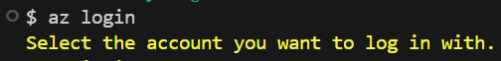
- Note the azure account has existing resource groups.
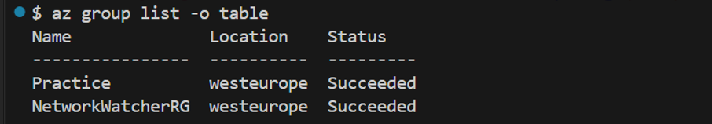

- Provisioning of a storage account called oleeystorage1.
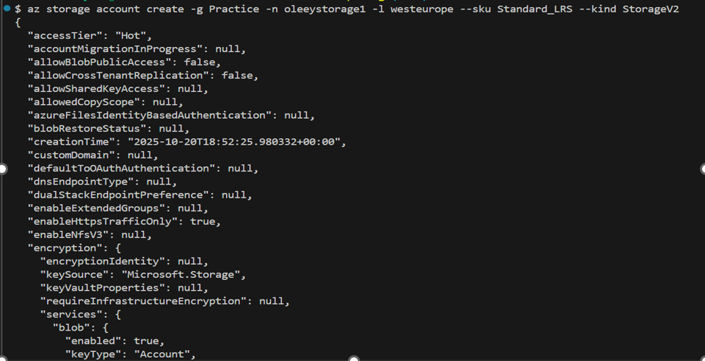
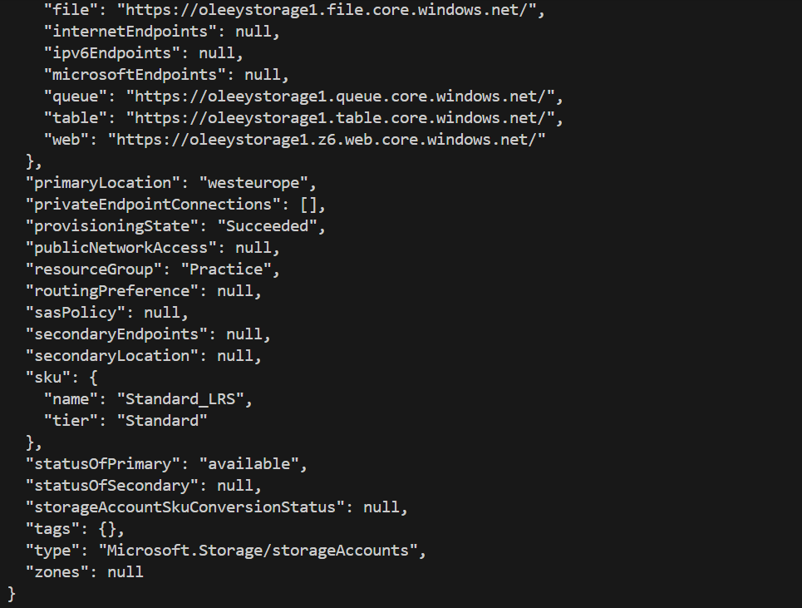
- Enabling a static website
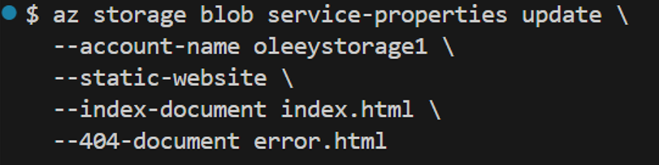

- Upload of a static html website folder to azure storage account: A storage blob data contributor role was given to the azure account to enable upload. This was done using the IAM in the Azure GUI.

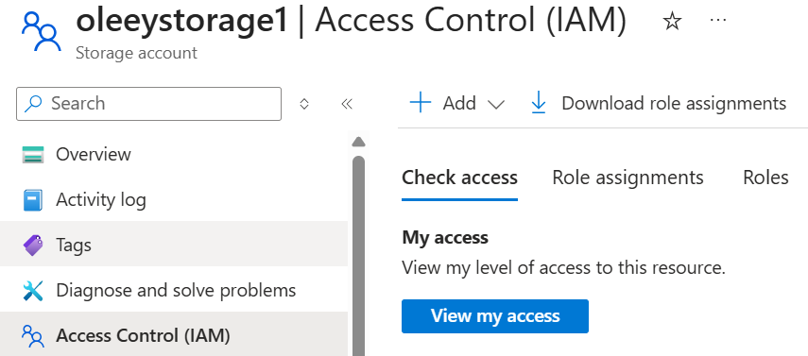

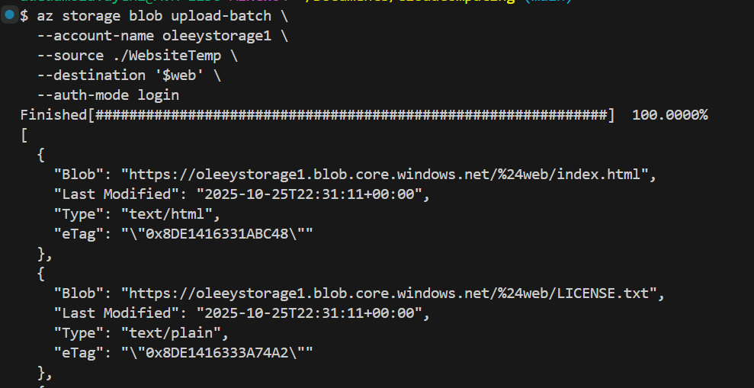

The website url link: Click Here
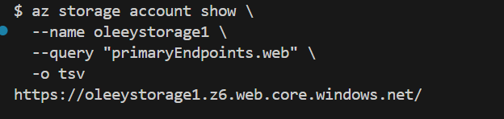

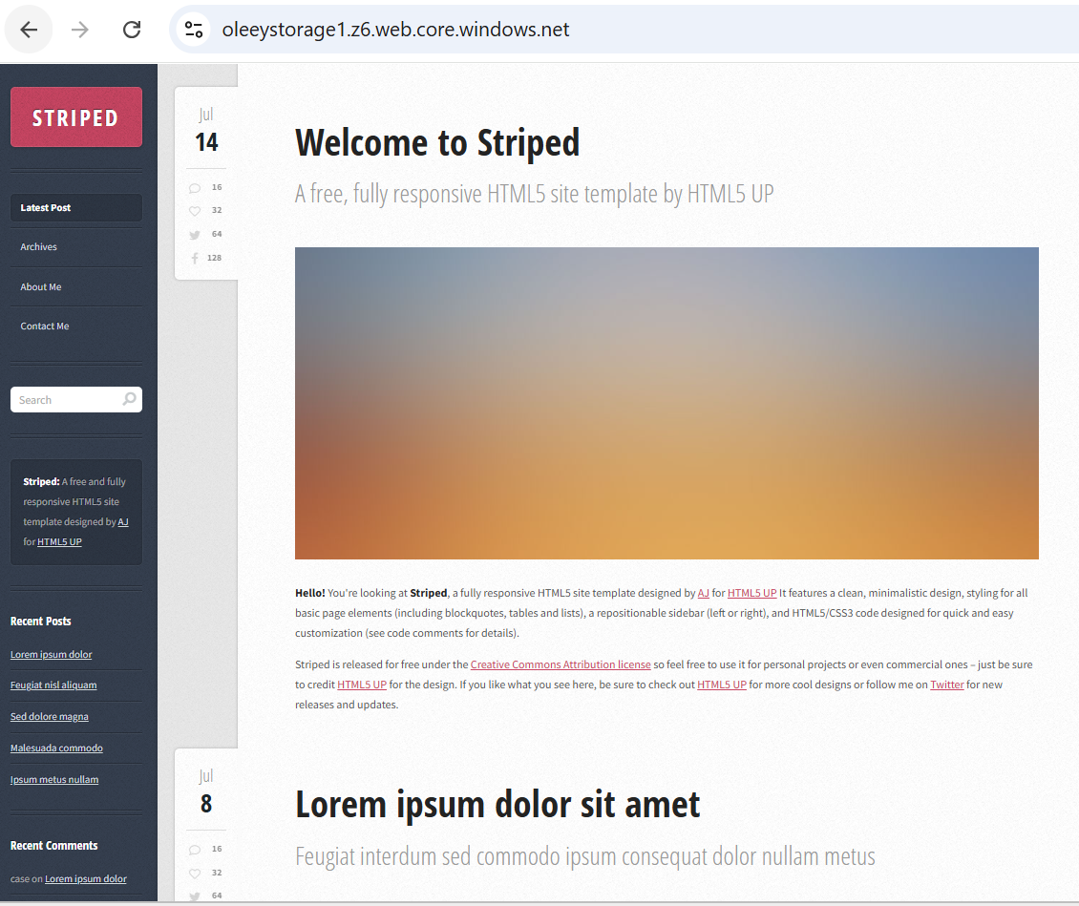

Section B
Github Actions Automation

- Creation of the “workflows” folder in the “.github” folder



- Creation of the yml file

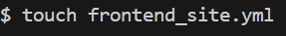

The yml file code:
name: Deploy_Static_Website

on:
push:
branches: [ main ]
paths:
- 'WebsiteTemp/**'
workflow_dispatch:

jobs:
deploy:
runs-on: ubuntu-latest
steps:
- name: Checkout code
uses: actions/checkout@v4

- name: Azure Login
uses: azure/login@v2
with:
creds: ${{ secrets.AZURE_CREDENTIAL }}

- name: Upload to Azure Storage
uses: azure/CLI@v2
with:
inlineScript: |
az storage blob upload-batch \
--account-name oleeystorage1 \
--account-key ${{ secrets.AZURE_STORAGE_KEY }} \
--destination '$web' \
--source ./WebsiteTemp \
--overwrite true

- name: Logout
run: az logout
if: always()

- The folders and file were committed and push to github using the code below:
- git add .
- git commit -m “committing all changes”
- git push origin main
- The workflow run, “Deploy_Static_Website” created in the yml file is showing under “Actions” in github after pushing to the github repository.
Section C
- Creation of Azure Service Principal. This is to enable the github actions login to azure.

az ad sp create-for-rbac \
--name "github-actions-deploy" \
--role contributor \
--scopes /subscriptions/$(az account show --query id -o tsv)/resourceGroups/Practice \
--sdk-auth
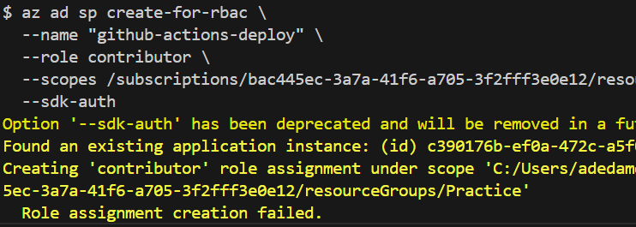
The role assignment failed because the application instance already exists. A “storage blob data contributor” role was assigned to the application using the “IAM” in the GUI. A new client secret key was also generated using the GUI. The information was put in a json format as seen below.

{
"clientId": "c571bbfa-xxxx",
"clientSecret": "Dbxxxxx",
"subscriptionId": "bac445ec-3a7a-41f6-a705-3f2fff3e0e12",
"tenantId": "a2253388-ec26-40fe-8727-270b60c01cbc"
}
The information provided above was stored in the github secrets and variables as “AZURE_CREDENTIAL” while the storage account key was saved as “AZURE_STORAGE_KEY”. Both secrets were referenced as variables in the yml file above. Below is the code to get the storage account key:
az storage account keys list -g Practice -n oleeystorage1.

The workflow run was tested manually after setting up the “AZURE_CREDENTIAL” and “AZURE_STORAGE_KEY”. Also, the html file was modified, and the change was pushed to the github repository which triggers the workflow run as seen below.
