Name: Nathan Adam

Batch code: LISUM01

Submission date:7th July 2021

Submitted to: Week 5: Cloud and API deployment

https://github.com/N-A-ML/Data_Glacier_Cloud_and_API_Deployment_Week_5 (on GitHub)

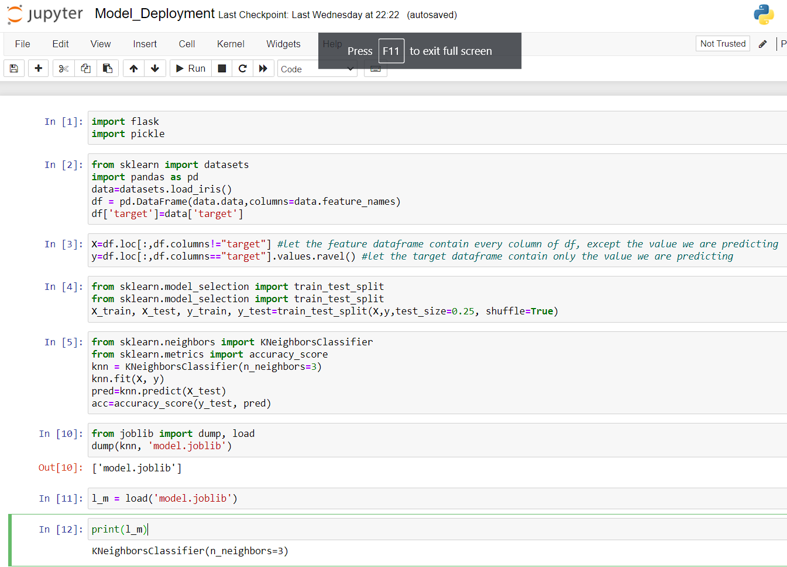Note: the app was deployed on the cloud with Heroku in week 4.   
Select data (iris dataset), create and save a simple model (knn classifier):

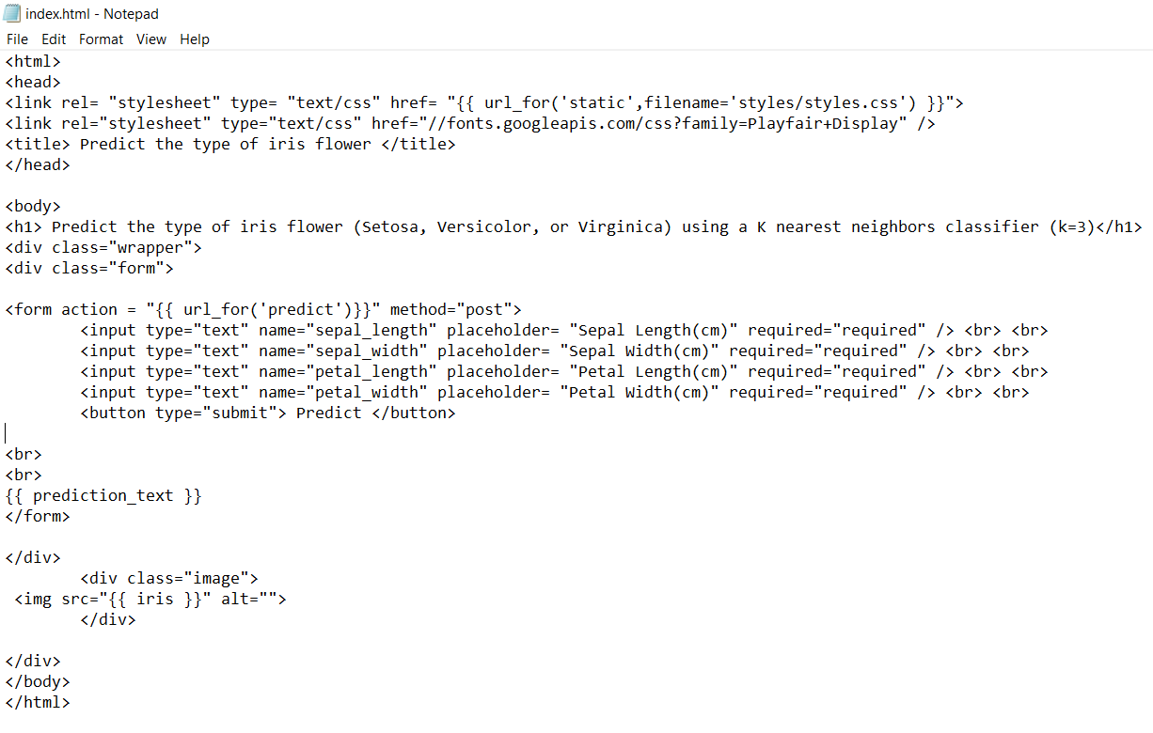

Create html and css files:

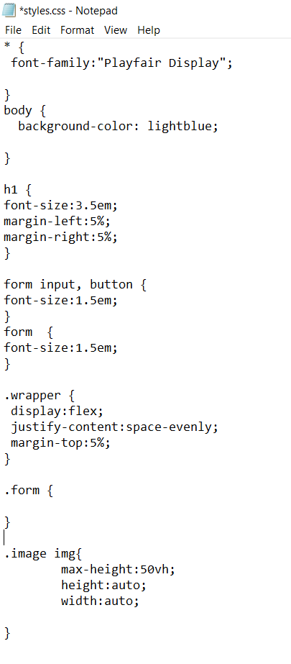

Use flask so the web app can be deployed locally. Images are included in the app:

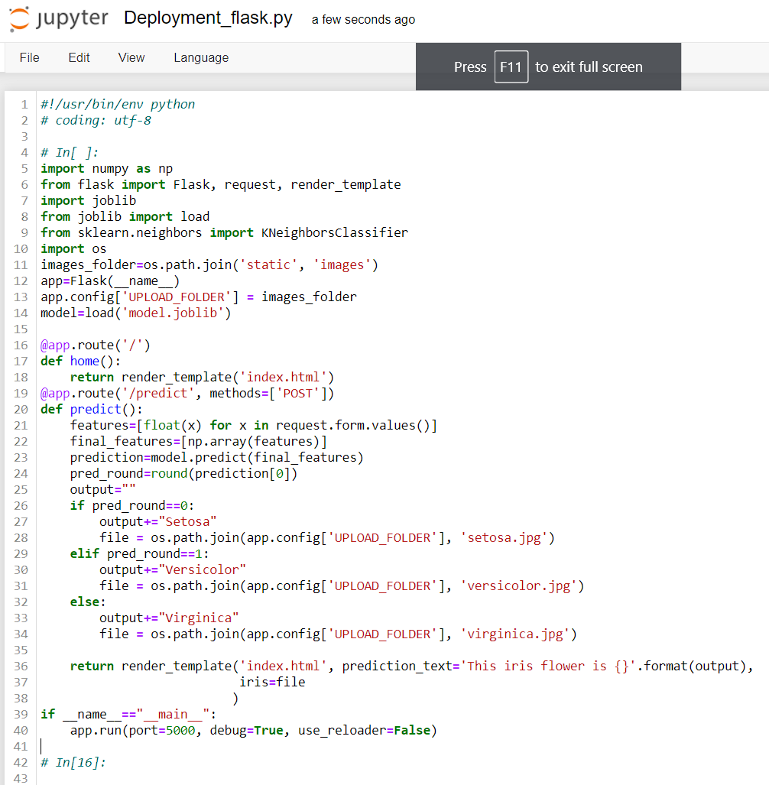

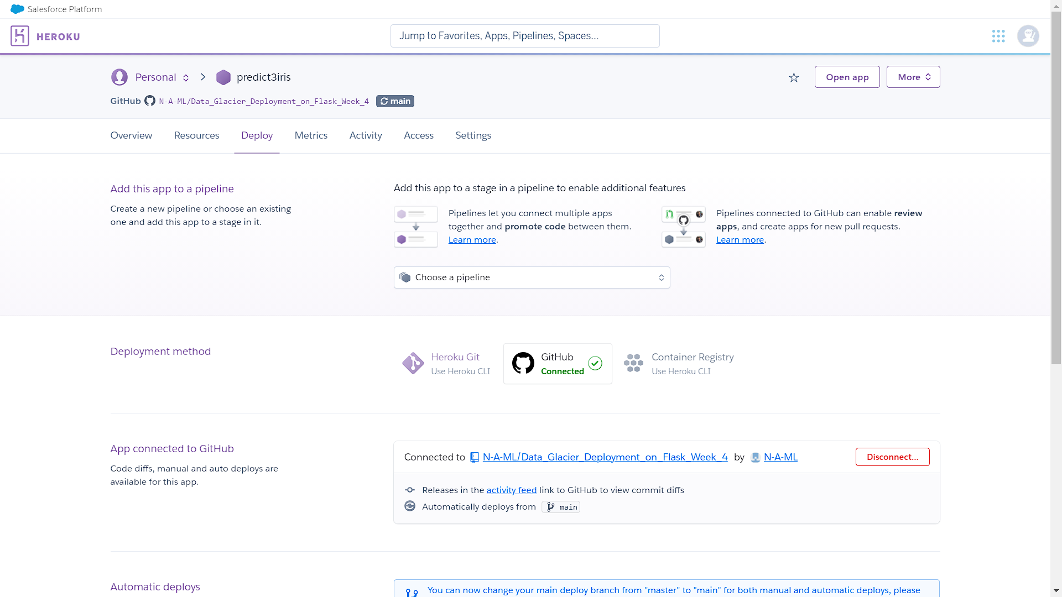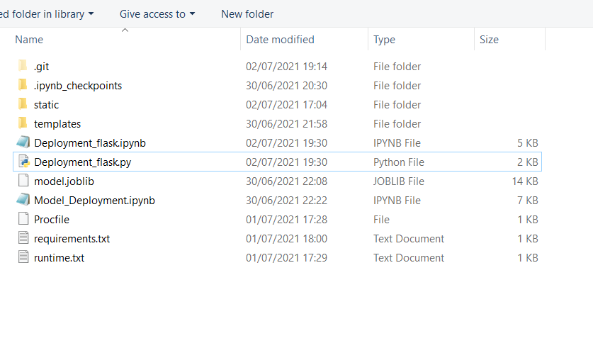

Generate Procfile (and enter the name of the app), requirements.txt and runtime.txt, and structure the files and folders correctly:

Ensure that relevant packages are installed in the working directory (e.g., gunicorn) and upload the files and folders to GitHub. Link the GitHub repository to Heroku and troubleshoot any problems by checking the logs.

Finally, launch the app on the cloud with Heroku and test it:

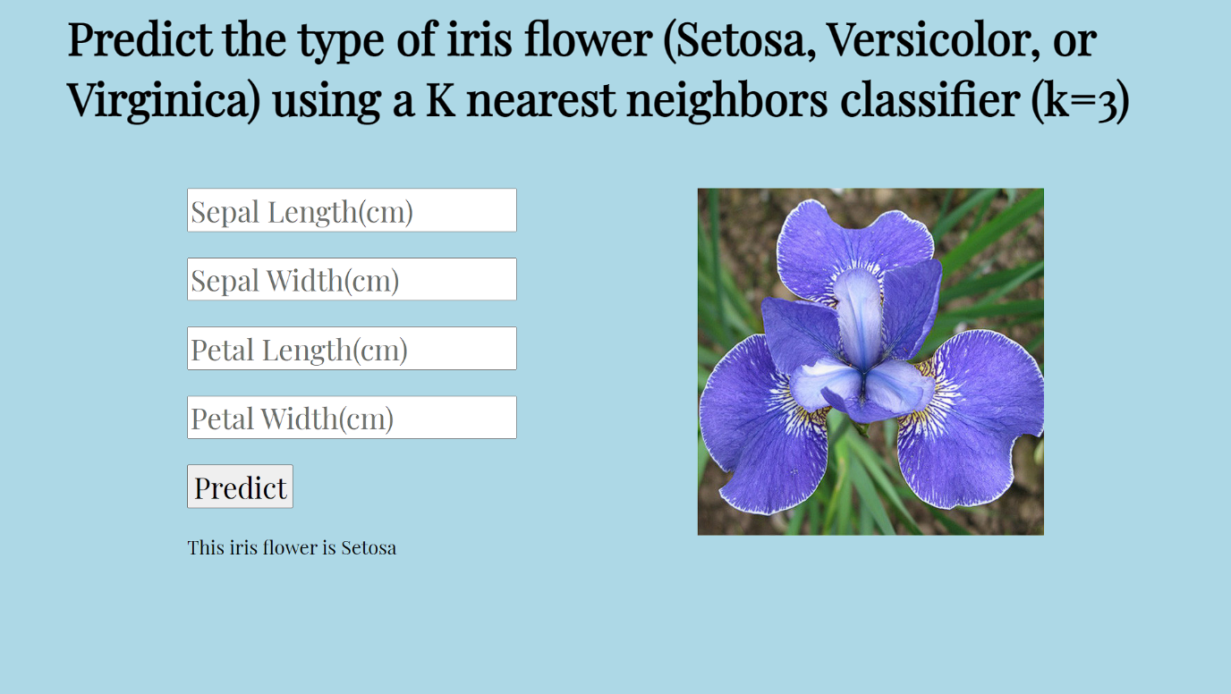

The app is working as intended.

A simple python file was created. This will help us test whether the predictions are working as expected:

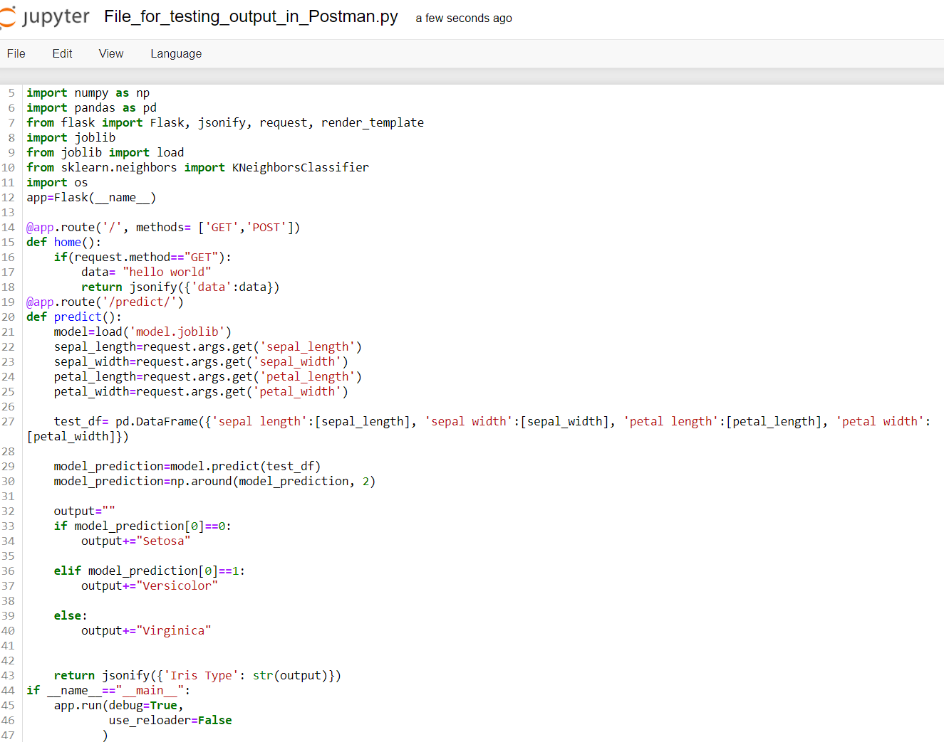

I used Postman to check whether each page and each type of prediction was working correctly:

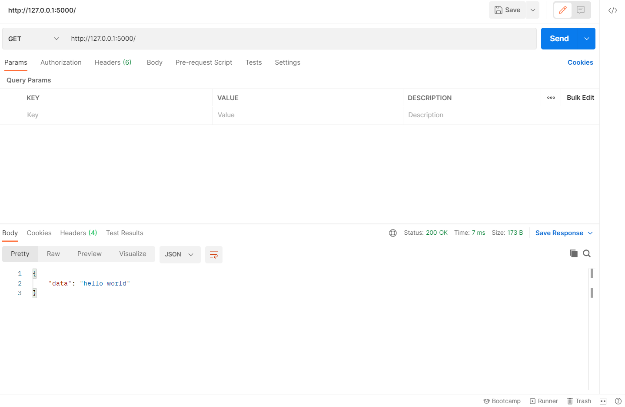Homepage:

Predictions for the 3 different types of iris: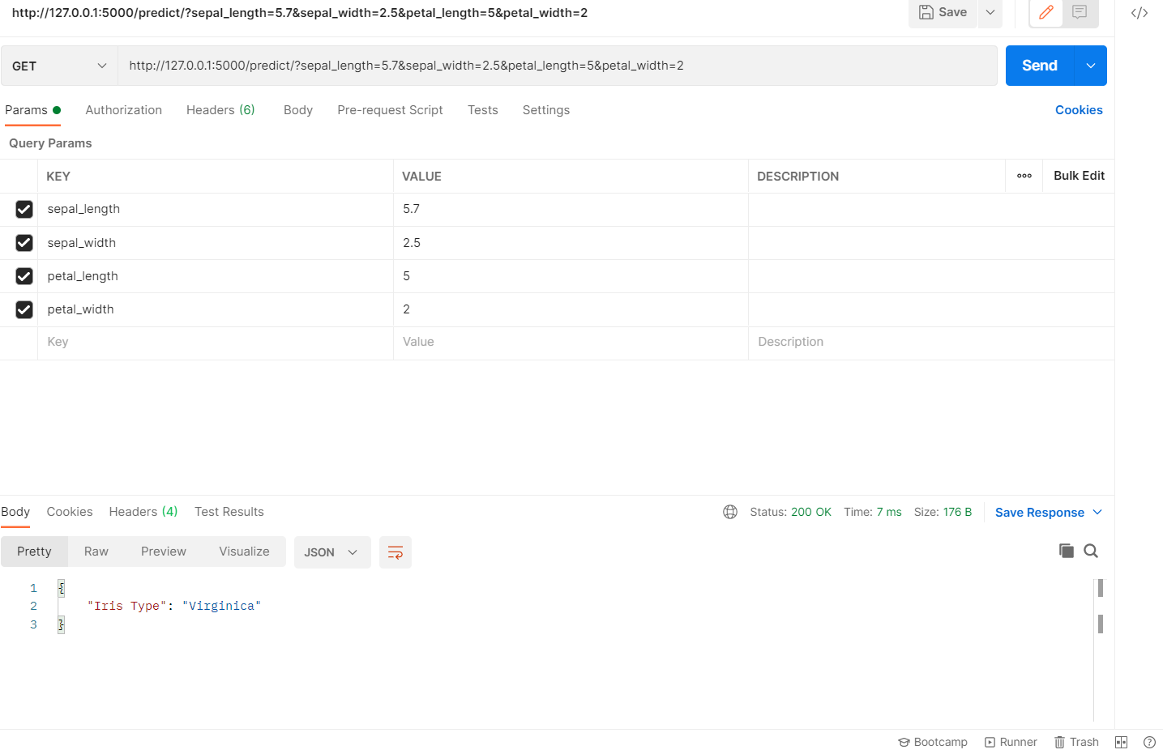

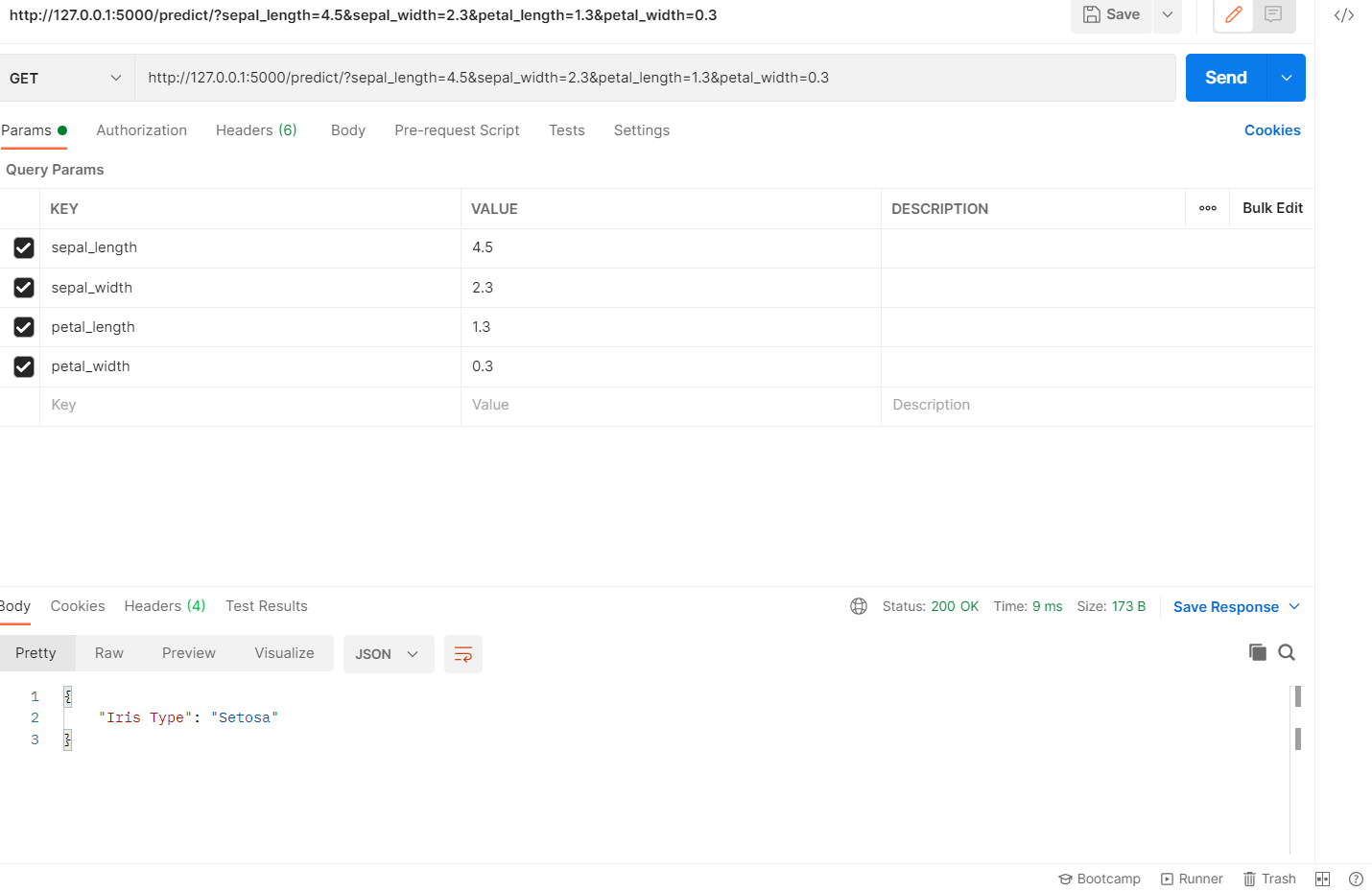

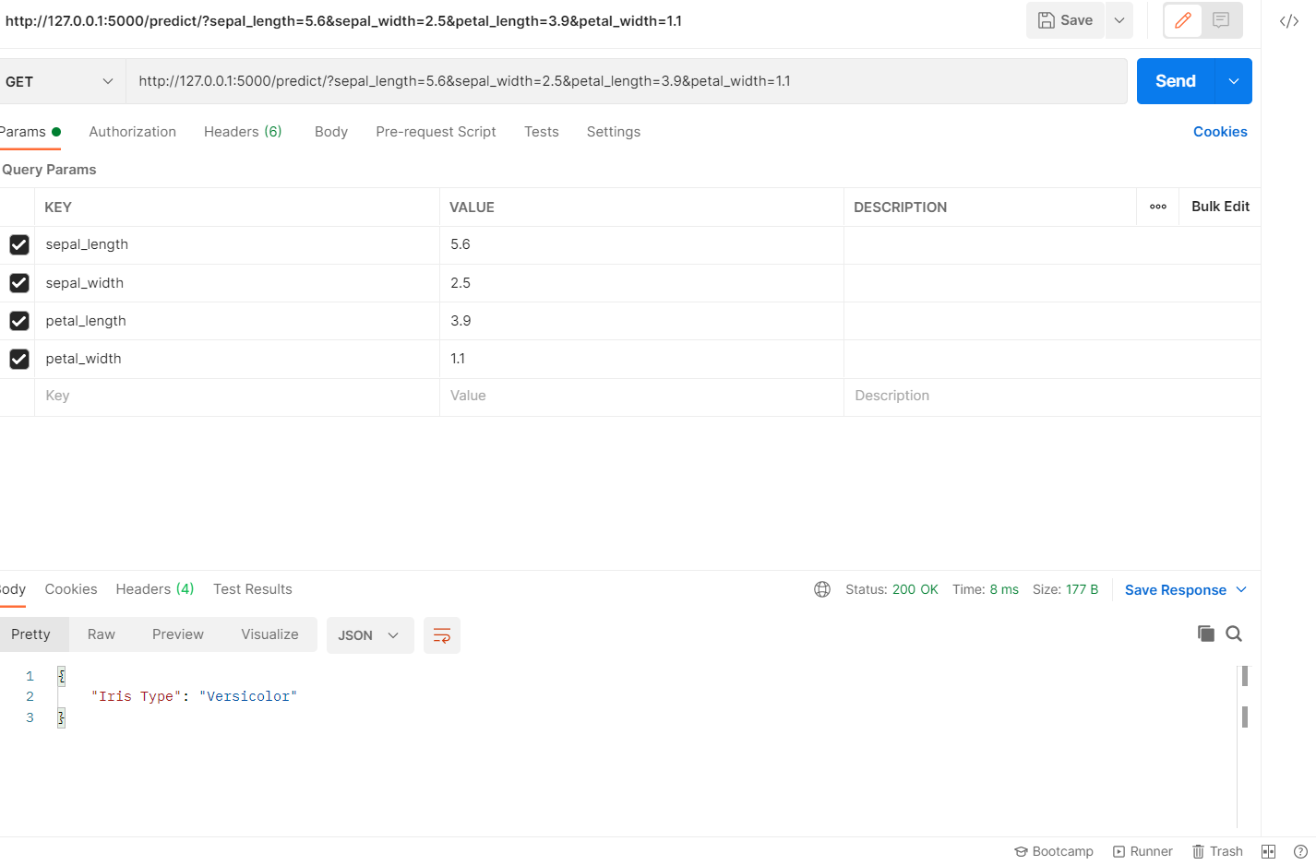The iris types were predicted correctly and everything is working as intended.