Name: Nathan Adam

Batch code: LISUM01

Submission date:3rd July 2021

Submitted to: Week 4 Deployment on Flask (on canvas)

<https://github.com/N-A-ML/Data_Glacier_Deployment_on_Flask_Week_4> (on GitHub)

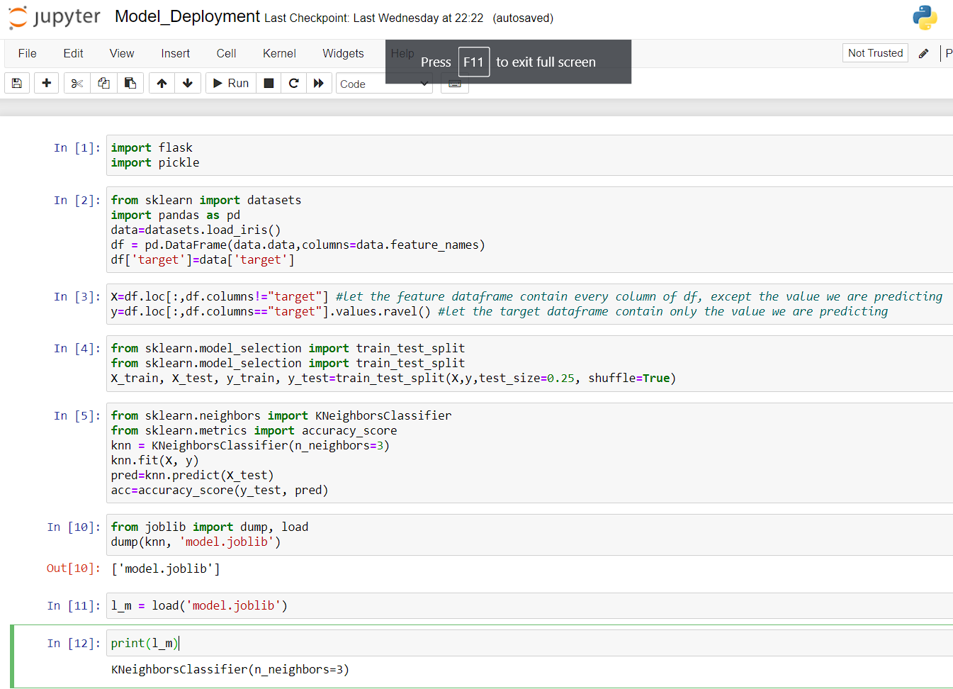  
Select data (iris dataset), create and save a simple model (knn classifier):

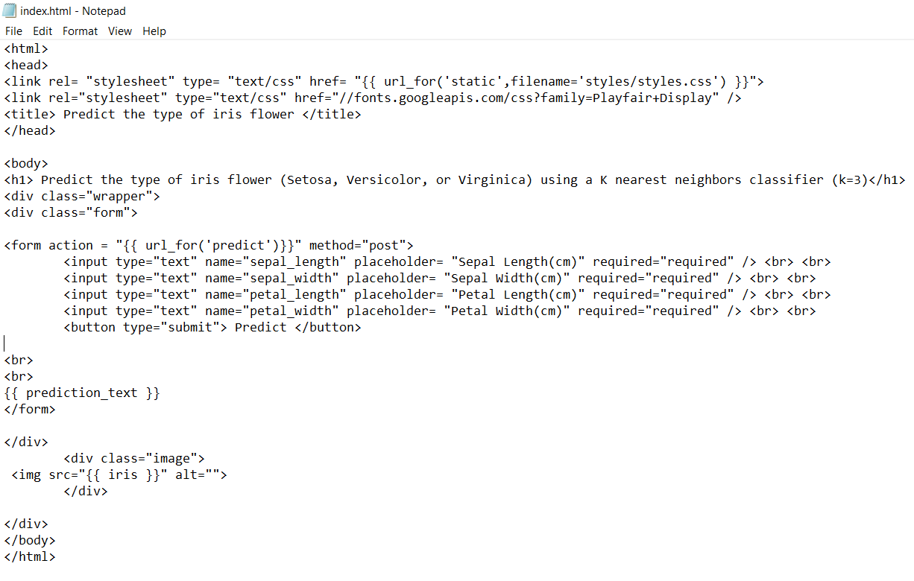

Create html and css files:

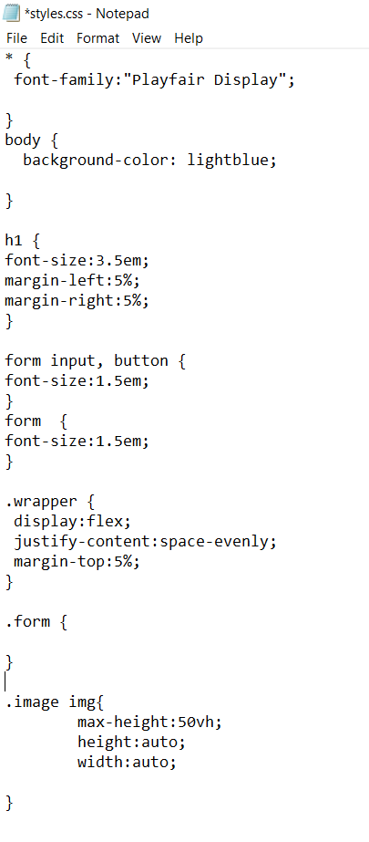

Use flask so the web app can be deployed locally. Images are included in the app:

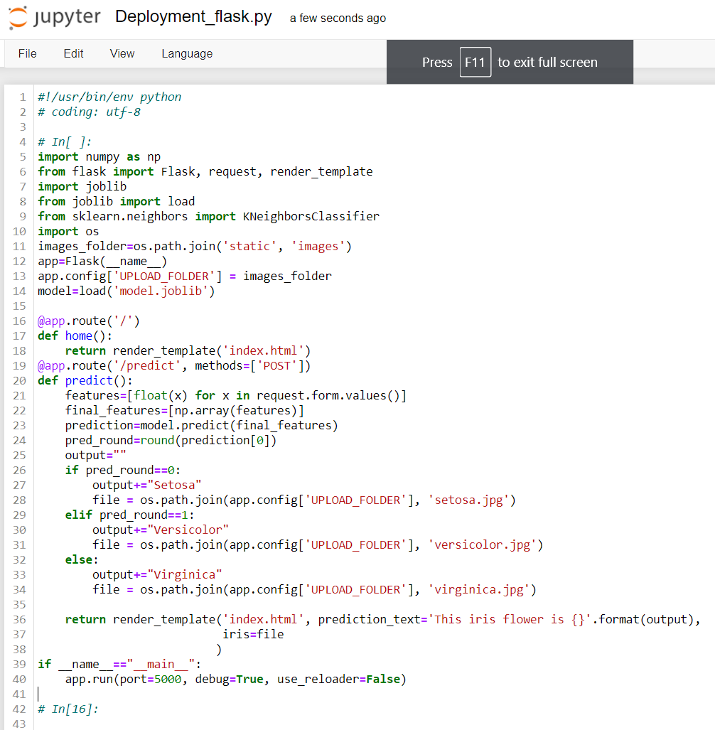

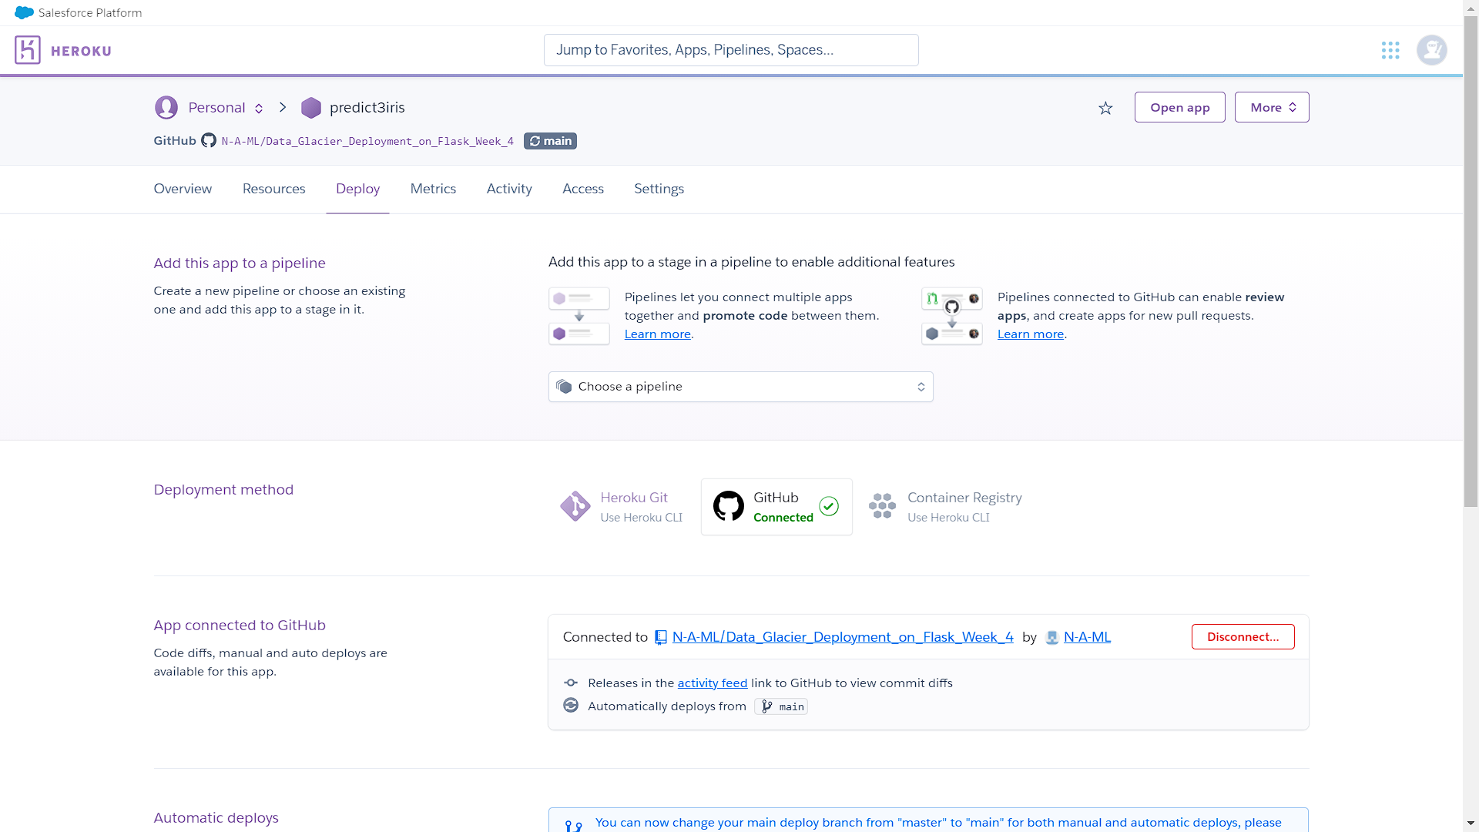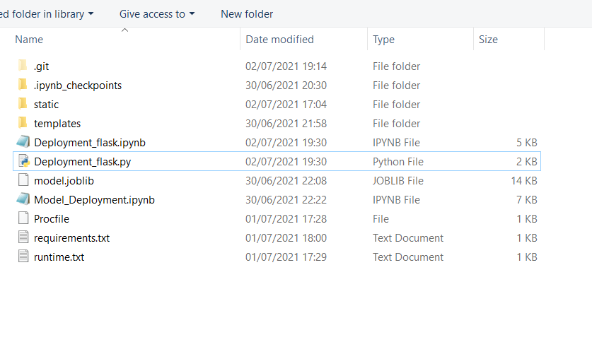

Generate Procfile (and enter the name of the app), requirements.txt and runtime.txt, and structure the files and folders correctly:

Ensure that relevant packages are installed in the working directory (e.g., gunicorn) and upload the files and folders to GitHub. Link the GitHub repository to Heroku and troubleshoot any problems by checking the logs.

Finally, launch the app and test it:

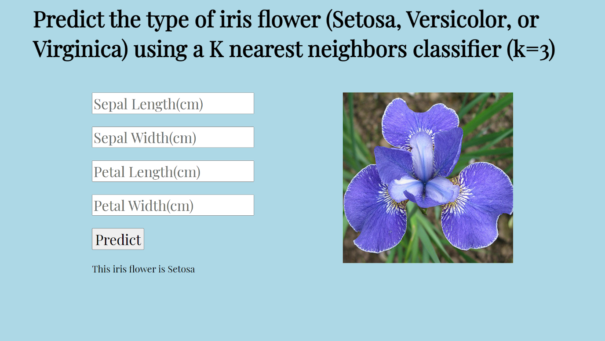

The app is working as intended.