Contents

1) Introduction 2

Purpose 2

2) Possible Errors while working with Airflow 2

3) How do I check Logs 2

4) How do I restart the webserver 4

5) How do I restart the failed task 4

6) Scheduling Details 6

a. How do I manually run the job 6

b. How do I manually schedule a job 6

7) SLA 7

# Introduction

This document describes all the possible errors that user may encounter while monitoring Apache Airflow. It also depicts how to view logs.

Purpose: Intent of this document is to depict actions to be taken in case any issues occur during monitoring the Airflow

# Possible Errors while working with Airflow

* + - UI is not opening
    - Task didn’t run at scheduled time
    - Job fails due to below reasons
      * cluster is not created
      * cluster creation takes lot of time (Timeout)
    - Failed to import into DagBag

# How do I check Logs

Go to the dag, and dag run of the run you want to change

Go to Graph View

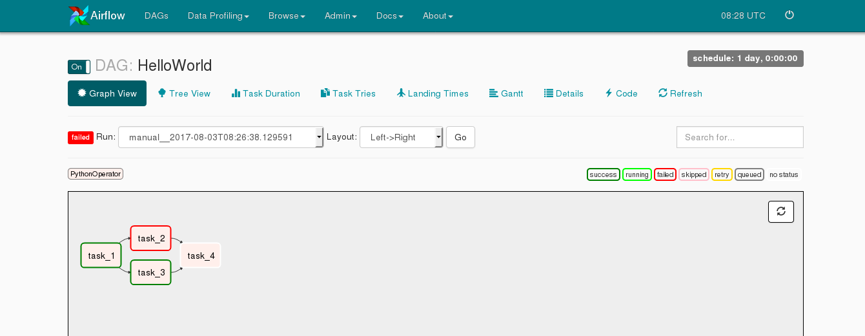

Click on failed task

It will show following window.

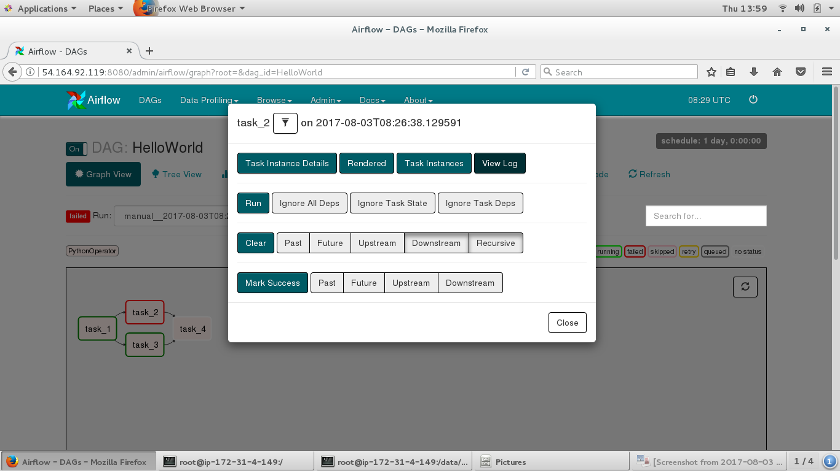

Click on View Log.

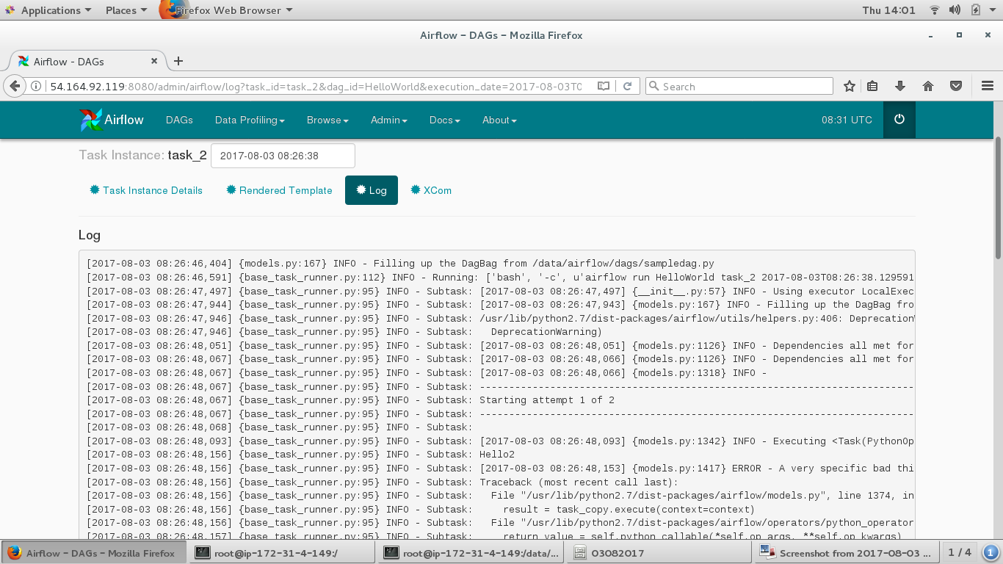

We can check logs via Linux commands.

Go to log directory as below

$ /logs/airflow/<dag_name>/task_2/log_file

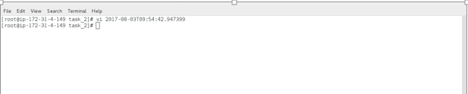

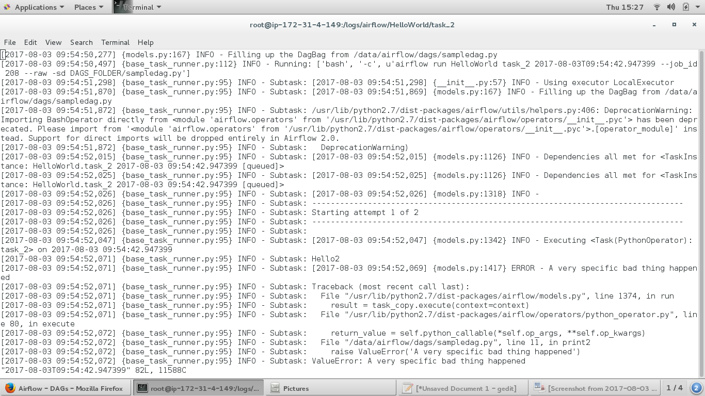

# How do I restart the webserver

Sometimes Airflow UI itself does not open. In that case we need to restart the webserver with the below command at terminal

> Airflow webserver

# How do I restart the failed task

Go to the dag, and dag run of the run you want to change

Go to Graph View





Click on Clear and then run the task.

This will let the failed task run again, and if it succeeds, the dependent task should run. This works because when you clear a task's status, the scheduler will treat it as if it hadn't run before for this dag run.

# Scheduling Details

# How do I manually run the job

Click on the arrow button in “Links” for the task to be run.

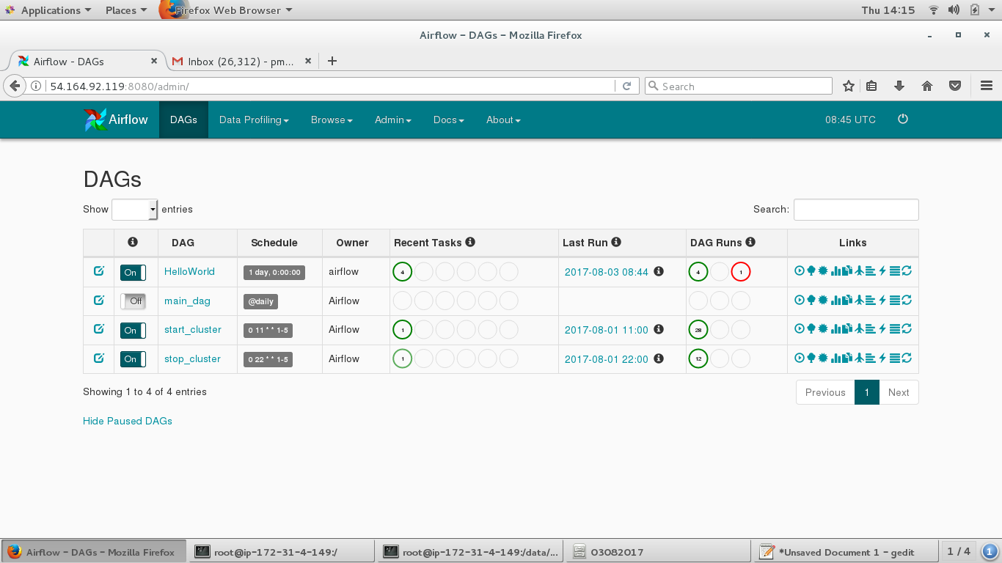

# How do I manually schedule a job

Click on Dag Runs options

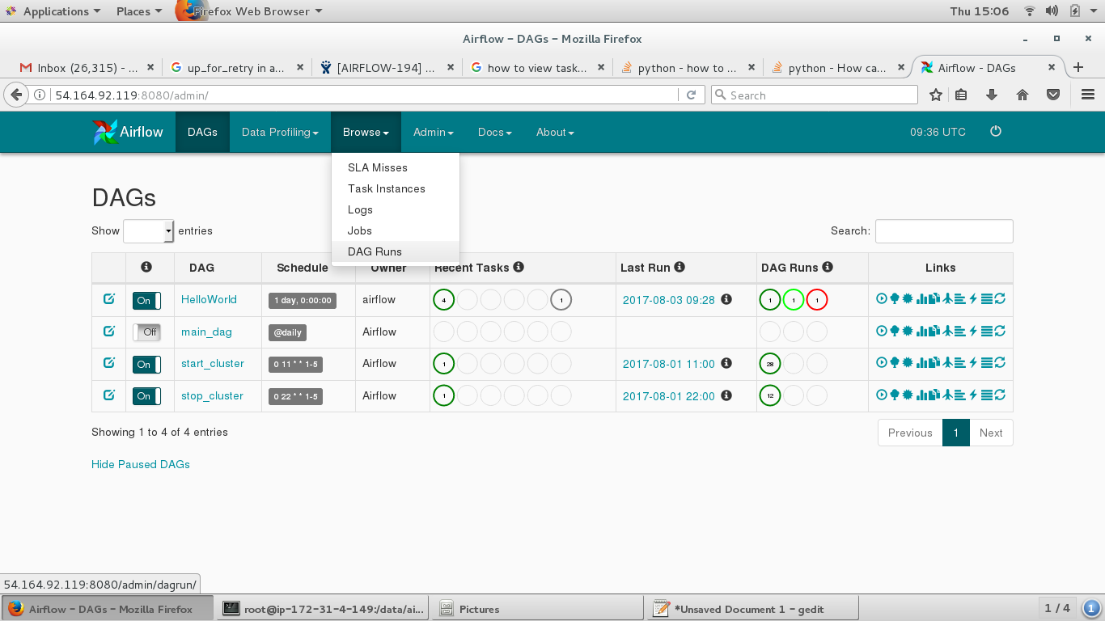

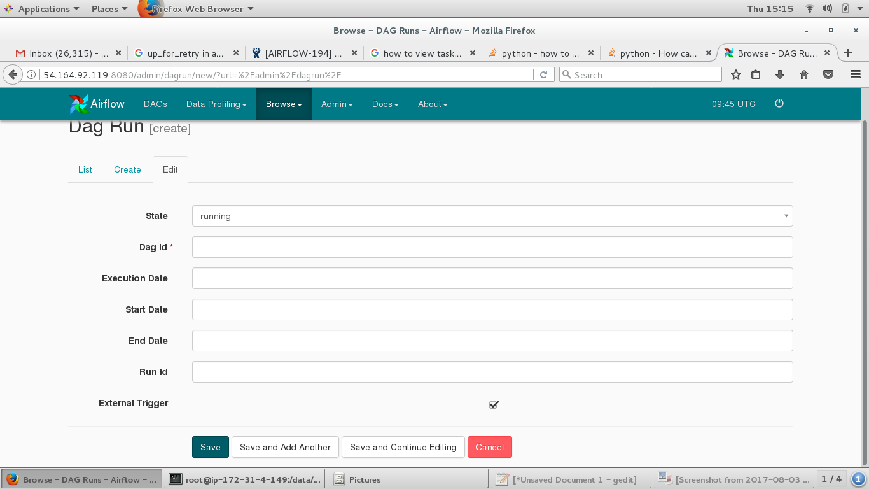

Enter required details like Dag Id, Execution date & Start date and Click on Save button above.

# SLA

SLA is the time by which job is expected to be succeeded. It can be set in the DAG itself. The scheduler pays an attention towards the jobs with SLA set and sends an email for SLA misses. SLA misses are also recorded into the database for the future reference.