**EXPORT ELASTICSEARCH DATA TO CSV FILE**

**Prerequisites:-**

1. Elasticsearch
2. Kibana
3. Logstash

**Step1**- Run elasticsearch by using command

*“/bin/elasticsearch”*

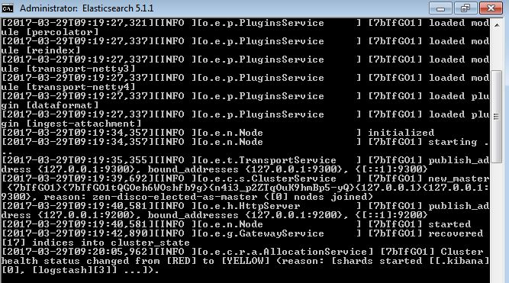

**Step2**- Run kibana by using commamd

*“ /bin/kibana”*

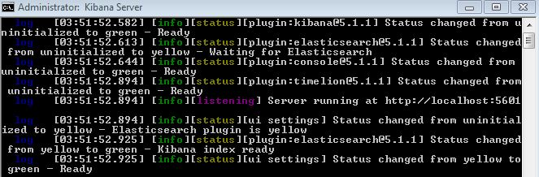

**Step3**- Install following logstash pugins

1)**Elasticsearch input** **plugin**(we are taking input from elasticsearch)

*“/bin>logstash-plugin install –version 4.0.0 logstash-input-elasticsearch”*

**

2) **CSV output plugin**(we need to export elasticsearch index to csv file)

*“/bin>logstash-plugin install --version 3.0.3 logstash-output-csv”*



**Step4**- Create config file under **bin** folder of logstash

Eg. Following is output-csv.conf file

input {

elasticsearch {

hosts => ["localhost:9200"] index => "mongodb2"

query => '{

"query": {“ write your query here”}

}'

}

}

output{

stdout { }

csv {

fields => ["@timestamp","content","component","duration"]

path => "D:/Elastic/mongodb1.csv"

csv_options => {"write_headers"=>true

"headers"=>["timestamp","content","component","duration"]

"col_sep"=>";"}

}

}

**Step5**- Run the output-csv.conf file by using command

/bin>logstash --log.level debug -f output-csv.conf

**Output:-**

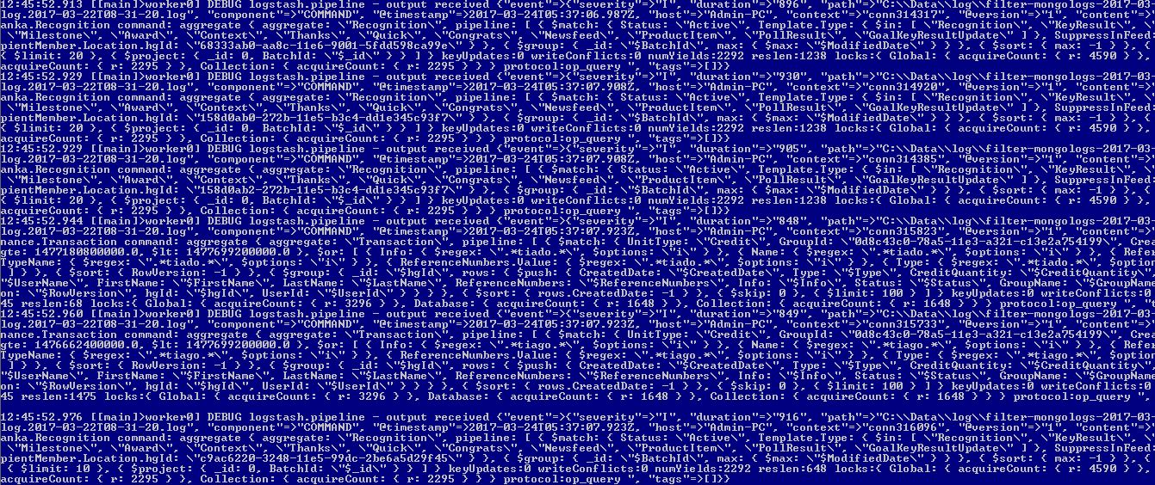

It gives the output in Excel file as follows

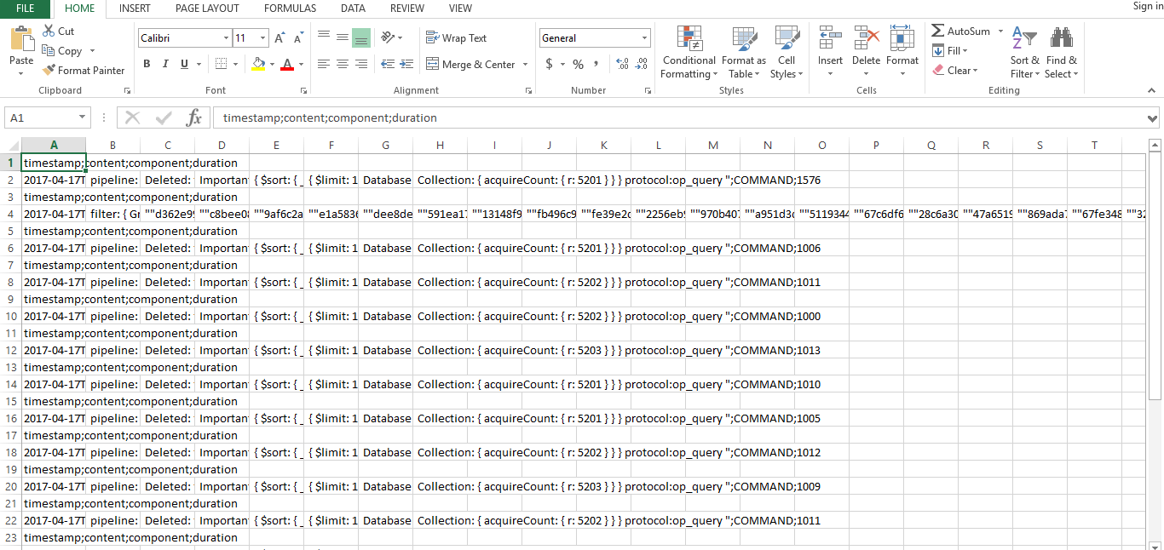

By doing this you can export elasticsearch index in csv file.