
Elasticsearch
Logstash
Kibana
ELK with MongoDB
http://BigDataGurukul.com

Table of Contents

1 Introduction 3
1.1 Purpose 3
1.2 Scope 3
1.2.1 In Scope 3
2 Perquisites 3
3 Installation & Working 3
4 Flow Diagram 12

Introduction
This document describes the process that is to be followed for the loading mongodb logs into elasticsearch using logstash and visualize those logs using kibana. Elasticsearch is acts as a NoSql database as well as search engine.Logstash is used for monitoring the various kinds of logs and Kibana is a visualization tool provided by elasticsearch. Elasticsearch is mostly used for “Full Text Search.”

Purpose
The Purpose of this document for ELK-MONGO is to describe the various phases, activities performed by the ELK Stack. Using logstash we can load a different kinds of logs into elasticsearch and also able export logs from elasticsearch to other source using logstash plugins. Using kibana we can visualize those logs in different graphical format.

Scope

In Scope

- ELK
- Mongodb

Perquisites
1) Elasticsearch
2) Kibana
3) Logstash
4) Mongodb
5) Set JAVA_HOME

Installation & Working
Step1- Download latest version of
1) Easticsearch
2) Kibana
3) Logstash

From elasticsearch official site “www.elasticsearch.org”

Step2- Run elasticsearch (bin/elasticsearch)

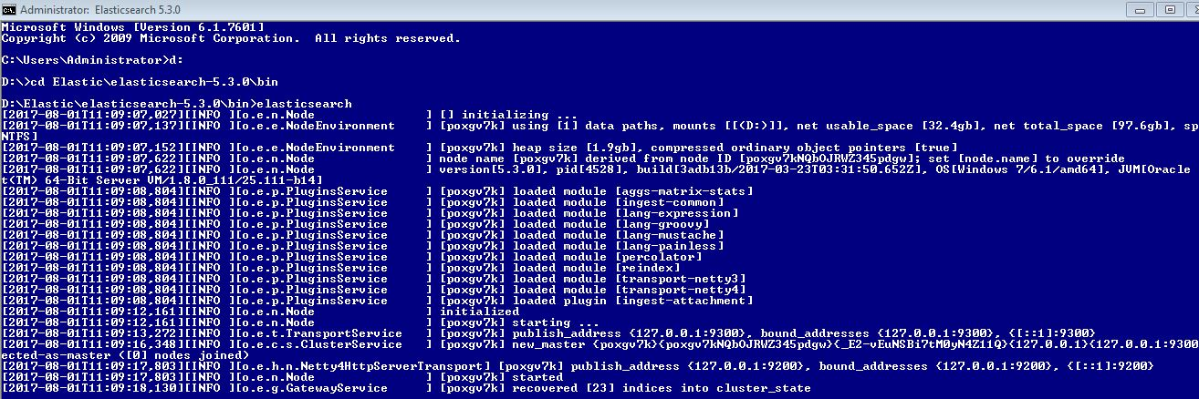
Step3-Create a configuration file in “/bin” folder of logstash.
And save it as “logstash.conf”

Content of “logstash.conf” file as follow-

input {
file {
path => "C:\Data\log\filter-mongologs-2017-03-18\mongodb-current.log"
start_position => "beginning"
}
}
filter {
grok {
match => {message => "%{TIMESTAMP_ISO8601:timestamp} %{MONGO3_SEVERITY:severity} %{MONGO3_COMPONENT:component}%{SPACE}(?:\[%{DATA:context}\])? %{GREEDYDATA:content}.*%{NUMBER:duration}+ms"}
}
mutate {
remove_field => ["message" ,"timestamp" , "tags" , "@version" ]
}
if [component] != "COMMAND" {
drop { } }
}
output {
elasticsearch{ hosts => ["localhost:9200"] index => "mongolog7" }
stdout{codec => "rubydebug"}
}
(Add the path of mongodb log file in input of logstash configuration file.)

Step4- Install Mongodb input plugin by using command :-

>> logstash-plugin install logstash-input-mongodb

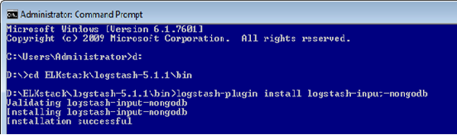

Step5- Install elasticsearch output plugin by using command :-

>>logstash-plugin install logstash-output-elasticsearch

Step6- In command prompt run the following command under /bin directory of logstash

>>logstash –f logstash.conf

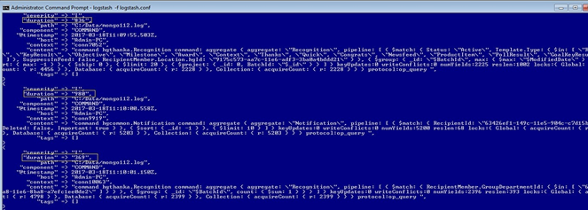

It will create an index in elasticsearch.

Step7- Run KIBANA (bin/kibana) (in cmd)

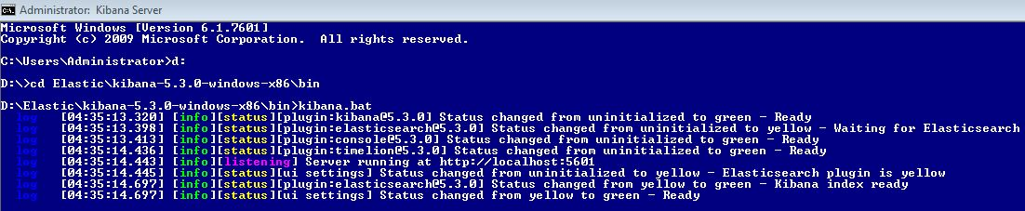

It is running on port (localhost:5601)

In console window(Dev Tools) check your index is created or not.

Run – GET (index name)/_search

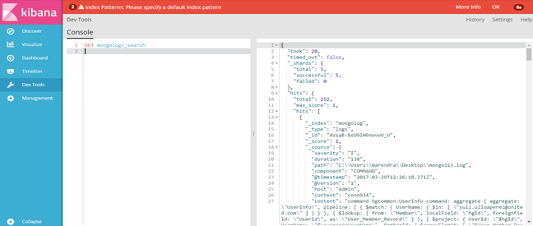

Step8- Go to the management window in kibana. It will ask to configure index pattern. Configure the index by entering index name (same index name in conf file).

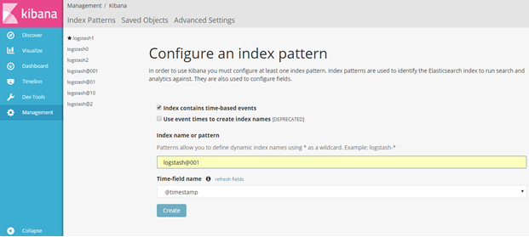

Click on Create.

It will show the following result.

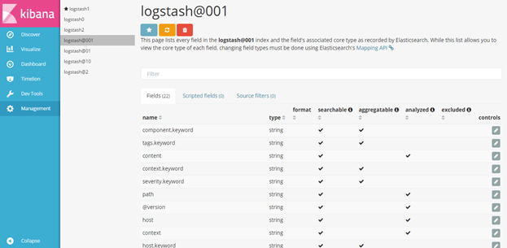

Step9- Go to the “Discover” window in Kibana

Click on New and add index “Index_name”(refresh the index as per time given in the corner of window if it is giving error while discovering the log)

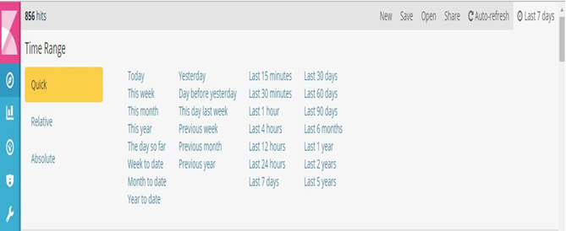

It will give following output

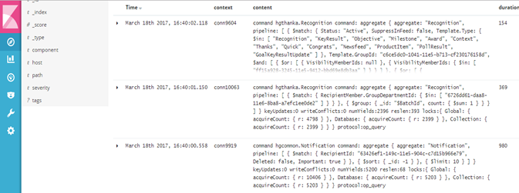

Step10- Now Visualize your index.

Go to visualize window and select the parameters.

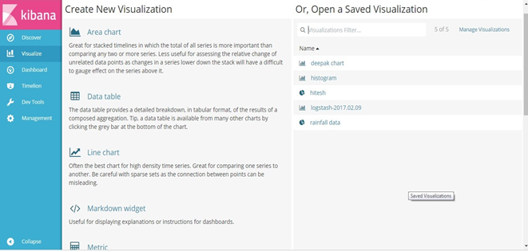

After selecting parameter select the add metrics to visualize your data.

Add the aggregation which you want to display in your visualization.

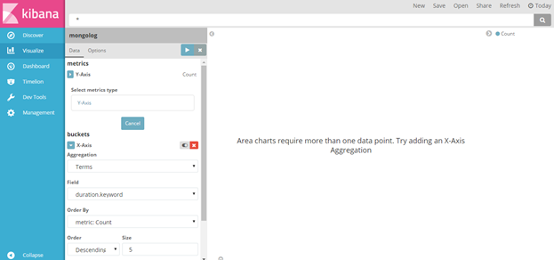

It will show the following output

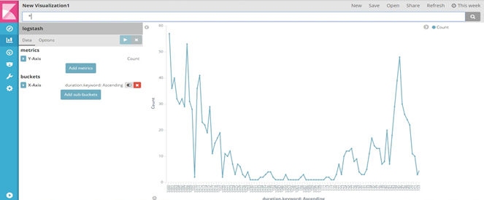
After that save this visualization. Click on “save” button on menu bar.

Step11- Create Dashboard in Kibana.

Go to dashboard window.

It will ask “Ready to get started?”

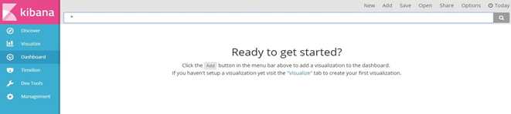

Then click on “Add” on upper menu bar.

Add your saved visualization on Dashboard.

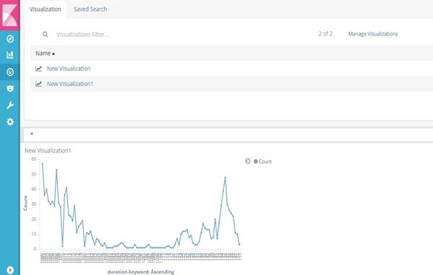
If you want to expand your dashboard to get more information then click on small arrow at the below corner of the visualization.

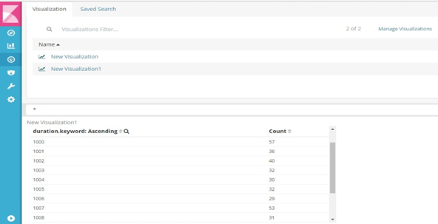

By doing this we can load the mongodb logs into elasticsearch using logstash and visualize those logs using Kibana.

Flow Diagram

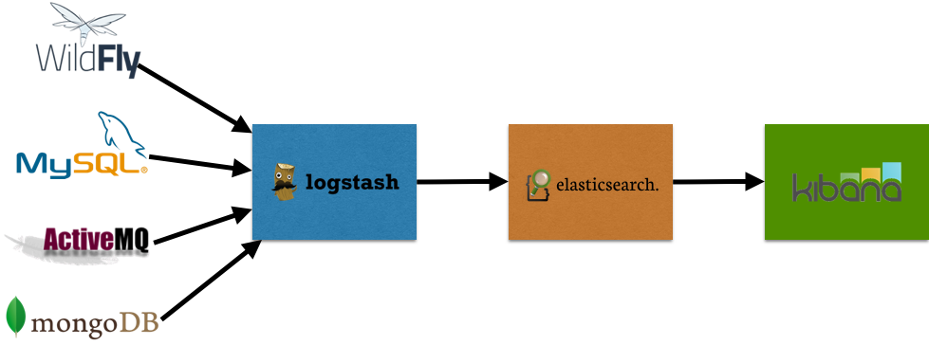

Thank You…

