Course ​​​: Computer Organization – ENCM 369

Lab # ​​​: Lab 1

Student Name ​: Nimna Wijedasa

Lab Section ​​: B04

Ex B

Table

Ex G

Source code

// lab1exG.c

// ENCM 369 Winter 2023 Lab 1 Exercise G

#include <stdio.h>

#include <stdlib.h>

#include <math.h>

#define MAX_ABS_F (5.0e-9)

#define POLY_DEGREE 4

double polyval(const double *a, int n, double x);

/* Return a[0] + a[1] * x + ... + a[n] * pow(x, n). */

int main(void)

{

double f[] = {1.47, 0.73, -2.97, -1.15, 1.00};

double dfdx[POLY_DEGREE];

double guess;

int max_updates;

int update_count;

int n_scanned;

int i;

double current_x, current_f, current_dfdx;

printf("This program demonstrates use of Newton's Method to find\n"

"approximate roots of the polynomial\nf(x) = ");

printf("%.2f", f[0]);

i = 1;

loop_top_1:

if (!(i <= POLY_DEGREE)) goto past_end_0;

if (f[i] >= 0) goto else_code_1;

printf(" - %.2f*pow(x,%d)", -f[i], i);

goto end_if_1;

else_code_1:

printf(" + %.2f*pow(x,%d)", f[i], i);

end_if_1:

i++;

goto loop_top_1;

past_end_0:

printf("\nPlease enter a guess at a root, and a maximum number of\n"

"updates to do, separated by a space.\n");

n_scanned = scanf("%lf%d", &guess, &max_updates);

if (!(n_scanned != 2)) goto end_1;

printf("Sorry, I couldn't understand the input.\n");

exit(1);

end_1:

;

if (!(max_updates < 1)) goto end_2;

printf("Sorry, I must be allowed do at least one update.\n");

exit(1);

end_2:

;

printf("Running with initial guess %f.\n", guess);

for (i = POLY_DEGREE - 1; i >= 0; i--)

dfdx[i] = (i + 1) * f[i + 1]; // Calculus!

current_x = guess;

update_count = 0;

int k = 1;

loop_top_in:

if (k == 0) goto past_end_1;

current_f = polyval(f, POLY_DEGREE, current_x);

printf("%d update(s) done; x is %.15f; f(x) is %.15e\n",

update_count, current_x, current_f);

if (fabs(current_f) < MAX_ABS_F)

goto past_end_1;

if (update_count == max_updates)

goto past_end_1;

current_dfdx = polyval(dfdx, POLY_DEGREE - 1, current_x);

current_x -= current_f / current_dfdx;

update_count++;

goto loop_top_in;

past_end_1:

if (fabs(current_f) >= MAX_ABS_F) goto else_code_2;

printf("Stopped with approximate solution of %.10f.\n",

current_x);

goto end_if_5;

else_code_2:

printf("%d updates performed, |f(x)| still >= %g.\n",

update_count, MAX_ABS_F);

end_if_5:

return 0;

}

double polyval(const double *a, int n, double x)

{

double result = a[n];

int i;

i = n - 1;

loop_top_2:

if (!(i >= 0)) goto past_end_2;

result *= x;

result += a[i];

i--;

goto loop_top_2;

past_end_2:

return result;

}

Test runs

Left is goto C code that was converted from the C code which is on the right





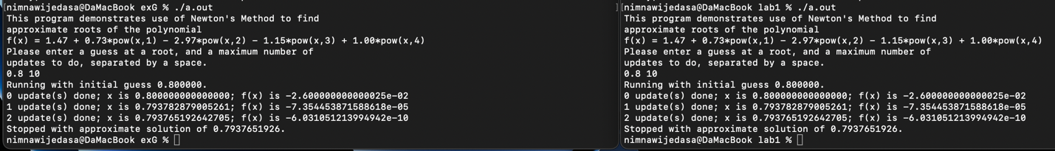

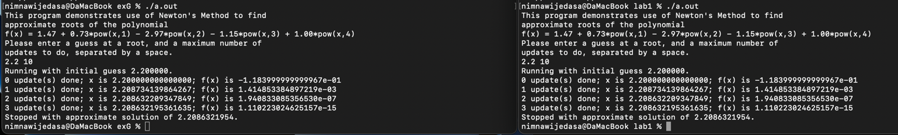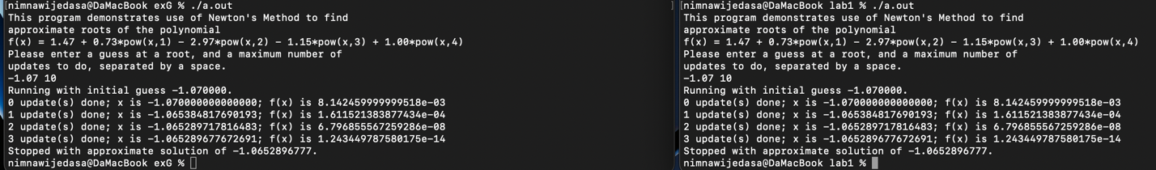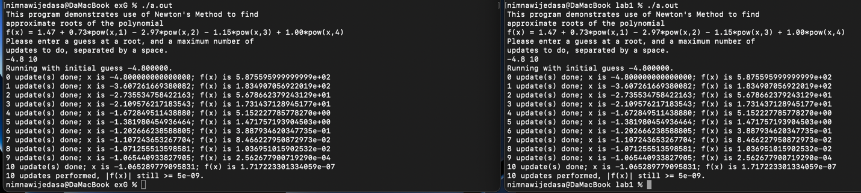

Ex H

// lab1exH.c

// ENCM 369 Winter 2023 Lab 1 Exercise H

#include <stdio.h>

void print_array(const char *str, const int *a, int n);

// Prints the string given by str on stdout, then

// prints a[0], a[1], ..., a[n - 1] on stdout on a single line.

void sort_array(int *x, int n);

// Sorts x[0], x[1], ..., x[n - 1] from smallest to largest.

int main(void)

{

int test_array[] = { 4000, 5000, 7000, 1000, 3000, 4000, 2000, 6000 };

print_array("before sorting ...", test_array, 8);

sort_array(test_array, 8);

print_array("after sorting ...", test_array, 8);

return 0;

}

void print_array(const char *str, const int *a, int n)

{

int i = 0;

puts(str);

start:

if (!(i < n)) goto end;

printf(" %d", a[i]);

printf("\n");

i++;

goto start;

end:

;

};

void sort_array(int *x, int n)

{

// This is an implementation of an algorithm called insertion sort.

int outer = 1, inner, vti;

outer_loop:

if (!(outer < n)) goto quit_outer_loop;

vti = x[outer];

inner = outer;

inner_loop:

if (!(inner > 0)) goto quit_inner_loop;

if (!(vti < x[inner - 1])) goto quit_inner_loop;

x[inner] = x[inner - 1];

inner--;

goto inner_loop;

quit_inner_loop:

x[inner] = vti;

outer++;

goto outer_loop;

quit_outer_loop:;

};

