Course : Programming Fundamental – ENSF 337

Lab # : Lab 2

Instructor : M. Moussavi

Student Names : Nimna Wijedasa, Mehvish Shakeel

UCID : 30146042 , 30161318

Lab Section : B02

Date submitted : Sept 29, 2022

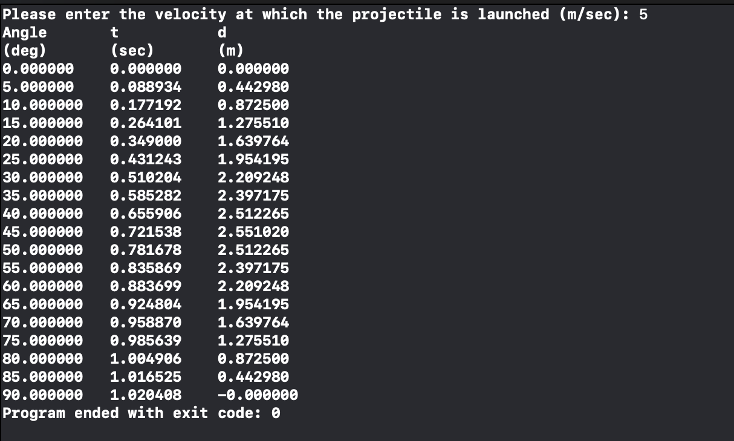

Exercise B

Exercise C

Exercise D (p ii)

Exercise F (p ii)

|  |  |  |  |  |
| --- | --- | --- | --- | --- |
| Run # | Your inputs | What is the value of n | What is the value of i | What is the value d |
| 1 | 12 0.56 | 2 | 12 | .56 |
| 2 | 5.12 9.56 | 2 | 5 | .12 |
| 3 | 12 ab | 1. | 12 | 1234.5 |
| 4 | ab 12 | 0 | 33 | 1234.5 |
| 5 | 5ab 9.56 | 1 | 5 | 1234.5 |
| 6 | 13 67 | 2 | 13 | 67.0 |