Course  ​​​ : Programming Fundamental – ENSF 337

Lab #  ​​​ : Lab 8

Instructor ​​ : M. Moussavi

Student Name  ​: Nimna Wijedasa

Lab Section  ​​: B02

Date submitted ​ : Nov 25, 2022

Exercise A

Point 1

Point 2

Point 3

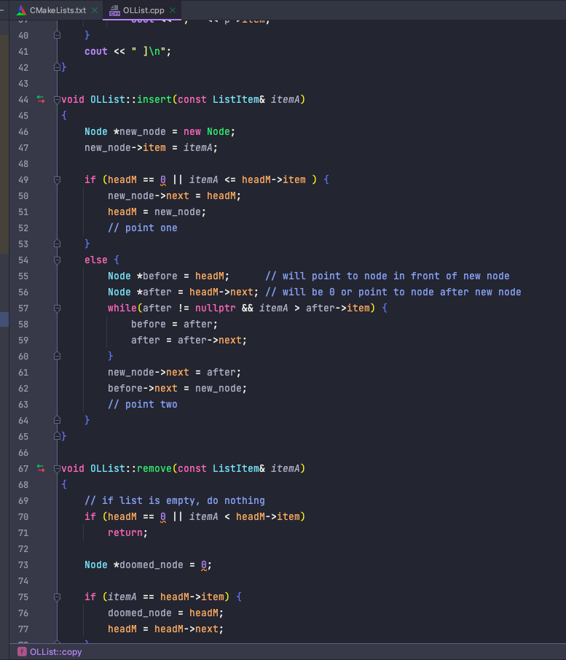

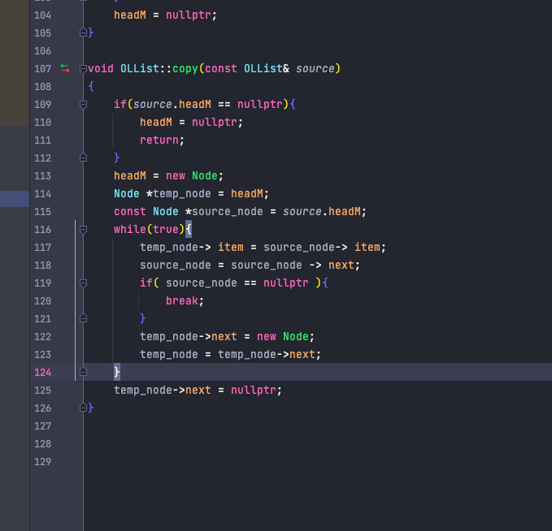

Exercise C

