**Abstract**

Abundance indices derived from fisheries dependent data (catch-per-unit-effort or CPUE) have a known potential for bias. These biases can arise from gear effects (saturation of the gear), systemic and structural changes to the fishing fleet over time (effort creep), and/or from non-random sampling relative to the spatiotemporal distribution of the underlying fish population. However, given the cost and lack of availability of fisheries independent surveys, these fisheries dependent CPUE remain a common and informative input to stock assessments. Given their common use, increasingly sophisticated standardization methods have been developed in order to standardize CPUE to remove the effects of gear, vessel, and spatial sampling. Recent research efforts have focused on the development of spatiotemporal models which simultaneously standardize the CPUE and interpolate abundance into unfished areas when estimating the index. These spatiotemporal models can be aided by environmental covariates (e.g. sst) and indices (e.g. ENSO) to interpolate into unfished areas. These spatiotemporal models have been demonstrated in simulation studies to perform better than conventional delta-generalized linear models. However, they have not been evaluated in situations where the spatial sampling coverage changes over time (e.g. fisheries expansion or spatial closures). This paper develops a simulation framework to evaluate 1) how the nature of spatial fisheries dependent sampling patterns may bias estimated abundance indices, 2) how temporal shifts in spatial sampling impact our ability to estimate temporal changes in catchability, and 3) how including an environmental covariate and/or a spatially varying coefficient in the formulation of the spatiotemporal model can improve the estimation of abundance indices given these shifts in spatial sampling. These models are then applied to a case study example where the spatial sampling pattern changed dramatically over time (contraction of the Japanese pole-and-line fishery for skipjack tuna in the western and central Pacific). Results indicate …

**Overview**

This paper seeks to evaluate the following objectives in a simulation framework:

1. How the nature of spatial fisheries dependent sampling patterns may bias estimated abundance indices
2. How temporal shifts in spatial sampling impact our ability to estimate temporal changes in catchability
3. How including an environmental covariate and/or a spatially varying coefficient in the formulation of the VAST model can affect the estimation of abundance indices given these shifts in spatial sampling.

These methods are then be applied to a real world application where spatial sampling has changed over time: the Japanese pole-and-line fishery for skipjack tuna in the western and central Pacific Ocean (WCPO).

**Methods – Simulating Spatial Sampling Patterns**

The simulation uses as a base the SEAPODYM biomass field for adult skipjack tuna from 1979-2008 (1°x1° spatial resolution & quarterly temporal resolution). The spatial frame of the simulation covers the spatial extent of the Western and Central Pacific Fisheries Commission (WCPFC) assessment boundaries from 102° E to 210° E longitude and from -20° S to 50° N latitude. The output from the SEAPODYM model is a smooth biomass field with positive non-zero abundance predicted for all 1x1 degree spatial cells (not including land). Fish distributions are known to be spatially patchy so areas of zero skipjack abundance were introduced. The abundance $(A_{x,t})$ in each cell *x* and time *t* were randomly selected to be set to zero according to a single random draw from a multinomial distribution

$$Zero cells \sim Multinomial\left(1,size=n_{zero}, p_{zero}=\frac{1}{\sqrt{S_{x,t}}}\right)$$

$$A_{x,t}=\left\{\begin{aligned}S_{x,t} \\ 0 if cell_{x,t}∈Zero cells\end{aligned}\right.$$

Where $n_{zero}$ was equal to 10% of the total number of cells ($x×t$) in the SEAPODYM output (rounded to the nearest integer) and where the probability of being selected $p_{zero}$ as a zero cell was inversely proportional to the square root of the SEAPODYM abundance ($S_{x,t}$) at location *x* and time *t*.This had the effect that cells on the fringes of the spatiotemporal distribution of skipjack tuna were more likely to have zero abundance.

To address the first objective, $S_{x,t}$ was sampled under six different effort patterns (one fishery independent & five fishery dependent) with observation error.

$${\hat{A}}_{x,t}= A_{x,t}+ϵ$$

$ϵ \sim N\left(0, 0.15 ×A_{x,t}\right)$

Where ${\hat{A}}_{x,t}$ is the observed or sampled abundance at each spatial cell *x* and time *t*. In the fishery independent pattern (hereafter referred to as the *random* sampling pattern) each spatial cell *x* had an equal probability of being selected, regardless of the underlying skipjack abundance. The five fisheries dependent effort patterns (Figure 1) were based on the principle that fishers are more likely to fish in areas of higher abundance. In contrast to the *random* sampling pattern, the *preferential* sampling pattern the probability of a spatial cell *x* being selected in any given year was proportional to $\sqrt{S_{x}}$. Spatial cells with higher levels of simulated abundance were more likely to sampled (or fished). $S_{x}$ was used, rather than $A_{x}$, in order to allow for the sampling of cells with zero abundance.

It is well established that perceived underlying abundance does not solely drive the distribution of fishing effort in time and space. Economic factors and regulatory restrictions can also dictate the distribution of fishing effort. Simplistically, a regulatory instrument such as a spatial closure can exclude effort from areas that would otherwise be fished, and positive (negative) economic conditions can allow vessels to fish further away from (closer to) their home port. An additional four fisheries dependent sampling patterns were created, by modifying the base *preferential* sampling pattern, to explore how these external drivers impact the ability to estimate abundance. Two closure scenarios were created by applying temporally varying spatial closures to the *preferential* pattern. In the *fixed* closure scenario, fishing was prohibited south of 20° N during the 3rd quarter of the year. This is similar to the current fish aggregating device (FAD) fishing closure imposed on purse seine vessels targeting tropical tunas in the WCPFC convention area. A second *rotating* closure scenario was created by closing each quadrant of the spatial sampling frame to fishing in successive quarters of the year. The quadrants were determined by bisecting the area along the 155° E longitudinal and 15° N latitudinal axes. Fishery *expansion* and *contraction* scenarios were created by applying a temporally varying maximum distance to the distribution of fishing effort on top of the *preferential* pattern. Japan was chosen as the “home base” for the hypothetical fishing fleet and the distance from Tokyo, Japan (139.692222° E ,35.689722° N) to every spatial cell *x* was calculated in kilometres using the *distHaversine* function from the *geosphere* package in R 3.6.1. In the *expansion* scenario, fishing effort was constrained to a maximum distance of 1 000 km from Japan for the first 15 time-steps or quarters of the simulation (1/8th of the total simulation time of 30 years or 120 quarters). Over the next 90 time-steps the maximum distance was allowed to temporally vary according to a Brownian bridge which progressively relaxed the maximum distance to 10 000km by the 105th time-step in the simulation. All spatial cells *x* in the spatial sampling frame were able to be fished at this point, and this was maintained for the final 15 time-steps of the simulation. The effort *contraction* scenario, was created in the same way but with the pattern in time-varying maximum distance reversed.

Each effort sampling pattern generated 60 000 total observations, and each time-step *t* had an equal probability of being sampled. Each combination of the six effort sampling patterns and two catchability patterns (described in the following section) were simulated 100 times resulting in 1 200 total data sets used to estimate indices.

**Methods – Including Catchability**

A second set of simulations was developed to address the second objective, how do the changing fishing patterns impact the ability to estimate changes in catchability. This second set of simulations was identical to the 6 effort sampling patterns described except that catchability effects ( $Q_{v,s})$ for each vessel *v* and set *s* were added in addition to the observation error according to the following equations:

$${\hat{A}}_{x,t}= A_{x,t}×Q_{v,s}$$

$$Q_{v,s}={\overline{Q}}_{v,s}+ϵ$$

${\overline{Q}}_{v,s}=1+{Vessel}_{v}+{Gear}_{v}+Class_{v} ×Poles{}_{v,s}$

$${Vessel}_{v} \sim N(0, 0.05)$$

$${Class}_{v}=\left\{\begin{aligned}DW if B(1, p=0.5)=1 \\ OS if B\left(1, p=0.5\right)=0\end{aligned}\right.$$

$${Gear}_{v}=\left\{\begin{aligned}0.1×Binomial\left(1, p=\frac{1}{1+\exp\left(-0.12×\left(Y_{v}-60\right)\right)}\right) if Class_{v}=DW \\ -0.05 if Class_{v}=OS\end{aligned}\right.$$

$$Poles_{v,s}=\left\{\begin{aligned}0.05 ×\left(0.50+ \frac{-{\left(0.25×ρ_{s}-3.75\right)}^{2}}{{1+\left(0.25×ρ_{s}-3.75\right)}^{2}}\right) if Class_{v}=DW \\ 0.10 ×\left(0.75+ \frac{-{\left(0.25×ρ_{s}-6.25\right)}^{2}}{{1+\left(0.25×ρ_{s}-6.25\right)}^{2}}\right) if Class_{v}=OS\end{aligned}\right.$$

$$ρ_{s}\sim \left\{\begin{aligned}Pois(25) if Class_{v}=DW \\ Pois(15) if Class_{v}=OS\end{aligned}\right.$$

$ϵ \sim N\left(0, 0.15 ×Q_{v,s}\right)$

Where ${\overline{Q}}_{v,s}$ is the mean catchability for a vessel *v* and set *s, ${Vessel}_{v}$* is the unique vessel effect, ${Gear}_{v}$ is the vessel’s gear configuration effect, $Class_{v}$ is the vessels class effect, and is the effect of the number of poles fished. The vessel effect was sorted such that vessels with a later start year ( in the fishery had a higher vessel effect. This simulates the natural effort creep that occurs in most fisheries due to technological innovation. In the case study, vessels operating in the Japanese pole-and-line fishery for skipjack either belong to the offshore vessel (*OS)* class or the distant-water vessel (*DW*) class. *DW* vessels are larger (> 200 gross registered tons) allowing them to fish more poles, and there is information on gear configuration such as bird radar, sonar, and bait tanks. In the simulation, it was assumed that a vessel entering the fishery had an equal probability of being an *OS* or *DW* vessel. However, depending on the year entered, a *DW* vessel was randomly assigned either a lower or higher level of catchability depending on its gear configuration. *DW* vessels entering the fishery later in the simulation period had a better chance of being assigned the higher gear configuration. Lastly, given the difference in size between the two vessel classes an interaction between the number of poles fished and the vessel class. For each set *s* fished by a vessel, the number of poles fished was given as a random draw from the Poisson distribution with specified by the vessel class. A quadratic effect on catchability with respect to the number of poles fished was included. Up to a certain point more poles results in a greater catchability, however too many poles can result in reduced catchability due to over-crowding.

Unique vessels were simulated to enter the fishery in 3 waves: at the start, approximately 1/3rd of the way through the simulation, and approximately 2/3rd of the way through the simulation. Each vessel was assumed to participate in the fishery every year up through it’s decommissioning age. The vessel’s decommissioning age was given by a random draw from a Poisson distribution with equal to 1/3rd of the total simulation length. An example of the fleet and vessel characteristics across time is shown in Figure 2.

**Methods – Estimating Indices**

For each of the 1 200 simulated data sets, 4 different configurations of a spatiotemporal delta-lognormal GLMM implemented using the VAST package were used to estimate indices of abundance *It*. A baseline configuration of the VAST model consisted of specifying two sub-models: one for modelling the encounter probability with a binomial error structure and a positive catch component modelled with a lognormal error structure. Each component separately estimated spatial random effects at 150 “knots” which were uniformly distributed across the spatial domain of the simulation and a set of spatiotemporal random effects for each unique combination of spatial time-step. The spatial correlation structure of both the spatial random effects and the spatiotemporal random effects was governed by a multivariate normal random field with a Matern spatial covariance function. For the spatiotemporal random effects no correlation or structure was assumed for the temporal component of variation. Indices were calculated as a spatial average of the predicted density across a 1° x 1° spatial extrapolation grid spanning the simulation’s spatial domain. Uncertainty around the index were derived using the delta-method. Though the results focus on the index estimated for the entire WCPFC assessment area, indices were simultaneously estimated by each model for the 8 regions within the assessment area.

In order to examine the effect of changing the VAST model structure on the estimated indices, four configurations of the VAST model were constructed. Model configuration was done according to a full factorial combination of either including an environmental covariate on abundance or including a climate index as a spatially varying coefficient (SVC). The resulting configurations are:

* *NoEnviro*: The baseline VAST model as described above.
* *Enviro*: The baseline VAST model with the inclusion of an environmental covariate on abundance
* *NoEnviroSVC*: The *NoEnviro* model with the inclusion of a climate index as a spatially varying coefficient
* *EnviroSVC*: The *Enviro* model with the inclusion of a climate index as a spatially varying coefficient.

For the *Enviro* and *EnviroSVC* models, the Reynolds Monthly 2° x 2° gridded sea surface temperature (sst) from 1979 -2008, and aggregated to a quarterly time scale was included as a covariate on abundance using 3-degree polynomial spline implemented using the *bs* function in the *splines* package. Skipjack tuna are most abundant in tropical waters so it expected that *sst* and skipjack abundance are positively correlated. Implementing the relationship as a polynomial spline allows for the estimation of an optimal temperature with estimated abundance declining as the temperature moves away from the optimum. Additionally, within the SEAPODYM model, a temperature preference for adult skipjack tuna is estimated and used as a component of the advective movement of adult skipjack biomass in the model.

In the NoEnviroSVC and EnviroSVC models, the quarterly Nino4 index is included as a spatially varying covariate. Skipjack tuna are known to shift their distribution towards the central Pacific during positive phases of the El Nino Southern Oscillation (ENSO). The Nino4 index is the western most ENSO index, and is the temperature anomaly calculated over a region (…) which overlaps the most with the spatial simulation frame. Including the climate index as an SVC estimates an additional random set of mean zero random effects (corresponding to the spatial knots). These extra random effects can be interpreted as the slope of the relationship between abundance at that spatial location and the Nino4 index. A positive random effect indicates that abundance is estimated to increase at that given location with positive phases of the climate index, and the magnitude of the random effect will give the size of the estimated change in abundance.

For the data sets where catchability effects were included, the 4 VAST configurations were modified to include the estimation of normally distributed vessel random effects and the estimation of fixed effects for the remaining catchability components for both the binomial and lognormal components of the model.

**Methods – Model Performance**

Model performance was evaluated relative to the “true” index from the SEAPODYM output, .

Prior to assessing model performance all indices (estimated and true) were rescaled to a mean of 1 by dividing by the overall index mean. Model performance was evaluated in 3 different ways: accuracy, bias, and coverage. Model accuracy was measured using root mean squared error (RMSE)

A model with perfect accuracy would have an RMSE of 0. Additionally, RMSE gives greater weight to larger errors (as compared to mean absolute error) so poor fits to the true index are penalized, and result in a larger RMSE. Model bias was calculated using the bias coefficient .

The bias coefficient is a unit-less metric bounded between -1 and 1, and takes into account both the magnitude of the error and its bias. Positive values of indicate that are usually greater than , and values closer to 1 indicate a greater magnitude of error than values closer to 0. A value of 1 indicates that for all *t*. The same holds true for negative values though this indicates that are usually less than . Lastly, model coverage was calculated as the proportion of time steps (times 100) that fall within the estimated 95% confidence interval of the model.

Models were excluded from the analysis if they did not converge to a maximum gradient of at most 1e-04.

**Results**

General impressions…

Expectedly, model performance is quite good across all metrics and all VAST configurations under the *random* and *preferential* sampling patterns for both the *No Catchability* and *Catchability* scenarios. Interestingly, the *preferential* sampling pattern appears to very slightly outperform the *random* sampling pattern. The models also appear to work quite well for the *rotating* spatial closure, and it appears that including an environmental covariate on abundance outperforms the non enviro models. The *fixed* spatial closure scenario was dragged down by its poor performance in the closure quarter well in all quarters, and including an environmental covariate in the model resulted in a worse performance.

The *expansion* and *contraction* scenarios were overall quite poorly estimated which is not unexpected given the extreme shits in sampling distribution. These indices grew quite variable when the effort distribution was constrained to the area around Japan. This is not unexpected as the seasonal variation in abundance is highest in the northern latitudes around Japan.

Commentary…

Looking at the time series fits for the *expansion* and *contraction* scenarios the fit is actually not too bad when the sampling coverage still covers a decent portion of the simulation region. I need to do some more work to identify the inflection point between proportion of region sampled and reasonable model fit…

Overall it didn’t look like adding in the SVC made much of a difference, though I haven’t looked to closely at how it impacts the variance estimates

When the spatial coverage isn’t too bad the models are able to estimate catchability changes over time

Figures

Fig.3 – Time series fits under the *No* *Catchability* scenario for the *NoEnviro* model

Fig.4 – Time series fits under the *Catchability* scenario for the *NoEnviro* model

For the following figures the numbers above the boxes are the sample sizes. I had a number of models fail due to remote computing issues, however in general it appeared that the SVC models tended to fail at a higher rate due to singularities in the estimation. Probably one of the random effects too close to zero?

Fig. 5 & 6 – bias coefficient for *No Catchability* & *Catchability*

Fig. 7 & 8 – RMSE for *No Catchability* & *Catchability*

Fig. 9 & 10 – coverage for *No Catchability* & *Catchability*

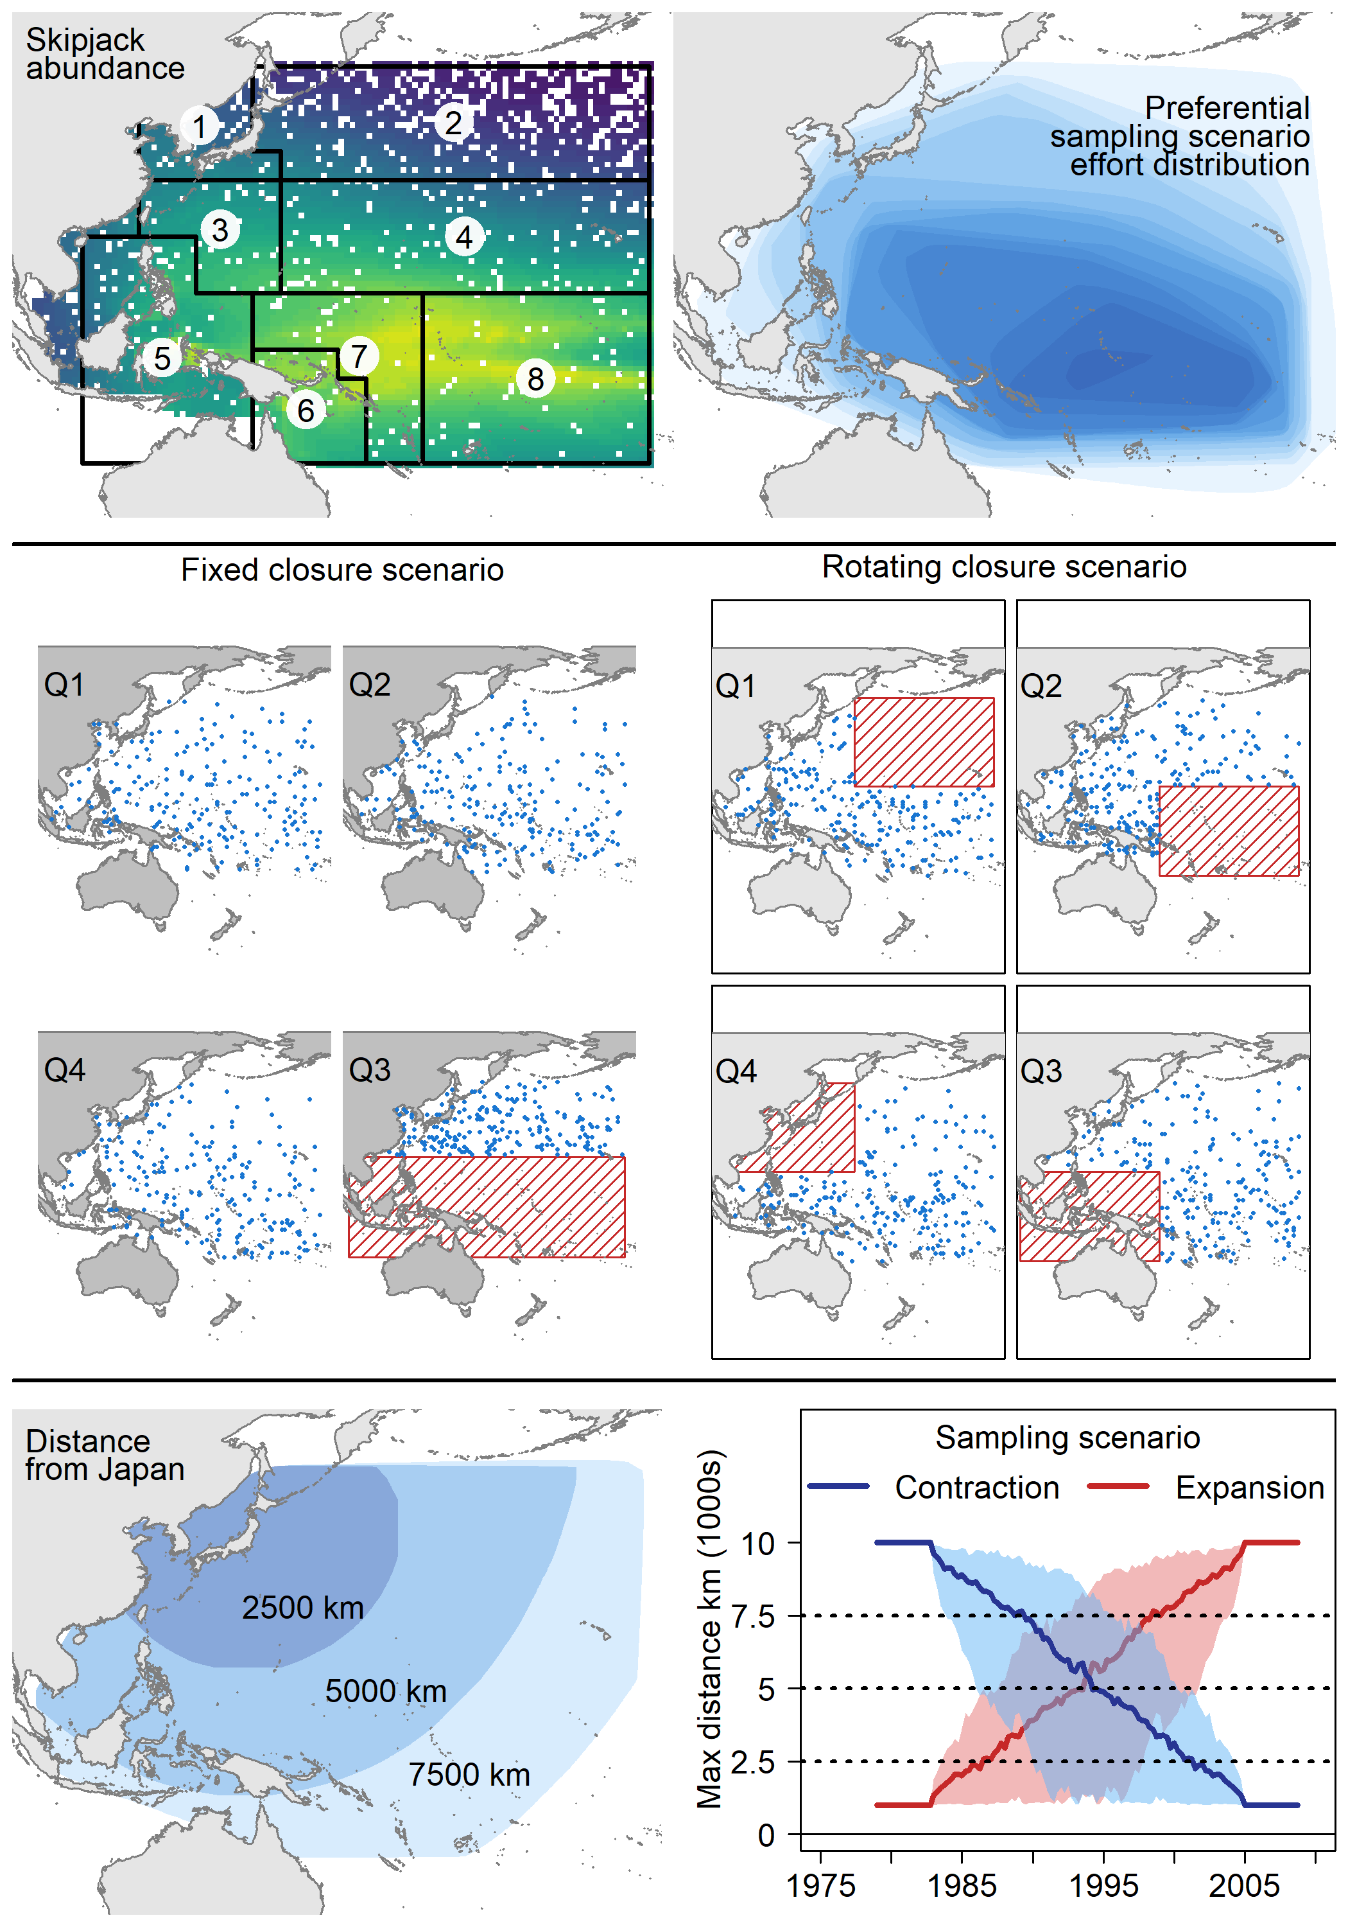

Figure 1 Top left: Simulated spatial distribution of skipjack abundance $A_{x,t}$ in the first time period. Warmer colors indicate greater levels of abundance around the equatorial region. The eight spatial regions of the 2019 WCPFC skipjack stock assessment are shown for reference. Top right: Simulated snapshot of the distribution of effort under the preferential effort pattern. Darker, more opaque blues indicate a greater density of effort. This corresponds to greater sampling in areas of higher skipjack abundance. Center left: The effort distribution under the fixed spatial closure scenario. In the 3rd quarter of the year no fishing takes place south of 20° N. Center right: The effort distribution under the rotating spatial closure scenario. In this scenario, quadrants of the spatial sampling frame are sequentially closed to fishing in each quarter of the year. Bottom left: Schematic indicating the approximate distances from Japan of locations within the spatial extent of the simulation. Bottom right: The maximum distance from Japan fished under the contraction (blue) and expansion (red) effort patterns in each time step of the simulation. The solid line indicates the median maximum distance for each effort pattern across all 100 replicates while the shaded region shows the 80th percentile across the replicates. The horizontal lines correspond to the distances depicted in the Bottom left panel.

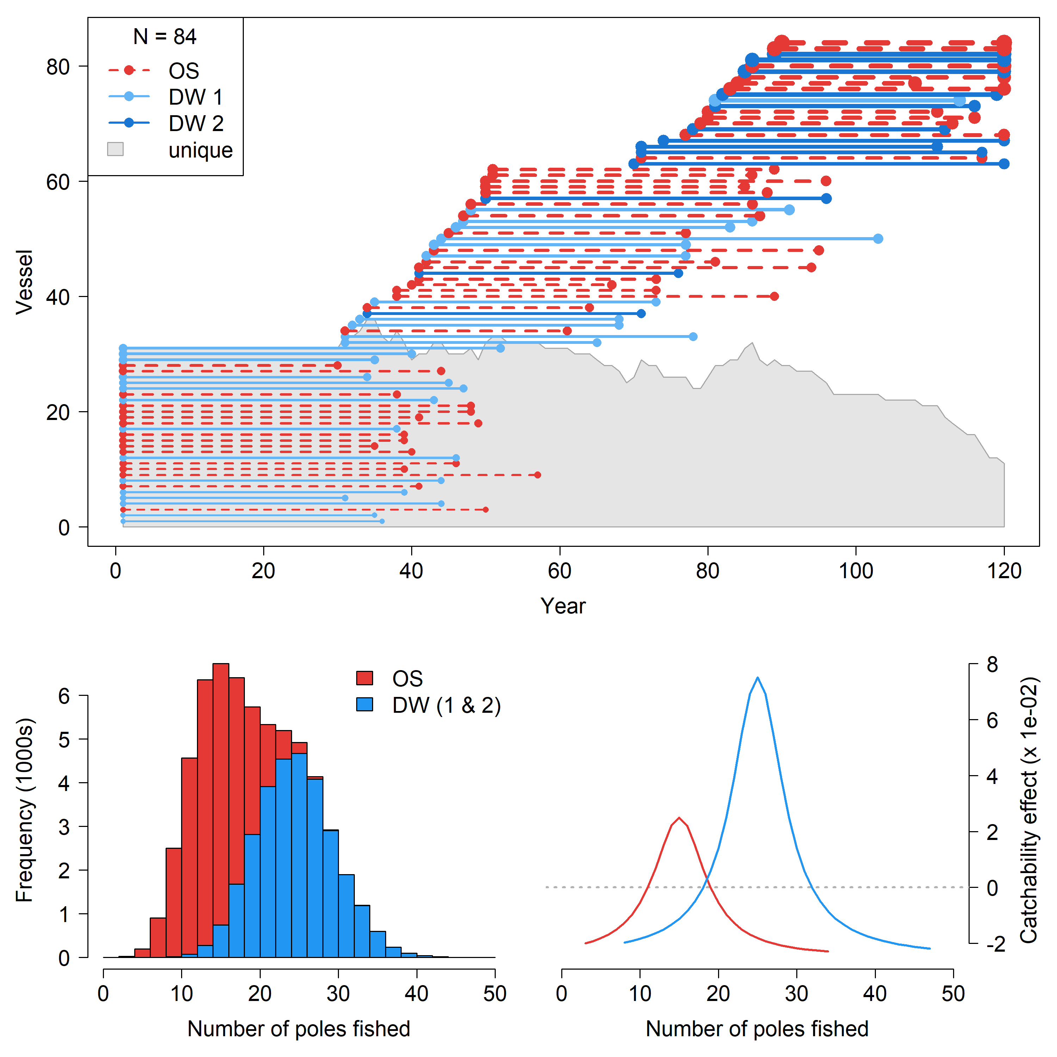

Figure 2 Top: Example of simulated fleet composition over time. Red dotted lines indicate OS vessels and blue solid lines indicate DW vessels. Dark blue indicates a DW vessel with a higher catchability effect. The start and end of each line indicates the activity period for unique vessels. The thickness of the line is an indication of the vessel effect, thicker lines indicate greater catchability effects. The gray polygon gives the number of unique vessels active in the fishery over time. Bottom left: The cumulative distribution of the number of poles fished with the color indicating the corresponding vessel class. Red OS and blue DW. Bottom right: The interactive effect on catchability of vessel class and number of poles fished.

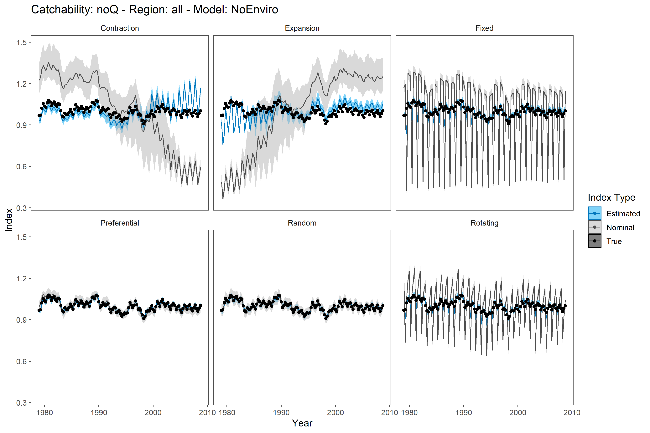

Figure 3

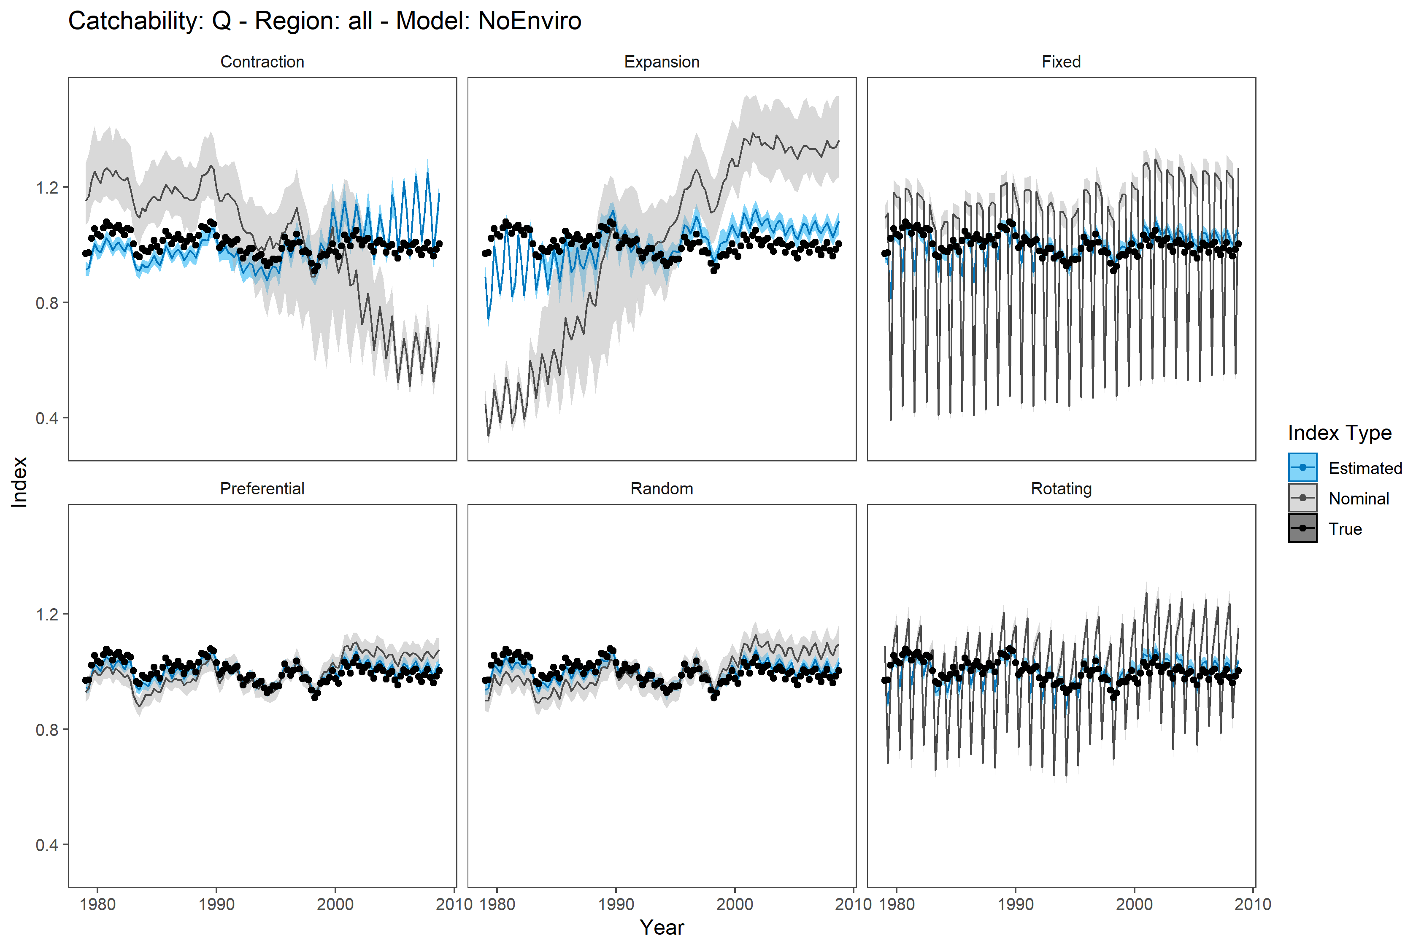

Figure 4

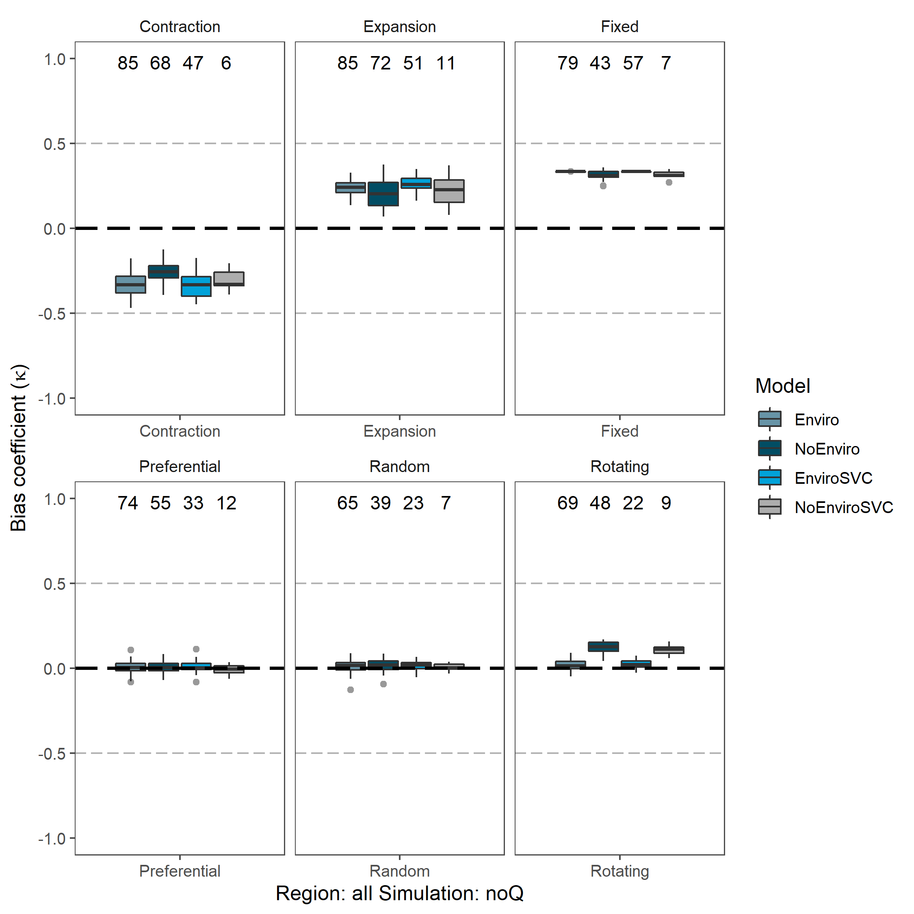

Figure 5

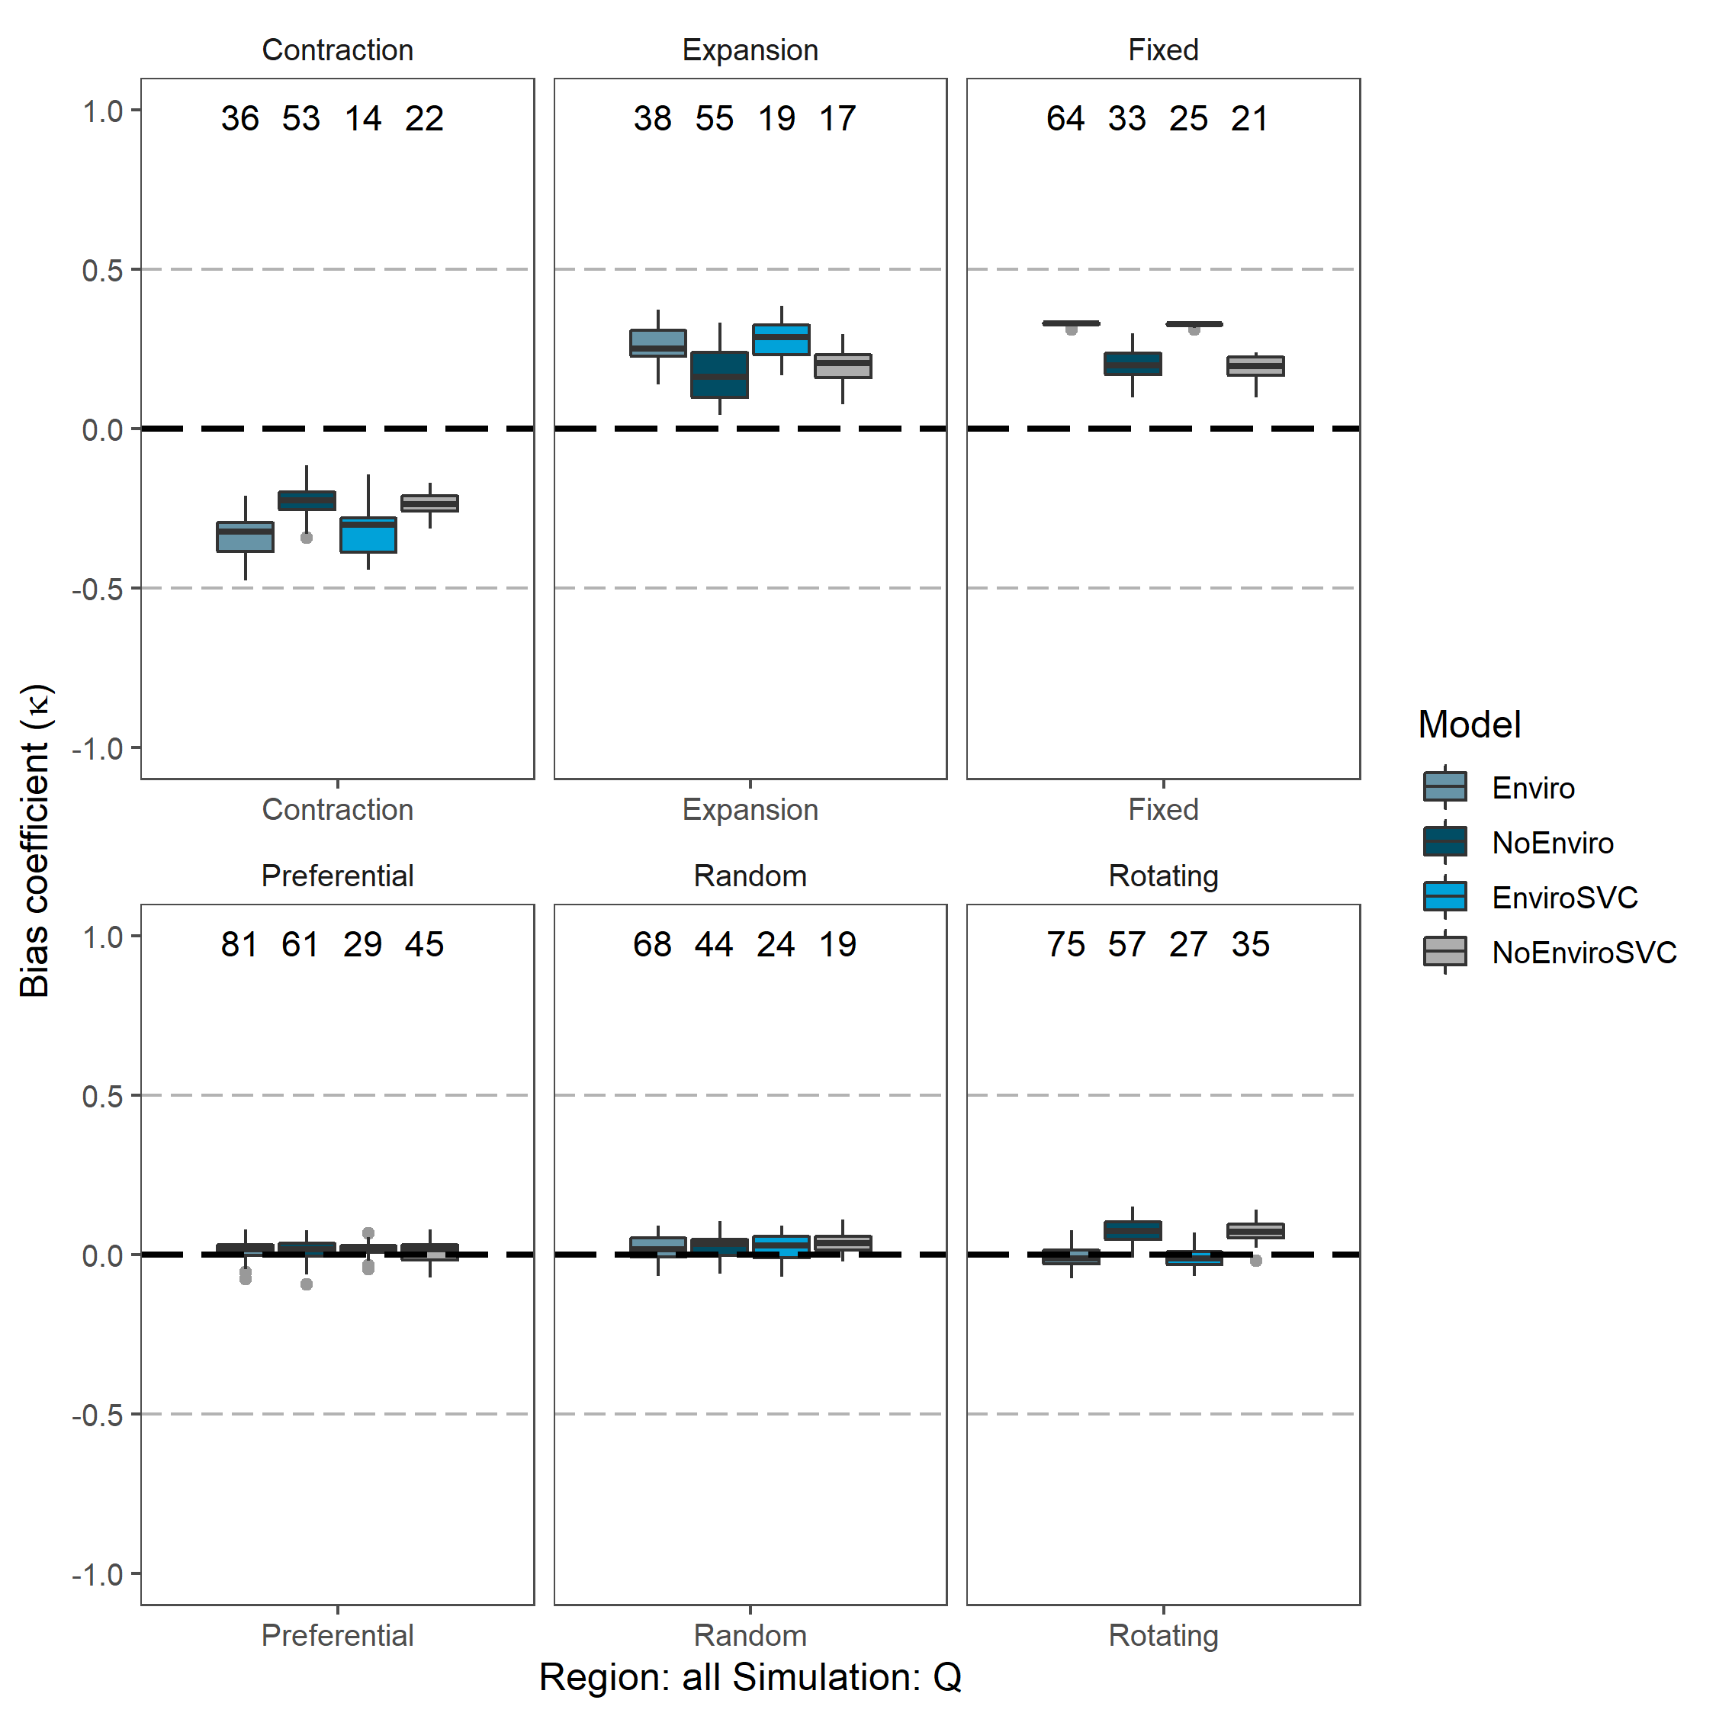

Figure 6

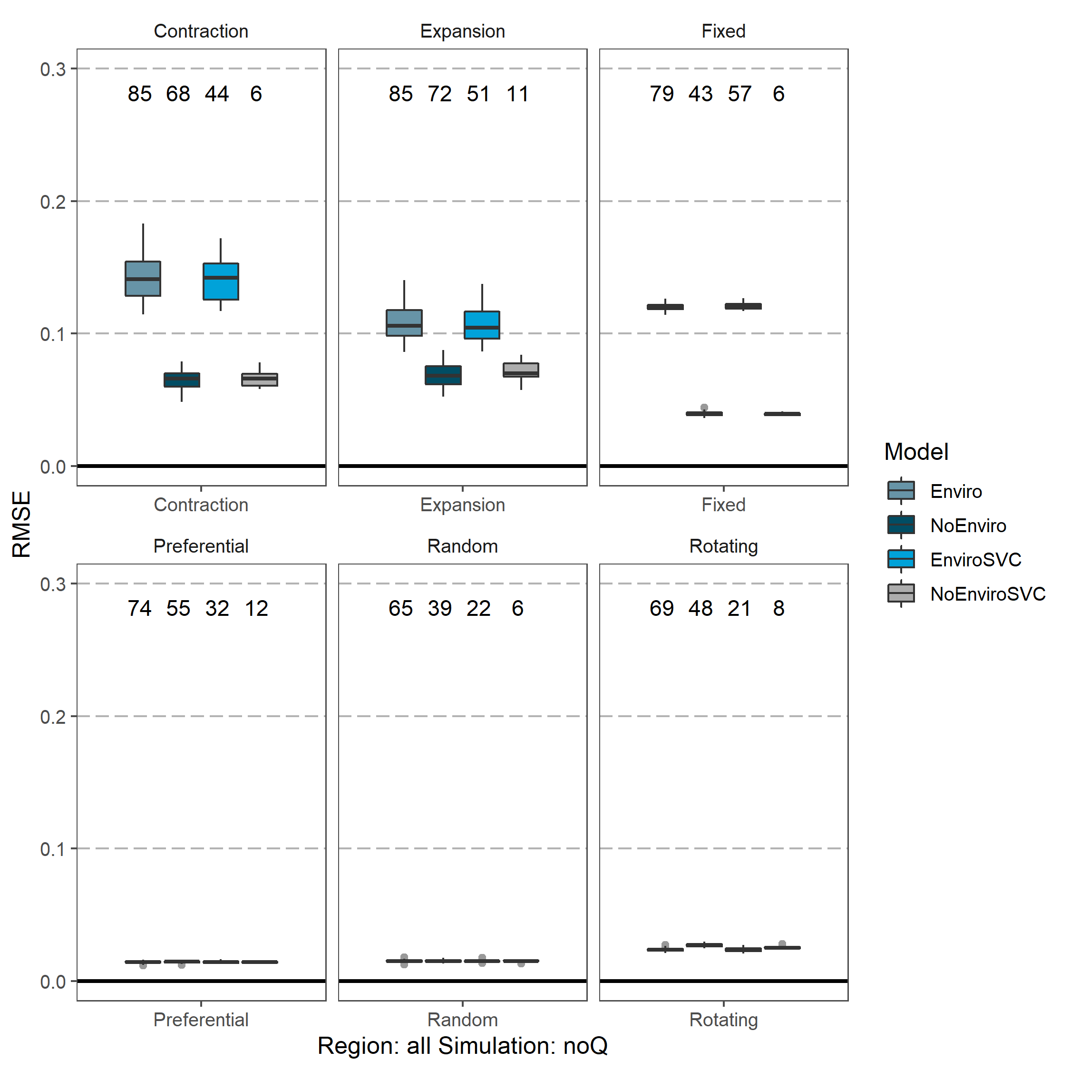

Figure 7

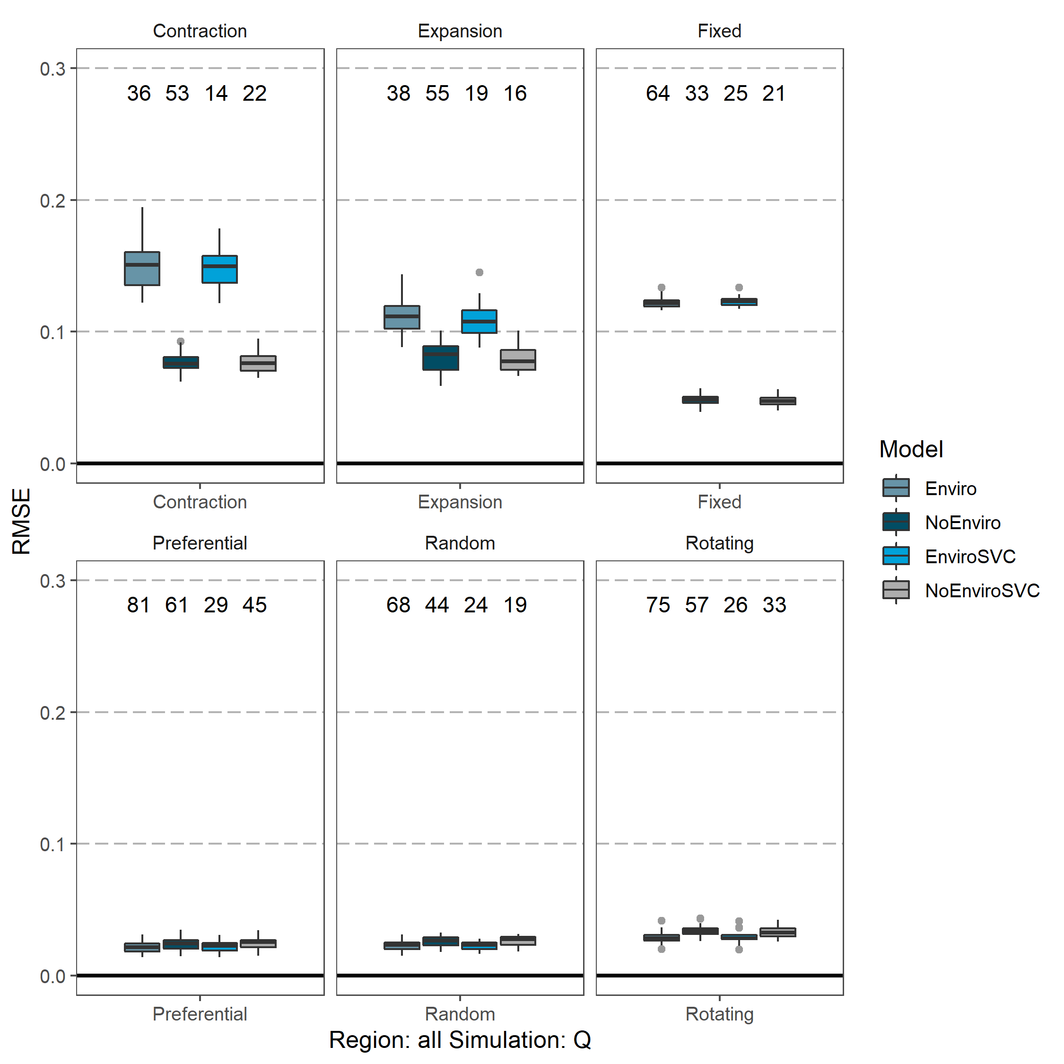

Figure 8

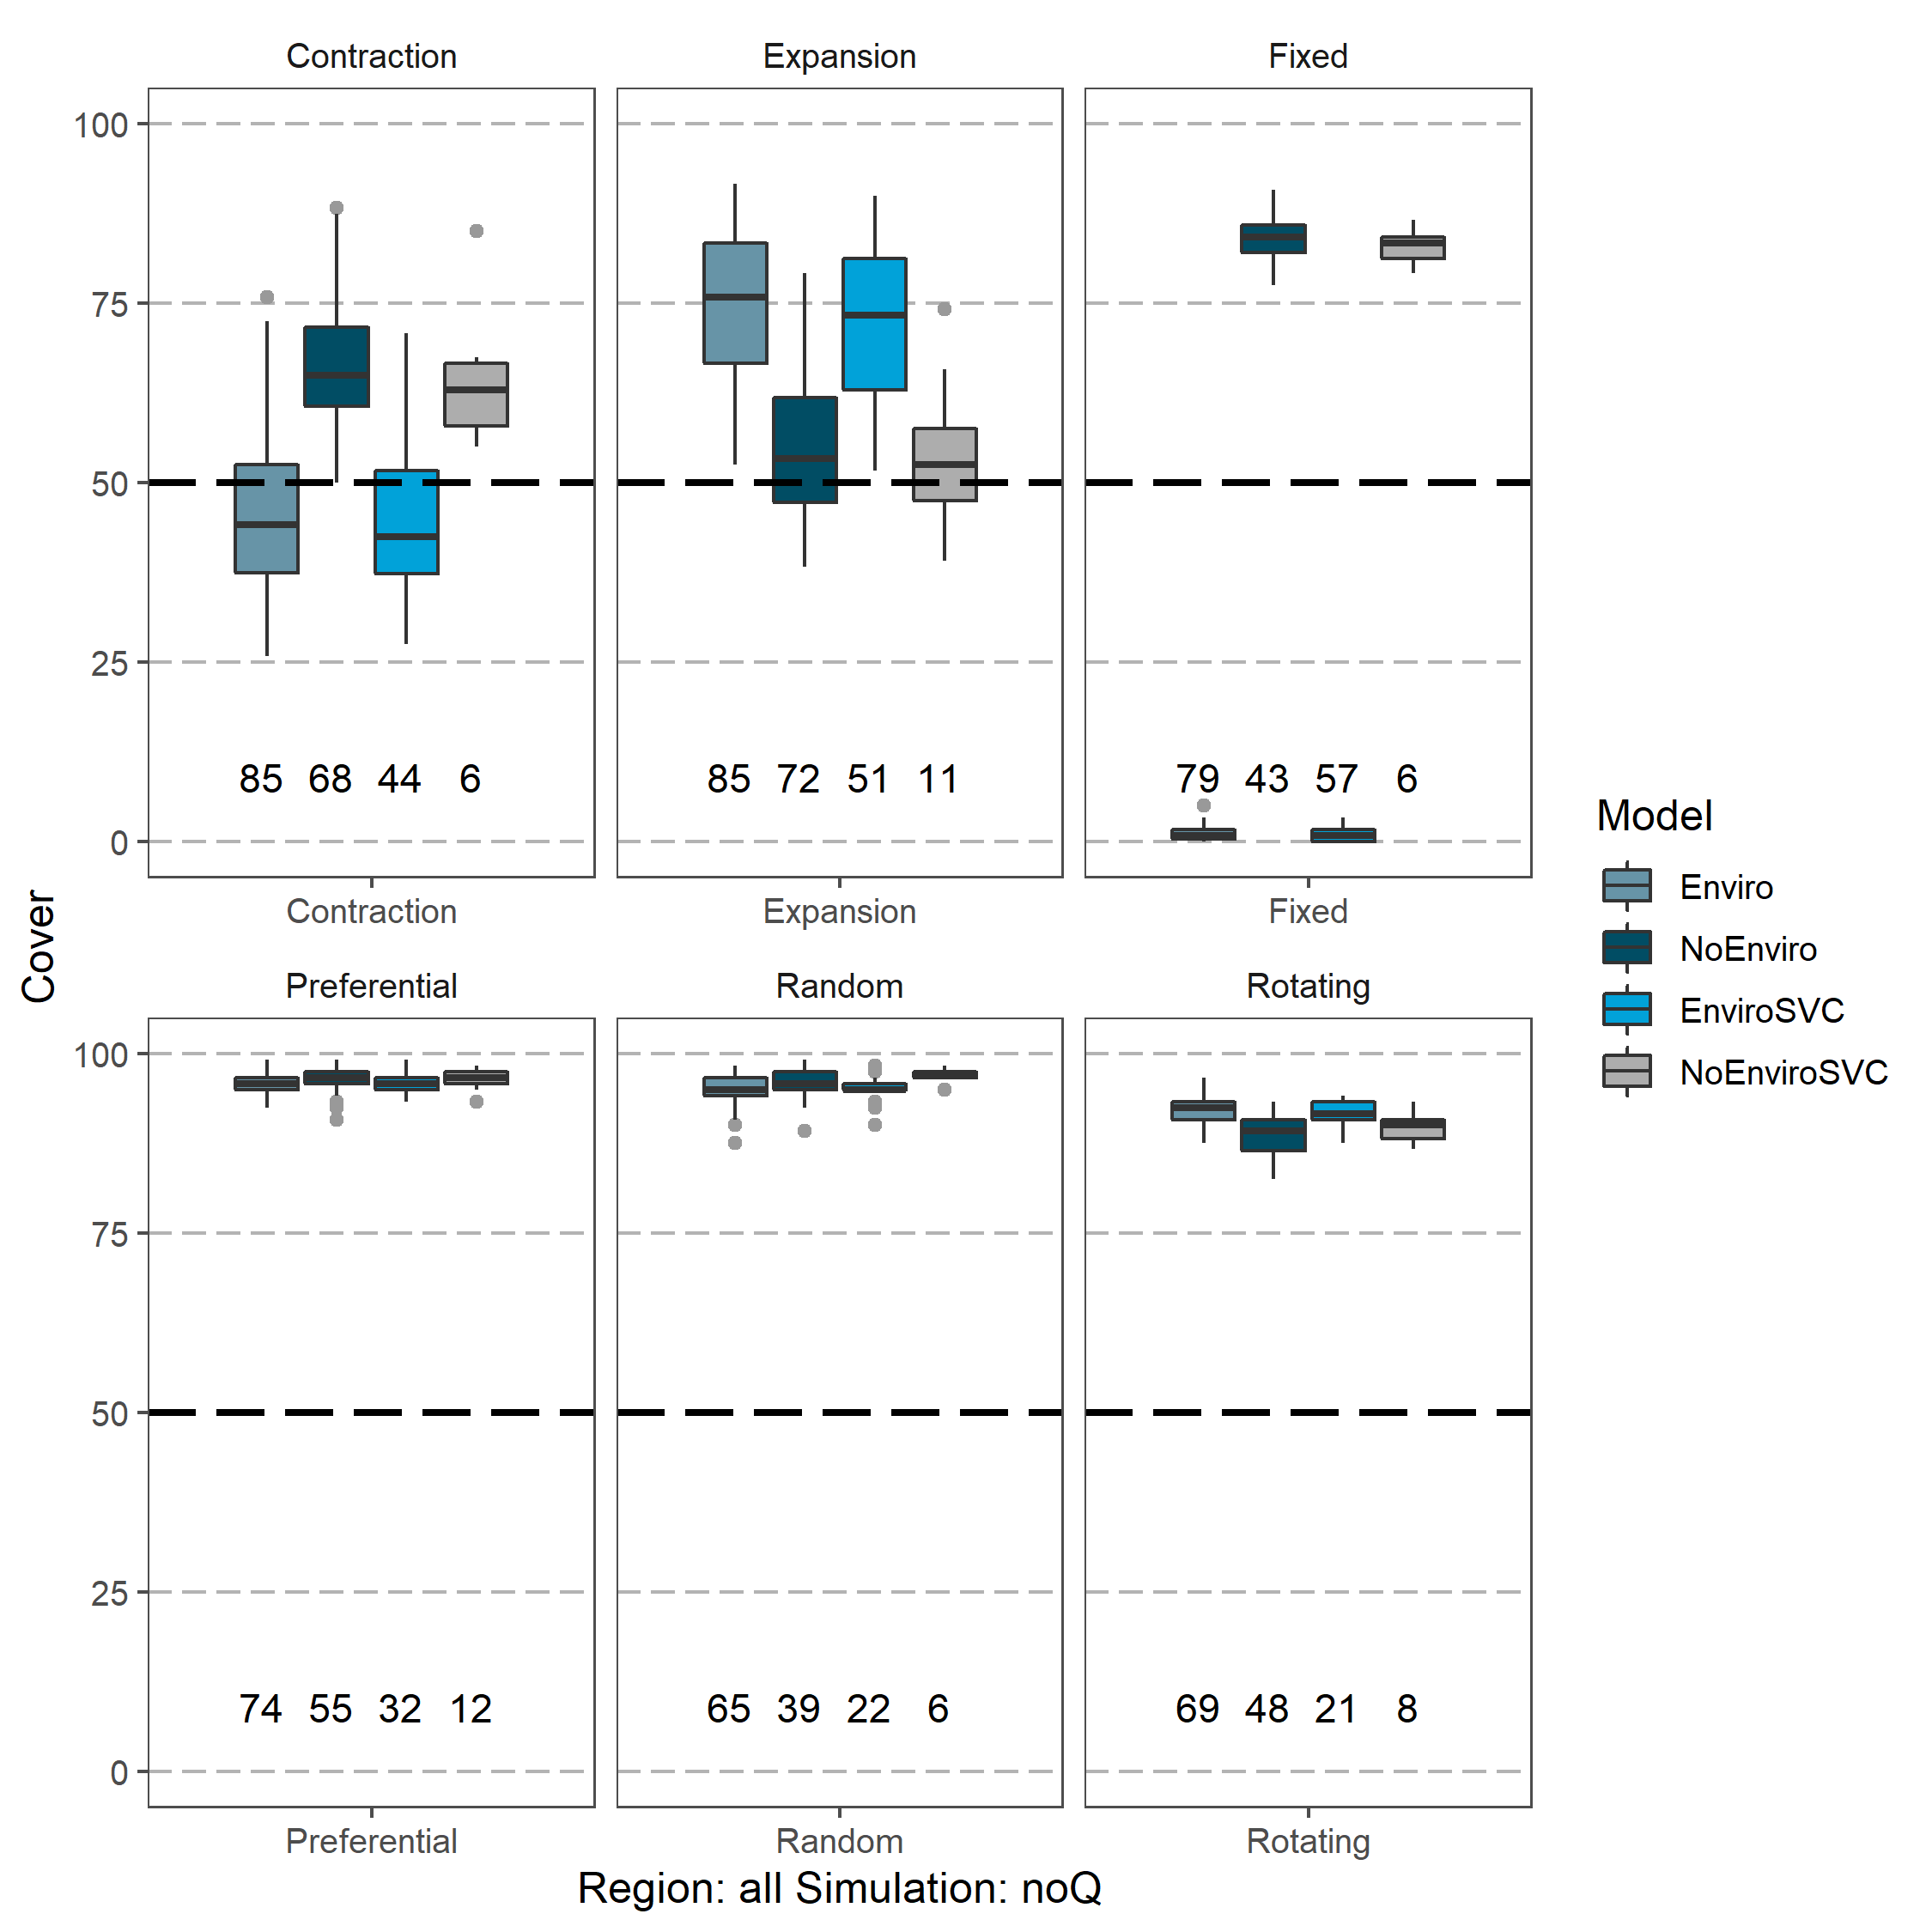

Figure 9

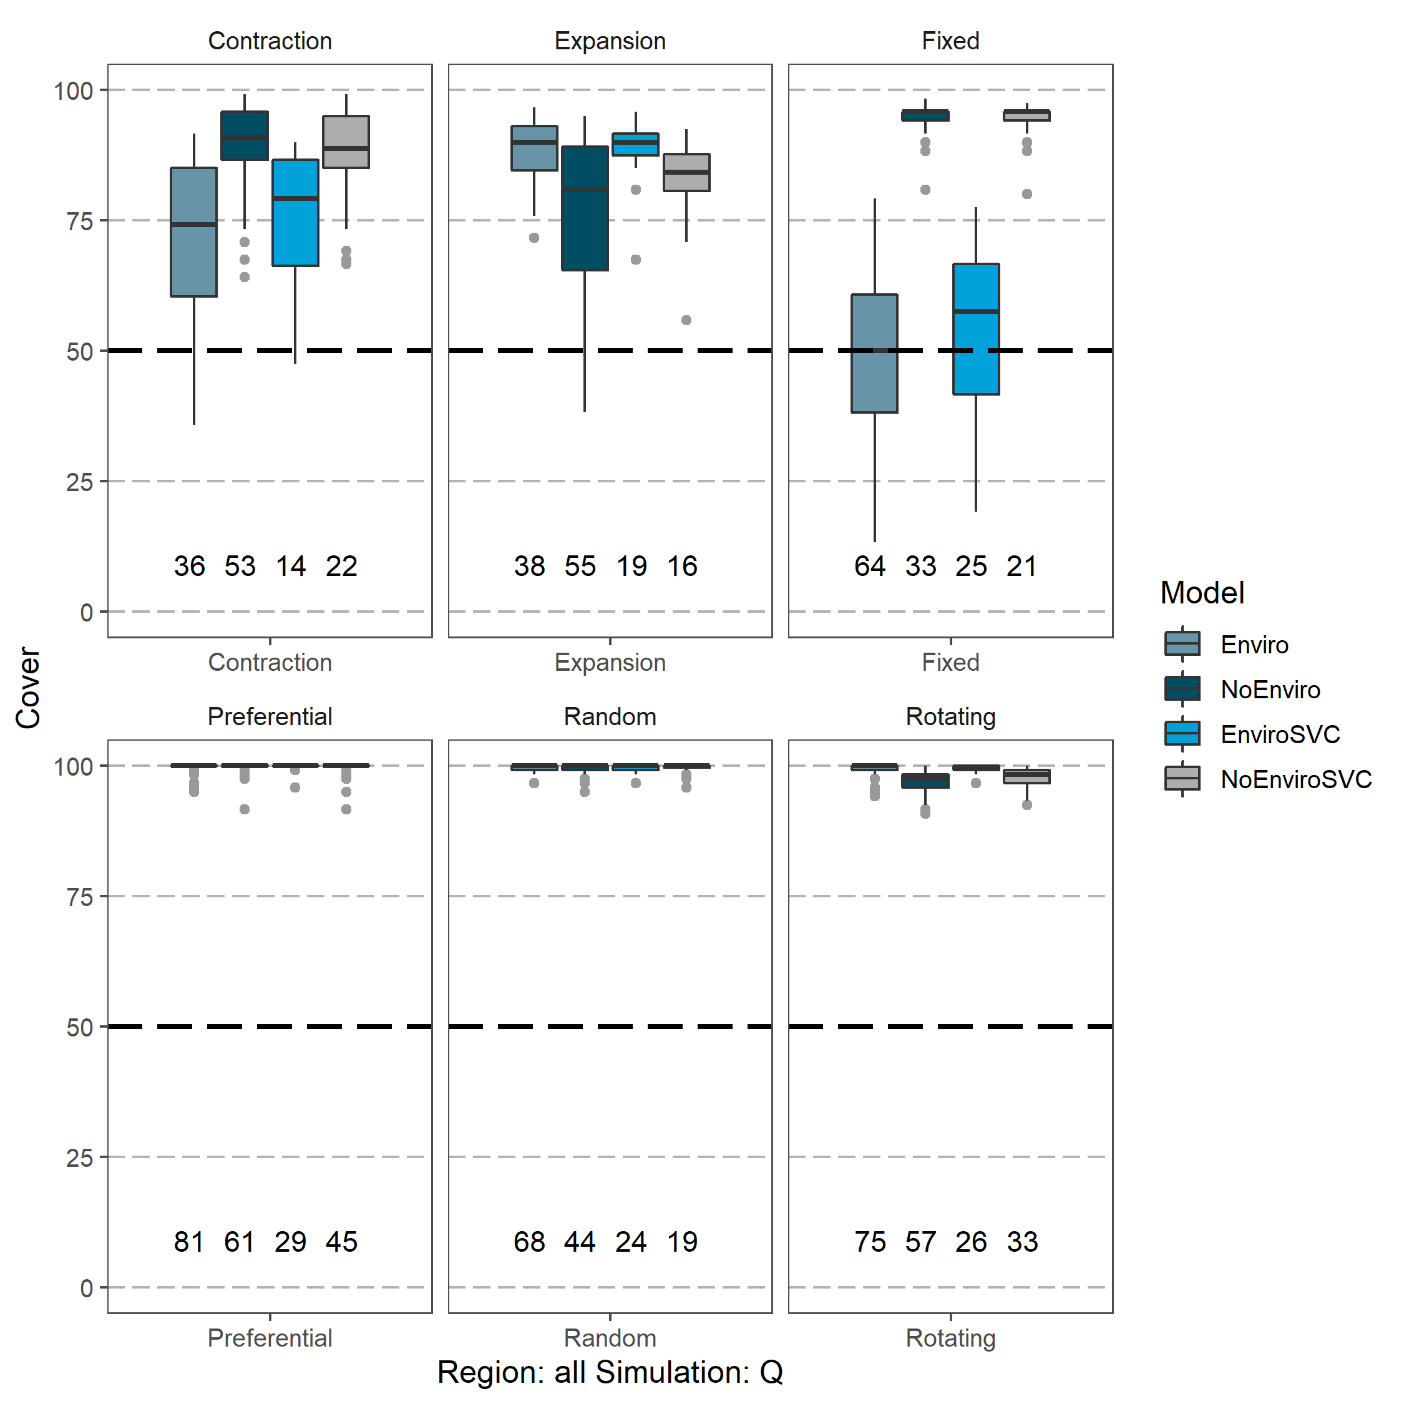

Figure 10