**AI-POWERED SPAM CLASSIFIER**

Phase 3   
 Data Preprocessing

|  |  |
| --- | --- |
| **PROJECT TITLE** | AI – Powered Spam Classifier |
| **SKILLS TAKEN AWAY** | * Python (+Python ML) * Csv files Handling * (CNN,Navis Bayes) ML algorithm * UI deployment |
| **DOMAIN** | ML - Cybersecurity |

***Project Definition :***

The "AI-Powered Spam Classifier" project's primary goal is to develop an intelligent system that automatically categorizes incoming messages as either spam or legitimate using advanced AI and ML techniques. This system seeks to enhance communication channels, improve user experience, and reduce unwanted content.

***Data Preprocessing :***

1) The given Data Set (spam.csv)

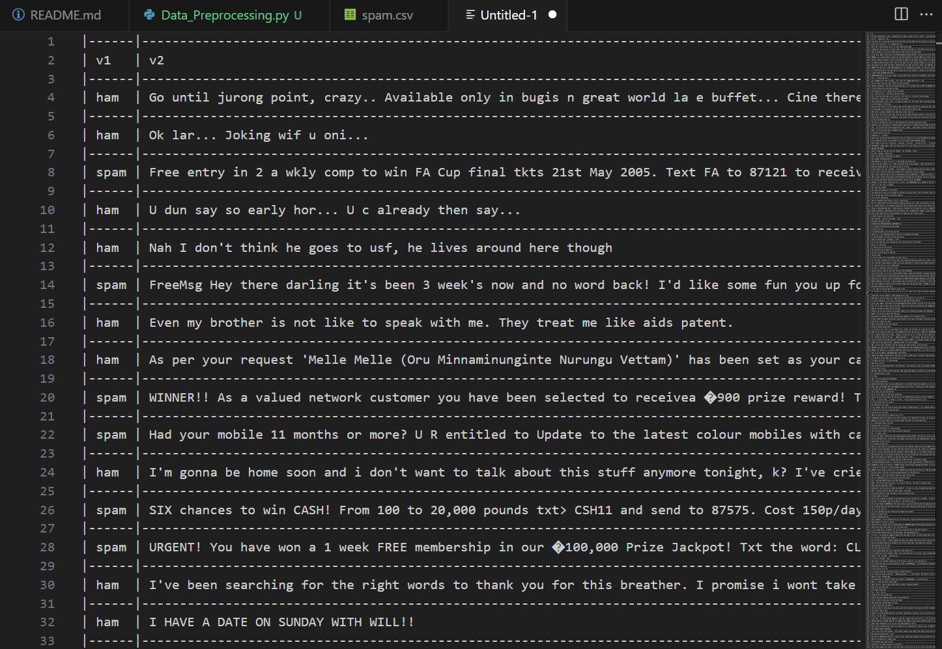

2) Importing required modules & packages

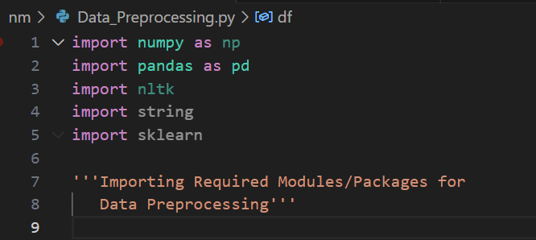

3) Reading the dataset

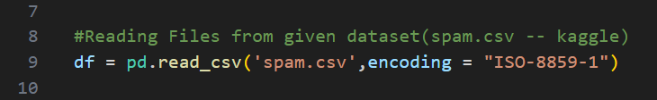

4) Ensuring whether dataset is present in project folder

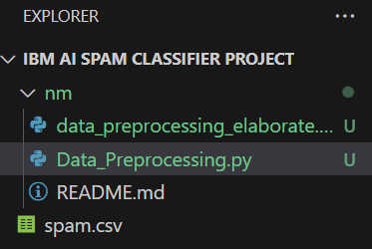

5) Removing null columns

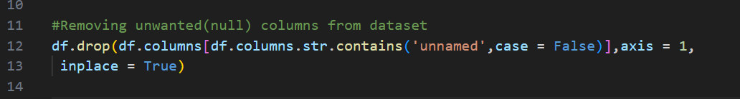

6) Checking null values

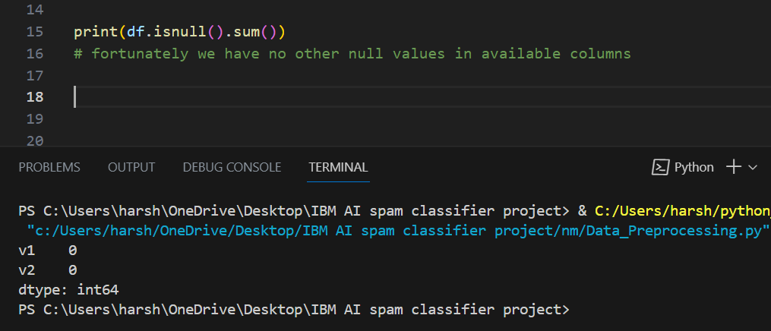

7) Renaming the columns

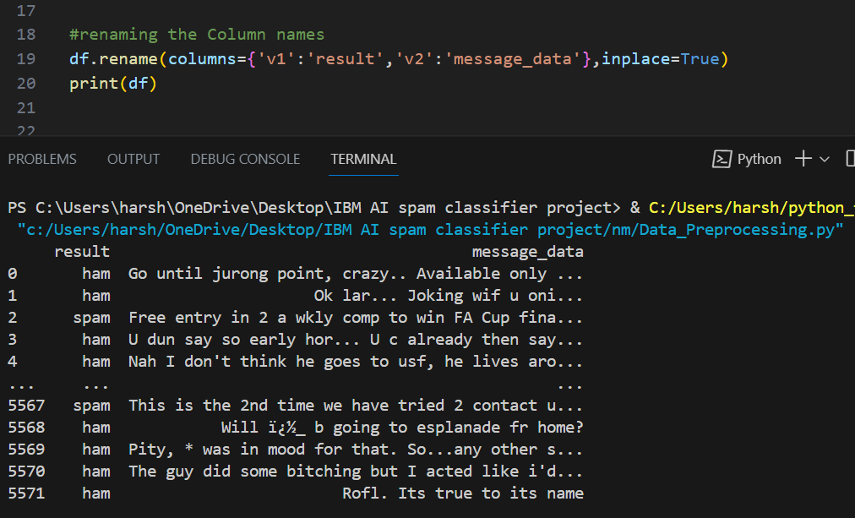

8) Changes in v1 column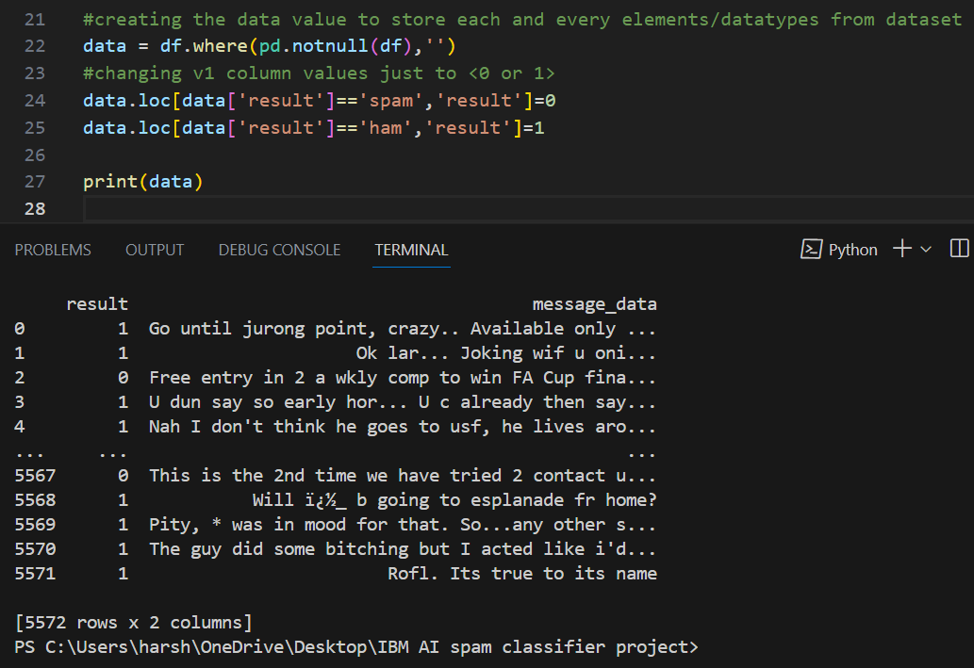

9) Removing special characters

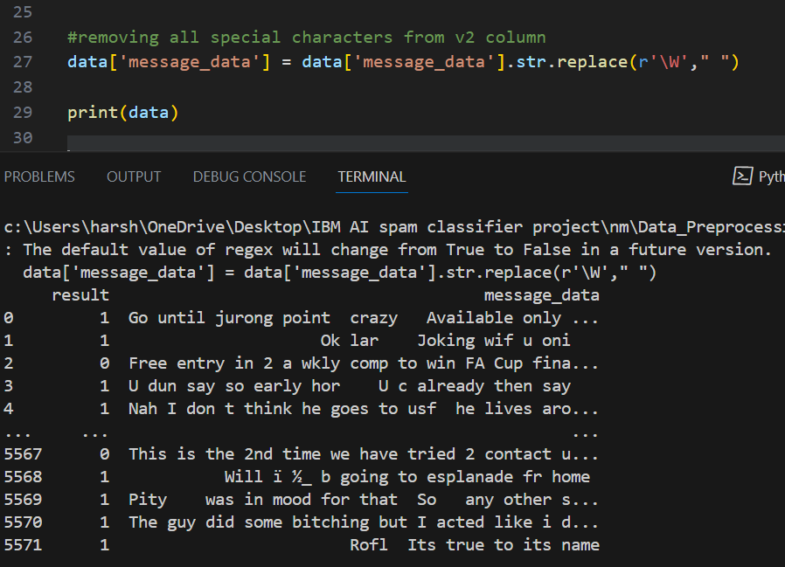

10) Lowercase Conversion of essential rows

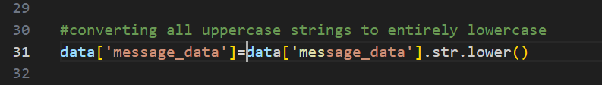

11) Finally printing the pre-processed data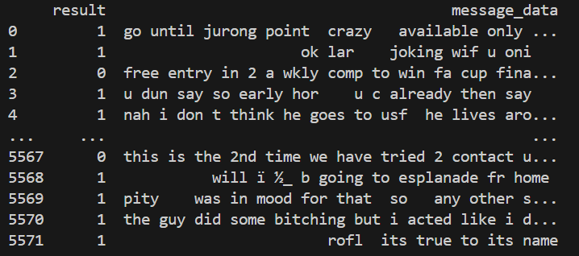

***Conclusion :***

The "AI-Powered Spam Classifier" project has delivered an effective spam filtering solution, enhancing communication while safeguarding user data. Its robust model, real-time integration, and privacy measures ensure a secure and efficient user experience, setting a standard for responsible AI deployment.

**Team Members :**

Harshavarthan. N, Anbuselvan. A, Rahul. S, Arul Prakash. A