**AI-POWERED SPAM CLASSIFIER**

Phase 4   
Project Development – Part ii

***Project Definition :***

The "AI-Powered Spam Classifier" project's primary goal is to develop an intelligent system that automatically categorizes incoming messages as either spam or legitimate using advanced AI and ML techniques. This system seeks to enhance communication channels, improve user experience, and reduce unwanted content.

***AI Model Training and Evaluating :***

1) Importing remaining required packages/modules

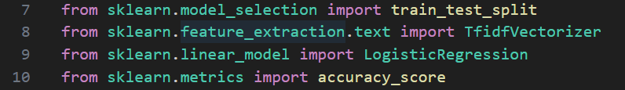

2) Previous code (data preprocessing)

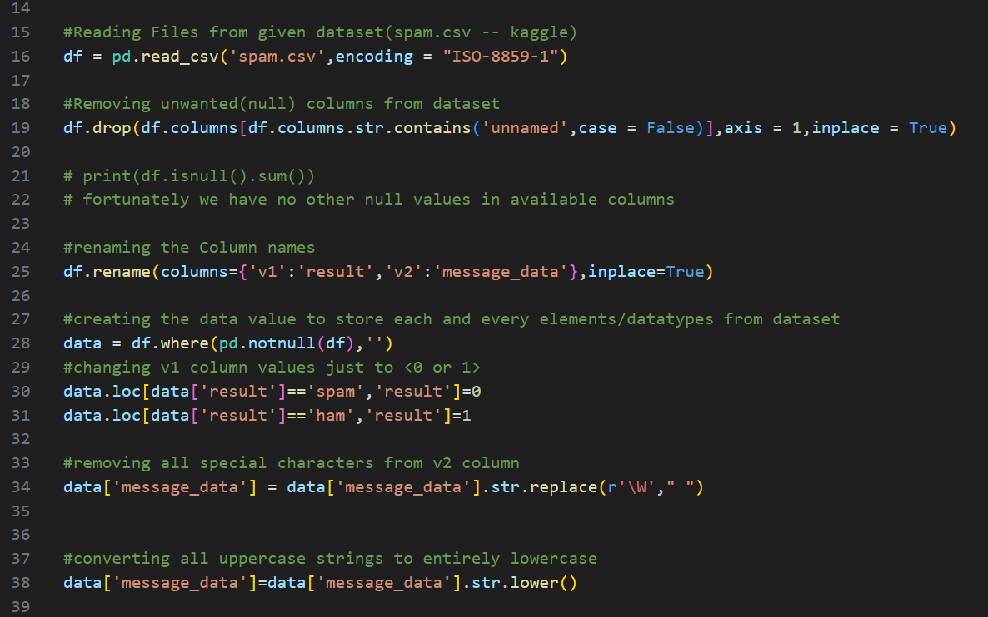

3) Allocating the respective data(column wise)



4) Splitting train data and test data



(Here, allocating 80% data for training the model and remaining 20% for testing the model)

5) Text to Feature vectors (using TfidVectorizer function)



6) Feature extraction and fitting the data

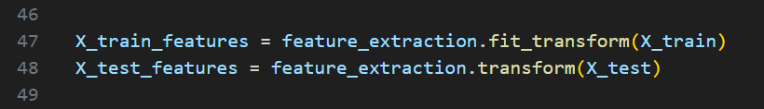

7) Converting/fitting the execution type to INT

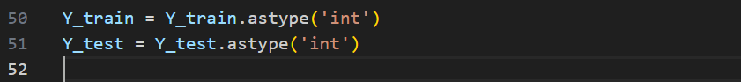

8) Creating the Model for AI implementation

9) Fitting train features to the model



10) Prediction and Accuracy scoring on training data

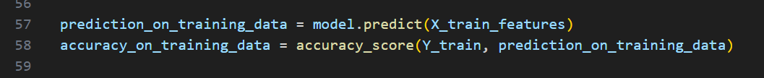

11) Prediction and Accuracy scoring on test data

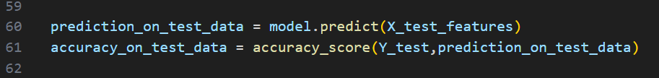

12) Execution of model on (Realtime)Prediction

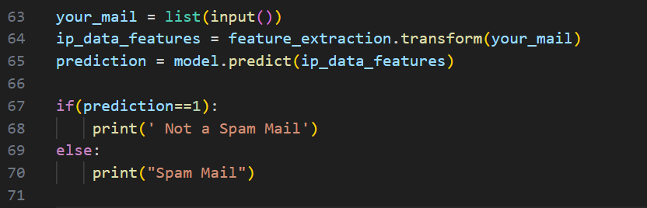

13) Our Model’s accuracy on Test Data = ***0.961434977***

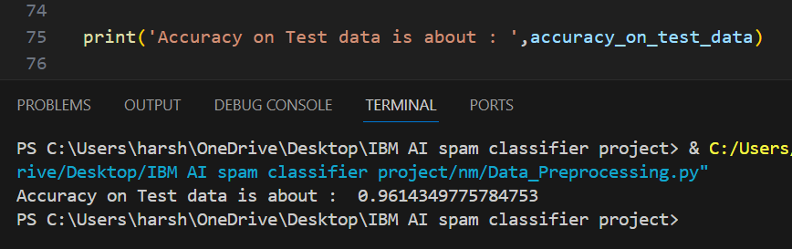

14) Our Model’s accuracy on Training Data = ***0.966120708***

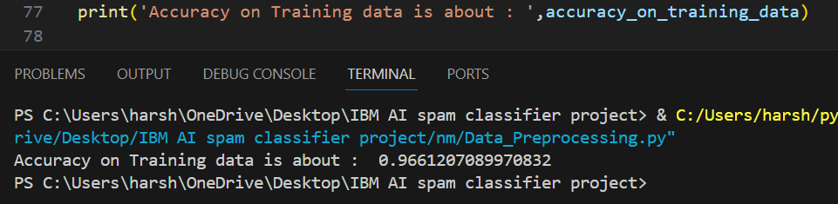

***Conclusion :***

The "AI-Powered Spam Classifier" project has delivered an effective spam filtering solution, enhancing communication while safeguarding user data. Its robust model, real-time integration, and privacy measures ensure a secure and efficient user experience, setting a standard for responsible AI deployment.

**Team Members :**

Harshavarthan. N, Anbuselvan. A, Rahul. S, Arul Prakash. A