Contents

1. Introduction 2

1.1. Purpose of the Report 2

1.2. Scope of the UI Design and Implementation 2

1.3. Overview of the Mobile Attendance System 2

2. User Research and Analysis 2

2.1. Stakeholder Analysis 2

2.2. User Personas 2

2.3. User Journeys 2

2.4. Requirements Gathering 3

3. UI Design Principles 3

3.1. User-Centric Design Approach 3

3.2. Accessibility Considerations 3

3.3. Visual Design Guidelines 3

**3.3.1.** **Color Schemes** 3

**3.3.2.** **Typography** 3

**3.3.3.** **Imagery and Icons** 3

3.4. Consistency and Standards 3

4. Wireframing and Prototyping 3

4.1. Tools and Technologies 3

4.2. Wireframes for Key Screens 3

**4.2.2.** **Login Screen** 4

**4.2.3.** **Dashboard** 5

**4.2.4.** **Attendance Marking** 7

**4.2.5.** **Report Generation** 8

**4.2.6.** **Notifications Management** 8

4.3. Interactive Prototypes 8

5. Detailed UI Design 11

5.1. Finalized UI Mockups 11

5.2. Design Specifications 11

**5.2.1.** **Layouts** 11

**5.2.2.** **Navigation Flow** 11

5.2.3. **UI Components** 11

5.3. Accessibility Features 11

**5.3.1.** **Screen Reader Support** 11

**5.3.2.** **High-Contrast Mode** 11

**5.3.3.** **Keyboard Navigation** 11

6. Conclusion 11

6.1. Summary of the UI Design and Implementation Process 11

6.2. Key Achievements and Outcomes 11

6.3. Future Work and Enhancements 11

7. Appendices 11

7.1. Glossary of Terms 11

7.2. Tools and Technologies Used 11

7.3. References and Resources 11

7.4. Additional User Feedback and Surveys 11

# Introduction

## Purpose of the Report

The purpose of this report is to document the user interface (UI) design and implementation process for a mobile attendance system. This system aims to streamline the attendance management process through the integration of biometric authentication, real-time tracking, and comprehensive reporting. This report will cover the design principles, research methodologies, wireframing, prototyping, and final implementation details.

## Scope of the UI Design and Implementation

The scope of the UI design and implementation encompasses:

Development of a mobile application interface for administrators, instructors, and students.

Integration of multibiometric authentication for secure attendance marking.

Real-time attendance tracking and reporting.

User-friendly design to ensure ease of use and accessibility.

Implementation of responsive and adaptive design techniques for compatibility across various devices.

## Overview of the Mobile Attendance System

The mobile attendance system is designed to automate and secure the attendance process in educational institutions. Key features include:

Biometric authentication (fingerprint and facial recognition).

Real-time attendance marking and tracking.

Automated attendance reports.

Push notifications, reminders, and alerts.

Customization options for different institution requirements.

# UI Design Principles

## User-Centric Design Approach

This is an iterative design process in which designers focus on the users and their needs in each phase of the design process. Here, design teams involve users throughout the design process via a variety of research and design techniques, to create highly usable and accessible products for them.

## Accessibility Considerations

Accessibility is a broad time in UI/UX design. Making a design accessible means that all the members of the target audience group have equal access to the product or service. It also means that the design is usable and useful in multiple settings, meeting the varying needs of users.

Our application is built with both the abled and the disabled in mind. Hence, we had to take into consideration certain aspects and produce a design that could be used by all thereby putting in place the following features.

* Screen readers were implemented having in mind users with visual disabilities
* Keyboard navigation was put in place so as to ease the interaction between users and the system allowing our users to make use mostly of their keyboard.
* Shortcut keys were implemented to ease the movement from one part of the software to another thereby reducing the time of navigating through the system especially in cases where the lecturer is running out of time.

## Visual Design Guidelines

Design guidelines are sets of recommendations on how to apply design principles to provide a positive user experience. During our design, we took into consideration the following guidelines

### **Color Schemes**

Our design was focused mainly on four different colors namely

* White and black mainly for the background
* Grey for the text boxes
* Blue for the headings and logo

### **Typography**

For the smooth execution of our project, the main typeface used was Poppins. Our headings were of size 22. The text in the various buttons were of size 14.

### **Imagery and Icons**

The sizes of the images as well as icons were set to 100x100 for size so as to fit explicitly with the design

# Wireframing and Prototyping

## Tools and Technologies

We started with wireframing where we put down our ideas on paper and later tried to adjust it so as to meet our users need.

Wireframing Tools: Sketch, Figma, Adobe XD

Prototyping Tools: InVision, Figma, Adobe XD

## Wireframes for Key Screens

* + 1. Registration Screen

In this screen users provide their information so as to be registered into the system. This screen is used by students and instructors.

Simple and clean layout.

Fields for Name, email, password, confirm password user type (student or instructor).

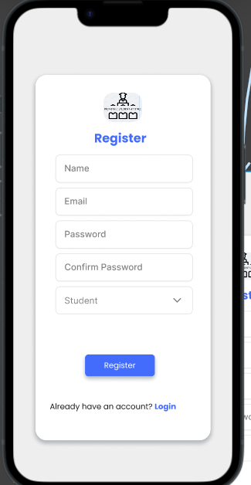

### **Login Screen**

This screen is used for registered users to gain access to their accounts. This screen is used by students and instructors.

Simple and clean layout.

Fields for email/username and password.

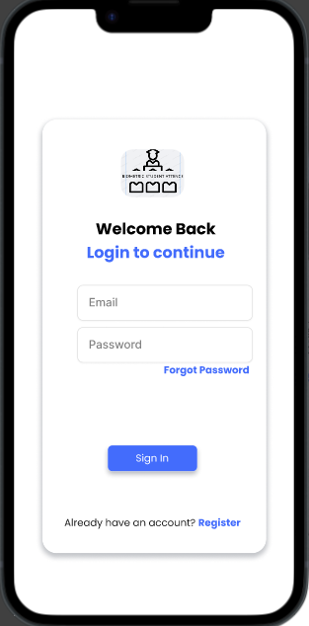

### **Instructor’s Dashboard**

Overview of attendance statistics.

Quick access to attendance sessions, reports, courses and notifications.

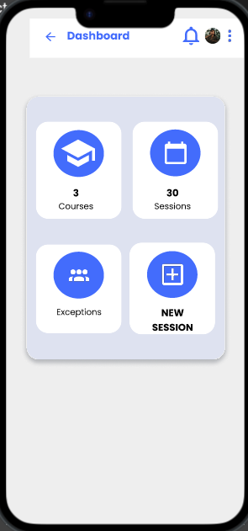

Courses is where the instructor sees all of his/her courses.

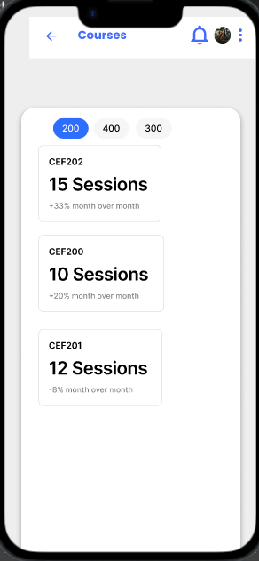

Sessions is where the instructors have access to all of their past sessions.

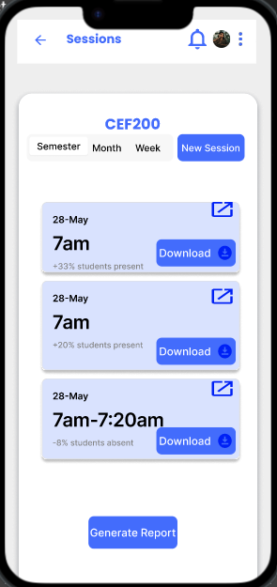

New Session is for the instructor to create an attendance session for students to mark to attendance for that session.

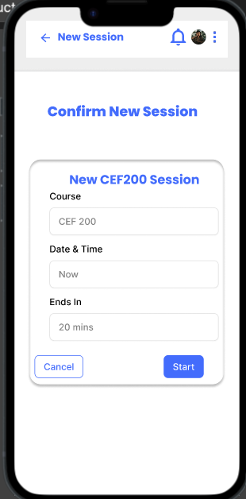

Exception is for the instructor to update the student’s attendance in case

of unforeseen circumstances such as phone being powered off or due to health issues.

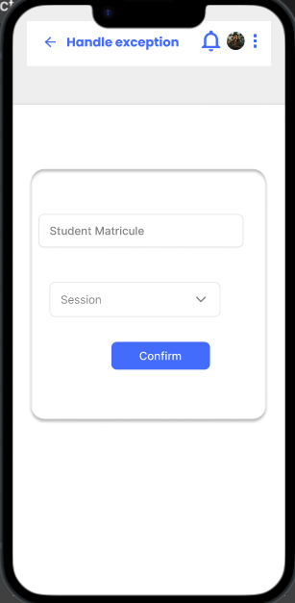

### **Attendance Marking**

Easy-to-use interface for marking attendance.

The student only inputs his fingerprint and his/her attendance is taken.

Integration with biometric authentication and GPS verification.

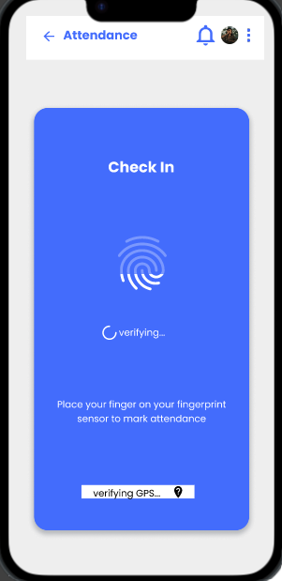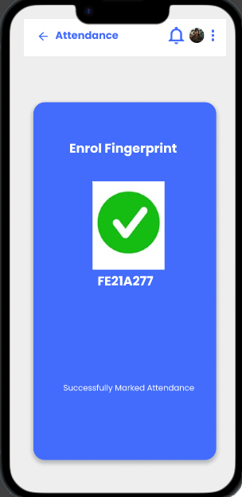

### **Report Generation**

This under the Session screen and is used to by the instructors for generating their reports. The report can be in different timeframes such as weekly and at the end of the semester.

### **Notifications Management**

This is acts as some sort of reminder to the instructors to take create their attendance session.

## Interactive Prototypes

Here, the prototypes are made based on the specific user. Students and Instructors have different user journeys as illustrated below.

**The student’s journey goes from left to right**

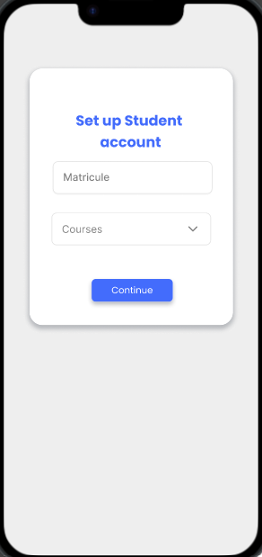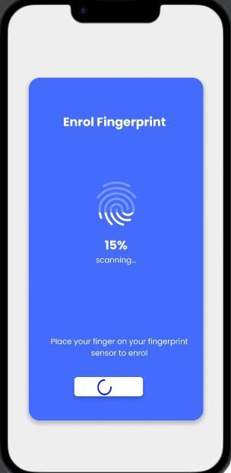

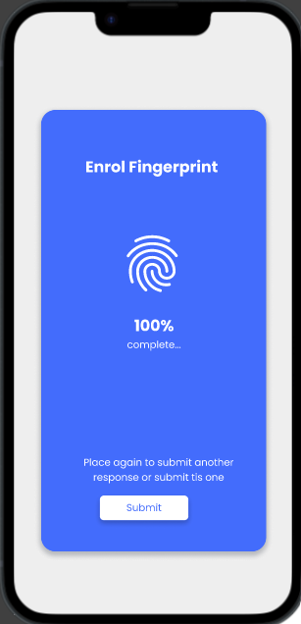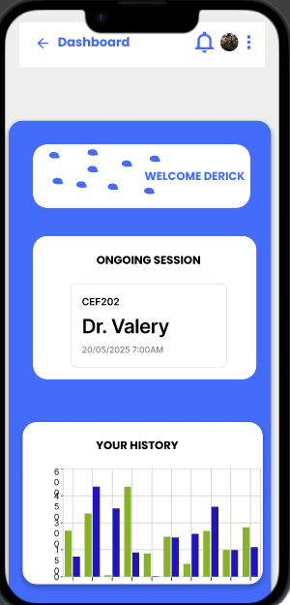

The instructors have a whole different user journey.

**The instructor’s journey goes from left to right**

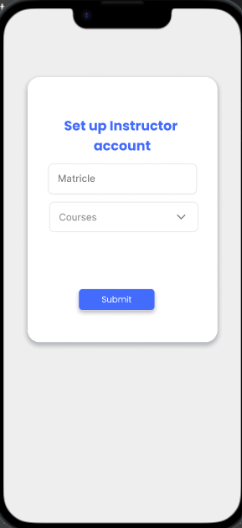



# Detailed UI Design

## Finalized UI Mock-ups

## Design Specifications

### **Layouts**

### **Navigation Flow**

### **UI Components**

## Accessibility Features

### **Screen Reader Support**

### **High-Contrast Mode**

### **Keyboard Navigation**

# Conclusion

## Summary of the UI Design and Implementation Process

Identifying our target users (instructors, students).

Understand their needs and pain points regarding attendance marking.

Consider factors like accessibility and varying technical skills.

After selecting the user’s and coming up the UI design of each user we did a clear and simple design.

## Key Achievements and Outcomes

We were able to come up with a detailed outline of each user’s journeys and what they can and can’t do at each step of their journey through out their life in the application.

## Future Work and Enhancements

In the next section of our work, we are going to do some actual implementation of code and databases so as to come out with some actual prototype or a sort of initial/beta release of the application.

# Appendices

## Glossary of Terms

## Tools and Technologies Used

## References and Resources

## Additional User Feedback and Surveys