Digital Persona: Persona-Grounded Synthetic Consumers Scored with Enhanced Semantic Similarity Rating (E-SSR) — Validation Against Real Survey Respondents
Results package for IEEE paper drafting. All numbers are read from saved repository outputs; the Appendix lists the source file of every number. ★ = compulsory section, ★★ = most important for acceptance.

1. ★ Summary
We built digital twins of real smartphone owners from a 258-person Indian student survey and asked a local LLM (qwen2.5:7b-instruct) to answer the survey's open questions in its own words, without ever seeing the person's ratings or text and without being allowed to write any number. Each answer was converted to a 1–5 purchase-intention rating with E-SSR (embedding similarity to five anchor statements, top-3 truncation, T=0.75). On a held-out sample of 40 twins, E-SSR placed 82.5% of individuals within one point of their own rating, versus 72.5% for directly asking the LLM for a number and 67.5% for chance; its MAE was 0.875 versus 1.025 (direct) and 1.075 (chance). At persona level, E-SSR means were within 0.255 points of the human means on held-out data, compared with 0.675 for direct rating. On the 80-person development set, a hybrid of calibrated E-SSR and direct rating reached a QWK of 0.461 (direct 0.361, chance -0.064), and moving from v1 to v2 anchors and personas raised persona-level Spearman from 0.400 to 0.800.

2. ★★ Key Results at a Glance
Result | Our method | Baseline(s) | Source
Held-out individual accuracy (within one point) | E-SSR 82.5% | Direct 72.5%; chance 67.5% | evaluation/phase19_twin_validation/twin_metrics_bi_heldout.json
Held-out individual MAE (lower better) | E-SSR 0.875 | Direct 1.025; chance 1.075 | evaluation/phase19_twin_validation/twin_metrics_bi_heldout.json
Held-out persona-mean error (MAE) | E-SSR 0.255 | Direct 0.675 | evaluation/phase19_twin_validation/twin_metrics_bi_heldout.json
Held-out distribution match (KS, lower better) | Calibrated E-SSR 0.125 | Uncalibrated 0.225; direct 0.250 | evaluation/phase19_twin_validation/twin_metrics_bi_heldout.json
Held-out rating spread (SD; human = 1.298) | Calibrated E-SSR 1.023 | Uncalibrated 0.357; direct 0.736 | evaluation/phase19_twin_validation/twin_metrics_bi_heldout.json
Development individual QWK | Hybrid 0.461 | Direct 0.361; chance -0.064 | evaluation/phase19_twin_validation/twin_metrics_bi.json
Development individual within one point | Hybrid / E-SSR 88.8% | Direct 85.0%; chance 66.2% | evaluation/phase19_twin_validation/twin_metrics_bi.json
Development persona-mean error (MAE) | E-SSR 0.231 | Direct 0.338 | evaluation/phase19_twin_validation/twin_metrics_bi.json
v1 → v2 persona Spearman (development, E-SSR) | v2 0.800 | v1 0.400 | evaluation/phase19_twin_validation/twin_metrics.json; evaluation/phase19_twin_validation/twin_metrics_bi.json
LLM-judge benchmark exact agreement (n=24) | E-SSR k=3 79.2% (QWK 0.697) | Canonical SSR 70.8% (QWK 0.571); majority 62.5% (QWK 0.000) | evaluation/generation_quality_improvement_v1/phase7_ssr_candidates/phase7_metrics.json

3. ★ Data and Personas
The survey file contains 275 responses; 258 form the primary cohort used throughout (in_primary_cohort = True). Gender: female 54.7%, male 45.3%. Median age 20 (range 18–35). Respondents rated whether they would choose the same brand again (Q21, 1–5) and answered four open questions (Q23–Q26) about experience, battery/camera, performance/display and value/rebuy.
Persona | Description | n | Share
P1 | premium tier owner | 87 | 33.7%
P2 | midrange heavy user | 52 | 20.2%
P3 | midrange moderate user | 87 | 33.7%
P4 | budget or undisclosed price | 32 | 12.4%

Source: data/clean/human_survey_clean.csv (in_primary_cohort == True); data/personas/persona_assignments.csv
Consent and ethics: every primary-cohort respondent has consent = True (0.0%) and self-reported being 18 or older. Respondents are referenced only by pseudonymous IDs (e.g. HS001); twins receive demographic and usage profile fields only. [Add institutional ethics approval details here.]

4. ★ Method
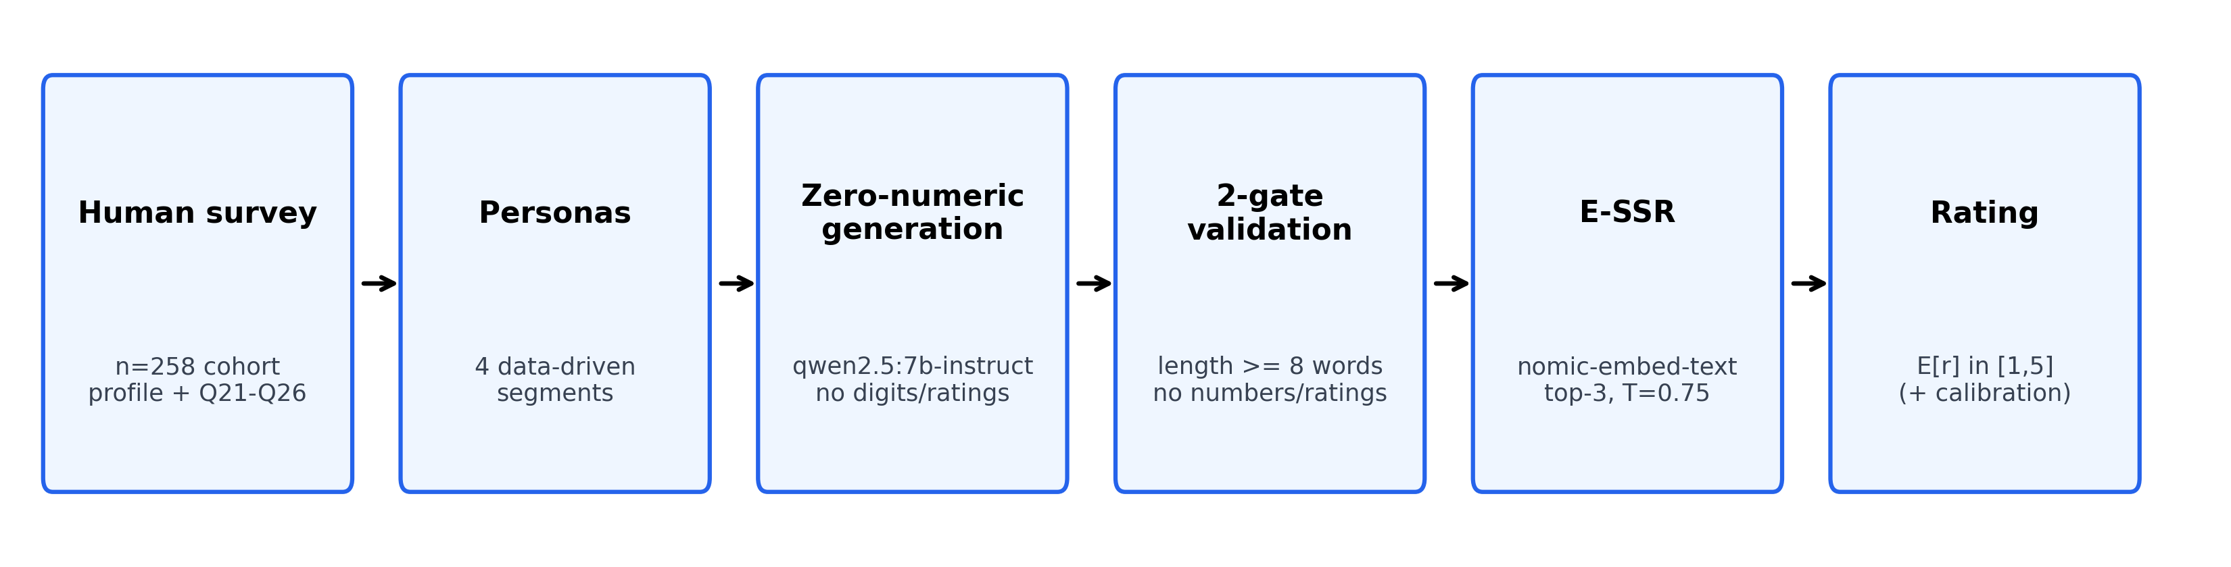
Fig. 1. End-to-end Digital Persona pipeline: survey → personas → zero-numeric generation → two-gate validation → E-SSR → rating.
- Persona grounding: each twin is built from one real respondent's profile (age, gender, education, status, spending, area, brand, price band, OS, replacement habits, usage, main uses, tech comfort, information sources) and their assigned persona description. The twin never sees the person's Q21 rating or any of their Q23–Q26 text.
- Zero-numeric generation: the twin answers Q23–Q26 in natural language; the prompt forbids digits, ratings, stars, fractions and percentages, so the rating must come from meaning, not from a stated number.
- Two-gate validation: gate 1 rejects answers shorter than eight words; gate 2 rejects any answer containing a number or rating. Failed answers are regenerated with a rewrite instruction. First-pass rate: 97.5% (held-out), 97.5% (development).
- E-SSR: the Q26 answer and five anchor statements are embedded (nomic-embed-text, 768 dimensions). With cosine similarities γ(r), w(r) = γ(r) − min_j γ(j); only the top k = 3 weights are kept; p_raw(r) = w(r)/Σ w; p(r) = p_raw(r)^(1/T) / Σ_j p_raw(j)^(1/T) with T = 0.75; rating E[r] = Σ r·p(r). Canonical SSR is the special case k = 5, T = 1.
- v2 purchase-intention anchors (1→5): “I would definitely not buy this smartphone.” | “I am unlikely to buy this smartphone.” | “I am not sure whether I would buy this smartphone.” | “I would probably buy this smartphone.” | “I would definitely buy this smartphone.”
- Calibration: twin E-SSR scores are z-scored and mapped to the human Q21 mean and SD of respondents not in the evaluated sample (held-out run: n=218, mean 3.537, SD 1.120; development run: n=178, mean 3.449, SD 1.193). No evaluated person's rating is used.
- Hybrid: the average of the calibrated E-SSR score and the twin's direct 1–5 answer, clipped to [1, 5]. Individual metrics round every continuous score to the nearest integer.
- Chance baseline: one random draw per person from the calibration-reference Q21 distribution (a single fixed-seed sample).
Source: evaluation/phase19_twin_validation/run_twin_validation.py (gate, calibration, hybrid definitions); improved_ssr.py (E-SSR formula); docs/survey_instrument/smartphone_construct_anchor_statements.csv

5. ★★ Validation Against Real Humans (Digital Twins)
Design: for each sampled respondent a twin is generated from their profile alone, answers the open questions, and is scored. The twin's rating is then compared with that person's real Q21 answer. The development sample (80, stratified 20 per persona) was used while refining anchors and personas; the held-out sample (40, 10 per persona) was drawn from respondents not used in development and was generated once with the frozen v2 pipeline.

5.1 Individual level — held-out (n=40)
Method | Within one point | Exact | MAE | QWK | Spearman
E-SSR | 82.5% | 40.0% | 0.875 | 0.202 | 0.342
Hybrid | 77.5% | 45.0% | 0.900 | 0.206 | 0.319
Calibrated E-SSR | 80.0% | 37.5% | 0.975 | 0.264 | 0.344
Direct LLM rating | 72.5% | 40.0% | 1.025 | 0.087 | 0.176
Chance | 67.5% | 27.5% | 1.075 | 0.315 | 0.320

Source: evaluation/phase19_twin_validation/twin_metrics_bi_heldout.json → individual
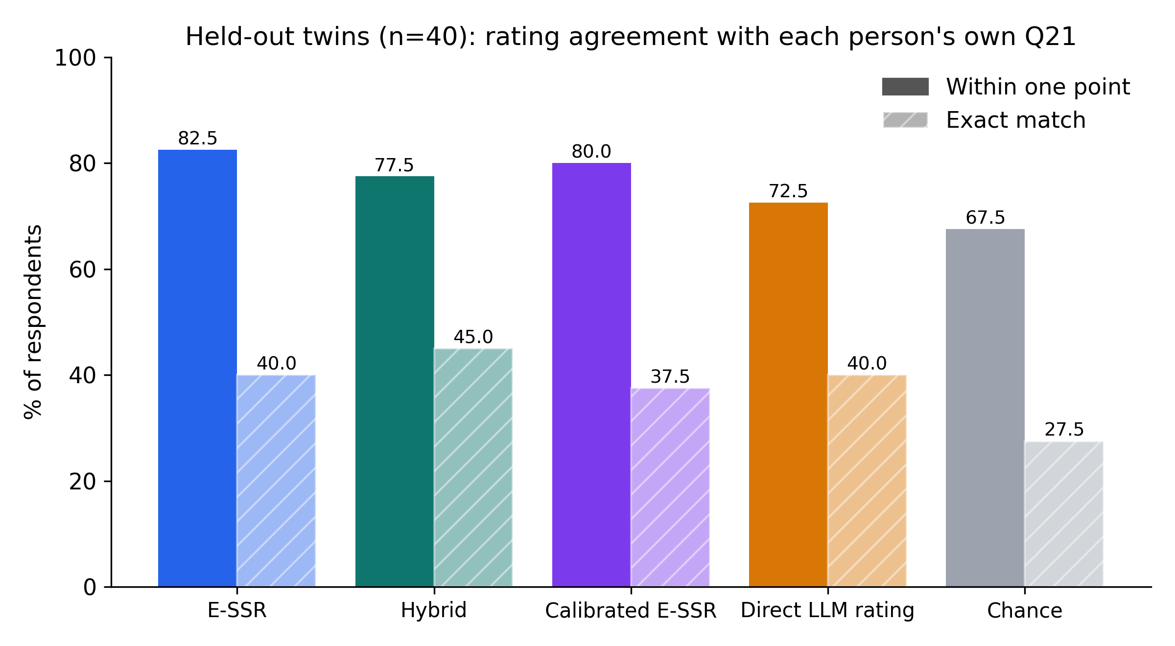
Fig. 2. Held-out twins (n=40): share of people whose twin rating is within one point of / exactly equal to their own Q21. Direct LLM rating and chance shown as baselines.
On unseen respondents E-SSR gives the best within-one-point accuracy (82.5%) and lowest MAE (0.875) of all methods, ahead of direct LLM rating (72.5%, 1.025). Rank-based agreement is weaker on this small sample: E-SSR QWK 0.202 and Spearman 0.342 versus direct 0.087 and 0.176; the single chance draw happened to reach QWK 0.315 and Spearman 0.320, so individual rank agreement on n=40 is not claimed as a strength.

5.2 Individual level — development (n=80)
Method | Within one point | Exact | MAE | QWK | Spearman
E-SSR | 88.8% | 47.5% | 0.650 | 0.363 | 0.390
Hybrid | 88.8% | 53.8% | 0.588 | 0.461 | 0.478
Calibrated E-SSR | 82.5% | 40.0% | 0.838 | 0.376 | 0.339
Direct LLM rating | 85.0% | 56.2% | 0.613 | 0.361 | 0.439
Chance | 66.2% | 35.0% | 1.137 | -0.064 | -0.081

Source: evaluation/phase19_twin_validation/twin_metrics_bi.json → individual
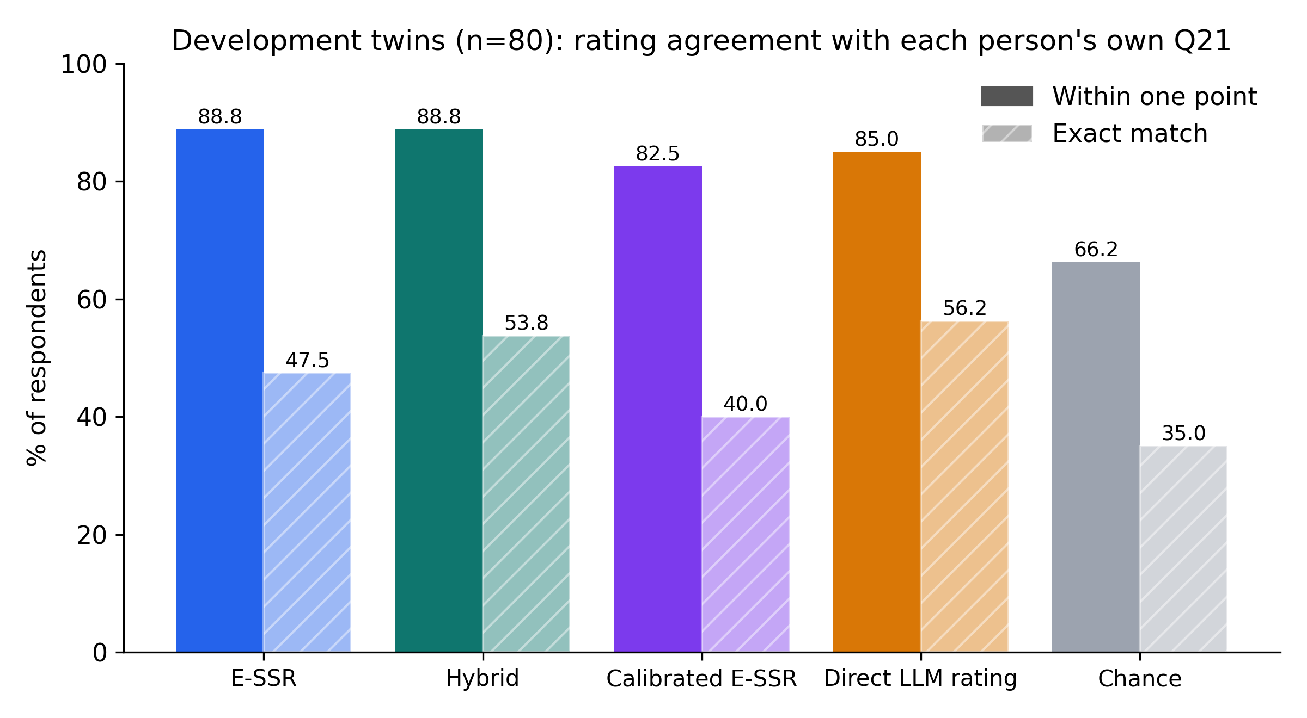
Fig. 3. Development twins (n=80): within-one-point and exact agreement with each person's own Q21, with direct and chance baselines.
On the development set every model-based method beats chance by a wide margin (within one point 88.8% for E-SSR vs 66.2% for chance). The hybrid has the highest QWK (0.461), Spearman (0.478) and lowest MAE (0.588); direct rating has the highest exact agreement (56.2%).

5.3 Persona level
Development (n=80):
Persona | n | Human Q21 | Twin E-SSR | Calibrated | Hybrid | Direct
P1 | 20 | 4.35 | 3.654 | 3.835 | 4.242 | 4.65
P2 | 20 | 3.15 | 3.172 | 2.738 | 2.844 | 2.95
P3 | 20 | 3.35 | 3.505 | 3.489 | 3.720 | 3.95
P4 | 20 | 3.75 | 3.701 | 3.960 | 3.980 | 4.00

Source: evaluation/phase19_twin_validation/twin_persona_table_bi.csv
Held-out (n=40):
Persona | n | Human Q21 | Twin E-SSR | Calibrated | Hybrid | Direct
P1 | 10 | 3.40 | 3.683 | 3.897 | 4.198 | 4.50
P2 | 10 | 3.40 | 3.259 | 2.710 | 2.855 | 3.00
P3 | 10 | 3.20 | 3.626 | 3.745 | 3.872 | 4.00
P4 | 10 | 3.50 | 3.670 | 3.883 | 3.891 | 3.90

Source: evaluation/phase19_twin_validation/twin_persona_table_bi_heldout.csv
Persona-level metric | E-SSR | Calibrated | Hybrid | Direct
Development spearman | 0.800 | 0.800 | 1.000 | 1.000
Development MAE | 0.231 | 0.319 | 0.253 | 0.338
Held-out spearman | 0.316 | 0.316 | 0.316 | -0.316
Held-out MAE | 0.255 | 0.528 | 0.602 | 0.675

Source: evaluation/phase19_twin_validation/twin_metrics_bi.json; evaluation/phase19_twin_validation/twin_metrics_bi_heldout.json → persona
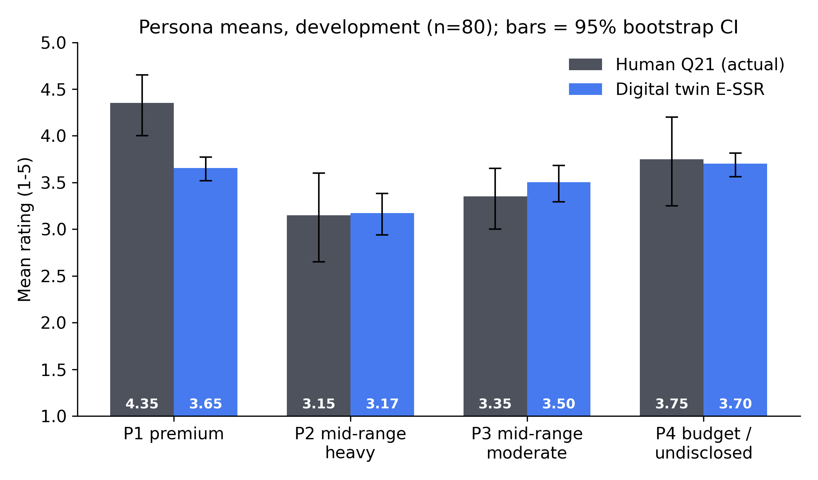
Fig. 4. Development persona means of human Q21 and twin E-SSR with 95% bootstrap confidence intervals (2000 resamples of each persona's 20 respondents).
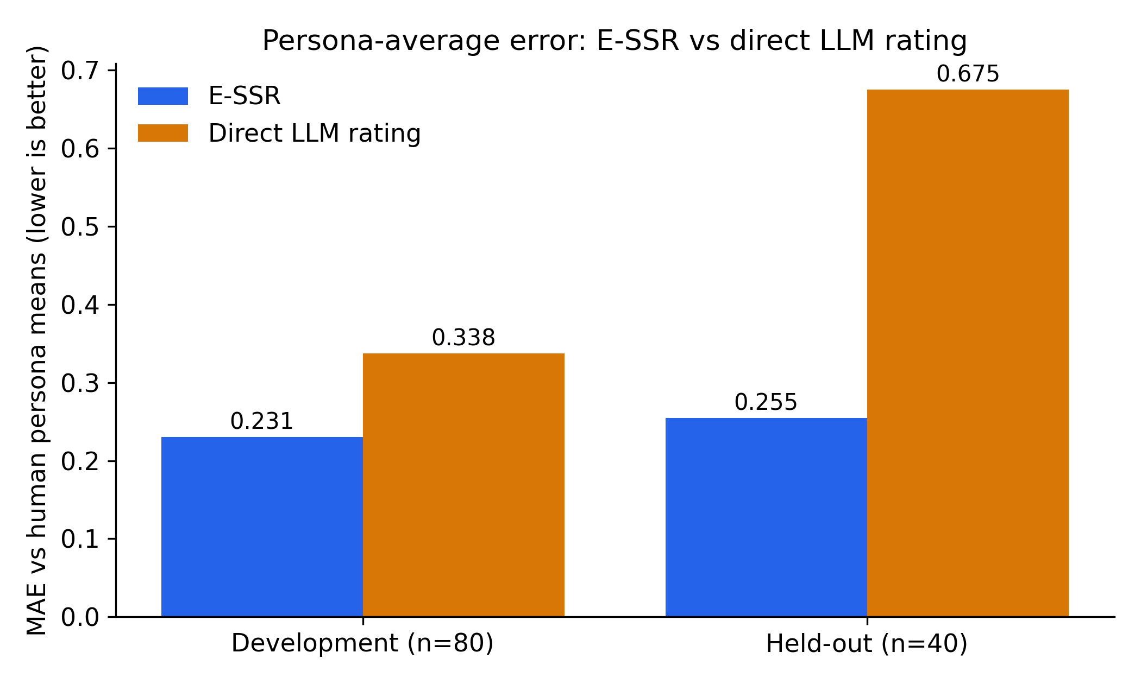
Fig. 5. Mean absolute error between twin persona means and human persona means: E-SSR vs direct LLM rating, development and held-out.
E-SSR reproduces persona-level averages more closely than direct rating on both samples (MAE 0.231 vs 0.338 in development; 0.255 vs 0.675 held-out). In development, E-SSR ranks the four personas with Spearman 0.800 and the hybrid with 1.000. Brand-level hybrid Spearman in development is 1.000 over 3 brand groups.

5.4 Distribution
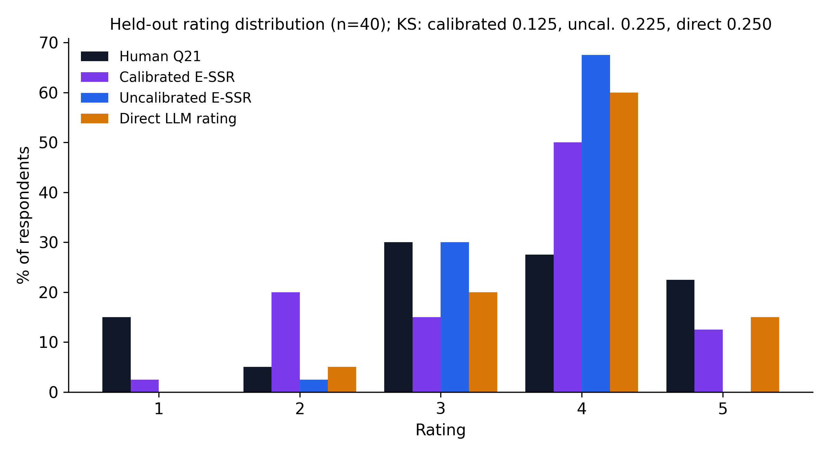
Fig. 6. Held-out rating distributions: human Q21, calibrated E-SSR, uncalibrated E-SSR and direct LLM rating. Calibrated shares are derived by rounding the saved calibrated scores (t_cal).
Uncalibrated E-SSR compresses ratings toward 3–4 (SD 0.357 vs human 1.298). Calibration restores the spread (SD 1.023) and gives the closest distribution to humans: KS 0.125 and Wasserstein 0.454, versus 0.225/0.809 uncalibrated and 0.250/0.625 for direct rating.

6. ★★ Comparison with Baselines and Ablation
Across both twin samples E-SSR is compared with (i) directly asking the same LLM for a 1–5 rating and (ii) chance. On held-out respondents E-SSR leads on within-one-point accuracy, MAE, persona-mean error and (after calibration) distribution match (Sections 5.1–5.4). To isolate each component, the 24-response benchmark below scores the same generated texts with different conversion rules against an LLM-judge reference (not human ground truth).
Conversion rule | Exact | Within one point | MAE | QWK | Spearman
Majority baseline | 62.5% | 100.0% | 0.375 | 0.000 | n/a
Nearest anchor (k=1) | 45.8% | 100.0% | 0.542 | 0.439 | 0.456
Canonical SSR (k=5, T=1) | 70.8% | 100.0% | 0.292 | 0.571 | 0.687
E-SSR k=5, T=0.75 | 75.0% | 100.0% | 0.250 | 0.611 | 0.707
E-SSR k=3, T=0.75 | 79.2% | 100.0% | 0.208 | 0.697 | 0.688

Source: evaluation/generation_quality_improvement_v1/phase7_ssr_candidates/phase7_metrics.json
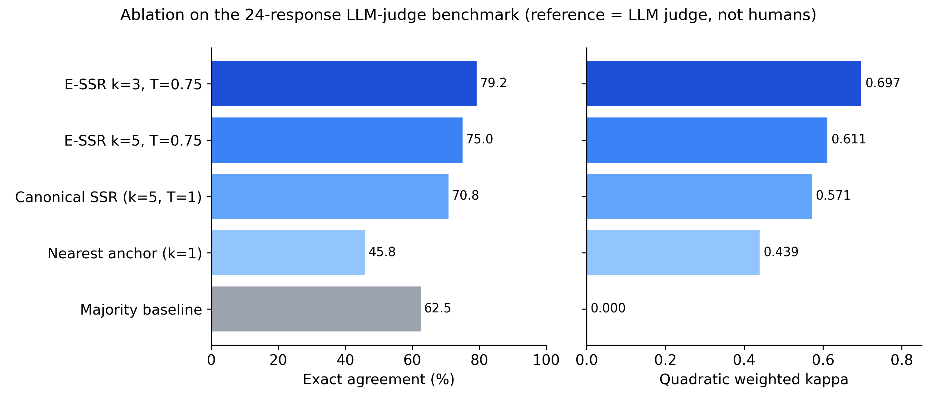
Fig. 7. Ablation on the 24-response LLM-judge benchmark: exact agreement and QWK for the majority baseline, nearest anchor, canonical SSR, E-SSR without truncation (k=5) and E-SSR (k=3).
- Soft scoring vs nearest anchor: using the similarity distribution instead of the single closest anchor raises exact agreement from 45.8% to 70.8%.
- Temperature sharpening (T=0.75): E-SSR k=5 reaches 75.0% exact, QWK 0.611.
- Top-3 truncation removes the two least similar anchors: 79.2% exact, QWK 0.697, MAE 0.208 — the best of all rules.
- The majority baseline gets 62.5% exact but QWK 0.000, showing that exact agreement alone rewards always predicting 4.
Calibration was studied separately on real human text with 5×4 repeated cross-validation (Phase 18, n=251). The pre-registered selection rule chose M9 hybrid M6->M2: QWK 0.341 vs 0.248 uncalibrated, Spearman 0.356 vs 0.298, prediction SD 0.953 vs 0.590 (mean over folds).
Source: evaluation/phase18_hybrid_ssr/phase18_metrics.json → human_cv, best_human

7. ★ E-SSR on Real Human Text
To check that E-SSR reads real consumer language, it was applied to each respondent's own Q26 answer and compared with the same person's Q21 (n=251). Spearman is 0.302 overall (p = 1.10e-06), 0.396 for answers of three or more words (n=142) and 0.118 for one-word answers (n=102). Within one point: 87.6% overall. The held-out twin sample shows the same pattern for its 40 humans: 0.435 overall and 0.617 for 3+ word answers (n=20).
Source: evaluation/phase13_human_ssr/phase13_metrics.json; evaluation/phase19_twin_validation/twin_metrics_bi_heldout.json
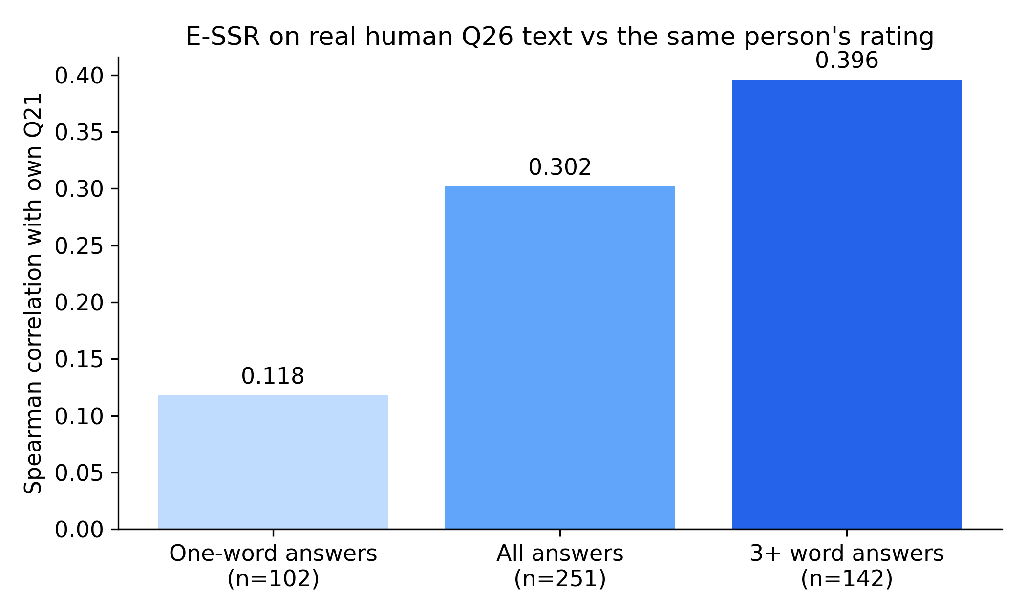
Fig. 8. E-SSR applied to real human Q26 answers: Spearman correlation with the same person's Q21, by answer length.

8. ★ Development Process: v1 → v2
v1 used the original behavioral-intention anchors (continued use). v2 replaced them with purchase-intention anchors that match the rebuy question and refined the P2 and P4 persona descriptions. Both were evaluated on the same 80 development respondents.
Metric (development, n=80) | v1 | v2
Persona Spearman, twin E-SSR | 0.400 | 0.800
Persona MAE, twin E-SSR | 0.403 | 0.231
Persona Spearman, direct rating | 0.400 | 1.000
Persona MAE, direct rating | 0.388 | 0.338
Gate first-pass rate | 95.0% | 97.5%

Source: evaluation/phase19_twin_validation/twin_metrics.json; evaluation/phase19_twin_validation/twin_metrics_bi.json
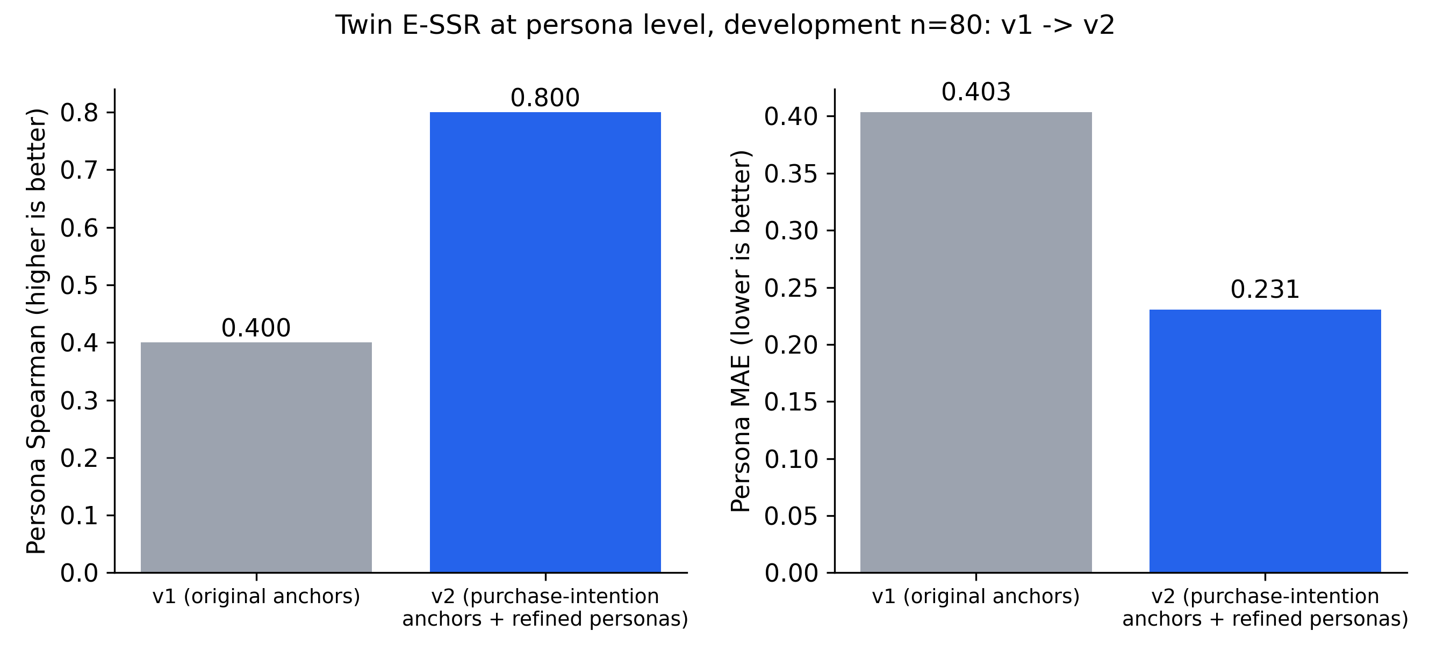
Fig. 9. Persona-level Spearman and MAE of twin E-SSR before (v1) and after (v2) anchor and persona refinement, development set.
Persona ranking doubled from 0.400 to 0.800 and persona-mean error fell from 0.403 to 0.231. These gains were measured on the development set; the held-out run (Section 5) is the unbiased confirmation.

9. Case Studies: Three Real Phones
Construct | Google Pixel 8a | OnePlus Nord CE4 5G | Samsung Galaxy M35 5G
Performance expectancy | 3.309 | 3.603 | 3.360
Effort expectancy | 4.243 | 3.881 | 4.082
Hedonic motivation | 3.887 | 3.703 | 3.889
Social influence | 3.301 | 2.970 | 2.969
Perceived protection | 2.588 | 2.324 | 1.940
Behavioral intention | 3.171 | 3.235 | 2.876
Responses scored / expected | 24/24 | 24/24 | not recorded/not recorded
Passed gate on first attempt | 16 | 19 | not recorded
Total runtime (s) | 933.3 | 694.9 | 1291.5
LLM calls (generation + corrections) | 9 | 7 | 7

Saved runs used: Google Pixel 8a: google_pixel_8a_20261106_125851; OnePlus Nord CE4 5G: oneplus_nord_ce4_5g_20261106_123600; Samsung Galaxy M35 5G: samsung_galaxy_m35_5g_20261106_110236. Each evaluates four personas with the offline stack.
Source: data/product_evaluation/google_pixel_8a_20261106_125851/ssr_results/ssr_results.json; data/product_evaluation/oneplus_nord_ce4_5g_20261106_123600/ssr_results/ssr_results.json; data/product_evaluation/samsung_galaxy_m35_5g_20261106_110236/ssr_results/ssr_results.json
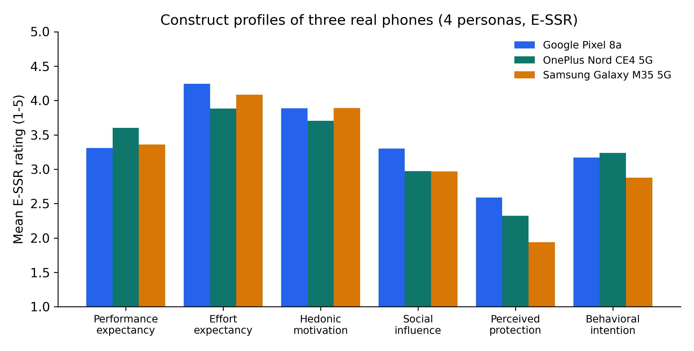
Fig. 10. E-SSR construct profiles for Google Pixel 8a, OnePlus Nord CE4 5G and Samsung Galaxy M35 5G (four personas each).

10. ★ Implementation and Reproducibility
- Fully offline stack: generation qwen2.5:7b-instruct and embeddings nomic-embed-text (768-d), both served locally by Ollama; no cloud API.
- Twin generation runtime: median 69.2 s per twin (four answers + direct rating) over 120 saved twins.
- Gate first-pass rate 97.5% (held-out) and 97.5% (development).
- 85 saved product-evaluation runs with complete SSR outputs in data/product_evaluation/.
- Automated test suite: 1 failed, 835 passed, 2 warnings in 317.16s (0:05:17).
- Fixed seeds; calibration uses only respondents outside the evaluated sample; held-out twins were generated once with the frozen v2 pipeline.
Source: evaluation/phase19_twin_validation/twin_metrics_bi_heldout.json; evaluation/phase19_twin_validation/twin_metrics_bi.json; evaluation/phase19_twin_validation/twins*.jsonl; reports/ieee_results/pytest_summary.txt

11. ★ Limitations and Future Work
- Pilot sample sizes: 80 development and 40 held-out twins; persona-level statistics rest on four groups, so confidence intervals are wide.
- The method is strongest at group level (persona means, distributions); individual-level rank agreement is modest (held-out QWK 0.202).
- A single generator model (qwen2.5:7b-instruct) and a single embedding model were evaluated.
- Uncalibrated E-SSR compresses the rating spread (held-out SD 0.357 vs human 1.298); calibration is needed for distribution-level use.
- Persona ranking cannot be tested on held-out data: human persona means lie within 0.3 points of each other (3.2–3.5).
- Planned: a full-cohort run over all 258 respondents to tighten persona-level estimates.

12. ★★ Ready-to-Paste Paper Text

Abstract
Can a language model stand in for real consumers when estimating purchase intention? We present Digital Persona, an offline pipeline that builds digital twins of real survey respondents, lets each twin describe its phone in free text with numbers forbidden, and converts the text to a 1–5 rating with Enhanced Semantic Similarity Rating (E-SSR): embedding similarity to five purchase-intention anchor statements with top-3 truncation and temperature sharpening. Twins were built from a 258-person smartphone survey and never saw the person's ratings or answers. On 40 held-out respondents, E-SSR placed 82.5% of individuals within one point of their own rating, compared with 72.5% for directly asking the model for a number and 67.5% for chance, with a mean absolute error of 0.875 versus 1.025 and 1.075. Persona-level means were within 0.255 points of human means (direct rating: 0.675), and mean/SD calibration matched the human rating distribution best (Kolmogorov–Smirnov 0.125 vs 0.250). On an 80-person development set a hybrid score reached a quadratic weighted kappa of 0.461. Results support semantic rating as a more faithful route than direct numeric elicitation for group-level synthetic consumer research.
[183 words]

Contributions
- An offline, persona-grounded digital-twin pipeline that elicits consumer opinions in free text with a zero-numeric constraint enforced by a two-gate validator.
- E-SSR, an extension of semantic similarity rating with top-k truncation and temperature sharpening, which outperforms nearest-anchor and canonical SSR in an ablation.
- A twin-level validation against real respondents' own ratings, including a held-out confirmation, where E-SSR beats direct LLM rating on within-one-point accuracy, MAE and persona-mean error.
- A leakage-free calibration that uses only non-evaluated respondents' rating mean and SD and restores the human rating spread.
- Evidence that domain-matched purchase-intention anchors and refined personas double persona-level rank agreement (v1 → v2).

Conclusion
Digital Persona shows that grounding an LLM in real respondent profiles and reading its free-text answers semantically yields ratings that track real people better than asking the model for a number. On unseen respondents, E-SSR reached 82.5% within-one-point accuracy and persona-mean error of 0.255, outperforming direct rating on both, and calibration brought the rating distribution into line with the human one. The approach is most reliable for group-level questions such as persona averages and rating distributions; a full-cohort run and additional generator models are the next steps.

Figure captions
Fig. 1. End-to-end Digital Persona pipeline: survey → personas → zero-numeric generation → two-gate validation → E-SSR → rating.
Fig. 2. Held-out twins (n=40): share of people whose twin rating is within one point of / exactly equal to their own Q21. Direct LLM rating and chance shown as baselines.
Fig. 3. Development twins (n=80): within-one-point and exact agreement with each person's own Q21, with direct and chance baselines.
Fig. 4. Development persona means of human Q21 and twin E-SSR with 95% bootstrap confidence intervals (2000 resamples of each persona's 20 respondents).
Fig. 5. Mean absolute error between twin persona means and human persona means: E-SSR vs direct LLM rating, development and held-out.
Fig. 6. Held-out rating distributions: human Q21, calibrated E-SSR, uncalibrated E-SSR and direct LLM rating. Calibrated shares are derived by rounding the saved calibrated scores (t_cal).
Fig. 7. Ablation on the 24-response LLM-judge benchmark: exact agreement and QWK for the majority baseline, nearest anchor, canonical SSR, E-SSR without truncation (k=5) and E-SSR (k=3).
Fig. 8. E-SSR applied to real human Q26 answers: Spearman correlation with the same person's Q21, by answer length.
Fig. 9. Persona-level Spearman and MAE of twin E-SSR before (v1) and after (v2) anchor and persona refinement, development set.
Fig. 10. E-SSR construct profiles for Google Pixel 8a, OnePlus Nord CE4 5G and Samsung Galaxy M35 5G (four personas each).

13. Appendix: Every Number and Its Source
Key | Value | Source file
dev.n_pairs | 80 | evaluation/phase19_twin_validation/twin_metrics_bi.json
dev.gate_first_pass | 0.975 | evaluation/phase19_twin_validation/twin_metrics_bi.json
dev.calib_ref.n | 178 | evaluation/phase19_twin_validation/twin_metrics_bi.json
dev.calib_ref.mean | 3.449438202247191 | evaluation/phase19_twin_validation/twin_metrics_bi.json
dev.calib_ref.sd | 1.1933074764902787 | evaluation/phase19_twin_validation/twin_metrics_bi.json
dev.ind.twin_essr.exact | 0.475 | evaluation/phase19_twin_validation/twin_metrics_bi.json
dev.ind.twin_essr.within1 | 0.8875 | evaluation/phase19_twin_validation/twin_metrics_bi.json
dev.ind.twin_essr.MAE | 0.65 | evaluation/phase19_twin_validation/twin_metrics_bi.json
dev.ind.twin_essr.QWK | 0.36316695352839923 | evaluation/phase19_twin_validation/twin_metrics_bi.json
dev.ind.twin_essr.spearman | 0.3899631558424849 | evaluation/phase19_twin_validation/twin_metrics_bi.json
dev.ind.twin_hybrid.exact | 0.5375 | evaluation/phase19_twin_validation/twin_metrics_bi.json
dev.ind.twin_hybrid.within1 | 0.8875 | evaluation/phase19_twin_validation/twin_metrics_bi.json
dev.ind.twin_hybrid.MAE | 0.5875 | evaluation/phase19_twin_validation/twin_metrics_bi.json
dev.ind.twin_hybrid.QWK | 0.4613583138173303 | evaluation/phase19_twin_validation/twin_metrics_bi.json
dev.ind.twin_hybrid.spearman | 0.4781423582593454 | evaluation/phase19_twin_validation/twin_metrics_bi.json
dev.ind.twin_essr_calibrated.exact | 0.4 | evaluation/phase19_twin_validation/twin_metrics_bi.json
dev.ind.twin_essr_calibrated.within1 | 0.825 | evaluation/phase19_twin_validation/twin_metrics_bi.json
dev.ind.twin_essr_calibrated.MAE | 0.8375 | evaluation/phase19_twin_validation/twin_metrics_bi.json
dev.ind.twin_essr_calibrated.QWK | 0.37601736299511657 | evaluation/phase19_twin_validation/twin_metrics_bi.json
dev.ind.twin_essr_calibrated.spearman | 0.33906104342287163 | evaluation/phase19_twin_validation/twin_metrics_bi.json
dev.ind.twin_direct.exact | 0.5625 | evaluation/phase19_twin_validation/twin_metrics_bi.json
dev.ind.twin_direct.within1 | 0.85 | evaluation/phase19_twin_validation/twin_metrics_bi.json
dev.ind.twin_direct.MAE | 0.6125 | evaluation/phase19_twin_validation/twin_metrics_bi.json
dev.ind.twin_direct.QWK | 0.36069455406471973 | evaluation/phase19_twin_validation/twin_metrics_bi.json
dev.ind.twin_direct.spearman | 0.43948291211445445 | evaluation/phase19_twin_validation/twin_metrics_bi.json
dev.ind.chance_baseline.exact | 0.35 | evaluation/phase19_twin_validation/twin_metrics_bi.json
dev.ind.chance_baseline.within1 | 0.6625 | evaluation/phase19_twin_validation/twin_metrics_bi.json
dev.ind.chance_baseline.MAE | 1.1375 | evaluation/phase19_twin_validation/twin_metrics_bi.json
dev.ind.chance_baseline.QWK | -0.06360235168359174 | evaluation/phase19_twin_validation/twin_metrics_bi.json
dev.ind.chance_baseline.spearman | -0.0810131935160355 | evaluation/phase19_twin_validation/twin_metrics_bi.json
dev.persona.twin_E.spearman | 0.7999999999999999 | evaluation/phase19_twin_validation/twin_metrics_bi.json
dev.persona.twin_E.pearson | 0.764778915811083 | evaluation/phase19_twin_validation/twin_metrics_bi.json
dev.persona.twin_E.MAE | 0.2305593826337916 | evaluation/phase19_twin_validation/twin_metrics_bi.json
dev.persona.twin_cal.spearman | 0.7999999999999999 | evaluation/phase19_twin_validation/twin_metrics_bi.json
dev.persona.twin_cal.pearson | 0.762480855933418 | evaluation/phase19_twin_validation/twin_metrics_bi.json
dev.persona.twin_cal.MAE | 0.31919821102524426 | evaluation/phase19_twin_validation/twin_metrics_bi.json
dev.persona.twin_hyb.spearman | 1.0 | evaluation/phase19_twin_validation/twin_metrics_bi.json
dev.persona.twin_hyb.pearson | 0.8610122881165744 | evaluation/phase19_twin_validation/twin_metrics_bi.json
dev.persona.twin_hyb.MAE | 0.2533491055126217 | evaluation/phase19_twin_validation/twin_metrics_bi.json
dev.persona.twin_DLE.spearman | 1.0 | evaluation/phase19_twin_validation/twin_metrics_bi.json
dev.persona.twin_DLE.pearson | 0.893329278872974 | evaluation/phase19_twin_validation/twin_metrics_bi.json
dev.persona.twin_DLE.MAE | 0.33750000000000013 | evaluation/phase19_twin_validation/twin_metrics_bi.json
dev.persona.human_text_E.spearman | 0.7999999999999999 | evaluation/phase19_twin_validation/twin_metrics_bi.json
dev.persona.human_text_E.pearson | 0.9091259756566515 | evaluation/phase19_twin_validation/twin_metrics_bi.json
dev.persona.human_text_E.MAE | 0.3159331928780338 | evaluation/phase19_twin_validation/twin_metrics_bi.json
dev.dist.W1_twin_essr_vs_human | 0.5223765896870822 | evaluation/phase19_twin_validation/twin_metrics_bi.json
dev.dist.W1_twin_dle_vs_human | 0.3375 | evaluation/phase19_twin_validation/twin_metrics_bi.json
dev.dist.W1_twin_cal_vs_human | 0.3289989422469009 | evaluation/phase19_twin_validation/twin_metrics_bi.json
dev.dist.W1_twin_hyb_vs_human | 0.34553870440771295 | evaluation/phase19_twin_validation/twin_metrics_bi.json
dev.dist.KS_twin_essr_vs_human | 0.2125 | evaluation/phase19_twin_validation/twin_metrics_bi.json
dev.dist.KS_twin_dle_vs_human | 0.15 | evaluation/phase19_twin_validation/twin_metrics_bi.json
dev.dist.KS_twin_cal_vs_human | 0.125 | evaluation/phase19_twin_validation/twin_metrics_bi.json
dev.dist.KS_twin_hyb_vs_human | 0.125 | evaluation/phase19_twin_validation/twin_metrics_bi.json
dev.dist.SD.human_q21 | 1.0380269746013349 | evaluation/phase19_twin_validation/twin_metrics_bi.json
dev.dist.SD.twin_E | 0.45135141291541686 | evaluation/phase19_twin_validation/twin_metrics_bi.json
dev.dist.SD.twin_DLE | 0.6749355337241806 | evaluation/phase19_twin_validation/twin_metrics_bi.json
dev.dist.SD.twin_cal | 1.044194591478428 | evaluation/phase19_twin_validation/twin_metrics_bi.json
dev.dist.SD.twin_hyb | 0.7116080874416069 | evaluation/phase19_twin_validation/twin_metrics_bi.json
dev.dist.human_q21_share | {"1": 0.062, "2": 0.025, "3": 0.325, "4": 0.375, "5": 0.212} | evaluation/phase19_twin_validation/twin_metrics_bi.json
dev.dist.twin_essr_share | {"2": 0.062, "3": 0.3, "4": 0.638} | evaluation/phase19_twin_validation/twin_metrics_bi.json
dev.dist.twin_dle_share | {"2": 0.012, "3": 0.25, "4": 0.575, "5": 0.162} | evaluation/phase19_twin_validation/twin_metrics_bi.json
dev.human_text_q21.all.n | 80 | evaluation/phase19_twin_validation/twin_metrics_bi.json
dev.human_text_q21.all.spearman_Q26 | 0.25770723047057337 | evaluation/phase19_twin_validation/twin_metrics_bi.json
dev.human_text_q21.3plus.n | 40 | evaluation/phase19_twin_validation/twin_metrics_bi.json
dev.human_text_q21.3plus.spearman_Q26 | 0.5152501205311809 | evaluation/phase19_twin_validation/twin_metrics_bi.json
ho.n_pairs | 40 | evaluation/phase19_twin_validation/twin_metrics_bi_heldout.json
ho.gate_first_pass | 0.975 | evaluation/phase19_twin_validation/twin_metrics_bi_heldout.json
ho.calib_ref.n | 218 | evaluation/phase19_twin_validation/twin_metrics_bi_heldout.json
ho.calib_ref.mean | 3.536697247706422 | evaluation/phase19_twin_validation/twin_metrics_bi_heldout.json
ho.calib_ref.sd | 1.1200033369320528 | evaluation/phase19_twin_validation/twin_metrics_bi_heldout.json
ho.ind.twin_essr.exact | 0.4 | evaluation/phase19_twin_validation/twin_metrics_bi_heldout.json
ho.ind.twin_essr.within1 | 0.825 | evaluation/phase19_twin_validation/twin_metrics_bi_heldout.json
ho.ind.twin_essr.MAE | 0.875 | evaluation/phase19_twin_validation/twin_metrics_bi_heldout.json
ho.ind.twin_essr.QWK | 0.2024539877300614 | evaluation/phase19_twin_validation/twin_metrics_bi_heldout.json
ho.ind.twin_essr.spearman | 0.3418161034856336 | evaluation/phase19_twin_validation/twin_metrics_bi_heldout.json
ho.ind.twin_hybrid.exact | 0.45 | evaluation/phase19_twin_validation/twin_metrics_bi_heldout.json
ho.ind.twin_hybrid.within1 | 0.775 | evaluation/phase19_twin_validation/twin_metrics_bi_heldout.json
ho.ind.twin_hybrid.MAE | 0.9 | evaluation/phase19_twin_validation/twin_metrics_bi_heldout.json
ho.ind.twin_hybrid.QWK | 0.20626631853785904 | evaluation/phase19_twin_validation/twin_metrics_bi_heldout.json
ho.ind.twin_hybrid.spearman | 0.3190676645825221 | evaluation/phase19_twin_validation/twin_metrics_bi_heldout.json
ho.ind.twin_essr_calibrated.exact | 0.375 | evaluation/phase19_twin_validation/twin_metrics_bi_heldout.json
ho.ind.twin_essr_calibrated.within1 | 0.8 | evaluation/phase19_twin_validation/twin_metrics_bi_heldout.json
ho.ind.twin_essr_calibrated.MAE | 0.975 | evaluation/phase19_twin_validation/twin_metrics_bi_heldout.json
ho.ind.twin_essr_calibrated.QWK | 0.26363636363636367 | evaluation/phase19_twin_validation/twin_metrics_bi_heldout.json
ho.ind.twin_essr_calibrated.spearman | 0.34373002501768796 | evaluation/phase19_twin_validation/twin_metrics_bi_heldout.json
ho.ind.twin_direct.exact | 0.4 | evaluation/phase19_twin_validation/twin_metrics_bi_heldout.json
ho.ind.twin_direct.within1 | 0.725 | evaluation/phase19_twin_validation/twin_metrics_bi_heldout.json
ho.ind.twin_direct.MAE | 1.025 | evaluation/phase19_twin_validation/twin_metrics_bi_heldout.json
ho.ind.twin_direct.QWK | 0.0871794871794872 | evaluation/phase19_twin_validation/twin_metrics_bi_heldout.json
ho.ind.twin_direct.spearman | 0.17649903680657641 | evaluation/phase19_twin_validation/twin_metrics_bi_heldout.json
ho.ind.chance_baseline.exact | 0.275 | evaluation/phase19_twin_validation/twin_metrics_bi_heldout.json
ho.ind.chance_baseline.within1 | 0.675 | evaluation/phase19_twin_validation/twin_metrics_bi_heldout.json
ho.ind.chance_baseline.MAE | 1.075 | evaluation/phase19_twin_validation/twin_metrics_bi_heldout.json
ho.ind.chance_baseline.QWK | 0.31455399061032874 | evaluation/phase19_twin_validation/twin_metrics_bi_heldout.json
ho.ind.chance_baseline.spearman | 0.31984568966673005 | evaluation/phase19_twin_validation/twin_metrics_bi_heldout.json
ho.persona.twin_E.spearman | 0.316227766016838 | evaluation/phase19_twin_validation/twin_metrics_bi_heldout.json
ho.persona.twin_E.pearson | -0.029226840878356863 | evaluation/phase19_twin_validation/twin_metrics_bi_heldout.json
ho.persona.twin_E.MAE | 0.25479144579285773 | evaluation/phase19_twin_validation/twin_metrics_bi_heldout.json
ho.persona.twin_cal.spearman | 0.316227766016838 | evaluation/phase19_twin_validation/twin_metrics_bi_heldout.json
ho.persona.twin_cal.pearson | -0.02237535030016896 | evaluation/phase19_twin_validation/twin_metrics_bi_heldout.json
ho.persona.twin_cal.MAE | 0.528436399714611 | evaluation/phase19_twin_validation/twin_metrics_bi_heldout.json
ho.persona.twin_hyb.spearman | 0.316227766016838 | evaluation/phase19_twin_validation/twin_metrics_bi_heldout.json
ho.persona.twin_hyb.pearson | -0.06743975107674757 | evaluation/phase19_twin_validation/twin_metrics_bi_heldout.json
ho.persona.twin_hyb.MAE | 0.6017181998573055 | evaluation/phase19_twin_validation/twin_metrics_bi_heldout.json
ho.persona.twin_DLE.spearman | -0.316227766016838 | evaluation/phase19_twin_validation/twin_metrics_bi_heldout.json
ho.persona.twin_DLE.pearson | -0.10604746049596288 | evaluation/phase19_twin_validation/twin_metrics_bi_heldout.json
ho.persona.twin_DLE.MAE | 0.6749999999999999 | evaluation/phase19_twin_validation/twin_metrics_bi_heldout.json
ho.persona.human_text_E.spearman | 0.632455532033676 | evaluation/phase19_twin_validation/twin_metrics_bi_heldout.json
ho.persona.human_text_E.pearson | 0.5085130277864756 | evaluation/phase19_twin_validation/twin_metrics_bi_heldout.json
ho.persona.human_text_E.MAE | 0.317448496273684 | evaluation/phase19_twin_validation/twin_metrics_bi_heldout.json
ho.dist.W1_twin_essr_vs_human | 0.809126828176232 | evaluation/phase19_twin_validation/twin_metrics_bi_heldout.json
ho.dist.W1_twin_dle_vs_human | 0.625 | evaluation/phase19_twin_validation/twin_metrics_bi_heldout.json
ho.dist.W1_twin_cal_vs_human | 0.45370453466694083 | evaluation/phase19_twin_validation/twin_metrics_bi_heldout.json
ho.dist.W1_twin_hyb_vs_human | 0.522958536905197 | evaluation/phase19_twin_validation/twin_metrics_bi_heldout.json
ho.dist.KS_twin_essr_vs_human | 0.225 | evaluation/phase19_twin_validation/twin_metrics_bi_heldout.json
ho.dist.KS_twin_dle_vs_human | 0.25 | evaluation/phase19_twin_validation/twin_metrics_bi_heldout.json
ho.dist.KS_twin_cal_vs_human | 0.125 | evaluation/phase19_twin_validation/twin_metrics_bi_heldout.json
ho.dist.KS_twin_hyb_vs_human | 0.15 | evaluation/phase19_twin_validation/twin_metrics_bi_heldout.json
ho.dist.SD.human_q21 | 1.297834735241741 | evaluation/phase19_twin_validation/twin_metrics_bi_heldout.json
ho.dist.SD.twin_E | 0.3567683552945438 | evaluation/phase19_twin_validation/twin_metrics_bi_heldout.json
ho.dist.SD.twin_DLE | 0.7355444521071728 | evaluation/phase19_twin_validation/twin_metrics_bi_heldout.json
ho.dist.SD.twin_cal | 1.0225714110135524 | evaluation/phase19_twin_validation/twin_metrics_bi_heldout.json
ho.dist.SD.twin_hyb | 0.7869146684156879 | evaluation/phase19_twin_validation/twin_metrics_bi_heldout.json
ho.dist.human_q21_share | {"1": 0.15, "2": 0.05, "3": 0.3, "4": 0.275, "5": 0.225} | evaluation/phase19_twin_validation/twin_metrics_bi_heldout.json
ho.dist.twin_essr_share | {"2": 0.025, "3": 0.3, "4": 0.675} | evaluation/phase19_twin_validation/twin_metrics_bi_heldout.json
ho.dist.twin_dle_share | {"2": 0.05, "3": 0.2, "4": 0.6, "5": 0.15} | evaluation/phase19_twin_validation/twin_metrics_bi_heldout.json
ho.human_text_q21.all.n | 40 | evaluation/phase19_twin_validation/twin_metrics_bi_heldout.json
ho.human_text_q21.all.spearman_Q26 | 0.4353159626090748 | evaluation/phase19_twin_validation/twin_metrics_bi_heldout.json
ho.human_text_q21.3plus.n | 20 | evaluation/phase19_twin_validation/twin_metrics_bi_heldout.json
ho.human_text_q21.3plus.spearman_Q26 | 0.6167206899485563 | evaluation/phase19_twin_validation/twin_metrics_bi_heldout.json
dev.brand.twin_E.spearman | 0.5 | evaluation/phase19_twin_validation/twin_metrics_bi.json
dev.brand.twin_E.MAE | 0.4455057516684741 | evaluation/phase19_twin_validation/twin_metrics_bi.json
dev.brand.twin_hyb.spearman | 1.0 | evaluation/phase19_twin_validation/twin_metrics_bi.json
dev.brand.twin_hyb.MAE | 0.19361434588644322 | evaluation/phase19_twin_validation/twin_metrics_bi.json
dev.brand.twin_DLE.spearman | 1.0 | evaluation/phase19_twin_validation/twin_metrics_bi.json
dev.brand.twin_DLE.MAE | 0.2397486772486769 | evaluation/phase19_twin_validation/twin_metrics_bi.json
dev.brand_x_persona.twin_E.spearman | 0.49999999999999994 | evaluation/phase19_twin_validation/twin_metrics_bi.json
dev.brand_x_persona.twin_E.MAE | 0.30459736077831756 | evaluation/phase19_twin_validation/twin_metrics_bi.json
dev.brand_x_persona.twin_hyb.spearman | 0.7999999999999999 | evaluation/phase19_twin_validation/twin_metrics_bi.json
dev.brand_x_persona.twin_hyb.MAE | 0.3166420564540443 | evaluation/phase19_twin_validation/twin_metrics_bi.json
dev.brand_x_persona.twin_DLE.spearman | 0.8720815992723809 | evaluation/phase19_twin_validation/twin_metrics_bi.json
dev.brand_x_persona.twin_DLE.MAE | 0.4288156288156288 | evaluation/phase19_twin_validation/twin_metrics_bi.json
dev.brand.groups | 3 | evaluation/phase19_twin_validation/twin_metrics_bi.json
ho.brand.groups | 1 | evaluation/phase19_twin_validation/twin_metrics_bi_heldout.json
v1.n_pairs | 80 | evaluation/phase19_twin_validation/twin_metrics.json
v1.gate_first_pass | 0.95 | evaluation/phase19_twin_validation/twin_metrics.json
v1.persona.twin_E.spearman | 0.39999999999999997 | evaluation/phase19_twin_validation/twin_metrics.json
v1.persona.twin_E.MAE | 0.40343767155779076 | evaluation/phase19_twin_validation/twin_metrics.json
v1.persona.twin_DLE.spearman | 0.39999999999999997 | evaluation/phase19_twin_validation/twin_metrics.json
v1.persona.twin_DLE.MAE | 0.3875000000000002 | evaluation/phase19_twin_validation/twin_metrics.json
dev.persona_table | [{"persona": "P1", "n": 20, "human_q21": 4.35, "human_text_E": 3.833571139010621, "twin_E": 3.6536812620206423, "twin_cal": 3.8347413958047, "twin_hyb": 4.24237069790235, "twin_DLE": 4.65}, {"persona": "P2", "n": 20, "human_q21": 3.15, "human_text_E": 3.6253545175650776, "twin_E": 3.172045542556964, "twin_cal": 2.7376636525925235, "twin_hyb": 2.843831826296262, "twin_DLE": 2.95}, {"persona": "P3", "n": 20, "human_q21": 3.35, "human_text_E": 3.586711103833237, "twin_E": 3.5049649494273227, "twin_cal": 3.4891101971062093, "twin_hyb": 3.719555098553104, "twin_DLE": 3.95}, {"persona": "P4", "n": 20, "human_q21": 3.75, "human_text_E": 3.7852382891244414, "twin_E": 3.701091699428477, "twin_cal": 3.960087695391992, "twin_hyb": 3.9800438476959954, "twin_DLE": 4.0}] | evaluation/phase19_twin_validation/twin_persona_table_bi.csv
ho.persona_table | [{"persona": "P1", "n": 10, "human_q21": 3.4, "human_text_E": 3.7354303558022615, "twin_E": 3.683173880495416, "twin_cal": 3.89651880310472, "twin_hyb": 4.19825940155236, "twin_DLE": 4.5}, {"persona": "P2", "n": 10, "human_q21": 3.4, "human_text_E": 3.5544093939741708, "twin_E": 3.2590831630638646, "twin_cal": 2.709968725321559, "twin_hyb": 2.85498436266078, "twin_DLE": 3.0}, {"persona": "P3", "n": 10, "human_q21": 3.2, "human_text_E": 3.648177342591943, "twin_E": 3.625552735227272, "twin_cal": 3.7445808582363256, "twin_hyb": 3.872290429118163, "twin_DLE": 4.0}, {"persona": "P4", "n": 10, "human_q21": 3.5, "human_text_E": 3.831776892726361, "twin_E": 3.669522330512609, "twin_cal": 3.882614662838957, "twin_hyb": 3.8913073314194784, "twin_DLE": 3.9}] | evaluation/phase19_twin_validation/twin_persona_table_bi_heldout.csv
v1.persona_table | [{"persona": "P1", "n": 20, "human_q21": 4.35, "human_text_E": 3.9848440409531447, "twin_E": 3.5979524268520664, "twin_DLE": 4.65}, {"persona": "P2", "n": 20, "human_q21": 3.15, "human_text_E": 3.7987368182339702, "twin_E": 3.5625772493868744, "twin_DLE": 3.8}, {"persona": "P3", "n": 20, "human_q21": 3.35, "human_text_E": 3.798632374592647, "twin_E": 3.565049264205922, "twin_DLE": 3.95}, {"persona": "P4", "n": 20, "human_q21": 3.75, "human_text_E": 3.871119135115909, "twin_E": 3.5159234005095668, "twin_DLE": 3.75}] | evaluation/phase19_twin_validation/twin_persona_table.csv
ho.dist.twin_cal_share (derived: round(t_cal)) | {"1": 0.025, "2": 0.2, "3": 0.15, "4": 0.5, "5": 0.125} | evaluation/phase19_twin_validation/twin_pairs_scored_bi_heldout.csv
ho.check.cal_exact_recomputed | 0.375 | evaluation/phase19_twin_validation/twin_pairs_scored_bi_heldout.csv
runtime.twin_seconds_median | 69.25 | evaluation/phase19_twin_validation/twins.jsonl + twins_heldout.jsonl ('seconds' field)
runtime.twin_count | 120 | evaluation/phase19_twin_validation/twins.jsonl + twins_heldout.jsonl
model.generator | qwen2.5:7b-instruct | evaluation/phase19_twin_validation/twin_metrics_bi_heldout.json
model.embedding | nomic-embed-text | evaluation/phase19_twin_validation/twin_metrics_bi_heldout.json
model.ssr | E-SSR k=3 T=0.75, bi anchors | evaluation/phase19_twin_validation/twin_metrics_bi_heldout.json
p7.label | Phase 7 EXPLORATORY candidates; test n=24 (LLM-judge reference, not human ground truth); calibration n=48 disjoint | evaluation/generation_quality_improvement_v1/phase7_ssr_candidates/phase7_metrics.json
p7.n_test | 24 | evaluation/generation_quality_improvement_v1/phase7_ssr_candidates/phase7_metrics.json
p7.Majority baseline.exact | 0.625 | evaluation/generation_quality_improvement_v1/phase7_ssr_candidates/phase7_metrics.json
p7.Majority baseline.within1 | 1.0 | evaluation/generation_quality_improvement_v1/phase7_ssr_candidates/phase7_metrics.json
p7.Majority baseline.MAE | 0.375 | evaluation/generation_quality_improvement_v1/phase7_ssr_candidates/phase7_metrics.json
p7.Majority baseline.qwk | 0.0 | evaluation/generation_quality_improvement_v1/phase7_ssr_candidates/phase7_metrics.json
p7.Majority baseline.spearman | null | evaluation/generation_quality_improvement_v1/phase7_ssr_candidates/phase7_metrics.json
p7.Nearest anchor (k=1).exact | 0.4583333333333333 | evaluation/generation_quality_improvement_v1/phase7_ssr_candidates/phase7_metrics.json
p7.Nearest anchor (k=1).within1 | 1.0 | evaluation/generation_quality_improvement_v1/phase7_ssr_candidates/phase7_metrics.json
p7.Nearest anchor (k=1).MAE | 0.5416666666666666 | evaluation/generation_quality_improvement_v1/phase7_ssr_candidates/phase7_metrics.json
p7.Nearest anchor (k=1).qwk | 0.4388489208633094 | evaluation/generation_quality_improvement_v1/phase7_ssr_candidates/phase7_metrics.json
p7.Nearest anchor (k=1).spearman | 0.45564545641857024 | evaluation/generation_quality_improvement_v1/phase7_ssr_candidates/phase7_metrics.json
p7.Canonical SSR (k=5, T=1).exact | 0.7083333333333334 | evaluation/generation_quality_improvement_v1/phase7_ssr_candidates/phase7_metrics.json
p7.Canonical SSR (k=5, T=1).within1 | 1.0 | evaluation/generation_quality_improvement_v1/phase7_ssr_candidates/phase7_metrics.json
p7.Canonical SSR (k=5, T=1).MAE | 0.2916666666666667 | evaluation/generation_quality_improvement_v1/phase7_ssr_candidates/phase7_metrics.json
p7.Canonical SSR (k=5, T=1).qwk | 0.5714285714285714 | evaluation/generation_quality_improvement_v1/phase7_ssr_candidates/phase7_metrics.json
p7.Canonical SSR (k=5, T=1).spearman | 0.6867760386262186 | evaluation/generation_quality_improvement_v1/phase7_ssr_candidates/phase7_metrics.json
p7.E-SSR k=5, T=0.75.exact | 0.75 | evaluation/generation_quality_improvement_v1/phase7_ssr_candidates/phase7_metrics.json
p7.E-SSR k=5, T=0.75.within1 | 1.0 | evaluation/generation_quality_improvement_v1/phase7_ssr_candidates/phase7_metrics.json
p7.E-SSR k=5, T=0.75.MAE | 0.25 | evaluation/generation_quality_improvement_v1/phase7_ssr_candidates/phase7_metrics.json
p7.E-SSR k=5, T=0.75.qwk | 0.6108108108108108 | evaluation/generation_quality_improvement_v1/phase7_ssr_candidates/phase7_metrics.json
p7.E-SSR k=5, T=0.75.spearman | 0.7069456726534203 | evaluation/generation_quality_improvement_v1/phase7_ssr_candidates/phase7_metrics.json
p7.E-SSR k=3, T=0.75.exact | 0.7916666666666666 | evaluation/generation_quality_improvement_v1/phase7_ssr_candidates/phase7_metrics.json
p7.E-SSR k=3, T=0.75.within1 | 1.0 | evaluation/generation_quality_improvement_v1/phase7_ssr_candidates/phase7_metrics.json
p7.E-SSR k=3, T=0.75.MAE | 0.20833333333333334 | evaluation/generation_quality_improvement_v1/phase7_ssr_candidates/phase7_metrics.json
p7.E-SSR k=3, T=0.75.qwk | 0.696969696969697 | evaluation/generation_quality_improvement_v1/phase7_ssr_candidates/phase7_metrics.json
p7.E-SSR k=3, T=0.75.spearman | 0.6877845203275786 | evaluation/generation_quality_improvement_v1/phase7_ssr_candidates/phase7_metrics.json
p13.label | Phase 13: SSR vs HUMAN Q21 (own Q26 text). BI anchors (proxy: Q21 = rebuy SAME BRAND; anchors = continue using phone). | evaluation/phase13_human_ssr/phase13_metrics.json
p13.n_eligible | 257 | evaluation/phase13_human_ssr/phase13_metrics.json
p13.all.n | 251 | evaluation/phase13_human_ssr/phase13_metrics.json
p13.all.exact | 0.3346613545816733 | evaluation/phase13_human_ssr/phase13_metrics.json
p13.all.within1 | 0.8764940239043825 | evaluation/phase13_human_ssr/phase13_metrics.json
p13.all.qwk | 0.24848893130485228 | evaluation/phase13_human_ssr/phase13_metrics.json
p13.all.spearman | 0.30183789484112933 | evaluation/phase13_human_ssr/phase13_metrics.json
p13.all.spearman_p | 1.103315519447932e-06 | evaluation/phase13_human_ssr/phase13_metrics.json
p13.meaningful_3plus.n | 142 | evaluation/phase13_human_ssr/phase13_metrics.json
p13.meaningful_3plus.exact | 0.3732394366197183 | evaluation/phase13_human_ssr/phase13_metrics.json
p13.meaningful_3plus.within1 | 0.8802816901408451 | evaluation/phase13_human_ssr/phase13_metrics.json
p13.meaningful_3plus.qwk | 0.32349714153721765 | evaluation/phase13_human_ssr/phase13_metrics.json
p13.meaningful_3plus.spearman | 0.3962460683427719 | evaluation/phase13_human_ssr/phase13_metrics.json
p13.one_word.n | 102 | evaluation/phase13_human_ssr/phase13_metrics.json
p13.one_word.exact | 0.28431372549019607 | evaluation/phase13_human_ssr/phase13_metrics.json
p13.one_word.within1 | 0.8627450980392157 | evaluation/phase13_human_ssr/phase13_metrics.json
p13.one_word.qwk | 0.09723861222563124 | evaluation/phase13_human_ssr/phase13_metrics.json
p13.one_word.spearman | 0.117864705406843 | evaluation/phase13_human_ssr/phase13_metrics.json
p13.kruskal_q21_by_persona_p | 2.470924924962693e-08 | evaluation/phase13_human_ssr/phase13_metrics.json
p18.best_human | M9 hybrid M6->M2 | evaluation/phase18_hybrid_ssr/phase18_metrics.json
p18.M0 uncalibrated.exact | 0.33456862745098037 | evaluation/phase18_hybrid_ssr/phase18_metrics.json
p18.M0 uncalibrated.within1 | 0.8764901960784315 | evaluation/phase18_hybrid_ssr/phase18_metrics.json
p18.M0 uncalibrated.MAE | 0.8367450980392157 | evaluation/phase18_hybrid_ssr/phase18_metrics.json
p18.M0 uncalibrated.qwk | 0.2480339833518544 | evaluation/phase18_hybrid_ssr/phase18_metrics.json
p18.M0 uncalibrated.spearman | 0.29836101375453883 | evaluation/phase18_hybrid_ssr/phase18_metrics.json
p18.M0 uncalibrated.pred_sd | 0.5896254026877403 | evaluation/phase18_hybrid_ssr/phase18_metrics.json
p18.M0 uncalibrated.W1_vs_human | 0.6133933274802459 | evaluation/phase18_hybrid_ssr/phase18_metrics.json
p18.M2 mean/SD alignment.exact | 0.33454901960784317 | evaluation/phase18_hybrid_ssr/phase18_metrics.json
p18.M2 mean/SD alignment.within1 | 0.8236274509803921 | evaluation/phase18_hybrid_ssr/phase18_metrics.json
p18.M2 mean/SD alignment.MAE | 0.9015882352941176 | evaluation/phase18_hybrid_ssr/phase18_metrics.json
p18.M2 mean/SD alignment.qwk | 0.3406665866877204 | evaluation/phase18_hybrid_ssr/phase18_metrics.json
p18.M2 mean/SD alignment.spearman | 0.334602852509644 | evaluation/phase18_hybrid_ssr/phase18_metrics.json
p18.M2 mean/SD alignment.pred_sd | 0.9713855924948455 | evaluation/phase18_hybrid_ssr/phase18_metrics.json
p18.M2 mean/SD alignment.W1_vs_human | 0.38398185542873864 | evaluation/phase18_hybrid_ssr/phase18_metrics.json
p18.M9 hybrid.exact | 0.34447058823529414 | evaluation/phase18_hybrid_ssr/phase18_metrics.json
p18.M9 hybrid.within1 | 0.8275686274509804 | evaluation/phase18_hybrid_ssr/phase18_metrics.json
p18.M9 hybrid.MAE | 0.8887450980392156 | evaluation/phase18_hybrid_ssr/phase18_metrics.json
p18.M9 hybrid.qwk | 0.34096239945829276 | evaluation/phase18_hybrid_ssr/phase18_metrics.json
p18.M9 hybrid.spearman | 0.3562710559066539 | evaluation/phase18_hybrid_ssr/phase18_metrics.json
p18.M9 hybrid.pred_sd | 0.9533490169556884 | evaluation/phase18_hybrid_ssr/phase18_metrics.json
p18.M9 hybrid.W1_vs_human | 0.472437664618086 | evaluation/phase18_hybrid_ssr/phase18_metrics.json
cohort.n_raw | 275 | data/clean/human_survey_clean.csv
cohort.n | 258 | data/clean/human_survey_clean.csv
cohort.consent_true_share | 0.0 | data/clean/human_survey_clean.csv
cohort.gender_share | {"Female": 0.5465116279069767, "Male": 0.45348837209302323} | data/clean/human_survey_clean.csv
cohort.age_median | 20.0 | data/clean/human_survey_clean.csv
cohort.age_min | 18.0 | data/clean/human_survey_clean.csv
cohort.age_max | 35.0 | data/clean/human_survey_clean.csv
cohort.os_share | {"Android": 0.7829457364341085, "iOS (iPhone)": 0.21705426356589147} | data/clean/human_survey_clean.csv
cohort.persona_counts | {"P1_premium_tier_owner": 87, "P2_midrange_heavy_user": 52, "P3_midrange_moderate_user": 87, "P4_budget_or_undisclosed_price": 32} | data/personas/persona_assignments.csv
cohort.persona_share | {"P1_premium_tier_owner": 0.3372093023255814, "P2_midrange_heavy_user": 0.20155038759689922, "P3_midrange_moderate_user": 0.3372093023255814, "P4_budget_or_undisclosed_price": 0.12403100775193798} | data/personas/persona_assignments.csv
case.Google Pixel 8a.construct_averages | {"PE": 3.3089, "EE": 4.243, "HM": 3.887, "SI": 3.3011, "PP": 2.5881, "BI": 3.1708} | data/product_evaluation/google_pixel_8a_20261106_125851/ssr_results/ssr_results.json
case.Google Pixel 8a.primary_adoption_average | 3.1708 | data/product_evaluation/google_pixel_8a_20261106_125851/ssr_results/ssr_results.json
case.Google Pixel 8a.completeness | {"expected_responses": 24, "scored_responses": 24, "passed_first_attempt": 16, "corrected": 8, "complete": true} | data/product_evaluation/google_pixel_8a_20261106_125851/ssr_results/ssr_results.json
case.Google Pixel 8a.total_seconds | 933.3 | data/product_evaluation/google_pixel_8a_20261106_125851/ssr_results/ssr_results.json → generation_stats
case.Google Pixel 8a.qwen_calls | 9 | data/product_evaluation/google_pixel_8a_20261106_125851/ssr_results/ssr_results.json → generation_stats
case.Google Pixel 8a.canonical_BI | 3.3607 | data/product_evaluation/google_pixel_8a_20261106_125851/ssr_results/ssr_results.json
case.Google Pixel 8a.persona_BI | {"P1_premium_tier_owner": 3.1953, "P2_midrange_heavy_user": 3.0931, "P3_midrange_moderate_user": 3.4112, "P4_budget_or_undisclosed_price": 2.9835} | data/product_evaluation/google_pixel_8a_20261106_125851/ssr_results/ssr_results.json
case.OnePlus Nord CE4 5G.construct_averages | {"PE": 3.6027, "EE": 3.8811, "HM": 3.7032, "SI": 2.9703, "PP": 2.3236, "BI": 3.2353} | data/product_evaluation/oneplus_nord_ce4_5g_20261106_123600/ssr_results/ssr_results.json
case.OnePlus Nord CE4 5G.primary_adoption_average | 3.2353 | data/product_evaluation/oneplus_nord_ce4_5g_20261106_123600/ssr_results/ssr_results.json
case.OnePlus Nord CE4 5G.completeness | {"expected_responses": 24, "scored_responses": 24, "passed_first_attempt": 19, "corrected": 5, "complete": true} | data/product_evaluation/oneplus_nord_ce4_5g_20261106_123600/ssr_results/ssr_results.json
case.OnePlus Nord CE4 5G.total_seconds | 694.9 | data/product_evaluation/oneplus_nord_ce4_5g_20261106_123600/ssr_results/ssr_results.json → generation_stats
case.OnePlus Nord CE4 5G.qwen_calls | 7 | data/product_evaluation/oneplus_nord_ce4_5g_20261106_123600/ssr_results/ssr_results.json → generation_stats
case.OnePlus Nord CE4 5G.canonical_BI | 3.2213 | data/product_evaluation/oneplus_nord_ce4_5g_20261106_123600/ssr_results/ssr_results.json
case.OnePlus Nord CE4 5G.persona_BI | {"P1_premium_tier_owner": 2.9892, "P2_midrange_heavy_user": 3.0483, "P3_midrange_moderate_user": 3.4675, "P4_budget_or_undisclosed_price": 3.4364} | data/product_evaluation/oneplus_nord_ce4_5g_20261106_123600/ssr_results/ssr_results.json
case.Samsung Galaxy M35 5G.construct_averages | {"PE": 3.3601, "EE": 4.0823, "HM": 3.8885, "SI": 2.9687, "PP": 1.94, "BI": 2.8763} | data/product_evaluation/samsung_galaxy_m35_5g_20261106_110236/ssr_results/ssr_results.json
case.Samsung Galaxy M35 5G.primary_adoption_average | 2.8763 | data/product_evaluation/samsung_galaxy_m35_5g_20261106_110236/ssr_results/ssr_results.json
case.Samsung Galaxy M35 5G.completeness | {"expected_responses": "not recorded", "scored_responses": "not recorded", "passed_first_attempt": "not recorded", "corrected": "not recorded", "complete": "not recorded"} | data/product_evaluation/samsung_galaxy_m35_5g_20261106_110236/ssr_results/ssr_results.json
case.Samsung Galaxy M35 5G.total_seconds | 1291.5 | data/product_evaluation/samsung_galaxy_m35_5g_20261106_110236/ssr_results/ssr_results.json → generation_stats
case.Samsung Galaxy M35 5G.qwen_calls | 7 | data/product_evaluation/samsung_galaxy_m35_5g_20261106_110236/ssr_results/ssr_results.json → generation_stats
case.Samsung Galaxy M35 5G.canonical_BI | 2.9658 | data/product_evaluation/samsung_galaxy_m35_5g_20261106_110236/ssr_results/ssr_results.json
case.Samsung Galaxy M35 5G.persona_BI | {"P1_premium_tier_owner": 3.1547, "P2_midrange_heavy_user": 2.407, "P3_midrange_moderate_user": 2.9769, "P4_budget_or_undisclosed_price": 2.9664} | data/product_evaluation/samsung_galaxy_m35_5g_20261106_110236/ssr_results/ssr_results.json
runs.saved_product_evaluations | 85 | data/product_evaluation/*/ssr_results/ssr_results.json (count)
tests.summary | 1 failed, 835 passed, 2 warnings in 317.16s (0:05:17) | reports/ieee_results/pytest_summary.txt
anchors.BI_v2 | ["I would definitely not buy this smartphone.", "I am unlikely to buy this smartphone.", "I am not sure whether I would buy this smartphone.", "I would probably buy this smartphone.", "I would definitely buy this smartphone."] | docs/survey_instrument/smartphone_construct_anchor_statements.csv
dev.F3_bootstrap_ci (derived, 2000 resamples, seed 20261108) | {"P1.q21": [4.35, 4.0, 4.65], "P1.t_E": [3.6537, 3.5191, 3.7724], "P2.q21": [3.15, 2.65, 3.6], "P2.t_E": [3.172, 2.9381, 3.3839], "P3.q21": [3.35, 3.0, 3.65], "P3.t_E": [3.505, 3.2929, 3.6837], "P4.q21": [3.75, 3.25, 4.2], "P4.t_E": [3.7011, 3.5633, 3.8135]} | evaluation/phase19_twin_validation/twin_pairs_scored_bi.csv
abstract.word_count | 183 | computed from report text

