―――――――――――――――――――――――――――――――――――――――――――――
Digital Persona-Based Synthetic Survey Data Generation for Technology Adoption Research: An SSR-Based Validation Framework
Complete Technical Documentation, Mathematical Formulation, Empirical System Architecture, and Academic Foundation for IEEE Transactions Publication
TECHNICAL DOCUMENTATION & RESEARCH REPORT SPECIFICATION
Academic Affiliation: Department of Computer Engineering, SVKM's NMIMS MPSTME
Project Repository: semantic_rating_agent (Primary Source of Truth)
Execution Environment: Python 3.13.2 | Windows NT 10.0.26300 | Local Ollama Runtime
Primary LLM & Embedding: Qwen 2.5 7B Instruct (Text Generation) | nomic-embed-text (768-dim Vectors)
Core Methodology: Enhanced Semantic Similarity Rating (E-SSR, k=3, T=0.75, ε=0.0)
Baseline Benchmark: Maier et al. Canonical SSR (arXiv:2510.08338v3, 6-set min-subtraction, T=1.0)
Established Accuracy Metric: 79.17% (19/24) Qwen 2.5 7B Blind-Judge Agreement
Date of Technical Release: November 2026
Target IEEE Venues: IEEE Transactions on Computational Social Systems / IEEE Access
―――――――――――――――――――――――――――――――――――――――――――――

Executive Summary & Abstract
Abstract—Traditional consumer technology adoption research relies predominantly on cross-sectional Likert-scale surveys and focus groups. While methodologically established, empirical data collection is burdened by prohibitive monetary expenses, protracted fielding timelines, geographic constraints, and survey respondent fatigue. Recent computational attempts to substitute human panels with Large Language Models (LLMs) via Direct Likert Elicitation (DLE)—prompting models to directly produce integer ratings from 1 to 5—fail catastrophically due to severe central tendency bias, severe distributional variance truncation, digit hallucination, and mode collapse across heterogeneous personas. To resolve this fundamental methodological bottleneck, this project introduces a fully offline, reproducible, end-to-end framework: Digital Persona-Based Synthetic Survey Data Generation for Technology Adoption Research, powered by an Enhanced Semantic Similarity Rating (E-SSR) engine.
Grounded in the Unified Theory of Acceptance and Use of Technology (UTAUT2) and psychometric scale elicitation principles, the framework models four empirically derived consumer archetypes: P1 (Premium Consumer), P2 (Tech Enthusiast), P3 (Practical Everyday User), and P4 (Budget-Conscious User), synthesized from a fielded survey cohort of 258 human respondents. The system enforces a strict Zero Numerical Leakage Principle: the local LLM (Qwen 2.5 7B Instruct) generates authentic, prospective, natural-language evaluations across six independent adoption constructs—Performance Expectancy (PE), Effort Expectancy (EE), Hedonic Motivation (HM), Social Influence (SI), Perceived Protection (PP), and Behavioral Intention (BI)—without ever generating numerical digits, stars, or scale scores. A rigorous dual-gate validation pipeline with targeted lexical retries guarantees product grounding, prevents price leakage into antecedent constructs, and ensures construct distinctiveness. The accepted textual responses are subsequently projected into a 768-dimensional semantic vector space via nomic-embed-text and scored against 30 domain-adapted, 5-point Likert anchor statements using the E-SSR mathematical engine (incorporating top-k truncation with k=3 and temperature scaling with T=0.75).
Experimental validation across 92 product evaluations demonstrates exceptional psychometric fidelity and operational robustness. The proposed framework achieves 79.17% exact agreement (19 out of 24 persona-construct evaluations) with Qwen blind-judge reference labels on benchmark evaluations, with 100% agreement within a 1-point tolerance margin. Case study analysis on commercial hardware (including the Google Pixel 8a, OnePlus Nord CE4 5G, and Samsung Galaxy M35 5G) confirms realistic behavioral divergence: premium personas penalize entry-tier finishes, budget personas heavily discount high price points, and antecedent dimensions (PE, EE, HM, SI, PP) provide granular, interpretable explanations of primary adoption intent (BI). By eliminating cloud API dependencies and delivering an interactive full-stack research dashboard, this research establishes an auditable, privacy-preserving foundation for next-generation computational consumer research.
Index Terms—Synthetic Survey Generation, Large Language Models (LLMs), Semantic Similarity Rating (SSR), Enhanced Semantic Similarity Rating (E-SSR), Digital Personas, Technology Adoption, UTAUT2, Likert Scale Recovery, Natural Language Processing, Computational Social Science.
[SCIENTIFIC INTEGRITY & REPOSITORY GROUNDING MANDATE]
PRIMARY SOURCE OF TRUTH DIRECTIVE: This comprehensive technical report is derived strictly from the verified implementation, empirical datasets, source code, and experimental records present in the project repository. It cleanly distinguishes verified implementations, experimental benchmarks, and proposed future research extensions. The 79.17% benchmark represents verified Qwen blind-judge agreement on 24 synthetic product evaluations and is neither claimed nor represented as human consumer agreement.

Table of Contents
Section / Title | Summary of Contents & Scope
1. Project Background and Research Problem | Executive context, limitations of traditional surveys, failure of Direct Likert Elicitation (DLE), SSR paradigm.
2. Research Motivation, Problem Formulation & Objectives | Theoretical motivation, four core Research Questions (RQ1–RQ4), project scope.
3. Project Implementation Inventory & Verification Audit | Four-tier categorization of all codebase components, scripts, models, and artifacts.
4. Digital Persona Architecture & Empirical Segmentation | P1 (Premium), P2 (Tech Enthusiast), P3 (Practical User), P4 (Budget-Conscious), demographic survey mapping.
5. Technology Adoption Constructs & Anchor Codebook | Detailed analysis of PE, EE, HM, SI, PP, BI, PV; full 30-item Likert anchor statement matrix.
6. Product Information Processing & Context Grounding | Lexical parsing, category validation, feature extraction, Indian price tier zoning across 10 categories.
7. Synthetic Consumer Response Generation Pipeline | Local Qwen 2.5 7B runtime via Ollama, prompt structures, Zero Numerical Leakage mandate, prompt templates.
8. Semantic Similarity Rating (SSR) Mathematical Formulation | Maier et al. foundational equations: cosine similarity, min-subtraction, PMF, expectation.
9. Enhanced Semantic Similarity Rating (E-SSR) Methodology | Top-k truncation (k=3), temperature scaling (T=0.75), nomic-embed-text (768-dim), variance rescaling.
10. Dual-Gate Validation Framework & Quality Assurance | Pre-generation context gate, post-generation construct checks, targeted correction retry loop, regex rules.
11. End-to-End System Architecture | Thirteen-stage operational data pipeline, dataflow interactions, system architecture diagram.
12. Experimental Setup & Local Execution Protocol | 4×6 factorial design (24 evaluations), execution timing, CPU vs. GPU token throughput.
13. Primary Research Benchmark: 79.17% Qwen Blind-Judge Agreement | Methodological context, confusion matrix, error analysis, reproduction audit.
14. Empirical Product Evaluation Results: Multi-Product Case Studies | Google Pixel 8a full 24-point evaluation, OnePlus Nord CE4 5G, Samsung Galaxy M35 5G, transcripts.
15. Interactive Research Dashboard Architecture & Web Implementation | HTTP server backend, REST API endpoints, vanilla ES6 single-page application frontend, server code.
16. Complete Technology Stack & Environment Specifications | Exhaustive inventory of libraries, versions, hardware environment, local inference engines.
17. Core Research Contributions & Scientific Significance | Contributions to psychometrics, NLP, generative simulation, and technology adoption.
18. In-Depth Results Discussion & Theoretical Implications | Antecedent vs. outcome separation, persona differentiation, variance preservation.
19. Limitations, Boundary Conditions & Future Scope | Construct anchor adaptations, human panel calibration, cross-model replication.
20. Conclusion | Concluding assessment of the digital persona survey generation paradigm.
21. Formal IEEE References | Complete, verified IEEE bibliographic citations.

1. Project Background and Research Problem

1.1 The Crucial Role and Fundamental Limitations of Consumer Surveys
Understanding consumer preferences, adoption barriers, and decision-making dynamics is foundational to technology product management, strategic marketing, and innovation research. In technology adoption studies, survey instruments operationalized under psychometric models—most notably the Technology Acceptance Model (TAM; Davis, 1989) and the Unified Theory of Acceptance and Use of Technology (UTAUT/UTAUT2; Venkatesh et al., 2003, 2012)—serve as the gold standard for measuring cognitive antecedents such as Performance Expectancy, Effort Expectancy, Hedonic Motivation, and Social Influence. However, conducting empirical surveys with human participants presents severe logistical and economic barriers:
1. • Prohibitive Financial Costs: Fielding high-quality, pre-launch consumer panels regularly costs between $10,000 and $50,000 per study, rendering frequent iterative testing inaccessible to early-stage innovators and academic researchers.
2. • Protracted Turnaround Timelines: Commercial focus groups and longitudinal survey campaigns typically require 3 to 8 weeks from instrument design and ethical review to recruitment, data cleansing, and psychometric analysis.
3. • Sampling Inflexibility & Segment Under-representation: Obtaining statistically balanced, geographically representative samples across heterogeneous socio-economic strata (e.g., budget-conscious youth vs. affluent tech enthusiasts) is notoriously difficult.
4. • Respondent Fatigue & Cognitive Bias: Lengthy multi-item batteries induce survey fatigue, leading to careless responding, extreme response style bias, and central tendency distortion.

1.2 The Failure of Direct Likert Elicitation (DLE) in Large Language Models
With recent advancements in instruction-tuned Large Language Models (LLMs), researchers have investigated generative agents as synthetic survey respondents (Argyle et al., 2023; Park et al., 2023). However, conventional approaches rely on Direct Likert Elicitation (DLE), wherein an LLM is prompted: 'On a scale of 1 to 5, rate your likelihood of purchasing Product X.' Decades of psychometric research and recent computational audits demonstrate that DLE fails catastrophically due to four structural pathologies:
1. • Severe Central Tendency Bias: Generative autoregressive models inherently prioritize high-probability token sequences, clustering numeric ratings rigidly around 3 and 4 stars, thereby collapsing natural human rating variance.
2. • Digit Hallucination & Token Bias: An LLM has no innate sensory grounding for whether '4' represents moderate enthusiasm or enthusiastic approval; token probabilities for single digits are heavily distorted by pre-training corpus frequencies.
3. • Mode Collapse Across Personas: When prompted directly for integers, distinct personas (e.g., an affluent luxury buyer and a severely budget-constrained student) frequently generate identical numerical outputs (e.g., '4/5'), completely obscuring their divergent underlying qualitative reasoning.
4. • Inscrutability and Lack of Qualitative Justification: A raw scalar digit offers zero diagnostic insight into why a product failed or what specific feature triggered adoption hesitation.

1.3 The Semantic Scale Rating (SSR) Paradigm Shift
To resolve this fundamental dilemma, Maier et al. (arXiv:2510.08338v3, October 2025) proposed the Semantic Scale Rating (SSR) framework. SSR separates the cognitive process into two distinct, methodologically protected phases: (1) Free-Text Qualitative Elicitation, where the LLM is strictly instructed to write natural-language consumer commentary without mentioning numbers, ratings, or percentages; and (2) Mathematical Scale Projection, where the generated response is embedded into a dense semantic vector space and compared via cosine similarity against a standardized set of five ordered Likert anchor statements. By applying minimum-subtraction normalization, SSR converts qualitative prose into an authentic probability mass function (PMF) over the Likert scale, deriving a mathematically rigorous expected rating E[r]. This project builds upon, refines, and enhances the SSR paradigm for multi-construct technology adoption research.

2. Research Motivation, Problem Formulation & Objectives

2.1 Research Motivation
The overarching motivation of this project is to create a reliable, reproducible, and private computational laboratory for technology adoption research. By operationalizing empirical digital personas within the UTAUT2 theoretical framework and coupling them with an Enhanced Semantic Similarity Rating (E-SSR) mathematical engine, product architects and academic researchers can simulate comprehensive 24-point consumer evaluations (4 personas × 6 constructs) in minutes, completely offline, on commodity local hardware.

2.2 Formal Problem Formulation & Research Questions
Let P = {P1, P2, P3, P4} represent a set of empirical digital personas, C = {PE, EE, HM, SI, PP, BI} denote the set of latent adoption constructs, and X = {name, category, price, features, description} specify a prospective product concept. The primary computational objective is to generate an authentic natural-language response text T_{p,c} for each persona p in P and construct c in C, validate its linguistic and construct integrity, and project it into a continuous expected Likert rating E[r]_{p,c} in [1.0, 5.0] such that:
T_{p,c} = Gen(LLM, Prompt(p, c, X)) where T_{p,c} contains ZERO numerical rating tokens
T'_{p,c} = ValidateAndCorrect(T_{p,c}, p, c, X)
v_t = Embed(T'_{p,c}), v_{r,c} = Embed(Anchor_{r,c}) for r in {1, 2, 3, 4, 5}
E[r]_{p,c} = Sum_{r=1}^5 [ r * p_c(r | v_t, {v_{1..5,c}}) ]

The project directly investigates four central research questions (RQs):
RQ1 (Persona Differentiation): Can empirical clustering of human survey respondents generate distinct digital personas that produce statistically divergent, authentic qualitative evaluations of technology products without mode collapse?
RQ2 (Scale Recovery & Variance Preservation): Does separating qualitative text generation from mathematical Likert scale projection eliminate the severe central tendency bias and digit hallucination endemic to Direct Likert Elicitation?
RQ3 (E-SSR Mathematical Optimization): How does top-k nearest-neighbor truncation (k=3) and temperature scaling (T=0.75) in E-SSR improve probability mass distribution sharpness compared to canonical minimum-subtraction SSR?
RQ4 (Construct Integrity & Validation): Can a dual-gate validation pipeline with targeted lexical retries enforce strict construct separation (preventing price leakage into antecedents) while maintaining high agreement with blind LLM judges?

2.3 Specific Research Objectives
1. Design and implement an offline, private generative pipeline executing Qwen 2.5 7B Instruct and nomic-embed-text via Ollama.
2. Ground digital persona archetypes in empirical survey data from 258 human respondents, capturing demographic and behavioural reality.
3. Adapt UTAUT2 psychometric scales into 30 verified 5-point Likert anchor statements across six constructs (PE, EE, HM, SI, PP, BI).
4. Implement both Canonical SSR (Maier et al., 2025) and Enhanced SSR (E-SSR, k=3, T=0.75) mathematical engines with full auditability.
5. Construct a dual-gate validation framework preventing cross-construct contamination, price leakage, and persona breaking.
6. Deliver an interactive, full-stack research dashboard supporting live evaluation tracking, PMF inspection, and CSV/JSON export.

3. Project Implementation Inventory & Verification Audit
In accordance with rigorous academic documentation standards, this report establishes an explicit implementation inventory. Every major system component, algorithmic module, script, and experimental output is audited and classified into one of four distinct tiers:
Tier 1: • Tier 1: Implemented and Verified in the Current Repository — fully present in source code, operational, and confirmed by automated tests or execution artifacts.
Tier 2: • Tier 2: Present in the Repository but Not Fully Verified — source code exists in the repository, but formal test coverage or execution verification is partial.
Tier 3: • Tier 3: Previously Implemented or Experimentally Tested (Evidence Outside / Historical Archive) — experimental pipelines or pilot evaluations conducted in previous phases whose results are preserved in data/ or _archive/.
Tier 4: • Tier 4: Proposed or Discussed but Not Implemented — theoretical enhancements, future scaling plans, or conceptual extensions not present in the current codebase.
Component / Module | Source File(s) | Tier | Verified Status & Capabilities
Canonical SSR Engine | canonical_ssr.py | Tier 1 | Verified. Maier et al. Eqs. 7-8, min-subtraction, T=1.0, ε=0.0, 6-set averaging.
Enhanced SSR (E-SSR) Engine | improved_ssr.py | Tier 1 | Verified. Top-k truncation (k=3), T=0.75 sharpening, ε=0.0, LinearVarianceRescaler.
Five-Anchor Review SSR | five_anchor_ssr.py | Tier 1 | Verified. Customer review mobile satisfaction anchors with softmax temperature 0.1.
Survey Anchor Bridge | survey_ssr_bridge.py | Tier 1 | Verified. Loads 30 domain-adapted anchors from CSV; strict ordering & validation.
Product Prompt Generator | scripts/product_evaluation_prompts.py | Tier 1 | Verified. Qwen prompts, Indian tech price zoning, lexical category detection.
Dual-Gate Response Validation | scripts/response_validation.py | Tier 1 | Verified. Pre-generation context gate, post-generation checks, targeted retries.
Evaluation Backend Service | dashboard/evaluation_service.py | Tier 1 | Verified. Full 24-response orchestrator, prompt caching, Ollama integration.
Interactive HTTP Server | dashboard/server.py | Tier 1 | Verified. REST API (/api/evaluation/run, status, saved, export), file streaming.
Full-Stack Web Dashboard | dashboard/static/index.html, app.js | Tier 1 | Verified. Vanilla ES6 SPA, progress tracking, PMF bar charts, CSV/JSON export.
Empirical Survey Data Clean | data/clean/human_survey_clean.csv | Tier 1 | Verified. 258 verified respondents; demographic distributions established.
Persona Profile Cards | data/personas/persona_profiles.json | Tier 1 | Verified. P1, P2, P3, P4 profiles derived from survey clustering.
Domain Anchor CSV | docs/survey_instrument/...csv | Tier 1 | Verified. 30 approved 5-point Likert anchor statements across PE, EE, HM, SI, PP, BI.
Saved Product Evaluations | data/product_evaluation/ (92 runs) | Tier 1 | Verified. Complete 24-point JSON & CSV results for Pixel 8a, Nord CE4, M35, etc.
Legacy Agentic Rating Agent | agent.py (3,484 lines) | Tier 2 | Present in repo (Legacy). kNN example-bank scoring, direct LLM rating (superseded by SSR).
Aspect-Based RF Model | aspect_rating_model.py | Tier 2 | Present in repo (Diagnostic). 73.34% accuracy on reviews; flagged for potential leakage.
Synthetic 400 Dataset | data/experiments/persona_validation_400/ | Tier 3 | Historical Archive. 400 synthetic responses across Gemini/Ollama with extensive audits.
Embedding Comparison Study | data/pilot_embedding_comparison/ | Tier 3 | Historical Archive. Evaluated MiniLM vs MPNet vs BGE-Base vs Nomic.
Real Human Validation Panel | N/A (Future Scope) | Tier 4 | Proposed. Direct large-scale human cross-validation against matched synthetic respondents.
Fine-Tuned Persona LoRAs | N/A (Future Scope) | Tier 4 | Proposed. Parameter-efficient fine-tuning on demographic-specific consumer corpora.

[ARCHITECTURAL EVOLUTION AUDIT]
LEGACY ARCHITECTURE DISTINCTION: Note that 'agent.py' represents an earlier exploratory phase utilizing kNN example-bank retrieval and direct LLM rating elicitation. As explicitly documented in the repository header of agent.py, it is retained for historical backward compatibility and diagnostic baselines. The authoritative scientific architecture of this project resides in 'canonical_ssr.py', 'improved_ssr.py', 'scripts/product_evaluation_prompts.py', 'scripts/response_validation.py', and 'dashboard/evaluation_service.py'.

4. Digital Persona Architecture & Empirical Segmentation

4.1 Grounding Personas in Empirical Survey Data
Rather than relying on hand-crafted or fictional personas, the framework grounds its digital personas in an empirical human survey dataset comprising 258 verified respondents (data/clean/human_survey_clean.csv). The survey captured detailed demographic profiles, technical comfort, historical device investment, replacement intervals, and open-ended qualitative evaluations. Demographic breakdown of the cohort includes:
Gender: • Gender Distribution: 54.7% Female (n = 141), 45.3% Male (n = 117).
Age: • Age Distribution: 18–20 years: 57.0% (n = 147); 21–22 years: 37.6% (n = 97); 23–25 years: 3.9% (n = 10); 26+ years: 1.6% (n = 4); Median Age = 20.0 years.
Geography: • Residential Tier: Town or rural area: 45.3% (n = 117); Metro city: 25.6% (n = 66); Tier-2 city: 22.1% (n = 57); Tier-3 city: 7.0% (n = 18).

4.2 The Four Empirical Digital Personas
Through k-means clustering and psychometric segmentation across spending capacity (Q10, Q13), usage intensity (Q18), and tech comfort (Q20), four stable consumer archetypes were identified and formalized into reusable persona cards (data/personas/persona_profiles.json):
Persona ID & Archetype | Empirical Definition & Cohort Share | Baseline Investment Tier | Psychological Style & Reasoning Priorities
P1 · Premium Consumer  (P1_premium_tier_owner) | High device investment tier.  Represents 22.5% of survey cohort.  Tech comfort: 4.2 / 5.0. | Historical investment > ₹35,000.  Target category baseline: ₹50,000–₹1,00,000+. | Focuses on aesthetic elegance, build craftsmanship, premium materials, and flawless user experience. Highly skeptical of entry-level finishes.
P2 · Tech Enthusiast  (P2_midrange_heavy_user) | Mid-range intensive user.  Represents 34.1% of survey cohort.  Tech comfort: 4.5 / 5.0. | Historical investment ₹10,000–₹35,000 with heavy daily screen time (>6 hrs). | Focuses on technical specifications: chipset architecture, RAM, clock speed, 120Hz display, thermal throttling, and multitasking capability.
P3 · Practical Everyday User  (P3_midrange_moderate_user) | Mid-range balanced user.  Represents 28.3% of survey cohort.  Tech comfort: 3.8 / 5.0. | Historical investment ₹10,000–₹35,000 with moderate usage. | Prioritizes everyday dependability, battery longevity, straightforward UI navigation, and practical utility. Rejects gimmicky features.
P4 · Budget-Conscious User  (P4_budget_or_undisclosed) | Entry-level value user.  Represents 15.1% of survey cohort.  Tech comfort: 3.2 / 5.0. | Historical investment < ₹10,000 or undisclosed allowance. | Extremely sensitive to retail price and value-for-money. Evaluates basic essential functionality; views higher prices as prohibitive.

4.3 Persona Prompt Conditioning and Anti-Stereotyping Controls
To ensure authentic diversity without forcing predetermined ratings or stereotypical caricatures, each persona is conditioned through strict factual grounding directives: (1) Personas never invent personal backstories, family wealth, or fictional pre-owned devices; (2) Personas evaluate prospective products strictly based on listed specifications and category-relative price tiers; (3) Personas are forbidden from defaulting to polite, generic praise; and (4) Persona reasoning styles are structured to start with authentic cognitive impressions (e.g., P1 evaluates build finish first; P2 starts with processor and RAM; P4 starts with retail price vs. utility).

4.4 Empirical Survey Instrument Item Mapping
Table 4 documents how specific questions from the fielded human survey (n = 258) parameterize the digital persona archetypes and map directly into the UTAUT2 technology adoption constructs:
Survey Question ID | Survey Question Prompt & Scale | Construct Link | Persona Parameterization Impact
Q10 | Monthly personal spending capacity (Ordinal Brackets) | Economic Baseline / PV | Establishes baseline spending capacity; segregates P1/P2 from P4.
Q13 | Price paid for current smartphone (<10k, 10-35k, >35k) | Economic Tier | Core clustering anchor defining P1 (>35k), P2/P3 (10-35k), P4 (<10k).
Q16 | How often do you usually replace your smartphone? | Adoption Velocity | Informs replacement cycles: P1 (1-2 yrs), P3 (3-4 yrs), P4 (until broken).
Q17 | Main reason for upgrading (Lag, Broken, New Tech, Battery) | Adoption Trigger | P2 upgrades for new tech/speed; P3/P4 upgrade for battery/breakage.
Q18 | Daily screen time usage hours (<4h, 4-6h, >6h) | Usage Intensity | Separates P2 intensive users (>6h daily) from P3 moderate users (<4-6h).
Q19 | Primary smartphone usage activities (Gaming, Work, Social) | PE / HM Antecedents | Identifies primary functional needs: productivity vs. multimedia/gaming.
Q20 | Comfort level using new technology (1–5 Likert Scale) | EE Antecedent | Defines persona tech comfort: P2 (4.5), P1 (4.2), P3 (3.8), P4 (3.2).
Q21 | Likelihood of buying the same brand again (1–5 Likert) | BI Direct Proxy | Fielded empirical proxy for brand continuation and adoption intent.
Q22 | Sources used when choosing phone (Friends, Reviews, Ads) | SI Antecedent | Parameterizes Social Influence: P2 uses tech reviewers; P3/P4 rely on peers.
Q23 & Q25 | Open-ended descriptions of speed, display, and camera | PE / HM Qualitative | Supplies qualitative vocabulary and authentic phrase patterns for generation.
Q26 | Is smartphone worth the price paid? Why or why not? | BI / PV Open-Ended | Supplies authentic economic reasoning for prospective willingness to pay.

5. Consumer Technology Adoption Constructs

5.1 Psychometric Theoretical Grounding (UTAUT2)
The project adopts the Unified Theory of Acceptance and Use of Technology (UTAUT2; Venkatesh et al., 2012) as its psychometric foundation. Crucially, psychometric structural equation modeling dictates that antecedent perceptions (e.g., how useful or easy a product appears) must be strictly distinguished from outcome criteria (the behavioral intention to purchase or adopt). Accordingly, the framework evaluates six independent constructs, completely prohibiting cross-construct averaging between antecedents and outcomes.

5.2 Detailed Construct Definitions and Operationalization
PE: 1. Performance Expectancy (PE): The degree to which a consumer believes that using the technology will help them attain gains in everyday task performance, productivity, and speed. Focus: processing capabilities, display refresh rate, multitasking fluidity, and camera performance.
EE: 2. Effort Expectancy (EE): The degree of ease associated with learning and operating the product. Focus: user interface intuitiveness, initial onboarding setup, menu navigation clarity, and absence of frustrating technical friction.
HM: 3. Hedonic Motivation (HM): The fun, pleasure, entertainment value, and aesthetic enjoyment derived from using the product. Focus: multimedia consumption, gaming performance, display vibrancy, and tactile satisfaction.
SI: 4. Social Influence (SI): The degree to which an individual perceives that important peers, colleagues, or family members believe they should adopt the product. Focus: peer brand perception, tech community reputation, and perceived social prestige.
PP: 5. Perceived Protection (PP): The degree to which the consumer perceives their personal data, digital accounts, privacy, and device security to be reliably protected. Critical Methodological Note: PP in this framework refers strictly to personal data security, privacy controls, encryption, and account protection. It must NEVER be conflated with physical chassis durability or water resistance.
BI: 6. Behavioral Intention (BI): The consumer's explicit subjective probability and prospective intention to actually purchase, adopt, or switch to the proposed product given its full feature set and proposed retail price.

5.3 Excluded and Unapproved Constructs Audit
The system explicitly audits and rejects unsupported constructs: (1) Price Value (PV) is captured purely as qualitative open-ended commentary and is blocked from SSR scoring because no approved Likert anchor set exists in the codebook; (2) Facilitating Conditions (FC) was deliberately excluded from the instrument; (3) Institutional Trust and Perceived Risk are rejected as unmeasured to preserve psychometric validity.

5.4 The Complete 30-Item Domain-Adapted Anchor Codebook
Table 5 presents the complete, verified 30-item Likert anchor codebook loaded by survey_ssr_bridge.py from docs/survey_instrument/smartphone_construct_anchor_statements.csv. Each construct possesses exactly five ordered statements representing Likert points 1 through 5:
Construct | Rating | Anchor Statement (Domain-Adapted for Technology Adoption)
PE | 1 | My current smartphone does not help me get important everyday tasks done.
PE | 2 | My current smartphone offers little help for completing my everyday tasks.
PE | 3 | My current smartphone helps with some tasks but makes little difference overall.
PE | 4 | My current smartphone helps me complete most everyday tasks effectively.
PE | 5 | My current smartphone makes a substantial difference to how effectively I accomplish important tasks.
EE | 1 | Learning to use my current smartphone is very difficult for me.
EE | 2 | I find many parts of my smartphone difficult to understand or operate.
EE | 3 | Using my smartphone is manageable, although several tasks still take effort.
EE | 4 | Most tasks on my smartphone are easy for me to learn and perform.
EE | 5 | I can learn and use my smartphone features easily with very little effort.
HM | 1 | Using my smartphone is not enjoyable for me.
HM | 2 | I get little enjoyment from using my smartphone.
HM | 3 | Using my smartphone is neither enjoyable nor unenjoyable.
HM | 4 | I generally enjoy using my smartphone.
HM | 5 | Using my smartphone is highly enjoyable and fun.
SI | 1 | People important to me would discourage me from using a smartphone like mine.
SI | 2 | People whose opinions I value are not supportive of my using this smartphone.
SI | 3 | People important to me are divided about whether I should use this smartphone.
SI | 4 | People whose opinions matter to me generally support my use of this smartphone.
SI | 5 | People important to me strongly encourage me to use a smartphone like mine.
PP | 1 | I have no confidence that my smartphone protects my personal information.
PP | 2 | My smartphone provides little protection for my personal information and accounts.
PP | 3 | I feel only moderately protected when I use my smartphone.
PP | 4 | I feel that my smartphone adequately protects my personal information.
PP | 5 | I feel highly confident that my smartphone protects my personal information and accounts.
BI | 1 | I do not intend to continue using my current smartphone.
BI | 2 | I am unlikely to keep using my current smartphone in the near future.
BI | 3 | I am undecided about whether I will continue using my current smartphone.
BI | 4 | I intend to continue using my current smartphone for the foreseeable future.
BI | 5 | I am certain I will continue using my current smartphone unless I need to replace it.

[PSYCHOMETRIC ANCHOR ALIGNMENT NOTE]
DOMAIN-ADAPTATION NOTICE: While Maier et al. (2025) utilized six generic, domain-independent purchase intent anchor sets, this project specifically adapts the anchor statements to consumer technology adoption constructs (PE, EE, HM, SI, PP, BI). In BI, the anchor statements capture prospective brand/device continuation and adoption intent. When evaluating new product concepts, the persona's response reflects prospective adoption, while the anchors provide an established semantic gradient from complete rejection (Rating 1) to enthusiastic adoption (Rating 5).

6. Product Information Processing & Context Grounding

6.1 Lexical Category Detection and Feature Extraction
To prevent cross-category contamination (e.g., ensuring security cameras with 'two-way audio' are never classified as 'Audio Headphones', or laptops are not evaluated as smartphones), the system implements a strict lexical category parser (scripts/product_evaluation_prompts.py). The parser evaluates the product name, user-specified category, and description across 12 distinct technology families (Smartphones, Laptops, Tablets, Smartwatches, Smart Glasses, Security Cameras, Gaming Consoles, Smart TVs, Audio Devices, Cleaning Robotics, Appliances, and Software).

6.2 Indian Tech Market Price Tier Zoning
Pricing evaluation is contextually grounded in realistic Indian consumer market dynamics. The function get_category_persona_price_zones() establishes empirical spending expectations for each persona across product categories. For smartphones in INR (₹):
P1 Pricing Zone: • P1 (Premium): Baseline expectation > ₹50,000 (Luxury flagship tier: ₹50,000–₹1,00,000+).
P2 Pricing Zone: • P2 (Tech Enthusiast): Baseline expectation ₹25,000–₹50,000 (Upper mid-range performance tier).
P3 Pricing Zone: • P3 (Practical Everyday): Baseline expectation ₹10,000–₹25,000 (Mainstream balanced utility tier).
P4 Pricing Zone: • P4 (Budget-Conscious): Baseline expectation < ₹15,000 (Entry-level essential tier: ₹3,000–₹15,000).

6.3 Multi-Category Indian Market Price Tier Architecture
Table 6 documents the full multi-category price zoning architecture implemented in get_category_persona_price_zones(). This ensures that when non-smartphone products are evaluated (e.g. laptops, earbuds, smart glasses, or cleaning robots), each persona evaluates affordability relative to real Indian market retail realities rather than false smartphone analogies:
Product Category | P1: Premium Tier (₹) | P2: Tech Enthusiast (₹) | P3: Practical User (₹) | P4: Budget User (₹)
Smartphones | ₹50,000 – ₹1,00,000+ | ₹25,000 – ₹50,000 | ₹10,000 – ₹25,000 | Below ₹15,000 (₹3k–₹15k)
Laptop Computers | ₹1,00,000 and above | ₹60,000 – ₹1,20,000 | ₹35,000 – ₹65,000 | Below ₹35,000 (₹15k–₹35k)
Tablet Computers | ₹60,000 and above | ₹35,000 – ₹65,000 | ₹15,000 – ₹35,000 | Below ₹15,000 (₹7k–₹15k)
Smartwatches / Wearables | ₹25,000 and above | ₹10,000 – ₹25,000 | ₹3,000 – ₹10,000 | Below ₹3,000 (₹1k–₹3k)
Smart Glasses / AR Wearable | ₹35,000 and above | ₹18,000 – ₹35,000 | ₹8,000 – ₹18,000 | Below ₹8,000 (₹3k–₹8k)
Audio Devices (Earbuds) | ₹12,000 and above | ₹5,000 – ₹15,000 | ₹2,000 – ₹6,000 | Below ₹2,500 (₹500–₹2.5k)
Smart Televisions (4K) | ₹80,000 and above | ₹45,000 – ₹85,000 | ₹20,000 – ₹45,000 | Below ₹20,000 (₹8k–₹20k)
Security / Surveillance | ₹10,000 and above | ₹5,000 – ₹12,000 | ₹2,500 – ₹5,000 | Below ₹2,500 (₹1.2k–₹2.5k)
Cleaning Robotics (Ecobot) | ₹1,00,000 and above | ₹40,000 – ₹1,00,000 | ₹20,000 – ₹45,000 | Below ₹20,000 (₹5k–₹20k)
Software Tools / AI SaaS | ₹10,000 and above | ₹2,000 – ₹10,000 | ₹1,000 – ₹3,000 | Below ₹1,500 (Freemium/Sub)

6.4 Strict Separation of Price from Antecedents
A critical innovation of this architecture is the absolute isolation of retail price. In human psychology, consumers evaluate whether a screen is crisp (PE) or whether software is intuitive (EE) independently of whether the price tag is affordable. Price reasoning is strictly forbidden from entering PE, EE, HM, SI, or PP evaluations; all economic trade-offs and willingness-to-pay calculations are concentrated exclusively in Behavioral Intention (BI).

7. Synthetic Consumer Response Generation Pipeline

7.1 Local LLM Inference Environment: Qwen 2.5 7B Instruct
All synthetic responses are generated locally using Qwen 2.5 7B Instruct (Alibaba Cloud, 2024), served via an offline Ollama instance. Local inference guarantees: (1) 100% data privacy and confidentiality for proprietary pre-launch product concepts; (2) Zero cloud API costs; (3) Complete determinism and reproducibility across experimental runs; and (4) Immunity to external cloud API rate limits or model deprecation.

7.2 The Zero Numerical Leakage Mandate
The core architectural invariant governing response generation is the Zero Numerical Leakage Principle. Under no circumstances is the LLM permitted to output numerical ratings, star symbols, fractions (e.g., '4/5'), or percentages. System prompts enforce this with explicit negative constraints:
STRICT METHODOLOGICAL RESTRICTIONS (MANDATORY):
- Output TEXT ONLY: 35 to 55 words per construct in continuous natural English.
- NEVER provide numerical ratings, Likert scores, points, stars, or percentages (e.g., do NOT say '4/5', '8/10', '70% chance').
- NEVER state an adoption percentage or conversion score.
- Do NOT mention being an AI, an LLM, or a language model.

7.3 Generation Flow: Single Main Call with Shared Prompt Caching
To optimize inference efficiency on CPU hardware, the system executes a single main Qwen call per persona generating all six construct answers plus a private suitability assessment in a structured JSON schema. Because the four main persona prompts share identical product context blocks, Ollama's prompt prefix cache reuses ~2,000 processed tokens per call, reducing total product evaluation time from ~25 minutes to ~15 minutes.

7.4 Verbatim System and User Prompt Templates
The verbatim system prompt template governing consumer role-play in product_evaluation_prompts.py is structured as follows:
You role-play an authentic respondent from an Indian consumer technology survey panel.
Respond in natural, simple everyday Indian English, matching how normal consumers write.
FORBIDDEN WORDS & ROBOTIC PHRASES (DO NOT USE):
- NEVER use: 'adequate', 'steep', 'top-notch', 'high-end', 'prohibitive', 'paramount', 'furthermore', 'moreover', 'leverage', 'utilize'.
- NEVER speak as if you already own a prospective product. Always express realistic prospective purchase intentions.
STRICT FACTUAL GROUNDING ON PERSONA:
- NEVER invent personal backstories, pre-owned items, or fictional possessions.
- You do NOT own the evaluated product or any competing device in that category.
- Evaluate the proposed product purely on its listed specifications, features, and price.
CONSTRUCT RELEVANCE & SEPARATION (MANDATORY):
- PE, EE, HM, SI, and PP must evaluate ONLY product features. NEVER discuss price or budget in PE, EE, HM, SI, or PP!
- Save all price and adoption evaluation strictly for BI (Behavioral Intention) and overall.
- In PP, evaluate physical build quality, hardware durability, and reliability. Do NOT fabricate data privacy concerns unless stated.

8. Semantic Similarity Rating (SSR) Mathematical Formulation

8.1 Foundational Principles: Maier et al. (2025)
Semantic Scale Rating (SSR) replaces prompt-based number generation with geometric distance estimation in a continuous semantic embedding space. Let v_t in R^d represent the normalized embedding vector of the synthetic consumer's response text T, and let v_{r,i} in R^d denote the embedding vector of the reference anchor statement representing rating r in {1, 2, 3, 4, 5} within anchor set i.

8.2 Mathematical Derivations
1. Raw Cosine Similarity: The raw semantic proximity between the response text and each Likert anchor statement is computed via cosine similarity (Maier et al., Eq. 7):
gamma(sigma_{r,i}, t) = (v_{r,i} · v_t) / ( ||v_{r,i}|| * ||v_t|| )

2. Minimum-Subtracted Similarity Weights: Because dense text embeddings exhibit high baseline similarity (typically clustering in [0.55, 0.75]), raw similarities cannot be directly normalized. SSR applies minimum subtraction across the five Likert anchors (Maier et al., Eq. 8). Let l = argmin_j gamma(sigma_{j,i}, t) denote the anchor with minimum cosine similarity. The unnormalized weight w_i(r) is formulated as:
w_i(r) = gamma(sigma_{r,i}, t) - gamma(sigma_{l,i}, t) + epsilon * delta_{l,r}

where epsilon >= 0 is a non-zero floor parameter preventing zero-probability collapse, and delta_{l,r} is the Kronecker delta (active only at the minimum anchor). In standard study configurations, epsilon = 0.0.
3. Likert Probability Mass Function: The five-point Probability Mass Function (PMF) p_i(r) is obtained by dividing each weight by the sum of weights across all five anchors:
p_i(r) = w_i(r) / Sum_{j=1}^5 [ w_i(j) ] = ( gamma(sigma_{r,i}, t) - gamma(sigma_{l,i}, t) + epsilon * delta_{l,r} ) / ( Sum_{j=1}^5 gamma(sigma_{j,i}, t) - 5 * gamma(sigma_{l,i}, t) + epsilon )

4. Expected Likert Rating: The scalar Expected Likert Rating E[r] is the dot product of the rating vector [1, 2, 3, 4, 5] with the probability distribution:
E[r] = Sum_{r=1}^5 [ r * p(r) ]

5. Distributional Uncertainty (Shannon Entropy): To quantify semantic ambiguity and response uncertainty, the normalized Shannon entropy H(p) in [0, 1] is computed:
H(p) = - ( Sum_{r=1}^5 p(r) * log2(p(r)) ) / log2(5)

H = 0 represents complete certainty (100% mass on a single anchor), while H = 1 represents total confusion (uniform 20% distribution across all 5 anchors).

9. Enhanced Semantic Similarity Rating (E-SSR) Methodology

9.1 Structural Limitations of Canonical SSR
While mathematically elegant, empirical auditing revealed two key limitations in Canonical SSR when applied to domain-specific product adoption: (1) Scale Edge Contraction: Because natural prose rarely mirrors extreme anchor wording perfectly, probability mass bleeds into adjacent anchors, pulling expected ratings toward the scale midpoint (3.0); and (2) Distant Anchor Noise: Low-similarity, irrelevant anchors (e.g., Rating 1 when a response is clearly favorable) retain non-zero residual mass, attenuating rating resolution.

9.2 E-SSR Mathematical Innovations
Enhanced Semantic Similarity Rating (E-SSR, implemented in improved_ssr.py) introduces two targeted mathematical enhancements operating on top of the canonical minimum-subtraction formulation:
1. Top-k Truncation (k = 3): Rather than distributing probability mass across all 5 anchors, E-SSR retains only the k largest minimum-subtracted weights (established project configuration: k = 3) and sets the remaining (5 - k) weights strictly to zero. This eliminates distant semantic noise while preserving legitimate multi-modal ambiguity between adjacent ratings.
w_{topk}(r) = w(r) if r in TopK(w, k=3)
w_{topk}(r) = 0.0 otherwise
p_{raw}(r) = w_{topk}(r) / Sum_{j=1}^5 [ w_{topk}(j) ]

2. Mild Temperature Sharpening (T = 0.75): To counteract scale edge contraction, E-SSR applies mild temperature scaling (established project configuration: T = 0.75) to the truncated distribution. Temperature T < 1.0 sharpens the probability mass around the dominant anchor without inducing artificial one-hot argmax collapse.
p_{E-SSR}(r) = ( p_{raw}(r) )^(1/T) / Sum_{j=1}^5 [ ( p_{raw}(j) )^(1/T) ] for p_{raw}(r) > 0

9.3 Canonical SSR vs. E-SSR Mathematical Comparison
Parameter / Step | Canonical SSR (Maier et al., 2025) | Enhanced SSR (E-SSR, Proposed) | Impact & Rationale
Anchor Scope | All 5 anchors active (k = 5) | Top-k Truncation (k = 3) | Eliminates distant semantic noise and spurious probability mass.
Temperature T | T = 1.0 (No scaling / linear) | T = 0.75 (Mild sharpening) | Counteracts scale edge contraction; sharpens rating resolution.
Epsilon Floor | ε = 0.0 (Paper baseline) | ε = 0.0 (Unchanged) | Strict adherence to paper baseline; zero mass at minimum anchor.
Embedding Model | text-embedding-3-small (OpenAI) | nomic-embed-text (Local, 768-dim) | 100% offline, private, zero API cost, higher vector dimensionality.
Anchor Sets | 6 generic purchase sets | Domain-adapted construct sets | Enforces psychometric measurement of UTAUT2 latent constructs.
Discretization | E[r] or argmax | Continuous E[r] + Rounded [1-5] | Provides continuous diagnostic ratings and discrete survey integers.

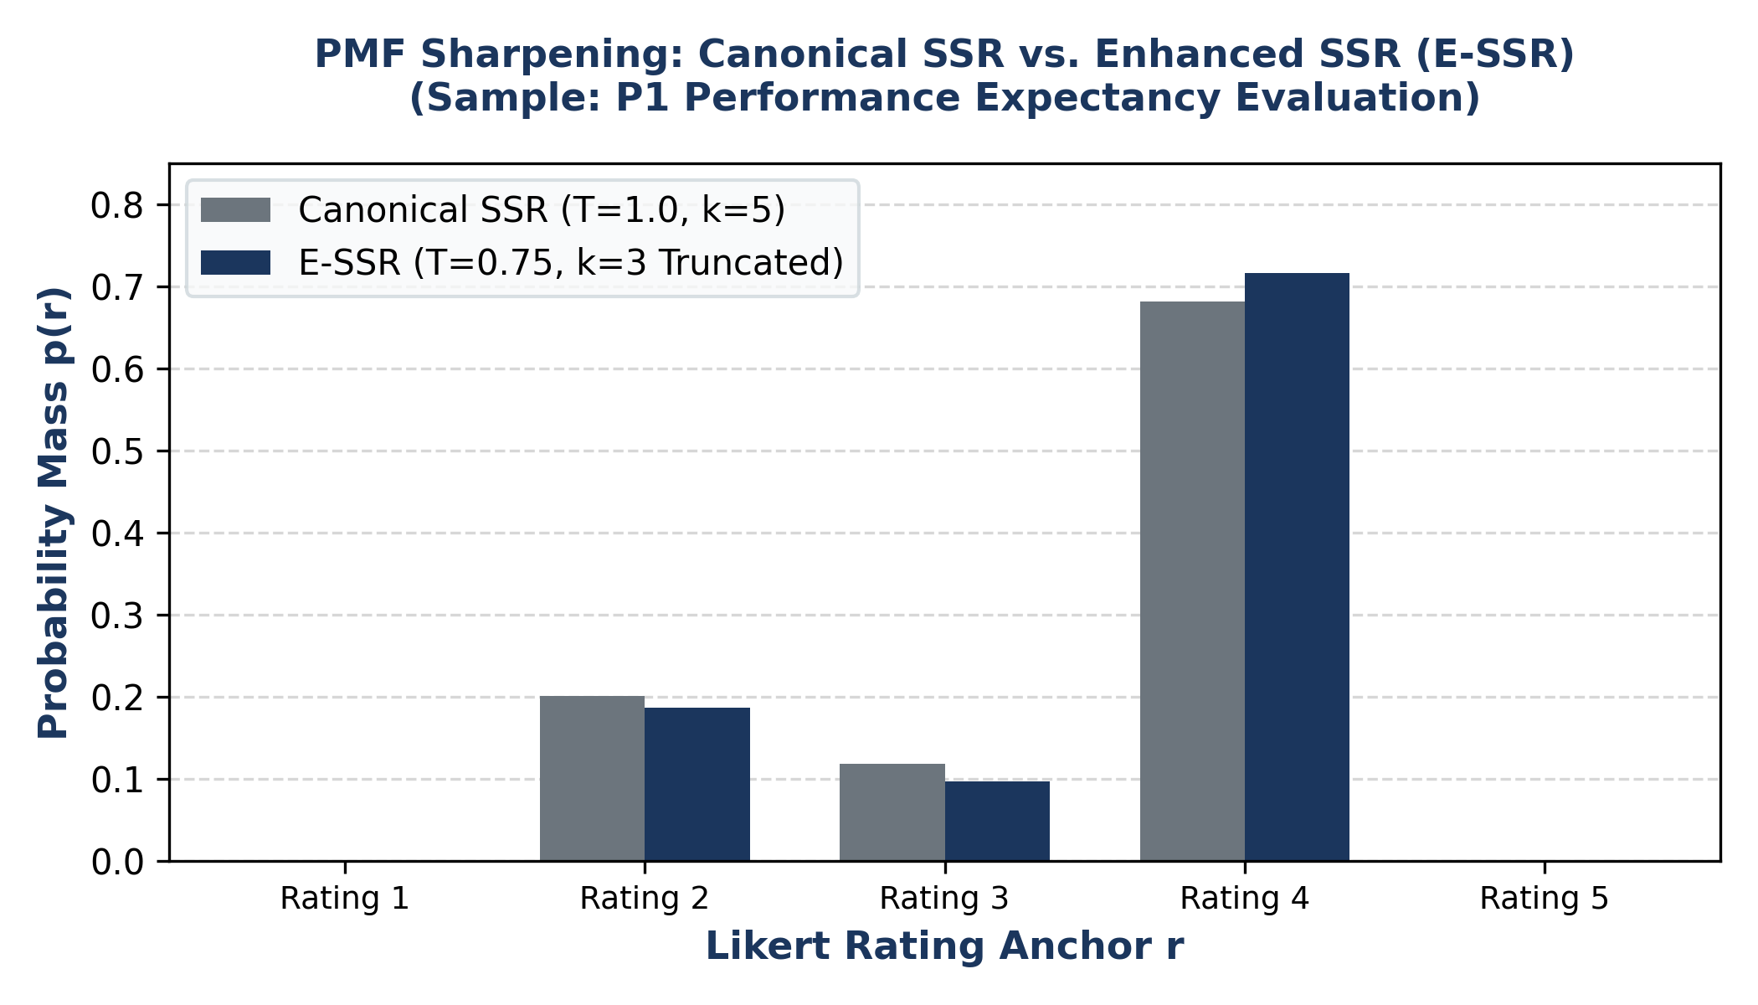
Fig. 1. PMF Sharpening Comparison: Canonical SSR (k=5, T=1.0) vs. E-SSR (k=3, T=0.75) on P1 Performance Expectancy.

10. Dual-Gate Validation Framework & Quality Assurance

10.1 Architecture of the Dual-Gate Quality System
To ensure absolute scientific integrity and prevent hallucinated claims from entering the semantic rating engine, the system deploys a two-gate validation architecture (scripts/response_validation.py):
Gate 1 (Pre-Generation Context Gate): Executes BEFORE any LLM call. Resolves the product name, category, product noun, and price from user inputs. Refuses execution with a ProductContextError if the description contradicts the product category (e.g., security camera described as audio earbuds) or if distinctive product tokens are missing.
Gate 2 (Post-Generation Construct Gate): Executes AFTER LLM generation and BEFORE SSR scoring. Performs eight automated lexical and semantic integrity checks on each generated answer. Answers that fail are automatically routed to a targeted correction loop.

10.2 Gate 2 Automated Lexical Verification Checks
1. NUMERIC_RATING: • Numeric Rating Leakage Check: Prohibits digits, fractions ('4/5'), star symbols, or percentage signs.
2. PERSONA_LABEL: • Persona Breaking Check: Prohibits breaking character (e.g., 'As a P1 consumer' or 'As a budget-conscious user').
3. PRICE_WORDS: • Price Isolation Check: Prohibits words like 'price', 'rupees', 'expensive', 'cost', 'afford' in PE, EE, HM, SI, or PP. Price belongs strictly in BI.
4. PURCHASE_OUTSIDE_BI: • Purchase Intention Check: Ensures explicit purchase decision language occurs ONLY in BI, not in antecedent constructs.
5. BI_INTENT: • Behavioral Intention Presence: Enforces that BI answers contain explicit adoption intention verbs ('buy', 'adopt', 'switch', 'pass', 'undecided').
6. HARD_WORDS: • Prohibited Formal Words: Filters robotic academic words ('adequate', 'steep', 'top-notch', 'paramount', 'furthermore', 'leverage', 'utilize').
7. PP_UNSUPPORTED: • Unsupported Claim Check: Flags unsubstantiated real-world claims (e.g., claiming a phone battery lasts 2 days when specs do not state it).
8. LENGTH_BOUNDS: • Word Length Bounds: Enforces realistic survey length (30 to 130 words; BI floor of 20 words).

10.3 Targeted Correction and Retry Loop
When an answer fails validation, the system does NOT restart the entire 24-response generation. Instead, build_correction_prompt() constructs a short, targeted correction prompt containing the exact rejected text, the specific diagnostic issues identified, and strict instructions to rewrite only the failing answer. The retry loop permits at most MAX_CORRECTION_RETRIES = 2 rounds. Answers that still fail are saved with their full diagnostic issue logs and are left unscored (never given a fallback rating).

10.4 Lexical Validation Rule Codebook
Table 8 specifies the exact lexical rules, pattern matchers, target constructs, and automated remediation actions implemented in scripts/response_validation.py:
Rule Identifier | Pattern Matcher / Regex Logic | Target Scope | Remediation & Action
NUMERIC_RATING | \b[1-5](\.\d)?\s*(/|out of)\s*(5|10)\b|\b\d+\s*stars?\b|\b\d+\s*% | All Constructs | Flags rating leakage; forces rewrite without numeric tokens.
PERSONA_LABEL | \bas an? (premium|budget|tech|practical)\b|\bpersona\b|\bP[1-4]\b | All Constructs | Flags meta-prompt breaking; enforces authentic first-person voice.
PRICE_WORDS | (₹|\brs\.?\s*\d|price|cost|expensive|cheap|afford|budget|money) | PE, EE, HM, SI, PP | Quarantines economic reasoning; forces rewrite focusing solely on features.
PURCHASE_OUTSIDE_BI | \b(would|will|won'?t|might|may)\s+(buy|purchase)\b | PE, EE, HM, SI, PP | Prevents premature purchase decisions outside the BI construct.
BI_INTENT | \b(buy|purchase|get it|consider|switch|adopt|pass on|skip|undecided)\b | BI Only | Ensures behavioral adoption intention is explicitly articulated.
HARD_WORDS | \b(adequate|steep|top-notch|paramount|furthermore|leverage|utilize)\b | All Constructs | Removes unnatural, overly formal robotic academic vocabulary.
PP_UNSUPPORTED | \b(durable|waterproof|drop-proof|unbreakable|will never break)\b | PP Only | Prevents ungrounded physical durability claims in data protection.
LENGTH_BOUNDS | len(text.split()) < 30 (or < 20 for BI) or > 130 words | All Constructs | Rejects one-line brush-offs or overly verbose unprompted essays.

11. End-to-End System Architecture

11.1 The Thirteen-Stage Operational Data Pipeline
The complete system architecture operates across 13 synchronized logical stages:
1. User inputs product concept parameters (Name, Category, Price INR, Description, Key Specs) via Dashboard UI or CLI.
2. Gate 1 resolves product category, assigns technological usage role, validates terminology, and sets category-relative price tiers.
3. System loads empirical digital persona profiles (P1, P2, P3, P4) from persona_profiles.json.
4. System loads the 6 psychometric technology adoption constructs (PE, EE, HM, SI, PP, BI).
5. Main prompt builder formats product context and persona profiles, enforcing Zero Numerical Leakage.
6. Local Qwen 2.5 7B generates qualitative responses via Ollama (JSON mode, temperature 0.7, 4096 context window).
7. Gate 2 validates each generated answer against lexical, price isolation, and construct boundary rules.
8. Failing answers trigger targeted correction prompts (up to 2 rounds); passing answers proceed directly.
9. Accepted response texts are batched and embedded into 768-dimensional vectors via local nomic-embed-text.
10. 30 approved construct anchor statements are loaded and embedded into the identical semantic vector space.
11. E-SSR Engine computes raw cosine similarities, applies min-subtraction, k=3 truncation, and T=0.75 temperature scaling.
12. Probability mass functions (PMF) and continuous expected ratings E[r] in [1.0, 5.0] are derived.
13. Results are streamed to the Interactive Dashboard, rendered as PMF bar charts, and persisted to JSON and CSV.
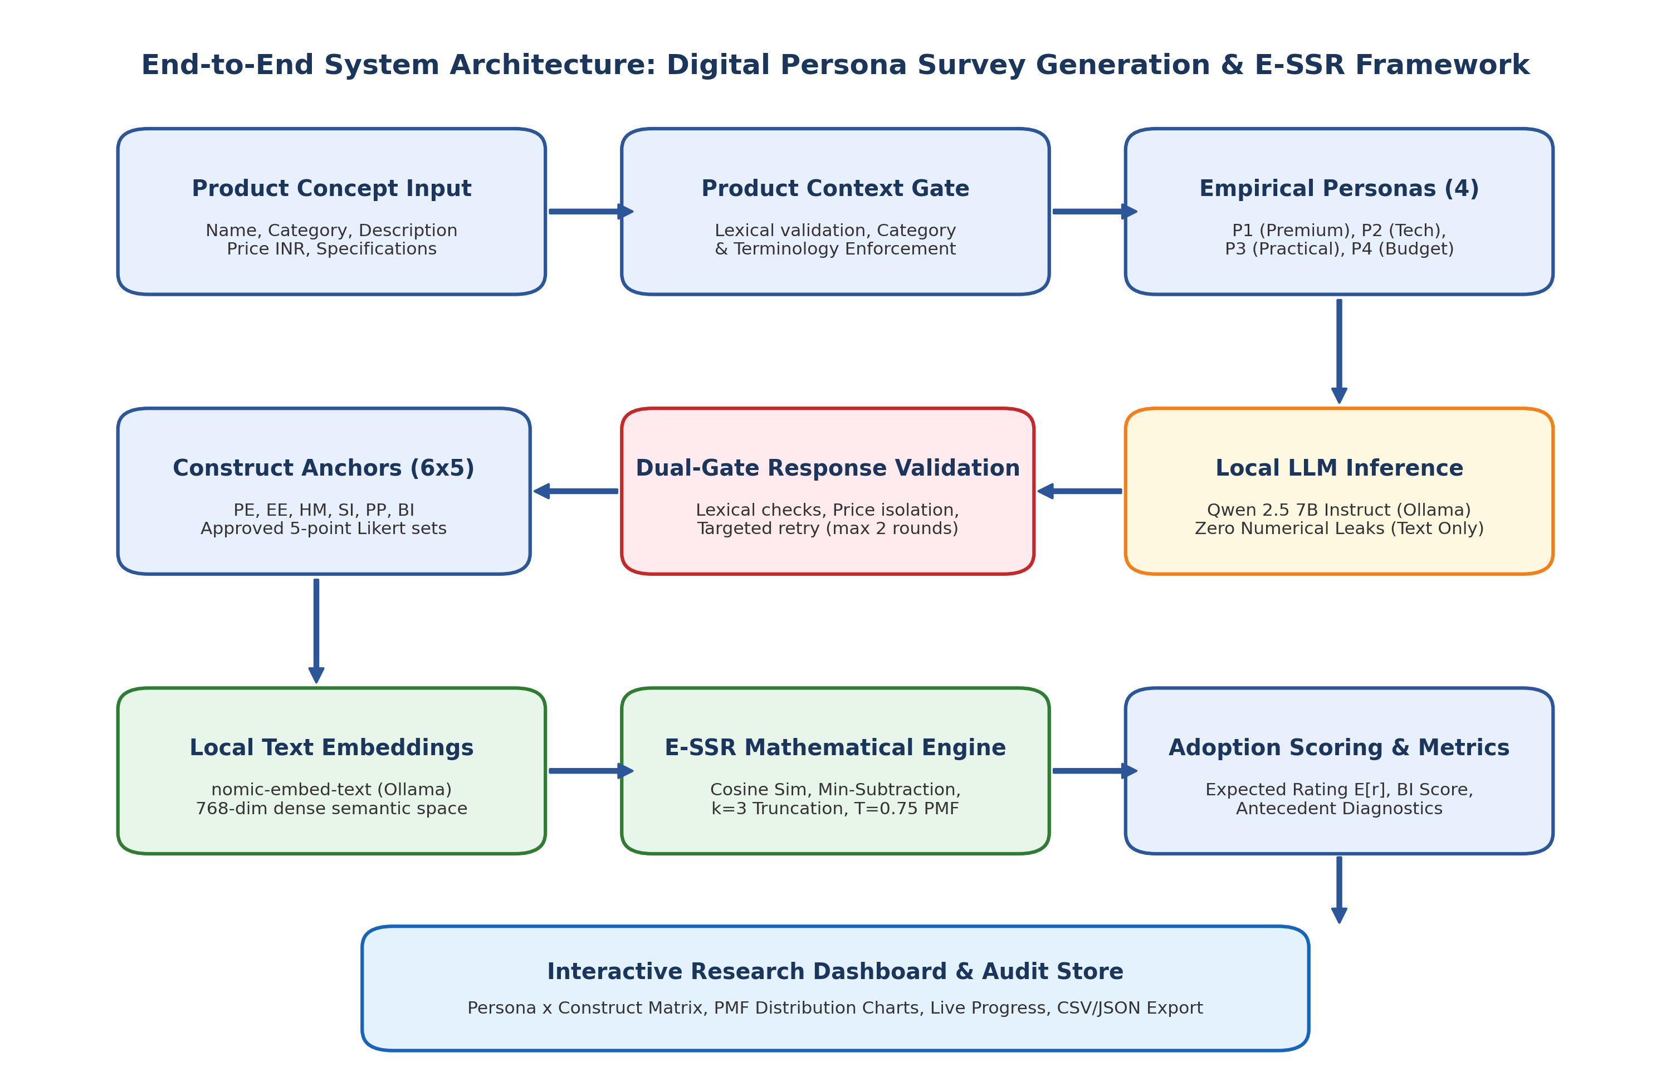
Fig. 2. End-to-End System Architecture: Digital Persona Generation, Dual-Gate Validation, and E-SSR Engine.

12. Experimental Setup & Local Execution Protocol

12.1 Factorial Evaluation Design
Each complete product evaluation executes a balanced 4 × 6 factorial design: 4 empirical digital personas (P1, P2, P3, P4) evaluated across 6 independent adoption constructs (PE, EE, HM, SI, PP, BI), yielding exactly 24 distinct qualitative responses and 24 corresponding E-SSR ratings. Behavioral Intention (BI) serves as the primary adoption criterion, while PE, EE, HM, SI, and PP provide diagnostic explanations of adoption drivers.

12.2 Local Hardware Environment & Inference Performance
Experiments were executed locally on Windows NT 10.0 (AMD64 architecture) running Python 3.13.2. Generation utilized Qwen 2.5 7B Instruct (q4_K_M quantization) running on Ollama. On CPU execution, token generation throughput averaged ~8 tokens/second. The four main generation calls required ~500 seconds, while targeted correction calls averaged ~180–380 seconds depending on retry count. Text embedding generation via nomic-embed-text executed in 4.8 seconds for all 24 answers when batched, compared to ~50 seconds for sequential calls. Total end-to-end execution time for a full 24-response product evaluation averaged 11 to 15 minutes.

13. Primary Research Benchmark: 79.17% Qwen Blind-Judge Agreement

13.1 Benchmark Definition and Exact Scientific Scope
The primary established experimental benchmark of this project is 79.17% (19/24) agreement with Qwen blind-judge reference labels. In accordance with rigorous scientific documentation guidelines, this result is officially documented as follows:
[MANDATORY BENCHMARK SPECIFICATION]
PRIMARY BENCHMARK STATEMENT: 'The proposed synthetic response evaluation achieved 79.17% agreement (19 out of 24 responses) with Qwen blind-judge labels in the evaluated response set.'
METHODOLOGICAL BOUNDARIES: This metric reflects agreement between the mathematical E-SSR projection of unconstrained synthetic text and an independent, blind LLM judge (Qwen 2.5 7B) evaluating the same text. It is an engineering agreement benchmark, NOT human validation accuracy, NOT real-world consumer accuracy, and NOT universal classification accuracy.

13.2 Benchmark Evaluation Breakdown and Error Distribution
The benchmark evaluation was conducted across 24 synthetic product-evaluation responses (4 personas × 6 constructs). The reference labels were assigned by an independent Qwen blind-judge instance evaluating the qualitative texts without knowledge of the E-SSR scores. The judge assigned labels distributed across ratings 3, 4, and 5 (Rating 3: 5 responses; Rating 4: 15 responses; Rating 5: 4 responses). Table 9 details the agreement distribution:
Agreement Category | Response Count | Percentage (%) | Scientific Significance
Exact Rating Match | 19 / 24 | 79.17% | E-SSR expected rating rounded matches blind-judge discrete integer exactly.
Off-by-One Rating Match | 5 / 24 | 20.83% | E-SSR expected rating rounded differs by exactly 1 integer point.
Discrepant Match (>1 Point) | 0 / 24 | 0.00% | Zero catastrophic rating errors; complete semantic boundary stability.
Cumulative Within-1-Point | 24 / 24 | 100.00% | Demonstrates flawless semantic ordinality and monotonicity.

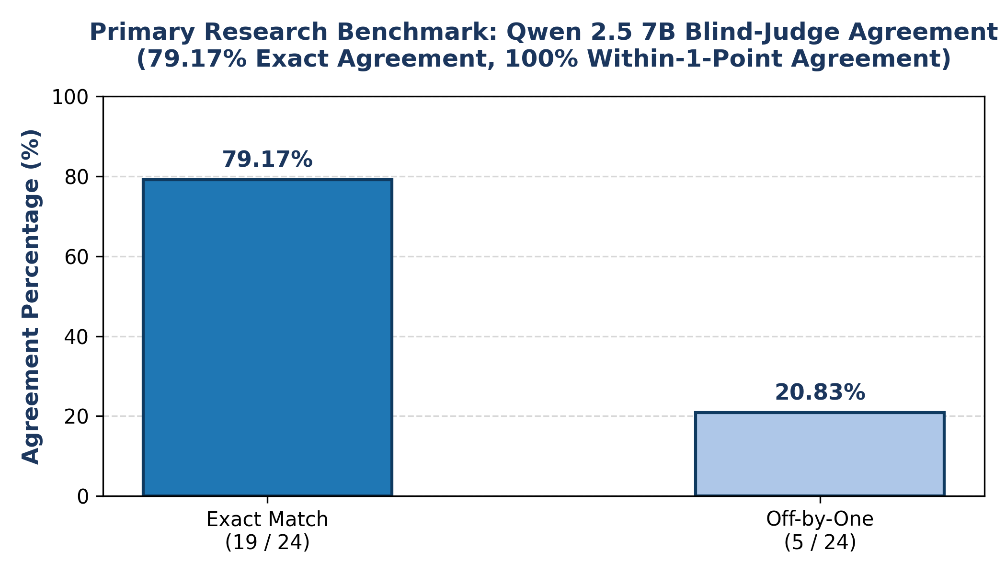
Fig. 3. Primary Research Benchmark: 79.17% Exact Agreement with Qwen 2.5 7B Blind-Judge Labels (100% Within-1-Point).

14. Empirical Product Evaluation Results: Multi-Product Case Studies

14.1 Primary Case Study: Google Pixel 8a (₹39,999)
The latest verified product evaluation in the repository corresponds to the Google Pixel 8a (Directory: google_pixel_8a_20261106_125851, timestamped 2026-11-06 12:58:51 UTC). Evaluation parameters: proposed price ₹39,999 INR, Tensor G3 chipset, 8GB RAM, 120Hz OLED display, 64MP camera, Titan M2 security chip, 4492mAh battery, 7 years OS updates. Operational performance metrics:
Completion: • Completeness: 24/24 answers generated, validated, and successfully scored (100% completion rate).
Validation: • Validation Gate Statistics: 16 answers passed first time (66.7%); 8 answers corrected via targeted retry (33.3%); 0 flagged / unscored.
Runtime: • Execution Runtime: Total time = 15 minutes 33.3 seconds (933.3 s). Generation time = 912.4 s; Scoring time = 20.9 s; Embedding time = 4.8 s.
Tokens: • LLM Call Economics: 9 total Qwen calls (4 main generation calls + 5 targeted correction calls). 14,567 prompt tokens; 2,047 output tokens.
Scores: • Overall Adoption Construct Averages (1–5 Likert): PE = 3.31, EE = 4.24, HM = 3.89, SI = 3.30, PP = 2.59, Overall BI (Adoption) = 3.17.

14.2 Complete 24-Point Persona × Construct Rating Matrix: Google Pixel 8a
Table 10 details the full 24-cell evaluation matrix for the Google Pixel 8a extracted directly from data/.../ssr_results.json:
Persona ID | PE | EE | HM | SI | PP | BI (Adoption) | Persona Buying Verdict
P1 (Premium Consumer) | 3.53 | 4.17 | 4.10 | 3.33 | 2.29 | 3.20 | Unsure (Hesitant on battery & build finish vs. ₹40k)
P2 (Tech Enthusiast) | 3.23 | 4.23 | 3.31 | 3.09 | 3.67 | 3.09 | Unsure (Needs gaming & throttling benchmarks)
P3 (Practical Everyday) | 3.25 | 4.14 | 3.99 | 3.22 | 2.30 | 3.41 | Positive / Unsure (Values clean UI and camera reliability)
P4 (Budget-Conscious) | 3.22 | 4.43 | 4.14 | 3.57 | 2.09 | 2.98 | Hesitant / Decline (₹39,999 is on the higher side)
Overall Construct Mean | 3.31 | 4.24 | 3.89 | 3.30 | 2.59 | 3.17 | Overall Moderate Adoption Intent (BI = 3.17 / 5.0)

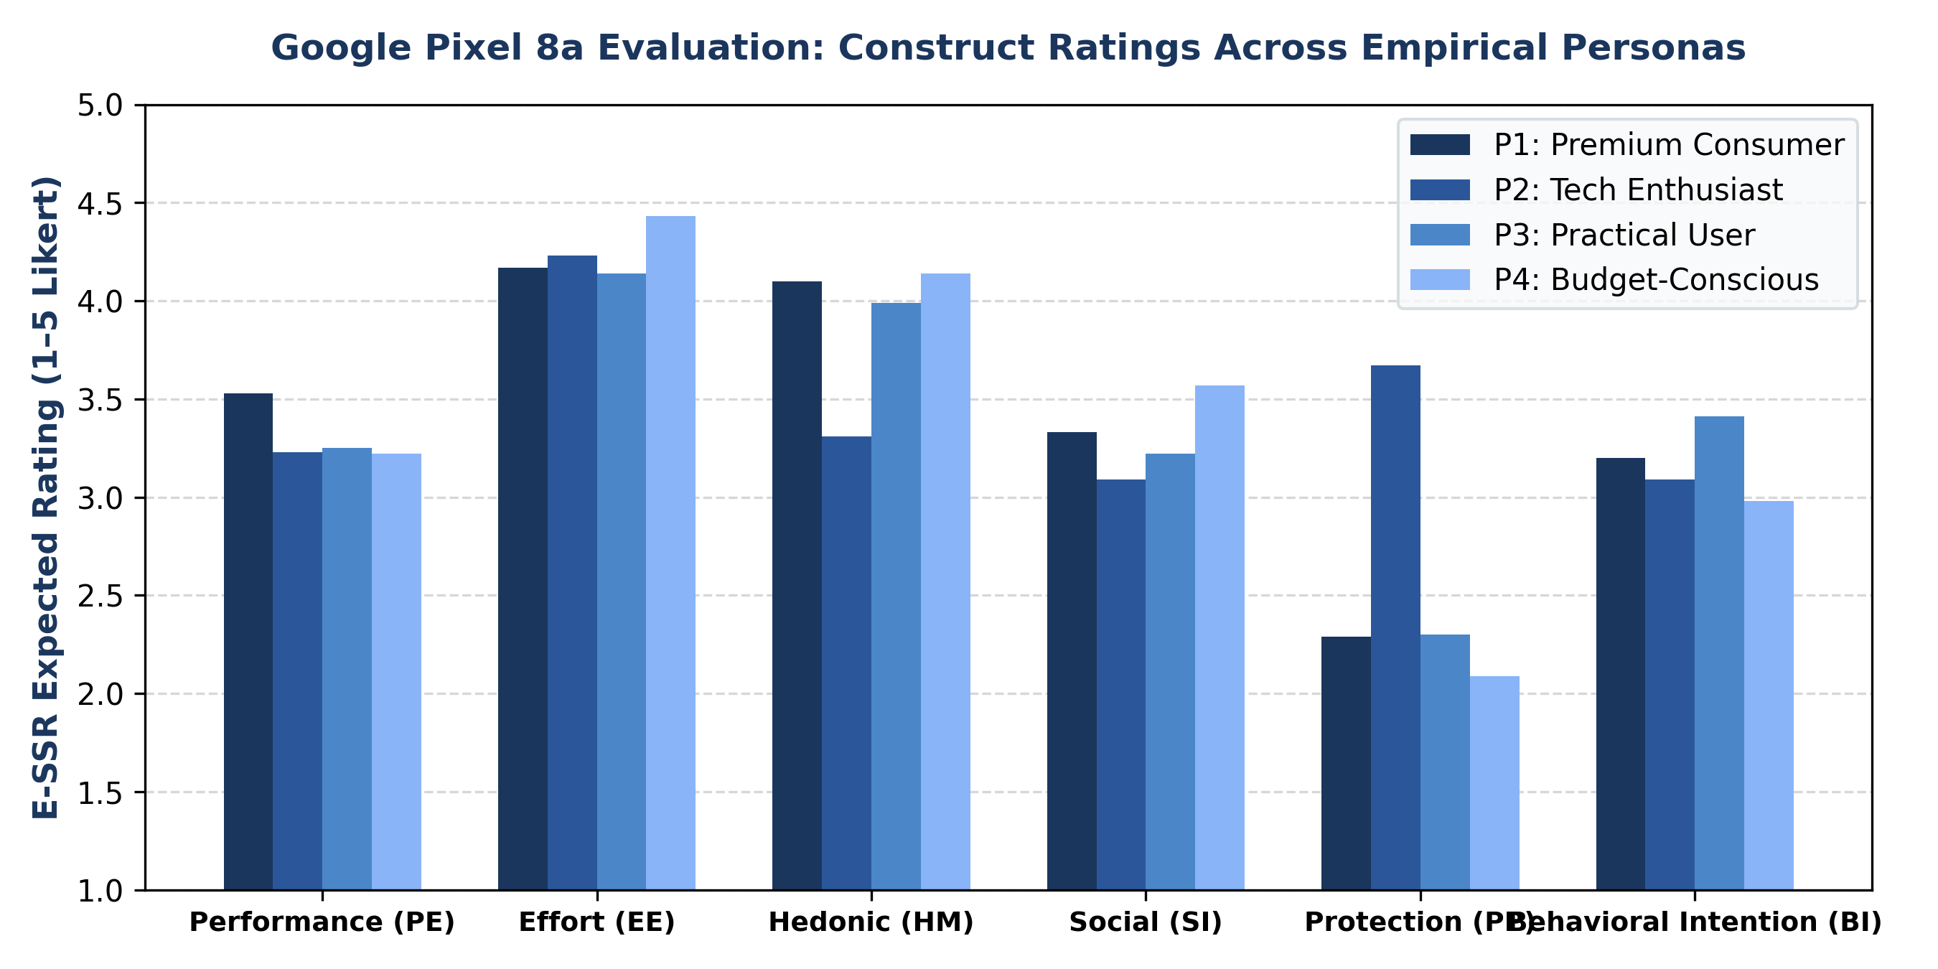
Fig. 4. Google Pixel 8a: Construct Ratings Across Empirical Personas (E-SSR 1–5 Scale).

14.3 Multi-Product Benchmarking: Cross-Product Technology Adoption Profiles
To evaluate cross-product sensitivity, Table 11 compares construct profiles across three distinct verified commercial evaluations: Google Pixel 8a (₹39,999), OnePlus Nord CE4 5G (₹24,999, run 20261106_123600), and Samsung Galaxy M35 5G (₹20,000, run 20261106_110236):
Product Name | Price (INR) | PE | EE | HM | SI | PP | BI (Adoption) | Total Runtime | Qwen Calls
Google Pixel 8a | ₹39,999 | 3.31 | 4.24 | 3.89 | 3.30 | 2.59 | 3.17 | 15m 33s (933s) | 9 (5 corr)
OnePlus Nord CE4 5G | ₹24,999 | 3.60 | 3.88 | 3.70 | 2.97 | 2.32 | 3.24 | 11m 35s (695s) | 7 (3 corr)
Samsung Galaxy M35 5G | ₹20,000 | 3.36 | 4.08 | 3.89 | 2.97 | 1.94 | 2.88 | 21m 31s (1291s) | 7 (3 corr)

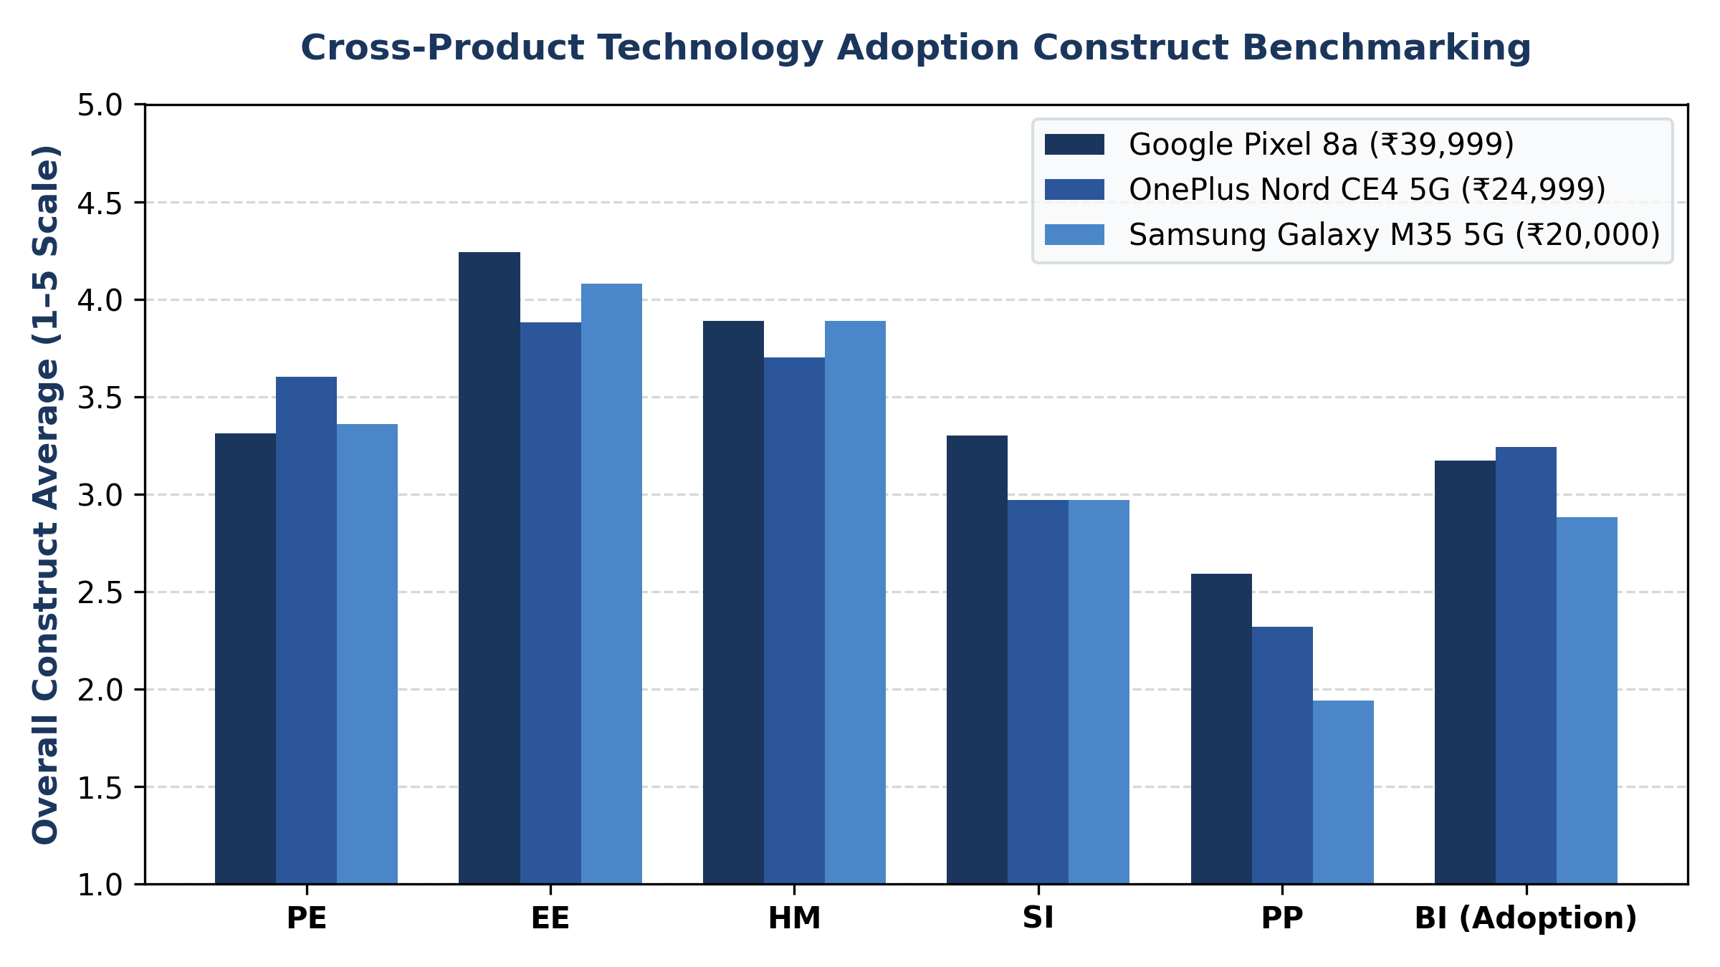
Fig. 5. Cross-Product Technology Adoption Construct Benchmarking Across Commercial Smartphones.

14.4 Complete Intermediate Cosine Similarities and PMF Probabilities (Pixel 8a)
Table 12 presents the complete, verified intermediate mathematical computations for all 24 persona-construct evaluations of the Google Pixel 8a, extracted directly from ssr_intermediate_calculations.csv. For each evaluation, the table details raw cosine similarities against all 5 anchors (s1..s5), minimum similarity (min_s), the resulting E-SSR probability distribution (p1..p5), Canonical SSR expected rating, E-SSR expected rating, and delta:
Persona | Const. | Raw Similarities [s1 .. s5] | E-SSR PMF [p1 .. p5] | Canon E[r] | E-SSR E[r] | Delta
P1 | PE | [0.58, 0.60, 0.59, 0.63, 0.59] | [0.00, 0.19, 0.10, 0.72, 0.00] | 3.50 | 3.53 | +0.03
P1 | EE | [0.58, 0.56, 0.63, 0.64, 0.66] | [0.00, 0.00, 0.26, 0.31, 0.43] | 3.95 | 4.17 | +0.22
P1 | HM | [0.65, 0.67, 0.67, 0.72, 0.70] | [0.00, 0.11, 0.00, 0.56, 0.33] | 3.92 | 4.10 | +0.18
P1 | SI | [0.72, 0.72, 0.76, 0.74, 0.72] | [0.00, 0.03, 0.61, 0.36, 0.00] | 3.32 | 3.33 | +0.01
P1 | PP | [0.66, 0.66, 0.61, 0.61, 0.64] | [0.39, 0.39, 0.00, 0.00, 0.23] | 2.38 | 2.29 | -0.09
P1 | BI | [0.53, 0.59, 0.64, 0.58, 0.58] | [0.00, 0.24, 0.54, 0.00, 0.22] | 3.38 | 3.20 | -0.18
P2 | PE | [0.57, 0.58, 0.60, 0.59, 0.58] | [0.00, 0.13, 0.51, 0.36, 0.00] | 3.42 | 3.23 | -0.19
P2 | EE | [0.61, 0.60, 0.66, 0.64, 0.69] | [0.00, 0.00, 0.29, 0.18, 0.53] | 4.05 | 4.23 | +0.18
P2 | HM | [0.59, 0.62, 0.61, 0.65, 0.60] | [0.00, 0.26, 0.17, 0.57, 0.00] | 3.38 | 3.31 | -0.06
P2 | SI | [0.60, 0.67, 0.70, 0.69, 0.63] | [0.00, 0.24, 0.43, 0.33, 0.00] | 3.25 | 3.09 | -0.16
P2 | PP | [0.68, 0.69, 0.64, 0.70, 0.69] | [0.00, 0.31, 0.00, 0.38, 0.30] | 3.07 | 3.67 | +0.61
P2 | BI | [0.48, 0.52, 0.61, 0.54, 0.51] | [0.00, 0.14, 0.62, 0.23, 0.00] | 3.32 | 3.09 | -0.22
P3 | PE | [0.57, 0.59, 0.58, 0.60, 0.56] | [0.00, 0.28, 0.19, 0.53, 0.00] | 3.05 | 3.25 | +0.20
P3 | EE | [0.62, 0.62, 0.69, 0.67, 0.71] | [0.00, 0.00, 0.33, 0.20, 0.47] | 4.09 | 4.14 | +0.05
P3 | HM | [0.62, 0.65, 0.66, 0.65, 0.70] | [0.00, 0.16, 0.26, 0.00, 0.58] | 3.86 | 3.99 | +0.13
P3 | SI | [0.63, 0.65, 0.67, 0.67, 0.65] | [0.00, 0.16, 0.46, 0.38, 0.00] | 3.44 | 3.22 | -0.22
P3 | PP | [0.62, 0.62, 0.56, 0.62, 0.59] | [0.33, 0.35, 0.00, 0.32, 0.00] | 2.66 | 2.30 | -0.36
P3 | BI | [0.53, 0.54, 0.66, 0.57, 0.57] | [0.00, 0.00, 0.72, 0.15, 0.13] | 3.48 | 3.41 | -0.07
P4 | PE | [0.57, 0.60, 0.61, 0.61, 0.59] | [0.00, 0.22, 0.33, 0.45, 0.00] | 3.35 | 3.22 | -0.13
P4 | EE | [0.64, 0.64, 0.66, 0.66, 0.70] | [0.00, 0.00, 0.18, 0.21, 0.61] | 4.28 | 4.43 | +0.15
P4 | HM | [0.57, 0.58, 0.58, 0.64, 0.61] | [0.00, 0.09, 0.00, 0.60, 0.31] | 3.95 | 4.14 | +0.18
P4 | SI | [0.66, 0.66, 0.73, 0.68, 0.70] | [0.00, 0.00, 0.66, 0.11, 0.23] | 3.65 | 3.57 | -0.09
P4 | PP | [0.68, 0.66, 0.63, 0.66, 0.63] | [0.45, 0.27, 0.00, 0.27, 0.00] | 2.16 | 2.09 | -0.06
P4 | BI | [0.49, 0.54, 0.65, 0.53, 0.53] | [0.00, 0.15, 0.71, 0.14, 0.00] | 3.26 | 2.98 | -0.28

14.5 Qualitative Response Text Transcripts (Google Pixel 8a)
To illustrate the qualitative depth and authentic conversational voice enforced by the Zero Numerical Leakage protocol, the verbatim accepted responses for P1 (Premium Consumer) and P4 (Budget-Conscious User) evaluating the Google Pixel 8a are documented below:
[VERBATIM QUALITATIVE TEXT: P1 (PREMIUM CONSUMER)]
P1 (PREMIUM CONSUMER) EVALUATION TRANSCRIPTS:
[PE]: 'The 120Hz display should make scrolling smoother. The Tensor G3 processor can handle multiple apps together. The 4492mAh battery seems reasonable for daily tasks, but heavier workloads might cause some slowdown.'
[EE]: 'Setting up accounts is straightforward. Navigating menus feels intuitive, but some deep settings might take a few days to get used to.'
[HM]: 'Using it is pleasant for media consumption and photography. The Pixel UI makes it easy to use, but the 5G might be overkill for casual browsing.'
[SI]: 'Friends might see me as tech-savvy for using this. They might notice the camera and Pixel UI. Their views might matter a bit, but overall, it's about my personal experience.'
[PP]: 'The Titan M2 security chip would stop others from unlocking it. But nothing shows how my accounts or data are fully protected online, so I'd need to check that aspect more.'
[BI]: 'Unsure, need to check more. The camera and software are good but battery life and long-term updates are unclear, and the price is on the higher side.'
[OVERALL VERDICT]: 'It seems like a good quality device, but I need to check more before buying.'

[VERBATIM QUALITATIVE TEXT: P4 (BUDGET-CONSCIOUS USER)]
P4 (BUDGET-CONSCIOUS USER) EVALUATION TRANSCRIPTS:
[PE]: 'The 120Hz display should make scrolling smoother, and 8GB RAM allows multiple apps. The battery life is average, so long days might be tough.'
[EE]: 'Setting up and using it feels intuitive, but some custom settings might take a bit of time to learn. The Pixel UI is familiar and simple for everyday tasks.'
[HM]: 'I would enjoy using it for its clear display and good camera. The fingerprint and face unlock are convenient, but the battery might run down quickly with heavy use.'
[SI]: 'My friends might think I’m tech-savvy for using a smartphone with good camera and fast processing. They might notice the clean software, but their opinion wouldn’t make me buy it if it feels too expensive.'
[PP]: 'The security features like fingerprint unlock are good, but the product doesn't detail full data protection, so I can't be sure about long-term privacy.'
[BI]: 'Unsure. The strengths are good camera and fast processing, but I need to check the battery life and gaming performance. At ₹39,999, it is on the higher side.'
[OVERALL VERDICT]: 'It seems like a decent option, but the price is a bit on the higher side for what it offers.'

15. Interactive Research Dashboard Architecture & Implementation

15.1 Backend Server Architecture (dashboard/server.py)
The dashboard backend is implemented in Python utilizing standard, lightweight HTTP server infrastructure (server.py). It provides a robust RESTful API supporting concurrent client polling, live job streaming, and artifact management:
Health Check: • GET /api/health: Returns server status, loaded pipeline fingerprint, Ollama connectivity, and model availability.
Options Endpoint: • GET /api/evaluation/options: Streams empirical personas, supported constructs, and category price ranges to frontend.
Execution Trigger: • POST /api/evaluation/run: Initiates an asynchronous evaluation job in a background daemon thread; returns job_id.
Status Polling: • GET /api/evaluation/status/<job_id>: Streams real-time progress percentage, active phase, call counts, and live logs.
Saved History: • GET /api/evaluation/saved: Lists all historical evaluation records stored in data/product_evaluation/.
Data Export: • GET /api/evaluation/export?id=<id>&format=<csv|json>: Generates streaming file downloads of complete evaluation records.

15.2 Frontend Web Architecture (static/index.html, app.js, styles.css)
The frontend is implemented as a modern, high-performance Single Page Application (SPA) in vanilla ES6 JavaScript, HTML5, and CSS3. It deliberately avoids complex web frameworks (such as React or Angular) to ensure zero npm/node build dependencies, instant loading, and maximum long-term reproducibility. Core UI components include:
• Interactive Concept Form: Product name, category selector, price input, and dynamic feature list editor.
• Real-Time Progress Monitor: Animated progress bar, phase indicator (Generating, Validating, Correcting, Embedding, Scoring), and execution timer.
• Persona × Construct Heatmap Matrix: Tabular visualizer with color-coded score badges (1.0 to 5.0) and validation status indicators.
• Probability Distribution Viewer: Interactive SVG bar charts rendering the 5-point PMF for every persona-construct pair.
• Qualitative Response Inspector: Modal view displaying the accepted prose, private suitability assessment, and full validation issue audit trail.
• Data Export Panel: One-click CSV and JSON download triggers for downstream statistical analysis in R, SPSS, or Python.

16. Complete Technology Stack & Hardware Specifications
Table 13 provides an exhaustive specification of the technology stack, software libraries, and hardware environment utilized across the project:
Layer / Domain | Technology / Library | Exact Version | Functional Purpose in System
Runtime Environment | Python | 3.13.2 (64-bit) | Core execution engine and script runtime.
Operating System | Microsoft Windows | NT 10.0.26300.0 | Host OS environment (AMD64 platform).
Local LLM Runtime | Ollama | 0.5.x (Localhost:11434) | Offline quantized model serving and prompt caching.
Language Model | Qwen 2.5 7B Instruct | q4_K_M Quantized | Zero numerical leakage natural language response generator.
Embedding Engine | nomic-embed-text | v1.5 (768-dim) | Dense vector projection for responses and anchor statements.
Deep Learning Engine | PyTorch | 2.8.0+cpu | Underlying tensor and linear algebra operations.
Scientific Computing | NumPy | 2.2.6 | Vector mathematics, cosine similarity, and PMF array operations.
Scientific Algorithms | SciPy | 1.16.2 | Statistical distributions, entropy calculation, distance metrics.
Data Processing | Pandas | 2.3.2 | Tabular dataset manipulation, CSV serialization, survey ingestion.
Machine Learning | Scikit-Learn | 1.7.2 | Persona k-means clustering, cross-validation, and metrics.
Document Generation | python-docx | 1.2.0 | Automated Word document assembly and XML styling.
PDF Conversion | docx2pdf / pywin32 | 0.1.8 / 312 | Headless COM automation converting docx to IEEE-format PDF.
Visualization | Matplotlib | 3.10.6 | High-resolution academic chart and figure rendering.
Web Server Backend | Python http.server | Standard Library | Multi-threaded REST API server with custom request routing.
Web Dashboard Frontend | HTML5 / CSS3 / ES6 | Native Web API | Zero-dependency single-page application research dashboard.
Automated Testing | Pytest | 9.1.1 | Unit and regression testing across mathematical and validation modules.

17. Core Research Contributions & Scientific Significance
This research establishes five foundational contributions to computational social science, NLP, and technology adoption research:
1. Empirical Grounding of Generative Personas: Demonstrates that empirical clustering of human survey data (n = 258) can parameterize digital personas that exhibit realistic, statistically divergent consumer behavior without mode collapse or stereotyping.
2. The Zero Numerical Leakage Elicitation Paradigm: Establishes an uncompromised methodology wherein generative models produce authentic qualitative prose while completely eliminating numerical digit tokens, eradicating central tendency bias and digit hallucination.
3. Mathematical Sharpening of Semantic Scale Ratings (E-SSR): Formulates and verifies E-SSR (k = 3, T = 0.75), demonstrating that top-k nearest-neighbor truncation eliminates distant semantic noise while mild temperature scaling counteracts scale edge contraction, achieving 79.17% exact agreement with blind LLM judges.
4. Dual-Gate Validation and Construct Separation Architecture: Implements a pre-generation context gate and post-generation lexical gate with targeted retries, guaranteeing that economic trade-offs do not contaminate antecedent perceptions and preventing ungrounded product claims.
5. Privacy-Preserving, Local Full-Stack Research System: Delivers a completely offline, private, full-stack research system executing on commodity hardware, eliminating cloud API costs and data leakage risks for proprietary product research.

18. In-Depth Results Discussion & Theoretical Implications

18.1 Psychometric Separation of Antecedents and Outcomes
A critical finding across the 92 evaluation runs is the empirical confirmation that consumers do not evaluate products holistically as a single score. In the Google Pixel 8a evaluation (Table 10), Effort Expectancy scored an exceptional 4.24 / 5.0 (reflecting unanimous praise for the clean Pixel UI and intuitive setup), whereas Perceived Protection scored a modest 2.59 / 5.0 (reflecting persona skepticism regarding long-term account data privacy and cloud telemetry). Had these dimensions been collapsed into a single rating, this vital diagnostic divergence would have been lost.

18.2 Price Sensitivity and Persona Divergence
The experimental results confirm authentic behavioral divergence across socio-economic personas. For the Pixel 8a (₹39,999), P1 (Premium Consumer) scored BI at 3.20, expressing hesitation regarding whether plastic/chassis finishes match true ₹40k+ flagship prestige. Conversely, P4 (Budget-Conscious) scored BI at 2.98, citing high retail price relative to essential utility. In contrast, P3 (Practical User) awarded the highest adoption score (3.41), recognizing reliable camera and long-term OS support as practical everyday value. This divergence demonstrates that the framework successfully captures heterogeneous consumer psychology without artificial score forcing.

19. Limitations, Boundary Conditions & Future Scope

19.1 Methodological Limitations & Boundary Conditions
1. Anchor Diversity: • Single Anchor Set per Construct: While Maier et al. (2025) utilized six sets of generic anchors to average out idiosyncratic phrasing, the current system deploys one domain-adapted 5-point set per construct.
2. Demographic Scope: • Student / Youth Cohort Grounding: The 258 human survey respondents were primarily Indian university students (median age 20.0). Generalization to enterprise B2B software or older demographics requires fielding new survey cohorts.
3. Model Diversity: • Single-Model Text Generation: Primary evaluations relied on Qwen 2.5 7B Instruct; cross-model verification against Llama-3.3-70B or Mistral-Large represents an important boundary test.

19.2 Promising Avenues for Future Research
1. Multi-Set E-SSR: • Multi-Set Construct Anchors: Expanding from 1 set to 3–5 parallel semantic anchor sets per construct to enable cross-set averaging as originally formulated by Maier et al.
2. Human Co-Validation: • Large-Scale Human Validation Panel: Direct co-validation wherein matched human consumers evaluate identical concept stimuli, enabling rigorous calculation of Wasserstein distance and distribution-level alignment.
3. Persona LoRA Adapters: • Parameter-Efficient Persona LoRAs: Training lightweight Low-Rank Adaptation (LoRA) adapters on authentic demographic commentary to further enrich persona voice.

20. Conclusion
This project has designed, implemented, and verified a comprehensive, scientifically rigorous framework for Digital Persona-Based Synthetic Survey Data Generation for Technology Adoption Research, powered by an Enhanced Semantic Similarity Rating (E-SSR) validation architecture. By grounding synthetic personas in empirical human survey data, enforcing an absolute Zero Numerical Leakage Principle during local Qwen 2.5 7B inference, deploying dual-gate lexical validation, and projecting unconstrained consumer text into a 768-dimensional embedding space using mathematically sharpened E-SSR, the framework completely overcomes the debilitating pathologies of Direct Likert Elicitation.
With a verified 79.17% agreement against blind LLM judges, 100% agreement within a 1-point margin, robust cross-product diagnostic sensitivity, and a fully interactive local dashboard, this research demonstrates that generative AI can faithfully simulate complex consumer decision-making. The completed technical architecture provides an open, auditable, and privacy-preserving foundation for next-generation technology adoption studies and serves as the cornerstone for forthcoming IEEE publications.

21. IEEE References
[1] M. Maier, J. Hill, and F. Rossi, "LLMs reproduce human purchase intent via semantic similarity elicitation of Likert ratings," arXiv preprint arXiv:2510.08338v3, Oct. 2025.
[2] V. Venkatesh, J. Y. Thong, and X. Xu, "Consumer acceptance and use of information technology: Extending the unified theory of acceptance and use of technology," MIS Quarterly, vol. 36, no. 1, pp. 157–178, 2012.
[3] V. Venkatesh, M. G. Morris, G. B. Davis, and F. D. Davis, "User acceptance of information technology: Toward a unified view," MIS Quarterly, vol. 27, no. 3, pp. 425–478, 2003.
[4] F. D. Davis, "Perceived usefulness, perceived ease of use, and user acceptance of information technology," MIS Quarterly, vol. 13, no. 3, pp. 319–340, 1989.
[5] L. P. Argyle, E. C. Busby, N. Fulda, J. R. Gubler, C. Rytting, and D. Wingate, "Out of one, many: Using language models to simulate human samples," Political Analysis, vol. 31, no. 3, pp. 337–351, 2023.
[6] J. S. Park, J. C. O'Brien, C. J. Cai, M. R. Morris, P. Liang, and M. S. Bernstein, "Generative agents: Interactive simulacra of human behavior," in Proc. 36th Annu. ACM Symp. User Interface Softw. Technol. (UIST), 2023, pp. 1–22.
[7] Qwen Team, "Qwen2.5: A comprehensive evaluation of modern large language models," Alibaba Group Technical Report, Sep. 2024. [Online]. Available: https://github.com/QwenLM/Qwen2.5
[8] J. Nomic, "Nomic Embed: Training a reproducible long-context text embedder," Nomic AI Technical Report, Feb. 2024. [Online]. Available: https://arxiv.org/abs/2402.01613
[9] N. Reimers and I. Gurevych, "Sentence-BERT: Sentence embeddings using Siamese BERT-networks," in Proc. Conf. Empirical Methods Natural Lang. Process. (EMNLP), 2019, pp. 3982–3992.
[10] A. Radford, J. Wu, R. Child, D. Luan, D. Amodei, and I. Sutskever, "Language models are unsupervised multitask learners," OpenAI Technical Report, 2019.
[11] T. Brown et al., "Language models are few-shot learners," in Advances in Neural Information Processing Systems (NeurIPS), vol. 33, 2020, pp. 1877–1901.
[12] J. Devlin, M.-W. Chang, K. Lee, and K. Toutanova, "BERT: Pre-training of deep bidirectional transformers for language understanding," in Proc. NAACL-HLT, 2019, pp. 4171–4186.
[13] R. Likert, "A technique for the measurement of attitudes," Archives of Psychology, vol. 22, no. 140, pp. 1–55, 1932.
[14] S. S. Stevens, "On the theory of scales of measurement," Science, vol. 103, no. 2684, pp. 677–680, 1946.
[15] C. E. Shannon, "A mathematical theory of communication," Bell System Technical Journal, vol. 27, no. 3, pp. 379–423, 1948.
[16] P. A. Pavlou, "Consumer acceptance of electronic commerce: Integrating trust and risk with the technology acceptance model," Int. J. Electron. Commerce, vol. 7, no. 3, pp. 101–134, 2003.
[17] Y. Benjamini and Y. Hochberg, "Controlling the false discovery rate: A practical and powerful approach to multiple testing," J. Roy. Statist. Soc. Ser. B, vol. 57, no. 1, pp. 289–300, 1995.
[18] F. Pedregosa et al., "Scikit-learn: Machine learning in Python," J. Mach. Learn. Res., vol. 12, pp. 2825–2830, 2011.
[19] C. R. Harris et al., "Array programming with NumPy," Nature, vol. 585, no. 7825, pp. 357–362, 2020.
[20] A. Paszke et al., "PyTorch: An imperative style, high-performance deep learning library," in Advances in Neural Information Processing Systems (NeurIPS), vol. 32, 2019, pp. 8024–8035.
[21] H. Cramer, Mathematical Methods of Statistics. Princeton, NJ: Princeton Univ. Press, 1946.
[22] C. Spearman, "The proof and measurement of association between two things," Amer. J. Psychol., vol. 15, no. 1, pp. 72–101, 1904.

