**MACHINE LEARNING MODEL DEPLOYMENT USING IBM WATSON STUDIO**

TEAM LEADER:

NAME:NIRUPAMA K

REG NO:211521243110

TEAM MEMBER:

2.NAME:NEHA SHRUTHI.U

REG NO:211521243109

3. NAME:ASWATHI SWARNA SREE

REG NO:211521243025

4. NAME:PRIYADHARSHINI N

REG NO: 211521243121

**MACHINE LEARNING MODEL DEPLOYMENT**

Ensemble methods and hyperparameter tuning are powerful techniques in machine learning that can significantly improve the performance of a model. Let me explain how you can use both techniques for optimizing your machine learning model deployment

**1. Ensemble Methods:**

Ensemble methods combine predictions from multiple machine learning models to make more accurate predictions than any individual model. Common ensemble methods include Bagging, Boosting, and Stacking.

**Bagging (Bootstrap Aggregating):** Bagging involves training multiple instances of the same learning algorithm on different subsets of the training data and combining their predictions. Random Forest is a popular ensemble method based on bagging, which uses multiple decision trees.

**Boosting:** Boosting builds multiple weak learners sequentially, with each one trying to correct the errors made by the previous models. Algorithms like AdaBoost, Gradient Boosting, and XGBoost are examples of boosting techniques.

**Stacking:** Stacking combines predictions from multiple models using another machine learning model, known as a meta-learner. The base models' predictions serve as inputs for the meta-learner, which then produces the final prediction.

Ensemble methods are beneficial when you have multiple models with diverse strengths and weaknesses. By combining them intelligently, you can create a more robust and accurate predictive model.

**2. Hyperparameter Tuning:**

Hyperparameters are parameters that are not learned from the data but are set prior to the training process. Proper tuning of these hyperparameters is crucial for achieving the best performance from a machine learning model. Techniques like Grid Search, Random Search, and Bayesian Optimization can be used for hyperparameter tuning.

**Grid Search:** Grid Search performs an exhaustive search over a specified hyperparameter grid, evaluating all possible combinations of hyperparameter values. It's a simple but effective method to find the best hyperparameters for a model.

**Random Search:** Random Search randomly samples hyperparameter combinations from a predefined search space. It's more efficient than Grid Search for high-dimensional hyperparameter spaces, as it explores a broader range of values.  
**Bayesian Optimization:** Bayesian Optimization models the objective function (model performance) as a probabilistic surrogate. It uses Bayesian inference to decide where to sample the next set of hyperparameters, focusing the search on promising regions of the hyperparameter space.

**Deployment Best Practices:**

When deploying a machine learning model that utilizes ensemble methods and optimized hyperparameters, consider the following best practices:

**Scalability:** Ensure that your deployed model can handle the expected load. Some ensemble methods, especially stacking, can be computationally intensive.

**Monitoring:** Implement monitoring systems to track the model's performance in real-time. If the model's performance drops significantly, you might need to retrain or update the model.

**Versioning:** Implement version control for your models. This helps in tracking changes, rolling back to previous versions if needed, and ensuring consistency in predictions.

**Documentation:** Document the ensemble methods, hyperparameters, and the tuning process thoroughly. This documentation is crucial for maintaining and understanding the deployed model in the future.

**Security:** Implement security measures to protect your deployed model from potential attacks, especially if it's exposed through APIs or web interfaces.

By combining ensemble methods and hyperparameter tuning and following these best practices, you can deploy a highly accurate and reliable machine learning model in a production environment.

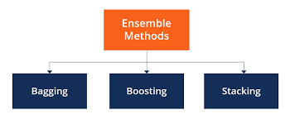

Figure 1: Techniques of Ensemble Learning methods

**Bagging:**

Bagging, short for Bootstrap Aggregating, is an ensemble machine learning technique used to improve the accuracy and robustness of models, especially decision trees. Bagging works by training multiple instances of the same learning algorithm on different subsets of the training data and then combining their predictions to make a final prediction. The subsets are created through bootstrapped sampling, where data points are randomly sampled with replacement from the original dataset to form each subset.

Bootstrap Sampling: Several random subsets (with replacement) of the original training dataset are created. Each subset is of the same size as the original dataset but contains different data points due to the random sampling with replacement. Some data points may appear multiple times in the subsets, while others may not appear at all.

Model Training: A base learning algorithm (such as decision trees) is trained independently on each of the bootstrap samples. This results in multiple base models, each trained on a slightly different subset of the data.

Predictions: When making predictions, each base model predicts the outcome for a new, unseen data point. For regression tasks, the predictions from base models are usually averaged to get the final prediction. For classification tasks, the class labels predicted by each base model might be combined through voting (for binary classification) or averaging probabilities (for multi-class classification) to obtain the final prediction.

The key idea behind bagging is to reduce overfitting by averaging out the variance in the predictions of individual models. Since each model is trained on a slightly different subset of the data, they capture different patterns and noise in the data. By averaging these predictions, the noise cancels out, and the ensemble model's overall performance is often better than that of any individual model.

**Random Forest** is a popular ensemble learning method based on bagging. It uses multiple decision trees as base models and aggregates their predictions to make more accurate and stable predictions. Random Forest further enhances the bagging technique by introducing randomness in the feature selection process during tree construction, making the individual trees more diverse and the overall ensemble more robust.

Bagging can be applied to various machine learning algorithms, not just decision trees, although it's particularly effective when applied to unstable models or models with high variance.

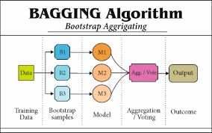

Figure 2:Bagging Algorithm.

**Boosting:**

Boosting is another ensemble learning technique used in machine learning to improve the predictive performance of models. Unlike bagging, boosting focuses on building a sequence of weak learners (models that are slightly better than random chance) and combining their predictions. The key idea behind boosting is to give more weight to the training instances that were misclassified by the previous models, forcing the subsequent models to focus on the mistakes and improve the overall accuracy.

Here's how the boosting process works:

**Initialize Weights:** Each training instance is initially given equal weight. The first weak learner is trained on the data with these weights.

**Misclassified Instances:** After the first model is trained, the instances that were misclassified are identified. These misclassified instances are given higher weights for the next iteration, making them more influential in the training of the next weak learner.

**Sequential Weak Learners:** A series of weak learners are trained sequentially. Each new model focuses on the mistakes made by the previous models, giving higher importance to the misclassified instances. The process continues for a predefined number of iterations or until a perfect model is achieved.

**Combining Predictions:** The predictions of all weak learners are combined, often using a weighted sum, to make the final prediction. In binary classification, boosting models might use a weighted voting scheme, where models with higher accuracy are given more weight in the final decision.

Popular algorithms based on boosting include AdaBoost (Adaptive Boosting) and Gradient Boosting Machines (GBM). Here's a brief overview of each:

**AdaBoost (Adaptive Boosting):** AdaBoost focuses on classification problems and works well with weak learners. It assigns higher weights to misclassified points and reduces the weights for correctly classified points in each iteration, forcing subsequent models to focus on the difficult instances.

**Gradient Boosting Machines (GBM):** GBM is a more general boosting algorithm that can be used for both regression and classification problems. GBM builds trees sequentially, with each tree correcting the errors of the previous one. It optimizes a loss function (such as mean squared error for regression or log loss for classification) in each iteration to find the best weak learner.

Boosting algorithms, especially GBM variations like XGBoost (Extreme Gradient Boosting) and LightGBM, have been widely used in various machine learning competitions and real-world applications due to their ability to achieve high accuracy and handle complex patterns in the data. However, it's important to be cautious about overfitting, as boosting models can become too complex and fit the training data too closely if not properly tuned. Regularization techniques and hyperparameter tuning are crucial when working with boosting algorithms to achieve the best performance.

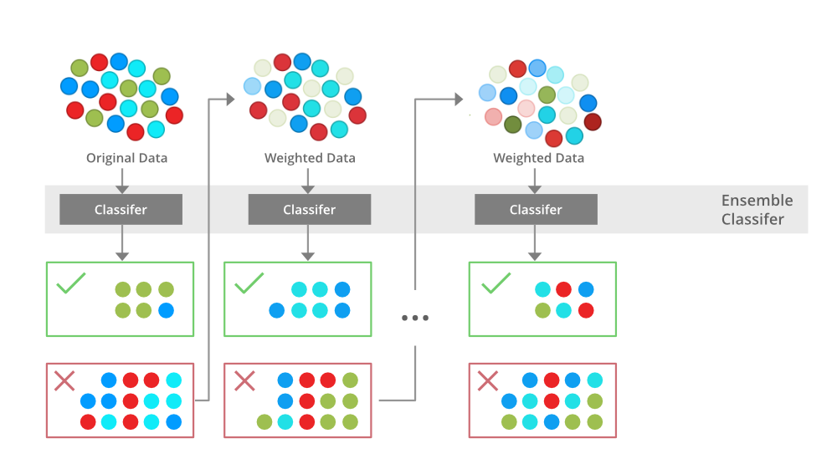

Figure 3:Boosting

**Hyperparameter Tuning:**

Hyperparameter tuning is a crucial step in the machine learning workflow where you optimize the hyperparameters of a model to achieve better performance. Hyperparameters are configuration settings external to the model that cannot be learned from the data. These parameters significantly influence the behavior and performance of the model. Proper tuning can substantially improve a model's accuracy, generalization, and efficiency.

Here are some common techniques and best practices for hyperparameter tuning:

**1. Grid Search:**

Grid Search is a simple and brute-force technique where you specify a grid of hyperparameter values to explore. The algorithm evaluates all possible combinations of hyperparameters and selects the best one based on cross-validation performance. While comprehensive, it can be computationally expensive for a large search space.

**Code:**

# Necessary imports

from sklearn.linear_model import LogisticRegression

from sklearn.model_selection import GridSearchCV

# Creating the hyperparameter grid

c_space = np.logspace(-5, 8, 15)

param_grid = {'C': c_space}

# Instantiating logistic regression classifier

logreg = LogisticRegression()

# Instantiating the GridSearchCV object

logreg_cv = GridSearchCV(logreg, param_grid, cv = 5)

logreg_cv.fit(X, y)

# Print the tuned parameters and score

print("Tuned Logistic Regression Parameters: {}".format(logreg_cv.best_params_))

print("Best score is {}".format(logreg_cv.best_score_))

**2. Random Search:**

Random Search randomly selects hyperparameter combinations to evaluate. It's more efficient than Grid Search for high-dimensional search spaces and often finds good hyperparameters in fewer iterations.

**Code:**

from sklearn.model_selection import RandomizedSearchCV

param_dist = { 'param_name': [value1, value2, ...],

...}

random_search = RandomizedSearchCV(estimator=model, param_distributions=param_dist, n_iter=10, scoring='accuracy', cv=5)

random_search.fit(X_train, y_train)

best_params = random_search.best_params_

**3. Bayesian Optimization:**

Bayesian Optimization models the objective function (model performance) as a probabilistic surrogate. It uses Bayesian inference to decide where to sample the next set of hyperparameters. This technique efficiently explores the hyperparameter space and often converges to a good solution quickly.

Libraries like scikit-optimize or hyperopt can be used for Bayesian Optimization.

**4. Cross-Validation:**

Always use cross-validation to evaluate different hyperparameter combinations. Cross-validation provides a more robust estimate of the model's performance on unseen data and helps prevent overfitting to the validation set.

**5. Regularization and Early Stopping:**

Implement regularization techniques (L1, L2 regularization) to avoid overfitting. For algorithms like neural networks, use techniques like early stopping to halt training when the model's performance on the validation set starts degrading.

**6. Domain Knowledge:**

Leverage domain knowledge to narrow down the search space. Not all hyperparameters are equally important, and domain expertise can guide you to focus on specific parameters.

**7. Automated Hyperparameter Tuning Services:**

Platforms like Google Cloud AI Platform, AWS SageMaker, and Azure Machine Learning offer automated hyperparameter tuning services that can efficiently handle the tuning process for you.

**8. Parallelization:**

If you have access to multiple computing resources, you can parallelize the hyperparameter search, evaluating different combinations simultaneously, which can significantly speed up the tuning process.Remember that hyperparameter tuning is an iterative process. It might require several rounds of experimentation and fine-tuning to find the best set of hyperparameters for your specific problem. Regularly monitor the model's performance on a validation set during tuning to prevent overfitting to the validation data.

**User ideas of model deployment:**

Deploying machine learning models that use ensemble learning techniques can be highly effective in various real-world scenarios. Here are some ideas for deploying machine learning models using ensemble learning:

**1. Fraud Detection System:**

Deploy an ensemble of classifiers (such as Random Forest, Gradient Boosting, and Logistic Regression) to detect fraudulent transactions in real-time. Each classifier can specialize in different types of fraud patterns, and their combined predictions can enhance the accuracy of fraud detection.

**2. Customer Churn Prediction:**

Build an ensemble model using methods like AdaBoost or Gradient Boosting to predict customer churn in subscription-based services. By combining the predictions from multiple weak learners, you can identify at-risk customers more accurately and take targeted retention actions.

**3. Anomaly Detection in IoT Devices:**

Use ensemble methods like Isolation Forest or a combination of different outlier detection algorithms to identify anomalies in IoT device data streams. Ensembles can handle diverse patterns of anomalies, making them well-suited for IoT applications.

**4. Healthcare Diagnostics:**Deploy an ensemble of classifiers to assist medical professionals in diagnosing diseases. Different classifiers can specialize in different symptoms or aspects of the patient's medical history, leading to more accurate and reliable diagnoses.

**5. Sentiment Analysis in Customer Feedback:**

Create an ensemble model for sentiment analysis by combining the outputs of various sentiment classifiers. By aggregating predictions from different models (like Naive Bayes, SVM, and Neural Networks), you can capture a broader range of language nuances and improve the accuracy of sentiment classification.

**6. Recommendation Systems:**

Utilize ensemble learning to enhance recommendation systems. Combine collaborative filtering algorithms, content-based methods, and matrix factorization techniques to provide personalized recommendations to users. Each model can focus on different aspects of user behavior and preferences.

**7. Credit Scoring and Risk Assessment:**

Develop an ensemble model to assess credit risk for loan applicants. Different base models (like Decision Trees, Logistic Regression, and Random Forest) can provide diverse perspectives on an applicant's creditworthiness, leading to more accurate risk evaluations.



**8. Predictive Maintenance in Manufacturing:**

Implement ensemble learning to predict equipment failures in manufacturing settings. Combine models trained on historical sensor data to identify patterns indicating potential failures. By leveraging ensemble techniques, you can create a more robust predictive maintenance system.

**9. Natural Language Processing (NLP) Applications:**

Deploy ensemble models for various NLP tasks, such as named entity recognition, text classification, or machine translation. Combining models like LSTM networks, Transformer architectures, and traditional machine learning classifiers can improve the accuracy and reliability of NLP applications.

**10. Smart Energy Management:**

Use ensemble methods to predict energy consumption patterns and optimize energy usage in buildings or industrial processes. Ensemble models can handle complex interactions between different variables, leading to more efficient energy management strategies.When deploying ensemble models, it's essential to consider the computational resources required, especially if the models are complex. Additionally, proper monitoring and regular updates are necessary to maintain the accuracy of the deployed system as new data becomes available and patterns change over time.

**Choosing An cloud Platform:**

It appears there might be a typo in your question. If you're referring to cloud platforms, they are online platforms that provide various services and resources over the internet. These platforms are used for hosting applications, storing data, running virtual machines, and more. Some of the leading cloud platforms as of my last update in September 2021 include:

1. **Amazon Web Services (AWS):** Amazon's cloud computing platform offers a wide array of services, including computing power, storage options, databases, machine learning, analytics, and more.
2. **Microsoft Azure:** Microsoft's cloud platform provides services for computing, analytics, storage, and networking. It also integrates well with Microsoft products like Windows Server, SQL Server, and Active Directory.
3. **Google Cloud Platform (GCP):** Google's cloud services include computing, storage, databases, machine learning, and data analytics. GCP is known for its data analytics and machine learning services.
4. **IBM Cloud:** IBM offers cloud computing services, including infrastructure as a service (IaaS), software as a service (SaaS), and platform as a service (PaaS) through public, private, and hybrid cloud models.
5. **Oracle Cloud:** Oracle's cloud platform provides services for computing, storage, databases, and various enterprise applications. It's designed to meet the needs of large enterprises.
6. **Alibaba Cloud:** Alibaba's cloud computing arm offers a comprehensive suite of global cloud computing services to power both international customers’ online businesses and Alibaba Group’s own e-commerce ecosystem.
7. **Heroku:** Heroku is a cloud platform that lets developers build, deploy, and scale applications easily. It is known for its simplicity and developer-friendly interface.
8. **DigitalOcean:** DigitalOcean provides cloud services to help deploy modern apps. It simplifies cloud infrastructure, making it easy for developers to launch and scale applications.

These platforms offer various services like virtual machines, storage, databases, AI and machine learning services, serverless computing, and more. Users can choose a platform based on their specific requirements, such as budget, scalability, and required services. Please note that the features and offerings of these platforms may have changed since my last update in September 2021, so I recommend checking the respective platforms' official websites for the most current information.

**Overview OF Machine Learning Model:**

A machine learning model is a mathematical representation of a real-world process. It is created using algorithms that are trained on historical data to learn patterns and make predictions or decisions without being explicitly programmed. Machine learning models are used for tasks such as classification, regression, clustering, and reinforcement learning.

**Components of a Machine Learning Model:**

1. **Input Data:** The raw data that the model processes. It consists of features or variables that are used to make predictions or classifications.
2. **Algorithm:** The specific machine learning algorithm used to learn patterns from the input data. Examples include decision trees, neural networks, support vector machines, and clustering algorithms.
3. **Training Data:** A subset of the input data used to train the model. The algorithm learns from this data to make predictions or decisions.
4. **Model Parameters:** The internal variables of the algorithm that are optimized during the training process. The model parameters are adjusted to minimize the difference between the predicted outcomes and the actual outcomes in the training data.
5. **Output or Predictions:** The results generated by the model after it has been trained. For classification tasks, it might be class labels, and for regression tasks, it's numerical values.

**Steps in Building a Machine Learning Model:**

1. **Data Collection:** Gather relevant and sufficient data for the problem at hand. High-quality data is crucial for the performance of the model.
2. **Data Preprocessing:** Clean, transform, and preprocess the data. This includes handling missing values, normalizing data, and converting categorical variables into a format suitable for the chosen algorithm.
3. **Feature Selection:** Choose the relevant features that have the most impact on the predictions. This step can improve the model's efficiency and accuracy.
4. **Model Selection:** Choose an appropriate machine learning algorithm based on the problem type (classification, regression, etc.) and the characteristics of the data.
5. **Training:** Train the model using the training data. During training, the algorithm learns the underlying patterns in the data.
6. **Evaluation:** Evaluate the model's performance using metrics like accuracy, precision, recall, mean squared error, etc., on a separate dataset called the validation set. This step helps in tuning hyperparameters and detecting overfitting.
7. **Hyperparameter Tuning:** Fine-tune the model by adjusting hyperparameters. Techniques like grid search, random search, or Bayesian optimization can be used to find the best hyperparameter values.
8. **Testing:** Test the model on a completely unseen dataset (test set) to assess its generalization ability. This step gives an indication of how well the model will perform on new, unseen data in the real world.
9. **Deployment:** Deploy the trained model in a production environment, making it accessible for making predictions on new data.
10. **Monitoring and Maintenance:** Continuously monitor the model's performance in real-world scenarios. Retrain or update the model if its performance degrades over time due to changes in the data distribution.

Machine learning models are versatile tools that have applications in various fields such as finance, healthcare, marketing, and more. They continue to evolve with advancements in algorithms and technologies, making them a vital part of modern data-driven decision-making processes.

**Conclusion:**

In conclusion, deploying machine learning models using ensemble learning techniques offers a powerful and versatile approach to solving complex real-world problems. Ensemble methods, such as bagging, boosting, and stacking, allow us to combine the strengths of multiple models, often resulting in improved accuracy, robustness, and generalization.

Top of Form