Paper Title

*First Author¹, Second Author², Third Author³, Fourth Author⁴
¹First Author Affiliation, Department Name, Organization Name, City, State, Country
^{2,3}Second & Third Author Affiliation, Department Name, Organization Name, City, State, Country
⁴Fourth Author Affiliation, Department Name, Organization Name, City, State, Country
*Email: xyz@gmail.com

Abstract- Abstract should be Times New Roman with Font size 12 and single spacing.
Keywords – At least Four key words need to be mentioned.

1. MaJOR HEADING
Paper Title should be in Times New Roman font with font size of 18. CCAEE paper format font should be 12 in times new roman with single spacing. Same affiliation can be mentioned at a time as mentioned in example. All references should be mentioned in increasing order [1]. Multiple references should be mentioned at time like [3-5]. The paper should consist of Introduction, Literature survey, problem identification/ Objective, Research methodology, experimental results, conclusion and futures scope. Authors are allowed to mention any acknowledgment of their funding agency/ persons. At last references should be mentioned.

  - Figure:
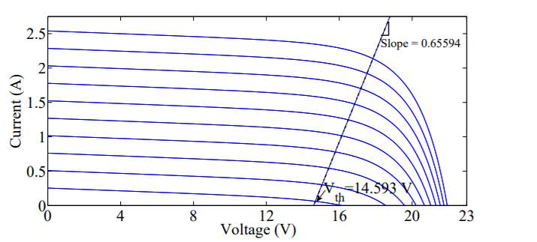
- Figure Name
Figure should be good quality and in jpg format. For graphs X- axis and Y axis vales and quantity should be clearly visible. Figure name should be mentioned below the figure. Figure number should be mentioned in increasing order. No copyright images should be included without written permission of owners and credits to them.

  - Formula:
W(i) = (y_{w}(i) + y_{o}(i)) / α (1)

All Terms of the equation need to be explained. Formulas need to numbered in increasing order.

  - Table:

Table -1 Experiment Result

 | Sample-1 | Sample-2
Data-1 | 1 | 4
Data-2 | 2 | 5
Data-3 | 3 | 6

Table name should be mentioned above the Table. All tables need to be numbered in increasing order.
No footnotes, headers, footers, page numbers are allowed.

REFERENCES
- H. Makino, T. Kosaka, Nobuyuki Matsui, “Digital PWMControl-Based Active Vibration Cancellation for Switched Reluctance Motors”, IEEE Transaction on Industry Application, vol.51, no.6, pp.4521-4530, Nov. 2015.

