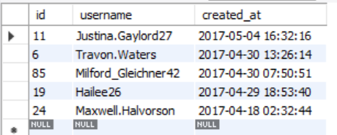1)

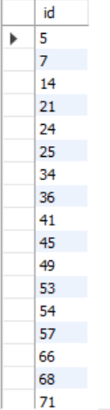

2)

3)

4)

5)

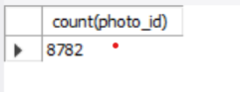7)

