CSC244

Preliminary Report

Project 1

FSM Vending Machine

Written by: Neil Rolf, Mehul Deep Lab Section: 02 (Neil), 04 (Mehul)

Instructor: James Gallipeau Date: 10/04/2022

**Inputs & Outputs**

Inputs: clock, $0.25, $0.50, $1.00, asynchronous reset

Outputs: MacGuffin, change in quarters, change in half-dollars, 7-segment display (inserted money), 7-segment display (change due)

**Assumptions**

Coins will be inserted one at a time.

**Required States (number of flip-flops)**

7 states from $0 to $1.50 in $0.25 increments

**State transition diagram**

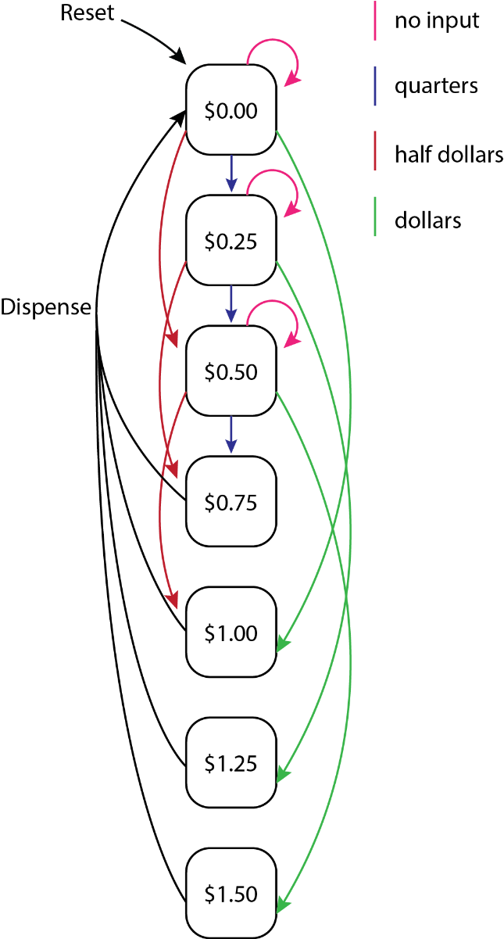

**State transition/output table**

|  |  |  |  |  |
| --- | --- | --- | --- | --- |
| **State Transition Table** | | | | |
| Current State S | Encoded State S 1:0 | Inputs D N | Next State S' | Encoded Next State S' 1:0 |
| 0.00 | 0 0 | 0 0 | 0.00 | 0 0 |
| 0.00 | 0 0 | 0 1 | 0.25 | 0 1 |
| 0.00 | 0 0 | 1 0 | 0.50 | 10 |
| 0.00 | 0 0 | 1 1 | 0.75 | 11 |
| 0.25 | 0 1 | 0 0 | 0.25 | 0 1 |
| 0.25 | 0 1 | 0 1 | 0.50 | 1 0 |
| 0.25 | 0 1 | 1 0 | 0.75 | 1 1 |
| 0.25 | 0 1 | 1 1 | 0.75 | 1 1 |
| 0.50 | 1 0 | 0 0 | 0.50 | 1 0 |
| 0.50 | 1 0 | 0 1 | 0.75 | 1 1 |
| 0.50 | 1 0 | 1 0 | 0.75 | 1 1 |
| 0.50 | 1 0 | 1 1 | 0.75 | 1 1 |
| 0.75 | 1 1 | 0 0 | 0.00 | 0 0 |
| 0.75 | 1 1 | 0 1 | 0.25 | 0 1 |
| 0.75 | 1 1 | 1 0 | 0.50 | 1 0 |
| 0.75 | 1 1 | 1 1 | 0.75 | 1 1 |

|  |  |  |
| --- | --- | --- |
| **Output Table** | | |
| State Name | Encoded State S 1:0 | Output |
| 0.00 | 0 0 | 0 |
| 0.25 | 0 1 | 0 |
| 0.50 | 1 0 | 0 |
| 0.75 | 1 1 | 1 |

The quarter, half dollar, and dollar inputs can be encoded into 2-bits due to the fact that no combination of next state inputs can surpass $0.75 before being returned to the initial $0.00 state. Only 4 possible next states exist.

**List of required System Verilog Modules (with inputs/outputs)**

Debounce (Clock):

* Input: Clock, Clock (noisy)
* Output: Clock (clean)

Debounce (Key):

* Input: Clock, Reset Key (noisy)
* Output: Reset Key (clean)

4:2 Encoder:

* Input: User input (switches) for quarters, half dollars, dollars
* Output: encoded input

D-flip-flops:

* Input: Clock (clean), Next State
* Output: Current State

7-Segment (State/Change):

* Input:
  + Decoder:
    - Input: 4bit binary
    - Output: Y[0-15]
* Output: 7-Segment LED’s[0-6], decimal point